# Plant Disease Detection using Machine Learning & Image Processing

Malathi T1, Muhammed Nayif M Navab Metha2, Nourin S3,Prince Sajuvin4

*1,2,3,4(B.Tech in Computer Science And Engineering, St. Thomas College of Engineering & Technology,Chengannur, India)*

*5(Assistant Professor, Department of Computer Science and Engineering, St. Thomas College of Engineering & Technology, Chengannur, India)*

***Abstract:*** *Most of individuals on earth make their living for the most part from horticultural work. Assuming there are any issues in that essential area, the populace's way of life will endure. Accordingly, it's vital for keep the agribusiness area in the right equilibrium by protecting something very similar from destructive impacts like plant sicknesses, dryness, and so on. In the rural area, ranchers get more cash-flow from cultivation than from different yields. These plants are helpless against numerous sicknesses rapidly, and early manual illness determination in crops is extremely difficult. stage. AI methods are utilized instead of manual illness distinguishing proof, which could prompt blunders. Picture.The impacted region of the picture is caught to finish the handling.*

***Keyword:*** *Image Processing ,Resnet ,Convolution Neural Network (CNN) ,Random Forest , Plant Diseases*

1. **INTRODUCTION**

Using calculations and ways to deal with find, analyze, and oversee plant ailments through the investigation of photos is known as plant sickness recognition using AI and picture handling. Typically, this technique involves the accompanying advances

Picture Obtaining: Take pictures of plant leaves or different segments showing infection side effects using cellphones or cameras. Preprocessing: Upgrade and clean the photos to raise their quality, dispose of clamor, and change further develop difference and light for more exact examination. Include extraction includes taking out appropriate subtleties from the photos, similar to measure, variety, surface, and structure, which are all fundamental for distinguishing great and unfortunate plant segments. Models for AI: To sort and figure sicknesses, apply AI techniques, for example, Arbitrary Woods, Backing Vector Machines (SVM), Convolutional Brain Organizations (CNNs), and others.

**II. PROPOSED SYSTEM**

The most popular use of convolutional neural networks (CNNs), a class of deep neural networks, is the analysis of visual information. For tasks like object detection, image segmentation, and image classification, they are especially well-suited. Design and Architecture: CNNs are made up of several convolutional layers, each of which applies a set of learnable filters or kernels to the input data. As these filters move across the input image, the dot product between each weight and the input is calculated at each place.

Activation Function: To add non-linearity to the model, a non-linear activation function such as the Rectified Linear Unit (ReLU) usually comes after each convolutional operation.

Fully Connected Layers: Using the features that the convolutional layers have extracted, one or more fully connected layers are usually used at the conclusion of the network to carry out high-level reasoning. Softmax Layer: To calculate the probability distribution across the many classes in classification tasks, a softmax layer is frequently utilized.

Feature Learning: Using the raw input data, CNNs automatically deduce hierarchical representations of features. Higher layers pick up more intricate and abstract aspects pertinent to the current job, whereas lower levels record simpler features like edges and textures. Weight sharing, spatial hierarchies, and the convolutional operation allow CNNs to capture translational invariance, which makes them resistant to changes in object position within an image.

1. **Block diagram**

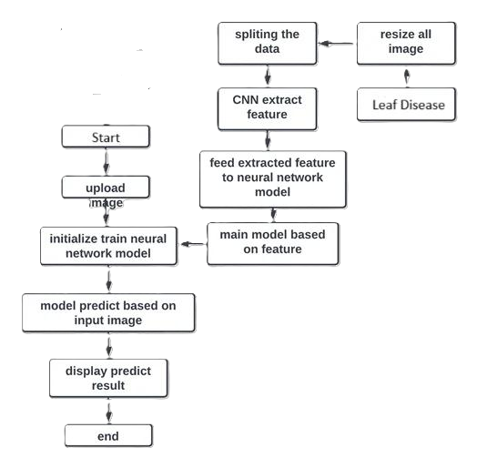

**Figure 1 :** Block diagram of the model

Training: As with other neural networks, CNNs are trained by gradient descent and backpropagation. However, training CNNs frequently necessitates significant computational resources and data because to their huge number of parameters.

Rotation, scaling, and flipping are examples of data augmentation techniques that are frequently used to artificially expand the training sample and enhance model generalization.

Applications: CNNs have demonstrated state-of-the-art performance in a range of computer vision tasks, such as semantic segmentation (i.e., assigning an object class label to each pixel in an image) and image classification (i.e., recognizing objects in photos)

Skip connections, also known as residual connections, are the main innovation of ResNet; they allow connections to flow through levels without having to go through them. The disappearing gradient issue is resolved by these links, which enable the gradient to travel straight across the network. ResNet learns the residual mapping rather than attempting to learn the intended underlying mapping; therefore, the term "Residual Network."

Blocks that Remain: The residual block is the fundamental unit of construction in ResNet. ReLU activation functions and batch normalization come after two or more convolutional layers in each residual block. By using a skip connection, the convolutional layers' output is enhanced with the initial input. Remaining blocks can be classified as basic, bottleneck, or any combination of these depending on the computational power and number of convolutional layers.

* Deep Architectures: ResNet architectures have a very deep design. There were 34, 50, 101, and 152 layer versions introduced in the original ResNet study. Research has now descended to much deeper structures, such ResNet with over a thousand layers, also referred to as "ResNet-1001" or "ResNet-1202."
* Global Average Pooling: Towards the conclusion of the network, ResNet usually employs global average pooling (GAP) rather than fully connected layers. By introducing spatial features and lowering the total number of parameters, GAP helps decrease overfitting.
* Pre-Activation Residual Units: Batch normalization and ReLU activation are applied prior to convolution operations in pre-activation residual units, which the authors implemented in later versions of ResNet. This adjustment promotes the propagation of gradients and makes it easier to train even deeper networks.

Applications: In a variety of computer vision tasks, such as picture classification, object detection, semantic segmentation, and image recognition tasks across several domains, ResNet architectures have demonstrated state-of-the-art performance.

Transfer Learning: Pre-trained ResNet models, which have been trained on extensive datasets such as ImageNet, are frequently employed in this context. To save time and computing resources, researchers and practitioners refine these pre-trained models on smaller datasets for particular objectives.

**III.IMPLEMENTATION**

1. **Information Gathering:** Compile a collection of photos showing both healthy and diseased plants. These photos can be obtained by taking your own photos, using web scraping techniques, or browsing online databases.
2. **Preprocessing**: Use preprocessing to improve the pictures' features and lower their noise. This could involve using noise reduction, normalization, and scaling methods.
3. **Feature Extraction:** Take pertinent features out of the pictures. This may entail methods like as texture analysis, color histogram analysis, or deep learning-based feature extraction with pre-trained convolutional neural networks (CNNs) such as ResNet, VGG, or Inception.
4. **Model Selection:** Select a machine learning model that is suitable for the classification task. Support Vector Machines (SVM), Random Forests, and deep learning models such as CNNs are popular options.
5. **Training:** Divide the dataset into sets for testing and training. Utilizing the training set, train the model of choice. Adjust hyperparameters as needed to boost efficiency.
6. **Validation**: Using metrics like accuracy, precision, recall, and F1-score, assess how well your model performs on the testing set. If needed, make modifications to your model or data pretreatment methods.
7. **Deployment:** After you're happy with the model's performance, use it in an actual situation. This can entail incorporating it into an Internet of Things (IoT) device for on-site illness detection, a web service, or a mobile application.

**IV. RESULT ANALYSIS**

* **DISEASE DETECTED**

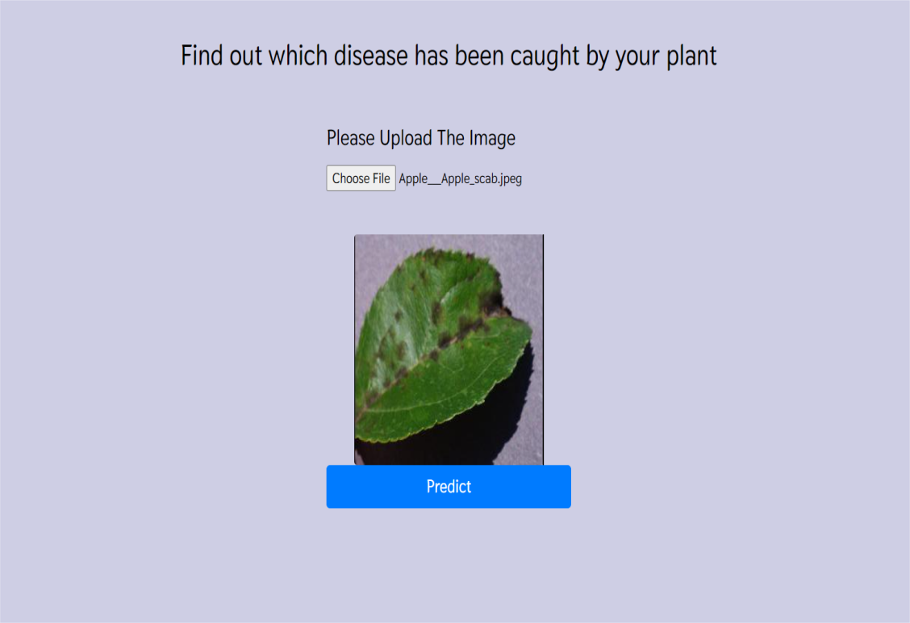

* **Apple Scab**: One of the most prevalent and economically significant diseases infecting apple trees, apple scab is caused by the fungus Venturia inaequalis. It appears on leaves, fruit, and twigs as dark, olive-green or black lesions. Defoliation and decreased fruit quality can result from severe infections.

**Apple mosaic virus:** This virus can cause mottling, deformation, and yellowing of the leaves in addition to poor fruit quality and yield. It can be managed by utilizing virus-free stock and keeping things clean. The primary means of transmission is through contaminated plant matter.

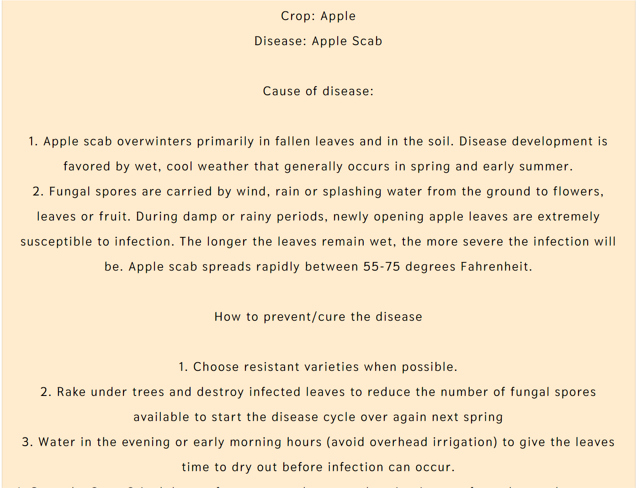

* **NO DISEASE**

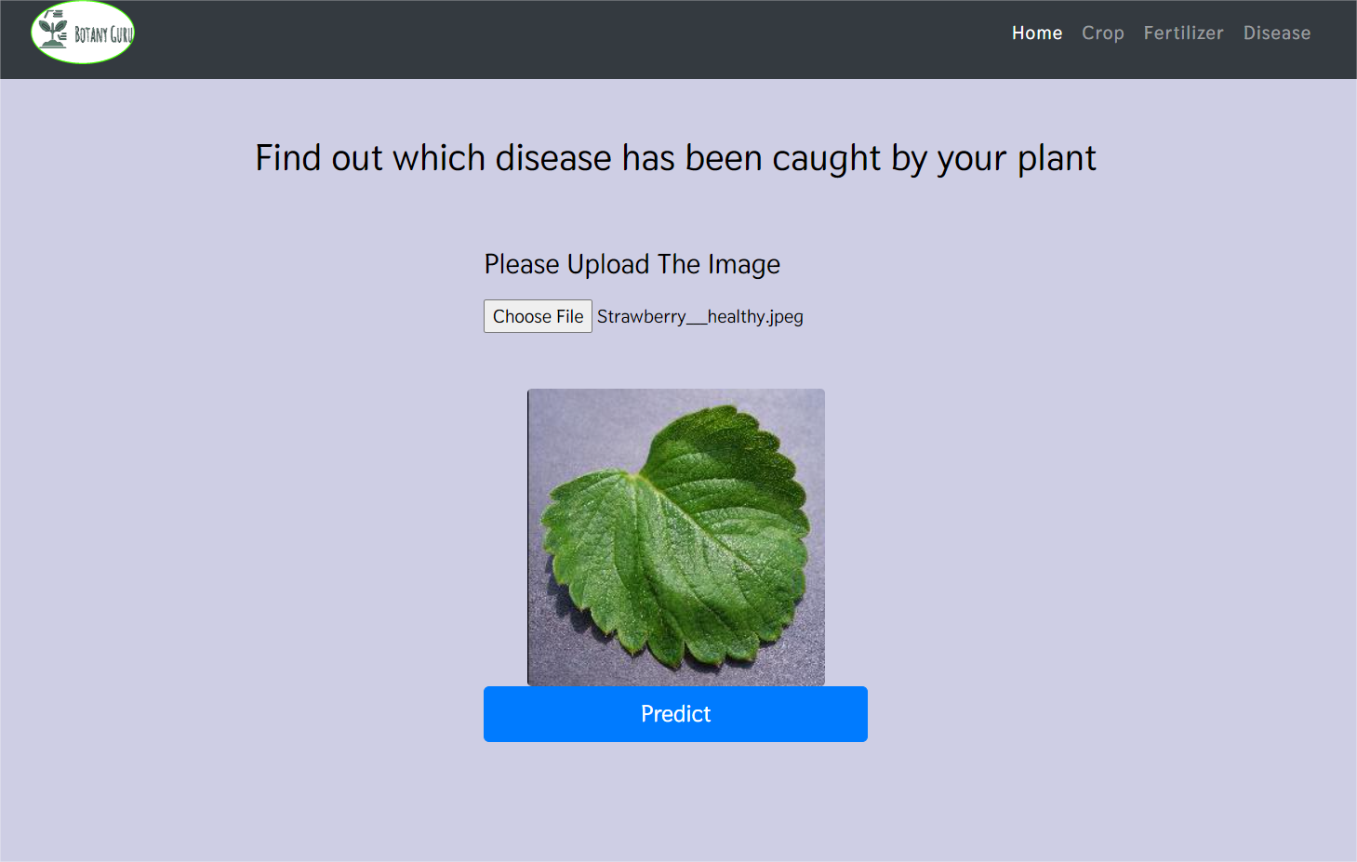

Several fungal species, including Podosphaera aphanis and Sphaerotheca macularis, are the cause of powdery mildew. On the leaves, stems, and occasionally the fruit of strawberry plants, it manifests as a white, powdery growth. Reduced photosynthesis, leaf deformation, and decreased fruit yield are all possible outcomes of severe infections.

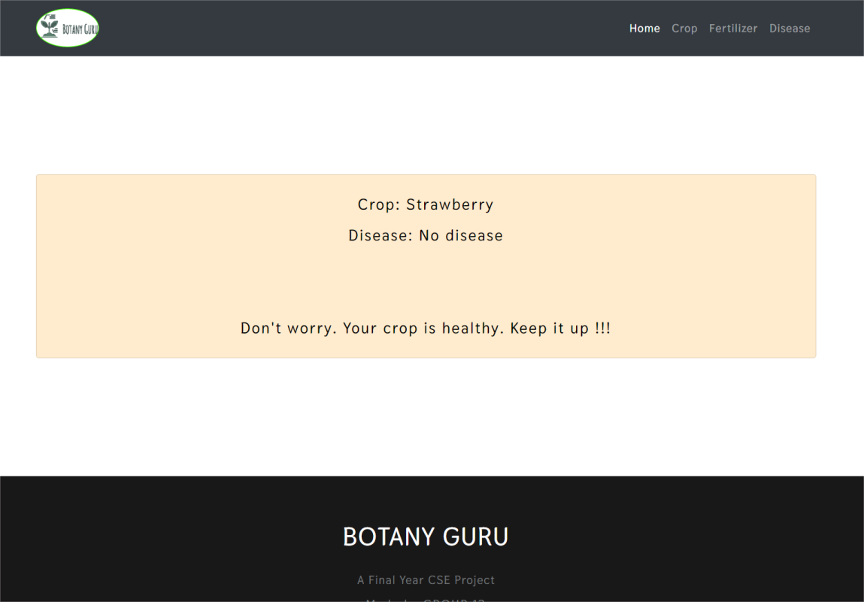

Botrytis cinerea is the fungus that causes gray mold, also known as botrytis fruit rot. Strawberries that are both ripe and overripe will produce fuzzy mold that is grayish-brown as a result. Fruit rot can be significantly exacerbated by gray mold, particularly in damp and humid environments.

**V.CONCLUSION**

In conclusion, there are encouraging options for the identification and treatment of plant diseases provided by the combination of machine learning and image processing methods. Researchers and agricultural practitioners can improve disease management tactics and hence crop health, production, and food security by utilizing computational algorithms and visual data analysis.

Convolutional neural networks (CNNs) and support vector machines (SVMs) are two examples of machine learning techniques that have shown impressive abilities in automatically extracting patterns and attributes from plant photos.Before feeding plant photos into machine learning models, image processing techniques are essential for preprocessing and improving the images. methods include feature extraction, picture segmentation, and image

In conclusion, there is a lot of potential for transforming plant disease diagnosis and management through the combination of machine learning and image processing. We can increase the productivity and resilience of agricultural systems by utilizing artificial intelligence and computer vision, which will support efforts towards sustainable development and global food security.

The machine learning experiment on plant disease identification shows how cutting edge technology may be used to solve important agricultural problems.

Through the utilization of machine learning algorithms and image processing techniques, the study effectively illustrates the viability of precise and prompt plant disease identification.

The results highlight how crucial it is to combine cutting-edge technology with time-tested farming methods in order to improve crop management, reduce yield losses, and advance sustainable farming practices.

**VI . ACKNOWLEDGEMENT**

We express our special gratitude to **Dr. SHYJITH M B ,** Head of the Department of Computer Science and Engineering for providing us constant guidance and encouragement throughout the Project preliminary work.

We express our sincere gratitude to the Project Supervisor **Mr JAISON MATHEW JOHN,** Assistant Professor, Department of Computer Science and Engineering for the inspiration and timely suggestions.

We also express sincere gratitude to our guide **Mr JAISON MATHEW JOHN,** Assistant Professor , Department of Computer Science and Engineering for his guidance and support . We have to appreciate the guidance given by the panel members during the Project Preliminary presentations, thanks to their comments and advice. Last but not the least we place a deep sense of gratitude to our family members and friends who have been constant sources of inspiration during the preparation of the Project Preliminary works.

**References**

[1]. S. D. Khirade and A. B. Patil, “Plant Disease Detection Using Image Processing, ” 2015 International conference on computing communica tion control and automation, pp. 768–771, 2015.

[2] Q. Yao, Z. Guan, Y. Zhou, J. Tang, Y. Hu and B. Yang, “Application of support vector machine for detecting rice diseases using shape and color texture features,” 2009 international conference on engineering computation, pp. 79–83, 2009.

[3] R. Deshmukh and M. Deshmukh, “Detection of paddy leaf diseases, ” International Journal of Computer Applications, vol. 975, pp. 8887, 2015

[4] S. Phadikar and J. Sil, “Rice Disease Identification using Pattern Recognition Techniques, ” 2008 11th International Conference on Computer and Information Technology, pp. 420–423, 2008.

[5] G. Anthonys and N. Wickramarachch, “An Image Recognition System for Crop Disease Identification of Paddy fields in Sri Lanka,” 2009 International Conference on Industrial and Information Systems (ICIIS), pp. 403–407, 2009.

[6] S. Ramesh and D. vydeki “Rice Blast Disease Detection and Classification Using Machine Learning Algorithm,” 2018 2nd International Conference on Micro-Electronics and Telecommunication Engineering (ICMETE), pp. 255–259, 2018.

[7] K. Elangovan and S. Nalini, “Plant Disease Classification Using Image Segmentation and SVM Techniques,” International Journal of Computational Intelligence Research, vol. 13(7), pp. 1821–1828, 2017.

[8] N. Mangla, P. B. Raj, S. G. Hegde and R. Pooja, “Paddy leaf disease detection using image processing and machine learning, ” Int J Innov Res Elec Electron Instrument Control Eng, vol. 7(2), pp. 97–99, 2019.

[9] S. Phadikar, J. Sil and A. K. Das, “Classification of rice leaf diseases based on morphological changes,”International Journal of Information and Electronics Engineering, vol. 2(3), pp. 460–463, 2012.

[10] T. Suman and T. Dhruvakumar, “Classification of paddy leaf diseases using shape and color features,” International Journal of Electrical and Electronics Engineers, vol. 7(1), pp. 239–250, 2015.

[11] G. Athanikar and P. Badar, “Potato Leaf Diseases Detection and Classification System, ” International Journal of Computer Science and Mobile Computing, vol. 5(2), pp. 76–88, 2016.