PNEUMONIA DETECTION IN CHEST X-RAYS USING NEURAL NETWORKS

**Dr .X.S. Asha Shiny**, Associate professor, Department of Information Technology,

**CMR Engineering College,UGC Autonomous**, Hyderabad.

**B.Bhavana**,B.Tech **IV-Year** , Department of Information Technology,

**CMR Engineering College,UGC Autonomous**, Hyderabad.

**A.Jyothirmayee**,B.Tech., Department of Information Technology,

**CMR Engineering College,UGC Autonomous**, Hyderabad.

**B.Sushanth**,B.Tech., Department of Information Technology,

**CMR Engineering College,UGC Autonomous**, Hyderabad.

**D.Sathish** ,B.Tech., Department of Information Technology,

**CMR Engineering College,UGC Autonomous**, Hyderabad.

*Abstract*—Deep learning techniques are widely used to design robust classification models in several areas such as medical diagnosis tasks in which it achieves good performance. In this paper, we have proposed the CNN model (Convolutional Neural Network) for the classification of Chest X-ray images for Radiological Society of North America Pneumonia (RSNA) datasets. The study also tries to achieve the same RSNA benchmark results using the limited computational resources by trying out various approaches to the methodologies that have been implemented in recent years. The proposed method is based on a noncomplex CNN and the use of transfer learning algorithms like Xception, InceptionV3/V4, EfficientNetB7. Along with this, the study also tries to achieve the same RSNA benchmark results using the limited computational resources by trying out various approaches to the methodologies that have been implemented in recent years. The RSNA benchmark MAP score is 0.25 but using the Mask RCNN model (Region Convolutional Neural Network) on a stratified sample of 3017 along with image augmentation gave a MAP (Mean Average Precision) score of 0.15. Meanwhile, the YoloV3 without any hyperparameter tuning gave the MAP score of 0.32 but still, the loss keeps decreasing. Running the model for a greater number of iterations can give better results. Pneumonia is one of the major causes of cancer-related deaths due to its aggressive nature and delayed detections at advanced stages. Early detection of Pneumonia is very important for the survival of an individual, and is a significant challenging problem. Generally, chest radiographs (Xray) and computed tomography (CT) scans are used initially for the diagnosis of the malignant nodules; however, the possible existence of benign nodules leads to erroneous decisions. At early stages, the benign and the malignant nodules show very close resemblance to each other. In this paper, a novel deep learning-based model with multiple strategies is proposed for the precise diagnosis of the malignant nodules. Due to the recent achievements of deep convolutional neural networks (CNN) in image analysis, we have used two deep three-dimensional (3D) customized mixed link network (CMixNet) architectures for lung nodule detection and classification, respectively.

Keywords—X-Rays, Deep learning techniques, CNN model, RSNA.

INTRODUCTION

Pneumonia diagnosis is a time-consuming process that involves highly skilled professionals to analyse a chest radiograph or chest X-ray (CXR) and confirm the diagnosis with clinical history, vital signs, and laboratory tests. It helps doctors to work out the extent and placement of the infection in the lungs. Respiratory illness manifests as a neighbourhood of inflated opacity on X- Ray. However, the identification of respiratory illness in CXR is troublesome due to different conditions which may appear as opacity in the lungs such as - carcinoma, bleeding, pulmonary edema, etc. The early detection of Pneumonia can increase overall 5-year survival rates by extracting the lung nodules and distinguishing their location for surgery. Hence, this diagnosis according to nodule location (solitary and juxtapleural) can improve the treatment. In this paper, we aim to classify small lung masses as nodule or non-nodule by using a Computer Aided Diagnosis (CADx) system. Also classify this nodule as a solitary nodule or juxtapleural nodule. In this study, two main schemes of supervised learning for classification are proposed in which; two segmentation approaches are achieved (Thresholding ? K-means clustering and Bounding box ? Maximum intensity projection) for both two schemes. For the first scheme, a combination of the first-order and second-order features is extracted. Fisher score ranking is used as a feature selection method. The higher five, ten, and fifteen ranks of features are selected, respectively, from the two sets of features. The first scheme is implemented by using Support Vector Machine (SVM) classifier. The second scheme used Deep Convolutional neural network (DCNN) for deep learning classification. Tenfold cross-validation and random oversampling are used to manage limited and imbalanced data. ROC curve is used to evaluate the DCNN classifier.The CXRs of the patient that are taken at different intervals and the correlation with clinical symptoms are useful in identifying pneumonia. A chest X-ray examines your lungs, bones, and heart using a focused beam of radiation. Chest X-rays are quick, non-invasive tests. Usually, one will know the results of their X- ray within one to two days. Faster diagnosis can guarantee timely access to treatment and save much needed time and money. Chest X-rays use focused beams of radiation. The images created by these radiation beams are of the inside of your body. The negative pictures of black-and-white photographs resemble X-ray images. The thickness of your body's tissues varies. Every part of your body has a different ratio of radiation passing through it. Your bones, for instance, are incredibly thick and don't let much radiation through. On an X-ray picture, bones appear white. Your lungs, on the other hand, enable 2 more radiation to get through. An X-ray picture of your lungs shows them to be grey. To identify and treat health disorders, healthcare practitioners examine the colours and shading on an X- ray. Chest X-rays are taken by a radiology technician. X-ray testing is a specialty for these professionals. The appearance of the CXR is affected by factors such as the patient's posture and the depth of inspiration, making it more difficult to interpret. In addition, radiologists must interpret a large number of CXRs on a daily basis. Traditional X-ray and computed tomography (CT scan) is attempted to diagnose lung nodules [2]. The most accurate modality for imaging lung nodules is CT. It allows the detection of a small lung nodule, but a large amount of data leads to a high false negative rate to detect the small nodules. Computer Aided Diagnosis (CADx) system is one of the robust systems which is used in the detection and diagnosis of Pneumonia. Because of the nodule’s small size in the lung, it is difficult to distinguish between it and another mass in a 2D slice.For example, “the data indicate that …”

**CONVOLUTIONAL NEURAL NETWORK(CNN)**

A convolutional neural network, or CNN, is a deep learning neural network sketched for processing structured arrays of data such as portrayals.

**1.**CNN are very satisfactory at picking up on design in the input image, such as lines, gradients, circles, or even eyes and faces.

**2.**This characteristic that makes convolutional neural network so robust for computer vision.

**3.**CNN can run directly on an underdone image and does not need any preprocessing.

**4.**A convolutional neural network is a feed forward neural network, seldom with up to 20.

**5.**The strength of a convolutional neural network comes from a particular kind of layer called the convolutional layer.

**6.**CNN contains many convolutional layers assembled on top of each other, each one competent of recognizing more sophisticated shapes.

**7.**With three or four convolutional layers it is viable to recognize handwritten digits and with 25 layers it is possible to differentiate human faces.

**8.**The agenda for this sphere is to activate machines to view the world as humans do, perceive it in an alike fashion and even use the knowledge for a multitude of duty such as image and video recognition, image inspection and classification, media recreation, recommendation systems, natural language processing, etc.

**9.**It's a deep learning algorithm that's capable of assessing images and identifying objects in them, including classifying them. The architecture of a convolutional neural network is similar to the human brain, and is capable of executing tasks that relate to analyzing pixel information.

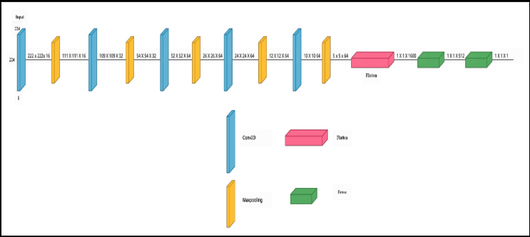

**SYSTEM ARCHITECTURE**

We need to upload the dataset of selected feature values where feature extraction is done, it can significantly impact the accuracy and efficiency of pneumonia detection. Additionally, factors like the number of layers, filter sizes, and the presence of additional techniques like data augmentation and transfer learning can all influence the system's ability to detect pneumonia accurately. It's essential to choose an architecture and parameters that are suitable for the specific task and dataset to achieve the best results.

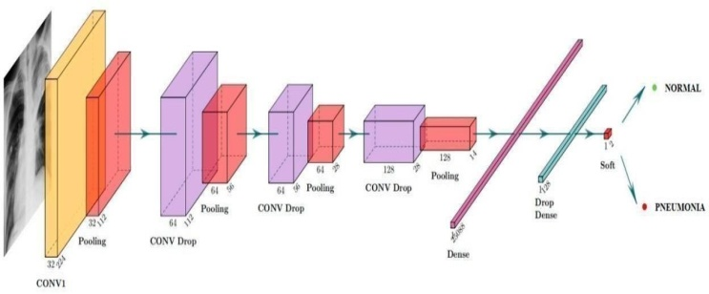

**INPUT DESIGN**

The input design is the link between the information system and the user. It comprises the developing specification and procedures for data preparation and those steps are necessary to put transaction data in to a usable form for processing can be achieved by inspecting the computer to read data from a written or printed document or it can occur by having people keying the data directly into the system. The design of input focuses on controlling the amount of input required, controlling the errors, avoiding delay, avoiding extra steps and keeping the process simple. The input is designed in such a way so that it provides security and ease of use with retaining the privacy.Input Design is the process of converting a user-oriented description of the input into a computer-based system. This design is important to avoid errors in the data input process and show the correct direction to the management for getting correct information from the computerized system.

**OUTPUT DESIGN**

A quality output is one, which meets the requirements of the end user and presents the information clearly. In any system results of processing are communicated to the users and to other system through outputs. In output design it is determined how the information is to be displaced for immediate need and also the hard copy output. It is the most important and direct source information to the user. Efficient and intelligent output design improves the system’s relationship to help user decision-making.

**1.**Designing computer output should proceed in an organized, well thought out manner; the right output must be developed while ensuring that each output element is designed so that people will find the system can use easily and effectively. When analysis design computer output, they should Identify the specific output that is needed to meet the requirements.

**2.** Select methods for presenting information.

**3.**Create document, report, or other formats that contain information produced by the system.

The output form of an information system should accomplish one or more of the following objectives.

**1.**Convey information about past activities, current status or projections of theFuture.

**2.**Signal important events, opportunities, problems, or warnings.

**3.**Trigger an action.

**4.**Confirm an action.

**MODULES**

**1.**Upload Pneumonia Dataset

**2.**Read &split Dataset To Train & Test

**3.**Execute SVM Algorithms

**4.**Execute K-Means Algorithm

**5.**Predict Pneumonia

**6.**Accuracy Graph

**RESULT**

In fig(a) , you can upload scan image for predict Pneumonia here that image predicted as Normal it means there is no pneumonia.

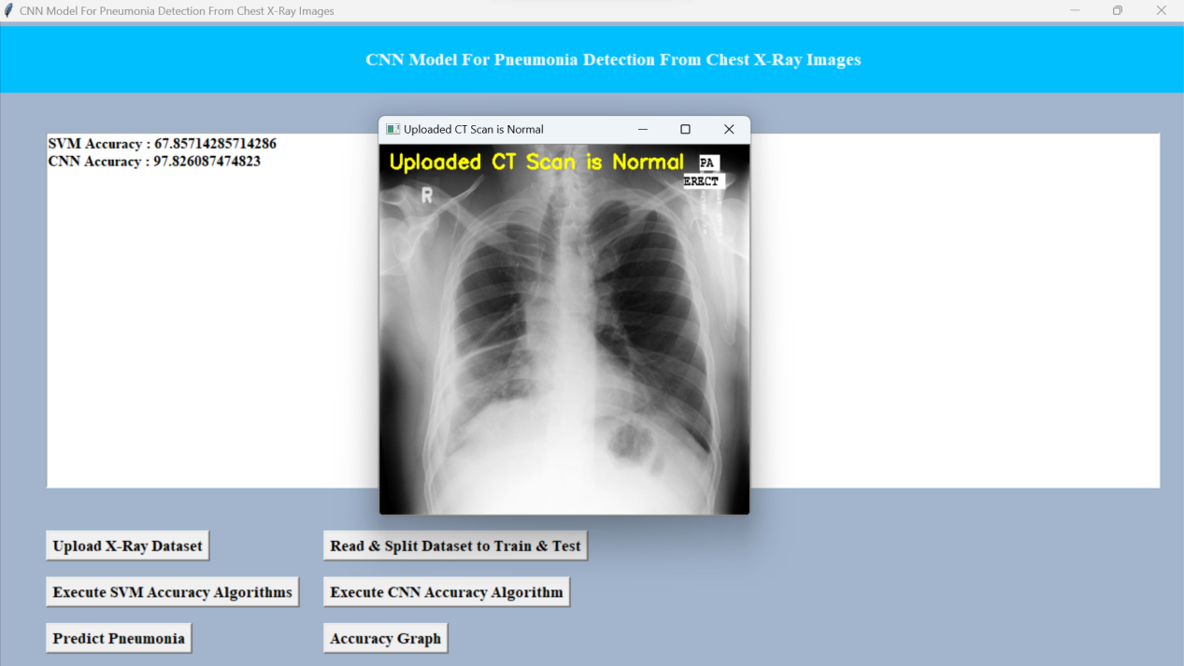

**Fig (a)**

##### **ACKNOWLEDGEMENT**

**1 .**We are extremely grateful to **Dr. A. Srinivasula Reddy**, Principal and **Dr. Madhavi Pingili,** HOD,

**Department of IT, CMR Engineering College** for their constant support.

**2 .**We are extremely thankful **to Dr. X.S. Asha Shiny**, Associate Professor, Internal Guide, Department of IT, for her constant guidance, encouragement and moral support throughout the project.

**3.**We express our thanks to all staff members and friends for all the help and co-ordination extended in bringing out this project successfully in time.

##### **REFERENCES**

**1.**Abbasi, A., Hoshmand-Kochi, M., Li, M. G. 7. 8., & Duong, T. Q. (n.d.). Predicting COVID-19 pneumonia severity on chest X-ray with deep learning. Retrieved April 28, 2021, from Arxiv.org website: http://arxiv.org/abs/2005.11856v3.

**2.**Jain, R., Gupta, M., Tan eja, S., & Hemanth, D. J. (2021). Deep learning-based detection and analysis of COVID-19 on chest X-ray images. Applied Intelligence, 51(3), 1690–1700.

**3.**N. Darapaneni et al., “Deep convolutional neural network (CNN) design for pathology detection of COVID-19 in chest X-ray images,” in Lecture Notes in Computer Science, Cham: Springer International Publishing, 2021, pp. 211–223.

**4.**Wang, D., Mo, J., Zhou, G., Xu, L., & Liu, Y. (2020). An efficient mixture of deep and machine learning models for COVID-19 diagnosis in chest X-ray images. PloS One, 15(11), e0242535.

**5.**Arias-Londono, J. D., Gomez-Garcia, J. A., Moro-Velazquez, L., & Godino-Llorente, J. I. (2020). Artificial intelligence applied to chest X-ray images for the automatic detection of COVID-19. A thoughtful evaluation approach. IEEE Access: Practical Innovations, Open Solutions, 8, 226811–226827.

**6.**I. Pan, S. Agarwal, and D. Merck, “Generalizable inter-institutional classification of abnormal chest radiographs using efficient convolutional neural networks,” J. Digit. Imaging, vol. 32, no. 5, pp. 888–896, 2019.

**7.**H. H. Pham, T. T. Le, D. Q. Tran, D. T. Ngo, and H. Q. Nguyen, “Interpreting chest X-rays via CNNs that exploit hierarchical disease dependencies and uncertainty labels,” arXiv [eess.IV], 2019.

**8.**Stephen, O., Sain, M., Maduh, U. J., & Jeong, D.-U. (2019). An efficient deep learning approach to pneumonia classification in healthcare. Journal of Healthcare Engineering, 2019, 4180949.

**9.** T. Franquet, “Imaging of community-acquired pneumonia,” J. Thorac. Imaging, vol. 33, no. 5, pp. 282–294, 2018.