##### **A comprehensive study to facilitate Student Space platform with collaborative learning**

##### **Ramprasad Dolai, Arnav Ghosh, Subhadeep Samanta , Risav Mondal, Aparajita Mukherjee, Kaustuv Bhattacharjee, Anirban Das**

University of Engineering and Management, Kolkata

***Abstract*-** The Student Space Virtual Study Groups Platform is a groundbreaking solution designed to transform collaborative learning for students, addressing challenges in forming and sustaining study groups. This online platform integrates advanced technology to create a user-friendly environment, featuring an intuitive interface, dynamic group formation with smart algorithms, real-time collaboration through video conferencing and document editing, centralized resource sharing, and smart scheduling tools. Student Space aims to overcome the limitations of traditional study groups, offering an inclusive and adaptable virtual space for students to connect, collaborate, and excel academically. Anticipated impacts include improved academic performance and the creation of a vibrant academic community. Ongoing enhancements, such as integration with Learning Management Systems, a mobile app for on-the-go collaboration, and improved AI-driven matching algorithms, are planned for the future.

***Index Terms***- Java Script, Context API, Student Space, User Interface, State Management, Web Development.

1. Introduction

In response to the growing need for innovative educational solutions that foster collaboration and enrich the learning experience, the Student Space Virtual Study Groups Platform has emerged as a cutting-edge initiative. This platform is meticulously designed to transform the landscape of collaborative learning in digital environments. Its primary objective is to establish a dynamic and user-friendly online space where students can effortlessly form, join, and engage in virtual study groups. By bridging the gap between physical and virtual learning environments, the platform aims to cultivate a sense of community and collaboration among students across diverse academic disciplines. Key features include a user-centric design for easy navigation, dynamic group formation, real-time communication through chat and video conferencing, collaborative learning tools, a customizable notification system, analytics for progress tracking, and features like consulting with seniors. The platform prioritizes seamless and comprehensive learning experiences through its various functionalities.

1. BACKGROUND STUDY

A background study on a Students Space Virtual Study Group would typically encompass an exploration of the educational landscape, the need for virtual study groups, and the potential benefits they offer. It could include:

Educational Landscape: Overview of the current education system and the shift toward digital learning.

The prevalence of remote and online education, especially in response to global events like the COVID-19 pandemic.

Challenges in Traditional Learning: Identification of challenges faced by students in traditional learning environments, such as limited interaction, geographical constraints, and varying learning paces.

Potential Challenges and Solutions**:** Anticipation of challenges that might arise in implementing a Students Space Virtual Study Group. Discussion of strategies and solutions to address these challenges, ensuring a smooth and effective virtual learning environment.

Future Implications: Consideration of how the concept of virtual study groups aligns with the future of education. Exploration of potential developments and improvements in technology that could further enhance the virtual learning experience.

Rise of Virtual Study Groups: Examination of the growing trend of virtual study groups as a response to the limitations of traditional education.

Exploration of how technology facilitates collaborative learning and provides opportunities for students to connect globally.

Students Space Virtual Study Group:Identification of specific needs and challenges faced by students that could be addressed through a dedicated virtual study group. Consideration of factors like diverse learning styles, the importance of peer interaction, and the need for additional support beyond formal class hours.

Advantages of Virtual Study Groups: Discussion of the potential benefits, such as increased engagement, improved understanding through peer teaching, and the fostering of a sense of community among students.

Technology Integration: Examination of the technological tools and platforms that can be utilized for creating an effective Students Space Virtual Study Group. Consideration of features like video conferencing, collaborative document editing, and discussion forums.

1. METHODOLOGY

User Needs Analysis:Conduct a thorough analysis of students' requirements for virtual study group collaboration, considering preferences, study habits, and technological preferences.

User Persona Development: Create detailed user personas based on the diverse needs and characteristics of the student population to guide the design and features of the platform.

Platform Features Definition: Identify essential features such as virtual meeting rooms, discussion forums, file sharing, and collaborative document editing to facilitate effective study group interactions.

Technology Stack Selection: Choose a robust and scalable technology stack that supports real-time communication, seamless collaboration, and easy integration with other educational tools.

User Interface (UI) Design: Design an intuitive and visually appealing user interface that enhances user experience and encourages active participation in virtual study group

Accessibility Considerations: Ensure the platform is accessible to all students, including those with disabilities, by implementing features such as keyboard navigation, screen reader compatibility, and adjustable font sizes.

Security and Privacy Measures: Prioritize the security and privacy of users by implementing encryption protocols, secure login processes, and clear privacy policies.

Collaborative Tools Integration: Integrate collaborative tools like video conferencing, document sharing, and interactive whiteboards to facilitate effective virtual study sessions.

Scalability Planning: Design the platform to handle varying numbers of users and accommodate growth, ensuring a scalable infrastructure to support a large user base.

User Onboarding and Training: Develop onboarding processes and training materials to help users familiarize themselves with the platform's features and functionalities.

Feedback Mechanism: Implement feedback loops to gather input from users, enabling continuous improvement based on their experiences and suggestions

IV. RESULTS AND DISCUSSION

How Student Space Works:

Registration: Students can register using their college credentials, ensuring a secure and authenticated user base

Group Formation: Users have the autonomy to create study groups based on courses, subjects, or specific study topics, making the platform adaptable to diverse academic needs.

Real-Time Interaction: The platform provides a real-time communication hub where students can engage in discussions, share resources, and colla1borate on projects.

Collaborative Learning: With tools for file sharing and collaborative editing, students can create a shared space for learning materials and collaborative projects.

Progress Tracking: Users can monitor their study progress, set goals, and receive insights into their learning habits through the platform's analytics features.

Technical Architecture:

Frontend: HTML, CSS, JavaScript, React.js. Backend: Node.js, Express.js. Database: MongoDB. Real-Time Communication: WebSocket (or alternative)

System Requirements: Web Browser Compatibility: Ensure compatibility with major web browsers. Mobile Responsiveness: Optimize the platform for mobile devices.

Security Measures:

Data Encryption: Implement SSL for secure data transmission.

User Authentication: Use secure authentication protocols to protect user accounts.

Hosting:

Cloud Hosting: Consider platforms like AWS, Azure, or Heroku for scalability. Domain Configuration: Set up a domain for easy access.

Launch Strategy: Soft Launch: Release the platform to a limited audience for initial feedback.

Marketing and Promotion: Develop a marketing strategy to promote the platform to the wider student community.

A two-layer exploratory path model, explaining student satisfaction with the quality of their learning

experience, was built from a collection of separate univariate regression models. These regression models resulted from the application of a multi stage variable reduction procedure.

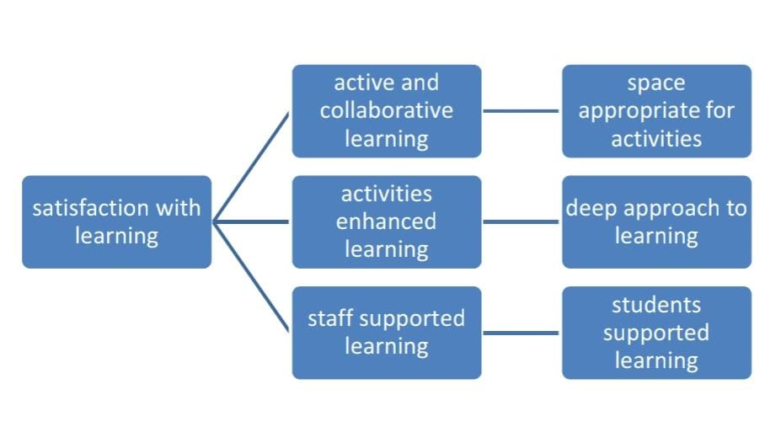

References

1. Astin, A. W. (1993). What matters in college? Four critical years revisited. San Francisco: JosseyBass
2. Centre for Educational Research and Innovation. (1998). Staying ahead: In-service training and
3. teacher professional development. Paris: OECD Publishing.