# PREDICTIVE HR ANALYTICS TO OPTIMIZE DECISION-MAKING PROCESSES AND ENHANCE WORKFORCE PERFORMANCE

Sanjoy Dutta, Antara Ray, Madhusree Chinya, Sujata Ghatak, Aparajita Mukherjee, Kaustuv Bhattacharjee, Anirban Das

Department of Computer Applications

University of Engineering and Management, Kolkata

***Abstract***- This paper explores the application of predictive analytics in Human Resource Management (HRM) to optimize decision-making processes and enhance workforce performance. The primary objective is to develop a predictive model that identifies key factors influencing employee retention within our organization. Utilizing historical HR data, machine learning algorithms are employed to analyze patterns and forecast potential attrition risks.

The methodology involves data preprocessing, feature selection, and model training using a comprehensive dataset spanning employee demographics, performance metrics, and engagement indicators. The model's predictive accuracy is assessed through cross-validation, and the final model is validated using a separate test dataset.

Results indicate a significant improvement in the accuracy of attrition predictions compared to traditional methods. Identified risk factors include job satisfaction, career development opportunities, and team dynamics. The project concludes with actionable insights for HR practitioners to proactively address potential retention challenges.

This paper demonstrates the transformative potential of data-driven decision-making in HRM. By leveraging predictive analytics, organizations can strategically allocate resources, implement targeted interventions, and foster a more engaged and satisfied workforce.

***Index Terms***- HR Analytics, People Analytics, Talent Analytics, Workforce Analytics

1. Introduction

HR analytics is the process of collecting and analyzing Human Resource (HR) data in order to improve an organization’s workforce performance. The process can also be referred to as talent analytics, people analytics, or even workforce analytics. This method of data analysis takes data that is routinely collected by HR and correlates it to HR and organizational objectives. Doing so provides measured evidence of how HR initiatives are contributing to the organization’s goals and strategies. For example, if a software engineering firm has high employee turnover, the company is not operating at a fully productive level. It takes time and investment to bring employees up to a fully productive level. HR analytics provides data-backed insight on what is working well and what is not so that organizations can make improvements and plan more effectively for the future. As in the example above, knowing the cause of the firm’s high turnover can provide valuable insight into how it might be reduced. By reducing the turnover, the company can increase its revenue and productivity.

1. BACKGROUND STUDY

**Key Concepts in HR Analytics:** Key concepts in HR Analytics revolve around leveraging data-driven insights to optimize human resource management. One fundamental concept is predictive analytics, which involves using historical data to forecast future trends in areas such as talent acquisition, employee performance, and turnover. Descriptive analytics focuses on summarizing and interpreting past data to provide a comprehensive understanding of workforce dynamics. Employee segmentation is another critical concept, emphasizing the categorization of the workforce based on various attributes to tailor HR strategies. Metrics and key performance indicators (KPIs) play a pivotal role, offering quantifiable measures to evaluate the effectiveness of HR initiatives and guide decision-making. The concept of data governance underscores the importance of establishing robust data management practices to ensure the accuracy, integrity, and security of HR data. Overall, these key concepts collectively empower organizations to move beyond traditional HR practices, fostering a more strategic and proactive approach to human resource management through the lens of analytics.

Top of Form

**Applications of HR Analytics:** HR Analytics, also known as People Analytics or Talent Analytics, offers a diverse range of applications that empower organizations to make informed decisions about their workforce. One key application is in the area of recruitment, where analytics is used to optimize the hiring process, assess candidate fit, and predict talent acquisition trends. In employee engagement, HR Analytics measures and analyzes factors contributing to job satisfaction, enabling organizations to enhance workplace environments. Performance management benefits from analytics by providing insights into individual and team achievements, facilitating targeted training and development initiatives. Additionally, HR Analytics plays a crucial role in talent retention, identifying factors influencing turnover and enabling proactive retention strategies.

**Emerging Trends and Future Directions:** Emerging trends in HR Analytics signal a dynamic future for the field, driven by technological advancements and evolving workplace dynamics. One prominent trend is the increased integration of artificial intelligence (AI) and machine learning (ML) algorithms, allowing for more sophisticated predictive analytics in talent management. The emphasis on employee experience is rising, with HR Analytics increasingly focusing on understanding and enhancing the holistic journey of employees within organizations. Another notable trend involves the ethical use of data, with a growing emphasis on privacy, fairness, and transparency to mitigate biases in decision-making. Real-time analytics and the adoption of advanced dashboard technologies are streamlining data visualization, making insights more accessible to a broader audience within organizations. The gig economy and remote work trends are also shaping HR Analytics, necessitating new metrics and methodologies to effectively manage and measure the performance of a dispersed workforce. As HR Analytics continues to mature, the future holds promises of even more personalized, agile, and strategic approaches to human capital management, enabling organizations to navigate the complexities of the modern workplace effectively.

In particular, human resource analytics (HR analytics) comprise “the use of statistical tools, measures and procedures, which can be used in employing and masking the most effectual decisions such as HRM strategies and practices” ([Mohammed, 2019](https://www.sciencedirect.com/science/article/pii/S1029313223000295#bib68)). Data analytics plays a crucial role in enhancing decision-making ([Davenport, Harris, & Shapiro, 2010](https://www.sciencedirect.com/science/article/pii/S1053482223000384#bb0110); [Duan, Edwards, & Dwivedi, 2019](https://www.sciencedirect.com/science/article/pii/S1053482223000384" \l "bb0135); [Elgendy & Elragal, 2016](https://www.sciencedirect.com/science/article/pii/S1053482223000384" \l "bb0140)).

III. METHODOLOGY

The experimental setup for an HR Analytics project involves defining the parameters, methodologies, and tools used to collect and analyze data. Here's a general outline of the experimental setup for an HR Analytics project:

**Data Collection:** Identify the sources of HR data, which may include employee records, performance evaluations, recruitment data, and engagement surveys. Determine the time frame for data collection to ensure a representative dataset.

**Data Cleaning and Preprocessing:** Cleanse the data to address missing values, outliers, and inconsistencies Standardize or normalize data to ensure consistency in measurement units.

**Variable Selection:** Identify the key variables relevant to the research objectives, such as employee performance metrics, recruitment success indicators, and engagement scores.

**Data Analysis Tools:** Choose appropriate data analysis tools and software. Common tools for HR Analytics include Python with libraries like Pandas, NumPy, and scikit-learn, as well as statistical software like R.

**Descriptive Analytics:** Utilize descriptive analytics to summarize and interpret the main features of the dataset. This may involve generating summary statistics, visualizations, and exploratory data analysis.

**Predictive Modeling:** Employ predictive analytics to build models that forecast future outcomes, such as turnover risk or employee performance. This may involve regression analysis, machine learning algorithms, or time-series forecasting methods.

**Ethical Considerations:** Implement measures to ensure data privacy and comply with ethical standards. Anonymize or aggregate sensitive data, and establish protocols for handling and storing information securely.

**Testing Hypotheses:** If the project involves testing specific hypotheses, outline the statistical tests or experiments to be conducted. This may include A/B testing for HR interventions or hypothesis tests to assess the significance of observed patterns.

**Validation and Model Evaluation:** Validate predictive models using appropriate techniques such as cross-validation. Evaluate model performance based on relevant metrics, considering factors like accuracy, precision, recall, and area under the ROC curve.

**Interpretation and Visualization:** Interpret the results of the analysis and visualize key findings. Use dashboards, charts, and graphs to communicate insights effectively.

**Implementation Strategy:** Develop a strategy for implementing the insights gained from the analysis into HR practices. This could involve recommendations for process improvements, policy changes, or targeted interventions.

**Documentation and Reporting:** Document the entire experimental setup, data preprocessing steps, analysis methods, and results. Prepare a comprehensive report that communicates the findings, implications, and recommendations of the HR Analytics project.

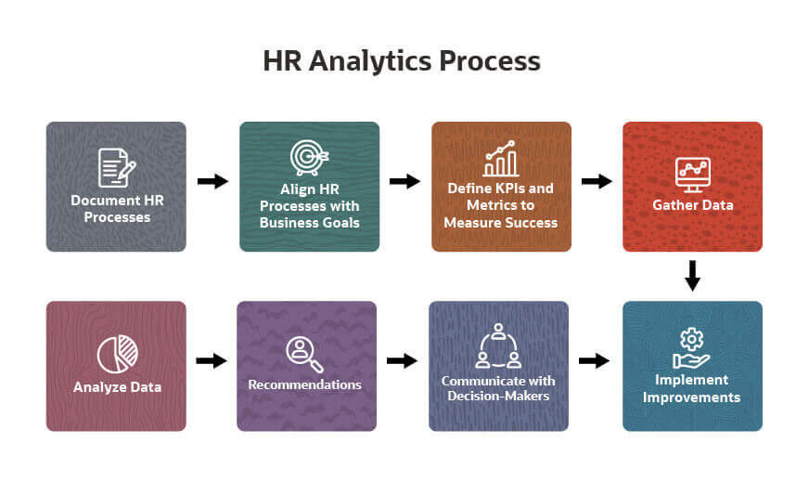

Figure(1)

Figure(1) represents the flow chart of the methodology of HR Analytics dashboard

IV. RESULTS AND DISCUSSION

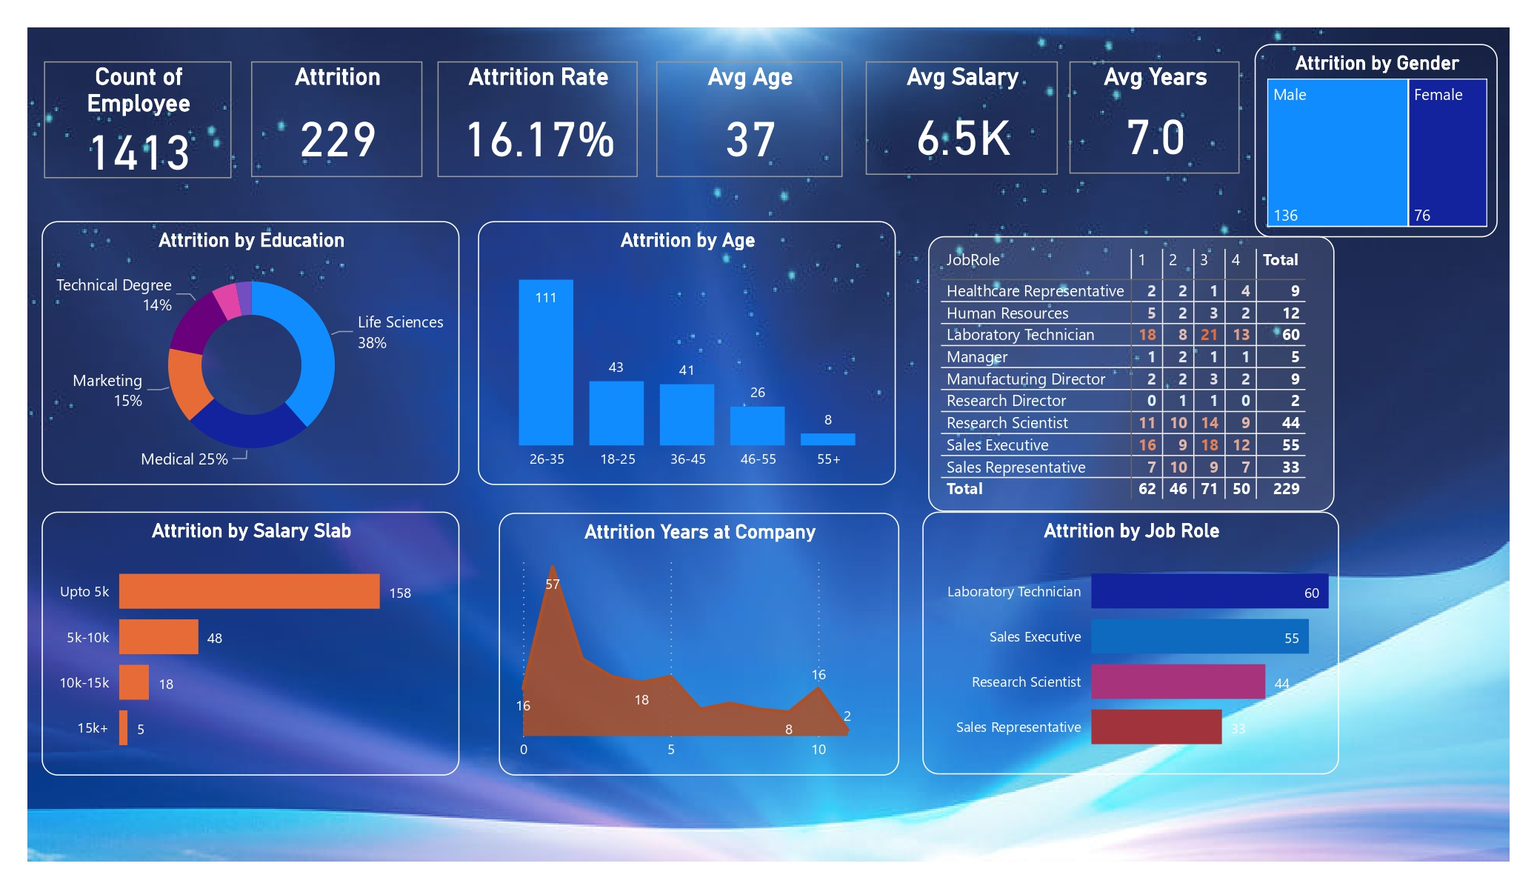

Figure(1) Key Primary Indicators

Followed by figure(1),the organization can come to a decision that the attrition rate is dependent on salary, job role, experience, age of the employee. Here total employee number, attrition, attrition rate, average age etc. are the KPI(Key Primary Indicator).Life sciences degree holders are the people who have left most. The people having age among 26-35 are left most. After one year experience, they leave the organization. Salary is one of the factor of high attrition rate. Laboratory technicians are the people who have left most. It is also visible that after being five or ten years experienced, the employees have left but their attrition rate is less in compared to after being one year experienced. HR team should consult with each other on these issues.

V. CONCLUSION

In conclusion, this HR Analytics project has delved into the vast landscape of human resource management, leveraging data-driven insights to address critical challenges and enhance strategic decision-making. The research aimed to explore the current state of HR Analytics adoption, identify obstacles faced by organizations, and propose actionable solutions for optimizing talent management practices.

References

[1].A. Mohammed,HR analytics: A modern tool in HR for predictive decision making Journal of Management, 6 (3) (2019), pp. 51-63

[2] HR Analytics: Driving Return on Human Capital Investment,Davenport, T.H., Harris, J., & Shapiro, J.(2010),International Association for Human Resource Information Management Journal

[4] J.B. Barney

Organizational culture: Can it be a source of sustained competitive advantage?

Academy of Management Review, 11 (1986), pp. 656-665

[5] People Analytics in the Era of Big Data,Rasmussen, T., Ulrich, D., & Kaufman, A.(2015),Organizational Dynamics

[6] The Rise (and Fall?) of HR Analytics: A Study into the Future Application, Value, Structure, System Support, and System Use,Marler, J.H., & Boudreau, J.W.(2017),Human Resource Management

[7] Predictive Analytics for Human Resources,Jac Fitz-enz(2014)

[8] People Analytics: How Social Sensing Technology Will Transform Business and What It Tells Us about the Future of Work, Ben Waber(2013)

[9] T.H. Davenport, J. Harris, J. Shapiro,Competing on talent analytics,Harvard Business Review, 88 (10) (2010), p. 52