# BLOCKCHAIN ENABLED ONLINE ELECTORAL SYSTEM TO ADDRESS SECURITY CHALLENGES AND TRANSPARENCY

##### Yousuf Sk, Manirujjaman Sarkar, Sushmita Sarkar, Priyankan Guha, Ankur Biswas, Kaustuv Bhattacharjee, Anirban Das

UNIVERSITY OF ENGINEERING AND MANAGEMENT, KOLKATA

***Abstract-*** The right to vote is a foundational privilege for citizens in any democratic nation, empowering them to select future leaders and express their views on community matters. Voting fosters an understanding of the significance of citizenship and individual participation. Modern online voting systems, software platforms facilitating secure voting, have emerged as a digital alternative to traditional paper-based methods. These systems eliminate the need for physical presence, offering the convenience of voting from anywhere with an internet connection. Importantly, online voting platforms enhance the security and integrity of the voting process, employing measures such as encryption to prevent issues like voter fraud. Additionally, they address concerns by ensuring voters cannot cast multiple ballots, thus upholding the fairness of elections. While online voting presents advantages, it also poses challenges related to cybersecurity and privacy, necessitating a careful balance between accessibility and security considerations. It's crucial to stay updated on the latest developments in the field of online voting.

***Index Terms-*** Blockchain, Online Electoral System, Security, Transparency, Immutability.

1. **Introduction**

# India, being a democratic nation, has embraced the digital age, and its citizens are now integral participants in the growing Digital India initiative, facilitated by the Aadhaar card—a digital identification system. The evolution of voting mechanisms in India reflects a transition from the early days of hand-counting to more sophisticated systems, including paper ballots, punch cards, and electronic voting machines (EVMs). This progression signifies the country's commitment to modernizing its electoral processes, enhancing efficiency, and adapting to technological advancements for a more streamlined and inclusive democratic experience.

# Existing System- The present election system relies on manual processes, necessitating voters to physically visit polling booths to cast their ballots, which often results in time wastage. This system contributes to a significant issue: a notable portion of the population opts not to participate in the electoral process. In a democracy, the importance of every individual's vote cannot be overstated. Introducing a new online voting system to replace the traditional manual approach has the potential to address several concerns. Notably, such a digital system could mitigate voting fraud, enhance the overall efficiency of the voting process, and bring greater transparency to both the voting and counting processes. This transition could encourage broader participation in the democratic process by making voting more accessible and convenient for citizens.

## **Proposed System-** The identified shortcomings in the current voting mechanism underscore the need for specific enhancements. One viable solution involves replacing the existing system with a new one designed to address these issues comprehensively. The implementation of such a system holds the promise of diminishing instances of voting fraud while simultaneously elevating the precision of both the voting and counting processes. This proposed change aims to instill greater confidence in the democratic process by ensuring the integrity of each vote and streamlining the overall electoral procedures for the benefit of citizens.

* The proposed Online Election System comprises essential components such as user registration, user login, and admin login functionalities. This digital platform is designed to effectively handle voter information, allowing registered voters to log in and exercise their voting rights securely.
* During the registration process, voters are required to provide key details, including their full name, age, Aadhaar card number, mobile number, and email address. Verification mechanisms will be implemented to ensure the accuracy and legitimacy of the provided information. Once the verification process is successfully completed, the voter will be granted access to the system, enabling them to participate in the electoral process.
* This approach aims to streamline the voting experience, enhance security through user authentication, and ensure that only verified individuals can exercise their voting rights within the Online Election System.

**Blockchain-** Blockchain technology offers an immutable, transparent, and efficient system that is highly secure and resistant to unauthorized access. Its inability to modify or erase information from blocks makes it an ideal solution for voting systems. In this technology, a distributed network of interconnected nodes supports the blockchain, each node possessing a copy of the distributed ledger containing the complete history of transactions processed by the network. The absence of a centralized authority ensures that decisions, including the acceptance of transactions, are made by consensus among the majority of nodes. This decentralized approach guarantees user anonymity, making blockchain a viable foundation for secure and trustworthy e-voting.

Implementing blockchain in voting systems has the potential to enhance accessibility, reduce costs, and significantly improve security. It represents a paradigm shift towards decentralized systems that prioritize data integrity, availability, and fault tolerance. Blockchain systems function as decentralized networks of computers validating and recording online transactions, forming interconnected ledgers known as blockchains. The records on these blockchains are inherently immutable, reinforcing the reliability and security of the entire voting process.

**Benefits of Online Electoral system over the current system:**

1. raising the level of participation The Internet voting system tends to maximize user participation, by allowing them to bounce from anywhere and from any device that has an internet connection.

2. Security By considering the significance of the electoral system is enforced using “Blockchain”.

3. Efficiency The reduction in organizational and perpetration costs significantly increases the effectiveness of election operations compared to traditional paper voting, for illustration.

4. Precision The electronic vote eliminates errors in manual count, which brings with it an accurate and quick publication of results, with receipt of vote for each vote cast**.**

## **Plan of Work-** For our proposed plan of work, we're considering two modules that are to be completed in

## three phases. Two modules are as follows:

1. Front-end for the operation

2. Back-end using Solidity to apply Blockchain.

Each of these modules will be considered as one phase and the remaining one phase will cover the connection and testing of these modules.

Phase 1 : In this phase, we will cover the front-end module, in which we will make the interactive user- interface for the admin as well as the user. Similarly, the research work related to the implementation of Blockchain in decentralized operations will be done.

Phase 2: In this phase, we will cover the back-end module, we will apply the Blockchain using the Ethereum framework and convert the system into a decentralized application.

Phase 3: The connection of two different modules along with the testing of the platform will be completed in this phase.

1. **BACKGROUND STUDY**

Enhancing participation is a key objective of the proposed Internet voting system, allowing users to vote from anywhere with an internet connection, thereby maximizing accessibility.

Security is prioritized in the plan, with the utilization of "Blockchain" technology to safeguard the integrity of the electoral system against tampering and fraud.

Efficiency is a notable feature, as the digital system significantly reduces organizational and operational costs compared to traditional paper voting methods, resulting in streamlined election operations.

Precision is improved through electronic voting, eliminating errors associated with manual counting and ensuring the accurate and swift publication of election results, complete with a verifiable receipt for each vote.

The plan of action is divided into two modules over three phases. The initial phase focuses on front-end operations, creating an interactive user interface for administrators and users, along with concurrent research on implementing Blockchain in decentralized operations.

The second phase addresses back-end operations, applying Blockchain using the Ethereum framework to convert the system into a decentralized application.

The final phase involves connecting and testing both modules, ensuring a seamless integration of front-end and back-end components. This phased approach systematically progresses from user interface development and research to the application of Blockchain technology, resulting in a fully tested and integrated Internet voting system.

1. **METHODOLOGY**

In our proposed work plan, we have delineated two principal modules to be executed across three

phases. The initial module concentrates on the front-end operation, involving the development of an interactive user interface for administrators and users. Concurrently, research will be conducted

regarding the integration of Blockchain into decentralized operations. This phase is elaborated as

follows:

Phase 1: Front-end Module

Admin Module (Division A):

Dashboard: This segment will feature various charts displaying data such as the count of parties and voters.

Add Candidate: Administrators can include campaigners participating in the election, and their

details will be visible on the user interface.

Create Election: Administrators have the privilege to initiate elections. Users can cast votes only

within the stipulated start and end dates of the election.

Election Details: Administrators can modify election details, including start and end dates.

Campaigner Details: This section showcases all added campaigners, and administrators can make

updates if required.

User Module (Division B):

Dashboard: Users can access information about parties and their campaigners.

Voter Register: Users are required to register before exercising their voting rights.

Voting Area: Registered users can cast their votes through this platform.

Results: Users can review the outcomes of the election.

Phase 2: Back-end Module

In this phase, attention will be directed towards the back-end module by implementing Blockchain

using the Ethereum framework, with the aim of transforming the system into a decentralized

application.

Phase 3: Connection and Testing

The final phase entails the integration of the front-end and back-end modules, followed by thorough testing of the entire platform.

This structured approach ensures a methodical development process, commencing with the creation of user interfaces and research on Blockchain integration, progressing to the application of Blockchain in the back-end, and concluding with the integration and comprehensive testing of both modules. Each phase contributes to the overarching objective of creating a secure and efficient online voting system.

## **Phase One Flow Diagram**

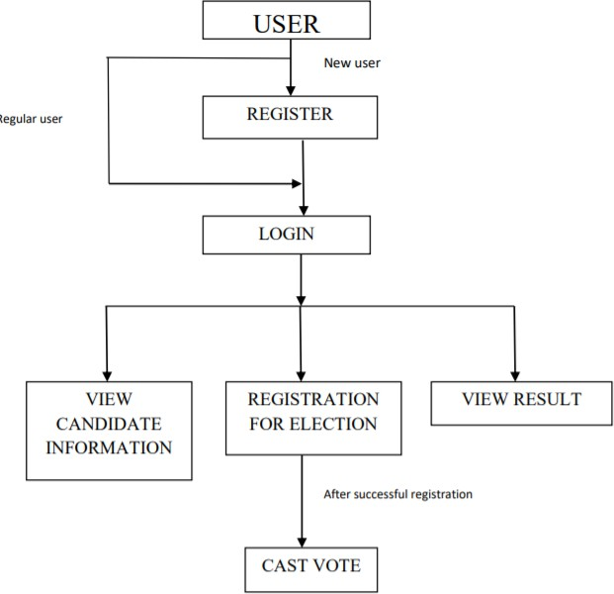

Fig.3.1 User flow diagram

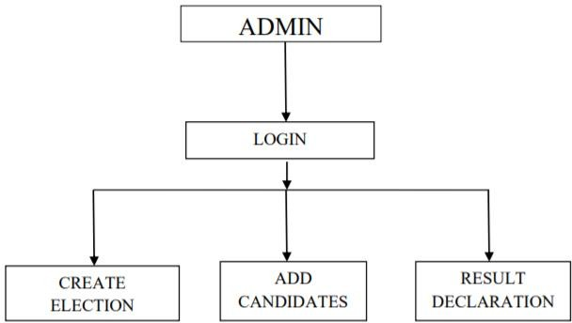

Fig.3.2 Admin flow diagram

## **Research Methodology of Phase Two:**

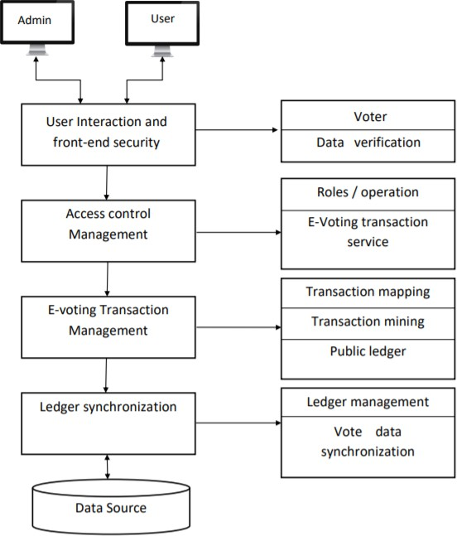

Fig.3.3 Research methodology

1. **RESULTS AND DISCUSSION**

The current voting system in India relies on Electronic Voting Machines (EVMs), having replaced the paper ballot system due to concerns of fraud and booth capturing. The paper ballot method faced criticism for its vulnerability to fraudulent voting and instances where party supporters took over booths and filled them with pre-filled fake ballots.

There is a pressing need to upgrade the existing voting system to enhance security, traceability, and transparency in the voting process. The rise of the internet has prompted a shift towards an online platform, aiming to expedite procedures and improve voter accessibility.

While the current system is dependable, there is still room for improvement. The proposed solution is an online voting system utilizing blockchain technology, representing a progressive step towards fortifying the voting process. Blockchain, known for its distributed, immutable, secure, and publicly accessible ledger, operates through key features:

The ledger is distributed across multiple locations, eliminating a single point of failure in data preservation.

Any proposed "new block" in the ledger must reference the previous version, creating an unalterable chain that prevents tampering with the integrity of previous entries.

The development plan includes creating a user-friendly interface for the decentralized operation, constituting 30% of the total work. The primary focus, comprising the majority of the system, revolves around blockchain technology, ensuring a secure and reliable voting process. This forward-looking approach aims to utilize technology to strengthen the democratic process and address vulnerabilities present in the traditional voting system.

1. **CONCLUSION**

In this project, we have introduced an electronic voting system based on blockchain technology, utilizing smart contracts to ensure secure and cost-effective choices while maintaining voter privacy. This application of blockchain technology offers a novel solution to address the challenges and barriers associated with electronic voting systems, ensuring the security and integrity of elections and establishing a basis for transparency. By employing an Ethereum private blockchain, we can efficiently record numerous transactions per second, utilizing smart contracts to optimize the blockchain's workload.

The project is structured into three modules:

The front-end module

The back-end module

Connecting the two modules and conducting testing

Progress has been made in encrypting 30% of the first and second modules, involving the creation of an interactive user interface for both administrators and users, along with research on implementing blockchain in decentralized applications.

Looking ahead, there are plans to enhance the security of the voting process and accurately verify individuals by incorporating Machine Learning (ML) and Artificial Intelligence (AI) methodologies. These technologies can be applied to confirm whether the person casting the vote matches the one registered during the enrollment process, thereby further fortifying the overall integrity and security of the electoral system.

**References**

1. Bitcoin, Nakamoto S. "Bitcoin: A peer-to-peer electronic cash system." (2008).
2. Introduction to Blockchain by NPTEL IITM.
3. Beginning BlockchainA Beginner’s Guide to Building Blockchain Solutions, Bikramaditya Singhal, Gautam Dhameja and Priyansu Sekhar Panda, ISBN 978-1-4842-3443-3e-ISBN 978-1-4842-3444-0, https://doi.org/10.1007/978-1-4842-3444-0, Library of Congress Control Number: 2018945613
4. Z.A. Usmani, K. Patanwala, M. Panigrahi and A. Nair, "Multi-purpose platform independent online voting system", 2017 International Conference on Innovations in Information Embedded and Communication Systems (ICIIECS), pp. 1-5, 2017, March.