**SWASTHYA : A COMPREHENSIVE SYSTEM TO MANAGE HOSPITALS**

##### Akash Chowdhury, Pritam Mandal, Priyabrata Dutta, Sujoy Mondal, Poulami Ghosh, Kaustuv Bhattacharjee, Anirban Das

***Abstract*-** Swasthya : A Comprehensive System To Manage Hospitals designed to better and expedite healthcare facilities' operational efficacy facilities to get benefits on Health and Services. This integrates various aspects of hospital operations, administration, and patient care. This is built upon a robust database architecture, allowing healthcare professionals to manage patient information securely and efficiently. It encompasses modules that cater to different departments within a hospital.

***Index Terms***- Account Management ,Administration ,Appointment Scheduling ,Cost Effectiveness ,Patient Care, Patient Information

1. Introduction

Patient safety has become a major concern in global healthcare systems in recent years. "The absence of preventable harm to a patient and reduction of risk of unnecessary harm associated with healthcare to an acceptable minimum" is how the World Health Organization (WHO) defines patient safety. So We Created a immersive and robust system to keep data of patient and billing system.

Swasthya : A Comprehensive System To Manage Hospitals designed to better and expedite healthcare facilities' operational efficacy to get benefits on Health and Services. It enhances patient care, streamlines administrative tasks, and ensures compliance with healthcare regulations. This system can be customized to meet the specific needs of different healthcare facilities, contributing to better healthcare delivery and patient satisfaction.

1. BACKGROUND STUDY

**The field of hospital management, often known as healthcare operation, deals with the management, operation, and leadership of hospitals, clinic networks, public health systems, and health care organizations. For those who hold directorial responsibilities in a sanitarium striving to provide the best possible patient care, hospital management is a valuable resource. On occasion, health care management is referred to as healthcare administration or operation. The word "medical operation" refers to a broad range of uses including health, complaint, care, and case management. Medical operation methods aim to improve the quality and outcomes of healthcare delivery by altering the behaviors of consumers and providers.**

**Our medical operation programs aim to improve patient health and prevent unnecessary financial expenses. Medical operation personnel are licensed healthcare professionals with extensive clinical and medical operation experience. They cover member care prior to, during, and following a sanitarium confinement. Because there is such many medical situations these days, handling medical difficulties has become essential. Delivering related healthcare installations requires an acceptable hygienic environment and appropriate medical operations. Particularly, the global patient operation script necessitates more work and urgent consideration from the many authorities. The current advancements in medical research and science are also helping case and sanitarium supervisors in an efficient manner.**

**We read journals already made in this field like:**

**It would be vital to do a study on the scope of registration of targeted families, the depth of coverage, the scope of coverage, and the height of benefit packages offered by the current programs. This is because to the expectation that multiple expensive illnesses may put the family or individual at danger of impoverishment if the benefit packages and cover quantity are insufficient. Furthermore, even the registered households would still be responsible for paying for outpatient care if the depth of coverage was restricted to hospitalization, which would have an effect on the overall goal of reducing out-of-pocket expenses. A few studies on enrollment and coverage issues have been carried out utilizing primary survey data and information from state and federal government officials.**

1. METHODOLOGY

Creating a full-stack Hospital Management System (HMS) in Java involves both front-end and back-end development. Here's a simplified step-by-step guide on how you could approach building a basic version of an HMS:

Front-End Side:

Choose a Front-end Framework: We Considered using a popular front-end framework/library like Java Servlets , JSP.

Design the User Interface (UI): Create UI components like HTML,CSS,Bootstrap for different modules (patient management, appointment scheduling, etc.). Use a responsive design for better user experience across different devices.

Implement Views and Components: Develop pages for patient registration, appointment scheduling, medical history, etc. Implement components for forms, tables, and other UI elements.

Handle User Authentication: Implement user authentication for secure access to the system. Use tokens or session management for user sessions.

Back-end (Server Side):

Choose a Back-end Framework: Java provides various frameworks for back-end development, such as Spring Boot, Java EE, or Micronaut. We Choosed Java EE based on Our preference and project requirements.

Set Up the Database: Design the database schema for storing information such as patients, doctors, appointments, etc. Use a relational database like MySQL.

Data Flow Diagram

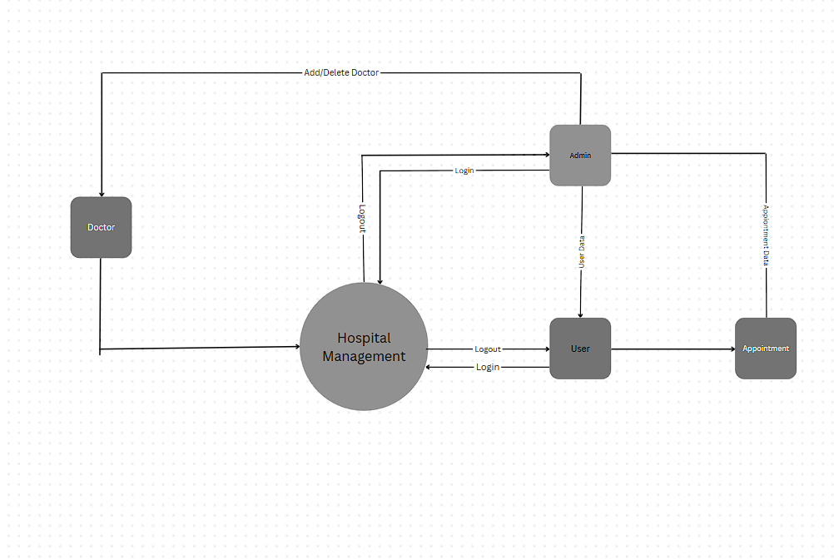

1. RESULTS AND DISCUSSION

**Result:**

* The option to register and submit information about oneself, comprising name, age, gender, and type of blood, is accessible to new users. The patient entry will be made in the hms database.
* Patients receive a screen with an assortment of available doctors, times, and dates from which to select the most suited appointment day and practitioner. The patient can elect to schedule their appointment.
* The physician accesses the patient's record, updates his information, and adds a note detailing the patient's care.
* The admin updates the doctor's details and adds new doctors.
* Because the administrator has complete access to the system, he can oversee any activity related to it. He has the highest level of privilege when it comes to using the system.
* The Admin should be able to amend their information, and the hms database should update accordingly.

**Discussion:**

* System streamlines the laborious manual process of overseeing hospital operations.
* Physicians have easy access to the treatment records and details of their patients.
* They save time, effort, money, and resources by using our convenient and adaptable solution.

1. CONCLUSION

This project underwent numerous compilation, debugging, error-removal, and bug-free processes. It also added more functionality to the Hospital Management System and enhanced interactivity to make it more dependable and practical. The user's requirements have been followed in the development and deployment of the complete project. According to the testing criteria that are used, it is discovered to be bug-free.

References

1. Government of india. A critical assessment of the existing health insurance models in india 2011; 2011 public health foundation of india report submitted to planning commission of india, government of india
2. Patel j, shah j, agarwal m, kedia g. Post utilization survey of rsby beneficiaries in civil hospital, ahmedabad: a cross sectional study. 2013; 2013
3. Ghosh s. Publicly-financed health insurance for the poor understanding rsby in maharashtra. 2014; 2014 2014.
4. Nandi a, ashok a, laxminarayan r. The socioeconomic and institutional determinants of participation in india's health insurance scheme for the poor. Plos one. 2013;8(6) 2013.
5. Rathi p, mukherji a, sen g. Rashtriya swasthya bima yojana: evaluating utilisation, roll-out and perceptions in amravati district, maharashtra. Econ polit wkly. 2012;47:57–64.
6. Krishnaswamy k, ruchismita r. Performance trends and policy recommendations: an evaluation of the mass health insurance scheme of government of india. Chennai: centre for insurance and risk management; 2011 2011.