Wanderlust Chronicles- The Road Explorer Tourism Platform

Tapas Chatterjee, Dipanjan Dey, Bijay Kumar Sethy, Rajib Kuri, Somnath Banerjee, Kaustuv Bhattacharjee, Anirban Das

University of Engineering and Management, Kolkata

***ABSTRACT***- Thisplatform is a dynamic and immersive tourism portal designed exclusively for foreigners seeking to explore the rich and diverse tapestry of India. With a primary focus on showcasing the vibrant Indian culture, offering updated news, and highlighting must-visit destinations, this platform aims to provide an authentic and comprehensive experience to travellers. The website will serve as a digital gateway, offering an extensive exploration of India's cultural heritage, including its traditions, festivals, art, music, and cuisine. Engaging multimedia content such as videos and captivating images will be strategically incorporated to offer a visually stimulating and informative experience for visitors.

***Index Terms -***  HTML, CSS, JAVASCRIPT, BOOTSTRAP, USER INTERFACE, WEB DEVELOPMENT.

**I. INTRODUCTION**

This is a virtual guide tailored for international travellers eager to experience the beauty and diversity of India. We've crafted this platform with the goal of making your journey across India not just memorable, but also easy to plan. Here you can explore famous destinations across the country, from the majestic Taj Mahal to the serene backwaters of Kerala. Our aim is to showcase the essence of each place, giving you a glimpse into the heart of India. Stay up-to-date with the latest news and events through our real-time updates. Whether it's cultural festivals or breaking news, we want you to feel connected to the vibrant spirit of the country. Our project is designed with international travellers in mind. We want to simplify users journey by providing useful resources and information, making it easy for users to plan and navigate the way through India.

**II.** **BACKGROUND STUDY**

Research in website usability and design emphasizes the significance of a user-friendly interface for tourism websites. Studies by Nielsen and Norman (2000) underscore the importance of intuitive navigation and visually appealing layouts in enhancing user satisfaction. The surge in mobile technology has led to an exploration of the role of mobile applications in tourism. Kim et al. (2009) found that mobile apps significantly influence travel decision making, providing users with real-time information and personalized experiences. Personalization features and recommendation systems have garnered attention in tourism website literature. Al-Shboul et al. (2018) conducted research on personalized travel recommendations, emphasizing the potential for enhancing user engagement and satisfaction. Research by Werthner and Ricci (2004) explores the evolution of e-tourism and the impact of online booking systems. The study delves into the challenges and opportunities presented by the digitization of tourism services. Importance of online reviews in shaping traveller perceptions is a prominent theme. Hu et al. (2019) examined the impact of online reviews on hotel booking decisions, emphasizing the importance of reputation management for tourism businesses. Research by Gössling et al. (2018) explores the economic impacts of online tourism platforms. The study investigates how online channels contribute to destination revenue and the overall economic sustainability of the tourism industry.

## II. METHODOLOGY

User-Centric Approach: Begin by understanding the diverse needs and preferences of users to tailor the portal to their expectations.

Agile Development: Embrace an agile methodology to ensure flexibility and responsiveness to evolving trends and user feedback.

Interactive Design: Implement an interactive and engaging user interface, allowing visitors to navigate seamlessly and access information effortlessly.

Content Curation: Curate dynamic content that not only informs but also captivates users, promoting a sense of exploration and discovery.

Multimedia Integration: Integrate multimedia elements such as videos, virtual tours, and high-quality images to provide a visually rich and immersive experience.

Geo-Tagging and Mapping: Utilize advanced geotagging and mapping technologies to enable users to plan and visualize their journeys effectively.

Personalization Algorithms: Employ intelligent algorithms to personalize user experiences, recommending destinations and activities based on preferences and past interactions.

Social Integration: Facilitate social sharing and interaction, allowing users to share their experiences and recommendations, fostering a sense of community.

Real-Time Updates: Provide real-time updates on weather, events, and local conditions to enhance the timeliness and relevance of information.

Gamification Elements: Incorporate gamification elements to encourage user engagement, such as rewarding exploration milestones or achievements.

**Project Structure:** Main HTML file containing the structure of the website.

**Style:** file for styling and layout.

**script.js:** file for interactivity and dynamic features.

**Assets/:** Folder containing images, logos, and other multimedia resources.

**IV. Results and Discussion**

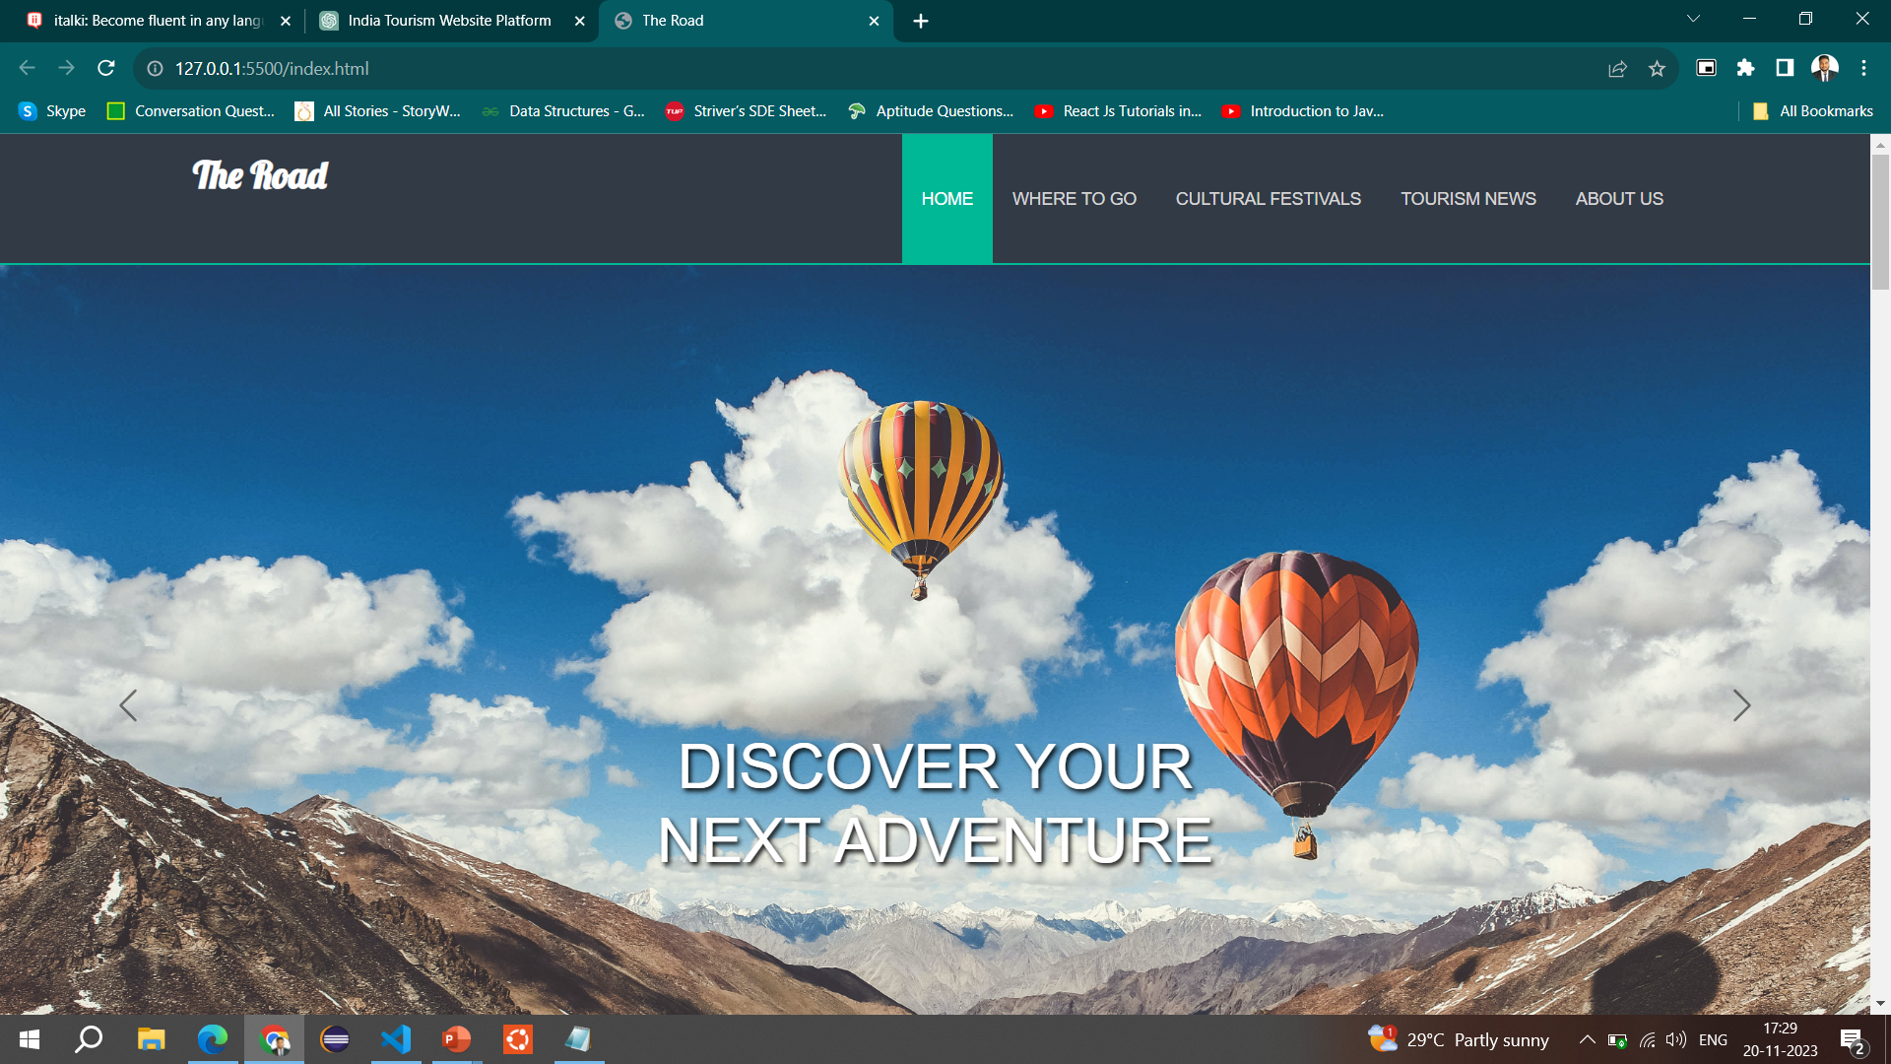

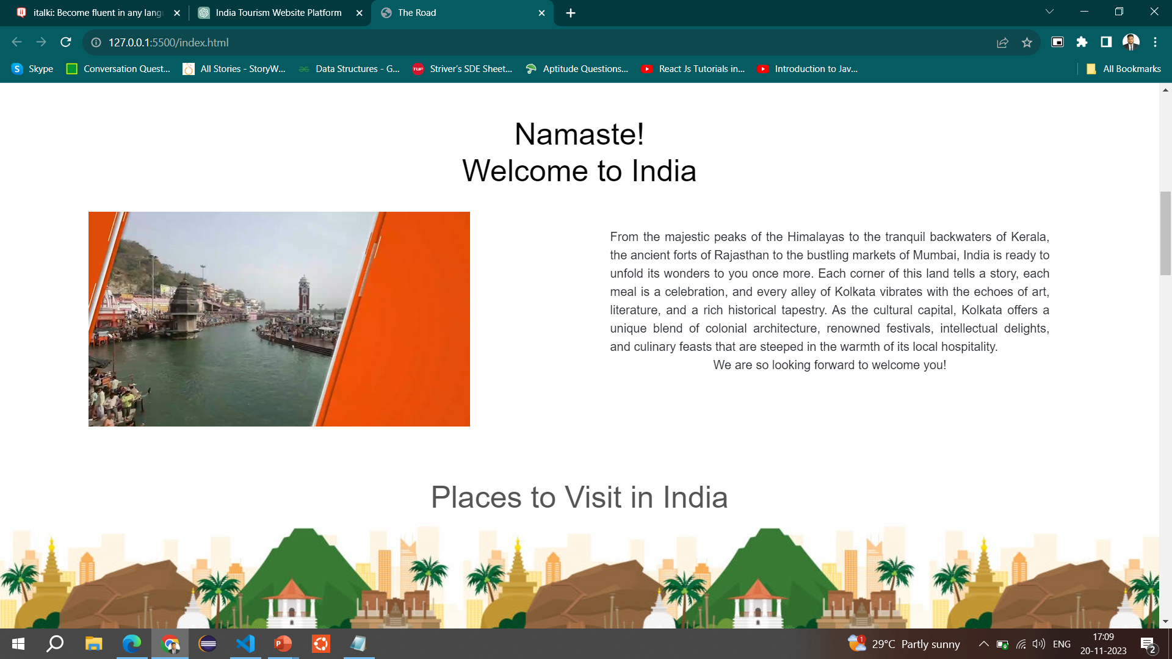

Website development involves the creation and maintenance of websites, encompassing various aspects such as design, content, and functionality. Frontend development specifically focuses on the user interface and user experience of a website, determining how users interact with and perceive the information presented. Frontend development is the process of building the visual elements of a website that users interact with directly. This includes the layout, design, and interactivity. It is crucial for creating a seamless and engaging user experience.

**Key Aspects**  **:** HTML is the backbone of web development, providing the structure for web pages. It uses a markup system to define the layout and content hierarchy. Important elements include headings, paragraphs, lists, and links, allowing developers to structure information in a way that is both logical and accessible. CSS is responsible for styling and formatting the HTML structure. It defines the visual presentation of a web page, including colours, fonts, and layout. Important aspects include selectors, properties, and values, enabling designers to create visually appealing and consistent designs across various devices. JavaScript adds interactivity and dynamic behaviour to web pages. It is a versatile scripting language that allows for real-time updates and user interactions.

**Reasons for Choosing HTML, CSS, and JavaScript:** Universality: HTML, CSS, and JavaScript are universally supported by web browsers, ensuring compatibility and accessibility for a global audience. Ease of Learning: These languages are beginner-friendly, with a shallow learning curve, making them ideal for those new to web development. Versatility: HTML, CSS, and JavaScript can be used together to create a fully functional and visually appealing frontend. They provide a comprehensive toolkit for building modern and dynamic websites. Community Support: These languages have extensive community support, with a wealth of online resources, tutorials, and frameworks that facilitate development. Integration: HTML, CSS, and JavaScript seamlessly integrate with backend technologies, allowing for the development of robust and scalable web applications.

**VI. Conclusion**

Thisis a special website for foreigners exploring India is about more than just technology. It's like building a bridge between different cultures. This website is really important because it helps people from other countries understand and enjoy what India is all about. This project isn't just about sharing information. It's also a way to help travellers connect with India's rich culture, keep up with the latest news, and find cool places to visit. This website can be super helpful for travellers. It gives them good advice on where to go and what to do. Plus, by talking about India's culture and what's happening now, it makes the trip more interesting and meaningful. Looking ahead, this project could become even cooler. It might include things like letting people share their own stories and tips. That way, travellers can learn from each other and feel like they're part of a bigger community.

## References

1. Michael Abelar, “Ultra Reference: An in-depth reference book for the programming language”.
2. Zak Ruvalcaba, Anne Boehm,”Murach's HTML5 and CSS 3”.
3. Riwanto Megosinarso, “A Quick Guide to Responsive Web Development Using Bootstrap 3.
4. Research by Gössling et al. (2018) explores the economic impacts of online tourism platforms.