##### **Enhancing User Experience in Music Streaming: A React.js and Context API Approach for Spotify Clone**

##### Ankita Mukhuti, Drisha Kundu, Ankur Biswas, Kaustuv Bhattacharjee, Anirban Das

Master Of Computer Application, University of Engineering and Management

***Abstract*-** The evolution of web technologies has revolutionized the way music streaming platforms operate. This research paper delves into the development and implementation of a Spotify clone using React.js and Context API. The study aims to explore the efficacy of these technologies in replicating the core functionalities of the renowned music streaming service while evaluating their advantages and limitations in the context of a clone project. The research methodology involves an in-depth examination of React.js and its application in building user interfaces, along with an analysis of the Context API for state management within the Spotify clone. The paper outlines the step-by-step process of creating the clone, highlighting key architectural decisions, data handling strategies, and user experience design considerations. Additionally, this paper investigates the performance metrics, scalability, and maintenance aspects of the React.js and Context API-based Spotify clone in comparison to the original platform. The study incorporates user feedback and usability testing to evaluate the similarity in functionality and user experience between the clone and the original application. The findings of this research contribute to the understanding of leveraging React.js and Context API in replicating complex applications like Spotify. Moreover, the paper discusses the potential implications and future directions for utilizing these technologies in developing similar web-based projects.

***Index Terms***- REACT JS, CONTEXT API, SPOTIFY CLONE, USER INTERFACE, STATE MANAGEMENT, WEB DEVELOPMENT.

1. **Introduction**

In the realm of modern web development, creating robust and immersive applications requires harnessing the power of cutting-edge technologies. This research delves into the development process of a Spotify-inspired music streaming platform using React.js and the Context API. The project aims to replicate the fundamental functionalities of Spotify while exploring the utilization of React.js, a popular JavaScript library for building user interfaces, and the Context API, a state management tool within React, to facilitate a seamless and intuitive user experience.

This paper embarks on an exploration of the foundational principles and technical intricacies involved in recreating a music streaming service. It delves into the design choices, architectural considerations, and challenges encountered during the implementation of this project. Furthermore, it assesses the efficacy of utilizing React.js and the Context API in developing a scalable and efficient music streaming application, emphasizing their role in managing state, handling data flow, and enhancing the overall user interactivity.

The research document is structured to present a comprehensive overview of the project's objectives, the methodology adopted in implementing the Spotify clone, an in-depth analysis of the technologies employed, and a critical evaluation of the outcomes. By examining the implementation process and analyzing the advantages and limitations of React.js and the Context API in this context, this research aims to provide valuable insights and recommendations for developers seeking to create similar applications or utilize these technologies in their projects.

Through this exploration, the paper endeavors to contribute to the growing body of knowledge on web development, particularly in the realm of building dynamic and responsive applications using React.js and leveraging the Context API for state management, offering valuable guidance and insights for developers venturing into similar endeavors.

1. **BACKGROUND STUDY**

Detailing Spotify’s inception, founded by Daniel Ek and Martin Lorentson in 2006, and its growth trajectory into one of the leading music streaming platforms globally. The music streaming industry has witnessed unprecedented growth, with platforms like Spotify revolutionizing how music is accessed and enjoyed. This paper explores the development of a Spotify-inspired application using React.js, a popular JavaScript library for building user interfaces, in conjunction with the Context API, which provides a state management solution within React applications.

**Significance of the Study:**

With the increasing demand for personalized music experiences, the development of a Spotify clone holds substantial significance. Understanding and implementing the intricacies of React.js and the Context API in recreating the functionalities and user experience of a prominent platform like Spotify could offer valuable insights for developers, educators, and businesses aiming to enhance their web development skills and create immersive applications.

**Literature Review:**

**Music Streaming Platforms:** Scholars often trace the evolution of music consumption from physical formats (vinyl, CDs) to digital platforms and streaming services. They explore how streaming platforms disrupted traditional music distribution models and the subsequent impact on artists, record labels, and consumers. Researchers examine how streaming platforms have altered the relationship between artists and their audience. This includes discussions on direct engagement through social media, the impact of streaming on artist revenue, and the challenges of standing out in a crowded digital landscape. Competition among streaming platforms and its impact on the industry are widely discussed. Studies analyze market strategies, subscriber retention tactics, and the influence of exclusive content deals on user acquisition and retention. Anticipating future trends, the literature speculates on potential advancements in streaming technology, changes in user behaviors, regulatory challenges, and the sustainability of the current streaming model. The success of Spotify, as one of the pioneering music streaming platforms, has been extensively examined in academic and business literature. Scholars often highlight Spotify's innovative business model, which disrupted traditional music distribution. The freemium model (offering both free ad-supported and premium subscription options) is a focal point of discussion, emphasizing its role in attracting users and converting them to paying subscribers. Spotify's success is often attributed to its strong focus on user experience. This review discusses the platform's user-centric design, intuitive interface, personalized recommendations, curated playlists, and social features that enhance engagement and retention. The use of sophisticated algorithms for music discovery and recommendation is a significant area of study. Researchers analyze Spotify's algorithms, exploring how they leverage user data, machine learning, and collaborative filtering to deliver tailored music suggestions. The impact of Spotify on artists and record labels is a common topic. Researchers examine how the platform's royalty distribution model, playlist placements, and data-driven insights influence artists' success and label strategies. Recent literature might explore Spotify's response to evolving industry dynamics, changes in user behavior, advancements in music recommendation algorithms, strategies for podcast expansion, and the platform's sustainability in an increasingly competitive streaming landscape.

**React.js:** Certainly! React.js, a popular JavaScript library for building user interfaces, has garnered extensive attention in academic and technical literature due to its impact on frontend web development. React.js, a JavaScript library developed by Facebook, has revolutionized the way developers build user interfaces for web applications. Its introduction marked a significant shift in frontend development paradigms. React.js focuses on creating interactive, efficient, and reusable UI components, offering a declarative and component-based approach to building modern web applications. One of React's standout features is the Virtual DOM (Document Object Model), which enhances performance by optimizing the way the browser updates the UI. Rather than directly manipulating the entire DOM upon changes, React uses a virtual representation of the DOM, allowing it to identify and update only the specific components that require changes. This approach significantly improves rendering efficiency and application performance, especially in complex and dynamic applications. Furthermore, React introduces JSX (JavaScript XML), a syntax extension that enables developers to write HTML-like code within JavaScript files. JSX simplifies the creation of UI components by blending HTML structures with JavaScript logic, enhancing readability and maintainability while providing a familiar syntax for frontend developers. Researchers delve into performance optimization strategies, analyzing techniques to minimize rendering bottlenecks, improve app speed, and handle large datasets efficiently using React's optimizations like memorization and virtualization. React.js gained popularity not only for its technical prowess but also for its thriving ecosystem, extensive community support, and rich set of tools and libraries. Its flexibility allows for integration with other frameworks and libraries, empowering developers to customize their development workflows based on project requirements. Overall, React.js has emerged as a cornerstone in modern web development, offering a robust solution for building interactive, scalable, and high-performance user interfaces. Its emphasis on component reusability, declarative programming, and efficient rendering has made it a preferred choice for developers aiming to create sophisticated web applications. The supportive React community and the abundance of learning resources (documentation, tutorials, online forums, conferences) available for developers are often acknowledged in literature reviews. Anticipating the future, reviews may touch upon emerging trends in React.js development, potential advancements, challenges (like SEO optimization for single-page applications), and the evolution of the React ecosystem. As React.js continues to evolve with updates, new features, and community-driven enhancements, recent literature might explore cutting-edge topics, advancements in React tooling, performance improvements, and emerging best practices.

**Context API:** The Context API in React.js has garnered attention in the development community and has been a subject of exploration in technical literature. It's a feature that enables the sharing of data across the component tree without the need for prop drilling, enhancing state management and facilitating the passing of data to deeply nested components. The Context API is often discussed in the context of state management within React applications. Literature reviews focus on its role in providing a centralized state that can be accessed by multiple components, simplifying data flow and reducing the complexity of passing props down the component tree. Researchers and developers highlight how the Context API addresses the issue of prop drilling, a challenge in larger applications where passing props through multiple layers of components becomes cumbersome and less maintainable. This API facilitates the propagation of data to components deeply nested in the hierarchy without explicitly passing props at each level. Authors discuss how context providers and consumers enable the creation of reusable components that can easily consume shared state data, promoting a more modular and scalable architecture. Studies explore the performance implications of using the Context API, discussing scenarios where it might be more beneficial or less efficient compared to other state management solutions like Redux or React's useState and useReducer hooks. Understanding the potential impact on performance in large-scale applications is a key area of interest. Some reviews compare the Context API with other state management solutions available in the React ecosystem, evaluating its advantages, limitations, and suitability for different application architectures. Comparative analyses may include Redux, MobX, or even simple prop drilling to highlight the trade-offs and use cases. Recent literature may speculate on the future of the Context API, potential enhancements, or improvements in React that might further optimize its usage or expand its capabilities. This review on the Context API often offer insights into its strengths, practical applications, optimal use cases, and considerations for leveraging it effectively within React applications. As React evolves, newer studies might explore advancements, best practices, and evolving patterns in utilizing the Context API.

1. **METHODOLOGY**

Music streaming platforms like Spotify offer an extensive catalog of songs, playlists, and features that users love. However, there's a need to create a personalized music streaming experience that resonates with users while leveraging Spotify's vast music database. The challenge is to develop a Spotify clone using React.js that seamlessly integrates with the Spotify API, providing users with a familiar yet innovative platform to discover, play, and manage music.

**Implementation:** To implement Spotify Clone, we must create a react app and install necessary dependencies like axios for API requests, style components, react-icons. After completing these processes, we implemented Spotify authentication using OAuth 2.0 and use Spotify's authentication API to allow users to log in with their Spotify account. We utilize Spotify Web API to fetch user information, playlists, albums, tracks, etc. and handle API requests using Axios or Fetch within React components. After doing the authentication, we design the user interface to mimic Spotify's layout using React components, CSS, and potentially a UI library like Material-UI or Styled Components. Here we are using styled components. For authentication we register our app on the Spotify Developer Dashboard to get client ID and secret. After getting the client id, we used it on our authentication code. After completing all the steps, we test the application thoroughly to ensure proper functionality. We should remember to handle errors gracefully, especially when dealing with API requests or authentication. It's also important to keep the API keys and secrets secure by implementing proper environment variable handling.

**Application Architecture:**

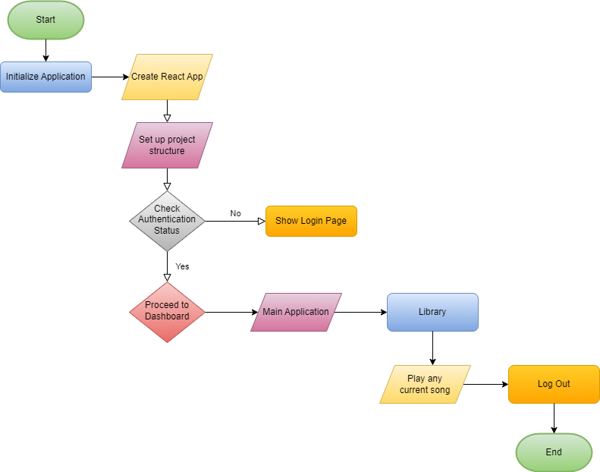

**Fig.1**

1. **RESULTS AND DISCUSSION**

**RESULT:** The applicationconnects with OAuth or Spotify's authentication API to enable users to log in using their Spotify accounts. This manages user authentication state across components, storing user credentials or tokens securely. We design a login/signup interface, handle user input, and manage authentication-related errors or messages and integrate with Spotify’s API to fetch track data, album art, and playback information. We create an audio player interface with play/pause controls, track progress bar, volume adjustment, and track skipping functionalities. Using React state or Context API, we manage the playback state, track information, and user interaction with the player. Utilize React.js to create modular components for various parts of the Spotify clone, such as header, music player, playlist, search bar, etc. In this application, uses of the Context API is managing global states, such as user authentication status, current playback state, playlists, or search results and create context providers to encapsulate related state and functions, allowing components to consume and update shared state without prop drilling. Testing and performance metrics in a Spotify clone project developed with React.js and the Context API are crucial for ensuring the application's functionality, reliability, and responsiveness. Objective to test individual components and functions in isolation to ensure they work as intended. Utilize testing libraries like Jest along with React Testing Library for unit tests of React components and utility functions. Test the interactions and integration between different modules or components within the application. Conduct tests to verify the functionality of integrated systems, especially areas like playlist management, authentication, and API interactions. Gather feedback from real users to evaluate the application's usability, UI/UX, and overall satisfaction. Measure the time taken for the application to load initially and subsequent loading times during user interactions.



**Fig.2**





**Fig.3**



**Fig.4**

**DISCUSSION:** Original Spotify offers user authentication through email, Facebook, or Apple ID and also provides seamless playback, high-quality streaming, control over playback features, and cross-device synchronization but Spotify Clone implemented authentication, possibly using OAuth or another method, allowing users to log in with their Spotify accountsand attempts to replicate music playback functionalities, though the audio quality, seamless cross-device synchronization, or advanced features might differ. React.js's component-based architecture facilitates modular and reusable code, enhancing the Spotify clone's development. Context API simplifies state management by providing a centralized way to share data across components, increasing the application's efficiency. Working with a third-party API like Spotify’s might pose limitations in data access, rate limiting, or feature restrictions, impacting the clone's functionalities. Understanding and navigating API constraints early in the project allows for better planning and mitigating potential feature limitations.Managing complex application state across multiple components using the Context API can become challenging, leading to potential state management issues. Properly structuring and organizing the context and state management early on helps in avoiding cluttered or convoluted state structures. Implementing secure authentication methods while integrating with external authentication services (like OAuth for Spotify authentication). Understanding OAuth protocols thoroughly and implementing secure authentication practices is crucial to safeguard user data and application security. Comprehensive understanding of the third-party API's documentation is crucial for effective integration and accurate implementation. Ensuring effective communication and collaboration among team members promotes a cohesive development process, aiding in issue resolution and knowledge sharing.

**References**

1. Font, F., Brookes, T., Fazekas, G., Guerber, M., La Burthe, A., Plans, D., Plumbley, M., Shaashua, M., Wang, W., Serra, X., 2016. Audio Commons: bringing Creative Commons audio content to the creative industries. In: Audio Engineering Society
2. Fonseca, E., Pons Puig, J., Favory, X., Font Corbera, F., Bogdanov, D., Ferraro, A., Oramas, S., Porter, A., Serra, X., 2017. Freesound datasets: a platform for the creation of open audio datasets. In: Proceedings of the International Society for Music Information Retrieval Conference. International Society for Music Information Retrieval, pp. 486–493.