**HydroSight: Groundwater Prospector**

**Sharmi Khan, Piya Khan, Suryadipta Bhattacharyya, Palash Kundu, Ankur Biswas, Pou**lami Ghosh, **Kaustuv Bhattacharjee, Anirban Das**

Department of Master of Computer Application, University of Engineering & Management, Kolkata

***Abstract*-** Access to groundwater is crucial for the sustenance of communities, particularly in key regions of West Bengal such as Midnapore, Birbhum, Purulia, and other areas. A significant portion of the population relies heavily on groundwater for various essential needs, including drinking water and daily chores. HydroSight is a project aimed at revolutionizing groundwater prospecting using data analysis techniques. Our initiative leverages data provided by the State Water Investigation Directorate (SWID), Government of West Bengal. Using machine learning techniques, we will generate compelling visual representations of data. HydroSight isn't just about technology; it's about working together to solve a real-time problem.

***Index Terms***- Groundwater level prospecting, Predictive Data Analysis, Machine Learning techniques, Data Representation, Visual representation of Data.

ntroduction

Water is one of the most important resources of our life. From the very beginning, we found life in the water bodies, even before lands. From shaping our ecosystem to human civilization, everything depends on water. It is a crucial time to create an effective management of water resources in the context of a growing population and compounding challenges posed by climate change. Groundwater, hidden in the geological layers of aquifers, is a silent and essential reservoir, serving as a fundamental source for various sectors, including agriculture, industry, and domestic consumption. Climate change, weather patterns, rainfall, etc have a significant impact on groundwater. The depth of the groundwater table completely depends upon the soil pour surface, fracture and it is recharged from the surface to the subsurface. It may be discharged naturally as a spring from different slopes and surfaces and make an oasis or wetland etc. Groundwater is much cheaper, more convenient, and less vulnerable to pollution than surface water. Therefore, common people use it more

Our research project is embarking on an exhaustive exploration of predictive data analysis, with the aim of discovering the complexities involved in detection. This analysis will also help us to get the prediction which will help us to provide a precautionary statement to the government. Here in this project, we analyze the data of the past 10 years and by making a predictive data analysis we will be able to find the futuristic data of groundwater level with the properties of rainfall, climate, landform, etc. This analysis will be available to the government and society so that we act like responsible people towards nature and we can have to solution to protect our civilization, nature, and the ecosystem.

II. BACKGROUND STUDY

As we can see some statistics and records about groundwater have been published in a journal named” Present Scenario of Water Supply in Kolkata” that, “Officially 15% of core Kolkata’s water come from groundwater sources & in reality up to 25% to 30% of the water used in households is groundwater. According to the Central Groundwater Board (CGWB) Booklet the groundwater allocation for domestic and industrial uses within KMC area is about 320 MLD. The depth to the groundwater level in the confined aquifer in use varies from 12.09 to 19.59m below ground level in the pre-monsoon period, and 10.72 to 15.42m below ground level in the post onsoon period. In 2006 groundwater withdrawal by KMC was 144.30 MLD and this has been reduced to 114 MLD in 2011. KMC is intended to further reduce and discourage use of groundwater. P.K. Sikdar, a researcher at the Indian Institute of Social Welfare and Business Management (IISWBM) pointed out, “Groundwater (availability) is rapidly shrinking in the city. It might lead to land subsidence as there is a layer of around 40 etres of clay underground and then sand that might give away.” He also said, “Earlier, in the fifties, the groundwater used to flow from north to south but a change was noticed three decades ago when a groundwater pressure trough developed in the south-central part of Kolkata city due to heavy groundwater abstraction and the water started flowing into the trough from all directions,” he said. “This pressure trough then began to widen slowly and still persists today. The pressure troughs remain even after the monsoon, suggesting that the discharge has been more than recharge.” He further said the groundwater level that was more or less near the sea level has dropped drastically by 15 to 16 metres in the past five decades.”

**Data Science and Analysis :**

Regarding this I saw the journal “International Journal of Data Science and Analytics”, there it is explained that’ “Data Science has been established as an important emergent scientific field and paradigm driving research evolution in such disciplines as statistics, computing science and intelligence science, and practical transformation in such domains as science, engineering, the public sector, business, social science, and lifestyle”.

**Algorithm for prediction:**

About predictive data model I follow the algorithm states in “Prediction of Data Analysis Using Machine Learningpasted-image.tiff Techniques” that,

This is how we wants to create a real-time solution for this issues, states earlier. We are putting very much concentration to improve it and establish an example of real-time analyzer for groundwater level.

III. METHODOLOGY

Setting up Jupyter Notebook for Data Analysis: Jupyter's support for Python, along with its extensive library ecosystem, provides a robust foundation for HydroSight's data analysis tasks. By utilizing Jupyter, HydroSight ensures that the predictive models are not only accurate but also well-documented and easily shareable with users, contributing to the overall transparency and reliability of the groundwater prediction system.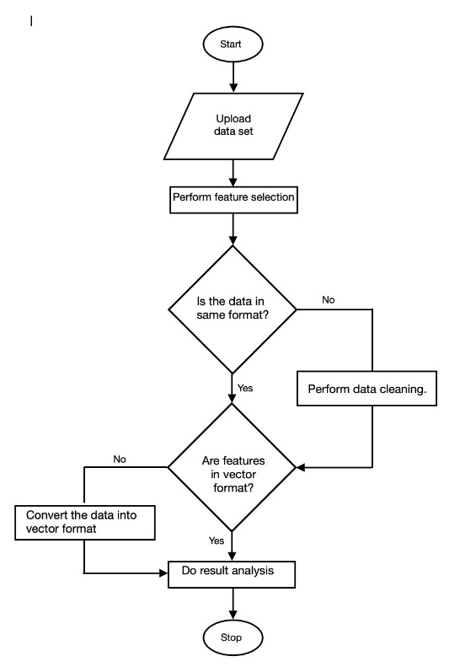

To begin our data analysis journey in Jupyter Notebook, let's first install the Jupyter environment from the command prompt. Once that's set up, we'll systematically import key libraries and modules essential for data manipulation and visualization. Among these are NumPy for numerical operations, Pandas for data handling, Matplotlib and Seaborn for plotting, and ipywidgets for interactive widgets.

With our toolkit in place, the next step involves incorporating the main dataset into our Jupyter Notebook. This dataset, typically in CSV format, will be loaded into our notebook using Pandas' **read_csv** function. This foundational step sets the stage for our data exploration and analysis.

IV. RESULTS AND DISCUSSION

Navigating through the experimental phase of our data analysis project, this section outlines the meticulous setup and configuration. From the installation of Jupyter Notebook to the integration of essential libraries and the incorporation of the core dataset, each step is a building block in our analytical framework. With the experiment executed, the subsequent analysis of results becomes the focal point, unraveling insights vital to our data-driven exploration in Jupyter Notebook.

**Jupyter in HydroSight:**

**Jupyter** is an open-source web application that allows you to create and share live code, equations, visualizations, and narrative text. The name "Jupyter" is a combination of three programming languages it supports, they are Julia, Python, and R. This powerful framework provides an interactive computing environment, fostering collaboration, data analysis, and machine learning. In the context of HydroSight, the Jupyter framework plays a crucial role in the data analysis pipeline. Leveraging Jupyter notebooks allows for a systematic and transparent approach to implementing machine learning algorithms for predictive modelling. The interactive nature of Jupyter notebooks enables developers and data scientists to explore data, experiment with different algorithms, and visualize results in a coherent and reproducible manner.

V. CONCLUSION

The Hydrosight Groundwater Prospector project represents a significant advancement in water resource management. This Prospector not only addresses current water resource challenges but also holds immense promise for the future. By harnessing the power of artificial intelligence, machine learning, and statistical models, the innovative detector seamlessly integrates crucial geological, hydrological, and climate data, the system provides a real-time understanding of water availability in a specific location. The real-time nature of the data acquisition ensures timely alerts to individuals and communities, fostering a proactive approach to water preservation, and also lays the groundwork for a more sustainable future. This prospector offers a valuable tool for informed decision-making and effective water conservation measures.

This project obtains real-time data from various sensors and satellites. The project aims to provide a reliable and accurate prediction of the water level and quality for the present and future scenarios. The project uses data analysis, machine learning, artificial intelligence and statistical models to process the data and generate the prediction. The project also provides a user-friendly. Hydrosight: Ground Water Prospector is a promising project that can help in detecting water availability and preserving water resources. The use of AI and machine learning in this project can help in analyzing data and making predictions for the future. This can be useful for communities and individuals who rely on water resources for their daily needs.

References

1. **SWID, State Water Investigation Directorate,** Government of India.
2. **Present Scenario of Water Supply in Kolkata**, July 2020, International Research Journal of Engineering and Technology (IRJET).
3. Pre-monsoon and Post-monsoon Groundwater Table/ Piezometric Surface Configuration in Kolkata.
4. **International Journal of Data Science and Analytics**, by João Gama.
5. **Prediction Of Data Analysis Using Machine Learning Techniques,** by Dr.M..Balakrishnan, Dr.A.B.Arockia Christopher, Dr.A.S.Muthanantha Murugavel, J.Ramprasath, March 2021, International Journal of Aquatic Science