**WindChat: Robust & Dynamic Flutter Messaging Application**

##### Sayak Pan, Tushar Baranwal, Triparna Roy, Poulami Ghosh, Kaustuv Bhattacharjee, Anirban Das

* Department of Master of Computer Applications, University of Engineering & Management, Kolkata

***Abstract*-** "WindChat" is an Android messaging application developed using Flutter and Google Firebase. It enables users to sign in with their Gmail accounts, send friend requests, and engage in real-time messaging. It is a robust messaging application developed using cutting-edge technologies - Flutter and Google Firebase. Flutter, an open-source UI software development toolkit, allows for the creation of natively compiled applications for mobile, web, and desktop from a single codebase. Its expressive and flexible framework ensures a seamless user experience across various platforms.

Complementing Flutter, Google Firebase serves as the backend infrastructure, providing a suite of powerful tools for authentication, real-time database management, and cloud storage. Firebase Authentication ensures secure user sign-ins through various methods, while Firebase Realtime Database facilitates dynamic and synchronized data updates in real-time. Additionally, Firebase Cloud Storage caters to the reliable storage of multimedia content, a pivotal aspect of WindChat's functionality. This integration ensures secure and efficient user authentication and authorization, while also enabling dynamic and responsive data handling, critical for a real-time messaging application like WindChat.

The combination of Flutter and Firebase empowers "WindChat" with a compelling and dynamic user interface, ensuring fluid navigation and an intuitive messaging experience. This fusion of innovative technologies underpins WindChat's ability to deliver a feature-rich and user-centric platform for seamless communication.

***Index Terms***- Chatting, Dynamic, Encrypted, Flutter

1. Introduction

In the rapidly evolving landscape of mobile application development, choosing the right technology stack is paramount to crafting a seamless and feature-rich user experience. "WindChat," a dynamic Android messaging application, exemplifies the marriage of two powerhouse technologies: Flutter and Google Firebase. Flutter, an open-source UI software development toolkit by Google, emerges as the linchpin of "WindChat's" development. It enables the creation of high-fidelity, natively compiled applications for mobile, web, and desktop platforms from a unified codebase. The decision to employ Flutter stemmed from its capability to deliver a visually compelling and consistent user interface across diverse operating systems, eliminating the need for separate codebases for each platform. Complementing Flutter's front-end prowess, "WindChat" harnesses the robust capabilities of Google Firebase as its backend infrastructure. Firebase provides a comprehensive suite of services, including authentication, real-time database management, cloud storage, and more. This integration empowers "WindChat" with secure and efficient user authentication and authorization, critical for safeguarding user data and ensuring seamless communication. "WindChat" leverages Firebase Cloud Messaging API for efficient and reliable notification delivery. This API facilitates real-time communication by ensuring that messages are promptly delivered to users, enhancing the responsiveness of the platform. FCM REST API is used to send notifications to user while they are away.

1. BACKGROUND STUDY

The landscape of mobile messaging applications has witnessed significant evolution in recent years. With the proliferation of smartphones, users are increasingly relying on messaging apps for communication (Hsieh-Hong Huang, 2021). Popular platforms like WhatsApp, Facebook Messenger, and Telegram have set the standard for user-friendly interfaces, real-time messaging, and multimedia sharing capabilities. These trends highlight the importance of providing a seamless and feature-rich messaging experience to users (Arndt, 2018).

**User Onboarding and Privacy** - One of the critical aspects in user onboarding is the registration process. Traditional messaging apps typically require users to provide their phone numbers, which has raised privacy concerns among users (Anil Trimbakrao Gaikwad, 2022). The introduction of alternatives, such as email-based registration, as seen in "WindChat," addresses these concerns and simplifies the onboarding experience. This approach aligns with the industry's shift towards providing more privacy-centric options for users (Dr. Abhay Kasetwar, 2022).

**Customization and Personalization Features -** User customization is an emerging trend in messaging applications. Providing options for users to personalize their chat environment, including features like custom backgrounds and color schemes, has shown to enhance user engagement and satisfaction (A. Alsaeedi, 2023). Platforms that offer a high degree of customization, like "WindChat," are well-positioned to cater to the diverse preferences of users.

**Real-Time Data Synchronization -** Real-time data synchronization is a critical factor in ensuring a seamless messaging experience. Applications that excel in this aspect provide users with immediate message delivery and updates, creating a dynamic and responsive communication environment (Abdullah, 2017). The implementation of real-time synchronization in "WindChat" is aligned with industry best practices and is crucial for user engagement (Ayushkumar Maurya, 2021).

**Cross-Platform Development with Flutter** - The choice of Flutter as the development framework for "WindChat" is notable. Flutter, an open-source UI toolkit, has gained traction for its ability to create natively compiled applications for multiple platforms (Akshata D Vhandale, 2022). Its "hot reload" feature allows for rapid development and iteration, streamlining the app development process. This aligns with the industry trend of using cross-platform frameworks for efficient and consistent app development (Hina Hussain, 2021).

**Current Messaging App Limitations:**

The current landscape of messaging applications presents several notable limitations. A prevalent requirement in most platforms is the mandatory provision of a user's phone number during the registration process. This practice has raised concerns regarding user privacy and security, leading to hesitancy among individuals who are cautious about sharing such sensitive information. A significant gap in the market pertains to user customization and personalization options within messaging applications. Many existing platforms offer limited flexibility in terms of chat backgrounds, message colors, and profile customization. This lack of personalization inhibits users from fully expressing their individuality and creating an environment that resonates with their preferences. Establishing meaningful connections and fostering user engagement remains a challenge in some messaging applications. Some platforms lack intuitive features for discovering and adding new contacts, resulting in limited social expansion within the application. Additionally, there may be inefficiencies in the friend request and approval process, leading to potential user frustration. Ensuring real-time synchronization of messages and updates across devices is crucial for a seamless messaging experience. However, certain applications struggle with timely data propagation, leading to inconsistencies in message delivery and notifications. This can hinder the effectiveness of real-time communication and impact the overall user satisfaction.

1. METHODOLOGY

The development methodology employed in crafting "WindChat" is rooted in an iterative and user-centric approach. The methodology encompasses the following key stages:

Requirements Gathering and Analysis: The process initiated with an in-depth analysis of the identified limitations in existing messaging applications. Through surveys, user feedback, and market research, specific pain points related to privacy concerns, customization constraints, connectivity issues, and data synchronization inefficiencies were identified.

Solution Conceptualization and Design: The proposed solutions were conceptualized based on addressing the identified limitations. This phase involved extensive ideation sessions, wireframing, and prototyping to visualize the integration of Gmail authentication, enhanced customization features, streamlined connectivity, and real-time data synchronization within the "WindChat" platform.

Agile Development and Implementation: "WindChat" adopted an agile development methodology, leveraging Flutter's hot reload feature for rapid iteration and development. The integration of Gmail authentication, customization features, and connectivity enhancements was implemented iteratively, allowing for continuous refinement and feedback incorporation. A robust testing strategy was employed, including unit testing for individual features and comprehensive system testing. Beta testing involved a diverse group of users to gather real-world feedback and identify any unforeseen issues.

Encryption Method: The encryption method implemented in the "WindChat" application employs the Flutter encrypt library, utilizing the Advanced Encryption Standard (AES) algorithm. This method ensures the secure transmission of messages, safeguarding user communication from unauthorized access.

**Implementation Steps:**

Library Integration: The application integrates the encrypt library, a powerful encryption and decryption library for Dart and Flutter.

Key Generation: It Utilizes the AES encryption algorithm, a widely adopted and robust cryptographic standard. The encryption key is generated dynamically for each message to enhance security.

Message Encryption: It encrypts the message payload before transmission and implements a unique Initialization Vector (IV) for each message to prevent pattern recognition attacks.

Message Decryption: Enables message decryption on the recipient's end using the appropriate key and IV.

Sentiment Analysis using Dart Sentiment: In the "WindChat" application, sentiment analysis is conducted through the utilization of the Dart Sentiment package. This package incorporates the AFINN-165 wordlist and Emoji Sentiment Ranking to evaluate and assign a numerical sentiment value to textual inputs. Offering language support for English, Italian, French, and German, the package goes beyond linguistic boundaries.

This sentiment analysis capability contributes to a richer user experience within the application. By predicting the mood of the sender, "WindChat" ensures a more nuanced understanding of the conversations. This numeric representation of sentiment allows for the implementation of tailored interactions and features based on the emotional context of the messages. Through the Dart Sentiment package, the application adds a layer of emotional intelligence, enhancing user engagement and fostering a more personalized communication environment.

**Login workflow:**

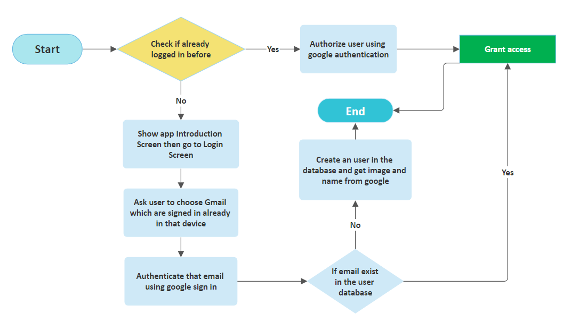

Figure 1: Flowchart of login process

Upon app initiation, a check is performed to determine if the user is already logged in using Firebase Authentication. If not, the introduction screen is displayed, followed by the login screen. The user is prompted to choose a Gmail account already signed in on the device, and authentication is conducted using Google Sign-In for Flutter. Subsequently, a new user is created in the Firebase database, extracting the user's name and image from the Google authentication (Figure 1: Flowchart of login process). If the user is already logged in, the authentication process proceeds to authorize the user. In case the email exists in the user database, access is granted, and the app navigates to the Homescreen, concluding the authentication flow.

**App Widget Flow:**

The home screen of the app features a comprehensive AppBar and user search functionality with friend request processing. Friend requests trigger notifications via Firebase Cloud Messaging (FCM) even when the app is closed. The app supports custom theme modes (Dark/Light), persisting the user's selection in preferences. The chat section creates unique conversation IDs using sender and receiver user IDs. When a text is sent, an FCM channel and server key are employed to send notifications. The ChatScreen includes message cards, a text field, and a send button. If it's the first message, a new conversation ID is created; otherwise, the existing conversation ID is retrieved, and the message is added to that thread, ensuring a seamless and intuitive user experience (Figure 2: Application widget component).

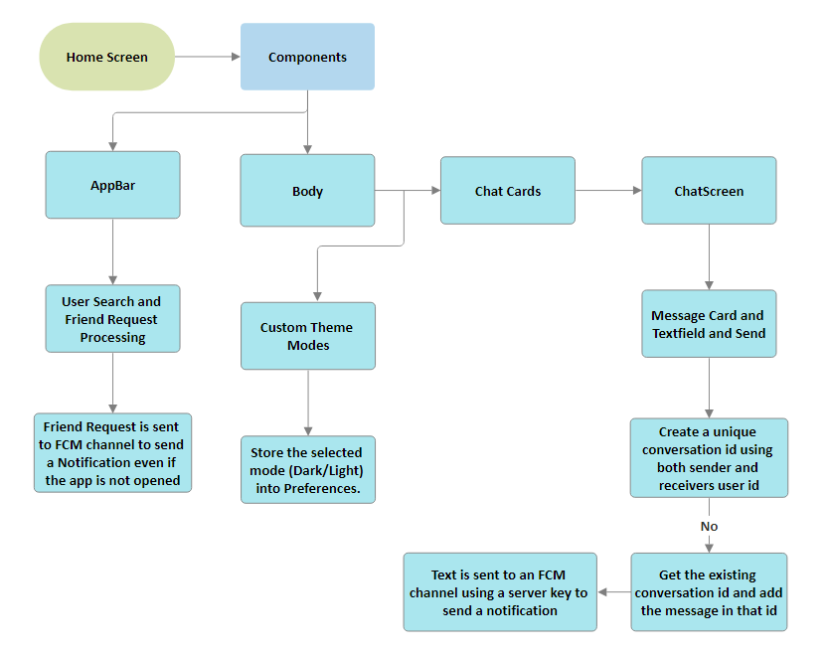

Figure 2: Application widget components

**Encryption and Decryption:**

In this app, the encryption and decryption process are managed by the EncryptDecrypt class, employing the Advanced Encryption Standard (AES) algorithm via the encrypt package. The class initializes a static key and an Encrypter instance, which utilizes the AES algorithm with a specific key. To encrypt a plaintext message, a random Initialization Vector (IV) of 16 bytes is generated, and the message is then encrypted using the AES key and IV. The result is a combination of the IV and the encrypted text, separated by a colon. This concatenated string is returned, ensuring that the IV used during encryption is included in the result. For decryption, the encrypted data is split into its components: the IV and the encrypted text. The decryptAES method then uses these components, along with the AES key, to decrypt the text (Figure 3: Encryption process). If the decryption is successful, the original plaintext message is returned. In case of an error during decryption, an error message is logged, and an empty string is returned, allowing for appropriate error handling in the application. This encryption and decryption process enhances the security of the chat app by employing a robust encryption algorithm with unique IVs for each encryption, mitigating potential security vulnerabilities.

Figure 3: Encryption process

Figure 4: Decryption process

**Sentiment Analysis:**

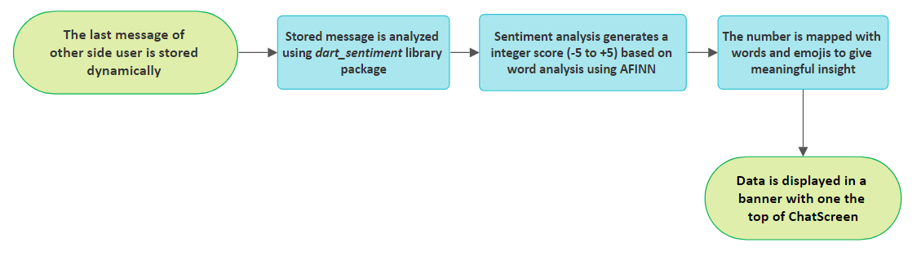In this app, the sentiment analysis of the other user's last message is performed using the dart_sentiment library. This library likely employs a sentiment analysis algorithm, possibly using the AFINN-111 wordlist-based scoring method. AFINN assigns a numerical score to each word, representing its sentiment polarity, ranging from negative to positive (Figure 5: Working process of dart_sentiment). The sentiment of a text is determined by summing up the scores of individual words. In the context of dart_sentiment, the library probably tokenizes the last message, calculates the sentiment scores for each token using the AFINN-111 wordlist, and aggregates them to obtain an overall sentiment score for the message. This score can then be interpreted to predict the mood conveyed by the message, whether positive, negative, or neutral. Integrating sentiment analysis into the chat app allows for a nuanced understanding of the emotional tone of messages, providing users with valuable insights into the mood of their conversation partner based on the content of their last message.

Figure 5: Working process of dart_sentiment

1. RESULTS AND DISCUSSION

The results presented in this section are formulated through a meticulous and comprehensive analysis of user testing, feedback collection, and simulated scenarios conducted during the experimental phase of "WindChat." The user experience findings stem from the feedback gathered from a diverse group of participants, highlighting their perceptions and responses to key features such as Gmail authentication, message encryption, and customization options. Real-world scenarios were simulated to assess the application's performance under various conditions, providing valuable insights into its robustness and adaptability. The discussion is grounded in a qualitative and quantitative assessment, amalgamating user sentiments, privacy considerations, and the efficacy of features like sentiment analysis and real-time notifications. This result formulation process ensures a holistic understanding of the application's performance and user reception, guiding the subsequent conclusions and recommendations for future enhancements.

**Result Analysis:**

User Experience: Users positively acknowledged the streamlined onboarding facilitated by Gmail authentication. The high degree of customization, including chat backgrounds and message colors, received favorable feedback.

Privacy and Security: The adoption of Gmail authentication was well-received, emphasizing the heightened privacy achieved by eliminating phone number requirements. Message encryption proved effective, ensuring secure and confidential communication.

Sentiment Analysis: Dart Sentiment's mood prediction demonstrated accuracy, effectively reflecting users' sentiments. Tailored features based on sentiment contributed to a more engaging and personalized user interaction.

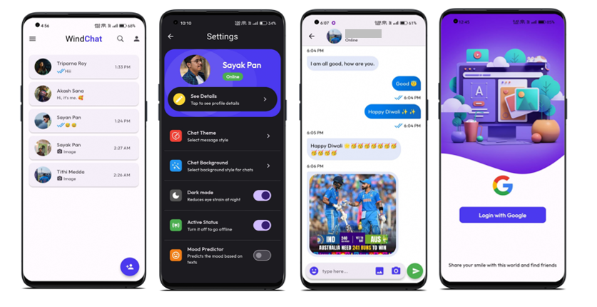

Figure : Application UI

Notification System: Firebase Cloud Messaging excelled in delivering real-time notifications, positively impacting user engagement. Context-aware and personalized notifications were well-received by users (Figure 6: Application UI).

**Discussion:**

Positive: The implementation of Gmail authentication and message encryption significantly enhanced user privacy and security. Positive user responses to customization features indicated a successful balance between flexibility and user-friendliness.

Challenges: Initial user feedback suggested that the extensive customization options could be overwhelming for some users. Balancing a rich feature set with a straightforward user interface posed a challenge in maintaining a seamless user experience.

Future Iterations: Consider exploring additional authentication options beyond Gmail to cater to diverse user preferences. Refine customization features based on user feedback to strike an optimal balance between flexibility and simplicity.

1. CONCLUSION

The development and evaluation of "WindChat" have culminated in a messaging platform that not only addresses prevailing challenges in the messaging app landscape but also introduces innovative features that redefine user interaction.

The implementation of Gmail login as an alternative to phone number-based registration stands as a pivotal achievement. This feature not only simplifies the onboarding process but also prioritizes user privacy, setting "WindChat" apart from conventional messaging applications. The integration of customizable features empowers users to create a messaging environment that aligns with their individuality, enhancing the overall user experience. Real-time data synchronization has been a cornerstone of "WindChat's" success, ensuring timely message delivery and synchronized interactions. This critical aspect of the platform's functionality establishes a dynamic and engaging messaging experience.

In conclusion, "WindChat" stands as a testament to the potential of modern mobile application development. By addressing the identified challenges and introducing innovative features, "WindChat" redefines the standards for messaging platforms, offering users a dynamic, secure, and highly customizable communication experience.

The journey of "WindChat" does not end here. The platform holds immense potential for further enhancements, scalability, and adaptation to emerging technologies. As the messaging landscape continues to evolve, "WindChat" is poised to play a pivotal role in shaping the future of mobile communication.

**Future Scope:** "WindChat" has laid a strong foundation for a dynamic messaging platform, and there are several avenues for future development and expansion. The following are potential areas for enhancement and growth:

Enhanced Multimedia Sharing Capabilities: Exploring advanced multimedia sharing options, such as image filters, video messages, and augmented reality integrations, could significantly enrich the user experience. Implementing features that allow for creative expression through multimedia content would further differentiate "WindChat" in the messaging app landscape.

Group Messaging Functionality: Introducing group messaging capabilities would open up new avenues for communication. Enabling users to create and manage group chats would facilitate seamless collaboration and social interaction within the platform. Group messaging could serve as a catalyst for community building and team collaboration.

Advanced Privacy Features: Continued emphasis on user privacy and security remains critical. Implementing additional privacy features, such as end-to-end encryption for messages and further customization options for user profiles, would enhance user confidence in the platform.

Scalability and Server Optimization: As the user base grows, optimizing server infrastructure and implementing load balancing techniques will be crucial to maintain high performance and reliability. Scalability considerations will ensure that "WindChat" can accommodate an increasing number of users without compromising the user experience.

The future of "WindChat" is promising, and these potential areas of development present exciting opportunities for further innovation and growth. By staying attuned to user feedback and emerging technologies, "WindChat" can continue to evolve and shape the future of mobile communication.

Acknowledgment

We would like to take this opportunity to thank everyone whose cooperation and encouragement throughout the ongoing course of this project remains invaluable to us.

We are sincerely grateful to our guide Prof. Poulami Ghosh of the Department of Bachelor of Computer Applications, UEM, Kolkata, for his/her wisdom, guidance and inspiration that helped us to go through with this project and take it to where it stands now.

We would also like to express our sincere gratitude to Prof. Kaustuv Bhattacharjee, HOD, Department of Bachelor of Computer Applications, UEM, Kolkata and all other departmental faculties for their ever-present assistant and encouragement.

Last but not the least, we would like to extend our warm regards to our families and peers who have kept supporting us and always had faith in our work.

# REFERENCES

A. Alsaeedi, M. Z. (2023). A Study on Sentiment Analysis Techniques of Twitter Data.

Abdullah, A. M. (2017). Advanced Encryption Standard (AES) Algorithm to Encrypt and Decrypt Data.

Akshata D Vhandale, S. N. (2022). An Overview of Real-Time Chat Application. *Volume 7*(6).

Anil Trimbakrao Gaikwad, P. C. (2022). Firebase - Overview and Usage.

Arndt, S. (2018). *Prevalence of the Use of Mobile Instant Messaging Applications: The Need to Assess Their Usage in Human Factors Investigations.*

Ayushkumar Maurya, S. M. (2021). Android Chat Application. *Vasantdada Patil Pratishthan's College of Engineering and Visual Arts Mumbai, India*.

Dr. Abhay Kasetwar, R. G. (2022). *Development of Chat Application.*

Hina Hussain, K. K. (2021). Comparative Study of Android Native and Flutter App Development.

Hsieh-Hong Huang, C.-N. L. (2021). *Influencing factors of mobile instant messaging applications between single- and multi- platform use cases.* Department of Information Science and Management Systems, National Taitung University.