**Pest Detection and Classification in Peanut Crops Using CNN and EViTA Algorithms**

**Monis Tariq#, G Jaya Prakash Reddy, C Vighnesh, G Bharath Reddy, D Pranish**

Assistant Professor, Department of IT, Guru Nanak Institutions Technical Campus, Hyderabad.

Department of IT, Guru Nanak Institutions Technical Campus, Hyderabad.

**Abstract:** The field of image classification and identification tasks has seen tremendous progress driven by the quick development of Convolutional Neural Network (CNN) methods. Unlike the widely used Vision Transformer (ViT) methods, this study presents an improved CNN-based model for pest recognition, segmentation, and classification. According to recent research, ViT is better at classifying images than standard machine learning and CNN methods. Taking this into consideration, we investigate how CNN models can incorporate two branch segment representations by using a double-layer CNN encoder. This new CNN-based method handles token chunks with different sizes and levels of computational complexity with ease. These elements are then combined with various attention processes to improve the overall aspects of the image. We use publicly accessible pest databases that impact peanut & other crops in our experiments. When compared to cutting-edge algorithms, the suggested CNN model shows unique characteristics and performs better in pest picture prediction, obtaining a high accuracy rate of 99.25%.

**Keywords:** Pest, peanut, moth flame optimization, CNN, vision transformer.

**I.INRODUCTION**

Agriculture is critical to feeding both human and livestock populations worldwide. Agriculture’s role in clean energy generation has expanded with the adoption of environment tally friendly artificial intelligence (AI), and Internet of Things (IoT) technologies. Moreover, farming is additionally the well-spring of natural substances utilized in making mate-rials, synthetic compounds and drugs. Regardless of a minor 15% expansion in how much land under horticultural use between the 1960s and the early piece of 100 years, farming creation tripled. This was ascribed to reception of pesticides and fertilizers, as well as precision farming and the development of higher yielding crop and livestock varieties. As of late, the rate of development in rural creation has been declining. This pattern, combined with arising difficulties like environment change, populace development, country to metropolitan relocation.

The horticulture furthermore, food dealing with industry is among the critical regions in any nation what’s more, expects a major part in broadening the item nature of rustic and food things. In horticultural countries, the extension in food dealing with changes is basically because of the impact of ware benefit and local market demands. In unambiguous con-ditions, it requires limit, steady help of stuff, and workspaces routinely. Trouble bug disease is one of the immense issues in the cultivation region that results in corruption of yield quality. Irritations, microorganisms, and weeds make huge setback yields and results in a low market for the final prod-ucts. Finding better ways to deal with get for sure, even little extensions in efficiency can have the impact between changing them into an advantage or a mishap.

The current study focuses on predicting the PEST in our environment. Even Machine learning and CNN algorithms are given suitable for image classification, segmentation, and identification in effective manner.

**II.RELATED WORKS**

This project introduces a novel CNN-based model for picture classification, segmentation, and identification with the goal of advancing the field of pest recognition in agriculture. Taking a different tack from traditional Vision Transformer (ViT) methods, our work aims to improve pest prediction efficiency and accuracy by addressing issues in the peanut crop ecology. Our goal is to create a reliable solution that surpasses current algorithms and helps to boost agricultural yields in a sustainable way by utilising publically available insect datasets.

The main objective of this research is to overcome the shortcomings of Vision Transformer (ViT) techniques by creating and implementing a cutting-edge CNN-based model for agricultural pest detection. Our objective is to improve the accuracy of picture classification, segmentation, and general pest recognition by including attention mechanisms and a double-layer CNN encoder. The project's unique emphasis on pests that affect peanut crops guarantees its applicability to actual agricultural problems. Furthermore, by offering a dependable and effective pest management solution, we want to optimise crop productivity and eventually assist farmers and the agriculture sector.

* Nowadays, technology is focused on utilization of this rich resource of energy. So many ways to harness and utilize this source of energy have already been introduced; solar drying of crops is one of its applications. Drying of crops is required to improve the quality of the crops as well as to protect crops from so many unwanted issues like moisture, pest/insect attacks, and birds/animals.
* In this paper, we studied about the working mechanism of indirect solar dryers and introduced IoT-based system to control and monitor the temperature of the solar dryer as per the requirement of speciﬁc crop. To achieve the automation accurately and precisely deep learning method is also used to set the required temperature according to the requirement of the speciﬁc crop.

**III. LITERATURE SURVEY**

B. B. Sharma, G. Gupta, P. Vaidya, S. Basheer, F. H. Memon, and R. N. Thakur, The energy which is obtained from the sun in the form of light and heat is known as solar energy. Nowadays, technology is focused on utilization of this rich resource of energy. So many ways to harness and utilize this source of energy have already been introduced; solar drying of crops is one of its applications. Drying of crops is required to improve the quality of the crops as well as to protect crops from so many unwanted issues like moisture, pest/insect attacks, and birds/animals. Traditional methods are still used to dry the crops; drying of crops is required to preserving food product for long time. In this paper, we studied about the working mechanism of indirect solar dryers and introduced IoT-based system to control and monitor the temperature of the solar dryer as per the requirement of specific crop. To achieve the automation accurately and precisely deep learning method is also used to set the required temperature according to the requirement of the specific crop.

T H. Qi, Y. Liang, Q. Ding, and J. Zou, Peanut is an important food crop, and diseases of its leaves can directly reduce its yield and quality. In order to solve the problem of automatic identification of peanut-leaf diseases, this paper uses a traditional machine-learning method to ensemble the output of a deep learning model to identify diseases of peanut leaves. The identification of peanut-leaf diseases included healthy leaves, rust disease on a single leaf, leaf-spot disease on a single leaf, scorch disease on a single leaf, and both rust disease and scorch disease on a single leaf. Three types of data-augmentation methods were used: image flipping, rotation, and scaling. In this experiment, the deep-learning model had a higher accuracy than the traditional machine-learning methods. Moreover, the deep-learning model achieved better performance when using data augmentation and a stacking ensemble. After ensemble by logistic regression, the accuracy of residual network with 50 layers (ResNet50) was as high as 97.59%, and the F1 score of dense convolutional network with 121 layers (DenseNet121) was as high as 90.50. The deep-learning model used in this experiment had the greatest improvement in F1 score after the logistic regression ensemble. Deep-learning networks with deeper network layers like ResNet50 and DenseNet121 performed better in this experiment. This study can provide a reference for the identification of peanut-leaf diseases.

C. R. Rahman, P. S. Arko, M. E. Ali, M. A. I. Khan, S. H. Apon, F. Nowrin, and A. Wasif, Accurate and timely detection of diseases and pests in rice plants can help farmers in applying timely treatment on the plants and thereby can reduce the economic losses substantially. Recent developments in deep learning-based convolutional neural networks (CNN) have greatly improved image classification accuracy. Being motivated by the success of CNNs in image classification, deep learning-based approaches have been developed in this paper for detecting diseases and pests from rice plant images. The contribution of this paper is two fold: (i) State-of-the-art large scale architectures such as VGG16 and InceptionV3 have been adopted and fine tuned for detecting and recognising rice diseases and pests. Experimental results show the effectiveness of these models with real datasets. (ii) Since large scale architectures are not suitable for mobile devices, a two-stage small CNN architecture has been proposed, and compared with the state-of-the-art memory efficient CNN architectures such as MobileNet, NasNet Mobile and SqueezeNet. Experimental results show that the proposed architecture can achieve the desired accuracy of 93.3% with a significantly reduced model size (e.g., 99% smaller than VGG16).

K. Thenmozhi and U. S. Reddy, the growth of most important field crops such as rice, wheat, maize, soybean, and sugarcane are affected due to attack of various pests and the crop production is reduced due to different types of insects. The classification and identification of all types of crop insects correctly is a difficult task for the farmers due to the similar appearance in the earlier stage of crop growth. To address this issue, Convolutional neural network (CNN) with deep architectures is being applied as it performs automatic feature extraction and learns complex high-level features in image classification applications. This study proposed an efficient deep CNN model to classify insect species on three publicly available insect datasets. The National Bureau of Agricultural Insect Resources (NBAIR) dataset used as first insect dataset that consists of 40 classes of field crop insect images, while the second and third dataset (Xie1, Xie2) contains 24 and 40 classes of insects respectively. The proposed model was evaluated and compared with pre-trained deep learning architectures such as AlexNet, ResNet, GoogLeNet and VGGNet for insect classification. Transfer learning was applied to fine-tune the pre-trained models. The data augmentation techniques such as reflection, scaling, rotation, and translation are also applied to prevent the network from overfitting. The effectiveness of hyperparameters was analysed in the proposed model to improve accuracy. The highest classification accuracy of 96.75, 97.47, and 95.97% was achieved in proposed CNN model for NBAIR insect dataset (40 classes), Xie1 (24 classes) insect dataset and Xie2 (40 classes) insect dataset respectively. The results demonstrated that the proposed CNN model is effective in classifying various types of insects in field crops than pre-trained models and can be implemented in the agriculture sector for crop protection.

M. Islam, A. Dinh, K. Wahid, and P. Bhowmik, Modern phenotyping and plant disease detection provide promising step towards food security and sustainable agriculture. In particular, imaging and computer vision based phenotyping offers the ability to study quantitative plant physiology. On the contrary, manual interpretation requires tremendous amount of work, expertise in plant diseases, and also requires excessive processing time. In this work, we present an approach that integrates image processing and machine learning to allow diagnosing diseases from leaf images. This automated method classifies diseases (or absence thereof) on potato plants from a publicly available plant image database called ‘Plant Village’. Our segmentation approach and utilization of support vector machine demonstrate disease classification over 300 images with an accuracy of 95%. Thus, the proposed approach presents a path toward automated plant diseases diagnosis on a massive scale.

**IV. PROPOSED SYSTEM**

We provide a unique CNN-based model for pest detection, segmentation, and classification in this creative method. Our suggested approach effectively processes and analyses pest photos by utilising the built-in advantages of convolutional neural networks. In contrast to conventional models, our method uses the vision transformer architecture and a dual-branch segment representation scheme.

Our technique smoothly combines both tiny and big portions of tokens, improving the overall robustness of picture characteristics, by use of a well-crafted double-layer CNN encoder. Three separate pest datasets pertaining to peanut & other crops are used to verify the model, which demonstrates its better performance over state-of-the-art vision transformer and CNN models.

* It is excellent at automatically identifying hierarchical elements in pictures, which enables them to recognise intricate patterns and traits.
* Allowing the model to benefit from the information gathered from extensive pre-training on datasets.

The project's implementation entails utilising Flask, a Python web framework, to deploy the created CNN-based insect recognition model via an intuitive user interface. Users will be able to upload photographs for pest identification and classification with ease because to the application's seamless user interface. These photos will be processed by the backend, which will use the CNN model to provide real-time results regarding the type of insect found. Widespread use in agricultural settings is made possible by the integration of Flask, which guarantees an effective and engaging user experience. The deployment phase also includes scalability optimisation of the model to guarantee its flexibility in different agricultural situations. The goal of this approachable and user-friendly platform is to enable farmers and other agricultural stakeholders to make knowledgeable decisions about crop protection and pest management.

**WORKING MODULES**

**1) Dataset:**

To identify and categorise pests in peanut & other crops, we obtained a dataset in the first module that included 102 types of pest photos. The collection consists of 67,714 images of pests, each tagged with a label or category.

**2) Importing the Necessary Libraries:**

Using Python, we imported necessary libraries to make the CNN model creation process easier. Among these libraries are Scikit-learn for partitioning datasets, PIL for converting images, Keras for building the main model, and other common libraries like Pandas, NumPy, Matplotlib, and TensorFlow.

**3) Retrieving the Images:**

We were able to obtain images of the pests and their labels. For homogeneity, we then scaled each image to (224,224).

**4) Splitting the Dataset:**

We split the dataset into 45,095 image for training and 22,619 for testing in order to make model evaluation and training easier.

1. **Building the Model:**

Using the sequential model from the Keras library, we built a Convolutional Neural Network (CNN). Convolutional, max-pooling, dropout, and dense layers are all part of the design. Using the softmax activation function, the final dense layer outputs 102 nodes, which represent the different pest categories.

Training accuracy for our model was 99.25%.

1. **Accuracy on Test Set:**

The model demonstrated outstanding performance on the test set, achieving an accuracy of 99.47%.

1. **Saving the Trained Model:**

After we were satisfied with the model's performance, we used the pickle library to save it in a.h5 file. This file can be used to detect and classify pests in peanuts and other crops in an environment that is ready for production.

**V. TECHNIQUE USED OR ALGORITHM USED**

**IOT with Deep learning**

In this paper, we blended the Internet of Things with deep learning to enhance the productivity of the solar dryer and trained system with 3244 images as an input and achieved an accuracy to identify the exact crop.

ResNet, a powerful CNN technique, enhances pest classification and detection in IoT applications by utilizing residual learning. In ResNet, convolutional layers capture intricate features from pest images, while residual connections facilitate the training of exceptionally deep networks. IoT devices capture real-time pest data and transmit it to the ResNet model, enabling on-device classification. The residual blocks aid in mitigating vanishing gradient issues, enabling efficient learning. With IoT integration, ResNet ensures swift data transmission, allowing timely detection and classification of pests in agricultural settings. The model adapts to evolving pest scenarios through continuous learning on incoming IoT data, contributing to a dynamic and

**Convolutional Neural Network (CNN):**

CNN is right now perhaps of the most well known model and has displayed their extraordinary execution on many image grouping issues in prominent field [30]. The idea of sharing loads in CNN makes a powerful image segment by finding powerful elements in the images and lessen the dissipating tendency issue. The development of CNN integrates convolution layer, pooling layer, and totally related layer.

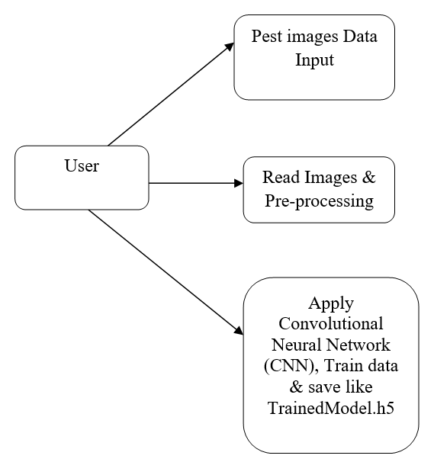

Figure 1. CNN working mechanism.

**SYSTEM ARCHITECTURE**

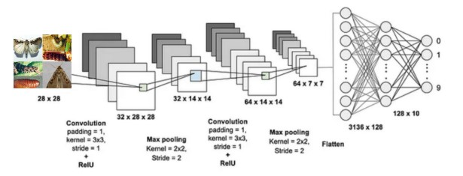

Figure 2. System Architecture.

The convolutional layer goes about as channels moreover, the chief errand is to remove features from the insect images. The convolutional layer is followed by pooling layer, which performs down looking at and holds the fundamental information in the insect images. This layer reduces the spatial size of depiction as well as the amount of limits and prevents over fitting which makes the model more capable. The last layer is the totally related layers that use a ReLu establishment capacity and takes the certain level components from the insect images for gathering them into various classifications with marks.

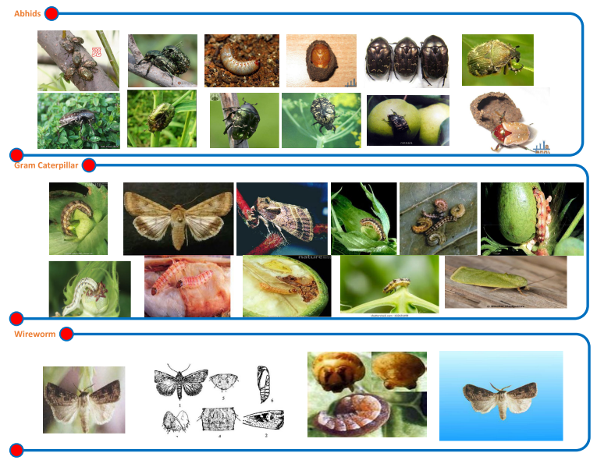

Figure 3. Sample insect images dataset of Aphids, Gram caterpillar, and Wireworm.

Vision Transformer (ViT) initial devotees an image into a progression of fix tokens by parceling it with a specific fix size and a short time later straightforwardly expanding each fix into little fragment. An Additional game plan section (EAS) is added to the course of action, as in the primary MFO result. Furthermore, since self-thought in the Straight projector for smooth images fragments is position agnostic what’s more, vision applications extraordinarily need position information, ViT adds position embedding into each portion, including the EAS token.

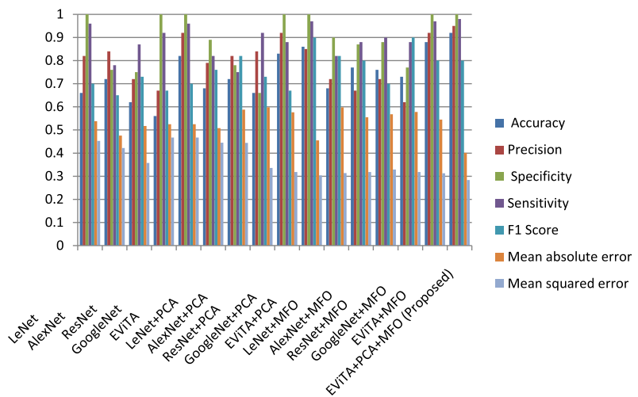

Figure 4. Proposed performance analysis chart of proposed EViTA model.

A brief time frame later, all tokens are gone through stacked transformer encoders finally the EAS token is used for plan. A transformer encoder is made from a gathering of blocks where each block contains multiheaded self-thought (MSC) with a feed-forward network (FFN).

CNN is right now perhaps of the most well known model and has displayed their extraordinary execution on many image grouping issues in prominent field. The idea of sharing loads in CNN makes a powerful image segment by finding powerful elements in the images and lessen the dissipating tendency issue. The designing of a normal CNN is given in Fig. 2. The development of CNN integrates convolution layer, pooling layer, and totally related layer. The convolutional layer goes about as channels moreover, the chief errand is to remove features from the insect images. The convolutional layer is followed by pooling layer, which performs down looking at and holds the fundamental information in the insect images. This layer reduces the spatial size of depiction as well as the amount of limits and prevents overfitting which makes the model more capable. The last layer is the totally related layers that use a ReLu establishment capacity and takes the certain level components from the insect images for gathering them into various classifications with marks.

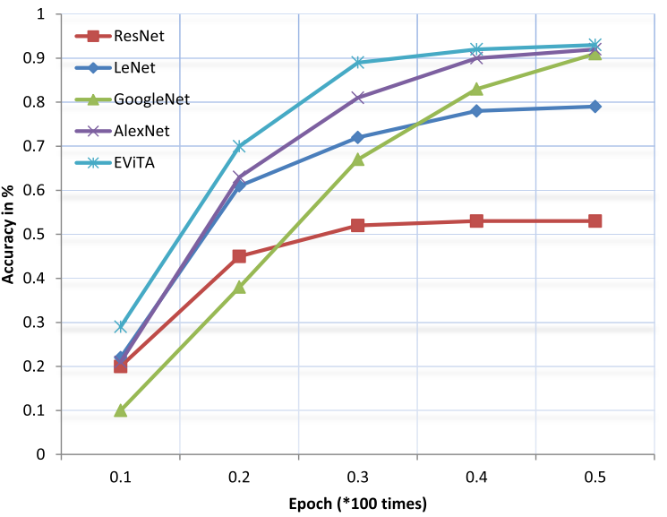

Figure 5. Accuracy rate with different epochs.

**VI.CONCLUSION**

In conclusion, the CNNpest model was developed and put into use as part of our project with the goal of revolutionizing pest detection and categorization in peanut crops. Using a Convolutional Neural Network (CNN) architecture that was meticulously designed, our model demonstrated remarkable accuracy in differentiating between 102 pest categories out of a dataset consisting of 67,714 images. The thorough preprocessing of the images which included resizing and converting data from images- made training and testing easier and produced impressive test accuracy of 99.47% and learning accuracy of 99.25%. The CNNpest model has been successfully implemented into a production-ready environment and saved in a.h5 format, demonstrating its usefulness for farmers and other agricultural stakeholders. In order to prevent pests from harming peanut crops, our model provides a reliable and fast means of identifying pests.

**REFERENCES**

[1] J. M. Alston, ‘‘Reflections on agricultural R&D, productivity, and the data constraint: Unfinished business, unsettled issues,’’ Amer. J. Agricult. Econ., vol. 100, no. 2, pp. 392–413, Mar. 2018.

[2] FAOSTAT FAO. (2018). Food and Agriculture Organization of the United Nations. Rome. [Online]. Available: <http://faostat.fao.org>.

[3] M. F. Neves, ‘‘The food business environment and the role of China and Brazil building a ‘food bridge,’’’ China Agricult. Econ. Rev., vol. 2, no. 1, pp. 25–35, Feb. 2010.

[4] T. Kasinathan, D. Singaraju, and S. R. Uyyala, ‘‘Insect classification and detection in field crops using modern machine learning techniques,’’ Inf. Process. Agricult., vol. 8, no. 3, pp. 446–457, Sep. 2021.

[5] S. Li, Y. Hong, X. Chen, and X. Liang, ‘‘Present situation and development strategies of peanut production, breeding and seed industry in Guang-dong,’’ Guangdong Agric. Sci., vol. 47, pp. 78–83, Jan. 2020.

[6] M. P. Singh, J. E. Erickson, K. J. Boote, B. L. Tillman, J. W. Jones, and A. H. C. Bruggen, ‘‘Late leaf spot effects on growth, photosynthesis, and yield in peanut cultivars of differing resistance,’’ Agronomy J., vol. 103, no. 1, pp. 85–91, Jan. 2011.

[7] Ravindra Changala, "Brain Tumor Detection and Classification Using Deep Learning Models on MRI Scans", EAI Endorsed Transactions on Pervasive Health and Technology, Volume 10, March 2024.

[8] Ravindra Changala, "Sentiment Analysis in Social Media Using Deep Learning Techniques", International Journal of Intelligent Systems and Applications in Engineering, 2024, 12(3), 1588–1597.

[9] Ravindra Changala, "Integration of IoT and DNN Model to Support the Precision Crop", International Journal of Intelligent Systems and Applications in Engineering, Vol.12 No.16S (2024).

[10] Ravindra Changala, "UI/UX Design for Online Learning Approach by Predictive Student Experience", 7th International Conference on Electronics, Communication and Aerospace Technology, ICECA 2023 - Proceedings, 2023, pp. 794–799, IEEE Xplore.

[11] Ravindra Changala, "Optimization of Irrigation and Herbicides Using Artificial Intelligence in Agriculture", International Journal of Intelligent Systems and Applications in Engineering, 2023, 11(3), pp. 503–518.

[12] H. Qi, B. Zhu, L. Kong, W. Yang, J. Zou, Y. Lan, and L. Zhang, ‘‘Hyper-spectral inversion model of chlorophyll content in peanut leaves,’’ Appl. Sci., vol. 10, no. 7, p. 2259, Mar. 2020.

[13] H. Qi, Y. Liang, Q. Ding, and J. Zou, ‘‘Automatic identification of peanut-leaf diseases based on stack ensemble,’’ Appl. Sci., vol. 11, no. 4, p. 1950, Feb. 2021.

[14] C. R. Rahman, P. S. Arko, M. E. Ali, M. A. I. Khan, S. H. Apon, F. Nowrin, and A. Wasif, ‘‘Identification and recognition of Rice diseases and pests using convolutional neural networks,’’ Biosyst. Eng., vol. 194, pp. 112–120, Jun. 2020.

[15] Ravindra Changala, Development of Predictive Model for Medical Domains to Predict Chronic Diseases (Diabetes) Using Machine Learning Algorithms And Classification Techniques, ARPN Journal of Engineering and Applied Sciences, Volume 14, Issue 6, 2019.

[16] Ravindra Changala, “Evaluation and Analysis of Discovered Patterns Using Pattern Classification Methods in Text Mining” in ARPN Journal of Engineering and Applied Sciences, Volume 13, Issue 11, Pages 3706-3717 with ISSN:1819-6608 in June 2018.

[17] Ravindra Changala “A Survey on Development of Pattern Evolving Model for Discovery of Patterns in Text Mining Using Data Mining Techniques” in Journal of Theoretical and Applied Information Technology, August 2017. Vol.95. No.16, ISSN: 1817-3195, pp.3974-3987.

[18] Y. Lu, S. Yi, N. Zeng, Y. Liu, and Y. Zhang, ‘‘Identification of Rice diseases using deep convolutional neural networks,’’ Neurocomputing, vol. 267, pp. 378–384, Dec. 2017.

[19] B. B. Sharma, G. Gupta, P. Vaidya, S. Basheer, F. H. Memon, and R. N. Thakur, ‘‘Internet of Things-based crop classification model using deep learning for indirect solar drying,’’ Wireless Commun. Mobile Com-put., vol. 2022, pp. 1–11, Jun. 2022.

[20] R. M. Rakholia, J. H. Tailor, J. R. Saini, J. Kaur, and H. Pahuja, ‘‘Ground-nuts leaf disease recognition using neural network with progressive resiz-ing,’’ Int. J. Adv. Comput. Sci. Appl., vol. 13, no. 6, pp. 1–6, 2022.

[21] Ravindra Changala, Framework for Virtualized Network Functions (VNFs) in Cloud of Things Based on Network Traffic Services, International Journal on Recent and Innovation Trends in Computing and Communication, ISSN: 2321-8169 Volume 11, Issue 11s, August 2023.

[22] Ravindra Changala, Block Chain and Machine Learning Models to Evaluate Faults in the Smart Manufacturing System, International Journal of Scientific Research in Science and Technology, Volume 10, Issue 5, ISSN: 2395-6011, Page Number 247-255, September-October-2023.

[23] M. Konate, J. Sanou, A. Miningou, D. K. Okello, H. Desmae, P. Janila, and R. H. Mumm, ‘‘Past, present and future perspectives on groundnut breeding in Burkina Faso,’’ Agronomy, vol. 10, no. 5, p. 704, May 2020.

[24] A. Tomar, G. Gupta, W. Salehi, C. Vanipriya, N. Kumar, and B. Sharma, ‘‘A review on leaf-based plant disease detection systems using machine learning,’’ in Proc. Recent Innov. Comput. (ICRIC), vol. 1. Jammu and Kashmir, India: Springer, May 2022, pp. 297–303.

[25] Ravindra Changala, Development of CNN Model to Avoid Food Spoiling Level, International Journal of Scientific Research in Computer Science, Engineering and Information Technology, ISSN: 2456-3307, Volume 9, Issue 5, September-October-2023, Page Number 261-268.

[26] Ravindra Changala, A Novel Prediction Model to Analyze Evolutionary Trends and Patterns in Forecasting of Crime Data Using Data Mining and Big Data Analytics, Mukt Shabd Journal, Volume XI, Issue X, October 2022, ISSN NO: 2347-3150.