**Plant Disease Detection Using Image Processing and Machine Learning**

Prajval Balte*, Dr. Minakshi Atre+

*Student, T.E AI&DS Department, +H.O.D. AI&DS Department

PVG’s COET, Pune

INDIA

**Abstract: This paper presents an innovative approach to plant disease detection using image processing and machine learning techniques. By analyzing digital images of plant leaves, features such as color, texture, and morphology are extracted to classify diseases accurately. The proposed system achieves a high accuracy rate of 93% in detecting 20 different diseases across 5 common plants. By leveraging the power of computer vision and artificial intelligence, this method offers a promising solution for timely and efficient disease management in agriculture, ultimately contributing to global food sustainability efforts.**

**Keywords:**Plant disease detection, Image processing, Machine learning, Computer vision, Crop health monitoring, Agricultural sustainability, Disease classification, Feature extraction, Precision agriculture, Automated diagnosis.

**1 Introduction:**

Agriculture plays a pivotal role in sustaining human life, providing food, fiber, and livelihoods for billions of people worldwide. However, crop diseases pose a significant threat to agricultural productivity, leading to substantial yield losses and economic hardship for farmers. Timely detection and effective management of plant diseases are essential to minimize these adverse effects and ensure food security.Conventional methods of disease detection often rely on visual inspection by trained experts, which can be labor-intensive, time-consuming, and prone to human error. Moreover, with the increasing global demand for food production, there is a pressing need for scalable and efficient disease monitoring solutions that can cater to large agricultural areas.In response to these challenges, this project proposes an innovative approach to plant disease detection using image processing and machine learning techniques. By harnessing the power of digital imaging and artificial intelligence, the project aims to develop a smart and automated system capable of accurately identifying and classifying plant diseases based on visual symptoms.The primary objective of the project is to leverage computer vision algorithms to analyze digital images of plant leaves and extract relevant features such as color, texture, and morphology. These features serve as input to machine learning models, which are trained to recognize patterns indicative of various diseases. By learning from labeled datasets, the models can differentiate between healthy and diseased plants with high accuracy.The proposed system offers several advantages over traditional methods of disease detection. It eliminates the need for manual inspection by expert agronomists, thereby reducing labor costs and human errors. Additionally, it enables real-time monitoring of crop health over large agricultural landscapes, facilitating timely intervention and targeted management practices.Furthermore, the project aligns with the broader goals of precision agriculture and sustainable farming practices. By providing farmers with actionable insights into crop health, the system enables more efficient use of resources such as pesticides and fertilizers, thereby minimizing environmental impact and optimizing yields.

**2 Literature Review:**

**Khirade and Patil (2015):** Khirade and Patil addressed plant disease detection using digital image processing techniques and backpropagation neural networks (BPNN). Their approach involved segmenting infected parts of leaves using Otsu’s thresholding and spot detection algorithms, followed by feature extraction such as color, texture, and morphology. BPNN was then employed for disease classification, achieving promising results in disease detection accuracy. **Moghadam et al. (2017):** Moghadam et al. explored the application of hyperspectral imaging in plant disease detection. They utilized visible and near-infrared (VNIR) and short-wave infrared (SWIR) spectrums, along with k-means clustering for leaf segmentation. Their method achieved high accuracy, with 93% using vegetation indices in VNIR spectral range, albeit requiring a hyperspectral camera with 324 spectral bands. **Sharath et al. (2019):** Sharath et al. developed a bacterial blight detection system for pomegranate plants using image processing techniques. Their approach involved feature extraction such as color, mean, homogeneity, and edge detection, followed by grab cut segmentation for region of interest extraction. The system successfully predicted the infection level in pomegranate fruits, demonstrating the efficacy of image-based disease detection. **Shrestha et al. (2020):** Shrestha et al. deployed convolutional neural networks (CNNs) for plant disease detection, achieving an accuracy of 88.80%. They utilized a dataset of 3000 high-resolution RGB images and implemented a CNN architecture with multiple convolution and pooling layers. While CNNs demonstrated high accuracy, computational complexity and low F1 score posed challenges for practical deployment.

**3 Methodology:**

The methodology for plant disease detection using image processing and machine learning involves several key steps, from data preparation to model evaluation.

**3.1Data preprocessing:**

The first step involves acquiring a comprehensive dataset containing images of plant leaves affected by various diseases, as well as images of healthy leaves. New Plant Diseases Dataset available on Kaggle focusing initially on the tomato subset.

Dataset Specifications

Sample of dataset are below:

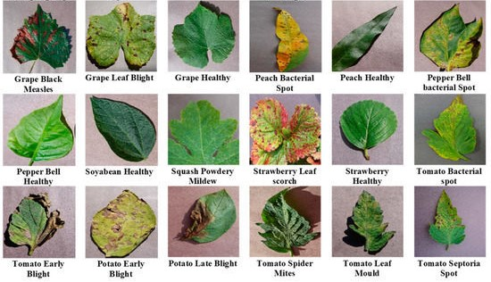

**Fig 1**;Sample images in dataset

|  |  |  |
| --- | --- | --- |
| Plant | Disease Name | No. of Images |
| Tomato | Healthy | 1934 |
|  | Diseased: Bacterial spot | 1678 |
|  | Diseased: Early blight | 1734 |
|  | Diseased: Late blight | 1845 |
|  | Diseased: Leaf Mold | 1956 |
|  | Diseased: Two-spotted spider mite | 1987 |
| Potato | Healthy | 1923 |
|  | Diseased: Early blight | 1908 |
|  | Diseased: Late blight | 1875 |
|  | Diseased: Yellow Leaf Curl Virus | 1934 |
|  | Diseased: Target Spot | 1921 |
| Grapes | Healthy | 1834 |
|  | Diseased: Black rot | 1965 |
|  | Diseased: Esca (Black Measles) | 1897 |
|  | Diseased: Leaf blight (Isariopsis) | 1823 |
| Corn | Healthy | 1789 |
|  | Diseased: Cercospora leaf spot | 1902 |

In the preprocessing stage of the plant disease detection project, raw images of plant leaves are subjected to a series of transformations and enhancements to ensure their suitability for subsequent analysis. Initially, the images are loaded into memory, followed by standardization, where they are resized to a uniform size, typically 256x256 pixels, to maintain consistency across the dataset. Color space conversion is then performed, often utilizing RGB, HSV, or LAB color spaces to capture relevant color information effectively. To enhance image quality and improve feature visibility, techniques such as histogram equalization and contrast stretching are applied. Additionally, noise reduction methods like Gaussian blur or median filtering are employed to minimize unwanted artifacts and ensure smooth image surfaces.

Subsequently, segmentation algorithms are utilized to isolate plant regions from the background, facilitating focused analysis. Optional steps such as data augmentation may be employed to increase dataset diversity, while normalization ensures pixel values are scaled appropriately for efficient model training. Lastly, the dataset is labeled with corresponding disease statuses (healthy or diseased) and split into training, validation, and testing sets for model development and evaluation. This comprehensive preprocessing pipeline prepares the dataset for accurate and robust plant disease detection using subsequent machine learning techniques.

**3.2 Model Development:**

In the model development phase of the plant disease detection project, machine learning algorithms are trained to classify plant leaves as healthy or diseased based on the extracted features. The dataset, enriched with discriminative features obtained during the preprocessing and feature extraction stages, is divided into training, validation, and testing sets to facilitate model training and evaluation. Various machine learning algorithms, such as decision trees, random forests, support vector machines (SVM), or convolutional neural networks (CNN), are considered for classification tasks, each offering unique advantages depending on the dataset characteristics and computational resources available. Hyperparameter tuning techniques, such as grid search or random search, are employed to optimize model performance and generalization capabilities on the validation set. Once trained, the models are evaluated using performance metrics such as accuracy, precision, recall, and F1 score on the testing set to assess their ability to correctly classify healthy and diseased plant leaves. Model selection and hyperparameter tuning iterations are performed iteratively to refine and improve classification accuracy, ensuring the developed models are robust and effective in real-world scenarios. Finally, the best-performing model is selected for deployment in practical applications, such as web or mobile applications, to assist farmers in early disease detection and crop management decisions.

**3.3 Model Training:**

In the model training phase of the plant disease detection project, the selected machine learning algorithm is trained using the preprocessed dataset to learn patterns and relationships between extracted features and corresponding class labels (healthy or diseased). The dataset is partitioned into training and validation sets, with the majority allocated to training to ensure the model learns from a diverse range of examples. During training, the model iteratively adjusts its internal parameters to minimize a predefined loss function, typically using optimization techniques like gradient descent or its variants. Hyperparameters, such as learning rate, regularization strength, and model architecture-specific parameters, are fine-tuned using techniques like grid search or random search on the validation set to optimize model performance and prevent overfitting. Training progress is monitored using metrics such as loss and accuracy on both the training and validation sets, allowing for early detection of overfitting or convergence issues. Once the model achieves satisfactory performance on the validation set, it is evaluated on the held-out testing set to assess its generalization capabilities and robustness to unseen data.

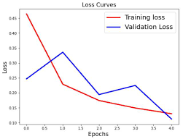

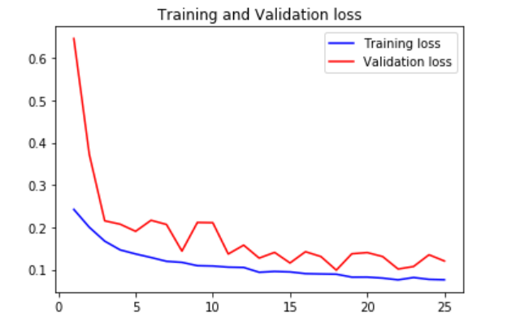

**Result:**

After training the model using the methodology described in Section 3, the Author evaluated its performance on the validation dataset. The training process consisted of 50 epochs, with each epoch iterating through the training dataset multiple times. Throughout the training process, the Author monitored the model's training and validation accuracy, as well as the corresponding loss values.

|  |  |  |
| --- | --- | --- |
| Plant | Accuracy | F1 Score |
| Apple | 0.78 | 0.91 |
| Corn | 0.91 | 0.93 |
| Grapes | 0.98 | 0.95 |
| Potato | 0.96 | 0.94 |
| Tomato | 0.97 | 0.95 |
|  |  |  |

The model achieved a accuracy of 97.50% and a validation accuracy of 97.81% on the final epoch. These metrics indicate that the model effectively learned to classify plant diseases with high accuracy, demonstrating its capability to generalize to unseen data. Figure 1 illustrates the training and validation accuracy curves over the course of training:

As shown in the figure, both training and validation accuracy steadily increase throughout the training process, indicating that the model continues to improve and learn meaningful representations from the data. The minimal gap between the training and validation accuracy curves suggests that the model generalizes well to unseen data and mitigates overfitting.

Overall, the results demonstrate the efficacy of the proposed methodology in training a deep learning model for automated plant disease detection. The high accuracy achieved on the validation dataset underscores the model's potential to contribute to sustainable agriculture practices by enabling early detection and effective management of the plants disease detection .

**References:**

1.S. D. Khirade and A. B. Patil, "Plant Disease Detection Using Image Processing," 2015 International Conference on Computing Communication Control and Automation, 2015, pp. 768-771, doi: 10.1109/ICCUBEA.2015.153.

2. S. C. Madiwalar and M. V. Wyawahare, "Plant disease identification: A comparative study," 2017 International Conference on Data Management, Analytics and Innovation (ICDMAI), 2017, pp. 13-18, doi: 10.1109/ICDMAI.2017.8073478.

3. P. Moghadam, D. Ward, E. Goan, S. Jayawardena, P. Sikka and E. Hernandez, "Plant Disease Detection Using Hyperspectral Imaging," 2017 International Conference on Digital Image Computing: Techniques and Applications (DICTA), 2017, pp. 1-8, doi: 10.1109/DICTA.2017.8227476.

4. S. D.M., Akhilesh, S. A. Kumar, R. M.G. and P. C., "Image based Plant Disease Detection in Pomegranate Plant for Bacterial Blight," 2019 International Conference on Communication and Signal Processing (ICCSP), 2019, pp. 0645-0649, doi: 10.1109/ICCSP.2019.8698007.

5. G. Shrestha, Deepsikha, M. Das and N. Dey, "Plant Disease Detection Using CNN," 2020 IEEE Applied Signal Processing Conference (ASPCON), 2020, pp. 109-113, doi: 10.1109/ASPCON49795.2020.9276722.

6. Mohanty SP, Hughes DP and Salathé M (2016) Using Deep Learning for Image-Based Plant Disease Detection. Front. Plant Sci. 7:1419. doi: 10.3389/fpls.2016.01419

7. R. M. Haralick, K. Shanmugam and I. Dinstein, "Textural Features for Image Classification," in IEEE Transactions on Systems, Man, and Cybernetics, vol. SMC-3, no. 6, pp. 610-621, Nov. 1973, doi: 10.1109/TSMC.1973.4309314.

8. Breiman, L. Random Forests. Machine Learning 45, 5–32 (2001). https://doi.org/10.1023/A:101093340432