**Polyphenols: A sword against COVID-19**

Anjali Bhati1 and Richa Choudhary1*.

1School of Biological and Life Sciences, Galgotias University, India

*Corresponding author: richa.choudhary@galgotiasuniversity.edu.in

**Abstract**

The COVID-19 pandemic caused by the severe acute respiratory syndrome-coronavirus-2 (SARS-COV-2) has led to a crisis in the whole world which propelled to find effective antiviral agents. In spite of the fact that repurposing of known drugs right now gives a quickened course to endorsement, there is no palatable treatment. Polyphenols, an important class of phytochemicals, have long been known for their antiviral and immunomodulatory activity. The composition of polyphenols is classified according to the presence of one or more hydroxy groups on the aromatic ring. These ingredients are classified based on their molecular weight, chemical structure, and complexity with respect to flavonoids like isoflavonoids, flavonols, anthocyanidins, and non-flavonoids like phenolic acids, and stilbenes. Recently several studies suggest the potential of plant-derived natural polyphenols as promising biologically active substances against SARS-COV-2. A growing body of evidence suggests that antivirus polyphenolic-based compounds inhibit SARS-CoV-2-enzymes, which are imperative for virus replication. Moreover, several polyphenols, such as quercetin, exhibited strong binding interactions with RNA-dependent RNA polymerase (RdRp), forming stable complexes with the enzyme, hence, inhibiting the duplication of the virus in the host cell. On the other hand, naturally occurring polyphenols display various resistance mechanisms against deadly viruses like inhibiting the binding of SARS-COV-2 spike protein to host cell receptors and altering immune response against COVID-19 infection. This review aims to provide an outlook on the potential use of polyphenols in developing natural therapeutic targets and approaches against viral disease.

**Keywords:** SARS-COV-2, Polyphenols, phytochemicals, Antiviral drugs, RNA-dependent RNA Polymerase,

**1.INTRODUCTION**

In December 2019, an outbreak of an unknown respiratory disorder was reported first in Wuhan, China and soon it became a global pandemic (Cohen et al., 2020). World Health Organization (WHO) officially announced its name as Severe Acute Respiratory Syndrome-Coronavirus-2 (SARS-COV-2) in March 2020. Coronaviruses, named for the crown-like spikes on their envelope, belong to the Coronaviridae family under sub-family of *Ortho*-coronavirinae, in order of Nidovirales (Banerjee et al. 2019). Coronavirus has a single-stranded stranded positive sense RNA genome which is the largest known viral RNA genome ranging from 26 to 32 kilobases. COVID-19 marked an unprecedented global health crisis causing widespread morbidity and mortality (Tatsi et al., 2021). Coronavirus disease is highly contagious and spreads rapidly from one person to another. It causes a range of symptoms from mild respiratory issues to severe respiratory distress and it can lead to death, particularly in older individuals or those with weak immunity. The COVID-19 pandemic spurred to identification of effective antiviral agents. In the relentless search for effective strategies to combat COVID-19, natural compounds with potential antiviral and immune-modulating properties have emerged as subjects of immense interest. Polyphenols with their potent antiviral and immunomodulatory activities serve as powerful weapons to prevent and cure COVID-19 infection and other related disorders ([Fraga, Croft, Kennedy, & Tomás-Barberán, 2019](https://www.sciencedirect.com/science/article/pii/S221242922100016X" \l "bib20)).

Polyphenols are bioactive compounds produced as secondary metabolites in plants including fruits, vegetables, nuts, whole grains, tea, coffee, and red wine. These compounds, which are known by their multiple phenolic (aromatic) rings and hydroxyl groups, have attracted a great deal of attention and scientific study in recent years. Polyphenols have drawn attention for their ability to battle oxidative stress, inflammation, and chronic diseases (Del et al., 2019). Compounds present in polyphenols such as catechin, quercetin, kaempferol, gallic acid, and resveratrol have anti-inflammatory, immune-modulating, and antioxidant properties (Santos‐Buelga et al., 2019). They are typically categorized into several classes (Figure.1) including flavonoids (anthocyanins, flavones, flavanones, flavonols, isoflavones, and flavan-3-ols), phenolic acids (Ferulic acid, Vanillic acid), stilbenes (resveratrol), lignans (Pinoresinol) and tannins (gallic acid).

Several studies have described that different polyphenols, such as quercetin, epigallocatechin gallate, resveratrol, or ferulic acid derivatives can inhibit the process of replication of coronavirus or inhibit viral activity in the early stage of infection (Mehany et al., 2021, Mezhibovsky et al., 2023). These effects have been associated with the properties of polyphenols to exert immunomodulatory effects such as modulation of the expression of cytokines including IL-6, IL-8, and IFN-β (Cragg et al., 2013, Wu et al., 2021b). In this review, we will explore polyphenols' potential as natural weapons against COVID-19, shedding light on the scientific findings and clinical studies.

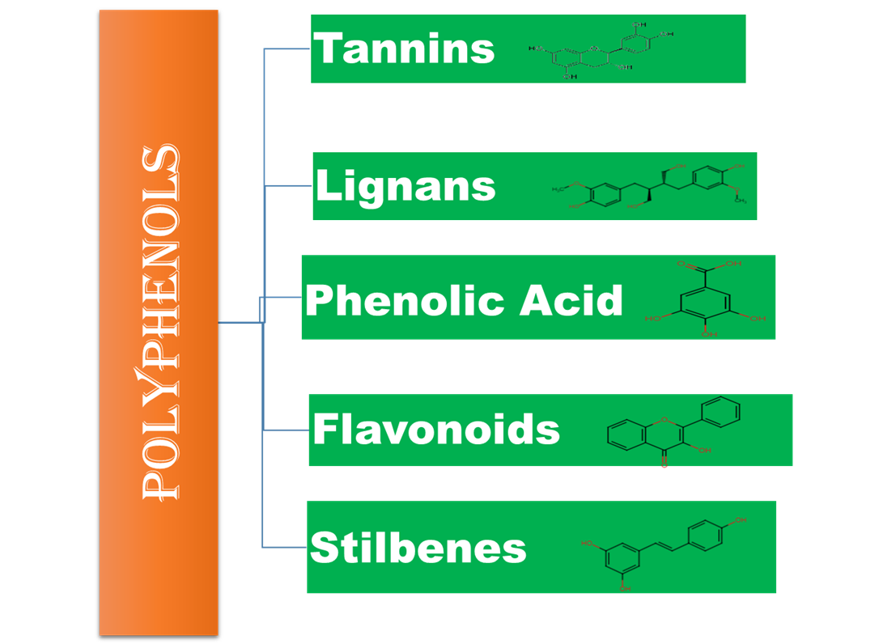

**Figure 1. Figure showing types of polyphenols.**

**2.POLYPHENOLS AGAINST CORONAVIRUS**

Antioxidant and anti-inflammatory effects are well-known benefits of polyphenols. The response of the immune system can be modulated by polyphenols. It also obstructs the entry of host cells as well as the coronavirus's ability to replicate.

2.1 **Inhibit the entry of coronavirus to host cells**

SARS-COV-2 has spike protein (S protein) on its surface consisting of two subunits S1 and S2. The receptor-binding domain (RBD), a component of the spike protein that binds to the ACE-2 receptor of humans is found in the S1 subunit. A type I transmembrane metallo carboxypeptidase called ACE-2 is present in numerous tissues, including the epithelial cells, lungs, heart, blood vessels, kidneys, and liver. As it hydrolyzes vasoconstricting angiotensin II to produce vasodilating angiotensin, ACE-2 is an essential enzyme in the physiological renin-angiotensin system (Paraiso, Revel and Stevens, 2020) Some polyphenols such asEpigallocatechin gallate (EGCG), Resveratrol, and Curcumin have a strong binding affinity with the ACE-2 receptor and inhibit the entry of SARS-COV-2 into a host cell (Goc et al.,2017). Polyphenols have the ability to reduce the severity of the coronavirus effect on humans by modulating the ACE-2 expression. The SARS-CoV proteins (3-chymotrypsin-like protease (3CLpro), papain-like protease (PLpro), RNA-dependent RNA polymerase (RdRp), and spike (S)) that are essential for the binding of the viral genome to host cells can be inhibited by polyphenols (da Silva, 2021, Zang et al., 2020).

2.2 **Inhibit the replication of the SARS-COV-2**

RNA-dependent RNA polymerase (RdRp) is an essential viral enzyme that is used for the replication process by coronavirus. Several polyphenols, such as epigallocatechin gallate, gallocatechin gallate, and quercetin interact with RNA-dependent RNA polymerase (RdRp), forming stable complexes with the enzyme and preventing the virus from replicating inside the host cell (Wu et al., 2021). Polyphenols inhibit the viral proteases and stop the replication of coronavirus. Yu et al., 2012 identified myricetin and scutellarein as a inhibitor of viral helicase. In several experimental settings, it was found that chalcones exhibit the inhibitory effect against SARS-3CLpro activity (Park et al., 2017, Ghosh et al.,2020). This SARS-3CLpro is important for virus replication, hence it may be a potent drug target for the production of novel therapeutic intervention for SARS-CoV-2. Table.1 summarizes the antiviral activities of polyphenols, and their mechanism of action.

2.3 **Reduce cytokine storm**

The majority of patients with severe COVID-19 experienced a high level of pro-inflammatory response, resulting in the cytokine release syndrome (CRS) with a strikingly increased level of several pro- and anti-inflammatory cytokines and chemokines, including interferon (IFN)-, interferon-gamma induced protein 10 (IP-10), interleukin (IL)-1ra, IL-2ra, IL-6, IL-10, IL-18, hepatocyte growth factor (Wu et al., 2021b). By blocking some of the major inflammatory response regulators including TNF-, IL-1, and IL-6, polyphenols have an anti-inflammatory effect on macrophages. Polyphenols can help in mitigating the cytokine storm by reducing excessive inflammation.

**Table.1: Overview of antiviral activities of certain polyphenols.**

| **Polyphenols** | **Biological Action against SARS-COV-2** | **Reference** |
| --- | --- | --- |
| Resveratrol | Modulate SARS-COV-2 disease severity by regulating ACE-2 expression and function | Horne and Vohl, 2020 |
| Quercetin and Luteolin | Binds with S-protein and inhibit the entry of virus into host cell | Paraiso et al. , 2020 |
| Flavonoids | Interacts with catalytic residues of the SARS-COV-2 main protease and prevents entry. | da Silva, 2021 |
| Epigallocatechin gallate | Interact with RdRp and prevent the virus from replicating inside the host cell | Wu et al., 2021(a) |
| Kaempferol | Reduced pro-inflammatory cytokines | Paraiso et al., 2020 |
| Curcumin | Inhibit NF-κB activated by several different inflammatory stimuli | Giovinazzo et al., 2020 |
| Catechins | Balancing of pro- and anti-inflammatory cytokines production | Giovinazzo et al., 2020 |
| Apigenin | Inhibits the production of proinflammatory cytokines IL-1β, IL-8, and TNF-α | Volkan Gelen et al., 2023 |
| Epigallocatechin gallate | Inhibit complex formation of virus with host cell receptor GRP78. | Mhatre et al., 2020 |
| Theaflavin | Inhibits chymotrypsin-like protease to prevent maturation of virus within the host cells | Hegyi et al.,2002 |
| Anthocyanins | Inhibit viral replication in the host cell | Annunziata et al., 2020 |
| Baicalin | Inhibit Angiotensin-converting enzyme*.* | Mehany et al., 2021 |
| myricetin and scutellarein | attenuate viral replication by inhibiting helicase activity. | Yu et al.,2013 |
| Chalcones | attenuate viral replication by inhibiting SARS-3CLpro activity. | Park et al., 2017, Ghosh et al.,2020 |

An important regulator of cytokine production and inflammation is nuclear factor-kappa B (NF-kB). Some polyphenols can modulate NF-kB signaling, lowering its activity and, as a result, reducing the production of cytokines that promote inflammation.

2.4 **Antiviral and Immunomodulatory activity of Polyphenol**

In addition to their antioxidant action, polyphenols have the potential to alter the expression of several types of pro-inflammatory genes and the immune system contributes to the regulating of inflammatory signals (Wu et al., 2021b). Polyphenols modulate immune responses in both the innate and adaptive systems, having both stimulatory and inhibitory effects in different areas. It alters the gene expression and immune response of host cells and affects viral activity. Apoptosis and cytotoxicity may be prevented by polyphenols because of their immunomodulatory qualities (Santos, Marcelo Lima Ribeiro and Gambero, 2021).

**3.CONCLUSION**

Natural plant-derived polyphenols have a remarkable potential for preventing the disease of SARS-COV-2. With a focus on the worldwide threat posed by SARS-CoV-2, the virus responsible for COVID-19, it investigated the potential of polyphenols as a class of natural chemicals to combat coronaviruses. Moreover, the growing body of evidence suggests that development of natural polyphenol based medication would be promising for deep understanding of disease etiology and also for the treatment of SARS-CoV-A infection. Polyphenols have intriguing antiviral capabilities, such as the ability to prevent viral entrance into host cells and inhibit the replication process of coronavirus. They possess anti-inflammatory and antiviral properties and prevent infection. Therefore, by inhibiting the viral enzymes, possible antiviral polyphenolic-based medications may ideally limit SARS-CoV-2 infection and replication.

**REFERENCE**

1. Annunziata, G., Zamparelli, M. S., Santoro, C., Ciampaglia, R., Stornaiuolo, M., Tenore, G. C., Sanduzzi, A., & Novellino, E. (2020). May Polyphenols Have a Role Against Coronavirus Infection? An Overview of in vitro Evidence. *Frontiers in Medicine*, *7*. https://doi.org/10.3389/fmed.2020.00240
2. Banerjee, A., Kulcsar, K. A., Misra, V., Frieman, M. B., & Mossman, K. (2019). Bats and coronaviruses. *Viruses*, *11*(1), 41.<https://doi.org/10.3390/v1101004>.
3. Cohen, J., & Normile, D. (2020). New SARS-like virus in China triggers alarm. *Science*, *367*(6475), 234–235.<https://doi.org/10.1126/science.367.6475.234>.
4. Cragg, G. M., & Newman, D. J. (2013). Natural products: A continuing source of novel drug leads. *Biochimica Et Biophysica Acta (BBA) - General Subjects*, *1830*(6), 3670–3695.<https://doi.org/10.1016/j.bbagen.2013.02.008>.
5. da Silva, Aline Priscilla Gomes. “Fighting Coronaviruses with Natural Polyphenols.” *Biocatalysis and Agricultural Biotechnology*, vol. 37, no. PMC8491928, Oct. 2021, p. 102179, https://doi.org/10.1016/j.bcab.2021.102179. Accessed 7 Nov. 2021.
6. Del Bò, C., Bernardi, S., Marino, M., Porrini, M., Tucci, M., Guglielmetti, S., Cherubini, A., Carrieri, B., Kirkup, B., Kroon, P. A., Zamora‐Ros, R., Liberona, N. H., Andrés‐Lacueva, C., & Riso, P. (2019). Systematic Review on Polyphenol Intake and Health Outcomes: Is there Sufficient Evidence to Define a Health-Promoting Polyphenol-Rich Dietary Pattern? *Nutrients*, *11*(6), 1355.<https://doi.org/10.3390/nu11061355>.
7. Fraga, C. G., Croft, K. D., Kennedy, D. O., & Tomás-Barberán, F. A. (2019). The effects of polyphenols and other bioactives on human health. *Food & Function*, *10*(2), 514–528.<https://doi.org/10.1039/c8fo01997e>.
8. Ghosh, R., Chakraborty, A., Biswas, A., & Chowdhuri, S. (2020). Evaluation of green tea polyphenols as novel coronavirus (SARS CoV-2) main protease (Mpro) inhibitors – anin silicodocking and molecular dynamics simulation study. Journal of Biomolecular Structure & Dynamics, 39(12), 4362–4374. https://doi.org/10.1080/07391102.2020.1779818
9. Giovinazzo, Giovanna, et al. “Can Natural Polyphenols Help in Reducing Cytokine Storm in COVID-19 Patients?” *Molecules*, vol. 25, no. 24, 12 Dec. 2020, p. 5888, https://doi.org/10.3390/molecules25245888. Accessed 20 Dec. 2020.
10. Goc, Anna, et al. “Phenolic Compounds Disrupt Spike-Mediated Receptor-Binding and Entry of SARS-CoV-2 Pseudo-Virions.” *PLOS ONE*, vol. 16, no. 6, 17 June 2021, p. e0253489, https://doi.org/10.1371/journal.pone.0253489. Accessed 17 July 2021.
11. 10) Hegyi A., Friebe A., Gorbalenya A.E., Ziebuhr J. Mutational analysis of the active centre of coronavirus 3C-like proteases. *J. Gen. Virol.* 2002.
12. Hendrayana, Made Agus, et al. “The Potential of Polyphenols from Natural Ingredients against SARS-CoV-2 Infection: A Review.” *Indonesian Journal of Pharmacology and Therapy*, vol. 2, no. 3, 16 Dec. 2021, https://doi.org/10.22146/ijpther.2310. Accessed 25 Sept. 2022.
13. Horne, Justine R., and Marie-Claude Vohl. “Biological Plausibility for Interactions between Dietary Fat, Resveratrol, ACE2, and SARS-CoV Illness Severity.” American Journal of Physiology-Endocrinology and Metabolism, vol. 318, no. 5, 1 May 2020, pp. E830–E833, https://doi.org/10.1152/ajpendo.00150.2020. Accessed 23 Jan. 2021.
14. Khalil, A., Tazeddinova, D. The upshot of Polyphenolic compounds on immunity amid COVID-19 pandemic and other emerging communicable diseases: An appraisal. *Nat. Prod. Bioprospect.* 10, 411–429 (2020). https://doi.org/10.1007/s13659-020-00271-z
15. Mehany, T., Khalifa, I., Barakat, H., Althwab, S. A., Alharbi, Y., & El-Sohaimy, S. A. (2021). Polyphenols as promising biologically active substances for preventing SARS-CoV-2: A review with research evidence and underlying mechanisms. *Food Bioscience*, *40*, 100891.<https://doi.org/10.1016/j.fbio.2021.100891>.
16. Mezhibovsky, E., Hoang, S. H., Szeto, S., & Roopchand, D. E. (2023). *In silico* analysis of dietary polyphenols and their gut microbial metabolites suggest inhibition of SARS-CoV-2 infection, replication, and host inflammatory mediators. *Journal of Biomolecular Structure & Dynamics*, 1–19.<https://doi.org/10.1080/07391102.2023.2180669>.
17. Mhatre, S., Srivastava, T., Naik, S., & Patravale, V. (2021). Antiviral activity of green tea and black tea polyphenols in prophylaxis and treatment of COVID-19: A review. *Phytomedicine*, *85*, 153286.<https://doi.org/10.1016/j.phymed.2020.153286>.
18. Milenkovic, D., Ruskovska, T., Rodriguez-Mateos, A. and Heiss, C. (2021). Polyphenols Could Prevent SARS-CoV-2 Infection by Modulating the Expression of miRNAs in the Host Cells. Aging and Disease, [online] 12(5), pp.1169–1182. Doi:https://doi.org/10.14336/AD.2021.0223.
19. Nevenka Gligorijević, et al. “Molecular Mechanisms of Possible Action of Phenolic Compounds in COVID-19 Protection and Prevention.” *International Journal of Molecular Sciences*, vol. 22, no. 22, 17 Nov. 2021, pp. 12385–12385, https://doi.org/10.3390/ijms222212385. Accessed 20 Oct. 2023.
20. Paraiso, Ines L, et al. “Potential Use of Polyphenols in the Battle against COVID-19.” *Current Opinion in Food Science*, vol. 32, Apr. 2020, pp. 149–155, https://doi.org/10.1016/j.cofs.2020.08.004. Accessed 15 Aug. 2021.
21. Park, J., Yuk, H. J., Ryu, H. W., Lim, S. H., Kim, K. S., Park, K. H., Ryu, Y. B., & Lee, W. S. (2017). Evaluation of polyphenols from Broussonetia papyrifera as coronavirus protease inhibitors. Journal of Enzyme Inhibition and Medicinal Chemistry, 32(1), 504–512. https://doi.org/10.1080/14756366.2016.1265519
22. Santos, J.C., Marcelo Lima Ribeiro and Gambero, A. (2021). The Impact of Polyphenols-Based Diet on the Inflammatory Profile in COVID-19 Elderly and Obese Patients. *Frontiers in Physiology*, [online] 11. doi:<https://doi.org/10.3389/fphys.2020.612268>.
23. Santos‐Buelga, C., González-Paramás, A. M., Taofiq, O., Ayuda-Durán, B., & González‐Manzano, S. (2019). Plant phenolics as functional food ingredients. In *Advances in food and nutrition research* (pp. 183–257).<https://doi.org/10.1016/bs.afnr.2019.02.012>.
24. Tatsi E-B, Filippatos F, Michos A. SARS-CoV-2 variants and effectiveness of vaccines: a review of current evidence. Epidemiology and infection. 2021;149:e237–e237.
25. Vicente Amirpasha Tirado-Kulieva, et al. “Phenolic Compounds versus SARS-CoV-2: An Update on the Main Findings against COVID-19.” *Heliyon*, vol. 8, no. 9, 1 Sept. 2022, pp. e10702–e10702, https://doi.org/10.1016/j.heliyon.2022.e10702. Accessed 20 Oct. 2023.
26. Volkan Gelen, et al. “Can Polyphenols Be Used as Anti-Inflammatory Agents against Covid-19 (SARS-CoV-2)-Induced Inflammation?” Biochemistry, 23 Feb. 2022, https://doi.org/10.5772/intechopen.98684. Accessed 25 Oct. 2023.
27. Wu, Yifei, et al. “Polyphenols as Alternative Treatments of COVID-19.” *Computational and Structural Biotechnology Journal*, vol. 19, no. P5371-5380, 2021, pp. 5371–5380, https://doi.org/10.1016/j.csbj.2021.09.022. Accessed 14 May 2022.
28. Wu, Yifei, et al. “Polyphenols as Potential Inhibitors of SARS-CoV-2 RNA Dependent RNA Polymerase (RdRp).” *Molecules*, vol. 26, no. 24, 8 Dec. 2021, p. 7438, https://doi.org/10.3390/molecules26247438.
29. Yu, M., Lee, J., J, L., Kim, Y., Chin, Y., Jee, J., Keum, Y., & Jeong, Y. (2012). Identification of myricetin and scutellarein as novel chemical inhibitors of the SARS coronavirus helicase, nsP13. Bioorganic & Medicinal Chemistry Letters, 22(12), 4049–4054. https://doi.org/10.1016/j.bmcl.2012.04.081
30. Zhang, D. H., Wu, K. L., Zhang, X., Deng, S. Q., & Peng, B. (2020). In silico screening of Chinese herbal medicines with the potential to directly inhibit 2019 novel coronavirus. Journal of Integrative Medicine, 18(2), 152–158.<https://doi.org/10.1016/j.joim.2020.02.005>