**An Alzheimer’s Disease Image Feature Extraction and Different Classification in Machine Learning Algorithm**

**Prabakaran N1 and Dr. Prabhakaran Paulraj2**

1Department of Computer Science and Engineering, Sai Rejeswari Institute of Technology, Proddatur, Andhra Pradesh, India

2Department of Computer Science and Engineering, St. Joseph College of Engineering and Technology, India.

prabakaran.om@gmail.com1, prabhuphd78@gmail.com2

# ABSTRACT

Alzheimer’s disease (AD) is a progressive neurodegenerative disorder, accounting for nearly 60% of all dementia cases. The occurrence of the disease has been increasing rapidly in recent years. Presently about 46.8 million individuals suffer from AD worldwide. The current absence of effective treatment to reverse or stop AD progression highlights the importance of disease prevention and early diagnosis. This research work finds that image feature extraction such as simple RGB Histogram Filter techniques on Alzheimer’s images dataset by implementing statistical learning. The Decision tree – J48 Classifier category gives 0.346 of kappa statistic value, 0.26 of mean absolute error, 0.396 of root mean squared error, 70,88% of relative absolute error, 96.72% of root relative squared error, 0.485 of F-Measure value, 0.344 of Matthews correlation coefficient (MCC) value which is produced an optimal results based on their performance compare with other models.

**Keywords:** Simple Histogram Filter, Decision Tree, Alzheimer’s disease, Random forest, J48**.**

**I. Introduction**

The recognition of Alzheimer’s disease using machine-learning approaches has several outcomes, but needs a collection of high accuracy, short processing time, and generalizability to various populations for successful application in clinical settings [1]. The detection of Alzheimer’s cannot find in the first stages within the current scenario. Earlier detection of this disease can help in providing the specified treatment to stop it happening anytime sooner as there is no cure for this disease. Alzheimer's malady is a highly acknowledged kind of dementia.  It is a progressive disease beginning with mild memory loss and possibly leading to loss of the ability to carry on a conversation and respond to the environment. Alzheimer’s disease is a brain disorder that slowly destroys memory and thinking skills and, eventually, the ability to carry out the simplest tasks. People with Alzheimer’s also experience changes in behavior and personality. Alzheimer's disease is the mostly affects the people who are crossing 65 years old and is categorized by continue deterioration of cognitive and memory abilities [2, 3].

The Image collections and processing of neuroimaging collected from magnetic resonance imaging, functional MRI, positron emission tomography, and diffusion tensor imaging, conducted by expert persons. An early detection of Alzheimer's disease and its prodromal stage, moderate cognitive impairment, is critical. A valid diagnosis based on brain imaging is required, and a strong diagnostic system assisted by neuroimaging processing can permit for a more useful and reliable approach, and potentially enlarged diagnostic accuracy. Traditional methods for examining neuroimaging biomarkers for the testing and analysis of neuropsychiatric diseases relied on mass univariate statistics approach, presumptuous that various brain areas function separately. However, given our present understanding of brain function, this assumption is incorrect [4].

The organization of proposed research work as follows: Section 2 shows the literature review; section 3 displays the materials and methods techniques; section 4 provides the proposed system; section 5 provides the experimental results and lastly, section 5 shows the conclusion.

**II. Literature Review**

Early successes in medical image processing gained in 2D pictures like Chest X-Ray (CXR) and retinal images [5], which later expanded to 3D images like magnetic resonance imaging. Existing Convolution Neural Networks-based magnetic resonance imaging processes are usually categorized on Level 2. During preprocessing, various works [6, 7] segment the grey matter area and subsequently use it as a Convolutional Neural Networks input.

Three Dimensional with Convolutional Neural Networks has dropout, batch normalization, as well residual module regularization techniques [8]. Multimodal DL techniques have sought to enhance the classification accuracy of AD by using multiple inputs and DL models. For Alzheimer's disease diagnosis utilizing brain Magnetic Resonance Imaging (MRI) data processing, Islam and Zhang [9-11] developed an ensemble of three deep Convolutional Neural Networks (CNN) with slightly varying topologies.

**III. Materials and Methods**

In this segment concentrations on the Materials and methods on this research work. Alzheimer’s dataset borrowed from Kaggle repository. The below table shows that the description of the borrowed dataset

**Table 1: Alzheimers Data Set**

|  |  |  |  |  |
| --- | --- | --- | --- | --- |
| **S.No** | **Category** | **Actual Image Size** | **Processed Image Size** | **Sample Size** |
| 1 | Non Demented | 256 x 256 | 176 x 208 | 50 |
| 2 | Very Mild Demented | 256 x 256 | 176 x 208 | 50 |
| 3 | Mild Demented | 256 x 256 | 176 x 208 | 50 |
| 4 | Moderate Demented | 256 x 256 | 176 x 208 | 50 |
| **Total Instance** | | | | **200** |

**Methods:**

The succeeding methods applied in this research work.

1) Borrowed dataset

2) Data preprocessing

3) Apply simple RGB Histogram Filter

4) Apply for Trees and Functions in machine learning algorithms

a) Functions: Logistic, Simple Logistic and Sequential Minimal Optimization (SMO).

b) Trees: Random Forest, Logistic Model Tree (LMT) and J48 in Decision Tree.

5) To get an Optimization results

6) Find a best Model

**IV. Proposed System**

10 Fold Cross Validation

Classification

Image Acquisition

Image Preprocessing

Image Feature Extraction

Simple Color Histogram

Logistic

Simple Logistic

SMO

LMT

Random Forest

J48

NO

Yes

Result

Get Model

**Fig. 1: The proposed system**

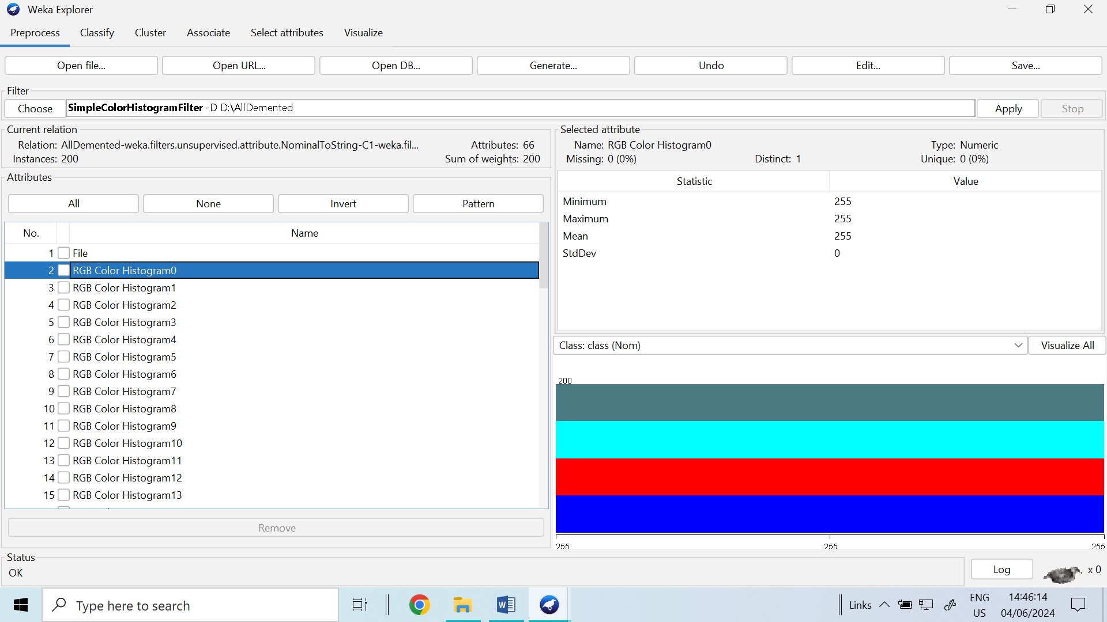

**Fig. 2: Class distribution in Weka**

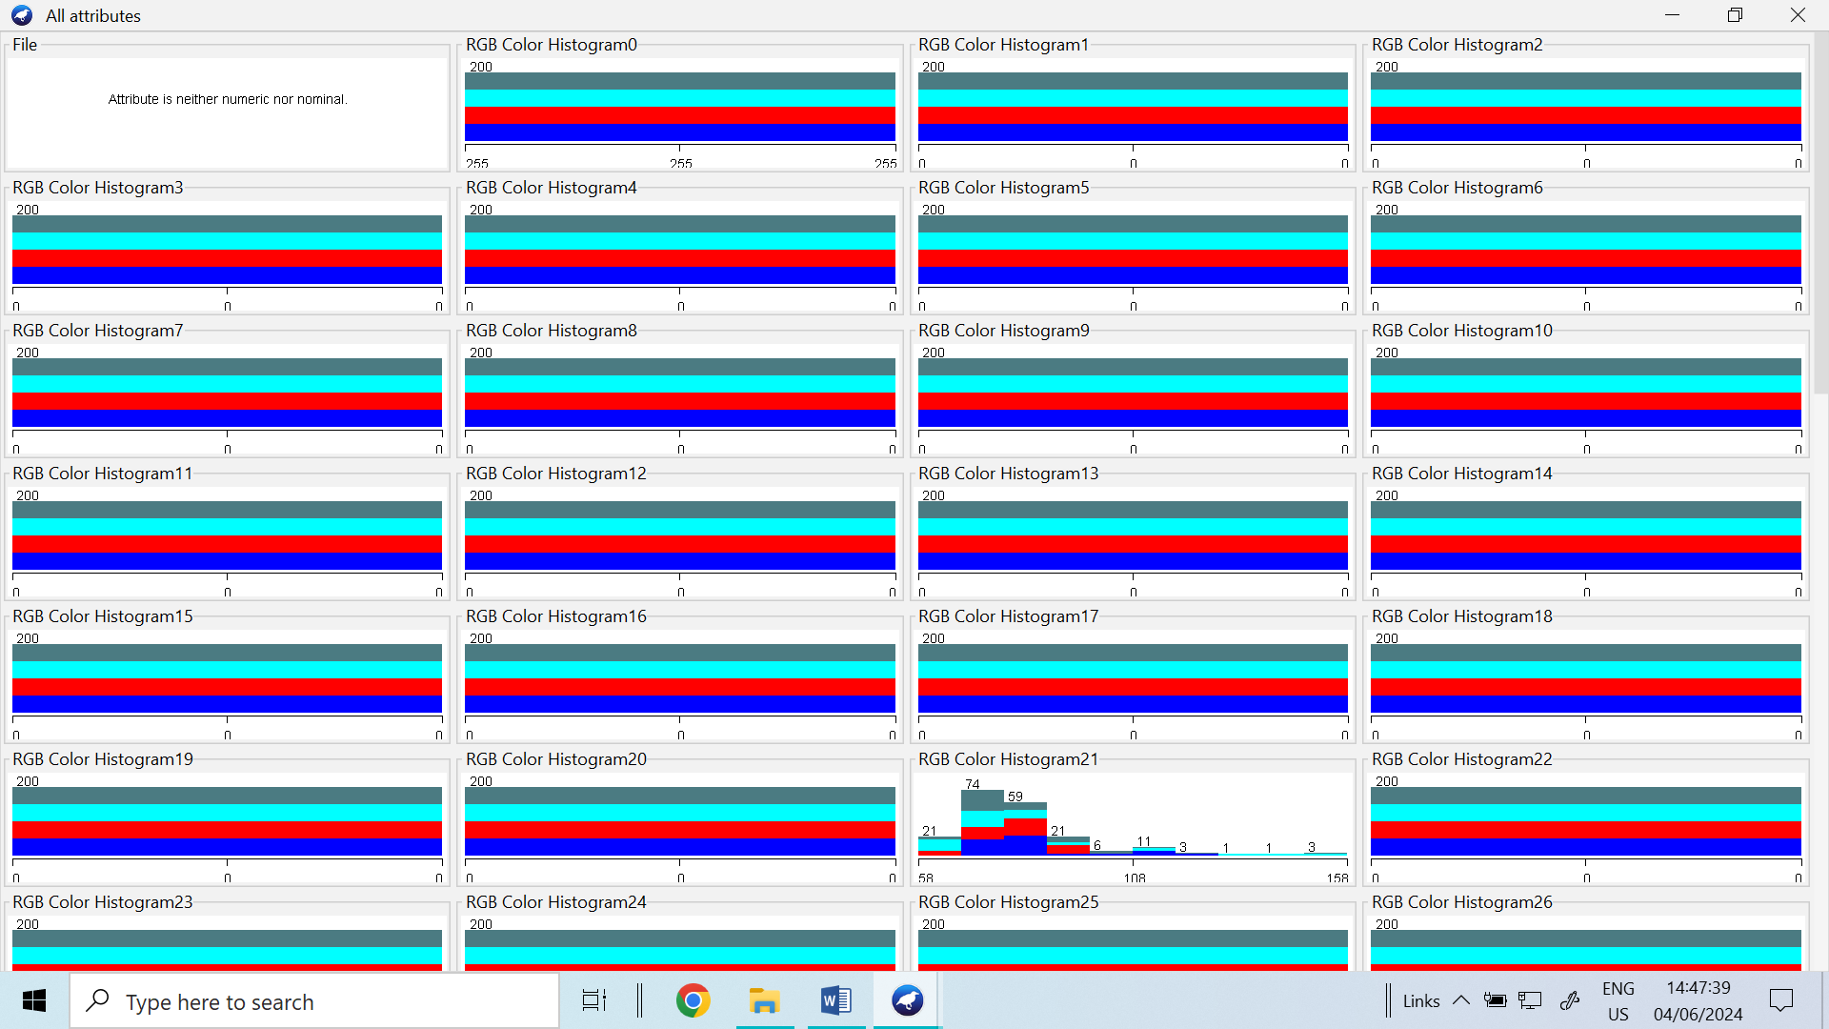

**Fig.3: Alzheimer’s Image Enhancement of Simple color Histogram filter technique**

1. **Kappa Statistic Value :** The Functions classifier of the Logistic category produced as a 0.32 of Kappa statistic value, the Functions classifier of the simple logistic category generated 0.24 of Kappa statistic value. The functions Classifier of the SMO Category generated as a 0.28 of Kappa statistic value, the trees classifier of the LMT category generates 0.21 of Kappa statistic value, the trees classifier of the Random Forest category generated 0.340 of Kappa statistic value and Trees classifier of the J48 category generated 0.346 of Kappa statistic value.

**Table 2: Performance of Trees and Functions Classifier**

|  |  |  |  |  |  |  |  |  |  |
| --- | --- | --- | --- | --- | --- | --- | --- | --- | --- |
| S.No | Classifier | Base category | Kappa | Mean Absolute Error | Root Mean squared Error | Relative Absolute Error | Root  Relative Squared Error | F-Measure | MCC |
| 1 | Functions | Logistic | 0.32 | 0.31 | 0.399 | 83.49% | 92.36% | 0.469 | 0.312 |
| 2 | Functions | Simple Logistic | 0.24 | 0.33 | 0.41 | 89.00 | 95.07 | 0.393 | 0.228 |
| 3 | Functions | SMO | 0.28 | 0.32 | 0.41 | 86.44% | 95.47% | 0.453 | 0.280 |
| 4 | Trees | LMT | 0.21 | 0.311 | 0.42 | 82.92% | 98.28% | 0.363 | 0.191 |
| 5 | Trees | Random Forest | 0.340 | 0.33 | 0.41 | 89.37% | 91.51% | 0.481 | 0.327 |
| 6 | Trees | J48 | 0.346 | 0.26 | 0.396 | 70.88% | 96.72% | 0.485 | 0.344 |

1. **Mean Absolute Error:** The Functions classifier of the Logistic category produced as a 0.31 of Mean Absolute Error value, the Functions classifier of the simple logistic category generates 0.33 of Mean Absolute Error value, the functions Classifier of the SMO Category generates 0.32 of Mean Absolute Error value, the Trees classifier of the LMT category generates 0.311 of Mean Absolute Error value, the Trees classifier of the Random Forest category generates 0.33 of Mean Absolute Error value and Trees classifier of the J48 category generates 0.26 of Mean Absolute Error value
2. **Root Mean Squared Error (RMSE):** the Functions classifier of the Logistic category produced as a 0.399 of Root mean squared error value, the Functions classifier of the simple logistic category generates 0.41 of Root mean squared error value, the functions Classifier of the SMO Category generates 0.41 of Root mean squared error value, the Trees classifier of the LMT category generates 0.42 of Root mean squared error value, the Trees classifier of the Random Forest category generates 0.41 of Root mean squared error value and Trees classifier of the J48 category generates 0.396 of Root mean squared error value
3. **Relative Absolute Error (RAE):** the Functions classifier of the Logistic category produced as a 83.49% of Relative absolute error value, the Functions classifier of the simple logistic category generates 89% of Relative absolute error value, the functions Classifier of the SMO Category generates 86.44% of Root Relative absolute error value, the Trees classifier of the LMT category generates 82.92% of Relative absolute error value, the Trees classifier of the Random Forest category generates 89.37% of Relative absolute error value and Trees classifier of the J48 category generates 70.88% of Relative absolute error value
4. **Root Relative Squared Error (RRSE):** the Functions classifier of the Logistic category produced as a 92.36% of Root relative squared error value, the Functions classifier of the simple logistic category generates 95.07% of Root relative squared error value, the functions Classifier of the SMO Category generates 95.47% of Root relative squared error value, the Trees classifier of the LMT category generates 98.28% of Root relative squared error value, the Trees classifier of the Random Forest category generates 91.51% of Root relative squared error value and Trees classifier of the J48 category generates 96.72% of Root relative squared error value
5. **F- Measure:**  The Functions classifier of the Logistic category produced as a 0.469 of F-Measure value, the Functions classifier of the simple logistic category generates 0.393 of F-Measure value, the functions Classifier of the SMO Category generates 0.453 of F-Measure value, the Trees classifier of the LMT category generates 0.363 of F-Measure value, the Trees classifier of the Random Forest category generates 0.481 of F-Measure value and Trees classifier of the J48 category generates 0.485 of F-Measure value.
6. **Mathew Correlation Coefficients (MCC):** The Functions classifier of the Logistic category produced as a 0.312 of MCC value, the Functions classifier of the simple logistic category generates 0.228 of MCC value, the functions Classifier of the SMO Category generates 0.28 of MCC value, the Trees classifier of the LMT category generates 0.191 of MCC value, the Trees classifier of the Random Forest category generates 0.327 of MCC value and Trees classifier of the J48 category generates 0.344 of MCC value

**V. Experimental Results of Classifier Vs Base category**

**Fig.4. Performance of various classifier with Kappa Statistic values**

The above Fig.4 shows that the least kappa statistic value is 0.21 which is produced by LMT classifier, simple Logistic, SMO, Logistic, and Random forest classifier. The highest kappa statistic value is 0.346 which is produced by J48 classifier.

**Fig.5. Performance of various classifier with Mean Absolute Error**

The above Fig.5 shows that the least MAE value is 0.26, which produced by J48 classifier. The LMT and SMO and Logistic are having 0.31 of MAE value. The Random Forest classifier and Simple Logistic classifier produced highest of MAE is 0.33.

**Fig.6. Performance of various classifier with Root Mean Squared Error**

The above Fig.6 shows that the least RMAE value is 0.396, which produced by J48 classifier. The Logistic is having 0.399 RMSE value. The Simple Logistic and SMO are having 0.41 of RMSE value. The LMT classifier produced highest of MAE is 0.42.

**Fig.7. Performance of various classifier with Root Absolute Error**

The above Fig.7 shows that the least percentage of RAE value is 70.88%, which produced by J48 classifier. The Logistic is having 83.49% of RAE value and SMO are having 86.44% of RAE value. The Simple Logistic and Random Forest classifier produced highest of RAE is 89%.

**Fig.8. Performance of various classifier with Relate Root Squared Error**

The above Fig.8 shows that the least percentage of RRSE value is 91.51%, which produced by Random Forest classifier. The Logistic is having 92.36% of RRSE value. The Simple Logistic and SMO are having 95% of RRSE value. The LMT classifier produced highest of RRSE is 98.28%. The J48 classifier produced 96.72% of RRSE value.

**Fig.9. Performance of various classifier with F-Measure**

The above Fig.9 shows that the least percentage of F-Measure value is 0.363, which produced by LMT classifier. The Logistic is having 0.469 of F-Measure value. The Simple Logistic is having 0.393 of F-Measure value. The SMO is having 0.453of F-Measure value. The Random Forest classifier produced highest of F-Measure is 0.481. The J48 classifier produced highest value of 0.485 F-Measure value.

**Fig.10. Performance of various classifier with MCC**

The above Fig.10 shows that the least percentage of MCC value is 0.191, which produced by LMT classifier. The Logistic is having 0.312 of MCC value. The Simple Logistic is having 0.228 of MCC value. The SMO is having 0.28 of MCC value. The Random Forest classifier produced highest of MCC is 0.327. The J48 classifier produced highest value of 0.344 MCC value.

**VI. Conclusion**

This research work finds that the highest kappa statistic value is 0.346, which produced by Tree- J48 classifier. The least MAE value is 0.10, which produced by Tree-J48 classifier. The least RMSE value is 0.396, which produced by Tree-J48 classifier. The least RAE value is 70.88%, which produced by Tree-J48 classifier. The least RRSE value is 91.51%, which produced by Random Forest classifier. The Tree-J48 is having highest F-Score level, which is 0.485 of F-Score value and MCC value is 0.344. The J48 Classifier is the best model to train the Alzheimer’s disease among other classifiers.

**VII. Reference**

[1] D. Deepa, Dr.Anitha Karthi, An Image Feature extraction technique Alzheimer’s disease using inductive learning, Indian Journal of Computer Science and Engineering (IJCSE), Vol. 13 No. 1 Jan-Feb 2022. pp: 278-287

[2] Oh, K., Chung, YC., Kim, K.W. et al. Classification and Visualization of Alzheimer’s Disease using Volumetric Convolutional Neural Network and Transfer Learning. Sci Rep 9, 18150 (2019). https://doi.org/10.1038/s41598-019-54548-6

[3] Grundman, M., Petersen, R. C. & Ferris, S. H. Mild cognitive impairment can be distinguished from alzheimer disease and normal aging for clinical trials. Archives of Neurology. 61, 59–66 (2014).

[4] Davatzikos, C., Fan, Y., Wu, D. X. & Shen, S. M. Detection of prodromal Alzheimer’s disease via pattern classifcation of magnetic resonance imaging. Neurobiology of Aging. 29, 514–523 (2018).

[5] Bar, Y., Diamant, I., Wolf, L. & Greenspan, H. Deep learning with non-medical training used for chest pathology identifcation. In: SPIE Medical Imaging, https://doi.org/10.1117/12.2083124 (2015).

[6] Abrol, A et al. Deep Residual Learning for Neuroimaging: An application to Predict Progression to Alzheimer’s Disease. bioRxiv,https://doi.org/10.1101/470252 (2018).

[7] Fedorov, A. et al. Prediction of Progression to Alzheimer’s disease with Deep InfoMax. arXiv:1904.10931 (2019).22. Rieke, J., Fabian, E., Weygandt, M., Haynes, J. D. & Ritter, K. Visualizing Convolutional Networks for MRI-Based Diagnosis of Alzheimer’s Disease. MICCAI. 24–31 (2018).

[8] Yang, C., Rangarajan, A. & Rnaka, S. Visual Explanations From Deep 3D Convolutional Neural Networks for Alzheimer’s Disease Classifcation. In: AMIA (2018).

[9] Korolev, S., Safiullin, A., Belyaev, M. & Dodonova, Y. Residual and plain convolutional neural networks for 3D brain MRI classifcation. In ISBI, https://doi.org/10.1109/ISBI.2017.7950647 (2017).

[10]. Li Q, Yang MQ. 2021. Comparison of machine learning approaches for enhancing Alzheimer’s disease classification. *PeerJ* 9:e10549  <https://doi.org/10.7717/peerj.10549>

[11].Islam, J., and Zhang, Y. (2018). Brain MRI analysis for Alzheimer’s disease diagnosis using an ensemble system of deep convolutional neural networks. Brain Inform. 5:2.