 

**IoT BASED WIRELESS COMMUNICATION OF TRANSMISSION LINE PARAMETERS**

**A PROJECT REPORT**

***Submitted by***

**JEYAPRATHA.R (913120105014)**

**MICHEAL SAGAYA SEBATINY.J (913120105018)**

**SHANMUGAPRIYA.S (913120105031)**

***In partial fulfillment for the award of the degree***

***of***

**BACHELOR OF ENGINEERING**

***in***

**ELECTRICAL AND ELECTRONICS ENGINEERING**

**VELAMMAL COLLEGE OF ENGINEERING AND TECHNOLOGY,**

**MADURAI-625 009**

**ANNA UNIVERSITY::CHENNAI 600 025**

**MAY 2024**

## ANNA UNIVERSITY: CHENNAI 600 025

## BONAFIDE CERTIFICATE

Certified that is report **“IoT BASED WIRELESS COMMUNICATION OF TRANSMISSION LINE PARAMETERS”** is the Bonafide work of **JEYAPRATHA.R (913120105014), MICHEAL SAYAGA SEBATINY (913120105018) and SHANMUGAPRIYA.S (913120105031)** who carried out the project under my supervision.

##### SIGNATURE SIGNATURE

**Dr.A.SHUNMUGALATHA, M.E., Ph.D., Dr.N.KARPAGAM**

##### Head of the Department Professor

Electrical and Electronics Engineering, Electrical and Electronics Engineering, Velammal College of Engineering and Velammal College of Engineering and Technology, Technology,

Madurai–625009. Madurai –625009.

Certified that the candidate was examined on the Viva-Voce Examination held at Velammal College of Engineering and Technology, Madurai on .

**INTERNAL EXAMINER EXTERNAL EXAMINER**

**ACKNOWLEDGEMENT**

First of all we thank the Almighty for strengthening us throughout the project and helping us to complete it successfully.

We find immense pleasure to convey our sincere thanks to our honorable Principal **Dr.P.ALLI ,** for providing necessary facilities in carrying out our project work in our campus.

We would like to express our hearty thanks to our Head of the Department **Dr.A.SHUNMUGALATHA, M.E., Ph.D.,** for her constant encouragement.

We take this opportunity to express our sincere and heartfelt thanks to our guide, **Dr.N.KARPAGAM** for her patient guidance, timely suggestion technical and moral support and the immense part of her dedication in completing the project work successfully.

We express our special thanks to other staff members of our department, the non-teaching staff and our friends who assisted us, by their support and encouragement.

We also express our special thanks to our Parents who have sacrificed greatly in our education and welfare. We thank all those who have helped directly and indirectly in doing this project and bringing out this successful report.

**ABSTRACT**

While the majority of health directors concur that using the word law Pink to signify a baby seizure is unusual in medical facilities, a sanitarium should nonetheless handle this issue carefully. It not only has the potential to destroy the affected family and terrify the personnel, but it also has the potential to have terrible long-term effects on the sanitarium’s reputation. Therefore, preventing a law Pink is a top priority that necessitated advance planning, careful physical wall design, and the implementation of the appropriate technologies in order to give families and carers peace of mind when it comes to guarding child cases from the possibility of a foreigner or even a family seize. The automatic identifying technology known as RFID, or Radio Frequency identifying, aids the agony script. RFID works by using radio frequency signals to check a small electronic table with a reading device.

**LIST OF CONTENTS**

|  |  |  |
| --- | --- | --- |
| **CHAPTER NO.** | **TITLE** | **PAGE NO.** |
|  | **ACKNOWLEDGEMENT** | **iii** |
|  | **ABSTRACT** | **iv** |
|  | **LIST OF CONTENTS** | **v** |
|  | **LIST OF FIGURES** | **vii** |
|  | **LIST OF ABBREVATION** | **x** |
| **1** | **INTRODUCTION** | **1** |
|  | 1.1 GENERAL | 1 |
|  | 1.2 OBJECTIVE | 3 |
|  | 1.3 EXISTING METHOD | 4 |
|  | 1.3.1 DRAWBACK | 4 |
| **2** | **LITERATURE SURVEY** | **5** |
|  | 2.1 RFID BASED PROTECTION TO  NEWBORNS IN THE HOSPITALS | 5 |
|  | 2.2 ACTIVE RFID BASED INFANT  SECURITY SYSTEM | 6 |
|  | 2.3 RFID APPLICATION INFANT SECURITY  SYSTEMS OF HEALTHCARE  ORGANIZATIONS | 7 |
|  | 2.4 AN INTELLIGENTLY REMOTE INFANT  MONITORING SYSTEM BASED ON  RFID | 8 |
| **3** | **PROPOSED SYSTEM** | **9** |
|  | 3.1 DESCRIPTION | 9 |
|  | 3.2 BLOCK DIAGRAM DESCRIPTION | 10 |
|  | 3.3 ADVANTAGES | 11 |
| **4** | **MODULE DESCRIPTION** | **12** |
|  | 4.1 POWER SUPPLY | 12 |
|  | 4.2 TRANSFORMER | 13 |
|  | 4.3 ARDUINO UNO CONTROLLER | 13 |
|  | 4.4 LIMIT SWITCH | 19 |
|  | 4.5 LDR SENSOR | 19 |
|  | 4.6 RFID (RADIO FREQUENCY  IDENTIFICATION) | 20 |
|  | 4.7 KEYBOARD ENCODER | 21 |
|  | 4.8 BUZZER | 21 |
|  | 4.9 VOICE BANK | 22 |
|  | 4.10 LCD DISPLAY | 23 |
| **5** | **RESULTS AND DISCUSSION** | **24** |
|  | 5.1 RESULTS | 24 |
|  | 5.2 COST ESTIMATION | 27 |
| **6** | **CONCLUSION** | **28** |
| **7** | **REFERENCES** | **29** |
| **8** | **PUBLICATION** | **31** |

**LIST OF FIGURES**

|  |  |  |
| --- | --- | --- |
| **FIGURE**  **NO.** | **DESCRIPTION** | **PAGE**  **NO.** |
| 2.1 | RFID system block diagram | 5 |
| 2.2 | Topological structure of the Infant Security System | 6 |
| 2.3 | Flowchart | 7 |
| 3.1.1 | Block diagram of the proposed system | 9 |
| 4.1.1 | 7085 Regulator IC Pin | 13 |
| 4.2.1 | Transformer | 13 |
| 4.3.1 | Arduino Board | 14 |
| 4.4.1 | Limit Switch | 19 |
| 4.5.1 | LDR Sensor | 20 |
| 4.6.1 | RFID Reader | 20 |
| 4.7.1 | Keyboard Encoder | 21 |
| 4.8.1 | Buzzer | 22 |
| 4.9.1 | Voice Bank | 22 |
| 4.10.1 | LCD Display | 23 |
| 5.1.1 | Implemented Prototype | 24 |
| 5.1.2 | LCD displaying the information for the RFID tag verification | 24 |
| 5.1.3 | LCD displaying the information for the RFID tag verification | 25 |
| 5.1.4 | LCD displaying the authorized person | 25 |
| 5.1.5 | LCD displaying the passkey window | 25 |
| 5.1.6 | LCD displaying the verification completion process | 25 |
| 5.1.7 | LCD displaying the denial of authority | 26 |
| 5.1.8 | Buzzer | 26 |
| 5.1.9 | Speaker | 26 |

**LIST OF ABBREVATION**

* **RFID -**  Radio Frequency Identification
* **LDR -** Light Dependent Resistor
* **LCD -** Light Crystal Display
* **IC -** Integrated chip
* **EAC -** Electronic Access Control
* **IT -** Information Technology
* **PIR -** Passive Infrared Sensor
* **USB -** Universal Serial Bus
* **PWM -** Pulse Width Modulation
* **LED -** Light Emitting Diode

**CHAPTER 1**

**INTRODUCTION**

**1.1 GENERAL**

Even while baby abduction in pediatric hospitals occurs with a low likelihood and in typically ignored, it can have catastrophic effects on families and medical personnel. We’ve developed an active RFID based technology that tracks the newborn to improve child security in hospitals. RFID is an identifying system that uses radio frequency signals to encode data. RFID markers and compendiums are among the essential components. The ID data of the subjects to which the label is attached is carried by and emitted by the label. The powered label, also known as an active RFID label, can collect data from an RFID anthology as well as measure and decode environmental information (such as the temperatures of people, terrain, etc.). RFID anthology provides means for computer communication and can accept data from several markers. Batteries are used to power RFID markers. Working with producers of medical devices that could be harmed by RFID to evaluate their products for any negative effects and urging them to take RFID can be installed, what power scenarios and usage rates are being used in various locations, and how to beat reduce implicit EMI with leaders and ICDs. The capacity to combine and modify information with other systems to enhance the visibility of the hospital information system is a crucial component of RFID healthcare systems. More recently, the RFID has also come to play a significant role in healthcare association due to its enormous potential for tracking personnel, cases, and equipment, admitting and registering cases, supporting a number of tasks directly related to cases like bill payment, lozenge and drug disposal, and modernizing medical records. The procedures in place to prevent child seize are one implicit function of people tracking. Hospital administrators are seeking for solutions to improve kid security because more than two thirds of child occur in healthcare facilities. RFID simultaneously reads several markers at the moment. It continuously tracks the child’s movements and issue warning if the label becomes loose or is severed from the child’s ankle. Options for configuration are provided. Data and reports are readily available thanks to it. The markers last long. By preventing serious crimes, the use of combination of barcode, RFID, and mortal readable textbooks considerably improve the provision of patient care in hospitals.

**1.2 OBJECTIVE**

To protect the neonate in the hospitals using the RFID technology. The RFID tag is tied in the cradle. To avoid the misuse of RFID tag, Password is being enabled. If the authorization is not matched then alarm is turned on. Protecting neonate in the hospitals from kidnapping and swapping. False alarms are common when using obsolete solutions. The right choice for healthcare executives is one that uses RFID technologies since it allows data filtering and changing exciter frequencies to identity and eliminate potential noise issues thus eradicating false alarms. Similarly, the tags should adjust easily to the initial baby’s weight loss to avoid accidental dropping of the bracelet. Further, it is crucial that the infant protection system is not dependent on a PC or server. Ideally, a secured perimeter and alarms continue to properly function, even in the case of a crash of the network or PC. An effective infant protection system provides the right information of the right time to the right people. It should also be able to seamlessly integrate with the platforms and devices that already exist within the hospital. For instance, nurse call system, electronic access control (EAC). CCTV/camera system, pagers, beepers or any other mobile device carried by caregivers, and IOS or Android devices.

**1.3 EXISTING METHOD**

The present setup has used active RFID tags that transmit their identity (ID) to the installed readers. Two RFID readers one with long range and the other is low range are installed. The system keep track of the ID’s broadcasted by the tags and store the necessary information in the database. At the time of issuance, the necessary information related to mother and child has to be stored in the database along with the IDs. RFID reader is placed inside the neonate hall. This reader is used to read information of all tags inside that room. In case of loss of tag signal (that is verifies automatically after on minute) the system will announces on the absence of that tag. Alarm sound will be activated and the door of the hall will be locked. When a mother approaches with a child to the exit door, the system matches the mother’s tag with child’s tag and in the case of mismatch the door will not open and the alarms will be activated.

**DRAWBACKS**

* The active RFID tag fixed in the ankle of baby has a frequency which is harmful.
* The authorization is provided to the room and not to the individual cradle.
* RFID can get accessed by non authorized person.
* Channel bandwidth of the RFID is limited.

**CHAPTER 2**

**LITERATURE SURVEY**

**Title: RFID based protection to newborns in the hospitals**

**Year: 2014**

**Author: Ahmed Qasim Abd Alhasan, Syed Imtiyaz Hassan**

Many hospitals, these days depend on the Information Technology (IT) to achieve perfection in the health services and operation management. The said dependency is because of the ability of emerging technologies to solve the problem of different nature. One of the problems where applicability of the IT can produce revolutionary solution is the cradle kidnapping and swapping of newborns in hospitals. It can be achieved with proper usage of the Radio frequency identification (RFID) technology. The present work is an attempt to explore and then utilize RFID technology in healthcare to protect the newborns in the hospitals from kidnapping and swapping. Apart from implementing a sample case the present work also characterize the RFID system in terms of the different elements that it constitutes.

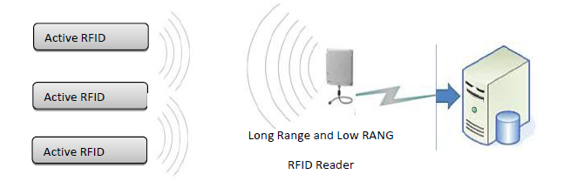

Fig. 2.1 RFID system block diagram

**Title: Active RFID Based Infant Security System**

**Year: 2011**

**Author: Lin Lin, Nan Yu, Tao Wang, and Changan Zhan**

Although infant abduction in pediatric area of hospitals happens at a low probability normally overlooked, its impact can be devastating for families and healthcare staff. To improve infant security in hospitals, we have developed an active RFID based system that tracks the body temperature of newborns. The system can measure body temperature through the near infrared sensor attached to baby’s wrist and estimate the location of the subject through the signal strengthen received by RFID readers network. It documents security records for the patients in a database and reports abnormal situation with text, warning lamp signal or alarm. We design the database in a way compatible with the general hospital information system. Currently the most common approach to identifying newborn in hospitals relies on the information ban attached to baby’s writs. It provides an economic and convenient way to pair babies and parents, but nothing helpful in preventing babies from abduction.

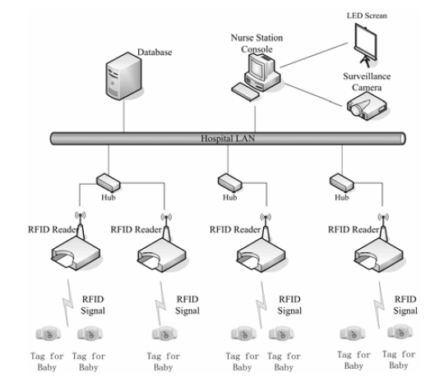

Fig. 2.2 Topological Structure of the Infant Security System

**Title: RFID Application Infant Security Systems of Healthcare**

**Organizations**

**Year: 2014**

**Author: Azevedo, Susana and Carvalho, Helena and Cruz Machado**

The Radio Frequency Identification (RFID) technology is actually considered a hot topic in all scientific areas and has been described as a major enabling technology for the automation of many processes. Although it is not a new technology it has only recently come to the awareness of the public and widely used in many sectors and particularly in the Healthcare. This paper aims to illustrate the security systems inside the hospitals. To attain this objective a case study about the experience of three hospitals and one RFID technology provider is presented to highlight the main architectural characteristics, functionality, and advantages associated with the RFID deployment.

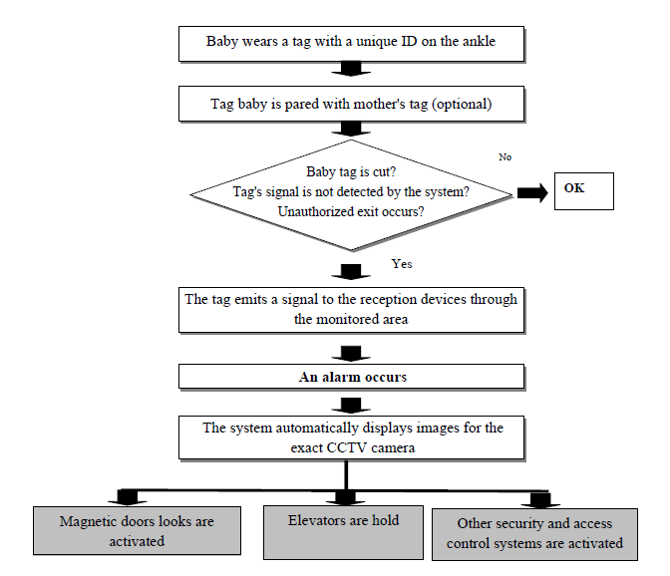

Fig. 2.3 Flowchart

**Title: An Intelligently Remote Infant Monitoring System Based**

**On RFID**

**Year: 2012**

**Author: Shou-Hsiung Cheng**

This study proposes a straight forward and efficient intelligently remote infant monitoring system to reduce the potential risks of the theft, misuse hold and abnormal body temperature. The system can accurately recognizes the locations of newborn babies by using neutral network classifiers after the active RFID readers has received different intensity of electromagnetic waves transmitted by active RFID tags. The newborn babies of temperature anomalies also can be diagnosed by the body temperature sensors and the proposed infant monitoring system. The remote infant monitoring system improved infant care and safety, reduced systems and human-based errors and enabled fast communicating with the clinical staff and families. This system can be used infants at home or in a hospital nursery room.

**CHAPTER 3**

**PROPOSED SYSTEM**

**3.1 DESCRIPTION**

In this proposed method, a PIR sensor and baby presence detecting sensor (limit switch), RFID reader, Voice chip and keyboard encoder involved in this security system. If we want to lift the infant from cradle, we need to show the authorized ID card to the RFID reader. The reader will verify the card and ask for the password. The system authentication enables the authorized person to lift the baby. Infant can be accessed if the password matches otherwise the voice alert will be initiated to avoid kidnapping of baby. We also have a protection to give an alarm if anybody trying to bypass the entire system by cutting wires of our system power supply.

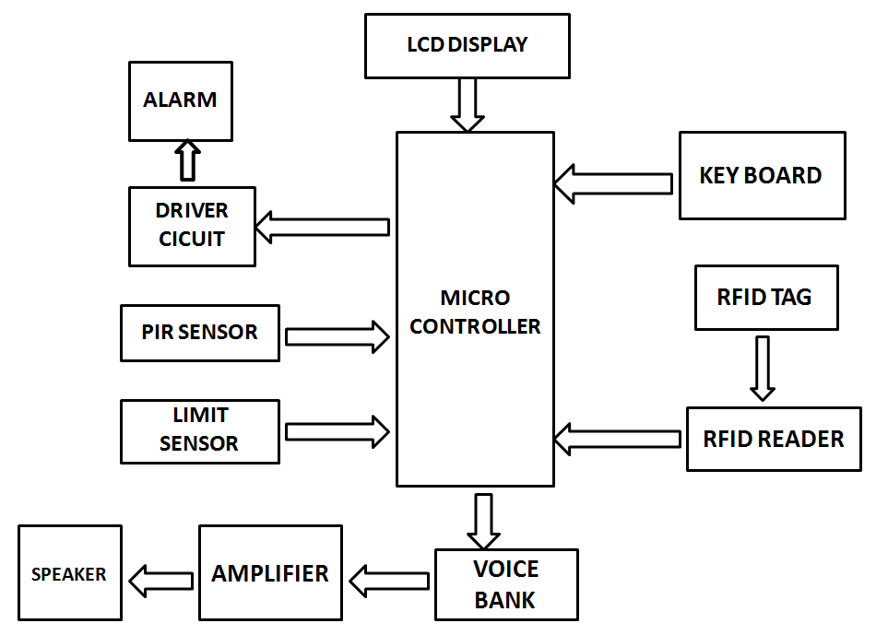

Fig. 3.1.1 Block Diagram of the proposed system

**3.2 BLOCK DIAGRAM DESCRIPTION**

A power supply circuit is very essential in any project. This power supply circuit is designed to get regulated output DC voltage. 7802 IC is used to give the constant 5v supply. Bridge rectifiers using diodes is used for rectifying purposes. The power supply section is for supplying voltages to the entire circuit unit.

The Arduino Uno is a microcontroller board based on the ATmega328. It has 14 digital input/output pins (of which 6 can be used as PWM outputs), 6analog inputs, a 16 MHz crystal oscillator, a USB connection, A power jack, an ICSP header, and a reset button. It contains everything needed to support the microcontroller.

RFID is a board term for technologies that use radio waves to automatically identify people or objects. There are several methods of identification, but the most common is to store a serial number that identifies a person or object, and perhaps other information, on a microchip that is attached to an antenna. The antenna enables the chip to transmit the identification information to a reader. The reader converts the radio waves back from the RFID tag into digital information that can then be passed on to computers that can make use of it.

A limit switch is an electromechanical device operated by a physical force applied to it by an object. Limit switches are used to detect the presence or absence of an object. These switches were originally used to define the limit of travel of an object.

LDR is also referred to as a photoresistor, photocell, or photoconductor. It is a specific kind of resistor, and the amount of light that strikes its surface affects how much resistance it exhibits. As the light level rises, the resistance value will decrease. As a result, these resistors are widely used in a variety of application due to this variation in resistance. The wavelength of the incident light affects the LDR sensitivity as well.

IC APR33 is used as the voice bank. The prerecorded messages can be stored in any location. This can be replayed by selecting the respective signal.

The piezoelectric type uses the piezoelectric ceramic’s piezoelectric effect and pulse current to make the metal plate vibrate and generate sound. This kind of buzzer is made with a resonance box, multi resonator, piezoelectric plate, housing, impedance matcher, etc. Some of the buzzers are also designed with LEDs.

LCD is essentially used for expose the information. Here we are using 2x16 LCD. It is used to display numbers, texts and graphics. This is in contrast to LEDs, which are limited to numbers and characters. The LCDs are fragile with only a few millimeter thickness. Since the LCDs utilize less power, they are efficient with low power electronic circuits, and can be charged for long terms. The LCDs don’t provoke light and so light is needed to read the display. The LCDs have long lasting life and a wide operating temperature range.

**3.3 ADVANTAGES**

* Tags are able to store more information per chip than a barcode, and wireless scanners that have the ability to instantly identify and capture data when within scanning range.
* RFID can also improve the efficiency in which healthcare providers are able to render care to their patient.
* Additionally, it was found that the RFID system benefited families in the waiting area, providing real-time information on their family member’s location, improving the efficiency in which families are updated, and improving service quality.

**CHAPTER 4**

**MODULE DESCRIPTION**

**4.1 POWER SUPPLY**

It is an electronics unit. This is used to give regulated power to any electronics system. This power supply circuit is designed to get regulated output DC voltage. The 9 volt transformer, step down the main voltage (230v) into 9 volts. The secondary voltage of transformer is rectified using bridge rectifier. The rectifies unidirectional DC is smoothed by 1000mf filter capacitor. The smooth DC is then fed to the three terminal +ve regulator called 7805 to get 5v DC supply.

Description:

1. Transformer: This block consist step-down transformer for our required ratings.
2. Rectifier: This block consist diode based rectifier circuit.
3. Filter circuit: This block consist capacitor based filter circuit.
4. Regulator: This block consists +ve (and) –ve three terminal regulators.

Circuit Operation:

The mains voltage ac 230v is step down to 9 volt, using 9v step down transformer. The low value secondary voltage is fed to the rectifier is formed using four no. of IN 4007. For first half cycle, Diodes D1 & D2 come to action and next half cycle diode D3 & D4 come to action, finally unidirectional dc supply is fed to the filter capacitor. The charging & discharging property of capacitor provide pure smooth dc is nearly peak value of the secondary voltage. The pure DC supply is fed to regulator IC’s input terminal. Due to the regulator action, finally, regulated 5 volts is available at output terminals.

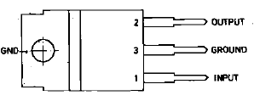

Fig. 4.1.1 7085 regulator IC pin

* 1. **TRANSFORMER**

The transformer, in a simple way, can be described as a device that steps up or steps down voltage. In a step-up transformer, the output voltage is increased, and in a step-down transformer, the output voltage is decreased. The step-up transformer will decrease the output current, and the step-down transformer will increase the output current to keep the input and output power of the system equal.

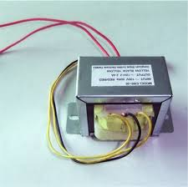

Fig. 4.2.1 Transformer

* 1. **ARDUINO UNO CONTROLLER**

The Arduino Uno is a microcontroller board based on the ATmega328. It has 14 digital input/output pins (of which 6 can be used as PWM outputs), 6 analog inputs, a 16 MHz crystal oscillator, a USB connection, a power jack, an ICSP header, and a reset button. It contains everything needed to support the microcontroller; simply connect it to a computer with a USB cable or power it with a AC-to-DC adapter or battery to get started. The Uno differs from all preceding boards in that it does not use the FRDI USB-to-serial driver chip. Instead, it features the Atmega8U2 programmed as a USB-to-serial converter.

Some of it’s features are:

* Microcontroller : ATmega328
* Operating Voltage : 5V
* Input Voltage (recommended) : 7-12V
* Input Voltage (limits) : 6-20V
* Digital I/O Pins : 14 (of which 6 provide PWM output)
* Analog Input Pins : 6
* DC Current per I/O Pin : 40mA
* DC Current for 3.3V Pin : 50mA
* Flash Memory : 32 KB of which 0.5 KB used by bootloader.
* SRAM : 2KB
* EEPROM : 1KB
* Clock Speed : 16 Mhz

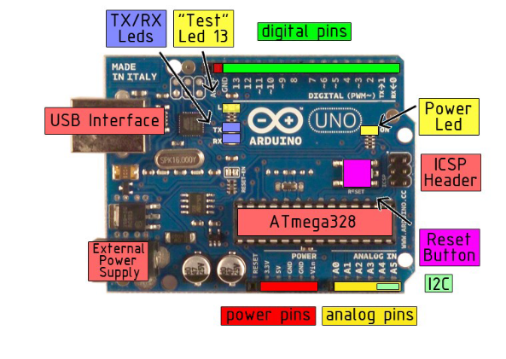

Fig. 4.3.1 Arduino board

The Arduino Uno can be powered via the USB connection or with an external power supply. The power source is selected automatically.

External (non-USB) power can come either from an AC-to-DC adapter (wall-wart) or battery. The adapter can be connected by plugging a 2.1mm center-positive plug into the board’s power jack. Leads from a battery can be inserted in the Gnd and Vin pin headers of the POWER connector.

The board can operate on an external supply of 6 to 20 volts. If supplied with less than 7V, however, the 5V pin may supply less than five volts and the board may be unstable. If using more than 12V, the voltage regulator may overheat and damage the board. The recommended range is 7 to 12 volts.

The power pins are as follows:

* **VIN.** The input voltage to the Arduino board when it’s using an external power source (as opposed to 5 volts from the USB connection or other regulated power source). You can supply voltage through this pin, or, if supplying voltage via the power jack, access it through this pin.
* **5V.** The regulated power supply used to power the microcontroller and other components o the board. This can come either from VIN via an on-board regulator, or be supplied by USB or another regulated5V supply.
* **3V3.** A 3.3 volt supply generated by the on-board regulator. Maximum current draw is 50mA.
* **GND.** Ground pins.

**MEMORY:**

The Atmega328 has 32KB of flash memory for storing code (of which 0.5 KB is used for the boot loader); It has also 2KB of SRAM and 1 KB of EEPROM.

**Input And Output:**

Each of the 14 digital pins on the Uno can be used as an input or output, using pin Mode(), digital Write(), and digital Read() functions. They operate at 5 volts. Each pin can provide or receive a maximum of 40mA and has an internal pull-up resistor (disconnected by default) of 20-5- kOhms. In addition, some pins have specialized

functions:

* **Serial: 0 (RX) and 1(TX).** Used to receive (RX) and transmit (TX) TTL serial data. These pins are connected to the corresponding pins of the ATmega8U2 USB-to-TTL Serial chip.
* **External Interrupts: 2 and 3.** These pins can be configured to trigger an interrupt on a low value, arising or falling edge, or a change in value.
* **PWM: 3,5,6,9,10, and 11.** Provide 8-bit PWM output with the analog Write() function.
* **SPI: 10 (SS), 11 (MOSI), 12 (MISO), 13 (SCK).** These pins support SPI communication, which, although provided by the underlying hardware, is not currently included in the Arduino language.
* **LED: 13.** There is a built-in LED connected to digital pin 13. When the pin is HIGH value, the LED is on, when the pin is LOW, it’s off.

The Uno has 6 analog inputs, each of which provide 10 bits of resolution (i.e. 1025 different values). By default they measure from ground to 5 volts, though is it possible to change the upper end of their range using the AREF pin and the analog Reference() function. Additionally, some pins have specialized

functionality:

* **I2C: 4 (SDA) and 5 (SCL).** Support I2C (TWI) communication using the Wire library.
* **AREF.** Reference voltage for the analog inputs. Used with analog Reference().
* **Reset.** Bring this line LOW to reset the microcontroller. Typically used to add a reset button to shields which block the one on the board.

Characteristics:

The maximum length and width of the Uno PCB are 2.7 and 2.1 inches respectively, with the USB connector and power jack extending beyond the former dimension. Three screw holes allow the board to be attached to a surface or case. Note that the distance between digital pins 7 and 8 is 160 mil (0.16’’), not an even multiple of the 100 mil spacing of the other pins.

Features:

* Advanced RISC Architecture
* 131 Powerful Instructions- Most Single Clock Cycle Execution
* 32 x8 General Purpose Working Registers
* Fully Static Operation
* Up to 20 MIPS Throughout at 20 MHz
* On-chip 2-cycle Multiplier
* High Endurance Non-volatile Memory Segments

ATMEGA:

The ATmega48PA328P AVR is supported with a full suite of program and system development tools including: C Compilers, Macro Assemblers, Program Debugger/Simulators, In-Circuit Emulators, and Evaluation kits.

Pin description of ATMEGA:

**VCC**

1 supply voltage.

**GND**

Ground

**Port B (PB&:0) XTAL!/XTAL2/TOSC1/TOSC2**

Port B is an 8=bit bi-directional I/O port with internal pull-up resistors (selected for each bit). The Port B output buffers have symmetrical drive characteristics with both high sink and source capability. As inputs, Port B pins that are externally pulled low will source current if the pull-up resistors are activated. The Port B pins are tri-stated when a reset condition becomes active, even if the clock is not running. Depending on the clock selection fuse settings, PB6 can be used as input to the inverting Oscillator amplifier and input to the internal clock operating circuit. Depending on the clock selection fuse settings, PB7 can be used as output from the inverting Oscillator amplifier.

If the Internal Calibrated RC Oscillator is used as chip clock source, PB7..6 is used as TOSC2..1 input for the Asynchronous Timer/Cpunter2 if the AS2 bit in ASSR is set.

**Port C (PC5:0)**

Port C is a 7-bit bi-directional I/O port with internal pull-up resistors (selected for each bit). The PC5..0 output buffers have symmetrical drive characteristics with both high sink and source capability. As inputs, Port C pins that are externally pulled low will source current if the pull-up resistors are activated. The port C pins are tri-stated when a reset condition becomes active, even if the clock is not running.

**PC6/RESET**

If the RSDTISBL Fuse is programmed, PC6 is used as an I/O pin. Note that the electrical characteristics of PC6 differ from those of the other pins of Port C. If the RSTDISBL Fuse is un programmed, PC6 is used as a Reset input. A low level on this pin for longer than the minimum pulse length will generate a Reset, even if the clock is not running. The Shorter pulses are not guaranteed to generated a Reset.

**Port D (PD7:0)**

Port D is an 8-bit bi-directional I/O port with internal pull-up resistors (selected for each bit). The Port D output buffers have symmetrical drive characteristics with both high sink and source capability. As inputs, Port D pins that are externally pulled low will source current if the pull-up resistors are activated. The Port D pins are tri-stated when a reset condition becomes active, even if the clock is not running.

**AVCC**

AVCC is the supply voltage pin for the A/D Converter, PC3:0. And ADC7:6. It should be externally connected to VCC, even if the ADC is not used. If the ADC is used, it should be connected to VCC a low-pass filter. Note that PC6..4 use digital supply voltage, VCC.

**AREF**

AREF is the analog reference pin for the A/D Converter.

**ADC7:6 (TQFP and QFN/MLF Package Only)**

In the TQFP and QFN/MLF package, ADC7:6 serve as analog inputs to the A/D converter. These pins are powered from the analog supply and serve as 10-bit ADC channels.

* 1. **LIMIT SWITCH**

A limit switch is an electromechanical device operated by a physical force applied to it by an object. Limit switches are used to detect the presence or absence of an object. These switches were originally used to define the limit of travel of an object, and as a result, they were names Limit Switch. Limit switches are electromechanical devices consisting of an actuator mechanically linked to an electrical switch. When an object contacts the actuator, the switch will operate causing an electrical connection to make or break.

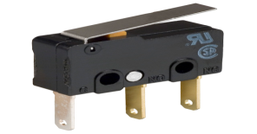

Fig. 4.4.1 Limit Switch

* 1. **LDR SENSOR**

LDR is also referred to as a photoresistor, photocell, or photoconductor. It is a specific kind of resistor, and the amount of light that strikes its surface affects how much resistance it exhibits. A light dependent resistor or LDR is an example of an electrical component that responds to light. When light beams strike it, the resistance changes right away. An LDR’s resistance level can vary by several orders of magnitude. As the light level rises, the resistance value will decrease. LDR resistance values range from many megaohms in complete darkness to only a few hundred ohms in strong light. As a result, these resistors are widely used in a variety of applications due to this variation in resistance. The wavelength of the incident light affects the LDR sensitivity as well.

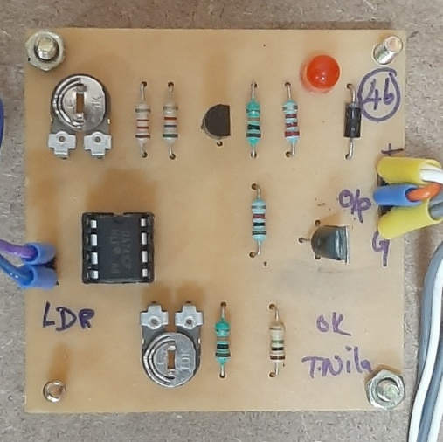

Fig. 4.5.1 LDR sensor

* 1. **RFID (RADIO FREQUENCY IDENTIFICATION)**

This technology is similar in concept to a cell phone RFID is a board term for technologies that use radio waves to automatically identify people or objects. There are several methods of identification, but the most common is to store a serial number that identifies a person or object, and perhaps other information, on a microchip that is attached to an antenna (the chip and the antenna together are called an RFID transponder or an RFID tag). The antenna enables the chip to transmit the identification information to a reader. The reader converts the radio waves back from the RFID tag into digital information that can then be passed on to computers that can make use of it.



Fig. 4.6.1 RFID Reader

* 1. **KEYBOARD ENCODER**

Keyboard encoder IC to generate BCD code for every key passing. It is a keyboard entry device to Binary coded decimal encoder. It is a part of our project system’s input device. It contains 18 pins IC 74C922, press button assembly having 12 nos. Of buttons. For every button press parallel BCD output goes to micro controller. This will be interlocked with the input card entry device with password facility as a security point of view. It contains 18 pins IC 74C922, press button assemble having 12 nos. Of buttons. After inserting the input card entry, necessary car desk’s password numbers have to be pressed on the press button assembly. For every button press parallel BCD output goes to micro controller via pins nos: 1,2,17 and 18 of IC 74C922. IC74C922 operates under crystal frequency of 4MHZ.

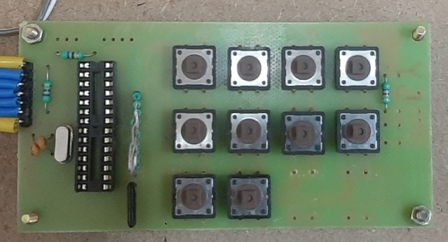

Fig. 4.7.1 Keyboard Encoder

* 1. **BUZZER**

The piezoelectric type uses the piezoelectric ceramic’s piezoelectric effect and pulse current to make the metal plate vibrate and generate sound. This kind of buzzer is made with a resonance box, multi resonator, piezoelectric plate, housing, impedance matcher, etc. Some of the buzzers are also designed with LEDs. The multi resonator of this mainly includes ICs and transistors. Once the supply is given to this resonator, it will oscillate and generated an audio signal with 1.5 to 2 KHz. The impedance matcher will force the piezoelectric plate to produce sound.

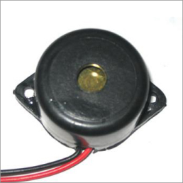

Fig. 4.8.1 Buzzer

* 1. **VOICE BANK**

IC APR 33 is used as the voice bank. The prerecorded messages can be stored in any location. This can be replayed by selecting the respective signal. The output of this IC is given to the power amplifier circuit. The aPR33A series are powerful audio processor along with high performance audio analog –tp-digital converters (ADCs) and digital-to-analog converters (DACs). The aPR33A series are a fully integrated solution offering high processing and analog output functionality. The aPR33A series incorporates all the functionality required to perform demanding audio/voice application.

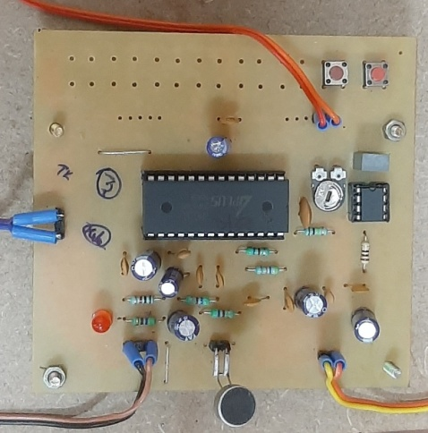

Fig. 4.9.1 Voice Bank

* 1. **LCD DISPLAY**

LCD is essentially used for expose the information. Here we are using 2x16 LCD. It is used to display numbers, texts and graphics. This is in contrast to LEDs, which are limited to numbers and characters. The LCDs are fragile with only a few millimeter thickness. Since the LCDs utilize less power, the y are efficient with low power electronic circuits, and can be charged for long terms. The LCDs don’t provoke light and so light is needed to read the display. The LCDs have long lasting life and a wide operating temperature range.

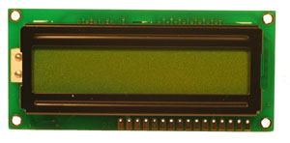

Fig. 4.10.1 LCD Display

**CHAPTER 5**

**RESULTS AND DISCUSSION**

**5.1 RESULTS**

Abduction of neonate from the hospitals using the RFID technology is successfully explained and implemented. This model helps in differentiating the authorized and unauthorized person, by providing the access to authorized to handle the neonate.

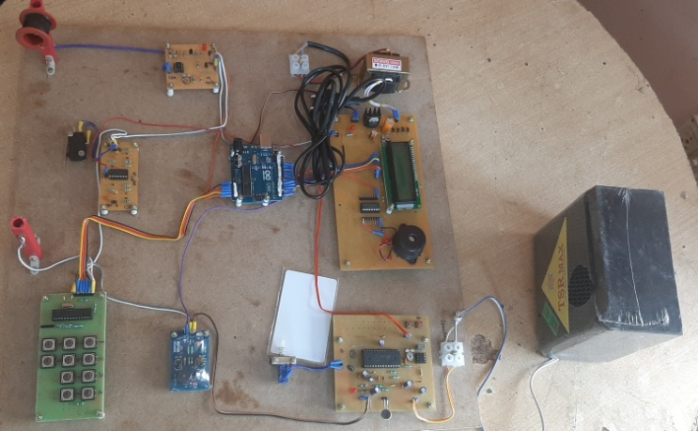

Fig. 5.1.1 Implemented Prototype

The figure 5.1.2 & 5.1.3 depicts the system authorization to handle the baby.

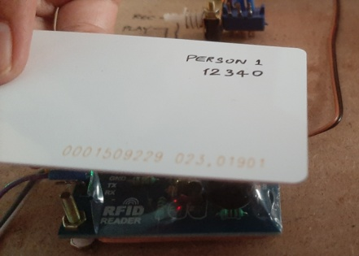

Fig. 5.1.2

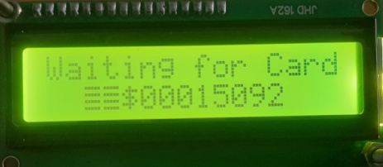

Fig. 5.1.3

**Figure 5.1.2 & 5.1.3 LCD displaying the information for RFID tag verification**

If the tag is authenticated pass key should be entered. The figure 5.1.4, 5.1.5 & 5.1.6 depicts the same,

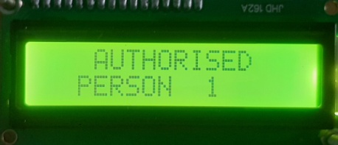

Fig. 5.1.4 LCD displaying the authorized person

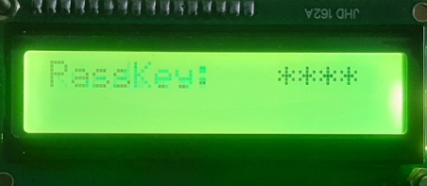

Fig. 5.1.5 LCD displaying the passkey window

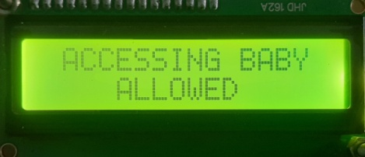

Fig. 5.1.6 LCD displaying the verification completion process

If the tag is not authenticated or if someone is trying to abduct the neonate, the buzzer is set on. The figure 5.1.7, 5.1.8 & 5.1.9 are depicted, LCD displaying the denial of authority, Buzzer and Speaker.

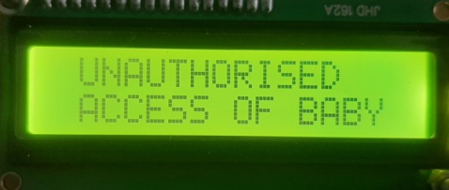

Fig. 5.1.7 LCD displaying the denial of authority

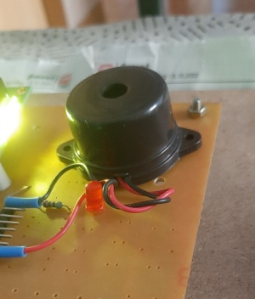 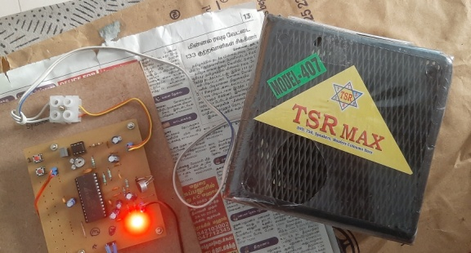

Fig. 5.1.8 Buzzer Fig. 5.1.9 Speaker

**5.2** **COST ESTIMATION**

|  |  |
| --- | --- |
| **COMPONENTS** | **COST** |
| Microcontroller with LCD | 1500 |
| Voice bank | 1000 |
| RFID reader | 2000 |
| Keyboard encoder | 300 |
| Limit switch Debouncer | 750 |
| Limit switch | 250 |
| LDR sensor | 150 |
| Buzzer | 120 |
| Wooden base and others | 1500 |
| **TOTAL** | **7570** |

**CHAPTER 6**

**CONCLUSION**

The present work is an attempt to explore and describe the basic architecture of neonate protection using RFID. A set of two RFID active tag is being provided to the authority with same ID for a neonate. Limit Switch senses the presence of the baby in the cradle, places at the bottom of the cradle. LDR sensor emits the light rays at the top of the cradle. If someone wants to handle the baby, RFID should be authenticated along with password. If not, the security system is turned on. The above system will stop any attempt of cradle abduct and exchange.

**CHAPTER 7**

**REFERENCES**

[1] KAmaraj.A., Sundaram,C., Shobana,G., (2018). Low cost child Abduction Prevention with RFID technology. Indian journal of Public Health Research and Development. 9.2001.10.5958/0976-55062018.01930.7

[2] Hassan, Syed, Alkorji, Ahmed. (2014). RFID based protection to newborns in the hospitals. ISOR Journal of Computer Engineering (ISOR-JCE) e-ISSN:2278-0661, p-ISSN:2278-8727 Volume 16, Issue 3, ER.I (May-Jun.2014), PP 28-32.

[3] Cheng, SH.(2012). An Intelligently Remote Infant Monitoring System Based on RFID. In: Pan, JS., Chen, SM., Nguyen. N.T. (eds) Intelligently information and Database Systems. ACIIDS2012. Lecture notes in Computer Science, vol 7196. Springer, Berlin, Heidelberg.

[https://doi.org/10.1007/978-3-642-28487-8 25](https://doi.org/10.1007/978-3-642-28487-8%2025).

[4] Lin,L., Yu, N., Wang, T., Zhan, C.(@011). Active RFID Based Infant Security System. In: Ma, M.(eds) Communication Systems and Information Technology. Lecture notes in Electrical Engineering, vol 100. Springer, Berlinn, Heidelberg.

[https://doi/org/10.1007/978-3-642-21762-3 26](https://doi/org/10.1007/978-3-642-21762-3%2026).

[5] Azevedo, Susana and Carvalho, Helena and Cruz Machado, Virgilio.(2014). RFID Application Infant Security Systems of Healthcare Organizations. Advances in Intelligent Systems and Computing. 281.10.1008/978-3-642-55122-1_92.

[6] Lin Lin, Nan Yu, Tao Wang, Changan Zhan. Active RFID Based Infant Security System. Communication Systems and Information Technology, 2011, Volume 100 ISBN: 978-3-642-21761-1.

[7] Pablo Picazo-Sanchez, Nasour Bagheri, Pedro-Lopez and Juan E. Tapiador, Two RFID Standard-based Security Protocols for Healthcare Environments. Journal of Medical Systems, 2013, Volume 37, Number 5. DOI: 10.1007/s10916-013-9962-3.

[8] Keerti Srivastava, Amit K. Awasthi, Sonam D. Kaul and R.C Mittal. AHash Based Mutual RFID Tag Authentication Protocol in Telecare Medicine Information System. Journal of Medical Systems, 2015, Volume 39, Number 1. DOI: 10.1007/s10916-014-0153-7.

[9] D Wyld. Preventing the Worst Case Scenario: An Analysis of RFID Technology and Infant Protection in Hospitals. The Internet Journal of Healthcare Administration. 2009. Volume 7 Number 1.

**CHAPTER 8**

**PUBLICATION**

