# **INVESTIGATION OF SUSTAINABLE NANO ADDED SOLID PROPELLANTS USING PROSOPSIS JULIFLORA AND PLASTIC WASTE OIL**

# **Sivasankar G A1, Bharathi M2, Divyadharshini R3, Sripanraj M4, Ajay D5, Karthikeyan K R6**

Department of Aeronautical Engineering, KIT Kalaignar Karunanidhi Institute of Technology, Coimbatore

Corresponding Author Email ID : gassaero@gmail.com

# ABSTRACT

This study investigates the creative use of leftover cooking oil and the invasive plant species Prosopis Juliflora as a sustainable and renewable resource. In many areas, Prosopis Juliflora has created ecological and economic problems that frequently result in land degradation. Additionally, disposing of used cooking oil raises environmental concerns. In order to create a unique biofuel, our study looks into the process of turning Prosopis Juliflora biomass into charcoal, which is then combined with leftover cooking oil. We examine the fuel characteristics, combustion efficiency, and emissions of this biofuel blend via a battery of tests in an effort to offer a sustainable and financially feasible solution for the management of waste oil as well as the problem of invasive plants. The objectives of this initiative are to enhance rural livelihoods, promote energy sustainability, and protect the environment.

# INTRODUCTION

The history of a project using solid propellant made of Prosopis juliflora results from people's growing interest in renewable and sustainable energy sources. Due to its rapid growth in arid settings and possible use as a biomass resource, Prosopis juliflora, an invasive plant in some areas, has drawn attention. Scientists and academics have attempted to investigate its potential applications in energy-related fields by taking advantage of its widespread availability. Research on its combustion characteristics, processing techniques, and potential as a solid propellant have emerged in this field. The idea for the project most likely came from a group effort to use eco-friendly, alternative materials for propulsion systems in an effort to lessen environmental effect and dependency on conventional fossil fuels. A project using Prosopis juliflora as a solid propellant has several different objectives. These include creating effective processing techniques for propellant synthesis, thoroughly verifying its safety, stability, and performance, and assessing its feasibility through an analysis of combustion characteristics and energy content. Simultaneously, evaluating the economic viability, scalability, and environmental impact are essential elements, as is guaranteeing regulatory compliance. By fulfilling these goals, the project will have demonstrated that using Prosopis juliflora as a viable and effective source of solid propellants is safe, practical, and environmentally sustainable, advancing the field of sustainable propulsion technology.

# RESEARCH METHODOLOGY

There are several issues to take into account while using Prosopis juliflora as a solid propellant. Its appropriateness depends on preserving a constant fuel quality, handling intricate conversion processes, and resolving environmental issues because of its invasiveness in certain habitats. Topping off the list of important aspects that need to be taken care of are steady handling and storage, adhering to safety regulations, and managing any possible environmental effects. In order to determine the environmental sustainability, safety, and dependability of using Prosopis juliflora as a solid propellant source, extensive research and development works are necessary to address these restrictions. A fuel, an oxidizer, and a binder make up the three primary components of solid propellants. Fuel gives the chemical energy needed for combustion, while oxidizer gives the oxygen needed for the reaction to happen. Together with guaranteeing appropriate combustion rates and structural integrity, a binder combines these ingredients and keeps them in a solid shape. Consistent energy release is ensured by the controlled combustion made possible by the design of solid propellants. Propelling systems require thrust, which is produced by the high-pressure gases produced by this controlled combustion and released through a nozzle. Because they are safe, easy to handle, and relatively simple, these propellants are used extensively in a variety of sectors, including space exploration and military applications.

Prosopis juliflora (mesquite) powder and oil obtained from plastic may be combined to form a composite material or fuel source. The high energy content of Prosopis juliflora is well recognized, and oil generated from plastics may enhance the composition by adding viscosity, stability, or combustibility. The oil made from plastic may function as a binding or stabilizing agent, and the mesquite powder, which is valued for its calorific content, may be used as a source of biomass. A number of uses for this combination might be investigated, including the creation of energy through the development of fuel sources or composite materials with certain qualities.However, the environmental impact and feasibility of such a combination would need thorough analysis, considering factors like the sustainability of using plastic- derived oil, the combustion characteristics of the mixture, and any potential emissions or byproducts resulting from its utilization. Research and testing would be necessary to assess its viability, efficiency.

# CONCEPTUAL WORKFLOW

Depending on how the finished composite material will be used, a mold for mixing Prosopis juliflora powder and oil obtained from plastic might be made. Fuel Pellets: If the goal is to produce fuel pellets, a mold with the right dimensions and form might be created to compress the mixture into pellet form. To form the composite into fuel units, this mold might be as simple as a rectangle or cylindrical shape.Composite Material: Molds with precise dimensions and forms can be used to press and harden a mixture into the appropriate shape and form for the creation of composite materials such as boards or panels. In order to create particular composite goods, this can include using molds with different chambers or forms. Prosopis juliflora powder and oil derived from plastic are made by a series of phases in production: Gather pods from Prosopis juliflora to begin harvesting. Pods undergo a process of drying and grinding till they become a fine powder. Oil can be extracted from plastic trash by using suitable techniques, such as chemical procedures or distillation.Blending: Combine the plastic-derived oil and Prosopis juliflora powder in specified proportions. Processing: Work the combination under pressure and heat to form the appropriate plastic-like material or composite material.

# THE PHENOMENA OF COMBUSTION

Depending on their chemical makeup, blend ratios, and method of combination, Prosopis juliflora powder and plastic-derived oil can have different combustion properties.Calorific Value: Due to their flammable nature, both elements probably contribute to the mixture's energy content. There are differences in their compositions that can affect the calorific value (amount of heat generated) during combustion.Flame Propagation: Depending on the ratios of Prosopis juliflora powder and oil generated from plastic, combustion behavior, including flame propagation and intensity, may change.

# EXPERIMENTAL STUDY & ANALYSIS

Collect used plastic oil and powdered Prosopis juliflora. Make sure the combustion chamber is airtight and clean.Combine the leftover plastic oil and Prosopis juliflora powder in the preferred ratio (e.g., 50/50,70/30,etc.).To ensure homogenous combustion, make sure to combine thoroughly.To start a combustion, provide heat.A suitable ignition is necessary to initiate the burning process.Keep an eye on the combustion process to ensure efficiency and stability.In order to preserve ideal burning conditions, regulate airflow.Keep an eye on and regulate the combustion chamber's temperature.In order to maintain the required temperature range of 800°C to 1200°C, adjust the heat input or airflow as necessary.Ash and unburned carbon leftovers should be gathered and disposed of.As certain that handling and disposal are done appropriately in compliance with environmental laws.Watch the temperature, pressure, and emissions of combustion constantly.

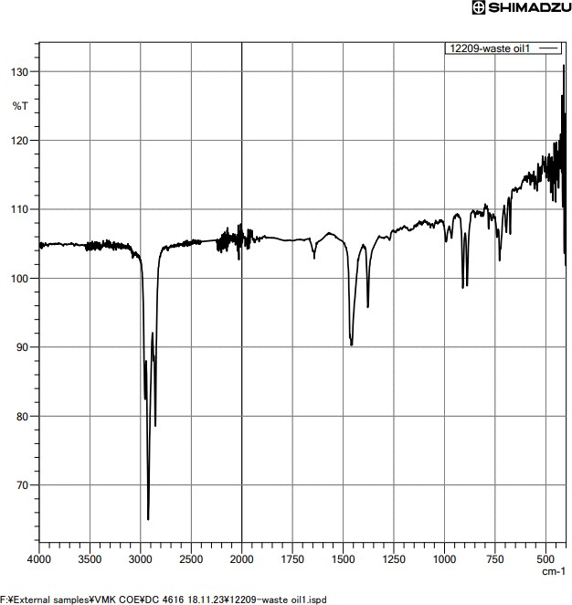

Table 1 - Plastic Waste Oil Sample

|  |  |  |
| --- | --- | --- |
| S.No | Item | Value |
| 1 | Option | elfkivmfvd |
| 2 | Intensity Mode | %Transmittance |
| 3 | Apodization | Box-Car |
| 4 | No.of Scans | 45 |
| 5 | Resolution | 4 cm-1 |

|  |  |  |  |  |  |  |
| --- | --- | --- | --- | --- | --- | --- |
| S.No | Mixture Ratio | Calorific value | Viscosity | Flash Point | Time Take n | Result |
| 1 | Mestique Powder(50%)  & Waste Plastic oil(50%) | 36 | 51 cSt at 42℃ | Above 151℃ | 9-11  mins | Balanced and Cost Effective |
| 2 | Mestique Powder(70%)  & Waste Plastic  oil(30%) | 39 | 42 cSt at 42℃ | Above 151℃ | 6-8  mins | More energy, Cleaner burn |
| 3 | Mestique Powder(30%)  & Waste Plastic oil(70%) | 33 | 61 cSt at 42℃ | Above 151℃ | 11-  13  mins | Less energy, eco friendly |

Table 2 - Characterstics of Propellant Mixtures

**CONCLUSION**

An inventive approach with potential advantages for the environment, economy, and performance is the development of a propellant using Prosopis juliflora powder and plastic waste oil. This project attempts to use sustainable materials for propellant development through rigorous testing, safety precautions, and ethical concerns.The thorough analysis takes into account the environmental impact, legal compliance, and economic viability in addition to technical factors like combustion testing and scalability. It is still essential to optimize the formulation while following safety regulations and standards.Although the project's potential for resource efficiency and environmentally friendly propulsion solutions is encouraging, more development, market research, and continuous assessments are necessary to reach its full potential.

# REFERENCES

Azam. M.M., Tewari, lC. Singh, Y. and Roy, M.M. 2011. Prosopis juliflora: A Rich Source of Antioxidant Product. Folder published by Central Arid Zone Research Institute, Jodhpur

EI Fad M.A. 1997. Management of Prosopisjuliflorafor use in agroforestry in the Sudan. Tropical Forestry Reports 16. University of Helsinki, Helsinki, Finland

Harsh, L.N., Tewari, J.C. and Sharma, N.K. 1996. Performance of Prosopis in arid region of India. In: Prosopis Semi-arid Fuel Wood and Forage Tree - Building Consensus for the Disfranchised. Texas A&M University, Kingsville, Texas, US

Mazing G Yu. Comparative analysis of developments in the active and reactive methods of projection.in Histology)' of rocketry, aeronautics edited by T D Crouch and A M Spencer. AAS History Series, Vol.14 (American Astronautically Society, San Diego) 1 993. p140.

Omen C & Jain S R. Ammonium nitrate: A promising rocket propellant oxidizer. J f1ard Mater, A67 (1999) 253- 281.

Melina F J. First J ATOs: Ammonium nitrate. Cornstarch. Black powder and glue, Jet Propel Soc. 26 (1 956) 51.

Winter F H & James G S. Highlights of 50 years or Aerojet. a pioneering American Rocket Company. 1 942- 1 992 in History of rocketry and astronautics, edited by P Jung. AAS History Series. VoI.22 (American Astronautically Society. San Diego) 1 998, p53- 104.

Felker, P., Meyer, 1.M. and Groski, SJ. 1990. Application of self-thinning in mesquite (Prosopis glandulosa varglandulosa) to range management and lumber production. Forest Ecology and Management 31: 225-232.

Geesing D Feiker, P. and Bingham, 2000. Influence of mesquite (Prosopis glandulous) on soil nitrogen and carbon development: implications for agroforestry and global carbon sequestration. Journal of Arid Environments 46: 157-180.

Gupta, 1. P., Rao, G.G.S.N., Gupta, G.N .and Ramana Rao, B. V. 1983. Soil drying and wind erosion as affected by different types of shelterbelts planted in the desert region of western Rajasthan, India. Journal of Arid Environments 6:53- 59.

Patel, V.I. (Ed.) 1986. The Role of Prosopis in Wasteland Development. Livre Bhai Patel Agroforestry Center, Sundry bag, Gujarat, India.

Silva, S. 1988. Prosopis juliflora (SW) DC in Brazil. In: Proceedings on II International Conference on Prosopis, Recife, Brazil, (Eds. M.A. Habit and J.C. Saavedra), pp. 29-51. FAD Publishers.

Singh, Gurbachan 2008. Managing Prosopis for livelihood security in salt affected and dry areas.