QR Code Based Smart Attendance System

Isha Pandey 1, Arjita Singh2, vikas Mishra3

Institute of technology and management,gida gorakhpur

***Abstract***

*In this era of technology smartphones play a significant role in our day to day life. Nowadays smartphones can solve most of the problem very quickly and easily. It has made life of every person simple and easier with different social app, commercial app, problem solving app, app for education and marketing etc. Followed by the technology the paper purposed a system that will handle a problem for recording the attendance. The proposed system is a couple of two applications, one for generating the QR Code by entering the student details and second application for taking the attendance and generating the attendance in CSV or XLS format. The teacher will need to scan the QR code of the particular student in order to confirm their attendance. The paper discusses how the system verifies student identity to eliminate false registrations. The system deals with the management and evaluation of attendance of all students. The student QR code will be provided to professor for taking their attendance. The professor handling the subjects is responsible to mark the attendance for all students of the group or class. The attendance will be marked as 0 and 1, 0 for absent and 1 for present in the database of the particular student row in the table. The student attendance reports will be generated in CSV and XLS sheet for further use.*

***Keywords:*** *QR, attendance, system, professor, student.*

# Introduction

Among the various types of attendance systems that have been developed, using punch cards, log books, fingerprint systems, barcodes, QR codes and also RFID still cause lots of problems such as providing incorrect information to the users. The purpose of the smartphone based attendance system is to computerize the traditional way of recording attendance and provide an easiest and smart way to track attendance in institutions nowadays, the most common device that have been come into account in marketing and business are smartphone devices. Moreover, it comprises lots of them running Android OS.

### Main objective

“QR Code Based Attendance Management System” is a combination of two android applications developed for taking and storing the attendance of the students on the daily basis in the college. Here the professor, who is handling the subjects, will be responsible to mark the attendance of the students. Each staff will be given an android application that is used for taking attendance and generate the overall attendance status. An accurate report based on the student attendance is generated here. Report of the student’s attendance on weekly and monthly basis is generated as desired. The main objective of the automated attendance system is to computerize the traditional way of recording attendance and provide an efficient and automated method to track attendance in institutions. Advantages of QR Code Based Smart Attendance System:

* + - Provide better security.
    - Maintenance of the system is easy and cost effective.
    - Generate the result quickly.
    - Provide accurate and efficient data.
    - User friendly.

### Problem statement

* + - Development of a SMART QR CODE BASED ATTENDANCE SYSTEM.
    - Integrating Android device with QR code and SQLite to store attendance results.
    - Analyzing the attendance on weekly and monthly basis.

### Feasibility

* + - **Economic feasibility:** The developed system is time effective because attendance is marked automatically. It is also cost effective because of no use of paperwork.
    - **Technical feasibility:** The system is economic and it does not use any other

additional Hardware and software.

* + - **Behavioral feasibility:** The system is user friendly.

### Characteristic of proposed system

* + - User Friendly
    - Reports are easily generated
    - Very less paper work
    - One spot solution for attendance calculation

# Methodology

To achieve the above discussed objectives, a step-by-step methodology has been followed.

The details of methodology are given below:

* Develop a QR code generator android app using the details of student such as roll number, student ID.
* Develop an Android app that take the attendance with respect to the specific subject

and generate the student attendance sheet as per attendance details.

### Software requirement

* + - Android Studio
    - Android OS 4.2+ (Mobile)
    - MS Excel

### Hardware requirement

* + - Android Smartphone running Android OS version 4.0.3(API level 15)+

### Input/output

* + - **Input:** QR code, Bar code
    - **Output:** XLS and CSV sheet

### Database used

* + - SQLite Database

### Use case

The various actors of the system along with their functionality are described in the

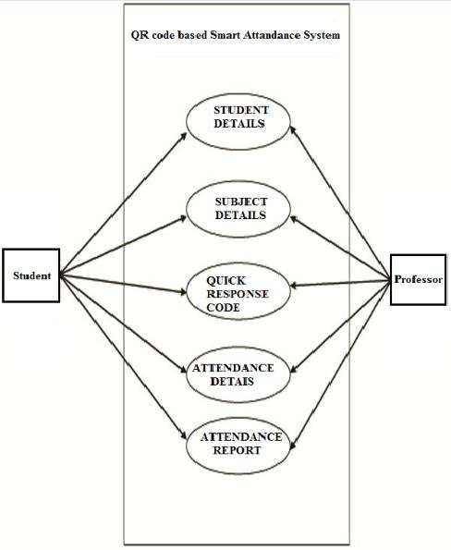

### Figure 1. Use case diagram

* 1. **Data flow diagram**

The data flow diagram of the system is given in the diagram:

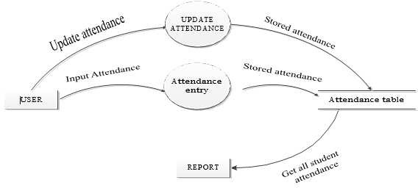

### Figure 2. Data flow diagram

* 1. **Database**

The database of student attendance is managed using SQLite. The database stores subjects

names, codes, student’s name, and attendance status. The database table is shown in below:

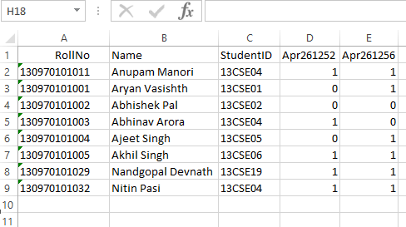

**Figure 3. Database for a particular subject**

* 1. **Sequence diagram**

The overall sequence diagram of the goal system is given below

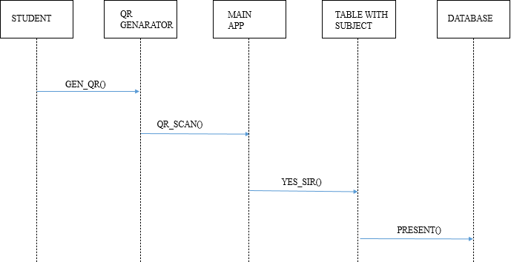

**Figure 4. Sequence diagram of the application system**

## Flow chart

The flow chart of the problem is shown in the figure below.

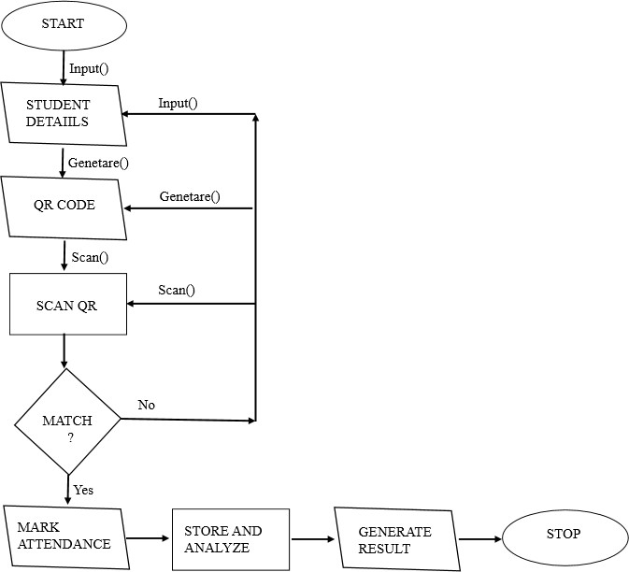

**Figure 5. Flowchart of the application system**

# Homepage of developed project

The graphical user interface of our project is shown in below, here Present Sir is our application name, ADD NEW SUBJECT, TAKE ATTENDANCE, EXPORT, DELETE

RECORDS are the buttons to perform various task.

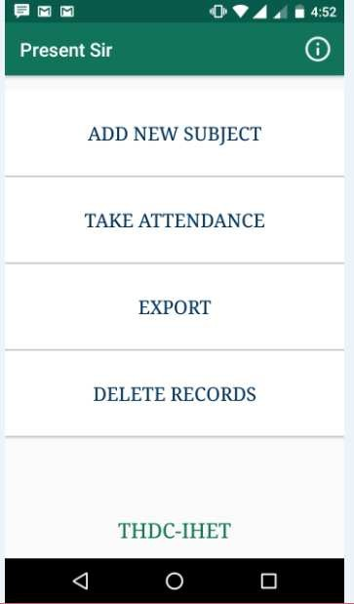

**Figure 6. GUI of developed project**

* 1. **QR code generation**

To generate the QR Code you need to enter the roll number of the student:

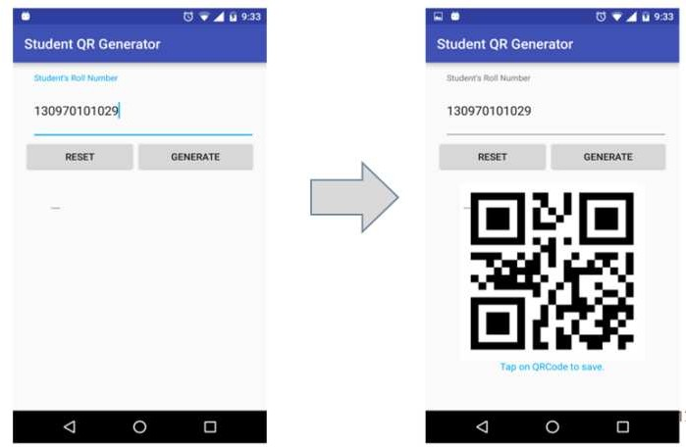

### Figure 7. QR code generation

* 1. **Adding subject to database**

For adding a subject, just fill the following field given in the screenshot:

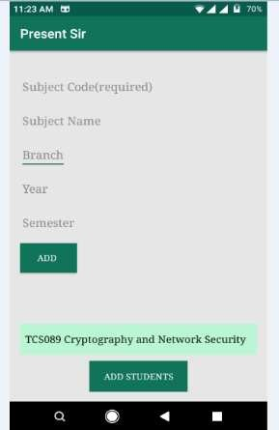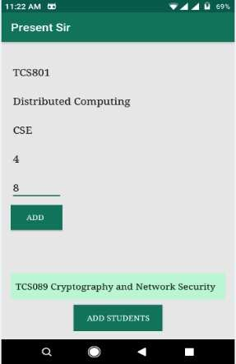

### Figure 8. Adding subjects and other details

* 1. **Adding student to database**

For adding the student first you need to select the desired subject in which you taking the attendance as shown in below:

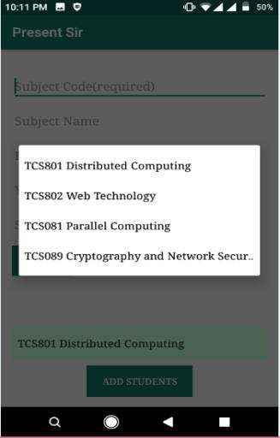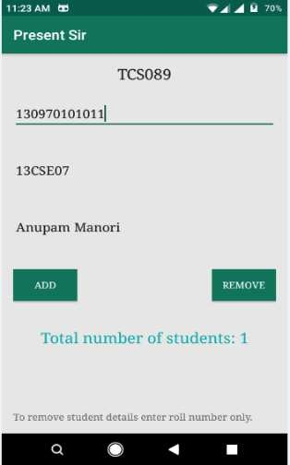

### Figure 9. Adding student to database

* 1. **Deleting subject from database**

If anyone need to delete a subject details permanently, teacher just need to enter the subject code:

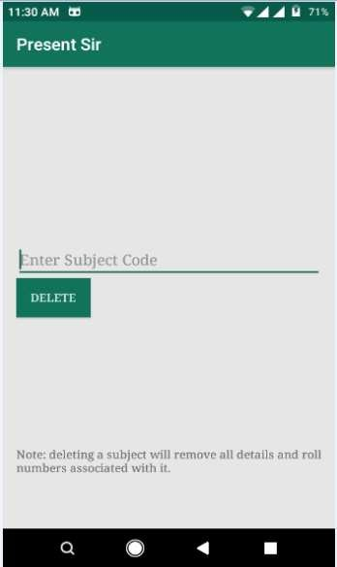

### Figure 10. Deleting subject from database

* 1. **Taking attendance**

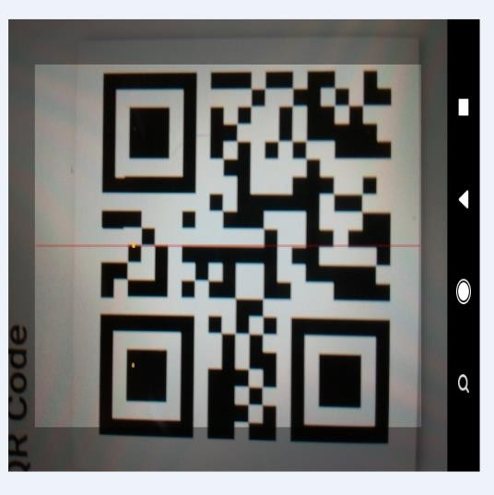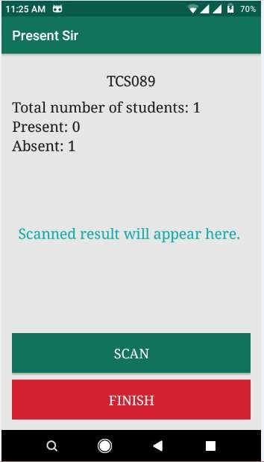

**Figure 11. Taking Attendance**

The right sided screenshot is the output of the scanned QR code this shows total number of students with number of students present as well as absent:

### Exporting attendance to CSV/XLS file

For exporting the overall attendance sheet in CSV/XLS format the teacher need to select the subject code.

Here is a screenshot of generated CSV file, 0 represents absent and 1 represents present:

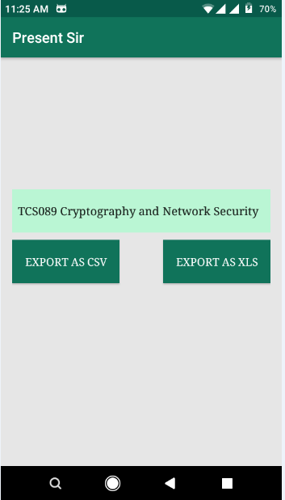

# Conclusion

**Figure 12. Exporting Attendance to CSV File**

The developed system presented in this paper has been successfully designed and tested. The student’s attendance status will be analysed and exported. Attendance monitoring system is very important in our daily life. It is possesses a really great advantage, among the whole types of code scanning technology, QR Code Based Smart Attendance System is the most accurate. In this project report, we have given an introduction of Attendance monitoring system and its advantage. It is an efficient method to store the attendance in the smart phone rather than wasting the paper.

# Future scope

Our future work will focus on providing missed class topics and notes available to students. Full control to professor with more secured and enhanced options. Finally we conclude, if we integrates this attendance monitoring system with face identification tool then system will solve the real world attendance problem.

# Acknowledgement

We owe special debt of gratitude to Professor Geetam Singh Tomar, Director, THDC Institute of Hydropower Engineering & Technology, Tehri for his support and assistance during the development of the project. His sincerity, thoroughness and perseverance have been a constant source of inspiration for us. It is only his cognizant efforts that our endeavours have seen light of the day. We also do not like to miss the opportunity to acknowledge the contribution of all faculty members of the department for their kind assistance and cooperation during the development of this paper.

1. Isha Pandey
2. Arjita Singh
3. Vikas Mishra

# References

1. “Android tutorials” [Online]. Available: https://developer.android.com/training/index.html
2. “Android tutorials” [Online]. Available: https://[www.tutorialspoint.com/android/](http://www.tutorialspoint.com/android/)
3. “QR code integration with Android” [Online]. Available: https://github.com/zxing/zxing
4. “About Bar Code” [Online]. Availab[le:h](http://files.microscan.com/whitepapers/barcode_basics.pdf)ttp[://files.microscan.com/whitepapers/barcode_basics.pdf](http://files.microscan.com/whitepapers/barcode_basics.pdf)
5. "ISS QR Code AIM Store: Historical Archive" [Online]. Available: Aimglobal.org
6. “Android Tutorial” [Online]. Available: [http://androidhive.com](http://androidhive.com/)