**QR**

**Based**

**Attendance System**

Isha Pandey 1, Arjita Singh2, vikas Mishra3

Institute of technology and management,gida gorakhpur

***Abstract***

*The QR Attendance System represents a modern, efficient, and user-friendly approach to attendance tracking, contributing to increased productivity and accuracy in various organizational settings. This system provide a efficient attendance tracking. It develop a unique QR code of each students inorganizations. Using MERN with power BI it touches streamlining attendance tracking, enhance accuracy, and reducing manual efforts. The system allows for innovative features or technological customizable email templates, escalates notifications to supervisors, and maintains attendance for auditing purposes. By automating the monitoring process, it ensures a consistent and virtual appearance. The QR Attendance System is a modern solution designed to streamline and enhance the process oftracking attendance in various educational and organizational settings. Traditional attendance methods,such as manual paper-based systems or card swiping, can be time-consuming,error-prone, and lack real- time data accessibility. The QR Attendance System leverages the convenience of Quick Response (QR)codes and mobile technology to create an efficient and reliable attendance tracking system.The system is built on the principle of generating unique QR codes for each participant, whether it be students, employees, or event attendees. These QR codes can be easily scanned using a mobile device equipped with a camera. The QR code contains essential information such as participant ID, name, and other relevant details. Participants simply present their QR codes to a designated scanner upon entry, The system deals with the management and evaluation of attendance of all students. The student QR code will be provided to professor for taking their aThe attendance will be marked as 0 and 1, 0 for absent and 1 for present in the database of the particular student row in the table. The student attendance reports will be generated in CSV and XLS sheet for further use.*

***Keywords:*** *QR attendance system,QR code*

# Introduction

1

Among the various types of attendance systems that have been developed, using punch cards, log books, fingerprint systems, barcodes, QR codes and also RFID still cause lots of problems such as providing incorrect information to the users. The purpose of the smartphone based attendance system is to computerize the traditional way of recording attendance and provide an easiest and smart way to track attendance in institutions nowadays, the most common device that have been come into account in marketing and business are smartphone devices. Moreover, it comprises lots of them running Android OS.

2

### Main objective

“QR Code Based Attendance Management System” is a combination of two android applications developed for taking and storing the attendance of the students on the daily basis in the college. Here the professor, who is handling the subjects, will be responsible to mark the attendance of the students. Each staff will be given an android application that is used for taking attendance and generate the overall attendance status. An accurate report based on the student attendance is generated here. Report of the student’s attendance on weekly and monthly basis is generated as desired. The main objective of the automated attendance system is to computerize the traditional way of recording attendance and provide an efficient and automated method to track attendance in institutions. Advantages of QR Code Based Smart Attendance System:

* + - Provide better security.
    - Maintenance of the system is easy and cost effective.
    - Generate the result quickly.
    - Provide accurate and efficient data.
    - User friendly.

### Problem statement

* + - QR Attendance System Background: Traditional methods of attendance tracking involve manual processes, such as calling Out names and using paper pen to take Attendance.

### Feasibility

* + - **Economic feasibility:** The developed system is time effective because attendance is marked automatically. It is also cost effective because of no use of paperwork.
    - **Technical feasibility:** The system is economic and it does not use any other additional Hardware and software.
    - **Behavioral feasibility:** The system is user friendly.

### 1.3. Characteristic of proposed system

* User Friendly
* Reports are easily generated
* Very less paper work
* One spot solution for attendance calculation

# Methodology

To achieve the above discussed objectives, a step-by-step methodology has been followed.

The details of methodology are given below:

* Develop a QR code generator android app using the details of student such as roll number, student ID.
* Develop an Android app that take the attendance with respect to the specific subject and generate the student attendance sheet as per attendance details.

### Software requirement

* + - Android Studio
    - Android OS 4.2+ (Mobile)

2

* + - MS Excel

### 2.2 Hardware requirement

* Android Smartphone running Android OS version 4.0.3(API level 15)+

### 2.3 Input/output

* **Input:** QR code, Bar code
* **Output:** XLS and CSV sheet

### Database used

* SQLite Database

### Use case

The various actors of the system along with their functionality are described in the

* + 1. Use case diagram

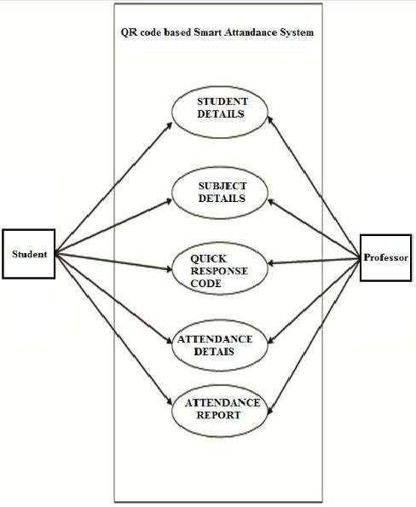

### Data flow diagram

The data flow diagram of the system is given in the diagram:

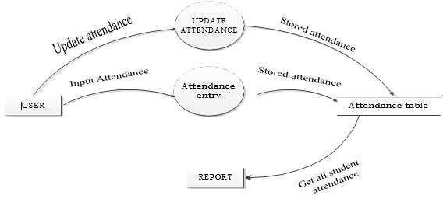

### Figure 2. Data flow diagram

* 1. **Database**

The database of student attendance is managed using SQLite. The database stores subjects names, codes, student’s name, and attendance status. The database table is shown in below:

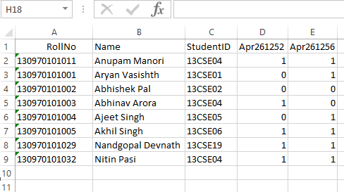

**Figure 3. Database for a particular subject**

## Sequence diagram

The overall sequence diagram of the goal system is given below

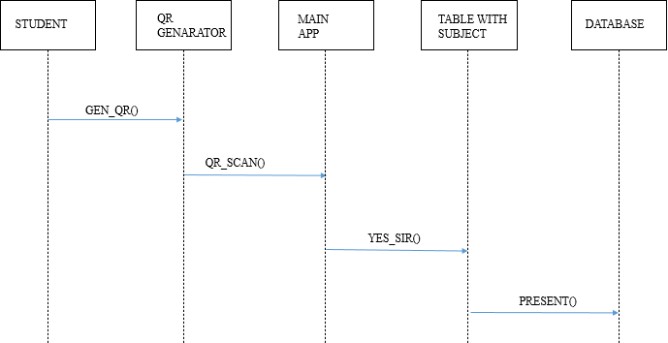

**Figure 4. Sequence diagram of the application system**

## Flow chart

The flow chart of the problem is shown in the figure below.

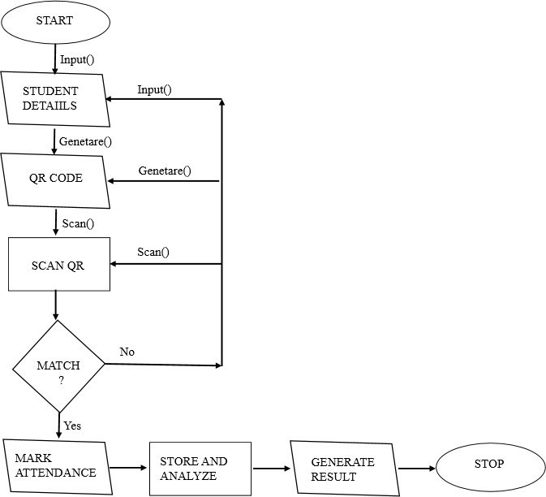

**Figure 5. Flowchart of the application system**

# Homepage of developed project

The graphical user interface of our project is shown in below, here Present Sir is our application name, ADD NEW SUBJECT, TAKE ATTENDANCE, EXPORT, DELETE

RECORDS are the buttons to perform various task.

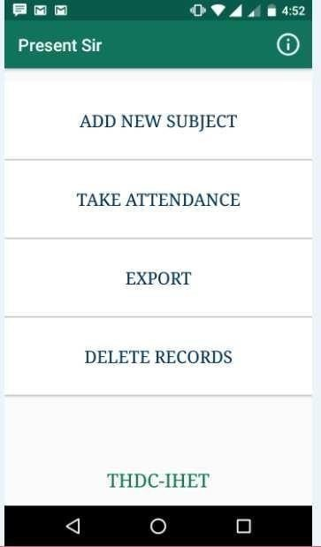

**Figure 6. GUI of developed project**

## QR code generation

To generate the QR Code you need to enter the roll number of the student:

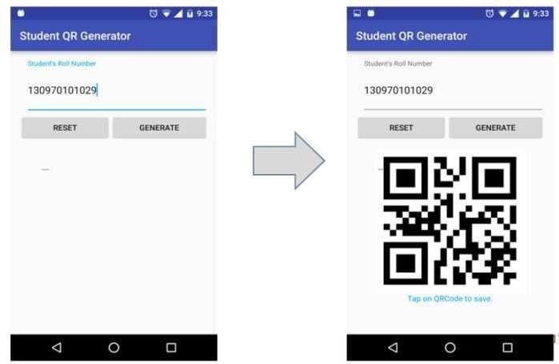

### Figure 7. QR code generation

* 1. **Adding subject to database**

For adding a subject, just fill the following field given in the screenshot:

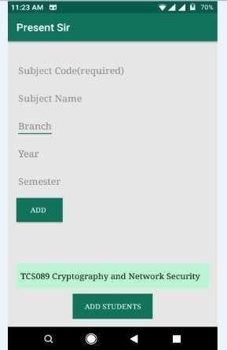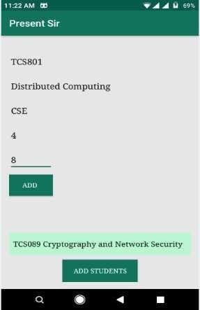

### Figure 8. Adding subjects and other details

* 1. **Adding student to database**

For adding the student first you need to select the desired subject in which you taking the attendance as shown in below:

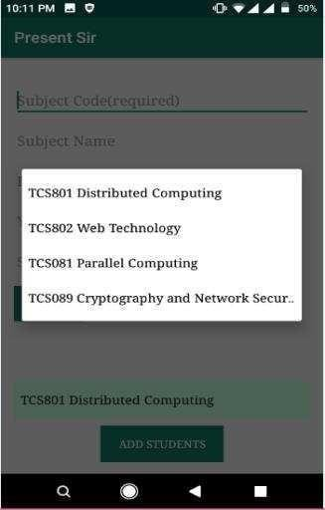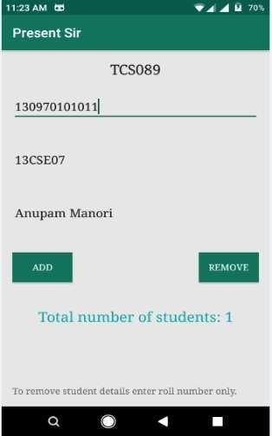

### Figure 9. Adding student to database

* 1. **Deleting subject from database**

If anyone need to delete a subject details permanently, teacher just need to enter the subject code:

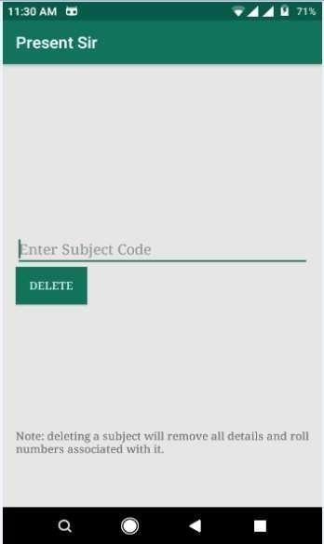

### Figure 10. Deleting subject from database

* 1. **Taking attendance**

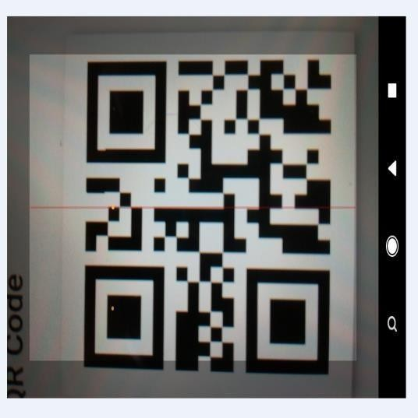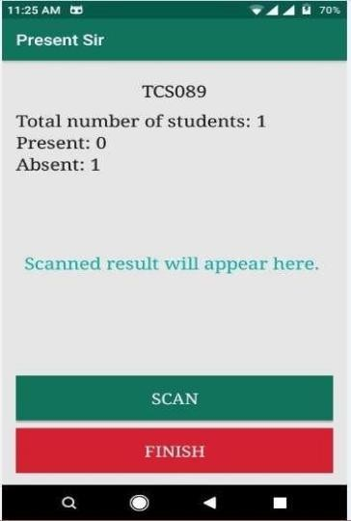

**Figure 11. Taking Attendance**

The right sided screenshot is the output of the scanned QR code this shows total number of students with number of students present as well as absent:

### Exporting attendance to CSV/XLS file

For exporting the overall attendance sheet in CSV/XLS format the teacher need to select the subject code.

Here is a screenshot of generated CSV file, 0 represents absent and 1 represents present:

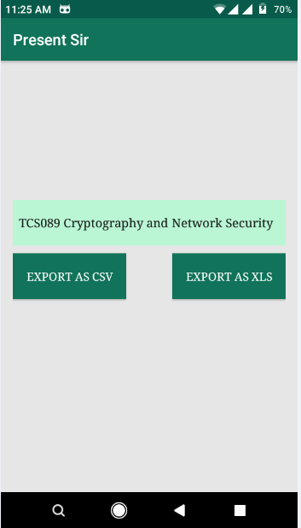

**Figure 12. Exporting Attendance to CSV File**

# Conclusion

The developed system presented in this paper has been successfully designed and tested. The student’s attendance status will be analysed and exported. Attendance monitoring system is very important in our daily life. It is possesses a really great advantage, among the whole types of code scanning technology, QR Code Based Smart Attendance System is the most accurate. In this project report, we have given an introduction of Attendance monitoring system and its advantage. It is an efficient method to store the attendance in the smart phone rather than wasting the paper.In conclusion, the literature on QR attendance systems reflects a growing interest in their implementation across various sectors. The studies discussed emphasize their effectiveness, user experience, security considerations, and integration with emerging technologies. As technology continues to evolve, ongoing research will likely contribute to refining and expanding the capabilities of QR attendance systems.

# Future scope

Our future work will focus on providing missed class topics and notes available to students. Full control to professor with more secured and enhanced options. Finally we conclude, if we integrates this attendance monitoring system with face identification tool then system will solve the real world attendance problem.

# Acknowledgement

We would like to thank my project guide “Mr. Ashutosh Rao”, HOD , Department of Computer Science & Engineering, Institute of Technology and Management, GIDA, Gorakhpur, U.P. for his valuable guidance and suggestions. I would like to thank my project coordinator “Mr. Nitin Dixit”, Associate Professor, Department of Computer Science & Engineering, Institute of Technology and Management,GIDA, Gorakhpur, U.P. for his valuable guidance and suggestions. I am thankful for his/her continual encouragement, support, and invaluable

suggestions. Without his encouragement and guidance, this project would not have been materialized. Throughout the writing of the project, I have received a great deal of support and assistance.I am very thankful to HOD “Mr. Ashutosh Kumar Rao” Department of Computer Science and Engineering, for his kind cooperation. I would also like to thank to the Honorable Director “Dr. N. K Singh” for his kind help and support. I would also like to thanks to all my friends who continuously supported me.I want to express my appreciation to every person who contributed either with inspirational or actual work to this project. Finally, I must express my very profound gratitude to my parents. Thanks to all. We also do not like to miss the opportunity to acknowledge the contribution of all faculty members of the department for their kind assistance and cooperation during the development of this paper.

1. Isha Pandey
2. Arjita Singh
3. Vikas Mishra

# References

1. Kumar, V. (2018). A High-Throughput FPGA-Based Architecture for Advanced Encryption Standard: AES-512 Using Pre-ciphered Lookup Table. Publisher. DOI:

<https://doi.org/10.1007/978-981-10-5903-2_5>

1. Masalha, F., & Hirzallah, N. (2014). A Students Attendance System Using QR Code. International Journal of Advanced Computer Science and Applications, 5(3), 75. DOI:

<https://doi.org/10.14569/IJACSA.2014.050310>

1. Wei, X., Manori, A., Devnath, N., Pasi, N., & Kumar, V. (2017). QR Code Based Smart Attendance System. International Journal of Smart Business and Technology, 5(1), 1-10. DOI:

<https://doi.org/10.21742/ijsbt.2017.5.1.01>

1. Wei, X., et al. (2017). QR Code-Based Smart Attendance System. Title of the Journal,Volume(Issue), pp. 1-10. <http://dx.doi.org/10.21742/ijsbt.2017.5.1.0>