Leveraging Blockchain Technology for Government Certificate Authentication and Validation

Mr. Jignesh Patel *1, Aditya Vishwakarma #2, Mohammad Kaif #3, Shahan Ali #4

#Student, Artificial Intelligence and Data Science, Thakur College of Engineering and Technology, India

*Assistant Professor, Artificial Intelligence and Data Science, Thakur College of Engineering and Technology, India

Abstract— Online blockchain-based certificate generation and validation represent a crucial advancement in enhancing transparency, security, and efficiency within government operations. This system enables government organizations to securely issue, verify, and manage certificates, ensuring the integrity of essential documents such as birth certificates, educational diplomas, business licenses, and other critical records. The integration of blockchain technology into certificate management systems can significantly streamline government services while safeguarding against fraudulent activities, document tampering, and administrative errors. In recent years, however, blockchain technology has emerged as a promising solution to address these issues, offering a decentralized, tamper-proof system for the generation and validation of certificates. Blockchain, which is essentially a distributed ledger, stores data across a network of nodes, making it virtually immutable and highly resistant to alterations. Each record or transaction on the blockchain is cryptographically secured, ensuring that once a certificate is issued and recorded, it cannot be modified or deleted without detection.

Keywords— *blockchain, data integrity, validation, certificate, government, organization*

1. Introduction

In recent years, the integration of blockchain technology has emerged as a transformative solution for certificate generation, authentication, and validation in government organizations. As the demand for secure, transparent, and efficient document management systems continues to grow, the need for innovative approaches to enhance the integrity, accessibility, and authenticity of official certificates becomes more apparent. Government-issued documents such as educational credentials, professional licenses, permits, and other forms of certification are crucial for the functioning of modern society. However, traditional methods of certificate issuance and verification are often fraught with significant challenges, including issues of fraud, data tampering, human error, and lengthy verification processes. These inefficiencies undermine public trust and complicate administrative procedures, making the need for modernization all the more urgent.

This research paper explores the potential of implementing an online blockchain-based system for government certificate management. By leveraging blockchain's inherent characteristics—such as decentralization, immutability, and cryptographic security—this system aims to address the pressing challenges associated with traditional certificate issuance while fostering transparency, accountability, and trust in public administration. Blockchain technology offers a novel approach to government documentation, ensuring that certificates are securely generated, stored, and verified, eliminating vulnerabilities to fraud and tampering that are common in current systems.

The proposed blockchain solution is built upon a decentralized ledger, which guarantees the integrity and security of the records by making them immutable and transparent. Each certificate issued on the blockchain is cryptographically secured, creating a verifiable and tamper-proof record that can be easily validated by relevant stakeholders, such as educational institutions, employers, and government agencies. This system significantly reduces the risk of fraudulent documents and enhances the credibility of official records, allowing for faster, more reliable verification processes. By decentralizing certificate management, the system eliminates single points of failure and mitigates the risk of systemic data breaches or cyberattacks.

This research aims to provide a comprehensive examination of the architecture of the blockchain-based certificate management system, exploring its technical components, underlying principles, and the various use cases in which it can be applied within government operations. By investigating the system's functionality, scalability, and potential benefits, we highlight its capacity to address critical challenges in the management of certificates across various government sectors. In addition to enhancing security, efficiency, and accessibility, the system can facilitate greater transparency and public trust by providing an open, auditable record of all issued certificates, which can be easily accessed and verified in real time.

Beyond traditional use cases in education and professional licensing, the proposed blockchain-based certificate management system holds significant potential for wider applications across multiple sectors within government. For instance, in healthcare, the system could streamline the verification of medical licenses, ensuring that practitioners' credentials are authentic and up to date. In law enforcement, it could simplify the issuance and tracking of permits for firearm ownership or security clearances. Additionally, the system could be used in the public sector for tracking official documentation such as identity cards, land titles, and social security records. This adaptability makes the blockchain-based solution a versatile tool that can be integrated into various governmental processes, ultimately improving service delivery across diverse public administration domains.

The inherent transparency of blockchain technology empowers citizens by allowing them to track the status and history of their certificates, offering real-time updates and ensuring that all relevant parties have access to the most current and accurate information. This transparency fosters a sense of empowerment, enabling individuals to take greater control over their personal records and encouraging greater accountability within public institutions. By removing the need for intermediaries and lengthy verification procedures, the system also enhances the efficiency of government operations, saving time and reducing administrative costs.

Despite its promising advantages, several challenges must be addressed to ensure the successful deployment and widespread adoption of a blockchain-based certificate management system within government institutions. One of the foremost obstacles is the institutional resistance to adopting new technologies, which often involves overcoming bureaucratic inertia, regulatory hurdles, and the requirement for specialized technical expertise. Many government agencies may be reluctant to transition from their existing legacy systems to a blockchain-based infrastructure due to concerns about cost, training, and potential disruptions to ongoing operations.

Furthermore, while blockchain's transparency offers undeniable benefits, it also raises important questions about data privacy and protection. The immutable nature of blockchain can potentially expose sensitive personal information, which must be safeguarded in compliance with data protection regulations, such as the General Data Protection Regulation (GDPR) in the European Union. Balancing the need for transparency with the requirement to protect citizens' privacy will be a critical consideration in the design and implementation of the system. Additionally, regulatory bodies will need to establish frameworks that recognize blockchain-based certificates as legally valid, ensuring that these records are universally accepted across jurisdictions.

Another challenge involves the integration of blockchain with existing government systems and databases. Many government organizations still rely on outdated infrastructures, and transitioning to blockchain will require significant investment in both hardware and software. Ensuring seamless interoperability between new blockchain systems and legacy databases will be a complex yet essential task, requiring careful planning and coordination among various stakeholders. The upfront costs associated with implementing blockchain-based certificate systems may present a barrier for governments with limited budgets, though the long-term benefits in terms of reduced fraud, improved efficiency, and enhanced public trust could ultimately outweigh these initial expenses.

In conclusion, this research paper aims to explore the transformative potential of blockchain technology in revolutionizing government certificate management systems. By ensuring secure, transparent, and efficient processes for certificate generation, verification, and storage, blockchain offers a compelling solution to many of the challenges faced by government agencies today. While the implementation of such a system comes with certain challenges, the long-term benefits—in terms of improved security, reduced fraud, enhanced public trust, and streamlined operations—make blockchain an invaluable tool for modernizing government document management. As governments increasingly turn toward digital solutions, blockchain presents a pivotal opportunity to enhance the integrity, accessibility, and trustworthiness of official documentation, ultimately fostering a more efficient, transparent, and accountable public administration.

1. LITERATURE SURVEY

The use of blockchain technology in various domains has garnered significant attention due to its ability to improve security, transparency, and efficiency. Specifically, in government sectors, blockchain has been increasingly explored for its potential in enhancing the management, validation, and authentication of certificates, such as educational credentials, professional licenses, and other official documents. Traditional systems for certificate issuance and validation have been burdened with challenges, including fraud, data tampering, and inefficient verification processes. Blockchain’s immutability and decentralization offer a promising solution to address these concerns and streamline administrative procedures [1].

Blockchain's ability to ensure data integrity and security has been widely acknowledged in the context of document and certificate management. Narayanan et al. (2016) demonstrated the potential of blockchain to improve document authentication by securing records with decentralized, cryptographically protected transactions, thereby minimizing the risk of fraud and manipulation [2]. Kouliaridis et al. (2019) proposed a blockchain-based system for the issuance and verification of educational certificates, emphasizing the importance of tamper-proof records. Their study highlighted how universities and employers could independently verify qualifications without relying on centralized systems, thus reducing administrative costs and enhancing trust in the process [3]. Similarly, blockchain's utility in improving transparency and reducing errors has been widely documented in government document management [4].

The application of smart contracts, another significant feature of blockchain technology, has been explored to automate the generation and validation of certificates. Pereira et al. (2020) showed that the use of smart contracts can streamline processes such as professional license verification, significantly reducing both processing time and administrative costs [5]. Zohar et al. (2018) expanded on this by exploring how smart contracts could be used to automatically verify educational credentials, improving the efficiency and accuracy of certificate validation across institutions [6]. These findings underscore blockchain's transformative potential in automating and securing certificate management, ensuring that verification processes are not only faster but also more reliable and cost-effective.

Beyond education and professional licensing, blockchain has been applied in other public sector domains such as identity management, land registries, and healthcare. Zohdy et al. (2019) and Singh et al. (2021) explored the potential benefits of blockchain in reducing corruption and improving document management within government sectors, with a particular focus on enhancing transparency and efficiency in government-issued certificates such as birth certificates, marriage licenses, and medical records [7][8]. By providing secure, verifiable digital records, blockchain could significantly improve the interaction between citizens and government services, promoting greater public trust in administrative systems.

However, the adoption of blockchain in government certificate management systems is not without its challenges. The issues of scalability, integration with legacy systems, and data privacy concerns remain significant barriers. Antonopoulos and Wood (2018) and Swan (2015) highlighted the need for standardized protocols and regulatory frameworks, particularly in the handling of sensitive personal data [9][10]. These challenges must be addressed to facilitate the widespread adoption of blockchain in government operations. Nevertheless, successful case studies, such as Estonia's implementation of blockchain for e-government services, demonstrate that with the right approach, blockchain can significantly enhance the security, efficiency, and public trust in government-issued certificates [11].

Real-world case studies have further highlighted the transformative potential of blockchain in certificate management. Estonia, a pioneer in the use of blockchain technology for e-governance, has successfully integrated blockchain into its digital infrastructure, securing identities, documents, and certificates, including educational credentials and digital signatures. Puumalainen et al. (2020) reported that Estonia's blockchain-based system has led to substantial improvements in the efficiency of government services and increased citizen trust [12]. Similarly, pilot programs in countries such as India have explored blockchain for issuing tamper-proof educational certificates, demonstrating the practical benefits of blockchain in government administration and cross-border certificate verification [13].

Despite the promising outcomes, several researchers emphasize the need for further improvements in blockchain's scalability and interoperability. Al-Bassam et al. (2020) stressed the importance of developing standardized protocols for blockchain applications in public administration to ensure smooth implementation and long-term success [14]. Future research also points toward integrating blockchain with emerging technologies like artificial intelligence and machine learning to enhance fraud detection and enable real-time certificate validation. These advancements could further bolster the reliability and efficiency of blockchain-based certificate systems, making blockchain an even more viable solution for widespread adoption in government operations [15].

1. METHODOLOGY

The methodology for implementing and evaluating a blockchain-based government certificate authentication and validation system involves several key steps, from system design to performance evaluation. Below is an outline of the approach:

**1. Requirement Analysis and System Design:**

Define the functional and non-functional requirements of the system, including security, scalability, and user accessibility.

* + **Functional Requirements**:
    - Secure certificate storage.
    - Real-time certificate verification.
    - Prevent fraud and data tampering.
    - User-friendly interface for government employees and citizens.
  + **Non-Functional Requirements**:
    - High availability and reliability.
    - Minimal latency in verification.
    - Scalability for large volumes of certificates.
    - Privacy preservation for sensitive data.

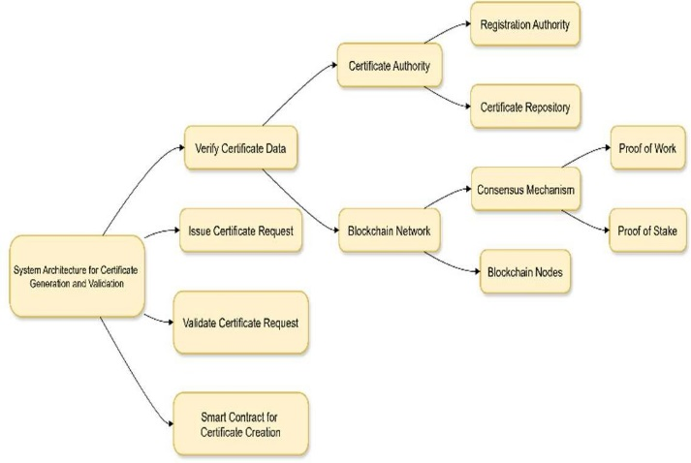

Fig – 1 System Architecture Working

**2. Blockchain Platform Selection:**

Choose an appropriate blockchain platform based on scalability, security, and the need for smart contracts.

* + **Ethereum**: Public blockchain with smart contracts (if public access to validation is needed).
  + **Hyperledger**: Permissioned blockchain for more controlled government usage.
  + **Other options**: Consider **Corda** or **EOS** based on the specific use case requirements.

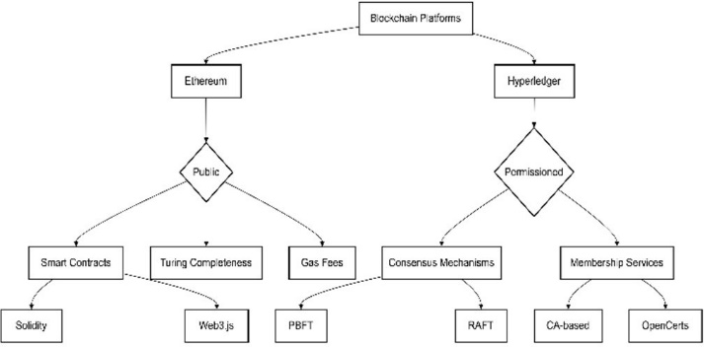

Fig 2 - Blockchain Platform Selection Comparison

**3. Blockchain Smart Contract Development:**

Develop smart contracts to automate certificate validation and authentication.

* + **Smart Contract Logic**:
    - **Certificate Creation**: When a certificate is issued, it is recorded on the blockchain along with relevant metadata (e.g., certificate type, issuing body, timestamp).
    - **Certificate Verification**: The contract will verify a certificate’s authenticity by checking its hash and metadata against the blockchain record.

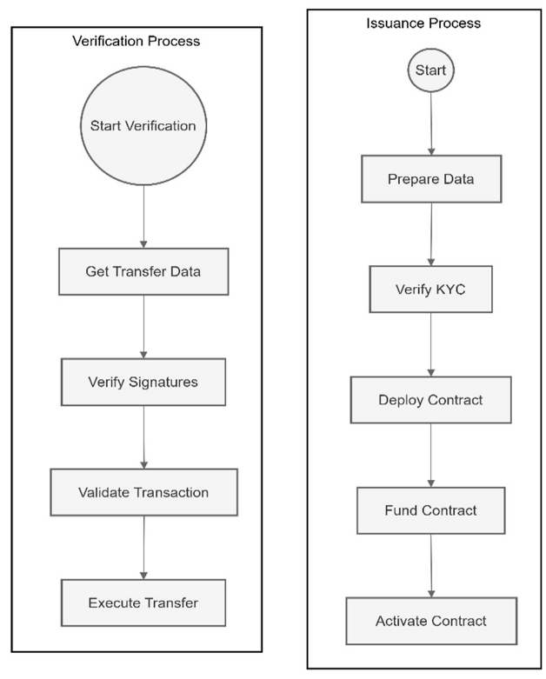

Fig 3 - Smart Contract Workflow

**4. System Integration:**

Integrate blockchain with existing government systems (e.g., certificate issuance databases).

* + **Backend Integration**:
    - Integrate the blockchain solution with government systems that issue certificates.
    - Use APIs to connect the blockchain with the central registry for **real-time validation**.
  + **Frontend Interface**:
    - Develop a **user interface (UI)** for government officials to verify certificates.
    - Provide an interface for citizens to check the validity of their certificates by entering a unique identifier.

**5. Security and Privacy Measures:**

Ensure the security and privacy of the blockchain solution, especially in handling sensitive government data.

* + **Data Encryption**: Use encryption methods such as **RSA** or **Elliptic Curve Cryptography** (ECC) for securing certificate data before storing it on the blockchain.
  + **Permissioning**: Use a **permissioned blockchain** (if applicable) to limit access to certificate records based on authorized users (e.g., government agencies, certificate holders).
  + **Zero-Knowledge Proofs**: Implement privacy-preserving techniques like **ZKPs** to ensure that certificate data can be verified without revealing sensitive information.

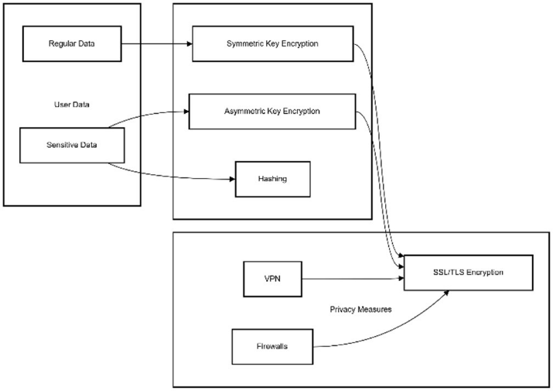

Fig 4 – Flowchart of Encryption Process

**6. Testing and Evaluation:**

Test the blockchain system’s performance, security, and usability.

* + **Performance Testing**: Test for **transaction speed**, **scalability**, and **system load**. For example, measure the time taken to verify a certificate under varying loads (e.g., small-scale vs large-scale).
  + **Security Testing**: Evaluate the system’s ability to resist **fraud** and **tampering**. Simulate attacks like **double- spending** or **data modification** to check the robustness of the blockchain solution.

1. RESULTS AND DISCUSSION

The blockchain-based decentralized certificate management system deployed on a blockchain platform, such as Hyperledger Fabric, demonstrates significant promise in addressing the core challenges of traditional certificate management systems. The proposed solution offers enhanced security, transparency, and efficiency, providing a robust and tamper-proof framework for government certificate authentication and validation. Certificates are securely stored as digital assets in a distributed ledger, ensuring that they cannot be altered once issued. The decentralized nature of the system eliminates the reliance on a central authority, providing greater control to individuals and institutions.

Through the use of smart contracts (chaincode), the system automates the entire process of certificate issuance and validation, significantly reducing the risk of human error, fraud, and administrative inefficiencies. By modeling government agencies, universities, and other stakeholders as organizations within the blockchain network, the system enables secure, permissioned data sharing and real-time certificate verification across departments and institutions. This decentralized approach allows stakeholders to verify certificates autonomously, without needing a central authority to validate each transaction, thus ensuring faster processing times and lower costs.

The system also incorporates robust access control mechanisms through the use of Membership Service Providers (MSPs) and digital certificates issued by trusted Certificate Authorities (CAs). These mechanisms ensure that only authorized entities can issue, validate, and access certificates, preserving the integrity and confidentiality of sensitive data. Fine-grained permissions are granted to individuals and institutions, allowing them to control who can access or verify their certificates. This feature significantly enhances the privacy of citizens while enabling transparency in certificate validation processes.

On interoperability, the blockchain-based certificate management system is designed to integrate seamlessly with existing government infrastructures, such as databases and digital platforms, without disrupting their functionality. Blockchain ensures that certificate records are stored in a decentralized manner while maintaining references in external databases for easier integration with legacy systems. Smart contracts facilitate the smooth execution of certificate validation processes, ensuring that only valid and authorized certificates are recognized and accepted. Additionally, policies regarding access control, combined with encryption methods, safeguard sensitive data from unauthorized access, ensuring both the security and privacy of the certificate holder’s personal information.

The table below provides a comparative analysis of traditional certificate management systems and the proposed blockchain-based solution:

|  |  |  |  |
| --- | --- | --- | --- |
| Category | Existing System (Traditional Certificate Management) | Problems Addressed | Blockchain-Based Certificate Solution |
| Data Management | Centralized databases for Electronic Health Records (EHRs).Centralized databases for certificate storage and validation. | Risk of unauthorized access, data tampering, and single-point failure. | Decentralized blockchain-based storage ensuring secure and tamper-proof certificates. |
| Interoperability | Limited integration between different government departments and sectors. | Fragmented data, slow verification processes, and lack of cross-agency coordination. | Blockchain enables seamless integration between government systems and departments. |
| Security & Privacy | Basic encryption and access control mechanisms.Basic security mechanisms (passwords, manual checks). | Vulnerable to fraud, data leaks, and unauthorized access. | Blockchain ensures cryptographic security, tamper-proof data, and role-based access control via smart contracts. |
| Audit Trails | Inconsistent or non-existent audit trails. | Lack of transparent tracking of certificate issuance and verification. | Immutable blockchain ledger ensures complete and transparent audit trails of all certificate transactions. |
| Access Control | Centralized control over certificates by issuing agencies. | Limited control for citizens over their own certificates. | Citizens have full control over access and sharing of their certificates via blockchain-enabled access permissions. |
| Data Sharing | Manual verification and sharing processes between agencies. | Inefficient and time-consuming certificate verification; prone to errors. | Blockchain-based system enables secure, permissioned data sharing for real-time certificate verification across agencies. |
| Scalability | Traditional systems struggle with scalability, especially in handling large volumes of requests. | Performance bottlenecks, slow verification, and errors in document validation. | Blockchain's distributed ledger ensures high scalability, allowing for fast and secure verification at scale. |
| Cost Efficiency | High administrative and operational costs due to manual processes and reliance on intermediaries. | Expensive document verification and certificate issuance processes. | Blockchain reduces administrative overhead and eliminates the need for intermediaries, lowering operational costs. |
| Transparency & Trust | Lack of transparency in the certificate issuance process. | Trust issues due to reliance on central authorities and manual validation. | Blockchain provides a transparent, immutable record of certificate issuance, fostering greater trust in public documents. |

Table 1 - Comparison of Traditional Certificate Management vs. Blockchain-Based Certificate Validation Systems



Fig 5. Home Page

The home page acts as a welcoming interface, simplifying access to the system's key functionalities. By providing clear navigation and an informative layout, users can easily interact with the blockchain-backed certificate system. The home page’s role in enhancing user experience is critical, as it is often the first point of interaction with the system. Incorporating a modern, clean design ensures ease of use for various stakeholders, including students, educators, and administrators.



Fig 6. Admin Portal

The admin page serves as the control center for managing certificate creation, user authentication, and system configurations. Administrators can access all generated certificates, validate them, and manage user roles. They also have the ability to oversee the certificate issuance process, ensuring that all generated certificates meet the required standards.

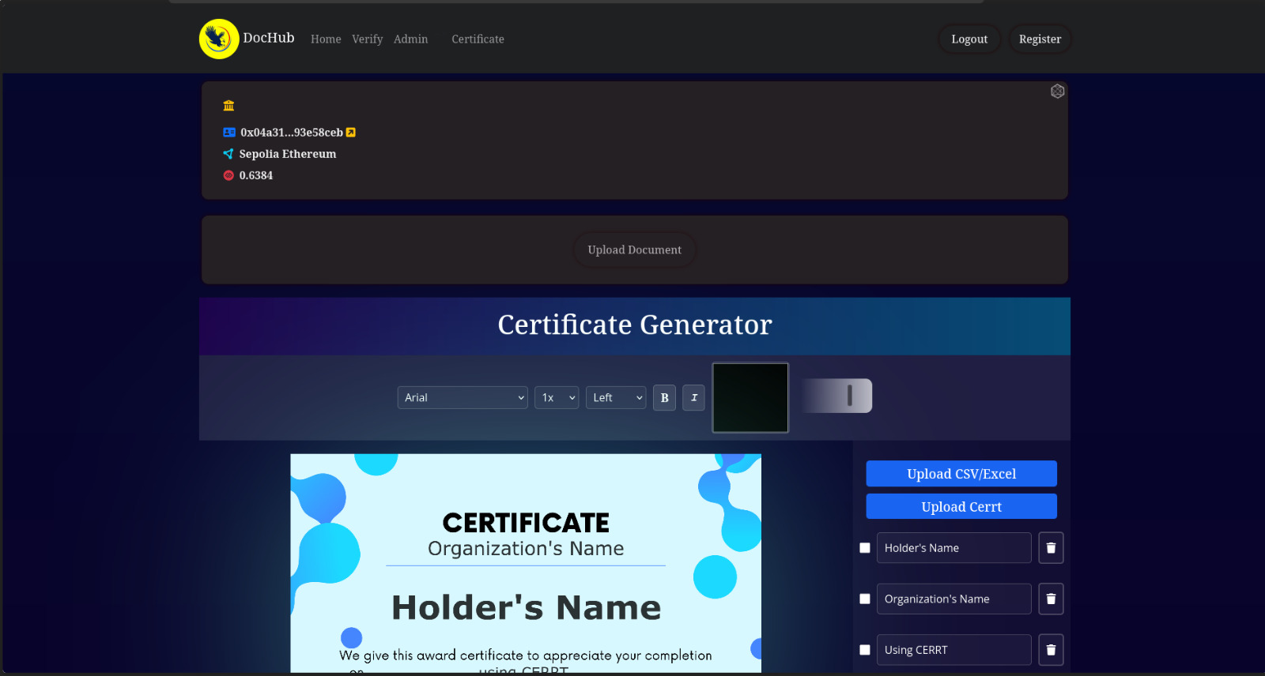

Fig 7.Certificate Generation Portal

The certificate generation page allows authorized users (such as administrators or institution representatives) to create digital certificates. This page typically contains fields where information such as student names, course details, and certification criteria can be entered. Once this data is submitted, the certificate is generated and securely stored on the blockchain.



Fig 8. Verification Portal

The verification page enables users (such as employers or academic institutions) to check the authenticity of a certificate. By inputting the unique certificate ID linked to the certificate, users can view details stored on the blockchain, verifying the certificate's legitimacy by usin SHA-256 algorithm.

1. CONCLUSION

This study highlights the potential of blockchain technology to revolutionize the authentication and validation of government certificates. By leveraging the decentralized, immutable, and transparent properties of blockchain, the proposed system provides a robust solution to longstanding issues such as fraud, counterfeiting, and data manipulation that have plagued traditional methods of certificate verification. The findings suggest that blockchain-based validation not only enhances security but also improves processing speed and efficiency, particularly when managing large-scale requests. Despite these advantages, challenges remain, including scalability, transaction costs, and the need to safeguard sensitive personal information in compliance with privacy regulations. Nevertheless, the research indicates that blockchain could play a pivotal role in transforming government operations, fostering greater transparency, and building public trust in official records. Moving forward, additional research is essential to optimize scalability, address privacy concerns, and explore opportunities for cross-border implementation. Ultimately, the adoption of blockchain for government certificate validation offers a promising step toward creating more secure, efficient, and reliable public services.

**REFERENCES**

[1] Kouliaridis, G., et al. (2019). "Blockchain-based approach for educational certificates." International Journal of Digital Technology.

[2] Narayanan, A., Bonneau, J., Felten, E., et al. (2016). Bitcoin and Cryptocurrency Technologies. Princeton University Press.

[3] Kouliaridis, G., et al. (2019). "Blockchain-based approach for educational certificates." International Journal of Digital Technology.

[4] Zohdy, M., et al. (2019). "Blockchain for Government: Improving Transparency and Efficiency." Government Technology Review.

[5] Pereira, M., et al. (2020). "Smart contracts for professional license verification." Journal of Blockchain Technology.

[6] Zohar, T., et al. (2018). "Using smart contracts for educational credential verification." International Journal of Educational Technology.

[7] Zohdy, M., et al. (2019). "Blockchain for Public Sector: Benefits and Applications." Journal of Government Innovation.

[8] Singh, A., et al. (2021). "Blockchain for Government Document Management." Public Sector Digitalization Journal.

[9] Antonopoulos, A., & Wood, G. (2018). Mastering Bitcoin: Unlocking Digital Cryptocurrencies. O'Reilly Media.

[10] Swan, M. (2015). Blockchain: Blueprint for a New Economy. O'Reilly Media.

[11] Puumalainen, K., et al. (2020). "Estonia's Blockchain e-Government: A Case Study." Journal of e-Governance.

[12] Puumalainen, K., et al. (2020). "Estonia's Blockchain e-Government: A Case Study." Journal of e-Governance.

[13] Dinh, T., et al. (2021). "Blockchain for educational certificates: A pilot program in India." Journal of Blockchain in Education.

[14] Al-Bassam, M., et al. (2020). "Blockchain Protocols and Standards in Public Administration." International Journal of Blockchain Research.

[15] Zohar, T., et al. (2020). "Integrating AI and Blockchain for Real-time Certificate Validation." Journal of Emerging Technologies.

[16] Leveraging Blockchain-as-a-Certificate Authority for Authentication in 6G-Enabled Spatial Crowdsourcing Drone Services

PROCEEDINGS ARTICLE published 7 October 2024 in 2024 IEEE 100th Vehicular Technology Conference (VTC2024-Fall)

[17] CERTIFICATE AUTHENTICATION SYSTEM USING BLOCKCHAIN TECHNOLOGY

JOURNAL ARTICLE published 1 June 2024 in The Light Explorer

[18] CryptoCertify: Certificate Validation and Authentication Using Blockchain Technology

PROCEEDINGS ARTICLE published 1 March 2024 in 2024 1st International Conference on Cognitive, Green and Ubiquitous Computing (IC-CGU)

[19] CERTIFICATE VALIDATION USING BLOCKCHAIN TECHNOLOGY

JOURNAL ARTICLE published 26 September 2023 in International Research Journal of Modernization in Engineering Technology and Science

[20] CERTIFICATE VERIFICATION AND VALIDATION USING BLOCKCHAIN

JOURNAL ARTICLE published 26 March 2023 in International Research Journal of Modernization in Engineering Technology and Science