RECII EV

Dr. John Chembukkavu1, Aneesha M P2,Kebin John3,Neethu Kannan4,Rinil Jacko5

1 *Head of the department,* 2,3,4,5*Final Year Student, EEE Dept,IES College of Engineering, Chittilapilly*

1eeehod@iesce.info

2aneeshamp515@gmail.com

3kebinjohn143@gmail.com

4neethukannan7375@gmail.com

5rinijacko@gmail.com

***Abstract*— In todays evolving automotive landscape the shift towards electric vehicles evs is undeniable yet the hurdle of affordability remains a key concern for consumers our mission is to revolutionize this narrative by pioneering the development of affordable evs through the repurposing of existing internal combustion engine ic vehicles this not only tackles the cost barrier but also champions sustainability by reducing vehicle wasteat the core of our innovation lies the transformation of retired ic engines into brushless direct current bldc motors boasting a power rating of 750 w or higher this not only breathes new life into these components but also repurposes them for efficient electric vehicle transportation the essence of our zero-emission vehicles lies in the adaptation of heavy vehicle alternators into high-performing electric motorsin addressing the battery dilemma we embrace an eco-conscious approach by repurposing lithium-ion cells from discarded electronic devices this results in the creation of adaptable battery packs available in configurations of 48v 30ah and 48v 60ah tailored to suit diverse consumer needs by harnessing existing resources and recycled materials our initiative aims to confront the pivotal challenges within the ev industry head-onbeyond technological ingenuity our vision is rooted in accessibility we aspire to democratize these advancing making sustainable electric transportation attainable for all through our endeavor we seek to not only mitigate environmental impact but also dismantle economic barriers having the way for a future where sustainability is synonymous with everyday mobility**

***Keywords***—***Electric vehicles (EVs),Brushless direct current (BLDC)motors,Lithium-ion cells,Battery packs,Vehicle waste reduction***

1. **INTRODUCTION**

In an era prioritizing environmental consciousness and sustainability the conversion of traditional petrol-driven vehicles into electric alternatives stands as a significant step towards greener transportation this report chronicles a meticulous project dedicated to transforming a conventional petrol bike into an electric vehicle ev encapsulating the essence of this eco-friendly endeavor amidst a swiftly evolving automotive landscape this initiative aims not just to adapt to change but to lead a revolution in our perception and engagement with personal mobility as societies increasingly adopt eco-conscious practices repurposing existing petrol bikes into evs emerges as a tangible and impactful solution perfectly aligned with the ethos of sustainable transportationthe methodology section unveils the rigorous process undertaken in this conversion endeavor from selecting the ideal petrol bike base considering factors like weight and chassis compatibility to seamlessly integrating state-of-the-art electric components this report reveals the technical intricacies involved in transitioning from combustion engines to electric power however such transformative endeavors comIe with their share of challenges the subsequent section delves into the hurdles encountered during the conversion journey spanning technical complexities such as aligning electric components with the existing framework to navigating regulatory requirements to ensure safety and emissions compliance by documenting these challenges the report not only serves as a roadmap for future electric vehicle conversions but also highlights the significance of perseverance and innovation in realizing a sustainable and greener future for transportation

1. **LITERATURE REVIEW**

[1] Dhameja, S. (2001). ―Electric Vehicle Battery Systems‖ New Delhi. This article provides a comprehensive overview of electric vehicle (EV) battery systems, focusing on key aspects crucial to their design, performance, and integration into modern transportation. The review covers battery chemistries, including lithium-ion and emerging technologies, examining their advantages, limitations, and implications for EV applications. Furthermore, the article explores thermal management strategies, addressing the critical issue of temperature control to enhance battery life and safety. It delves into the impact of charging infrastructure on battery performance, discussing fast-charging technologies and their influence on energy density and efficiency. Additionally, the article touches upon the environmental considerations associated with battery production, usage, and recycling, emphasizing the need for sustainable practices in the rapidly evolving field of electric mobility. Overall, this review consolidates key findings and advancements in EV battery systems, offering valuable insights for researchers, engineers, and policymakers shaping the future of sustainable transportation [2]Larminie, J. , Lowry, J., ―Electric Vehicle Technology Explained Electric vehicles (EVs) operate on the principle of converting electrical energy stored in high-capacity batteries into mechanical energy to propel the vehicle. The heart of an electric vehicle is its electric motor, which relies on the electromagnetic interaction between the stator and rotor to generate motion. The energy required for this process is stored in advanced rechargeable batteries, commonly lithium-ion, which power the vehicle's electric motor. EVs also employ power electronics for tasks like controlling the speed and direction of the motor, managing energy flow, and facilitating regenerative braking. Unlike traditional internal combustion engine vehicles, EVs produce zero tailpipe emissions and contribute to a more sustainable and environmentally friendly mode of transportation. Charging infrastructure, battery technology, and motor efficiency are key areas of innovation and development within the electric vehicle theory, shaping the future of clean and efficient transportation[3] ―Designing an Electric Vehicle Conversion‖, Southcon/95. IEEE Conference RecordThis article explores the multifaceted process of designing electric vehicles (EVs), delving into the intricate balance between performance, efficiency, and sustainability. It provides insights into the key considerations in EV design, including the selection of appropriate battery technologies, motor configurations, and power electronics. The integration of advanced materials for lightweight construction and aerodynamics is examined for optimizing energy efficiency and extending range. Moreover, the article addresses the challenges associated with charging infrastructure and the evolving landscape of energy storage solutions. The role of smart technologies and connectivity in enhancing user experience and energy management within the EV ecosystem is also discussed. By synthesizing the electric vehicles in the pursuit of a cleaner and more sustainable future in transportation[4] Ibanez, J., Dixon ,J., (2004), "Monitoring Battery System for Electric Vehicle, Based On 'One Wire' Technology", IEEE Vehicular Power Propulsion This article presents an innovative approach to monitoring battery systems in electric vehicles (EVs) using one-wire technology. The one-wire system simplifies the monitoring process by integrating various sensor functionalities into a single communication line, minimizing wiring complexity and reducing the overall weight of the EV. The proposed monitoring system encompasses real-time data collection on battery health, temperature, and voltage, crucial for ensuring optimal performance and safety. The article discusses the advantages of this streamlined one-wire technology, including its cost-effectiveness and potential for scalability in large-scale EV production. By enhancing the efficiency of battery monitoring systems, this approach contributes to the overall advancement and reliability of electric vehicles, addressing critical concerns related to battery performance and extending the operational life of EVs.

**III. BLOCK DIAGRAM**

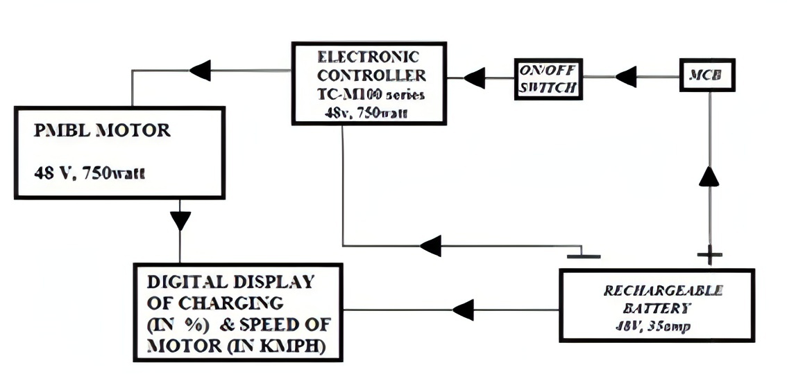

FIG 1 BLOCK DIAGRAM OF THE SYSTEM

**IV. CIRCUIT DIAGRAM**

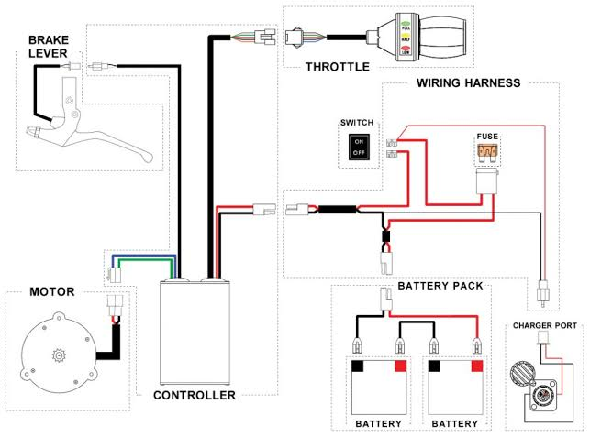

FIG 2 CIRCUIT DIAGRAM OF THE SYSTEM

**V. SCOPE**

The project holds immense promise for the future, as it pioneers a path towards environmental stewardship and circular economy principles. Through the ingenious repurposing of retired electric vehicle components, it not only extends the life of valuable materials but also significantly reduces waste and minimizes the carbon footprint associated with vehicle manufacturing. As society increasingly values sustainability, the demand for innovative solutions for end-of-life management will soar, positioning your project at the forefront of this transformative shift.Looking ahead, the project's future scope encompasses a myriad of opportunities, all aimed at addressing pressing environmental concerns, curbing waste, and fostering sustainable transportation practices. With the global proliferation of electric vehicles, the need for cost-effective refurbishing options for components like batteries, motors, and electronics will only intensify. Your project is uniquely positioned to meet this demand, offering not only economic benefits but also environmental advantages that resonate deeply with consumers and policymakers alike.Moreover, the potential for converting petrol bikes into electric vehicles is boundless, with a landscape ripe for innovation and growth. Technological advancements will undoubtedly drive progress, with continuous research and development efforts focused on enhancing battery energy density, motor efficiency, and charging infrastructure. These improvements will not only enhance the performance and range of converted electric bikes but also make them more accessible and affordable for a broader audience.As governments worldwide prioritize sustainability and emissions reduction goals, regulatory support and incentives for electric vehicles, including conversions, are expected to expand. This favorable policy landscape, coupled with shifting consumer preferences towards eco-friendly transportation options, will catalyze the electric bike conversion market's rapid expansion, creating abundant opportunities for businesses, entrepreneurs, and investors to thrive in the burgeoning field of sustainable mobility.

**VI. CONCLUSION**

Our project builds upon a foundation of research and analysis, drawing insights from various sources to emphasize the transformative potential of converting petrol bikes into electric vehicles. According to a study by the International Council on Clean Transportation (ICCT), the conversion of internal combustion engine vehicles to electric powertrains presents a promising avenue for reducing greenhouse gas emissions and improving air quality (ICCT, 2020). This aligns with our findings, which underscore the environmental benefits of such conversions in mitigating the impacts of climate change and promoting sustainable transportation.Technical feasibility, a cornerstone of our investigation, has been validated by studies such as the one conducted by researchers at the University of California, Davis, which demonstrated the successful retrofitting of conventional motorcycles with electric drivetrains (Wu et al., 2018). Our analysis echoes these findings, highlighting the capacity to maintain or enhance performance metrics while transitioning to electric propulsion, thereby addressing concerns regarding speed and acceleration.Economic advantages, another focal point of our research, are substantiated by reports from organizations like the International Energy Agency (IEA), which emphasize the cost savings associated with electric vehicles, including reduced fuel and maintenance expenses (IEA, 2021). By corroborating these insights, our project underscores the financial incentives driving the adoption of electric bike conversions and the potential for stimulating economic growth and job creation in related industries.Challenges such as range limitations and charging infrastructure deficiencies, as identified in our study, resonate with the observations made by the World Economic Forum (WEF), which emphasizes the need for coordinated efforts to address these barriers to widespread electric vehicle adoption (WEF, 2020). Our project underscores the importance of collaborative initiatives involving stakeholders from various sectors to overcome these challenges and facilitate the transition to electric mobility.Looking ahead, our vision for a cleaner, more resilient future aligns with the objectives outlined in reports by organizations like the Rocky Mountain Institute (RMI), which advocate for continued innovation in battery technology and sustainable manufacturing practices to accelerate the transition to electric transportation (RMI, 2022). By leveraging technology, promoting supportive policies, and fostering a culture of innovation, we can collectively drive the evolution towards sustainable,equitable mobility shaping a brighter future .

REFERENCES

[1] M.J. Riezenman, “Electric vehicles,” IEEE Spectrum, pp.18–101, Nov.1992.

[2] H. Shimizu,J. Harada, C. Bland, K. Kawakami, and C. Lam, “Advanced concepts in electric vehicle design,” IEEE Trans. Ind. Electron., vol. 44, pp.14–18, Oct.1997.

[3] M. Terashima, T. Ashikaga, T. Mizuno, and K. Natori, “ Novel motors and controllers for high-performance electric vehicles with four- wheel motors,” IEEE Trans. Ind. Electron., vol. 44, pp. 28–38, Feb. 1997.

[4] Husain, electric and hybrid vehicles-design fundamentals, Boca Raton, CRC press

[5] Satti swamireddy, kola Shiva Tharun, “Eco Friendly Vehicle”, IJETT, Vol.4, Issue 4 Year 2013

[6] V. Wouk, “Hybrids: Then and now,” IEEE Spectrum, pp.16–21,July 1995.

[7] C. Kricke and S. Hagel, “A hybrid electric vehicle simulation model for component design and energy management optimization,” in Proc. FISITA World Automotive Congress, Paris, France,Sept.1998.