ResearchOnSmartBabyCradleUsingSensorTechnology

**Shubhangi Roshan Katakwar                                           Assistant Prof. Sunil Vasant Kuntawar**

**Department of Electronics & Telecommunication,              Department of Electronics & Telecommunication,**

**BIT college, Ballarpur.                                                           BIT college, Ballarpur.**

Shubhangikatakwar2396@gmail.comsunilkuntawar22@gmail.com

**ABSTRACT—**Acradleisadevicedesigned to help babies fallasleep, employing a gentle side-to-side rocking motion. However, itdemandsconsiderablephysicaleffortfromparentstomanuallygenerate this swinging motion. Additionally, constant supervision isrequired to monitor the baby's activities when they are placed insidethe cradle. In the contemporary age of technological advancement,parents frequently grapple with a myriad of challenges in balancingtheirprofessionalresponsibilities with the nurturing needs of theirchildren.

Our paper aims to address the prevalent issues faced by parents byintroducinganinnovativeIoT-basedSmartCradleMonitoringSystem. The key objective is to alleviate the parenting challenges bycreatingasolutionthataidsintheseamlessmonitoringofinfants.TheSmartCradlefeaturesanautomatedswingingmechanismtriggered by the detection of a baby's crying sound. Additionally, itincorporatesabuilt-incameratoprovidecontinuous surveillance,empoweringparentswith an enhanced ability to keep a vigilant eyeontheirchild. To achieve this functionality, we have seamlesslyintegratedcomponentssuchasArduino,soundsensors,wetnesssensors,andtheswingingmechanism,amongotherelectronicelements,intothetraditionalcradledesign.Thisupgradedsolutionnotonlyoffersheightenedefficiencyandreliabilitybutalsosurpassesthecapabilitiesofconventionalcradles,providingparentswithamoreeffective means of caring for their infants.

# KEYWORDS-IoTTechnology,SmartBabyCradle.

1. **INTRODUCTION**

In recent decades, a substantial migration trend, particularly amongwomen in the workforce, has seen individuals flock to metropolitanareasinsearchofimprovedjobprospects.Thisphenomenonisespecially challenging for dual-income couples, where both partnersare employed, leading to difficulties in allocating sufficient time andcarefortheirinfants.TheCOVID-19pandemic exacerbated thesechallenges as remote work became prevalent, intensifying the delicatebalance between professional commitments and parenting duties. Thisstruggle became even more pronounced when infants fell ill, requiringconstant monitoring and potentially forcing parents to take leave fromwork. This not only impacts the career trajectories of parents but alsoplacessignificantstressonthem.Thefusionoftechnologicalinnovationwiththefundamentalfabricofchildcarepresentsanopportunity to redefine parenting dynamics in the digital era.

OurproposedSmartCradleSystem,atestamentto this symbioticrelationship between technology and caregiving, seamlessly integratesan array of sensors and intelligent mechanisms to create a nurturingenvironment for infants.

In response to the pressing need to ease the challenges associated withmonitoringandnurturingchildren,ourpaperintroducesacutting-edge solution: an automated Smart Cradle System leveragingIoT technology. This system is specifically designed to assist parentsin efficiently monitoring their children, whether they are at work or athome. Through the implementation of this IoT-based smart cradlesystem, our aim is to grant parents the peace of mind that comes fromknowingtheirchildisbeingcaredforandmonitoredeffectively.This,

inturn,enablesthemtobetternavigate the balance between theirprofessionalandparentingresponsibilities.Byembracingthistechnologicalleapinchildcare,weenvisionalandscapewhereparents no longer need to compromise their professional aspirationsforthesakeoftheir children's well-being. Instead, they can strideconfidently knowing that their infants are receiving the utmost careand attention, while they continue to contribute meaningfully to theircareersand society at large.

As we navigate the complex terrain of modernity, the Smart CradleSystemservesasabeacon—atestamenttotheharmoniouscoalescence of technological ingenuity and compassionate caregiving,paving the way for a more balanced, empowered, and nurturing futurefor both parents and their cherished little ones.

# LITERATUREREVIEW

1. Symon,Aslam Forhad et al. In this the author presents ababy monitoring system for busy parents so that they canensurethepropercareandsafetyoftheirbabies.Thissystem can detect the baby’s motion and sound; especiallycryingandvideooutputof the baby's present position canbedisplayedonadisplaymonitorso that the mother oranother responsible person can watch the baby while awayfromhim or her.
2. S. Brangui, et. al, In this paper the author intends to build ontheexisting related work and suggests an enhanced noisecancellingsystemforacomprehensivemonitoringandcontrol to overcome the sound pollution and make the babyrooms more comfortable. The proposed system design andimplementationarediscussedandthecorrespondingcomponentsaredetailedwiththeirinteractions.Additionally,a draftcost estimationis presented.
3. Prof. A.D. Anjikar, et. al, In this paper the author designedanautomatic baby rocker having a noise sensor to detectbabycry.Thegoalofthisframeworkistostructureashrewd infant support with numerous highlights which helpsin checking the children and updates the infant's status toguardians.
4. YangHu;WeihuaGuiet.al,Inthispapertheauthorproposed a system for adjusting the bassinet swaying extentbythesensorsignals.Thebassinetismadeupofanadaptiveswayingdeviceandothersensornetwork.Toimprove the household management and decrease the youngparents'Labourintensity,a newbabybassinet ismade.

a.

Marie R. Harper, et. al, In this paper the author invented acrib adapted to be rocked through an app. A baby crib orcradle adapted to be rocked automatically by an oscillatory,actionmotorhavingthe same effect as would be achievedbyamother rocking a crib containing an infant, the cribbeing pivotally supported at each end thereof to a supportrack and stand. The lower portion or bottom of the crib isadapted to be operable connected to the motor. The motoralsoincludesaregulating,reciprocatingmeansformotion

1. GimWong,ET.Al,Inthispapertheauthor presented anElectronicdevicethatcanbeattachedtoconventionalpivotallymountedtypecrib. Thepresentdeviceiselectronicallyactuatedandmaybeconnectedtoaconventionalcribwhichisoftenmanuallyrockedbypushingand pulling on the foot or headboard to give theslightrockingactiondesired.Thedeviceispreferablyactuated by a baby's voice picked up by a microphone ormicrophones and the periodicity and duration of the rockingmay be adjusted within limits. It can also be set into motionby manual actuation of a switch.
2. Chau-Kai-Hsieh, et. al, In this paper the author proposed ababy cry recognizer which includes an amplifier circuit foramplifying a received sound signal. This paper presents thedesignand implementation of a new indigenous low costE-Baby Cradle that swings automatically when baby cries,for this it has a cry analysing system which detects the babycryvoiceand accordingly the cradle swings till the babystops crying.
3. AmritaEbenezeret.al, In this paper the author gives anapproachtodesignababycradleconsistingofacryanalysing system which detects baby cry. Our project is anovel approach in designing an automatic cradle swingingsystemforassistinginfantcare.Thisequipmentcanbemainly used in the hospitals to provide aid to the nurse intakingcareof the infant or at home to monitor the babywhile the parent is at work and the baby is under the care ofbaby sitters.
4. Amin Shaikh1, et. al, In this paper the author proposed thiscradlesystem.There's a desire for a product that bridgesthisgap between parents and baby. This cradle system isproposed to assist these parents so they'll take excellent careof their baby from remote locations.
5. Sarah Ahmed Alswedani1 et. al, The author in this researchpaper provides significant attention on detecting baby cry,more accurately, by integrating four-sub modules in the cryclassification process including voice analysis, face imageanalysis, body gesture analysis, and finally decision fusion.
6. N. Saude and P. A. H. Vardhini, This paper presents IoTbasedsmartsystemsthatactasbabycradlemonitoringsystemsforengagedor working parents so that they canmanage properly, and also for proper care and safety of theinfant. Parents can recognize the baby's movement, soundlike crying and video output of the baby's present positionand motion will be visible on a screen monitor so the parentoranypersoncanwatchthe infant even while away fromthebaby.Thiscradlesystemisusefulfor monitoring ordetectingmovementandcryingconditionsofthechildautomatically.
7. H. M. Ishtiaq Salehin, et al. In this paper, they are using averyefficientanduser-friendlytechnologytoimplementautomaticswingingofthebabybassinetwithsounddetection of the baby crying using sound sensor and playinglullabythroughspeakers.Thehumiditysensorhasbeenused to know the diaper's moisture level, and notificationshavebeen sent to parents with certain conditions throughmobile calls and text messages. A webpage using HTMLand CSS has been developed, where parents/guardians cansupervisethe baby in real-time. Finally, the system willdetect if the baby is in the cradle using the face recognitiontechnique.
8. M. P. Joshi and D. C. Mehetre, This paper presents thedesignofSmartCradlewhichsupportssuchvideomonitoring.Thiscradleswingsautomaticallyondetectionof baby cry sound. Also it activates buzzer and gives alertson phone if-first, baby cry continues till specific time whichmeansnowcradlecannothandlebabyandbabyneedspersonal attention and second, if the mattress in the cradle is wet. This cradle has an automatic rotating toy for baby's entertainment.
9. W. A. Jabbar, et al. In this paper, the author designed asystem,whichconsistsofaNodeMicro-ControllerUnit(NodeMCU) Controller Board that is exploited to gather thedatareadbythesensorsanduploadedviaWi-FitotheAdaFruitMQTTserver.Theproposedsystemexploitssensorstomonitorthebaby'svitalparameters,suchasambient temperature, moisture, and crying. A prototype oftheproposedbabycradlehasbeendesignedusingNxSiemens software, and a red meranti wood is used as thematerial for the cradle. The system architecture consists of ababycradlethatwillautomaticallyswingusinga motorwhen the baby cries. Parents can also monitor their babies'condition through an external web camera and switch on thelullabytoylocatedonthebabycradleremotelyviatheMQTTserver to entertainthe baby.
10. Gare,HarshadSuresh,etal.Inthispaper,the author isproposing an automated cradle system which will connect totheparent’smobileforsendingalertmessages.Soundsensor will be attached to cradle in such a way that it willtakeinput sound of baby only, it will conclude the activityto be performed as per the range of sound in decibels, if thesoundismorethancertainamountthensystemwillautomaticallystartswingingthecradle,ifbabystillnotsleepyorstopcryalertwillsend to the parents. Motionsensor that is PIR sensor will detect the motion it is used forsecurity purpose and in point of view of any danger, if thereis too, much motion detected alert will send to the parents.Wet sensor is used for check that the baby has pee? If anykind of wetness is detected it will send the alert message tothe parents. There will be two temperature sensors used thatare DHT11 and LM35, DHT 11 will check the temperatureofthewholeroomandLM35sensorwillmeasuretemperatureofthebody,anditwillalerttheparent ifthereis a huge change.
11. N. L. Pratap,et al. In this paper, the authorproposed asystem, a smart cradle with an automated baby monitoringsystemwasdeveloped.TheS.ODIboardisusedforinterfacing the sensors and actuators. The baby monitoringsystem is attached to the cradle so that an incubator kind ofenvironmentwillbecreatedforthebaby.Thebabymonitoring system monitors the baby 24×7. The measuredparametersregardingthebaby'shealthliketemperature,heartbeat rate, dampness on the baby bed will be displayedin the mobile application. If the recorded readings show anyabnormalities,thenecessaryactionslikecontrollingtemperature,switchingonoroffthefan,settingupthecradle's movement, and playing music for the baby will betaken. If the readings seem abnormal, the caretaker alongwith the parents will get an alert message. The motion andposture status of the infant can be monitored using motionEye OS.
12. Prusty, Vedanta, Abhisek Rath, et al. In this paper, By usingthe concepts of Internet of Things, Embedded Systems &Cloud Technology, the author aims to build a smart systemthatcanbe productively used for efficient child care andmanagement. In this paper they have focused on the child’ssecurity and hygiene issues so as to raise the child in a goodand healthy environment.
13. V. P. Hotur, et al. In this paper, the author introduces acradlethatincludesanMP3playerforsoothingmusic,temperaturedetectorandbedwetsensorembeddedintoESP32wroom(microcontroller)platform.Availabilityofhigh speed internet facilitates using IoT platform with ease,and any ambiguity caused to the infant will be reported toparents in the form of SMS via GSM. Prevention for childabuse is also taken care in our model.
14. Kumar,V.Suresh,LokaiahPullagura, et al. This paperintroducesthenotionofasmartcradle,whichenablesfor

imparting the actuating movement of the crib in a smoothrocking motion

1. GimWong,ET.Al,Inthispapertheauthor presented anElectronicdevicethatcanbeattachedtoconventionalpivotallymountedtypecrib. Thepresentdeviceiselectronicallyactuatedandmaybeconnectedtoaconventionalcribwhichisoftenmanuallyrockedbypushingand pulling on the foot or headboard to give theslightrockingactiondesired.Thedeviceispreferablyactuated by a baby's voice picked up by a microphone ormicrophones and the periodicity and duration of the rockingmay be adjusted within limits. It can also be set into motionby manual actuation of a switch.
2. Chau-Kai-Hsieh, et. al, In this paper the author proposed ababy cry recognizer which includes an amplifier circuit foramplifying a received sound signal. This paper presents thedesignand implementation of a new indigenous low costE-Baby Cradle that swings automatically when baby cries,for this it has a cry analysing system which detects the babycryvoiceand accordingly the cradle swings till the babystops crying.
3. AmritaEbenezeret.al, In this paper the author gives anapproachtodesignababycradleconsistingofacryanalysing system which detects baby cry. Our project is anovel approach in designing an automatic cradle swingingsystemforassistinginfantcare.Thisequipmentcanbemainly used in the hospitals to provide aid to the nurse intakingcareof the infant or at home to monitor the babywhile the parent is at work and the baby is under the care ofbaby sitters.
4. Amin Shaikh1, et. al, In this paper the author proposed thiscradlesystem.There's a desire for a product that bridgesthisgap between parents and baby. This cradle system isproposed to assist these parents so they'll take excellent careof their baby from remote locations.
5. Sarah Ahmed Alswedani1 et. al, The author in this researchpaper provides significant attention on detecting baby cry,more accurately, by integrating four-sub modules in the cryclassification process including voice analysis, face imageanalysis, body gesture analysis, and finally decision fusion.
6. N. Saude and P. A. H. Vardhini, This paper presents IoTbasedsmartsystemsthatactasbabycradlemonitoringsystemsforengagedor working parents so that they canmanage properly, and also for proper care and safety of theinfant. Parents can recognize the baby's movement, soundlike crying and video output of the baby's present positionand motion will be visible on a screen monitor so the parentoranypersoncanwatchthe infant even while away fromthebaby.Thiscradlesystemisusefulfor monitoring ordetectingmovementandcryingconditionsofthechildautomatically.
7. H. M. Ishtiaq Salehin, et al. In this paper, they are using averyefficientanduser-friendlytechnologytoimplementautomaticswingingofthebabybassinetwithsounddetection of the baby crying using sound sensor and playinglullabythroughspeakers.Thehumiditysensorhasbeenused to know the diaper's moisture level, and notificationshavebeen sent to parents with certain conditions throughmobile calls and text messages. A webpage using HTMLand CSS has been developed, where parents/guardians cansupervisethe baby in real-time. Finally, the system willdetect if the baby is in the cradle using the face recognitiontechnique.
8. M. P. Joshi and D. C. Mehetre, This paper presents thedesignofSmartCradlewhichsupportssuchvideomonitoring.Thiscradleswingsautomaticallyondetectionof baby cry sound. Also it activates buzzer and gives alertson phone if-first, baby cry continues till specific time whichmeansnowcradlecannothandlebabyandbabyneeds

personal attention and second, if the mattress in the cradle iswet.Thiscradlehas an automatic rotating toy for baby'sentertainment.

1. W. A. Jabbar, et al. In this paper, the author designed asystem,whichconsistsofaNodeMicro-ControllerUnit(NodeMCU) Controller Board that is exploited to gather thedatareadbythesensorsanduploadedviaWi-FitotheAdaFruitMQTTserver.Theproposedsystemexploitssensorstomonitorthebaby'svitalparameters,suchasambient temperature, moisture, and crying. A prototype oftheproposedbabycradlehasbeendesignedusingNxSiemens software, and a red meranti wood is used as thematerial for the cradle. The system architecture consists of ababycradlethatwillautomaticallyswingusinga motorwhen the baby cries. Parents can also monitor their babies'condition through an external web camera and switch on thelullabytoylocatedonthebabycradleremotelyviatheMQTTserver to entertainthe baby.
2. Gare,HarshadSuresh,etal.Inthispaper,the author isproposing an automated cradle system which will connect totheparent’smobileforsendingalertmessages.Soundsensor will be attached to cradle in such a way that it willtakeinput sound of baby only, it will conclude the activityto be performed as per the range of sound in decibels, if thesoundismorethancertainamountthensystemwillautomaticallystartswingingthecradle,ifbabystillnotsleepyorstopcryalertwillsend to the parents. Motionsensor that is PIR sensor will detect the motion it is used forsecurity purpose and in point of view of any danger, if thereis too, much motion detected alert will send to the parents.Wet sensor is used for check that the baby has pee? If anykind of wetness is detected it will send the alert message tothe parents. There will be two temperature sensors used thatare DHT11 and LM35, DHT 11 will check the temperatureofthewholeroomandLM35sensorwillmeasuretemperatureofthebody,anditwillalerttheparent ifthereis a huge change.
3. N. L. Pratap,et al. In this paper, the authorproposed asystem, a smart cradle with an automated baby monitoringsystemwasdeveloped.TheS.ODIboardisusedforinterfacing the sensors and actuators. The baby monitoringsystem is attached to the cradle so that an incubator kind ofenvironmentwillbecreatedforthebaby.Thebabymonitoring system monitors the baby 24×7. The measuredparametersregardingthebaby'shealthliketemperature,heartbeat rate, dampness on the baby bed will be displayedin the mobile application. If the recorded readings show anyabnormalities,thenecessaryactionslikecontrollingtemperature,switchingonoroffthefan,settingupthecradle's movement, and playing music for the baby will betaken. If the readings seem abnormal, the caretaker alongwith the parents will get an alert message. The motion andposture status of the infant can be monitored using motionEye OS.
4. Prusty, Vedanta, Abhisek Rath, et al. In this paper, By usingthe concepts of Internet of Things, Embedded Systems &Cloud Technology, the author aims to build a smart systemthatcanbe productively used for efficient child care andmanagement. In this paper they have focused on the child’ssecurity and hygiene issues so as to raise the child in a goodand healthy environment.
5. V. P. Hotur, et al. In this paper, the author introduces acradlethatincludesanMP3playerforsoothingmusic,temperaturedetectorandbedwetsensorembeddedintoESP32wroom(microcontroller)platform.Availabilityofhigh speed internet facilitates using IoT platform with ease,and any ambiguity caused to the infant will be reported toparents in the form of SMS via GSM. Prevention for childabuse is also taken care in our model.
6. Kumar,V.Suresh,LokaiahPullagura, et al. This paperintroducesthenotionofasmartcradle,whichenablesfor

this kind of video monitoring to be carried out on an infant.An infant’s scream triggers the automated swinging of thiscradle, which begins when the sensor detects it. In addition,if the baby’s cry persists for an extended period of time, thegadgettriggersabuzzer and sends a text message to thephone,signallingthatthecradleisnolonger capable ofhandlingtheinfantandthatthebabyneedshumanassistanceifthecradle’smattressiswet.Thiscradleisequippedwithanautomaticspinningtoyforthebaby’sentertainment, which reduces the likelihood of a newborncryingthroughout the day.

1. Ullah, Ahsan, and Afzal Hossain. In this paper, the authorintroducesasystemwhichis an automatic music systemthat will be activated as soon as the baby's crying level isdetected while the baby is in the swing, which will help stopthe baby's crying. The prototype of the proposed system hasbeen developed and tested to prove its effectiveness in termsofcostandsimplicityandtoensuresecureoperation toenablechildparentinganywhereandanytimeoverthenetwork.
2. S. Durga, S. Itnal, K. Soujanya, et al. Here in this paper, theauthor proposed an algorithm which can effectively monitorthe babies from distance and here a specialised algorithm isproposed. Here the proposed design consists of NodeMCU(Node Microcontroller unit) and the breadboard and also thesensorswhichareusedforacquiringthedata.HeretheproposeddesignconsistsofNodeMCU(NodeMicrocontroller unit), the breadboard and also the sensorswhich are used for acquiring the data. Here the parametersare crying, moisture and ambient temperature.
3. R.Sonia,S. M. Jayadeva, et al. In this paper, the authoraimsatthe construction of a smart cradle. This cradle isdesigned using various input elements, output elements, acontrollermodule,andamobileapplication.Theinputelementsconsistofatemperaturesensor,asoundsensor oramicrophone,amoisture sensor, and a music player. Theoutputelementsinclude the motor and The controller usedin this study is the NodeMCU module. Cloud storage is alsoused and it is provided by the Arduino loT software. Thesensorsinthesmartcradlebeginrecordingrelevantparameterssuchastemperature,humidity,andsoundassoon as it is turned on. The information is then uploaded tothecloudThedataisthenprocessedinthecloudforanalysis. If indeed the child's temperature is over the saferange, the user receives a warning. Moisture levels abovenormal suggest that the infant has urinated. The sound of thebaby crying will be recorded in the microphone. The outputelements are energised as a result of the sensor's data. If thebaby has a high fever or has to go to the bathroom, the appwill notify the parent.
4. Chauhan,Harsha,Deepali Gupta, et al. In this paper, theauthor have proposed a solution based on IoT and BT formonitoring the infants or toddlers. This proposed solutionwillhelptoreducetheburdenofparentsandhealthcarestaffby enabling the features of security and alarm systems.
5. Wadhokar, Nisha, and Balasaheb Tarle. In this paper, theauthor projects the personification of a Smart Baby Cradle,brought about by integrating distinctive features, i.e., cradleswing.Thedatareadbythe sensors are gathered by thedevelopedsystem'sNodeMicro-ControllerUnit(NodeMCU)ControllerBoard and uploaded via Wi-Fi totheBlynkserver.Theproposedsystemprototypeisfabricated and tested to prove its effectiveness in simplicityand to ensure safe operation to enable the baby-parentinganywhereandanytimethroughthenetwork.Thesystemmonitorsthebaby'ssituationandsurroundingseffectively.
6. Perumal,Vigneshwaran.etal.Inthispaper, the authorproposed a cradle system which will be implemented withsensorsandprocessedbyARDUINO.Withthehelpofthesesensors an Arduino is able to monitor the baby in the cradlesystem.Theproposednewdesignsystemimplementedin

thetraditionalcradlesystemmakesitmoreconvenienttouse for caring mothers.

# METHODOLOGY

Infants or toddlers need parent’s attention 24x7, in this modern era,parents are involved in firm exploitation, office ferment and personalknead. So, they won’t be able to take care of their children. Therefore,inthispaperweproposedaSmartbabycradleusingsensortechnology.This isan IoT basedpaper.

In this paper we used Arduino Uno as a microcontroller, orchestratinganetworkofsensorsincludingtheLM393WetSensorforurinedetection, a sound sensor for cry recognition, a camera module forvisualmonitoring,andaDHT11sensorfortemperaturecontrol.LM393 Comparator IC wet sensor which will detect the baby’s urineinthecradleandasoundsensor,whenthebabywillcry,thenotification will be sent to Blynk App. And we used a camera modulewhich will show the baby in the cradle. And also a high torque servomotor,withthehelpofservomotormothercanmovebabycradle.OnemorefeatureinthisisthathereweusedaDHT11sensorwhichisusedtodetectthetemperature.Thesystemensuresoptimaltemperatureandhumiditylevelswithinthecradle.collectivelyprovidingcomprehensivecareforinfantsandenablingparentstofulfil professional obligations with peace of mind.

# BLOCK DIAGRAM

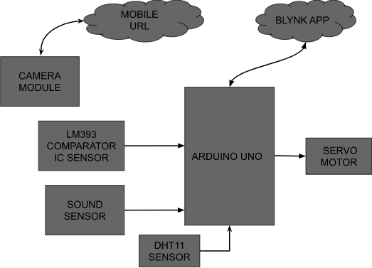

**DESCRIPTION**

In the above diagram we have used Arduino Uno as a microcontroller.Asanoutputdevicewehaveusedthe servo motor. And in inputdeviceswehaveusedDHT11Sensor,SoundSensor,LM393ComparatorICSensor,aCameraModuleconnectedtothemicrocontroller.Andwehaveusedtheblynkapp to show all thenotifications.

# FLOWCHART

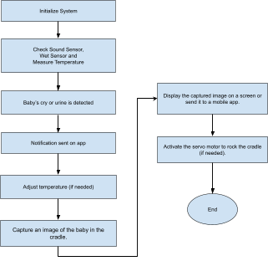

**CIRCUIT DIAGRAM**

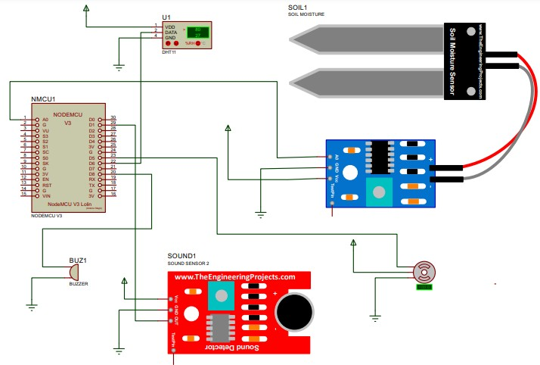

# WORKING

The "Smart Baby Cradle Using Sensor Technology" paper aims toprovide parents with a comprehensive infant monitoring solution. Itutilisesvariouscomponents,includingsoundsensors,LM393comparatorIC,ESP32cameramodule,MG996Rservomotor,Arduino Uno, and a mobile application powered by Blynk. The paperinitiates by initialising its components, and sensors such as the soundsensor,LM393IC, and DHT11 sensor collect data, monitoring thebaby's temperature, detecting sounds indicative of the baby's crying,andidentifyingdiaperwetnessthroughthecomparatorIC.Thecamera module captures the baby's movements and images, which aretransmittedtotheArduinoUno.Alltheseparametersarethendisplayedinreal-timeontheBlynkmobileapplication,allowingparents to monitor their baby's well-being. In response to the baby'scrying, the servo motor activates, gently rocking the cradle to soothethe baby. This system offers a user-friendly and effective solution forinfant care and monitoring.

# SYSTEM REQUIREMENTHARDWAREREQUIREMENT

1. Arduino Uno
2. Sound Sensor
3. LM393 Comparator IC Sensor
4. Servo Motor
5. Camera Module
6. TemperatureSensor

# SOFTWAREREQUIREMENT

1. Arduino IDE
2. Blynk App

# IMPLEMENTATION

**EXPERIMENTALSETUP**

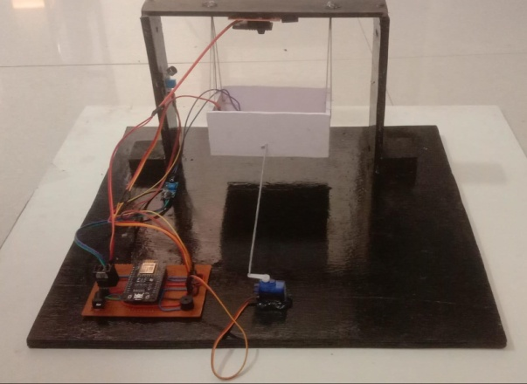

# SIDE VIEW

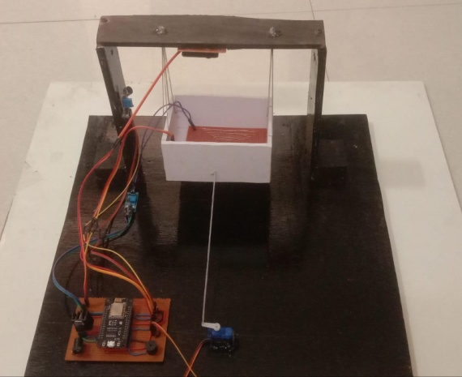

**TOPVIEWOFSETUP**

# Fig. shows the experimental setup ofthe system

**RESULT**

The "Smart Baby Cradle Using Sensor Technology" paper has beenexecutedsuccessfully,meetingitspredefinedobjectiveswithremarkableoutcomes.TheBlynkmobileapplicationservesasarobustplatform,enablingparentstomonitorcrucialparametersessential for the baby's well-being. These include real-time tracking ofthebaby'stemperature,soundlevelsinthevicinity,andeven thedetection of urine. The integration of the paper with the Blynk appunderscoresitseffectivenessinprovidingseamlessaccesstocomprehensive data, enhancing the ease of use for parents. Throughthe Blynk mobile application, parents gain not only valuable insightsinto their baby's current status but also the ability to view images oftheirinfant.Theincorporationofvisualdatafurther enhances themonitoring capabilities, contributing to a holistic tool that empowersparents to stay closely connected with their baby's health and comfort.

For a more detailed understanding, visual representations within theBlynk app offer a clear glimpse into the monitored parameters. Theseimagesprovideavisualbreakdown,illustratinghowparentscaneffortlesslynavigateandinterpretthereal-timedata on the baby'stemperature,ambientsoundlevels,andthesystem'scapabilitytodetecturine.Overall,thesuccessfulimplementationofthis paper,coupled with the intuitive Blynk mobile application, presents a robustsolution for parents seeking a comprehensive and user-friendly tool tooversee and ensure their baby's well-being.

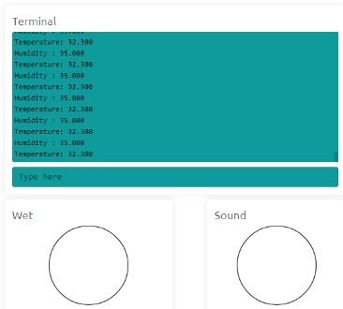

# PARAMETER:TEMPERATUREANDHUMIDITY

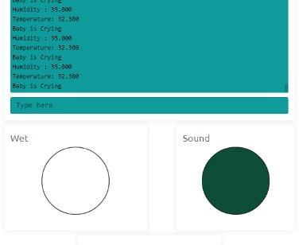

**PARAMETER:SOUNDDETECTAFTERBABYISCRYING**

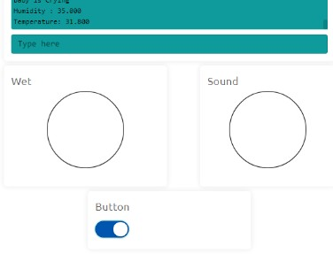

# PARAMETER:BUTTONGETONMANUALLYBYBLYNKAPP

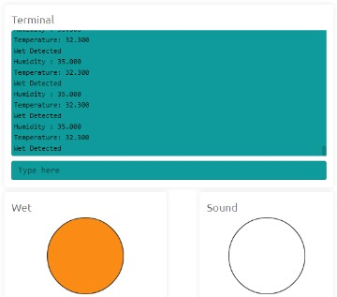

**PARAMETER:WETISDETECTED**

# CONCLUSION

The advent of the Internet of Things (IoT) has ushered in a new era ofintelligencefordevices.Asmartcradle,integratedwithababymonitoringsystemleveragingIoT,hasbeenconceptualisedandcrafted. This innovative system is designed to track crucial parametersofababy,includingtheircryingcondition,humiditylevels,andambienttemperature.TheutilisationofIoTtechnologyhassignificantlyexpandedthescopeofinformationthatcanbetransmittedovertheinternet,offeringremoteaccesstoparents orcaregivers.Theincorporationofacameramoduleinthecradleenablesmeticulousmonitoringofthebabywithinadefinedarea,capturingcontinuousinsightsintotheirmovements.Thispaperharnesses IoT technology to monitor the baby's activities, with relatednotificationspromptlytransmittedtomobileapplications.Thistechnologicalmarvelnotonlyelevatestheefficiencyofbabymonitoring but also augments the support system available to parentsandcaregivers.Thecapturedinsights,conveyedthroughtheintegration of IoT and cutting-edge sensor technology, pave the wayforamoreinformed and responsive approach to nurturing infants.Furthermore,the symbiotic relationship between IoT and the smartcradleembodiesanethosofadaptability,cateringtothe evolvingneeds of modern parenting in an increasingly interconnected world.

Inessence,thispaperunderscorestheprofoundimplicationsofIoT-driveninnovationinrevolutionisinginfantcarepractices.Itheraldsafuturewheretechnologyseamlesslyintertwineswithcaregiving,promisingnotjustconveniencebutalsoaninvaluablesense of security and empowerment for parents, fostering a nurturingenvironment where the well-being of infants remains at the forefront.

# FUTURE SCOPE

ThefuturetrajectoryoftheSmartBabyCradleUsingSensorTechnology paper is poised for transformative advancements. Thisinvolvestheincorporationofcutting-edgesensorsandartificialintelligence to enable a more thorough infant monitoring system withpredictivecapabilities.Thepaper'shorizonextendstowardsfacilitatingremotemedicalconsultationsandtailoringcaregivingapproachesthroughadvancedtechnology.Itsglobalexpansionaimstoensure widespread accessibility and sustainability, with a continuouscommitmenttoenhancingdatasecurityand privacy. Collaborativeefforts with experts and ongoing research initiatives will unlock thefullpotentialofthistechnology,providingparentswithanever-evolvingandeffective tool for nurturing and safeguarding thewell-being of their infants. In essence, the paper is set to redefine thelandscape of modern childcare.

# REFERENCE

1. Symon, Aslam Forhad et al. “Design and development of a smartbaby monitoring system based on Raspberry Pi and Pi camera.” 20194th International Conference on Advances in Electrical Engineering(ICAEE)(2019): 117-122.
2. S. Brangui, M. El Kihal and Y. Salih-Alj, "An enhanced noisecancellingsystemforacomprehensivemonitoringandcontrolofbaby environments", 2020 International Conference on Electrical andInformationTechnologies (ICEIT),pp. 404-409,2020.
3. Prof. A.D. Anjikar, Arshad, Khan Pathan, Pranjal R. Dandekar,“GENERALIDEAABOUTSMARTBABYCRADLE”in

International Journal of Innovative Computer Science & EngineeringVolume4 Issue1; JanuaryFebruary-2020

1. YangHu;WeihuaGui;,“AdaptiveSwayControlforBabyBassinetBasedonArtificialMetabolicAlgorithm”SchoolofInformationScienceandEngineering,CentralSouthUniversity,China. 2019.
2. MarieR. Harper; La Mirada; Maxine R. Blea; , “Automaticallyrockingbabycradle”, US3769641,Date ofPatent:Nov. 6,2019.
3. Gim Wong, “Automatic baby crib rocker” US 3952343, Date ofPatent:Apr. 27, 2019.
4. Chau-Kai-Hsieh; Chiung Lin; Taiwan; , “Baby Cry Recognizer”US 5668780, Date of Patent Sep. 16, 2019
5. Amrita Ebenezer; Anupreethi. S; , “Automatic Cradle Movementfor Infant Care” Undergraduate Academic Research Journal (UARJ),ISSN:2278 –1129, Vol.-1,Issue-1,2021
6. Amin Shaikh1, Ankit Sharma2, Naveen Yadav3, Omkar Mane4,Prof. Sneha Deshmukh5 Review on Internet of Things based SmartBabyCradleInternationalResearchJournalofEngineeringandTechnology (IRJET) e-ISSN: 2395-0056 Volume: 08 Issue: 03, Mar2021
7. Sarah Ahmed Alswedani1; Fathy Elbouraey Eassa2 A Smart BabyCradle Based on IoT International Journal of Computer Science andMobileComputingISSN2320–088XIMPACTFACTOR:7.056IJCSMC,Vol.9, Issue.7, July2020, pg.64– 76
8. N. Saude and P. A. H. Vardhini, "IoT based Smart Baby CradleSystemusingRaspberryPi B+," 2020 International Conference onSmartInnovationsinDesign, Environment, Management, PlanningandComputing(ICSIDEMPC),Aurangabad,India,2020,pp.273-278,doi: 10.1109/ICSIDEMPC49020.2020.9299602.
9. H.M.IshtiaqSalehin,Q.R.AnjumJoy,F.T.ZuhraAparna,A.T.RidwanandR.Khan,"Development of an IoT based Smart BabyMonitoring System with Face Recognition," 2021 IEEE World AI IoTCongress(AIIoT),Seattle,WA,USA,2021, pp. 0292-0296, doi:10.1109/AIIoT52608.2021.9454187.
10. M. P. Joshi and D. C. Mehetre, "IoT Based Smart Cradle SystemwithanAndroidAppforBabyMonitoring,"2019InternationalConference on Computing, Communication, Control and Automation(ICCUBEA),Pune,India,2017,pp.1-4,doi:10.1109/ICCUBEA.2017.8463676.
11. W.A.Jabbar,H.K.Shang,S.N.I.S.Hamid,A.A.Almohammedi, R. M. Ramli and M. A. H. Ali, "IoT-BBMS: Internetof Things-Based Baby Monitoring System for Smart Cradle," in IEEEAccess,vol.7,pp.93791-93805,2019,doi:10.1109/ACCESS.2019.2928481.
12. Gare, Harshad Suresh, B. K. Shahane, Kavita Suresh Jori, andSweetyG.Jachak."IOTbasedsmartcradlesystemforbabymonitoring."InternationalResearchJournalofEngineeringandTechnology6, no. 10 (2019).
13. N. L. Pratap, K. Anuroop, P. N. Devi, A. Sandeep and S. Nalajala,"IoTbasedSmartCradleforBabyMonitoringSystem," 2021 6thInternationalConferenceonInventiveComputationTechnologies(ICICT),Coimbatore,India,2021,pp.1298-1303,doi:10.1109/ICICT50816.2021.9358684.
14. Prusty,Vedanta,AbhisekRath,PradyutKumarBiswal,andKshirod Kumar Rout. "Internet of Things Based Smart Baby Cradle."In Innovative Data Communication Technologies and Application:ICIDCA 2019, pp. 793-799. Springer International Publishing, 2020.
15. V. P. Hotur, A. T. N. R, A. P, C. R and A. B. B, "Internet ofThings-basedBabyMonitoringSystemforSmartCradle,"2021InternationalConferenceonDesignInnovationsfor3CsComputeCommunicateControl(ICDI3C),Bangalore,India,2021,pp.265-270,doi: 10.1109/ICDI3C53598.2021.00060.
16. Kumar, V. Suresh, Lokaiah Pullagura, Nalli Vinaya Kumari, S.PoojaNayak,B.PadminiDevi,Adnan Alharbi, and Simon AtuahAsakipaam. "Internet of Things-Based Patient Cradle System with anAndroid App for Baby Monitoring with Machine Learning." WirelessCommunications and Mobile Computing 2022 (2022).
17. Ullah, Ahsan, and Afzal Hossain. "A Cost-effective Smart CradleBabyMonitoringSystemforassisttheParents."AdvancedInnovations in Computer Programming Languages 4, no. 3 (2022).
18. S.Durga,S.Itnal,K.Soujanya,C.Z.Basha and C. Saxena,"AdvancedandeffectivebabycaremonitoringSmartcradlesystem

usingInternetofThings,"20212ndInternationalConferenceonSmartElectronicsandCommunication(ICOSEC),Trichy,India,2021,pp. 35-42,doi: 10.1109/ICOSEC51865.2021.9591955.

1. R.Sonia,S.M.Jayadeva,S.D.P.Ragavendiran,R.N,J.Arumugam and S. S. Kumar, "IoT based Smart Cradle for NeonatalMonitoring,"20226thInternationalConferenceonElectronics,Communication and Aerospace Technology, Coimbatore, India, 2022,pp.432-437, doi: 10.1109/ICECA55336.2022.10009138.
2. Chauhan, Harsha, Deepali Gupta, Sheifali Gupta, and MohammadJunedulHaque."Asmartcradlesystemtomonitorinfantsforhealthcarebabywardsbased on IoT and blockchain." In 2021 3rdInternational Conference on Advances in Computing, CommunicationControl and Networking (ICAC3N), pp. 606-609. IEEE, 2021.
3. Wadhokar,Nisha,andBalasahebTarle."SmartCradleMonitoringSystemUsingIoT."AvailableatSSRN4626053(2023).
4. Perumal,Vigneshwaran. "Smart cradle monitoring system forbabies."InAIPConferenceProceedings,vol.2581,no.1.AIPPublishing, 2023.