**FORMULATION AND EVALUATION OF MOUTH DISSOLVING TABLET OF PROCHLORPERAZINE MALEATE”**

**DAGADGAVE SUDHIR, DR. ASHOK BHOSLE, MRS. TRUSHA P. SHANGRAPAWAR**

**PDEA Shankarrao Ursal College Of Pharmaceutical Science And Reasearch Center Kharadi Pune**

ABSTRACT

Prochlorperazine Maleate, a dopamine D2 receptor agonist and sympatholytic agent, is primarily used as an antiemetic drug. Despite its high permeability, it is classified as a Biopharmaceutics Classification System (BCS) class II drug due to its low solubility. To address this limitation, the solubility of Prochlorperazine Maleate was enhanced using the spray drying method, which improves its bioavailability. The drug undergoes hepatic metabolism and has a half-life of 4 to 6 hours. This study focuses on the formulation of a mouth dissolving tablet of Prochlorperazine Maleate, aimed at bypassing first-pass metabolism to accelerate the onset of action. The development of this formulation involves a thorough investigation of several factors, including the choice of excipients, drug stability, cost-effectiveness, and manufacturing feasibility. Super-disintegrants were incorporated into the formulation to facilitate rapid disintegration and dissolution, ensuring fast drug release in the oral cavity. This formulation approach is designed to improve patient compliance by providing a convenient and effective dosage form that enhances the therapeutic efficacy of Prochlorperazine Maleate. The study emphasizes the critical aspects of formulation development, such as excipient selection, stability assessment, and optimization of the manufacturing process, to achieve a product with optimal performance and cost-effectiveness. The mouth dissolving tablet of Prochlorperazine Maleate

KEYWORDIN **Prochlorperazine Maleate,Dopamine D2 receptor,Antiemetic Biopharmaceutics ,Low solubility,** spray drying

1. **Bioavailability**
2. **Mouth dissolving tablet**
3. **Super-disintegrants**
4. **Formulation development**

Top of Form

By messaging ChatGPT, you ag

Bottom of Form

PATIENTS, PARTICULARLY THOSE WITH DIFFICULTIES IN SWALLOWING CONVENTIONAL tablets.

1.INTRODUCTION

Prochlorperazine Maleate, a dopamine D2 receptor agonist and sympatholytic agent, is an antiemetic drug with a molecular weight of 373 g/mol and a half-life of 4 to 6 hours. Classified as a BCS class-II drug, it has low solubility and high permeability, requiring solubility enhancement through the spray drying method. A mouth dissolving tablet was developed to bypass first-pass metabolism and improve the onset of action. The formulation involves careful selection of excipients, stability assessment, and cost-effectiveness. Super-disintegrants were incorporated to ensure rapid disintegration, facilitating faster drug release and improving therapeutic efficacy.

2 MATERIALS AND METHOD

Prochlorperazine, as the active pharmaceutical ingredient (API), is formulated using poloxamer 188 as a polymer to enhance solubility. The spray drying technique is employed to prepare granules by dissolving the API and poloxamer 188 in a suitable solvent, then drying to produce solid granules. These granules are combined with two superdisintegrants, crosspovidone and crosscarmellose sodium, to facilitate quick tablet disintegration upon ingestion. Other excipients like microcrystalline cellulose for bulk, magnesium stearate as a lubricant, and colloidal silica for flow properties are added. The mixture is processed using direct compression, resulting in tablets with optimal disintegration and dissolution characteristics for effective drug delivery.

**2.1 Formulation of mouth dissolving tablet of prochlorperazine maleate**

pray dry prochlorperazine by dissolving it in ethanol. Use a spray dryer with an inlet temperature of 150-160°C and an outlet temperature of 60-80°C. Ensure constant airflow for efficient drying. Collect the powder with a cyclone separator, and follow safety protocols for handling flammable solvents.

**Table no.1 spray drying**

|  |  |
| --- | --- |
| **drug & polymer ratio (1:3)** | **160ml** |
| Solvent | Ethanol |
| Inlet Temperature | 140 to 160 |
| Outlet Temperature | 60 to 80 |
| Feed Rate | 1ml/min |

1. Blending with Excipients Primary Excipients: Select suitable excipients for the tablet formulation, such Cross carmalose sodium as blending Mix the spray-dried Prochlorperazine Maleate solid dispersion with the other excipients in a blender to ensure a uniform mixture.
2. Sieving: Sieve the dried granules in to sieve no 40 to obtain a uniform particle size distribution.
3. Pre-Compression excipient: Add a Lactose Citric acid Silicon dioxide to the blend or granules and mix gently to ensure uniform distribution.
4. Tablet Compression Compression: Use a tablet press to compress the blend into tablets. Adjust the compression force to ensure the tablets are adequately formed without capping or lamination.
5. Tooling: Choose appropriate tooling for the tablet size and shape desired.

**2.2 Evaluvation of tablet**

The prepared tablet batches (F1-F6) are subjected to post-compression evaluation and evaluation parameters like appearance, weight variation, thickness, hardness, friability, Content uniformity, disintegration time, dissolution time was performed and the results are shown in table

**Appearance**

The tablets were visually observed for capping, chipping and lamination.

**Thickness**

Vernier callipers were used to measure the thickness of 10 tablets, which were then converted to millimetres (mm).

**Hardness**

Hardness indicates the ability of a tablet to with stand mechanical shocks while handling. The hardness of the tablets was determined using Digital hardness tester. It is expressed in Kg/cm2.Digital hardness tester was used to measure hardness of the tablet. In which the tablet was placed in the tester and pressure needed to break the tablet was measured.

**Weight Variation**

Twenty tablets are ingested and their individual and collective weights are calculated on an electronic weighing scale in accordance with the I.P. protocol for uniformity of weight. One tablet's average weight was determined using the entire weight.

The weight variation test would provide a reliable way to assess the uniformity of the medication Content.

|  |
| --- |
|  |

**Table no 2. Weight Variation Limits for Tablet**

|  |  |  |
| --- | --- | --- |
| **IP\ BP** | **Limit** | **USP** |
| 80 mg < | ± 10% | 130 mg < |
| 80 mg to 250 mg | ± 7.5% | 130 mg to 324 mg |
| >250 mg | ± 5% | >324 mg |

**Friability**

Friability is the measure of tablet strength. It was carried out by using Roch friability apparatus, in which the accurately weighed 20 tablets was allowed to rolling and free fall at 25 rpm, after 100 revolutions weight of tablet was again measured and % friability was calculated by following formula

**% Friability = Wint – Wfinal / Wint × 100 ....Eqn8**

Where,

Wint = Initial weight of the tablets

Wfinal =Final weight of the tablets

**Disintegration Time**

Disintegration times for Mouth dissolving tablets were determined using USP tablet disintegration apparatus with saline phosphate buffer of pH 6.8 as medium. Maintained the medium temp at 37± 2° C. The time in minute taken for complete disintegration of the tablets with no palatable mass remaining in the apparatus was measured.

**Wetting Time**

In that the tissue paper has been folded twice and placed in petri dish above that tablet is placed and 6 ml water was added. The time required to get the tablet completely wet was measured.

**Water Absorption Ratio**

In this method, A piece of tissue paper folded twice was placed in a small petri dish containing 6ml of water. A tablet was put on the tissue paper and allowed to completely wet. The wetted tablet was then weighed. Water absorption ratio was determined using following equation.

**Water absorption ratio = Wa−Wb\ Wb ×100** **....Eqn9**

Where,

Wa – weight of tablet after absorption

Wb – weight of tablet before absorption.

**Drug Content**

This method is performed as per Indian Pharmacopoeia. Two tablets were crushed and added to 30 ml of Phosphate buffer Ph 6.8 in 100 ml volumetric flask sonicated to disintegrate, then diluted by acetonitrile and then this solution was filtered and diluted the filterate with a mixture of seven volumes acetonitrile and three volumes of Phosphate buffer Ph 6.8 . Absorbance was measured by UV spectroscopy at 254nm

**In-vitro Dissolution Study**

The in-vitro drug release study of formulated Mouth dissolving tablets F1-F6was carried out using USP dissolution apparatus type II (Electro Lab Dissolution Tester USP II) at 50 rpm. A temperature of 37±0.5 0C was maintained throughout the study. The dissolution test was carried out using 900ml of saline phosphate pH 6.8. A sample (5 ml) of the aliquot was withdrawn from the dissolution apparatus at 5, 10, 15, 20, 25and 30min. The samples were replaced with fresh dissolution. The samples were filtered through Whattman filter paper and analysed using UV-visible spectrophotometer (UV-1800, Shimadzu, Japan) at 254nm and the percentage drug release was calculated.

**2.3 STABLITY STUDY**

The prepared mouth dissoiving table tof solid dispersions of Prochlorperazine Maleate were placed in plastic tubes containing desiccant and stored at ambient conditions, such as room temperature at 370C ± 20C/40 % RH ± 5% for period of 90 days. Each tablet is weighed and wrapped in aluminium foil and packed in black PVC bottle and put at above specified condition in a heating humidity chamber for 3 months and evaluated for their physical appearance, hardness, disintegrate time, dissolution testing and drug Content at specified intervals of time

**4 Result and discussion**

|  |  |  |  |
| --- | --- | --- | --- |
| **Sr. No.** | **Test** | **Observation** | **Inference** |
| 1 | **Appearance** | Fine Powder | Compiles as per IP |
| 2 | **Colour** | White | Compiles as per IP |
| 3 | **Odour** | Odourless | Compiles as per IP |

4.1 Organoleptic properties

**Table no 03 organoleptic property**

**4.2 Melting Point** The melting point of an Piroxicam was found to be 205-210°C which is similar to melting point mention in IP which was 200-210°C this study indicates purity of the sample and the sample provided in Prochlorperazine malete and for further conformation more test is carried out.

**4.3 (DSC) of prochlorperazine maleate**

The differential scanning calorimetry (DSC) result of prochlorperazine maleate typically shows an endothermic peak corresponding to its melting point, which is around 198°C to 210°C. This peak indicates the thermal stability and purity of the compound.

**4.4 Preparation of Standard Calibration Curve of Prochlorperazine Maleate in Phosphate buffer**

The Standard curve of was determined by plotting absorbance Vs concentration at 254nm. It was found that there was linear relationship between concentration and absorbance with R2 value 0.9995 respectively, which reveals that, the drug P**FTIR Spectrum of Prochlorperazine Maleate** rochlorperazine Maleate obeys the Beers lamberts law.

|  |  |  |
| --- | --- | --- |
| **Sr. No.** | **Concentration (µg/ml)** | **Absorbance at254nm** |
| **1** | 0 | 0 |
| **2** | 5 | 0.1193 |
| **3** | 10 | 0.2438 |
| **4** | 15 | 0.3546 |
| **5** | 20 | 0.4781 |
| **6** | 25 | 0.5987 |

Table no 04 ;calibration curve

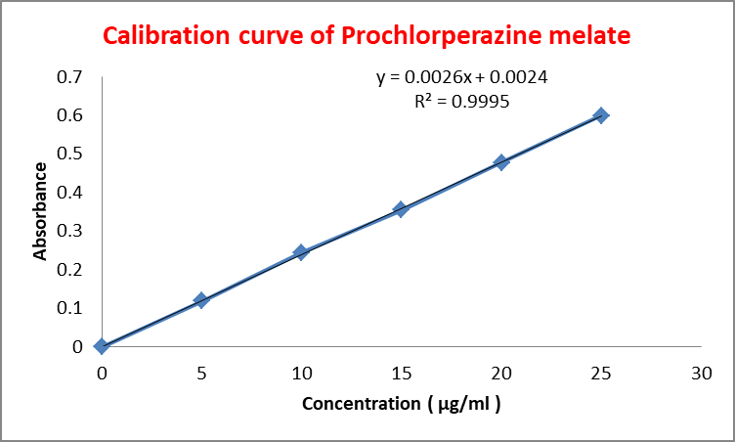

Fig no ;1 ;calibration curve

**4.5 FTIR Spectrum of Prochlorperazine Maleate** Major functional groups present in Prochlorperazine maleate show characteristic peaks in IR spectrum. shows peaks observed at different wave numbers and the functional group associated with these peaks. The major peaks are identical to functional group of Prochlorperazine Maleate. Hence, the sample was confirmed asProchlorperazine maleate

**Table no :04 Ftir spectra of prochlorperazine melate**

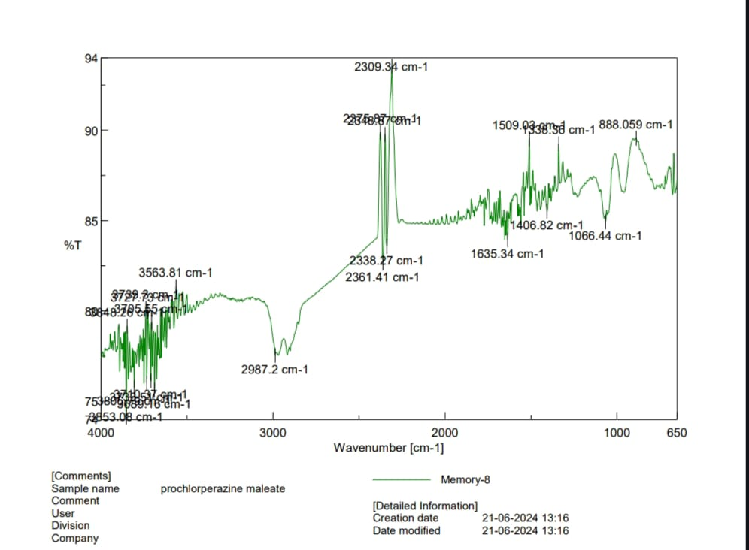

|  |  |  |  |
| --- | --- | --- | --- |
| **Sr.**  **no** | **Reference Peak**  **Wavcenumber(cm-1)** | **Reported Peak**  **Wavenumber( cm-1)** | **Functional**  **Group** |
| **1** | 1000-1300 | 1066 | C-N |
| **2** | 1450-1600 | 1509 | C=C(stretching) |
| **3** | 1650-1850 | 1750 | C=O(stretching) |
| **4** | 2500-3000 | 2987 | O-H |
| **5** | 600-800 | 676 | C-CL |

Fig no:02 Ftir spectra of prochlorperazine melate

**4.6 FTIR SPECTRA OF SOLID DISPERSION**

**Table no :05:Ftir spectra of solid disperssion**

|  |  |  |  |
| --- | --- | --- | --- |
| **Sr.**  **no** | **Reference Peak**  **Wavcenumber(cm-1)** | **Reported Peak**  **Wavenumber( cm-1)** | **Functional**  **Group** |
| **1** | 1000-1300 | 1066 | C-N |
| **2** | 1450-1600 | 1509 | C=C(stretching) |
| **3** | 1650-1850 | 1750 | C=O(stretching) |
| **4** | 2500-3000 | 2987 | O-H |
| **5** | 600-800 | 676 | C-CL |

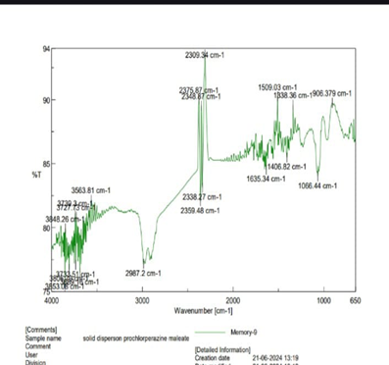

**Fig no :03:ftir spectra of solid disperssion**

**TABLE NO:06 FORMULATION AND EVALUATION OF FAST DISINTEGRATING TABLET OF SOLID DISPERSION** **PROCHLORPERAZINE MALEATE**

|  |  |  |  |  |  |  |  |
| --- | --- | --- | --- | --- | --- | --- | --- |
| **Ingredient** | **F1** | **F2** | **F3** | **F4** | **F3** | **F6** | |
| Unit formulation (mg per tablet) | | | | | | |
| Solid dispersion of Prochlorperazine Maleate (10mg) equivalent | 40 | 40 | 40 | 40 | 40 | | 40 |
| lactose | 126 | 124 | 122 | 126 | 124 | 122 | |
| Croscarmellose Sodium | 4 | 6 | 8 | - | - | - | |
| Crospovidone | - | - | - | 4 | 6 | 8 | |
| Sodium saccharine | 20 | 20 | 20 | 20 | 20 | 20 | |
| Citric acid | 5 | 5 | 5 | 5 | 5 | 5 | |
| Silicon dioxide | 5 | 5 | 5 | 5 | 5 | 5 | |
| Total | 200 | 200 | 200 | 200 | 200 | 200 | |

**4.7 EVALUATION OF SOLID DISPERSION OF PROCHLORPERAZINE MALEATE**

The solid dispersion (S1 to S4) of Prochlorperazine Maleate and Polaxamer 188 were evaluated for number of parameters like physical characteristic, solubility study, drug Content, % practical yield, in-vitro dissolution study and compatibility study.

**4.7.1 Physical Characteristics**

All batches of solid dispersion (S1 to S4) were evaluated for colour, appearance and odour. The crystalline Prochlorperazine Maleate is converted into amorphous form indicating enhanced solubility. The physical appearance of each formulation is shown below

**Table no 07: Physical Characteristics of Solid Dispersion of Prochlorperazine Maleate**

|  |  |  |  |  |  |  |  |  |  |  |  |  |  |  |  |  |  |  |  |  |  |  |  |  |  |  |  |  |
| --- | --- | --- | --- | --- | --- | --- | --- | --- | --- | --- | --- | --- | --- | --- | --- | --- | --- | --- | --- | --- | --- | --- | --- | --- | --- | --- | --- | --- |
| |  |  |  |  |  | | --- | --- | --- | --- | --- | | **Sr. No.** | **Formulations** | **Physical Appearance** | | | | **Colour** | **Appearance** | **Odour** | | 1 | S1 | White | Amorphous Powder | Odourless | | 2 | S2 | White | Amorphous Powder | Odourless | | 3 | S3 | White | Amorphous Powder | Odourless | | 4 | S4 | White | Amorphous Powder | Odourless | |

**Solubility Study of Solid Dispersion**

**Table no 08 Solubility Study of Solid Dispersion**

|  |  |  |  |
| --- | --- | --- | --- |
| **Sr. No.** | **Medium** | **Drug: Carrier (Ratio)** | **Solubility (mg/ml)** |
| 1 | Phosphate Buffer pH 6.8 | Pure drug | 0.089 |
| 2 | Phosphate Buffer pH 6.8 | 1:1 | 0.163 |
| 3 | Phosphate Buffer pH 6.8 | 1:2 | 0.310 |
| 4 | Phosphate Buffer pH 6.8 | 1:3 | 0.472 |
| 5 | Phosphate Buffer pH 6.8 | 1:4 | 0.478 |

**Results are mean of three determinations**

The solubility study of various solid dispersion batches (S1 to S4) was performed. Solid dispersion prepared by Spray drying showed improved solubility of Prochlorperazine Maleate as compared to pure drug. The ratio 1:4 (S4) was more soluble than pure drug and other solid dispersions.

**4.7.2 Drug Content**

The drug Content was found to be within the range of to indicating uniform distribution of drug in the formulated tablets as per pharmacopeia specification.

**Table 09 Drug Content**

|  |  |  |
| --- | --- | --- |
| **Formulation** | **Ratio** | **% Drug Content** |
| S1 | 1:1 | 98.63±1.99 |
| S2 | 1:2 | 97.05±2.50 |
| S3 | 1:3 | 98.42±1.35 |
| S4 | 1:4 | 97.7±1.55 |

**Results are mean of three determinations**

**4.7.3** **Percentage Practical Yield Study of Solid Dispersion**

Percentage practical yield was calculated to know about % yield or efficiency of any method which will help in selection of appropriate method. The practical yield for each batch is reported below.

**Table :10: Percentage Yield Study of Solid Dispersion**

|  |  |  |  |  |
| --- | --- | --- | --- | --- |
| Formulation | Ratio | Initial Weight(mg) | Final Weight (mg) | % Practical Yield |
| S1 | 1:1 | 300 | 220 | 73.3±1.90 |
| S2 | 1:2 | 450 | 310 | 68.8±1.85 |
| S3 | 1:3 | 600 | 430 | 71.6±1.55 |
| S4 | 1:4 | 750 | 526 | 70.13±1.89 |

**Results are mean of three determinations**

Different trial batches of solid dispersion show % practical yield from range 68±1.85 to 73±1.90. Batch S3 Showed 71.6±1.55 practical yield.

**4.7.4 In vitro Dissolution Study and Observation**

The dissolution study of pure drug and all formulations were carried out to calculate the %drug release

**Dissolution study of Pure Drug**

Dissolution study of pure drug in phosphate buffer pH 6.8 was carried out and % drug release was taken in UV spectrophotometer which is reported below

**Table 11: Dissolution profile of Prochlorperazine Maleate Pure Drug**

|  |  |
| --- | --- |
| **Time (min)** | **Cumulative % drug release** |
| 0 | 00 |
| 5 | 0.045±0.15 |
| 10 | 1.654±0.49 |
| 15 | 4.859±0.29 |
| 20 | 8.071±0.38 |
| 25 | 11.96±0.96 |
| 30 | 15.18±0.75 |

**Results are mean of three determinations**

The cumulative % drug release of pure drug of Prochlorperazine Maleate after 30 min was found to be 15.18±0.75

**Dissolution Profile of Solid Dispersion Prepared by Spray drying**

Dissolution study of solid dispersion prepared by Spray drying S1, S2, S3, S4 was carried out in phosphate buffer pH 6.8 and analysed spectrophotometrically at254nm. Each preparation was tested in triplicate and then mean values were calculated. The table indicates the % drug release of each formulation at the end of 30 min. The graph was plotted to show % drug release which was represented in Table below.

**Table 12 : Dissolution profile of solid dispersions prepared by Spray drying**

|  |  |  |  |  |
| --- | --- | --- | --- | --- |
| **Time (min)** | **Cumulative % drug release** | | | |
|  | **S1** | **S2** | **S3** | **S4** |
| **0** | **0** | **0** | **0** | **0** |
| **5** | **16.98±1.25** | **20.84±1.36** | **24.12±1.58** | **25.14±1.34** |
| **10** | **26.15±1.11** | **30.22±1.24** | **36.38±1.29** | **36.67±1.26** |
| **15** | **38.96±1.33** | **44.96±1.42** | **50.60±1.35** | **51.10±1.40** |
| **20** | **56.85±1.40** | **59.60±1.54** | **68.96±1.48** | **69.23±1.76** |
| **25** | **75.56±1.42** | **81.36±1.60** | **86.12±1.54** | **86.90±1.29** |
| **30** | **84.41±1.61** | **90.96±1.82** | **98.56±1.61** | **98.10±1.68** |

**Results are mean of three determinations**

Out of four formulations S3 shown maximum drug release. i.e., 98.56%. Solid dispersion (S3) of Prochlorperazine Maleate with polaxamer 188(1:3) prepared by Spray drying significantly improved its solubility and dissolution rate. Increased wetting and solubilizing effect of polaxamer 188 as well as the molecular dispersion of drug in solid dispersion and alteration of surface properties of drug particle may be responsible for the enhanced dissolution rate of Prochlorperazine Maleate from solid dispersion compared to pure Prochlorperazine Maleate

**Figure 04 Dissolution Profile of Solid Dispersions Prepared by Spray drying** **Comparative Dissolution Study**

The dissolution of pure drug was compared with solid dispersion by Spray drying (S3) which is shown in Table And graph was plotted to show % drug release which was represented in Figure

**Table 13 Comparative dissolution study of pure drug and** **Prochlorperazine Maleate and solid dispersion by Spray drying (S3)**

|  |  |  |
| --- | --- | --- |
| **Time (min)** | **Cumulative % Drug Release** |  |
| **Pure Drug** | **S3** |
| 0 | 00 | 00 |
| 5 | 0.045±0.15 | 24.12±1.58 |
| 10 | 1.654±0.49 | 36.38±1.29 |
| 15 | 4.859±0.29 | 50.60±1.35 |
| 20 | 8.071±0.38 | 68.96±1.48 |
| 25 | 11.96±0.96 | 86.12±1.54 |
| 30 | 15.18±0.75 | 98.56±1.61 |

**Fig no :05:cumulative percentage drug reiease**

According to graph 05. It was concluded that the S3 formulation gives highest drug release i.e 98.56±1.61 % in 30 min, in phosphate buffer pH 6.8 whereas the pure drug was found to be 15.18±0.75 % drug release in phosphate buffer in 30 min. In this comparative study Spray drying solid dispersion exhibit significant improvement in solubility and dissolution rate compared to that of pure drug. Thus, Spray drying technology offers a simple, efficient, shorter preparation time, solvent free promising alternative method of solid dispersion for Prochlorperazine Maleate with significant enhancement of the in-vitro dissolution rate, hence batch S3 was selected for the further studies.

**4.7.4 FORMULATION OF MOUTH DISSOIVING TABLET OF PROCHLORPERAZINE MALEATE**

According to comparative dissolution study showed in graph10.07. It is concluded that the solid dispersion prepared by Spray drying containing Prochlorperazine Maleate + polaxamer 188 (1:3) had shown 98.56 % drug release as compared to other solid dispersion. Hence the solid dispersion S3 is selected for further tablet formulations. Total 06 formulations were developed by using various concentration of superdisintrgrants like Crosprovidone and Croscarmellose sodium ,.

**4.7.5 PRE-COMPRESSION EVALUATION OF TABLET BLEND OF MOUTH DISSOLVING TABLETS OF PROCHLORPERAZINE MALEATE**

The characterization of mixed blend was done for determination of mass-volume relationship parameter. The parameter angle of repose, bulk density, tapped density, hausner’s ratio and compressibility index was evaluated and values are reported in table below

**Table no 14: Evaluation of Tablet Blend For Mouth Dissolving Tablets**

|  |  |  |  |  |  |
| --- | --- | --- | --- | --- | --- |
| **Formulation** | **Angle of Repose (θ˚)** | **Bulk Density (gm/ml)** | **Tapped Density (gm/ml)** | **Hauser’s Ratio (HR)** | **Compressi-bility Index (%)** |
| **F1** | 28.47 ± 1.34 | 0.50±0.23 | 0.60±0.33 | 1.2±0.68 | 16.66±1.23 |
| **F2** | 27.75 ± 1.40 | 0.51±0.14 | 0.61±0.24 | 1.19±0.56 | 16.39±1.55 |
| **F3** | 27.52 ± 1.74 | 0.51±0.36 | 0.60±0.46 | 1.17±0.45 | 15.00±1.73 |
| **F4** | 27.74 ± 1.50 | 0.52±0.12 | 0.62±0.35 | 1.19±0.32 | 16.12±1.44 |
| **F5** | 26.83 ± 1.28 | 0.52±0.27 | 0.60±0.14 | 1.13±0.61 | 13.34±1.68 |
| **F6** | 26.88 ± 1.64 | 0.52±0.16 | 0.61±0.42 | 1.17±0.87 | 14.75±1.73 |

**Results are mean of three determinations**

**4.7.5 Angle of Repose**

Angle of repose of various powder mixed blends(F1-F6), prepared with different superdisintegrants, was measured by funnel method. Angle of repose was found in the range **26.83 ± 1.64 - 28.47 ± 1.34.** The excellent flow ability of powder blend was also evidence with angle of repose.

**4.7.6 Bulk density**

The bulk density of various powder mixed blends(F1-F6) prepared with different superdisintegrants was measured by graduated cylinder. The bulk density was found in the range **0.50±0.23– 0.52±0.14g/ml.**

**4.7.7 Tapped Density**

The Tapped density of various powder mixed blends(F1-F6) prepared with different superdisintegrants was measured by using measuring cylinder. The tapped density was found in the range **0.60±0.14 - 0.62±0.35g/ml**. These values indicate good packing characteristics.

**4.7.8 Hauser’s Ratio**

The Hausner’s ratio of various powder mixed blends(F1-F6), prepared with different superdisintegrants, it is calculated by using bulk density and tapped density data. It was found in the range of **1.17±0.45 – 1.2±0.68** good flow properties (<1.25)

**4.7.9 Compressibility Index**

The Compressibility index of various powder mixed blends(F1-F6), prepared with different superdisintegrants, using bulk density and tapped density data, compressibility index was calculated. It was found in the range **14.75±1.55**

**- 16.66±1.68%.** This indicates good flow properties.

**5 POST-COMPRESSION EVALUATION OF MOUTH DISSOLVING TABLETS**

The Mouth dissoiving tablet of solid dispersion of Prochlorperazine Maleate were prepared & subjected to post-compression parameters like weight variation, thickness, hardness, friability, drug Content, in vitro disintegration time, wetting time, water absorption ratio and in vitro dissolution studies were carried out. All the formulations were passed the parameter which was reported in Table below.

|  |  |  |  |  |  |  |  |  |
| --- | --- | --- | --- | --- | --- | --- | --- | --- |
| **Formulations** | **Thickness (mm)** | **Hardness (kg/cm2)** | **Weight Variation (mg)** | **Friability (%)** | **Disintegration time (Sec)** | **Wetting Time (Sec)** | **% Water Absorption Ratio** | **Drug Content** |
| **F1** | 3.25±0.83 | 3.5±0.38 | 201±2.22 | 0.35±0.24 | 50±2.11 | 40±2.60 | 58±1.96 | 97.13±1.80 |
| **F2** | 3.27±0.54 | 3.4±0.70 | 199±2.44 | 0.40±0.38 | 43±2.55 | 36±2.41 | 68±2.45 | 96.24±2.20 |
| **F3** | 3.13±0.33 | 3.6±0.15 | 200±2.00 | 0.50±0.51 | 30±2.82 | 32±2.82 | 84±2.80 | 98.62±2.48 |
| **F4** | 3.22±0.48 | 3.4±0.80 | 198±2.60 | 0.32±0.26 | 52±1.90 | 42±2.68 | 55±2.40 | 97.57±2.68 |
| **F5** | 3.26±0.76 | 3.1±0.41 | 199±2.70 | 0.37±0.12 | 47±1.63 | 37±1.96 | 64±2.58 | 98.60±2.32 |
| **F6** | 3.25±0.35 | 3.2±0.85 | 200±2.00 | 0.48±0.71 | 35±2.82 | 33±2.83 | 78±2.80 | 98.13±2.48 |

**Table 16 Post-Compression Evaluation of Mouth dissoiving tablet of Prochlorperazine Maleate**

**Results are mean of three determinations**

**5.1 Thickness**

The thickness of the tablets was measured by using Vernier calliper by picking the tablets randomly. The values are almost uniform in all formulations. Thickness was found in the range from **3.13±0.33** **mm – 3.27±0.54mm**. Uniform in the values indicates that formulations were compressed without sticking to the dies and punches.

**5.2 Hardness**

Tablets were evaluated by using Monsanto Hardness tester. Hardness of the tablets was in the range **3.1±0.41- 3.6±0.15kg/cm2**. Uniform hardness was obtained due to equal compression force. The obtained hardness range showed good mechanical strength with an ability to withstand physical and mechanical stress conditions.

**5.3 Weight variation**

Tablets were prepared using direct compression technique. Since the material was free flowing, tablets were obtained of uniform weight due to uniform die fill. Tablets were obtained in the range with acceptable weight variations as per Pharmacopoeia specifications, limit of ±5%. It was found to be from **198±2.60 - 201±2.22mg**.

* 1. **Friability**

Tablets were evaluated by using Roche Friabilator and friability of tablets was observed in acceptable range**. 0.32±0.26 - 0.50±0.51** (less than 1%) This indicated a good mechanical resistance of the prepared mouth dissolving tablets.

* 1. **Drug Content of Prochlorperazine Maleate**

Tablets were evaluated by using assay method. The drug Content was obtained in the acceptable limit. The drug Content was found in the range **96.24±2.20- 98.62±2.48%w/w.** (i.e., 99-101% w/w). The found range was within the specified limit as per Pharmacopoeia.

**5.6 Disintegration time**

Tablets were subjected for the *in-vitro* disintegrate time in the USP Disintegrate test apparatus. The *in-vitro* disintegrate time for all six formulations varied from 30±2.17 to 50±2.11 seconds. The rapid disintegrate was seen in the formulations containing Crospovidone and Croscarmellose Sodium. This is due to rapid intake of the water from the medium, swelling and burst effect. It also noticed that the concentration of Croscarmellose sodium increased, the time taken for the disintegrate was reduced. The F3 formulations with highest concentration of Croscarmellose sodium shown significant rapid disintegrate.

**5.7 Wetting Time Test**

The values of wetting time for all formulations lie between **32±2.82 - 42±2.68** and it was observed that as the concentration of disintegrant increases the time taken for wetting decreases.

**Table 17 In vitro Cumulative % Drug Release**

|  |  |  |  |  |  |  |
| --- | --- | --- | --- | --- | --- | --- |
| **Time (min)** | **Cumulative % Drug Release** | | | | | |
| **F1** | **F2** | **F3** | **F4** | **F3** | **F6** |
| **0** | **00** | **00** | **00** | **00** | **00** | **00** |
| **5** | **21.32±2.18** | **29.62±2.46** | **32.8±2.42** | **20.22±2.28** | **27.32±2.46** | **30.8±2.82** |
| **10** | **33.93±2.0** | **42.09±2.60** | **44.09±2.30** | **32.73±2.08** | **38.09±2.60** | **41.19±2.40** |
| **15** | **48.70±1.19** | **54.4±2.19** | **58.60±2.50** | **46.80±1.29** | **52.43±2.39** | **54.60±2.40** |
| **20** | **68.79±2.16** | **72.8±2.31** | **76.22±2.28** | **66.89±2.26** | **72.90±2.41** | **76.22±2.28** |
| **25** | **78.18±2.14** | **84.6±2.51** | **87.3±2.60** | **77.28±2.24** | **82.64±2.81** | **85.38±2.70** |
| **30** | **90.28±2.18** | **92.6±2.0** | **98.6±2.46** | **88.28±2.68** | **90.65±2.22** | **94.62±2.32** |

**Results are mean of three determinations**

The rapid dissolution was observed in formulation **F3** releases **98.6±2.46 %** at the end of 30 minutes. Formulations F1-F6 released **88.28±2.68 to 98.6±2.46** at the end of 30 min. Rapid dissolution might be due to fast breakdown of particles and rapid absorption of drugs. The drug release was completely achieved in shorter duration of time. In all the formulations the drug release within 30 minutes. High dissolution may occur due to faster breakdown

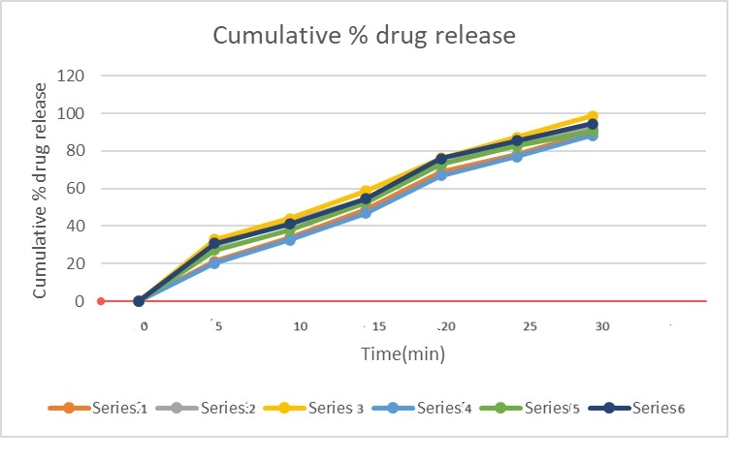

**Figure 06 Cumulative % drug release of F1-F6formulations**

In comparative study F3 formulation gives higher percent drug release compare to other remaining eight formulations at the end of 30 minutes and graphical representation is shown in Figure 06. Therefore, it was concluded that the best optimized batch was found to be F3 because of lesser disintegration time and highest percentage drug release at the end of 30 min among all the formulations. Because it containing Croscarmellose super-disintegrant with fast wetting time and highest swelling property.

**5.7. COMPARISON OF OPTIMIZED FORMULATION WITH CONVENTIONAL MARKETED TABLET**

The comparison between optimized batch was done with the marketed tablet and results are shown in the table below.

**Table 18 Comparison of Optimized Batch (F3) With Marketed Tablet**

|  |  |  |
| --- | --- | --- |
| **Time (mins)** | **Cumulative drug release of marketed tablet** | **Cumulative drug release from optimized batch (F3)** |
| **0** | **00** | **00** |
| **5** | **34.39±2.12** | **32.8±2.42** |
| **10** | **50.28±2.32** | **44.09±2.30** |
| **15** | **61.54±2.48** | **58.60±2.50** |
| **20** | **76.32±2.22** | **76.22±2.28** |
| **25** | **92.23±2.62** | **87.3±2.60** |
| **30** | **99.11±2.18** | **98.6±2.46** |

**Results are mean of three determinations**

**5.8. STABILITY STUDY**

The formulation F3 was selected for stability studies on the basis of their high cumulative % drug release and also results of in vitro disintegration time studied. The stability studies were carried out at 37˚C±2˚C/40˚C±5% relative humidity for the selected formulation up to three months. For every 1-month time interval the tablets were analysed for drug appearance, hardness, disintegration time, Content uniformity, % drug release up to three months. The results obtained in Table below

**Table 19 Stability Study**

|  |  |  |  |  |
| --- | --- | --- | --- | --- |
| **Formulation** | **Parameters Evaluated** | **Initial** | **After 2 Months** | **After 3 Months** |
| **F3** | **Appearance** | Brownish-white crystalline powder | Brownish-white crystalline powder | Brownish-white crystalline powder |
| **Hardness** | 3.6±0.15 | 3.6±0.15 | 3.6±0.15 |
| **Disintegration** | 30±2.82 | 32±2.56 | 33±2.86 |
| **Drug Content (%)** | 98.62±2.48 | 97.22±2.78 | 95.82±2.38 |
| **In vitro drug release** | 98.6±2.46 | 97.6±2.26 | 97.6±2.48 |

|  |
| --- |
|  |

**CONCLUSION**

The present study successfully formulated and evaluated mouth dissolving tablets of Prochlorperazine Maleate using crosscarmellose sodiumas a synthetic polymer. The use of The present study successfully formulated and evaluated mouth dissolving tablets of Prochlorperazine Maleate using crosscarmellose sodiumas a synthetic polymer. The use of crosscarmellose sodium, both alone and in combination with other excipients, effectively controlled the drug release over an extended period, enhancing patient compliance and therapeutic efficacy.

The characterization and compatibility studies confirmed the suitability of Prochlorperazine Maleate and crosscarmellose sodiumas a formulation combination.The optimal batch, F3, demonstrated an impressive 98 % drug release at the end of 30 min, surpassing the performance of other batches and the marketed formulation. Stability studies confirmed the robustness of the optimized batch under various conditions.

Overall, the study highlights the potential of crosscarmellose sodiumas an effective synthetic polymer for the development of mouth dissolving tablet formulations, offering a promising approach to improving the treatment regimen of Prochlorperazine Maleate. Further in-vivo and bioavailability studies are recommended to fully establish the clinical benefits of the optimized formulation., both alone and in combination with other excipients, effectively controlled the drug release over an extended period, enhancing patient compliance and therapeutic efficacy.

The characterization and compatibility studies confirmed the suitability of Prochlorperazine Maleate and crosscarmellose sodiumas a formulation combination.

The optimal batch, F3, demonstrated an impressive 98 % drug release at the end of 30 min, surpassing the performance of other batches and the marketed formulation.Stability studies confirmed the robustness of the optimized batch under various conditions.

Overall, the study highlights the potential of crosscarmellose sodiumas an effective natural polymer for the development of mouth dissolving formulations, offering a promising approach to improving the treatment regimen of Prochlorperazine Maleate. Further in-vivo and bioavailability studies are recommended to fully establish the clinical benefits of the optimized formulation.

**. REFERENCE**

1. Lieberman H.A., Lachman L., The Theory and Practice of Industrial Pharmacy, Indian Edition, CBS Publishers, and Distributors Pvt. Ltd., 2009, 293, 457, 479-501
2. Martin EW, Osol A, Alfonso R. Gennaro. Remington's pharmaceutical sciences. Mack Publishing Company; 1990.
3. Cooper. J, Gunn 1986, “Tutorial pharmacy”, New Delhi, CBS publishers and distributors: New Delhi: pp 211-233.
4. Gilbert S. banker, Vhristopher T.rhodes, “ Modern Pharmaceuticals”, Fourth edition, Marcel Decker , New York pp:221-233.
5. Sain MV, Patel G, Patel D, Patel Y, Patel MJ, Shah MT, Patel V, Yadav MP. MOUTH DISSOLVING TABLET-NOVEL DRUG DELIVERY SYSTEM.
6. Shyamkumar YD, Limbachiya MJ, Solanki K, Pandhya V. A Review on Sublingual Dosage Form.
7. Kale S, Warbhe P, Khatke S, Dange R, Khandagale NA. Sublingual Drug Delivery: A Promising Route for Enhanced Bioavailability and Patient Compliance.
8. Prathusha P, Kamarapu P. A Review on Mouth dissolving tablets. Journal of Formulation Science and Bioavailability. 2017.
9. Naimish AS, Vipul PP, Devang JP. SUBLINGUAL DELIVERY: A PROMISING APPROACH TO IMPROVE BIOAVAILABILITY. Pharma Science Monitor. 2013 Apr 1;4(2).
10. Saha PU, Verma SU, Das PS. Sublingual drug delivery: an indication of positional alternative route. International Journal of Current Pharmaceutical Research. 2017;9(6):5.
11. H.S. Bean & A.H. Beckett, Advances in Pharmaceutical Sciences Vol. 1-5
12. Alfred martin, Martin's physical pharmacy and pharmaceutical sciences: physical chemical and biopharmaceutical principles in the pharmaceutical sciences. —6th ed.1,231 pages
13. Rawlins Bentley‟s Textbook of Pharmaceutics, page no.958
14. Sidney H. Willig.,Good manufacturing practices for Pharmaceuticals: A plan for total quality control, Second edition; By Quality Assurance Guide; By Organization of Pharmaceutical producers of India.
15. Kumar S, Singh P. Various techniques for solubility enhancement: An overview. The Pharma Innovation. 2016;5(1, Part A):23.
16. Vemula VR, Lagishetty V, Lingala S. Solubility enhancement techniques. International journal of pharmaceutical sciences review and research. 2010 Nov;5(1):41-51.
17. Gibaldi M. Biopharmaceutics and clinical pharmacokinetics. Lea & Febiger; 1977.
18. Alhayyan AM, Alazmi AH, Albayabi MS, Al Nass AA, Alhafufi HR, Alanezi MT, Al-Mutawa BA, Alanazi AS, Alameer I, Alshammari AD. Techniques for Improving Solubility.
19. Shargel. Land Yu, Applied Biopharmaceutics and Pharmacokinetics 2nd edition, Connecticut Appleton Century Crofts, 1985
20. MS AK, RAJESH M, SUBRAMANIAN L. Solubility enhancement techniques: A comprehensive review. World Journal of Biology Pharmacy and Health Sciences. 2023;13(3):141-9.
21. Thorat YS, Gonjari ID, Hosmani AH. Solubility enhancement techniques: a review on conventional and novel approaches. International journal of pharmaceutical sciences and research. 2011 Oct 1;2(10):2501.
22. Kadam SV, Shinkar DM, Saudagar RB. Review on solubility enhancement techniques. IJPBS. 2013;3(3):462-75.
23. Varandal AB, Magar DD, Saudagar RB. Different approaches toward the enhancement of drug solubility: A review. Journal of Advanced Pharmacy Education & Research Oct-Dec. 2013;3(4).
24. Jörgensen AM, Friedl JD, Wibel R, Chamieh J, Cottet H, Bernkop-Schnürch A. Cosolvents in self-emulsifying drug delivery systems (SEDDS): do they really solve our solubility problems?. Molecular Pharmaceutics. 2020 Jul 13;17(9):3236-45.
25. Chandel P, Kumari R, Kapoor A. Liquisolid technique: an approach for enhancement of solubility. Journal of drug delivery and therapeutics. 2013 Jul 13;3(4):131-7.
26. Patel BB, Patel JK, Chakraborty S, Shukla D. Revealing facts behind spray dried solid dispersion technology used for solubility enhancement. Saudi Pharmaceutical Journal. 2015 Sep 1;23(4):352-65.
27. James Swarbrick, James. G.Boylan, Marcel Dekker Inc, Encyclopedia of Pharmaceutical Technology, Vol 13, New York, 1996.
28. H.C. Ansel et al., Pharmaceutical Dosage Form and Drug Delivery System, Lippincott Williams and Walkins, New Delhi.
29. Carter S.J., Cooper and Gunn’s-Dispensing for Pharmaceutical Students, CBS publishers, New Delhi.
30. M.E. Aulton, Pharmaceutics, The Science& Dosage Form Design, Churchill Livingstone, Edinburgh.