REAL-TIME ATTENDANCE TRACKING MANAGEMENT SYSTEM

Dr.D.Selvaraj (1) , M.K.Aswitha (2) , N.Dhaarani (3),

S.Harinee(4) , K.Jayashree (5)

(1)Professor,

*Department of ECE,*

*Panimalar Engineering College,*

Chennai, India.

(2)(3)(4)(5)UG Student,

*Department of ECE,*

*Panimalar Engineering College,*

Chennai, India.

mails2selvaraj@yahoo.com(1)

aswitha0306@gmail.com (2)

dhaaraninagarajan7@gmail.com (3)

harinee2409@gmail.com (4)

jayashree240403@gmail.com (5)

***ABSTRACT:***

An innovative program designed to improve attendance tracking and management in various situations is the Real-Time Tracking and Management system using RSSI. This project combines Radio Signal Strength Indicator (RSSI) technology with embedded devices to provide accurate real-time tracking of individuals within defined premises. It also combines with a powerful reporting system to produce analytical data and attendance records. Better resource allocation and management are made possible by the integration of manpower data, which maximizes worker utilization.

***KEYWORDS: RSSI Technology, GSM, Python Image Processing, PLX-DAQ, IOT.***

1. INTRODUCTION

Traditional attendance monitoring procedures are revolutionized by a Smart Attendance Management System that combines real-time tracking and reporting with RSSI (Received Signal Strength Indicator) technology and workforce integration. This system ensures accurate attendance records by monitoring people in real-time through the use of sophisticated RSSI technology. This creative system's workforce integration guarantees a thorough strategy that combines human oversight with technological efficiency for precise attendance tracking. When combined, these components provide a clever solution that improves reporting precision, simplifies tracking attendance, and maximizes resource use across a range of organizational contexts.

1. SCOPE OF THE PROJECT

The significant scope of this project is to create an integrated attendance management system using Arduino, RSSI technology, Python image processing, and IoT communication for real-time monitoring and reporting of student attendance.

1. EXISTING SYSTEM AND ITS DISADVANTAGES

The existing system may rely on manual methods of attendance tracking, such as taking roll calls or using paper-based systems. With manual attendance tracking, there is often a delay in updating and accessing attendance information.This can be time-consuming, prone to errors, and require manual effort to update and maintain attendance records.This can result in challenges when it comes to monitoring student attendance in real-time, making it difficult for staff or administrators to take immediate action if a student is absent.

1. PROPOSED SYSTEM AND ITS ADVANTAGES

The proposed system automates the attendance tracking process using Arduino Uno microcontroller, RSSI technology, and Python image processing. The present and absent status of students are updated in the PLX-DAQ database, providing a centralized and reliable repository for attendance records.This automation reduces the need for manual effort and streamlines the attendance tracking process, leading to improved efficiency. This enhances data accuracy, accessibility, and makes it easier to generate reports and analyze attendance patterns.

1. BLOCK DIAGRAMAND WORKING

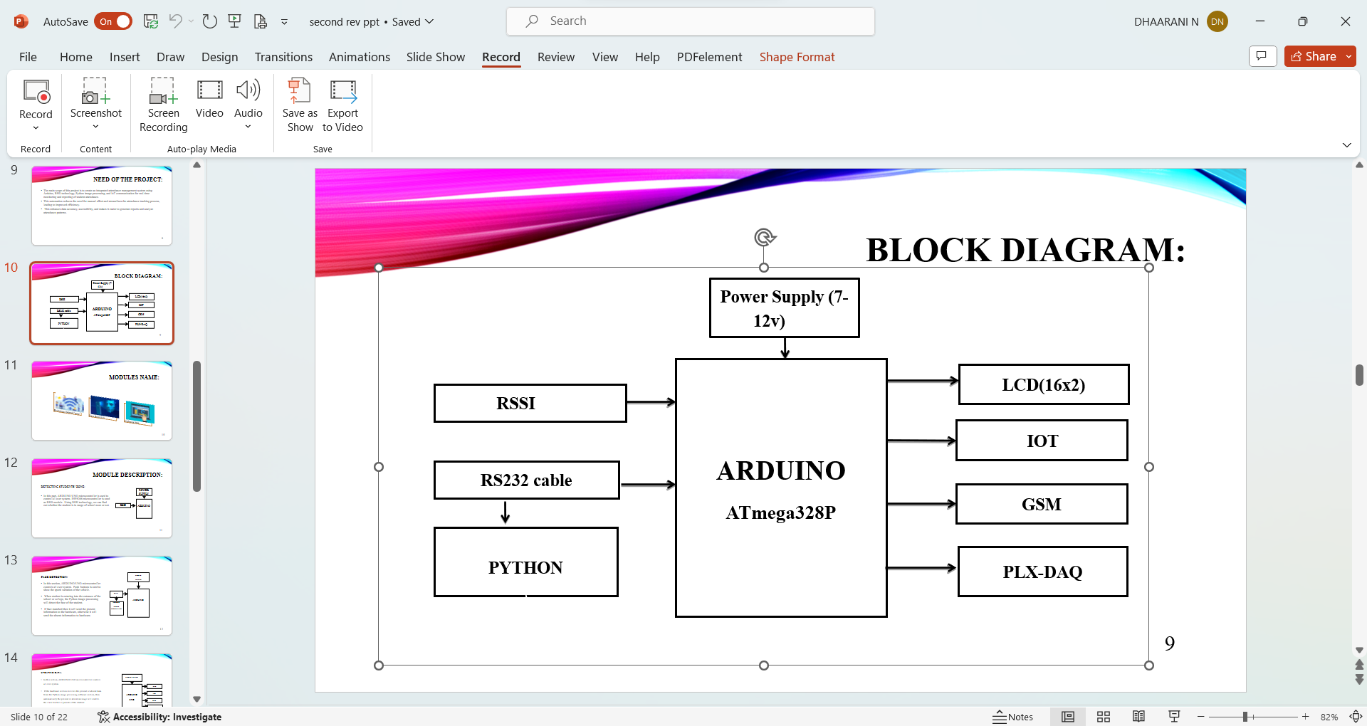

Fig., 1 Block Diagram

In this system, Arduino uno microcontroller is used to control all over system. Receive Signal Strength Identification (RSSI) technology is used to identify whether student reach the school zone or not according to the signal strength. Python image processing is used to recognize the students’ face. After the confirmation of two process, the present and absent status will be updated in PLX-DAQ database. The students’ status will also be updated in IOT webpage. If student is absent, then the alert message will be sent to the staff or principal with the help of Global System for Mobile communication (GSM). Liquid Crystal Display (LCD) is used to display the recent status about the students.

1. HARDWARE AND SOFTWARE DESCRIPTION

I. ARDUINO UNO

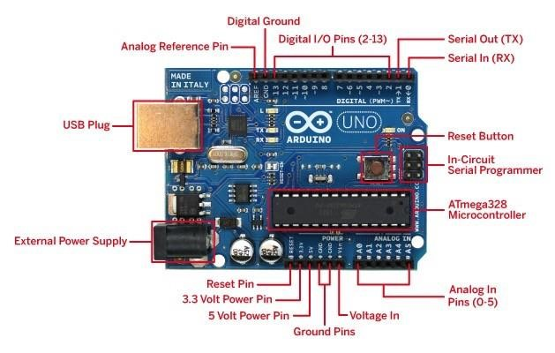

Fig., 2 Pin Diagram of Arduino UNO

The Arduino Uno is a widely used microcontroller board that is based on the ATmega328P microcontroller chip. It features 14 digital input/output pins, 6 analog inputs, a 16 MHz quartz crystal, a USB connection for programming and power, and a power jack, making it a versatile and user-friendly option suitable for both novice and experienced users.

Arduino Uno is composed of several key components, each with its own function:

**Microcontroller:**The Atmega328P microcontroller chip functions as the central processing unit of the board, governing all of its operations.

**Digital input and output pins**: The board comprises 14 digital input/output pins, capable of interfacing with a range of sensors, actuators, and components. These pins can be programmed as inputs or outputs, as per the project’s requirements.

**Analog input pins:**The board also features that there are 6 analog input pins that can read analog signals such as temperature and light levels.

**USB connection:**The USB connection is used for programming and power, allowing the board to be powered and programmed using a USB cable connected to a computer.

**Power jack:**The board can be powered using an external power supply through the power jack.

**Reset button:**This reset button is used to reset the board, which is useful for restarting a program or uploading new code.

II. GSM

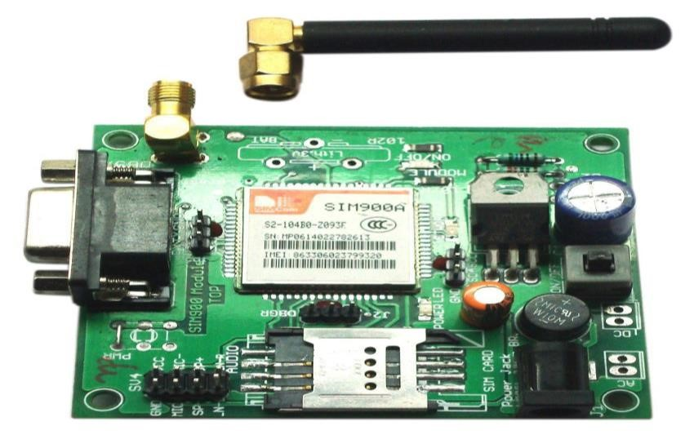 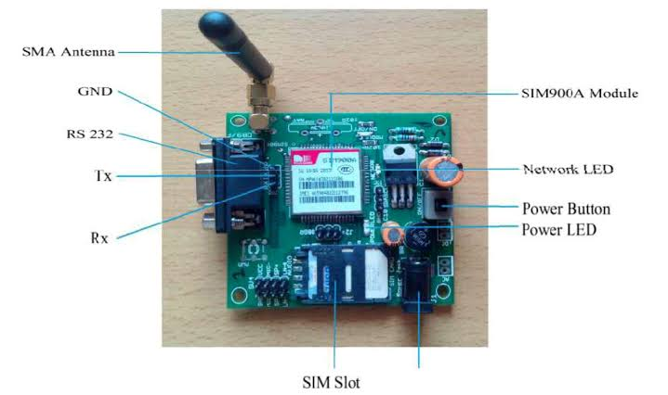

Fig., 3 GSM MODULE Fig., 4 Pin Diagram of GSM Module

A wireless modem that is compatible with GSM wireless networks is known as a GSM modem. The main distinction is that a wireless modem transmits and receives data using radio waves, whereas a dial-up modem sends and receives data over a fixed phone line. Commands are the foundation of how a GSM modem operates; they always begin with AT, or "attention," and end with a character. For instance, the dialing command in this case is ATD; ATD3314629080; a semicolon is used to finish the dialing command. Using a PC or controller, the GSM modem receives the AT commands. With the use of the GSM modem's MAX 232 pin, the controller and modem are serially interfaced.

III. LCD

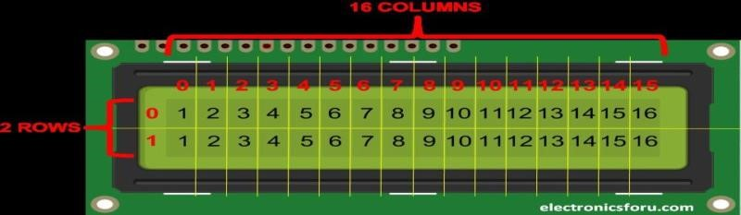

Fig., 5 16x2 LCD Display

LCD scream is a type of electronic display module and it has several uses. Lcd is a 16x2 type display which can show up to 16 characters in each of its two lines .Every character is displayed 5x7 pixel matrix.There are mainly two types of registers in their LCD namely command and Data register .The command instructions sent are kept in command register. Tasks such intializing, clears the screen, adjusting display are given as Instructions to an Lcd to perform which are commonly referred to as commands. An LCD is an electrical display module. It can able to create a visible image liquid crystal .

IV. INTERNET OF THINGS

The Internet of Things, commonly referred to as IoT, denotes a network infrastructure comprising physical entities such as cars, buildings, and various other objects. These entities are equipped with electronics, software, sensors, actuators, and network connectivity, facilitating the gathering and dissemination of data. When furnished with sensors and actuators, IoT joins the broader category of cyber-physical systems, encompassing smart grids, smart homes, intelligent transportation, and smart cities. This amalgamation empowers remote sensing and control via existing network structures, presenting opportunities for direct amalgamation of the physical domain with computer-based systems. Consequently, this convergence augments productivity, precision, and financial efficiency.

1. SOFTWARE REQUIREMENTS

I. ARDUINO SOFTWARE

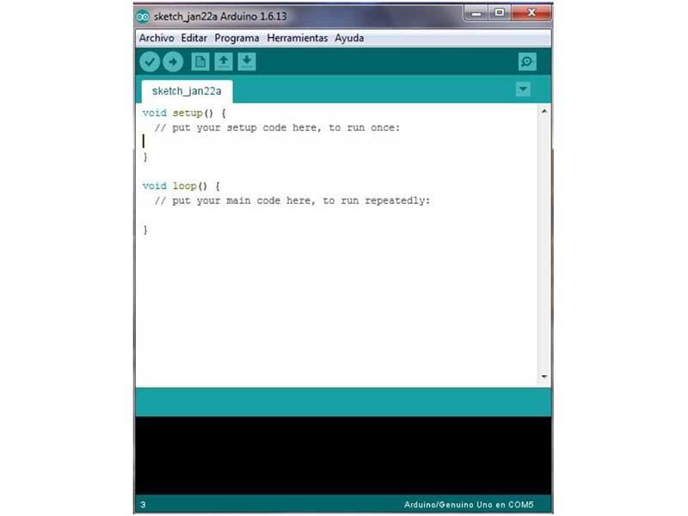

Fig., 6 Arduino Software

IDE- The Arduino Software is also known as the Arduino Integrated Development Environment. The IDE includes a text console, message box, text editor to write and edit the codes and a toolbar with buttons for frequently used tasks, and other menus. In this software we are using embedded C programming language for connecting the device. To upload programs and interact with the Arduino hardware, it connects to them.

1. APPLICATION AREAS

The evolution of markets and applications over recent years has wielded a considerable influence on their economic potential and their capacity to address societal trends and concerns in the ensuing decades. Societal trends are categorized into health and wellness, transportation and mobility, security and safety, energy and environment, communication, and e-society. These trends present significant opportunities in markets such as consumer electronics, automotive electronics, medical applications, and communication. The progression of semiconductor technology, encompassing More-Moore and More-than-Moore, as well as advancements in communications, networks, and software, directly contribute to enhancing these applications.

1. CONCLUSION

In conclusion, this innovative attendance management system seamlessly amalgamates cutting-edge technologies to create an efficient and automated solution. Arduino Uno serves as the central controller, orchestrating the integration of RSSI technology for location tracking and Python image processing for facial recognition. The system's ability to accurately determine a student's presence or absence through these processes and update the PLX-DAQ database and an IoT webpage ensures real-time monitoring and reporting. The inclusion of GSM alerts for absent students and a dynamic LCD display enhances communication and provides valuable insights for both school administration and students, marking a significant leap forward in attendance management within educational environments.

1. REFERENCES

1. Abbasi A and Bamakan H, “Automation Attendance Systems Approaches: A Practical Review,” BOHR Int. J. Internet Things Res., vol. 1, no. 1, pp. 7–15, 2022.

2. Alburaiki M.S.M, Johar G.M, Helmi R.A.A, and Alkawaz M.H, “Mobile Based Attendance System: Face Recognition and Location Detection using Machine Learning,” in 2021 IEEE 12th Control and System Graduate Research Colloquium, ICSGRC 2021 - Proceedings, 2021, pp. 177–182. doi: 10.1109/ICSGRC53186.2021.9515221.

3. Arsenovic M, Sladojevic S, Anderla A, and Stefanovic D, “Facetime – deep learning based face recognition attendance system,” in Proc. IEEE International Symposium Intelligent., 2017, pp. 53–58.

4. Ascigil O, Tasiopoulos A, Sourlas V, Psaras I, and Pavlou G, “Resource provisioning and allocation in function-as-a service edge-clouds,” IEEE Trans. Services Computing, is published, 10.1109/TSC.2021.3052139.

5. Bawar Ali, Abdalkarim, and Devrim Akgun, “A Literature Review on Smart Attendance Systems” Published on 23rd International Conference on Applied Engineering and Natural Sciences July 20-23, 2022, Konya, Turkey.

6. Behaine C and Scharcanski J, “Enhancing the performance of active shape models in face recognition applications,” IEEE Trans. Instrument. Measurement, vol. 61, no. 8, pp. 2330–2333, Aug. 2012

7. Bharath N Parashar, Alex Abraham Mathew, Ashwin S.A,”‘Smart Attendance Management System”, published paper in International Research Journal of Engineering and Technology on 2021.

8. Devesh Pratap Singh and Deepak Singh Rana, “An evaluation of the RSSI Indoor Positioning Integrated Classroom Attendance System”, published on 05-08-2022.

10. Hu P, Ning H, Ǫiu T, Song H, Wang Y, and Yao X, “Security and privacy preservation scheme of face identification and resolution framework using fog computing in Internet of Things,” IEEE Internet Things J., vol. 4, no. 5, pp. 1143– 1155, Oct. 2017.

11. Li X, Zhu Y, Wang J, Liu Z, Liu Y, and Zhang M, “On the soundness and security of privacy-preserving SVM for outsourcing data classification,” IEEE Trans. Dependable Secure Computing., vol. 15, no. 5, pp. 906–912, Sep./Oct. 2018.

12. Mubarak Salem Mubarak Alburaiki, Gapar Md Johar, Rabab Alayham Abbas Helmi, Mohammed Hazim Alkawaz, “Mobile Based Attendance System; Face Recognition and Placement Detection using Machine Learning”, published in [2021 IEEE 12th Control and System Graduate Research Colloquium (ICSGRC)](https://ieeexplore.ieee.org/xpl/conhome/9515195/proceeding).

13. Nithin Ramakrishnan, Meenakshi Sundaram.A, Sanju.V. “Wi-Fi Based Smart Attendance Monitoring System”, published in 2023 7th International Conference on Computation System and Information Technology for Sustainable Solutions (CSITSS).

14. Priyanka Wagh, Roshani , Thakare ,Jagruti , Chaudhari, Shweta Patil, “Attendance system based on face recognition using eigen face and PCA algorithms published in International Conference on Green Computing and Internet of Things (ICGCIoT)on 2015.

15. Ren Y, Zhang X, Feng G, Ǫian Z, “How to extract image features based on co-occurrence matrix securely and efficiently in cloud computing,” IEEE Trans. Cloud Computing., vol. 8, no. 1, pp. 207–219, Jan.–Mar. 2020.

16. Scheuner J and Leitner P, “Function-as-a-service performance evaluation: A multi vocal literature review,” J. Syst. Software., vol. 170, 2020, pp. 110708.

17. Venkata Kalyan Polamarasetty, Muralidhar Reddy Reddem, Dheeraj Ravi, Mahith Sai Madala, “Attendance System based on Face Recognition”, International Research Journal of Engineering and Technology (IRJET), Volume: 05 Issue: 04, Apr-2018.

18. Vrushaket Chaudhari, Shantanu Jain , Rushikesh Chaudhari, Tanvesh Chavan , Priyanka Shahane proposed, “Real Time Face Recognition Based Attendance System using Multi Task Cascaded Convolutional Neural Network”, published in International Conference on Emerging Smart Computing and Informatics (ESCI) on 2023.