**BLYNK RFID AND RETINAL LOCK**

**ACCESS SYSTEM**

# YOHESWARI.S1, ADHITHYARAM.L2,GOKULESH.S3,

HARISH RAJ .K.B4,JIVITHESH HARSHAA .R.D5

*1Assistant Professor Department of Computer Science and Engineering,*

*K.L.N. College of Engineering and, Sivagangai, India*

*2,3,4,5 Student, Department of Computer Science and Engineering,*

*K.L.N. College of Engineering, Sivagangai, India*

*Corresponding Author: sanjanasundar1808@gmail.com*

|  |
| --- |
| ***Abstract:****The BLYNK RFID AND RETINAL LOCKACCESS SYSTEM describes a digital door lock system that uses an ESP32-CAM module, which is a budget friendly development board with a very small size camera and a micro-SD card slot. The system uses retinal recognition technology to detect the retinal of the person who wants to access the door. The AI-Thinker ESP32-CAM module takes pictures of the person and sends them to the owner via the Blynk application installed on their mobile phone. The owner can then grant permission to access the door based on the person’s identity.When deploying your Blynk RFID and retinal scanner project, it's important to consider scalability and maintenance. As your user base and access requirements may change over time, plan for future expansion and updates. Regularly review and update your system's firmware, libraries, and security measures to stay ahead of potential vulnerabilities and evolving best practices in access control.Monitoring and auditing your system's usage is crucial. The Blynk platform can help you gather data on access attempts and system performance, allowing you to analyze the data for any anomalies and potential security breaches. This data can be valuable for compliance, troubleshooting, and performance optimization***.**  ***Key Word****: retinal and RFID scanning for lock to authentic users, using an ESP32-CAM and RFID reader controlling through Blynk.* |

1. **Introduction**

The Internet of Things (IoT) represents a revolutionary paradigm in therealmoftechnologyandconnectivity.WhatsetsIoTapartisitsability to facilitate seamless communication and data exchange between thesedevices, often without human intervention. This interconnectedness enables amyriad of applications across various domains, from smart homes and cities toindustrialautomationandhealthcare.Byleveragingsensors,actuators,andinternet connectivity, IoT systems gather real-time data, which can then beanalyzed and used to inform decision-making processes. This transformativetechnology has the potential to enhance efficiency, optimize resource utilization,andimprovetheoverallqualityoflifeforindividualsandcommunitiesworldwide. As IoT continues to evolve, it is poised to play an increasinglyintegral roleinshaping thewayweinteractwiththeworldaround us RFID technology uses electromagnetic fields to automatically identify andtrack tags attached to objects. In the context of access control, these tags areusually placed on keycards or fobs. When a person approaches an RFID reader,the reader emits radio waves which power the RFID tag. The tag then transmitsits unique identificationdata backtothe reader**.**Retinalscanningisabiometrictechnologythatleveragestheuniquepatternsof blood vessels in the retina at the back of the eye to identify individuals.

1. **RESEARCH AND FINDINGS**

Blynkisaversatileanduser-friendlyInternetofThings(IoT)platform that empowers individuals and businesses to seamlessly connect andcontrol a wide range of devices and projects over the internet. What sets Blynkapart is its intuitive drag-and-drop interface, which allows users to effortlesslycreatecustominterfacesfortheirIoTapplicationswithouttheneedforextensivecoding knowledge.

This platform supports a diverse array of hardware andcommunication protocols,making itcompatiblewithanextensiverange ofdevices, from microcontrollers like Arduino and Raspberry Pi to popular IoTdevelopment boards. With Blynk, users can remotely monitor and manage theirprojects,receivereal-timenotifications,andevenimplementautomationthroughauser-friendlymobileapp.Whetherforsmarthomeautomation,industrialmonitoring, or educational purposes, Blynk offers an accessible and powerfulsolution for bringingIoTprojects tolife.

Retinalscanningisabiometrictechnologythatleveragestheuniquepatternsof blood vessels in the retina at the back of the eye to identify individuals. Thismethodstandsatthepinnacleofsecurity technology,offeringunparalleledaccuracy andreliability.Commonly deployedinhighly sensitiveareaslikegovernment facilities, research labs, and high-security corporate environments,retinallockaccesssystemsprovideanexceptionallevelofsecurity.Thedistinctiveness and complexity of retinal patterns make it nearly impossible forunauthorizedindividualstogainaccess.Unlikeotherbiometricmethods,suchasfingerprints,retinalscansdonotrequirephysicalcontactwiththescanning

RFID technology uses electromagnetic fields to automatically identify andtrack tags attached to objects. In the context of access control, these tags areusually placed on keycards or fobs. When a person approaches an RFID reader,the reader emits radio waves which power the RFID tag. The tag then transmitsits unique identificationdata backtothe reader**.**RFID-based access control systems offer a convenient and efficient way tomanage access permissions.

They have largely replaced traditional lock-and-keysystems in manyenvironments due totheiradvantages,including Users can carry a small RFID card or fob, which is much easier than carrying aset of keys. RFID cards can be encrypted and provide a higher level of securitycompared to traditional keys, as they are harder to duplicate. RFID cards can beeasily deactivated or reactivated, providing flexibility in managing access rights.Thesesystemscankeeparecordofallaccessevents,providingvaluabledataforsecurityaudits.

1. **SYSTEM IMPLEMENTATION**

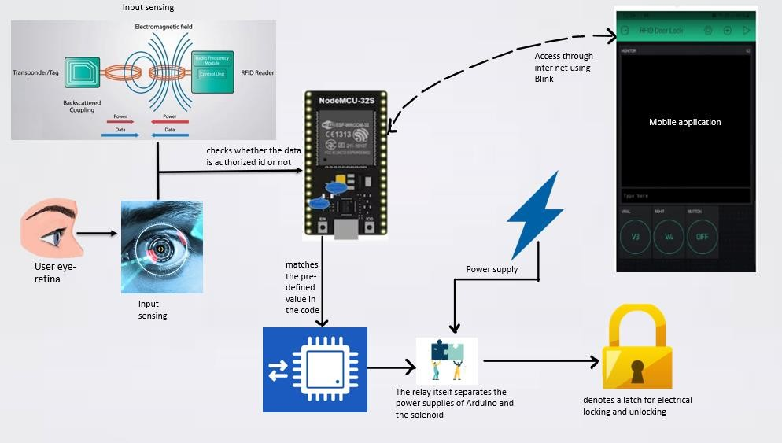

This diagrams are visual representations of the structure andcomponents of a hardware system, such as a computer, server, or networkinfrastructure. These diagrams help illustrate how various hardware componentsinteract and are interconnected.

1)RadioWavecommunication

Radiowavecommunicationisacornerstoneofmoderntechnology,enablingthetransmissionandreceptionofinformationthroughelectromagnetic waves. These waves span a wide frequency range, fromapproximately 3 kilohertz (kHz) to 300 gigahertz (GHz), accommodatingdiverseapplications.Fundamentally,radiowavesareaformofelectromagnetic radiation characterized by oscillating electric and magneticfields,travelingatthespeedoflight.

2) Retinal Scanner Authentication

Retinal scanner authentication is an advanced biometric security technology that leverages the unique patterns of blood vessels in the retina, located at the back of the eye, to verify a person's identity. This method provides an exceptionally high level of security due to the distinctiveness and stability of retinal patterns, which remain virtually unchanged throughout a person's life.

The process involves projecting a low-intensity infrared light into the eye, which is absorbed by the blood vessels in the retina. These absorbed patterns are then captured by a specialized camera, creating a highly detailed and unique biometric template.

3)Communication Connectivity

Communication connectivity is the lifeblood of our interconnected world, enabling seamless exchange of information across various platforms and devices. It encompasses the network infrastructures and technologies that facilitate this exchange, playing a crucial role in both personal and professional spheres.

At its core, communication connectivity relies on a multitude of technologies, ranging from traditional wired connections like Ethernet cables to wireless technologies like Wi-Fi and cellular networks.

These technologies enable devices to establish links and transmit data, allowing for real-time interactions, data sharing, and access to online resources.Wireless connectivity has seen exponential growth, with Wi-Fi networks forming the backbone of local communication within homes, offices, and public spaces. Cellular networks, on the other hand, provide ubiquitous connectivity, enabling mobile devices to communicate with each other and access the internet from virtually anywhere. The advent of 5G technology is poised to revolutionize connectivity further, promising faster.

#### 4)AccessControlLogicDecision

Access control logic decisions play a critical role in ensuring the securityandintegrityofsensitiveinformationandresourceswithinasystemorenvironment.Thislogicservesasthegatekeeper,determiningwhoisgrantedaccess,whatlevel of access they have,and under what conditions. At its core, access control logic relies on a set of predefined rules and policies. These rules are established based on factors such as user roles, privileges, and specific conditions. For example, in a corporate setting, an employee might have access to certain files and directories based on their job function, while a manager might have broader access permissions.

1. **CONCLUSION**

* Theretinaldoorlocksystemisthatitrepresentsahighlyadvanced and secure access control solution. By utilizing the unique biometricpattern of an individual's retina, it offers a level of security that surpassestraditional key orcode-basedsystems.
* Thistechnology providesnumerousbenefits, including reduced risk of unauthorized access, increased convenienceforusers,andpotentiallyevenimprovedaccessibilityforthosewithdisabilities.
* However, it's important to acknowledge some potential drawbacks. Costand implementation complexity may be higher compared to conventional locksystems. Additionally, concerns about privacy and data security may arise, asbiometricdataissensitiveandrequires stringentprotection measures.
* In spite of these considerations, the retinal door lock system holds greatpromiseforapplicationswhererobustsecurityisparamount.It has the potentialtorevolutionizeaccesscontrolinhigh-securityenvironmentssuchasgovernment facilities,
* research laboratories, and sensitive corporate spaces. Astechnologyadvancesandcostspotentiallydecrease,wemayseewideradoptionofthis cutting-edge securitysolution invarioussettings.

**References**

* + 1. Filip Lenko, “Specifics of RFID Based Access Control Systems Used inLogistics Centers”inTransportation Research Procedia
    2. Volume55,2021,Pages1613-1619
    3. Durica Jakub, Lenko Filip “Comparison of the difficulty overcoming ofRFID electronic access control systems and overcoming of pin tumblerlocks”inTransportation ResearchProcedia
    4. Volume55,2021,Pages1620-1626
    5. Nazariy K. Shaydyuk, “Biometric identification via retina scanning withlivenessdetectionusingspecklecontrastimaging”in2016IEEEInternationalCarnahan Conferenceon SecurityTechnology(ICCST)
    6. Amritha Nag, J N Nikhilendra, Mrutyunjay Kalmath, “IOT Based DoorAccess Control Using FaceRecognition” in: 2018 3rd InternationalConferenceforConvergence in Technology(I2CT)
    7. Andrea Motroni; Gabriele Bandini; Alice Buffi; Paolo Nepa “Investigation of Phase Offset Calibration for SAR-based RFID Localization in Harsh Environments” in 2023 IEEE 13th International Conference on RFID Technology and Applications (RFID-TA)