**Design and Analysis of Deep Learning Framework for Early Detection of Cancer Disease**

**Ravina Dable   
Electronics and communication Engineering  
TulsiramjiGaikwad-Patil College of Engineering & TechnologyNagpur, India  
ravinadable16@gmail.com**

**Prof. Rahul Dhuture  
Electronics and communication Engineering  
TulsiramjiGaikwad-Patil College of Engineering & TechnologyNagpur, India  
rahul.ece@tgpcet.com**

**Prof. Sandeep Thakre  
Electronics and communication Engineering  
TulsiramjiGaikwad-Patil College of Engineering & TechnologyNagpur, India  
sandeep.ece@tgpcet.com**

**ABSTRACT** Cancer, notably brain and lung cancers, is a leading global cause of death, challenging to detect early. Traditional diagnostic methods struggle due to their complexity and lack of specific symptoms. Deep learning models show promise but need improvement, especially for early-stage brain and lung cancers. Challenges include limited data, complex features, and interpretability issues. This research aims to enhance deep learning methodologies by incorporating advanced techniques like transfer learning and attention mechanisms. The goal is to accurately detect and classify early-stage cancers, addressing existing challenges, gaining insights into biological mechanisms, and ultimately improving patient outcomes through earlier detection and treatment.

**INDEX TERMS**— Transfer learning, attention mechanisms, cancer detection, machine learning, deep learning.

# **INTRODUCTION**

Cancer, a pervasive global health concern, necessitates continuous advancements in diagnostic methodologies to enhance early detection and improve treatment outcomes. In this pioneering research, we present a comprehensive framework designed to detect lung, breast, brain, and gastric cancers at their incipient stages. The multifaceted approach integrates meticulous data cleaning and preprocessing techniques to ensure the integrity and reliability of input datasets, laying a robust foundation for subsequent analysis.

Our exploration begins with the adoption of sophisticated feature extraction models, such as VGG19 and MobileNetV2. These models are meticulously curated to discern intricate patterns and nuanced structures within high-resolution medical images, facilitating a refined representation of potential cancerous lesions. This feature extraction process serves as a critical preparatory step, augmenting the efficacy of subsequent analysis and classification.

At the core of our methodology is the visionary incorporation of the Vision Transformer architecture, celebrated for its success in natural image classification. Customized for the intricacies of medical imaging, the Vision Transformer assumes the role of our primary classification model. Endowed with attention mechanisms, the model enhances interpretability, spotlighting critical features indicative of early-stage cancers. This sophisticated attention-based analysis augments our capacity to discern subtle abnormalities and significantly contributes to diagnostic precision.

The proposed framework is systematically applied across four distinct cancer types—lung, breast, brain, and gastric—

each posing unique challenges in terms of morphology, tissue complexity, and imaging characteristics. Embracing a multimodal approach, our framework synergizes advanced imaging analytics and deep learning to amplify the accuracy of early cancer detection. In our pursuit of diagnostic excellence, we leverage insights from transfer learning to address the challenges stemming from limited data, complex features, and interpretability concerns inherent in traditional diagnostic methodologies.

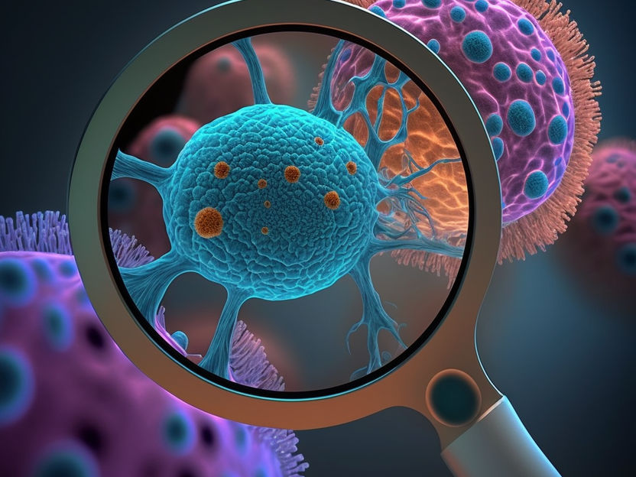

Preliminary results underscore the promising performance of our approach, demonstrating heightened sensitivity, specificity, and overall accuracy compared to conventional methodologies. This research not only presents a technological advancement in cancer diagnostics but also contributes significantly to the ongoing evolution of robust tools for early cancer detection. The envisioned outcome is a paradigm shift towards improved patient prognosis and personalized treatment strategies in the realm of oncology.

# **Literature Review**

[2] The proposed research aims to enhance early-stage cancer detection and classification through a systematic approach. It begins with an extensive literature review on deep learning methodologies for cancer, identifying gaps and limitations. Diverse cancer datasets, including lung, breast, prostate, and colorectal, will be collected and pre-processed to ensure consistency. The development of advanced deep learning models follows, incorporating techniques like transfer learning and attention mechanisms. The implementation of algorithms in MATLAB, specifically for Brain and Lung Cancer Detection, is a key aspect. The acquisition of medical images involves careful anonymization and de-identification, ensuring privacy. Preprocessing techniques address common challenges, while thresholding optimizes image segmentation. The Discrete Orthonormal Stockwell Transform (DOST) is applied for frequency-based feature extraction. Convolutional Neural Network (CNN) layers are utilized for automated image data representation, and a Support Vector Machine (SVM) classifier refines results from CNN layers.

In [5] the method employs YOLOv4 for real-time target detection, enhancing feature extraction through CSPDarknet53 and addressing fusion challenges. An improved version, E-YOLO, adjusts input size and introduces a Convolutional Block Attention Module (CBAM) for detailed feature extraction. The proposed model, EGCD, combines E-YOLO with CBAM to improve the accuracy of small-scale boundary detection in early gastric cancer targets. The model is evaluated for performance using an input classifier in the feature extraction module.

Author introduces the IWSACAE-LCCD technique for the identification and classification of LCC (Lung Cancer Cells) under HIs (Haematoxylin and Eosin-stained Images) in [1]. The proposed technique involves image preprocessing using the Median Filter (MF) approach to eliminate noise. Feature extraction is achieved through the MobileNetv2 architecture, known for its efficiency in deep learning tasks. Hyperparameter tuning is performed using an Invasive Weed Optimization with Social Adaptation (IWSA) algorithm, optimizing the MobileNetv2 model. The IWSA algorithm integrates opposition-based learning for enhanced metaheuristic efficiency. Finally, cancer detection utilizes a Convolutional Autoencoder (CAE) model. The CAE replaces fully connected layers with convolution layers, allowing unsupervised pre-trained ability.

In [3] method involves self-supervised learning (SSL) to train a convolutional neural network for feature extraction from RF ultrasound ROIs. The second stage utilizes Multiple Instance Learning (MIL) with a Transformer-based self-attention model for core classification, incorporating attention for robust cancer identification. SSL employs Variance-Invariance-Covariance Regularization (VICReg) on a ResNet, while MIL involves end-to-end training with a dropout layer for enhanced generalization.

A system for early skin cancer detection through a mobile app using AI in studied here [4]. The dataset, "ISIC: Skin Cancer," includes 3297 images divided into 80% training and 20% testing. Data preprocessing involves resizing and augmentation using Python, OpenCV, and TensorFlow. classification employs K-NN, Decision Trees, and Transfer Learning algorithms. The model, developed in Python 3.10 with TensorFlow, utilizes the ResNet50 architecture. [4] The mobile app, created in Android Studio using Java, offers features like skin scan, illness process tracking, and daily news updates. Evaluation focuses on image classification accuracy and user interface usability, meeting success criteria in a two-stage peer assessment.

**III. THE PROPOSED MODEL**

This research focuses on creating an early cancer detection system for lung, brain, breast, and gastric cancers. By combining existing datasets, the model aims to classify images into eight classes, indicating the presence or absence of each cancer type. It leverages datasets focused on early cancer detection images and employs cutting-edge deep learning techniques for classification. Below block diagram fig. 3.1 describes the method involved in our research work.

Fig. 3.1 block diagram for followed approach.

***DATA ACQUISITION:***

The primary goal of data acquisition is to curate a diverse and representative dataset comprising images of early-stage cancer for lung, brain, breast, and gastric cancers. The dataset will serve as the foundation for training a multiclass classification model. Multiple existing datasets dedicated to early cancer detection will be identified and combined to form a unified dataset. The inclusion of diverse datasets ensures a comprehensive representation of the various stages and manifestations of cancer across different organs.

Emphasis will be placed on sourcing images specifically depicting early-stage cancer conditions. Early detection is crucial for effective intervention and treatment, making it essential to prioritize images that capture the initial phases of cancer development. The acquired images will undergo rigorous quality checks to ensure accuracy and reliability. Quality control measures include verifying the authenticity of the images, ensuring proper metadata, and eliminating duplicates. The dataset will be carefully curated to maintain a balance between positive (cancerous) and negative (non-cancerous) instances, enhancing the model's robustness. The dataset will encompass a diverse set of images, including those depicting cancerous conditions as well as non-cancerous instances. This balanced representation is crucial for training a model that can effectively differentiate between normal and abnormal conditions.

***DATA PRE-PROCESSING:***

Data preprocessing plays a pivotal role in shaping the effectiveness of an early cancer detection system by refining the input dataset to better suit the requirements of the subsequent deep learning model. Below are the steps involving in this process.

**1. Data Cleaning:** Data cleaning is a crucial initial step in preparing the dataset for an early cancer detection model. In the context of medical imaging, this involves meticulous inspection for artifacts, labelling errors, or any inconsistencies that could compromise the dataset's quality. Ensuring accurate and reliable labelling, as well as removing irrelevant or corrupted data, is essential. This step guarantees that the model learns from a clean and representative dataset, minimizing the risk of biases introduced by noisy or inaccurate information.

**2. Data Augmentation:** To enhance the robustness and generalization capabilities of the early cancer detection model, data augmentation techniques are applied. This involves generating diverse variations of existing images through operations like rotation, flipping, zooming, and changes in brightness. In the realm of medical imaging, simulating different viewing angles and conditions is particularly valuable. Data augmentation mitigates the risk of overfitting by exposing the model to a more extensive range of scenarios, ensuring its adaptability to real-world variations in medical images.

**3. Median Filtering:** In the context of early cancer detection, where subtle details are crucial, median filtering is employed for noise reduction. This spatial domain technique replaces each pixel's value with the median value of its neighbouring pixels. By reducing noise in medical images, such as those indicative of early-stage cancer conditions, median filtering enhances the clarity of structures and features. This step is instrumental in maintaining the integrity of the images, ensuring that subtle patterns and indicators of potential cancers are not obscured by unwanted noise.

By seamlessly integrating these data preprocessing steps, the research strives to refine and optimize the dataset for subsequent use in a deep learning model. This approach aims to guarantee a high-quality, diverse, and noise-free dataset, laying the foundation for an effective early cancer detection system across multiple organ types.

***FEATURE EXTRACTION:***

The next critical step in the development of an early cancer detection system involves **feature extraction** through the utilization of transfer learning. Transfer learning leverages pre-trained deep learning models on large datasets, allowing the extraction of relevant features without the need for training an entire model from scratch. In this research, three distinct models—**MobileNetV2, VGG19, and ResNeXt-101**—will be explored for their efficacy in capturing discriminative features from medical images.

**1. MobileNetV2:** MobileNetV2, known for its efficiency and lightweight architecture, is a suitable candidate for feature extraction in medical imaging. Its depth-wise separable convolutions enable high computational efficiency, making it well-suited for applications with limited computational resources. By employing MobileNetV2, the research aims to assess its ability to extract relevant features indicative of early-stage cancer conditions.

**2. VGG19:** VGG19, a deeper architecture compared to its predecessors, is renowned for its simplicity and effectiveness. Its uniform architecture with small receptive fields makes it adept at capturing hierarchical features. By employing VGG19 for feature extraction, the research aims to evaluate its performance in discerning intricate patterns and structures present in medical images, particularly those associated with early cancer stages.

**3. ResNeXt-101:** ResNeXt-101, a state-of-the-art convolutional neural network, is characterized by its cardinality parameter, which enhances model performance by capturing diverse features. The research incorporates ResNeXt-101 to assess its potential in extracting nuanced features crucial for the accurate identification of early-stage cancers. Its deep and highly expressive architecture makes it well-suited for the complexities inherent in medical imaging datasets.

The feature extraction process involves utilizing the pre-trained weights of these models on large-scale image datasets. The models' convolutional layers are employed to extract high-level features from the input images, which are then fed into subsequent layers for classification. Through experimentation and performance evaluation, the most effective model among MobileNetV2, VGG19, and ResNeXt-101 will be selected for further refinement and integration into the early cancer detection system.

***VISION TRANSFORMER:***

The subsequent phase of the research involves classification using the innovative Vision Transformer (ViT) model, a groundbreaking approach introduced in 2021 for image recognition tasks. The ViT model represents a departure from traditional Convolutional Neural Networks (CNNs) by treating images as sequences of patches and directly predicting class labels. This step is integral to the research's objective of developing a robust early cancer detection system.

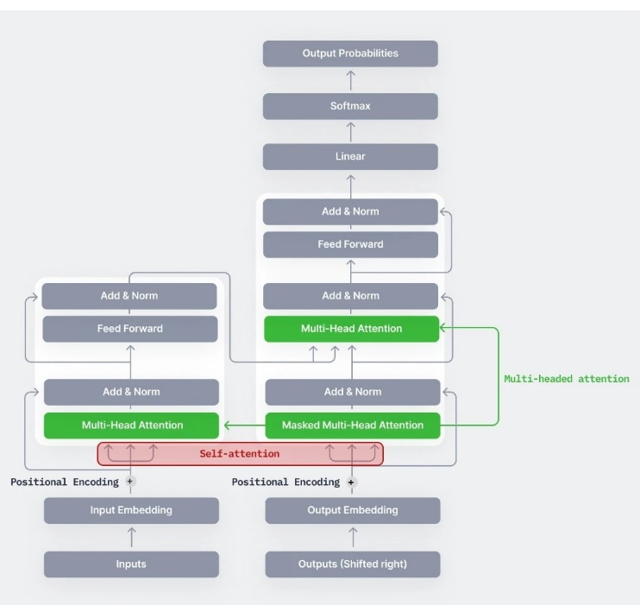

Fig 3.2 Vision Transformer

ViT represents images as sequences, where each patch is flattened into a vector and linearly projected to the desired input dimension. The key steps in the ViT architecture include.

* **Image Patching:**

**Splitting an Image into Patches:** The input image is divided into fixed-size patches, treating them as the fundamental elements akin to words in natural language. This enables the model to process images as sequences.

* **Patch Embedding:**

**Flattening and Linear Projection:** Each patch is flattened into a vector by concatenating the channels of its pixels. A linear projection is then applied to map these flattened patches to lower-dimensional embeddings.

* **Positional Embeddings:**

**Incorporating Spatial Information:** Positional embeddings are added to the flattened patches to introduce spatial information. This allows the model to understand the relative positions of different patches in the sequence.

* **Transformer Encoder Blocks:**

**Self-Attention Mechanism:** The core of the Transformer, the self-attention mechanism, is applied to capture relationships between different patches. Attention weights are calculated based on the content of each patch, providing the model with the ability to focus on relevant parts of the input.

**Layer Normalization:** Ensures stable training by normalizing the activations in each layer, aiding the model's adaptability to variations in input images.

**Multi-Head Attention (MSP):** Responsible for generating attention maps from embedded visual tokens. These maps help the model focus on crucial regions in the image, such as objects, contributing to effective feature extraction.

**Multi-Layer Perceptron (MLP):** A two-layer classification network with GELU activation function. The final MLP block, also known as the MLP head, serves as the output of the transformer. Applying SoftMax on this output provides classification labels for image categorization.

* **Skip Connections:**

**Influential Skip Connections:** Skip connections play a pivotal role in the architecture, impacting both performance and the similarity of representations. They enable the model to bypass certain layers, aiding in the flow of information and contributing to better gradient flow during training.

The Vision Transformer architecture transforms input images into sequences of patches, leveraging the self-attention mechanism of the Transformer model. Through the use of encoder blocks containing layer normalization, multi-head attention, and multi-layer perceptron, ViT captures both global and local features in a more unified manner. The incorporation of skip connections enhances the network's ability to retain spatial information. By understanding the nuances of the ViT architecture, the research aims to harness its capabilities for accurate and efficient classification in the context of early cancer detection across diverse organ types.

***PERFORMANCE EVALUATION:***

Accuracy provides a general overview of a model's performance, it might not be sufficient on its own, especially in imbalanced datasets. In early cancer detection, where positive cases (cancers) may be rare compared to non-cancerous instances, accuracy alone might be misleading. However, it is still valuable to gauge the overall effectiveness of the model in making correct predictions. A high accuracy score indicates that the model is performing well across both positive and negative classes.

Recall, also known as sensitivity or true positive rate, measures the ability of a classification model to identify all relevant instances from the positive class. It is calculated as the ratio of true positives to the sum of true positives and false negatives. Mathematically, it can be expressed as:

#### **Recall = True Positive (TP) / True Positive (TP) + False Negative (FN)**

Where,

**True Positive (TP) =** Represents the number of positive instances correctly identified by the model. i.e., Cases where both the Actual and Predicted Classes are Positive.

**False Negative (FN) =** Represents the number of positive instances that the model incorrectly identifies as Negative. i.e., cases, where the actual class is positive, but the model predicted them negatively, i.e., wrong predictions.

In the context of early cancer detection, recall is particularly crucial. It indicates the model's effectiveness in capturing and correctly identifying instances of early-stage cancer cases. A high recall ensures that the model minimizes the number of false negatives, which is vital for preventing cases where actual cancers are missed during diagnosis. Early detection is key to improving patient outcomes, and a high recall rate contributes directly to the model's ability to identify subtle signs of cancer in medical images.

**CONCLUSION**

This research developed a robust early cancer detection system covering lung, brain, breast, and gastric cancers. From meticulous data acquisition to performance evaluation, each step contributed to the goal of creating an accurate model. The combined datasets, emphasizing cancerous and non-cancerous images, formed the foundation. Data preprocessing ensured a resilient dataset. Transfer learning with MobileNetV2, VGG19, and ResNeXt-101 facilitated effective feature extraction, while Vision Transformer (ViT) marked a paradigm shift in classification.

this research represents a significant stride in the field of early cancer detection, amalgamating cutting-edge techniques in deep learning and computer vision. The model's accuracy and adaptability to clinical urgency in identifying early-stage cancers make it a promising tool for real-world applications. Future directions include continuous refinement of the model, integration of additional modalities, and validation on diverse datasets to enhance its applicability and generalization in clinical scenarios. The pursuit of accurate and timely cancer detection remains dynamic, and this work contributes meaningfully to this critical domain.

##### **References**

[1] H. Alqahtani, E. Alabdulkreem, F. A. Alotaibi, M. M. Alnfiai, C. Singla and A. S. Salama, "Improved Water Strider Algorithm With Convolutional Autoencoder for Lung and Colon Cancer Detection on Histopathological Images," in IEEE Access, vol. 12, pp. 949-956, 2024, doi: 10.1109/ACCESS.2023.3346894.

[2] O. H. Kesav and R. G. K, "A Systematic Study on Enhanced Deep Learning Based Methodologies for Detection and Classification of Early Stage Cancers," 2023 IEEE 5th International Conference on Cybernetics, Cognition and Machine Learning Applications (ICCCMLA), Hamburg, Germany, 2023, pp. 328-333, doi: 10.1109/ICCCMLA58983.2023.10346973.

[3] Mahdi Gilany1, Paul Wilson1, Andrea Perera-Ortega “TRUSformer: Improving Prostate Cancer Detection from Micro-Ultrasound Using Attention and Self-Supervision” arXiv:2303.02128v1 [eess.IV] 3 Mar 2023

4] A. İ. Sarı, B. Dervişoğlu and A. Rovshenov, "Early Detection of Skin Cancer with Mobile Application Using Artificial Intelligence Techniques," 2022 Innovations in Intelligent Systems and Applications Conference (ASYU), Antalya, Turkey, 2022, pp. 1-6, doi: 10.1109/ASYU56188.2022.9925565

[5] X. Li, Y. Chai, K. Zhang, W. Chen and P. Huang, "Early gastric cancer detection based on the combination of convolutional neural network and attention mechanism," 2021 China Automation Congress (CAC), Beijing, China, 2021, pp. 5731-5735, doi: 10.1109/CAC53003.2021.9728413.

[6] Woo S, et al. CBAM: Convolutional Block Attention Module[J]. Springer, Cham, 2018.

**.**