**Red Tacton-A Human Area Networking Technology**

Abstract:

In the recent days, Electronic bias come lower in size and lower in power Conditions and they’re less precious. We’ve begun to beautify our bodies with Particular Information and communication operations. Some Exemplifications includes cellular Phones, Pagers and particular digital sidekicks. Networking these kinds of bias can reduce Functional I/ O redundancies and allow new Conveniences and services. Mortal society is Entering a period of ultramodern computing, when networks are easily connected. The Perpetration of ubiquitous services requires three situations of connectivity Land Area Networks (LAN), Wide Area Networks (WAN), and Human Area Networks (HAN) for Connectivity to particular information, share data, media and communication appliances Within the important lower areas for communication. RedTacton is a technology that uses The face of the mortal body as a high speed and safe network transmission path. So we the Pupil are explaining the new and unique functional features and eventuality of RedTacton As a Human Area Networking Technology. Our Human body acts as a transmission medium Supporting half duplex communication at 10Mbit/s.

Key Word:

Red Tacton , Electric field sensing

1. INTRODUCTION

Red Tacton is a break- gamble technology that uses the face of the human body as a safe, high- speed network Transmission path. In the history, Bluetooth, Infrared dispatches (IrDA), Radio frequence ID systems (RFID), and other Technologies have been proposed to break the connectivity problem. But Red Tacton takes a different specialized approach. So We, in this paper are explaining the unique new functional features and enormous eventuality of Red Tacton as a Human Area Networking technology. Human Society is entering an a raw of ubiquitous computing when networks are seamlessly connected And the information is always accessible at our cutlet tips. Red Tacton is one of the new Human Area Networking Technology that uses the face of the Human body as safe, high speed network transmission path. Red Tacton is a break through Technology That, for the first time, enables dependable high speed HAN. In the history, Bluetooth, infrared communication, radio frequence ID systems and other technologies have bean proposed to break the “Last Cadence” connectivity problem. Still they each have colorful abecedarian specialized limitation that constrain their operation, similar as the precipitous fall out in transmission speed.

1. WHAT IS RED TACTON

Red Tacton Technology was introduced by Nippon Telegraph and Telephone Corporation (NTT). TACTON- meaning “action started by touching” and RED-It’s an auspicious color according to Japanese culture for warmth. It’s a technology that uses the face of the Mortal body as a safe, high speed network transmission. The study of Mortal Area Networking Red Tacton Uses the nanosecond electric field emitted on the face of the Mortal body. It’s fully distinct from wireless and infrared. A Transmission path is formed at a part of the Mortal body which comes in contact with a RedTacton transceiver. Physically Separating ends the contact and therefore ends communication. Using RedTacton, communication starts when outstations carried By the stoner are linked in several combinations according to the stoner’s natural, physical movements. Communication is Possible using any body shells, similar well.as the hands, fritters, bases, face, legs, skin or torso

1. WORKING PRINCIPLE

Transmitter should be with the user and the receiver can be with any device that needsdata transfer. RedTacton Transmitter produces an electric field that is weak to the body surface. RedTacton Receiver senses the change in electric Field on the body surface caused by the transmitter. RedTacton detects changes in the properties relatedto the optical field Of a crystal using a laser and converts the result to an electrical signal in an optical receiver circuit. Signal from the interface Is given to the data sense and transmitter circuit. Data Sense Circuit: It will sense the signal from the interface and if data Is present the signal is given to the transmitter. The transmitter gets into operation. Transmitter will varythe electric field Of the body surface. Change in electric field is detected by the sensor. Output of sensor is given to the detector. Detector Circuit will give its output to the Redtacton device at the receiver. Redtacton communication can be established just through A touch, walk or by stepping, sitting and also through other human movements. Communication cantake place in the duplex And interactive form at fast speed. Also, no deterioration is present in the signal since the human body is the transmission path. Any transmission media like conductors, dielectrics can be used other than human body.

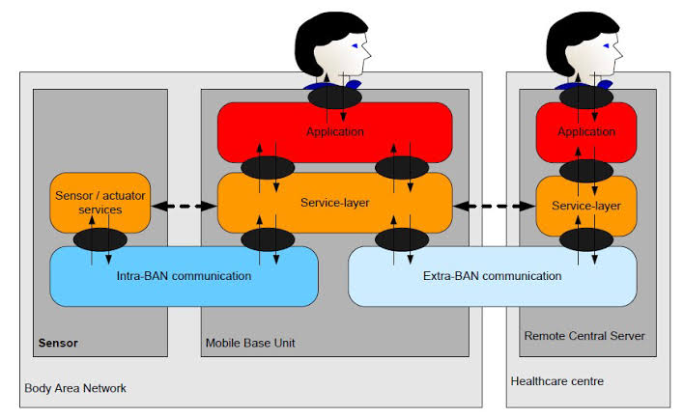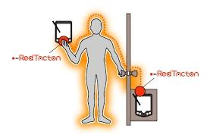

Current Problems:

Current problems with communication in body detector networks. While wireless detector networks are gradationally Getting mainstream, the lower affiliated body detector networks are still in their immaturity. Body detector networks consists of Number of communicating detectors that can be worn and that cover the body. These bias communicate to each other and Conceivably shoot data to an o, body position for farther processing. While related to wireless detector networks the challenges Are dutiful. Body detector networks have to deal with further dynamic terrain than wireless detector bumps because humans Infrequently sit still. This causes problems with the Communication between the bumps with the radio ways presently used. To Overcome problems with transmission similar as hindrance and disconnects the power of the transmission is increased. This Allows the signal to be entered from a lesser distance, leading to sequestration enterprises. Hindrance is a major problem with radio grounded technologies because utmost radio grounded ways use frequentness that are near to each other and that are also used for other purposes like telephony. Because the signal strength is increased to Minimize hindrance the power operation increases leading to batteries running out of power sooner. In table 3 the bandwidth conditions of multiple detectors are given, combining this with table 1 shows that it’s doable to make body detector networks With radio moment. But the energy operation of such a network is too large to keep such a network running without constantly Demanding to recharge the bumps. We’re presently witnessing a growing interest in the area of wireless body area networking (WBAN) accompanied by the strong demand of the medical and healthcare society as well as by the advances in low- power

Micro-and nano-electronics and wireless networking.

Consumers and croakers image an period where mobile health monitoring systems will work seamlessly and in Musicale to exclude the pause time between the onset of symptoms and opinion. To this end WBAN can assert a crucial donation, But as it shows particular characteristics when compared to traditional wireless detector and ad hoc networks, it can introduce

Several new exploration challenges.

The perpetration of NTT is sluggishly moving towards commercialization. The first marketable, Perpetration of their Security technology is the NTT Firmo evaluation tackle. The perpetration from KAIST is still in development in the lab and will Presumably be capitalized in the near future. At the moment it appears that about five exploration groups are laboriously pursuing body coupled dispatches.

Mechanism of Communication with RedTacton:

Data is obtained the usage of a photonic electric powered subject sensor that mixes an electro- opticcrystal and a laser Mild to locate fluctuations withinside the minute electric powered subject. Theclearly happening electric powered subject Caused at the floor of the human frame dissipates into the earth. Therefore, this electric powered subject is incredibly faint and Unstable. The photonic electric powered subject sensor advanced with the aid of using NTT permits susceptible electric powered Fields to bemeasured with the aid of using detecting adjustments withinside the optical homes of an electro-optic crystal with

Laser beam Transmission Steps

1.The Red Tacton transmitter induces a susceptible electric powered subject at the floor of the frame.

2. The Red Tacton receiver senses adjustmentswithinside the susceptible electric powered subject at the floor of the frame Brought about with the aid of using the transmitter.

3.It is predicated at the precept that the optical homes of the electro-optic crystal varies in keeping with the adjustments the susceptible electric powered subject.

4.It detects the adjustments withinside the optical homes of an electrooptic crystal the usage of a laser beam and converts the end result into an electrical sign in a detector

Red Tacton Receiver:

The sign from the interface is dispatched to the facts experience circuit and the transmitter circuit. The facts experience Circuit senses the sign and if the facts is giftit sends manage sign to the transmitter which turns on the transmitter circuit. The Transmitter circuit varies theelectrical area at the floor of our body. This extrade withinside the electric powered area is detected of means of the electro-optic sensor.

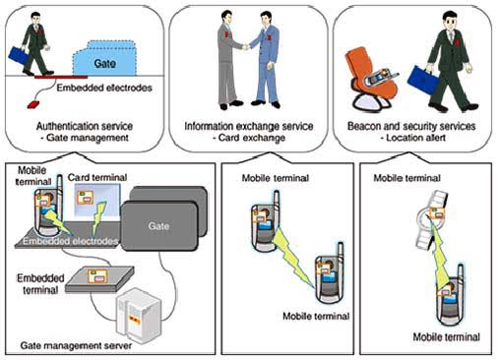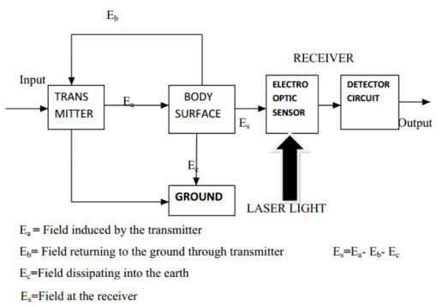

IV.APPLICATIONS

Red Tacton has wide range of applications, in thosesome of the applications are as follows:

One To One Services:

Enable one-to-one immolations designed to the Stoner s script and tastes. Attribute records recorded with inside the tool is dispatched to the widgets which might be in touch with it. The suitable provider is supplied primarily grounded Completely on the records acquired via way of means of the Red Tacton receiver.

Elimination of Human Error:

RedTacton gadgets embedded medication bottles transmit facts at the drug treatments attributes. Whenever the person Touches the incorrect medication, right away an alarm will cause at the terminal he is carrying. The alarm sounds most effective Every time the person absolutely touches the drugs bottle, it reduces fake alarms not unusual place with passive wi-fi ID tags,Which cause really with the aid of using proximity. Avoidance of hazard at production sites.

Marketing Applications:

When a customer stands in the front of an marketing and marketing panel, records matching and marketing and marketing His or her attributes is routinely displayed. By status in the front of gadgets they’reinterested by and additionally touching it, Clients can get extra associated records. Inside a shop, buyers can view associated records on their cellular terminals at onc After touching a product. Intuitive Operations

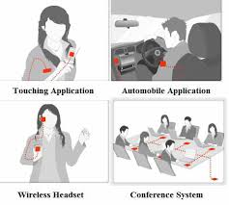

Personalization of Automobile:

The seat function and steerage wheel peak alter to suit the driving force simply with the aid of using sitting Withinside the car. The driver`s domestic is ready because the vacation spot withinside the car Navigation system. Various Conductors and dielectrics may be used as RedTacton communique media and this has the ability create new conduct patterns. Walls and walls may be used as communication.

Human Safety:

NO current flows into mortal body from RedTacton bias. RedTacton uses the Electric field that occurs naturally on the face of The mortal body for Communication. Transmitter and receiver electrodes are covered with an Insulating flicks. We delved the Goods of Red Tacton technology on mortal health, which is obviously an important tissue. The transmitting and entering Electrodes of the Red Tacton receiver are fully covered with separating film, so the body of the person acting as a transmission Medium is fully insulated. This makes it possible for current passes through into a person’s body from a transceiver. When communication occurs, relegation current is generated by the electrons in the body because the body is subordinated to Nanosecond electrical fields. Still similar relegation currents are veritably common everyday circumstances to which we’re all Subordinated. Red Tacton conforms to the “Radio Frequency- Exposure Protection Standard (RCR STD-38)” issued by the Association of Radio diligence and business.

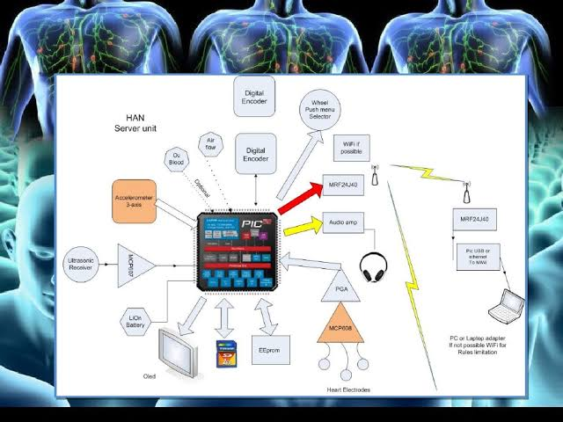User Verification management:

Carrying a mobile RedTacton-able device in one’s fund, ID is vindicated and the door uncorked when the stoner Holds the doorknob typically. Secure cinch administration is possible by combining particular verification tools similar as Point ID or other biometric in the mobile outstation.

Pros:

RedTacton does now no longer require the electrodeto be in direct touch with the skin.

1.High-pace communique is viable among an arbitrary factors at the body.

2.Body-primarily based totally networking is extra stable than different broadcast systems, which include Bluetooth Which have excessive variety of approximately 10m.

3.Superior than Infrared technologyv.) Superior than Wi-Fi.

1CONCLUSION

The execution of Red Tacton is ameliorate as compared to other technologies. It’s stylish to connect network within Short distances. There’s no any third persons can involve or Hacks because it carried out by our body itself, so the transmission Medium is our body . This Technology is used Particular Causes is speed of Network, it’s answered by Red Tacton by furnishing Veritably high speed of 10 Mbps within short distances. The evolution of Red Tacton technology is a conquest, which will probably be targeted for use in similar operations as wireless headset, medical operation, security operations, Transmission by applying different conduct. This could get as simple as two people equipped with Red Tacton bias being suitable To change data similar as textbook lines as well as business cards just by shaking hands.

References

1. <https://www.google.com/url?sa=t&source=web&rct=j&url=http://dspace.cusat.ac.in/jspui/bitstream/12345678>
2. <https://www.mepits.com/tutorial/454/trending-technologies/redtacton-echnologyhttps://alchetron.com/cdn/1412092747403707d286c->