 

**TRANSFORMER HEALTH MONITORING SYSTEM USING IoT**

**A PROJECT REPORT**

***Submitted by***

**D.S. ARAVIND (913120105003)**

**B. SHANMUGA SUNDARAPANDI (913120105032)**

***In partial fulfillment for the award of the degree***

***of***

**BACHELOR OF ENGINEERING**

***in***

**ELECTRICAL AND ELECTRONICS ENGINEERING**

**VELAMMAL COLLEGE OF ENGINEERING AND TECHNOLOGY,**

**MADURAI-625 009**

**ANNA UNIVERSITY::CHENNAI 600 025**

**MAY 2024**

## ANNA UNIVERSITY: CHENNAI 600 025

## BONAFIDE CERTIFICATE

Certified that is report **“TRANSFORMER HEALTH MONITORING SYSTEM USING IoT”** is the Bonafide work of **D.S.ARAVIND (913120105003)** and **B.SHANMUGA SUNDARAPANDI (913120105032)** who carried out the project under my supervision.

##### SIGNATURE SIGNATURE

**Dr.A.SHUNMUGALATHA, M.E., Ph.D., Dr.T.CHANDRASEKAR, M.E.,Ph.D.**

##### Dean(Academics) & Associate Professor

##### Head of the Department

Electrical and Electronics Engineering, Electrical and Electronics Engineering, Velammal College of Engineering and Velammal College of Engineering and Technology, Technology,

Madurai–625009. Madurai –625009.

Certified that the candidate was examined on the Viva-Voce Examination held at Velammal College of Engineering and Technology, Madurai on .

**INTERNAL EXAMINER EXTERNAL EXAMINER**

**ACKNOWLEDGEMENT**

First of all we thank the Almighty for strengthening us throughout the project and helping us to complete it successfully.

We find immense pleasure to convey our sincere thanks to our honorable Principal **Dr.P.ALLI ,** for providing necessary facilities in carrying out our project work in our campus.

We would like to express our hearty thanks to our Dean(Academics) & Head of the Department **Dr.A.SHUNMUGALATHA, M.E., Ph.D.,** for her constant encouragement.

We take this opportunity to express our sincere and heartfelt thanks to our guide, **Dr.T.CHANDRASEKAR, M.E.,Ph.D** for her patient guidance, timely suggestion technical and moral support and the immense part of her dedication in completing the project work successfully.

We express our special thanks to other staff members of our department, the non-teaching staff and our friends who assisted us, by their support and encouragement.

We also express our special thanks to our Parents who have sacrificed greatly in our education and welfare. We thank all those who have helped directly and indirectly in doing this project and bringing out this successful report.

**ABSTRACT**

Transformers are the main building block in a power system. Any damages in transformer adversely affects the balance of a power system. The damages are mainly occurring due to overloading and inefficient cooling. The main objective of the real time monitoring of the health conditions of the distribution transformer using IOT technology. The parameters such as temperature, voltage, current, and oil level of a transformer are monitored, processed and recorded in servers. For this purpose, we use sensors interfaced with Esp32 microcontroller. The recorded data can be send using Wi-Fi module and accessed from anywhere around the world using IOT technology. This helps in identifying human dependency, and solving a problem before a failure without human monitoring.

**LIST OF CONTENTS**

|  |  |  |
| --- | --- | --- |
| **CHAPTER NO.** | **TITLE** | **PAGE NO.** |
|  | **ACKNOWLEDGEMENT** | **3** |
|  | **ABSTRACT** | **4** |
|  | **LIST OF CONTENTS** | **5** |
|  | **LIST OF FIGURES** | **7** |
|  | **LIST OF ABBREVATION** | **9** |
| **1** | **INTRODUCTION** | **1** |
| 1.1 | GENERAL | 1 |
| 1.2 | OBJECTIVE | 3 |
| 1.3 | EXISTING METHOD | 4 |
| 1.4 | DRAWBACK | 4 |
| **2** | **LITERATURE SURVEY** | **5** |
| 2.1 | DISTRIBUTION TRANSFORMER MONITORING SYSTEM USING ARDUINO. | 5 |
| 2.2 | DESIGN AND IMPLEMENTATION SMART TRANSFORMER**.** | 6 |
| 2.3 | FAULT ANALYSIS OF OIL-FILLED POWER TRANSFORMERS USING SPECTROSCOPY TECHNIQUES**.** | 8 |
| 2.4 | A NEW LEAKAGE FLUX-BASED TECHNIQUE FOR TURN-TO-TURN FAULT PROTECTION AND FAULTY REGION IDENTIFICATION IN TRANSFORMERS | 10 |
| **3** | **PROPOSED SYSTEM** | **11** |
| 3.1 | DESCRIPTION | 11 |
| 3.2 | BLOCK DIAGRAM DESCRIPTION | 12 |
| 3.3 | ADVANTAGES | 13 |
| **4** | **MODULE DESCRIPTION** | **14** |
| 4.1 | POWER SUPPLY | 14 |
| 4.2 | POTENTIAL TRANSFORMER | 15 |
| 4.3 | CURRENT TRANSFORMER | 15 |
| 4.4 | LM2596 BUCK CONVERTER | 16 |
| 4.5 | VIBRATION SENSOR | 17 |
| 4.6 | ULTRASONIC SENSOR | 18 |
| 4.7 | DHT11- TEMPRATURE AND HUMIDITY SENSOR | 19 |
| 4.8 | Esp32 MICROCONTROLLER WITH WIFI CONNECTIVITY | 20 |
| 4.9 | RELAY | 23 |
| 4.10 | BUZZER | 24 |
| 4.11 | LCD DISPLAY | 24 |
| 4.12 | LAMP LOAD | 25 |
| **5** | **RESULTS AND DISCUSSION** | **26** |
| 5.1 | RESULT | 26 |
| 5.2 | COST ESTIMATION | 30 |
| **6** | **CONCLUSION** | **31** |
| **7** | **REFERENCES** | **32** |

**LIST OF FIGURES**

|  |  |  |
| --- | --- | --- |
| **FIGURE**  **NO.** | **DESCRIPTION** | **PAGE**  **NO.** |
| 2.1 | Block diagram 0f Based Transformer Monitoring System | 5 |
| 2.2 | Block diagram of Smart Transformer | 7 |
| 2.3 | Block diagram of Fault analysis | 9 |
| 3.1.1 | Block Diagram of the proposed system | 12 |
| 4.2.1 | Potential Transformer | 15 |
| 4.3.1 | Current Transformer | 16 |
| 4.4.1 | LM2596 BUCK CONVERTER | 17 |
| 4.5.1 | Vibration Sensor | 18 |
| 4.6.1 | Ultrasonic Sensor | 19 |
| 4.7.1 | DHT11- Temprature and humidity sensor | 20 |
| 4.8.1 | Esp32 microcontroller with wifi connectivity | 22 |
| 4.9.1 | Relay | 23 |
| 4.10.1 | Buzzer | 24 |
| 4.11.1 | LCD Display | 24 |
| 4.12.1 | Lamp Load | 25 |
| 5.1.1 | Implemented Prototype | 26 |
| 5.1.2 | Working Condition | 27 |
| 5.1.3 | Output of Voltage | 27 |
| 5.1.4 | Output of Oil level | 27 |
| 5.1.5 | Output 0f Relay | 28 |
| 5.1.6 | Output of Current & kwh | 28 |
| 5.1.7 | Output of Temperature | 28 |
| 5.1.8 | Output of Humidity | 29 |
| 5.1.9 | Output of Vibration | 29 |

**LIST OF ABBREVATION**

* **IoT -** Internet of Things
* **LCD -** Liquid-Crystal Display
* **Esp32 -** Electronic Stability Program

**CHAPTER 1**

**INTRODUCTION**

**1.1 GENERAL**

The Electricity plays an important role in our life. Every moment of our life depends upon electricity. Electricity has several components and equipment helping human to transfer and regulate the distribution according to usage. The most crucial equipment of transmission and distribution of electric power is transformer. Operation of distribution transformer under rated condition (as per specification in their name plate) guarantees their long service life. However, their life is significantly reduced if they are subjected to overloading, heating low or high voltage current resulting in unexpected failure and loss of supply to a large number of customers thus is affecting system reliability. Overloading, oil temperature load current and ineffective cooling of transformer are the major cause of failure in distribution transformer. As a large number of transformers are distributed over a wide area in present electric systems, it’s difficult to measure the condition manually of every single transformer. So, we need a distribution transformer system to monitor all essential parameters operation, and send to the monitoring system in time. It provides the necessary information about the health of the transformer. This will help and guide the utilities to optimally use the transformer and keep this equipment in operation for a longer period. The main aim of the project is to acquire real-time data of transformer remotely over the internet falling under the category of Internet of Things (IOT).

The distribution transformer is electrical equipment in power system which distributes power to the users directly, and its operating condition is important to the distribution network operators. The operation of distribution transformers underrated condition guarantees their long life. However, their life is significantly reduced if they are subjected to overloading, resulting in unexpected failures and loss of supply to a large number of customers thus effecting power system reliability. Overloading and insufficient cooling of transformers are the main causes of failure. The monitoring device systems which are presently used for monitoring distribution transformer exist some problems and deficiencies.

**1.2 OBJECTIVE**

A transformer health monitor system using IoT aims to provide continuous real-time monitoring of transformers to ensure their optimal performance and longevity. By deploying various sensors and IoT devices, the system collects data on parameters such as temperature, oil levels, vibration, and electrical parameters. This data is then transmitted to a centralized platform where it is analyzed using machine learning algorithms and predictive analytics. The system's objective is to detect any anomalies or potential issues in the transformer's operation, allowing for proactive maintenance and minimizing downtime. Additionally, the system enables remote monitoring, providing stakeholders with instant access to critical information about the transformer's health and performance. Ultimately, the goal is to enhance reliability, efficiency, and safety while reducing maintenance costs and the risk of unexpected failures. Real-time monitoring using IoT technology enables continuous tracking of parameters like temperature, voltage, current, and oil level.Sensors interfaced with microcontrollers like Esp32 and Wi-Fi modules record and transmit data. Remote access to this data allows for proactive maintenance and reduces human dependency in monitoring

**1.3 EXISTING METHOD**

A transformer health monitoring system typically includes various sensors to monitor temperature, oil level, pressure, and other parameters. These sensors collect data which is then analyzed by a monitoring system to detect any abnormalities or potential issues. Additionally, some systems may use diagnostic tools such as dissolved gas analysis (DGA) to assess the condition of the transformer oil and insulation .The data collected is usually processed using algorithms to detect patterns or trends that may indicate problems with the transformer. This information is then relayed to operators or maintenance personnel through a user interface, allowing them to take appropriate actions such as maintenance or replacement before any major issues occur Some advanced systems may also incorporate predictive analytics or machine learning algorithms to provide more accurate predictions of future failures or maintenance needs based on historical data and real-time monitoring. Overall, the goal of a transformer health monitoring system is to ensure the reliability and longevity of the transformer by detecting and addressing potential issues before they lead to costly downtime or failure.

**DRAWBACKS**

* Commonly, distribution transformers are situated in far-flung rural zones such that their consistent human scrutiny is hard because of limited numbers of employees.
* Existing monitoring systems are not capable of real-time operations, leading to numerous transformer failure cases detected daily.
* Incipient fault monitoring is among the internal errors detection elements overlooked by typical systems due to absence of inner error examination mechanisms.

**CHAPTER 2**

**LITERATURE SURVEY**

# Title: Distribution Transformer Monitoring System Using Arduino.

**Year: 2020**

# Author: Rohit R. Pawar, Yachao Ran

To maintain the reliability in grid operation it is important to monitor real time **transformer health**. We know the importance of transformers in electricity distribution and transmission. They are the main components and constitute the sizable portion of capital investment of the distribution grid. Real time transformer health monitoring systems help to replace the equipment before failure and continuity of the power will not be disturbed.

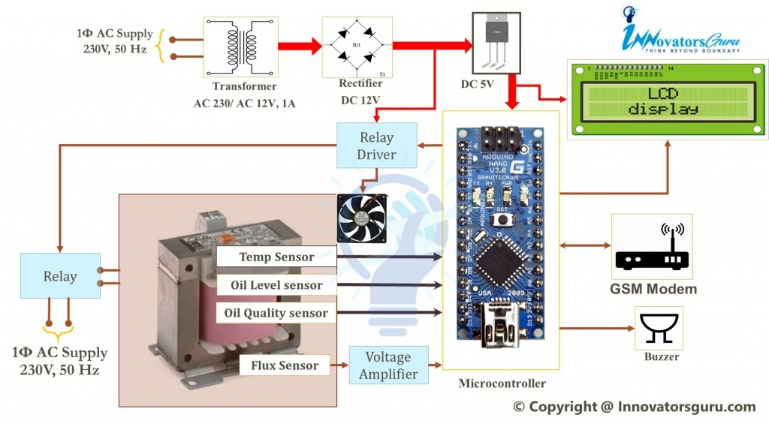

Fig. 2.1 Block diagram of Based Transformer Monitoring System

**Title: Design and Implementation Smart Transformer.**

**Year: 2019**

# Author: Walid K. A. Hasan, Abobaker Alraddad

Power transformers, which perform the function of transforming the voltage levels, are one of the most important electrical equipments that are used in power transmission systems. Hence, it is mandatory to perform power transformer maintenance; as they are normally scattered geographically, it is impractical to do periodical monitoring due to insufficient manpower. As the reason above, transformer failure may occur which causes the transformer from network unexpectedly power shutdown. To overcome this shutdown from transformer failure of the adapter, a system for transformer monitoring and self-protection was proposed in case the maintenance is delayed. In this paper, the temperature and humidity within the transformer were monitored, in addition to monitoring the rate of loading on the transformer. By using the internet of things (IoT), a self-protection system is designed and implemented for the transformer. Where, if the transformer is not serviced quickly, the transformer will separate loads of low-importance (workshops, Homes,) and it will keep the loads of high importance (hospitals,…). and if the transformer is unable to feed the loads of high importance, in this case the transformer will separates all loads and stay in no-load status where the transformer monitor its parameters by itself, if all parameters of the transformer return to the normal level, the transformer automatically returns the loads in order of priority. All these components have been grouped and combined into one device. In addition the device is powered using an AC-DC adapter by an external power source.

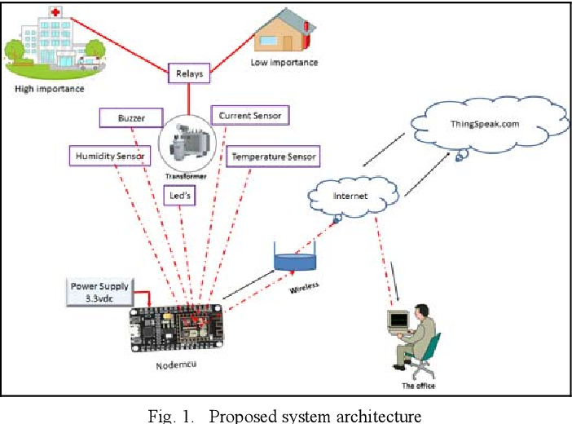

Fig. 2.2 Block diagram of Smart Transformer

# Title: Fault analysis of oil-filled power transformers using spectroscopy techniques.

**Year: 2017**

# Author: Hussain Kalathiripi, Subrata Karmakar

The power transformer plays a vital role in the power system network. Nowadays, the condition monitoring of oil-filled power transformer is greatest requirement for its reliable operations and quality power supply to the utility. The condition of such transformer can be indeed determined by knowing the ageing status of the dielectric liquid used for insulation and cooling. Though Dissolved Gas Analysis (DGA) has been well-acclaimed in the field of the transformer fault diagnosis, it has certain drawbacks like need of carrier gas, regular calibration. To overcome these drawbacks, in this proposed work, optical methods such as Ultra Violet-Visible (UV-vis) spectroscopy and Nuclear Magnetic Resonance (NMR) have been used. The obtain results of UV-vis spectroscopy demonstrate that all the characteristic peaks are covered and qualitatively analyzed within the wavelength region of 200-400 nm. Further, NMR spectroscopy results precisely identified the molecular groups present in the oil such as the methyl group, methylene group and the aromatic hydrocarbon groups. Moreover, this method is fast and reliable for determining the moisture content in the transformer oil. Overall, the obtained data confirms that UV-visible and NMR spectroscopy methods are highly efficient for analyzing the degraded transformer oils

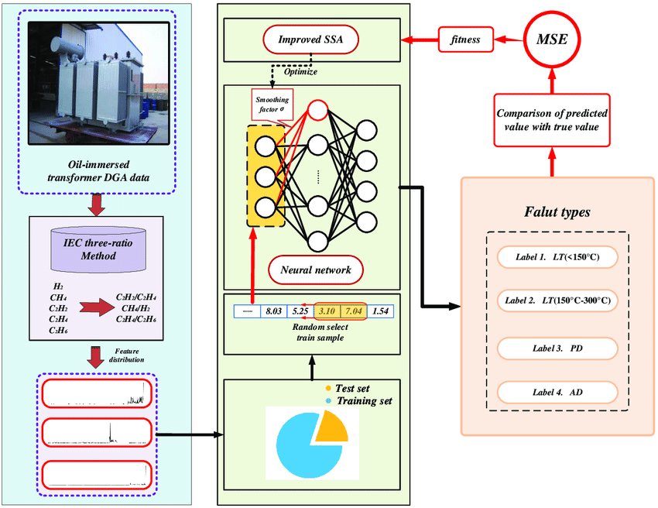

Fig. 2.3 Block diagram of Fault analysis

# Title: A New Leakage Flux-Based Technique for Turn-to-Turn Fault Protection and Faulty Region Identification in Transformers

**Year: 2018**

# Author: Farhad Haghjoo

Power transformer, as one of the most important apparatus in power system, must be protected against the turn-to-turn faults. Although the various methods based on the terminal currents and/or voltages have been presented for transformer protection, the flux-based methods can be used to achieve the more accurate, sensitive, and secure results. Since the symmetrical form of the magnetic flux distribution will be disturbed due to any fault occurrence in the transformer windings, it can be considered as an appropriate criterion to achieve a suitable protection algorithm, which can detect the fault occurrence and identify the faulty phase/region. In this paper, a new leakage flux sensor is introduced and then a flux-based technique is proposed to detect and identify the faulty phase in transformers to apply in online conditions. By using the proposed technique, the faulty region can be identified in offline conditions, as well. The experimental results (which are done on a distribution transformer) show that this technique is secure in the face of overfluxing and transformer energizing conditions and can detect turn-to-turn faults with high sensitivity. Moreover, tap changer operation, imbalanced loads, and/or unsymmetrical voltage sources cannot influence the proposed technique security.

**CHAPTER 3**

**PROPOSED SYSTEM**

**3.1 DESCRIPTION**

The Proposedmonitoring system based on IoT consists of three main systems:

1. Parameter measurement subsystem.
2. Protection Subsystem.
3. Data reception subsystem.

**Parameter measurement subsystem**

Transformer electrical and physical parameters are measured by using the Parameter measurement subsystem. Electrical parameters consist of internal flux, voltage, current, KVA, Frequency and power factor and in physical parameter we include temperature, oil level, oil quality and humidity.

**Protection Subsystem**

Controls a fan and protection relay to guard the transformer during defective situations. Monitors parameters inclusive of overcurrent, overvoltage, and overheating.

**Data Reception Subsystem**

Sends modern-day state and measured parameters to a far off IoT server.

CURRENT &

VOLTAGE

SENSOR

T

R

A

N

S

F

O

R

M

E

R

ESP

32

RELAY

TEMP

SENSOR

VIBRATION

SENSOR

OIL

SENSOR

LCD

DISPLAY

HUMIDITY

SENSOR

PC OR MOBILE

Fig. 3.1.1 Block Diagram of the proposed system

**3.2 BLOCK DIAGRAM DESCRIPTION**

This Proposed project presents design and implementation of IOT embedded system to measure load currents, over voltage, transformer oil level and temperature. This is implemented by using on-line measuring system using Internet of Things (IOT), with single chip Arduino microcontroller and sensors. It is installed at the distribution transformer site. The output values of sensors are processed and recorded in the system memory. System programmed with some predefined instructions to check abnormal conditions. If there is any abnormality on the system, details are automatically updated in the internet through serial communication. This Internet of Things (IOT) will help the utilities to optimally utilize transformers and identify problems before any catastrophic failure occurs. Thus, online measuring system is used to collect and analyze temperature data over time. So, Transformer Health Measuring will help to identify or recognize unexpected situations before any serious failure which leads to a greater reliability and significant cost savings. Transformer is one of the important electrical equipment that is used in power system. Monitoring transformer for the problem before they occur can prevent faults that are costly to repair and result in a loss of electricity.

For This Proposed Real-Time Framework, We Take a Voltage sensor, oil level, A Current sensor And a LM35 Temperature Sensor for Monitoring Voltage, Current, Temperature, Respectively Data of The Transformer and Then Send Them to A Desired Location Anywhere in The World. Then The Values Are Then Sent Directly Through a Wi-Fi Module Under TCP IP Protocol to A Dedicated IP That Displays the Data in Real Time Chart Form in Any Web Connected PC / Laptop/Mobile for Display. The Real Time Data Is Also Seen at The Sending End Upon an Android App Interfaced to The Microcontroller. The Supply of Power Is Given Through Step Down Transformer 230/12V, Which Steps Down the Voltage To 12V AC. This Is Converted to DC Using a Bridge Rectifier and It Is Then Regulated To +5V Using a Voltage Regulator 7805 Which Is Required for The Operation of The Arduino, 3.3 Volt for The Wi-Fi Unit and Other Component. If Overvoltage, less oil, over temperature And Over current Happens Then Microcontroller Will Send Data Message to An Android App And laptop.

**3.3 ADVANTAGES**

* Detect the faults in real time based on current, voltage, temperature, and internal flux. Increase system reliability and stability by the monitoring system.
* The system prevents faults and losses of the power supply which significantly benefits utility consumers.
* Overcurrent and overtemperature are prevented using this technique.

**CHAPTER 4**

**MODULE DESCRIPTION**

**4.1 POWER SUPPLY**

A power supply is the backbone of any electronic system, providing the necessary energy for devices to function properly. It converts raw electrical power from sources such as outlets, batteries, or renewable sources into a stable and usable form of energy. This conversion process ensures that electronic devices receive the appropriate voltage and current levels required for their operation, preventing damage from power fluctuations. Whether it's a desktop computer, a smartphone, or a complex industrial machine, the reliability and efficiency of the power supply directly impact the performance and longevity of the connected devices.

AC-DC Power Supply: Converts alternating current (AC) from the mains power grid into direct current (DC) used by most electronic devices.

DC-DC Converter: Converts one DC voltage level to another, commonly used in devices that require a specific voltage different from the input.

Linear Power Supply: Uses a linear regulator to regulate the output voltage, providing a clean and stable output but less efficient compared to other types.

Switched-Mode Power Supply (SMPS): Utilizes high-frequency switching to regulate the output voltage, offering higher efficiency and smaller size compared to linear power supplies.

Uninterruptible Power Supply (UPS): Provides backup power during mains power failure, ensuring continuous operation of critical devices.

* 1. **POTENTIAL TRANSFORMER**

A potential transformer, also known as a voltage transformer, is a type of instrument transformer used in electrical power systems to step down high voltage to a lower, safer level for measurement and control purposes. It consists of a primary winding connected in parallel with the power circuit and a secondary winding connected to the measuring instruments or control devices. The primary winding is typically connected across the high voltage source, while the secondary winding provides a reduced voltage proportional to the primary voltage. Potential transformers are essential for accurate voltage measurements, protection, and control in electrical systems.

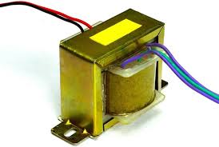

Fig. 4.2.1 Potential Transformer

* 1. **CURRENT TRANSFORMER**

A current transformer is an instrument transformer used to step down high currents to a standardized, safe level for measurement and protection purposes in electrical power systems. It consists of a primary winding connected in series with the power circuit and a secondary winding connected to measuring instruments, relays, or control devices. The primary winding carries the high current to be measured, while the secondary winding provides a proportional, reduced current that is safe for measurement and control. Current transformers are crucial for accurate current measurement, overcurrent protection, and metering in power systems.

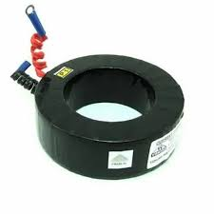

Fig. 4.3.1 Current Transformer

* 1. **LM2596 BUCK CONVERTER**

The LM2596 is a versatile buck (step-down) voltage regulator integrated circuit manufactured by Texas Instruments. It's widely utilized in electronics to convert higher voltages to lower, more manageable levels. With an input voltage range typically up to 40V, it offers an adjustable output voltage down to 1.25V. The maximum output current varies depending on the specific variant and configuration, often reaching several amps. Known for its high efficiency, typically over 80-90%, it operates at a switching frequency around 150 kHz. The LM2596 includes built-in features like thermal shutdown and overcurrent protection, ensuring safe operation. Its adjustable output voltage capability, achieved through an external resistor divider network, makes it adaptable to various applications, such as battery chargers, LED drivers, and automotive electronics. Available in packages like TO-220, TO-263, and DDPAK, the LM2596 remains a popular choice for stable and efficient voltage regulation needs in diverse electronic systems.

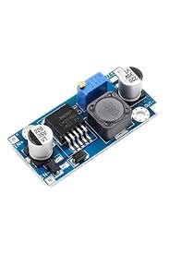

Fig 4.4.1LM2596 BUCK CONVERTER

* 1. **VIBRATION SENSOR**

A vibration sensor is a device that detects vibrations or movements in its surrounding environment. It operates by converting mechanical motion into electrical signals that can be interpreted by electronic devices. These sensors are used in various applications, such as monitoring machinery for abnormalities, detecting seismic activity, and even in consumer electronics like smartphones for auto screen rotation. There are different types of vibration sensors, including piezoelectric, accelerometer, and velocity sensors, each with its own method of detecting vibrations and specific use cases. Piezoelectric sensors generate electrical signals when subjected to mechanical stress, while accelerometers measure acceleration forces caused by vibrations. Velocity sensors, on the other hand, measure the velocity of an object's movement. Overall, vibration sensors play a crucial role in ensuring the safety, reliability, and performance of many mechanical and electronic systems.

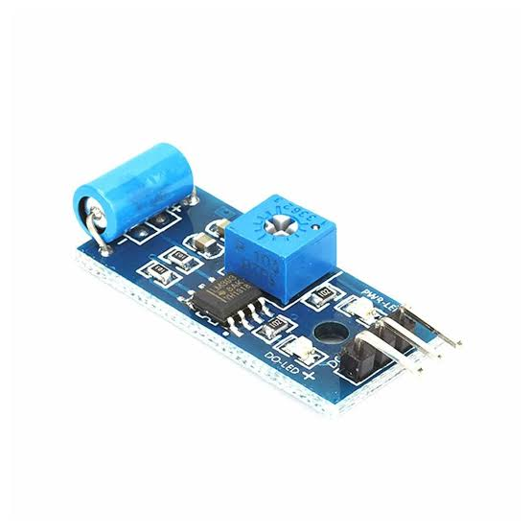

Fig 4.5.1 Vibration Sensor

* 1. **ULTRASONIC SENSOR**

Ultrasonic sensors are commonly used to measure oil levels in various applications, especially in industrial settings and automotive systems. These sensors utilize ultrasonic waves to determine the distance between the sensor and the oil surface, enabling accurate oil level measurements without direct contact with the oil.In the context of measuring oil levels, ultrasonic sensors are often installed above the oil reservoir or tank. When the sensor emits ultrasonic pulses, they travel through the air until they reach the surface of the oil. Upon reaching the oil surface, the pulses are reflected back to the sensor. By measuring the time it takes for the pulses to return, the sensor can calculate the distance to the oil surface.The oil level is then determined by subtracting this distance from the total depth of the tank or reservoir. This method allows for precise and reliable measurement of oil levels, even in challenging environments where the oil may be subject to agitation or varying temperatures. One of the key advantages of using ultrasonic sensors for oil level measurement is their non-contact nature, which eliminates the need for physical probes that could potentially be affected by the properties of the oil or require maintenance. Additionally, ultrasonic sensors are versatile and can be easily integrated into existing monitoring systems, providing real-time data on oil levels to ensure optimal operation and prevent issues such as overfilling or running dry. Overall ultrasonic sensors offer a reliable and efficient solution for measuring oil levels in a wide range of applications, contributing to improved efficiency, safety, and maintenance of equipment and processes.

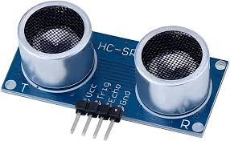

Fig 4.6.1 Ultrasonic Sensor

**4.7 DHT11- TEMPRATURE AND HUMIDITY SENSOR**

The DHT11 is a temperature and humidity sensor commonly used in electronics projects and IoT devices. It comes in a small package with four pins for easy integration into circuits. The sensor uses a capacitive humidity sensor and a thermistor to measure the surrounding air's humidity and temperature. It operates on 3.3V to 5V DC power supply and communicates with a microcontroller via a digital signal. The DHT11 provides reliable readings with an accuracy of ±2°C for temperature and ±5% for humidity. It's affordable and relatively easy to use, making it popular among hobbyists and DIY enthusiasts for monitoring environmental conditions in various applications such as weather stations, smart homes, and agricultural systems.

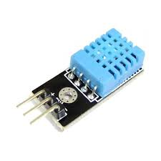

Fig 4.7.1 DHT11- Temprature and humidity sensor

* 1. **Esp32 MICROCONTROLLER WITH WIFI CONNECTIVITY**

The ESP32 is a highly versatile microcontroller developed by Espressif Systems, renowned for its dual-core processor, built-in Wi-Fi and Bluetooth capabilities, and low power consumption. Its two Xtensa LX6 microprocessor cores can be independently controlled, offering enhanced processing power for various applications. With integrated Wi-Fi and Bluetooth, the ESP32 enables seamless connectivity to networks and other devices, making it ideal for IoT projects, robotics, and automation. Despite its capabilities, the ESP32 is designed for low power consumption, making it suitable for battery-powered applications. Its rich peripheral set includes UART, SPI, I2C, ADC, DAC, PWM, and more, ensuring compatibility with a wide range of sensors and actuators. Additionally, it offers hardware-based security features such as secure boot and flash encryption, providing a secure platform for development. Supported by various development frameworks like Arduino IDE, ESP-IDF, and MicroPython, the ESP32 is accessible to developers of all levels. With its affordability and powerful features, the ESP32 has become a popular choice for both hobbyists and professionals in the embedded systems and IoT space.

* Processors:
  + CPU: Xtensa dual-core (or single-core) 32-bit LX6 microprocessor, operating at 160 or 240 MHz and performing at up to 600 [DMIPS](https://en.wikipedia.org/wiki/Dhrystone)
  + Ultra low power (ULP) co-processor
* Memory: 520 KiB RAM, 448 KiB ROM
* Wireless connectivity:Wi-Fi: 802.11 b/g/n
* Bluetooth: v4.2 BR/EDR and BLE (shares the radio with Wi-Fi)
* Peripheral interfaces:
* 34 × programmable GPIOs
* 12-bit SAR ADC up to 18 channels
* 2 × 8-bit DACs
* 10 × touch sensors (capacitive sensing GPIOs)
* 4 × SPI
* 3 × UART
* SD/SDIO/CE-ATA/MMC/eMMC host controller
* DIO/SPI slave controller
* 2 × I²S interfaces
* CAN bus 2.0
* Infrared remote controller (TX/RX, up to 8 channels)
* Pulse counter (capable of full quadrature decoding)
* Motor PWM
* LED PWM (up to 16 channels)
* Ultra low power analog pre-amplifier
* IEEE 802.11 standard security features all supported, including WPA, WPA2, WPA3 (depending on version)[5] and WLAN Authentication and Privacy Infrastructure (WAPI)
* Secure boot
* Flash encryption
* 1024-bit OTP, up to 768-bit for customers
* Cryptographic hardware acceleration: AES, SHA-2, RSA, elliptic curve cryptography (ECC), random number generator (RNG)
* Power management:
* Internal low-dropout regulator
* Individual power domain for RTC
* 5 μA deep sleep current
* Wake up from GPIO interrupt, timer, ADC measurements, capacitive touch sensor interrupt

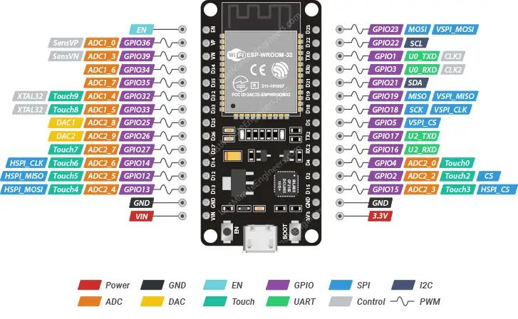

Fig 4.8.1 Esp32 MICROCONTROLLER WITH WIFI CONNECTIVITY

**4.9 RELAY**

A relay is an electrically operated switch that controls the flow of current in a circuit. It consists of several key components: a coil, an armature, and one or more sets of contacts. When a current flows through the coil, it generates a magnetic field which attracts the armature. This movement of the armature either closes or opens the contacts, depending on the type of relay and its configuration. Relays serve various purposes in electrical systems. They can amplify a signal, provide isolation between two circuits, or allow a low-power signal to control a high-power circuit. They're commonly used in applications such as industrial automation, automotive systems, telecommunications, and household appliances. Relays come in different types, including electromechanical relays, solid-state relays, and reed relays. Each type has its advantages and is chosen based on factors like switching speed, current carrying capacity, and reliability

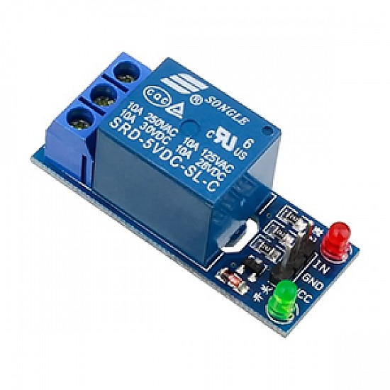

Fig 4.9.1 Relay

**4.10 BUZZER**

The piezoelectric type uses the piezoelectric ceramic’s piezoelectric effect and pulse current to make the metal plate vibrate and generate sound. This kind of buzzer is made with a resonance box, multi resonator, piezoelectric plate, housing, impedance matcher, etc. Some of the buzzers are also designed with LEDs. The multi resonator of this mainly includes ICs and transistors. Once the supply is given to this resonator, it will oscillate and generated an audio signal with 1.5 to 2 KHz. The impedance matcher will force the piezoelectric plate to produce sound.

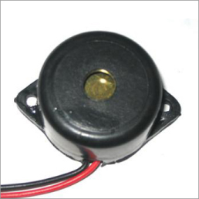

Fig. 4.10.1 Buzzer

* 1. **LCD DISPLAY**

LCD is essentially used for expose the information. Here we are using 2x16 LCD. It is used to display numbers, texts and graphics. This is in contrast to LEDs, which are limited to numbers and characters. The LCDs are fragile with only a few millimeter thickness. Since the LCDs utilize less power, the y are efficient with low power electronic circuits, and can be charged for long terms. The LCDs don’t provoke light and so light is needed to read the display. The LCDs have long lasting life and a wide operating temperature range.

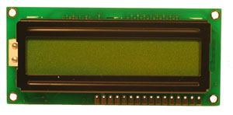

Fig. 4.11.1 LCD Display

* 1. **LAMP LOAD**

Lamp load refers to the total power consumption of lighting fixtures connected to an electrical circuit. It encompasses all types of lamps, including incandescent, fluorescent, LED, and other lighting technologies. The calculation of lamp load considers both the wattage of individual lamps and the number of lamps connected to the circuit. It's a crucial factor in electrical design and load calculations, as it helps determine the capacity requirements for wiring, circuit breakers, and other components to ensure safe and efficient operation. Lamp load is often expressed in watts or kilowatts, and it's essential for designing lighting systems that meet the needs of the space while adhering to safety standards and energy efficiency goals.

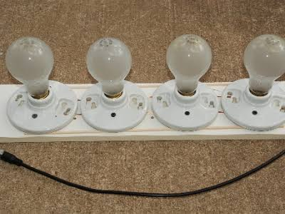

Fig. 4.12.1 Lamp Load

**CHAPTER 5**

**RESULTS AND DISCUSSION**

**5.1 RESULTS**

The Transformer Health monitoring system using IoT is successfully explained and implemented. This model helps with the advancement of communication technology now it is possible to receive fault information of transformer through Esp32 technology remotely to the operator and authorities so one can able to take possible solution before converting fault in to fatal situation.

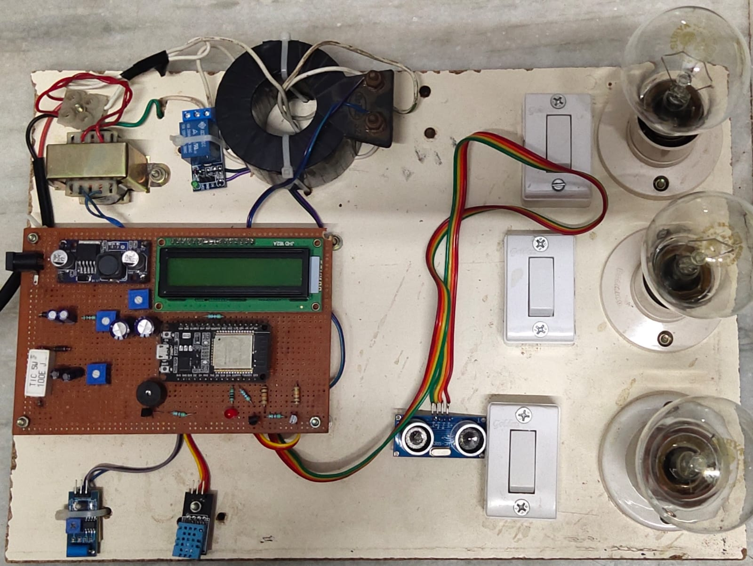

Fig. 5.1.1 Implemented Prototype

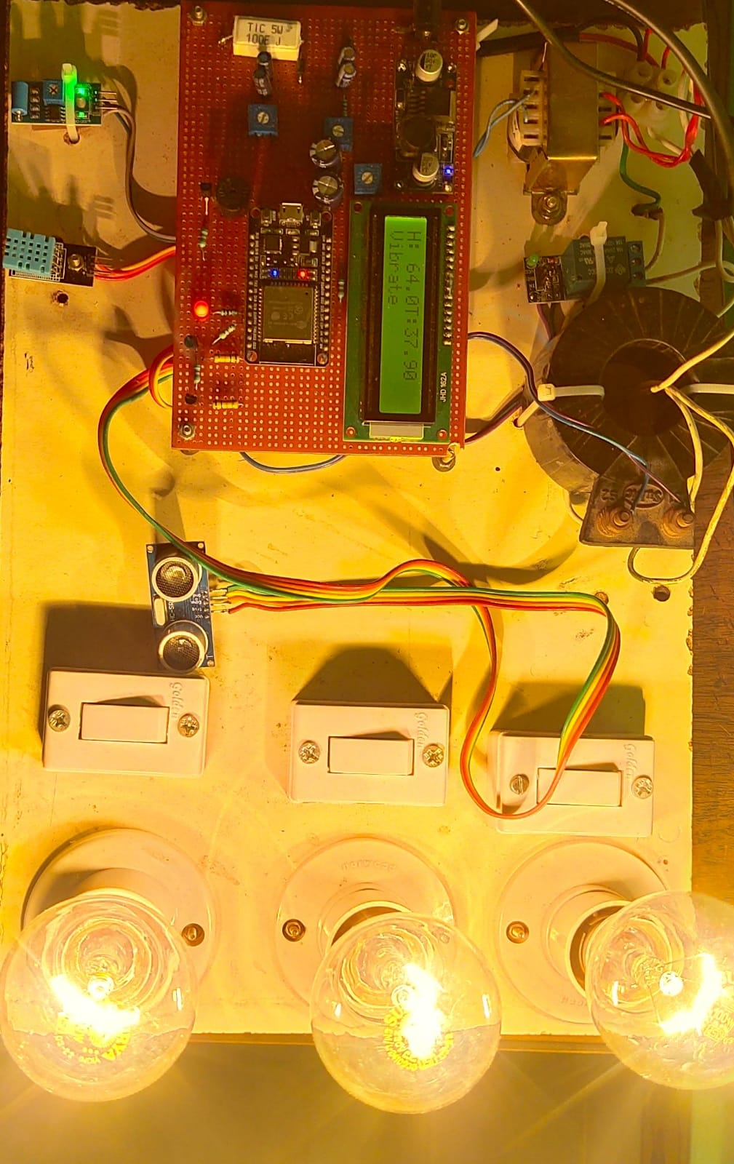

Fig. 5.1.2 Working Condition

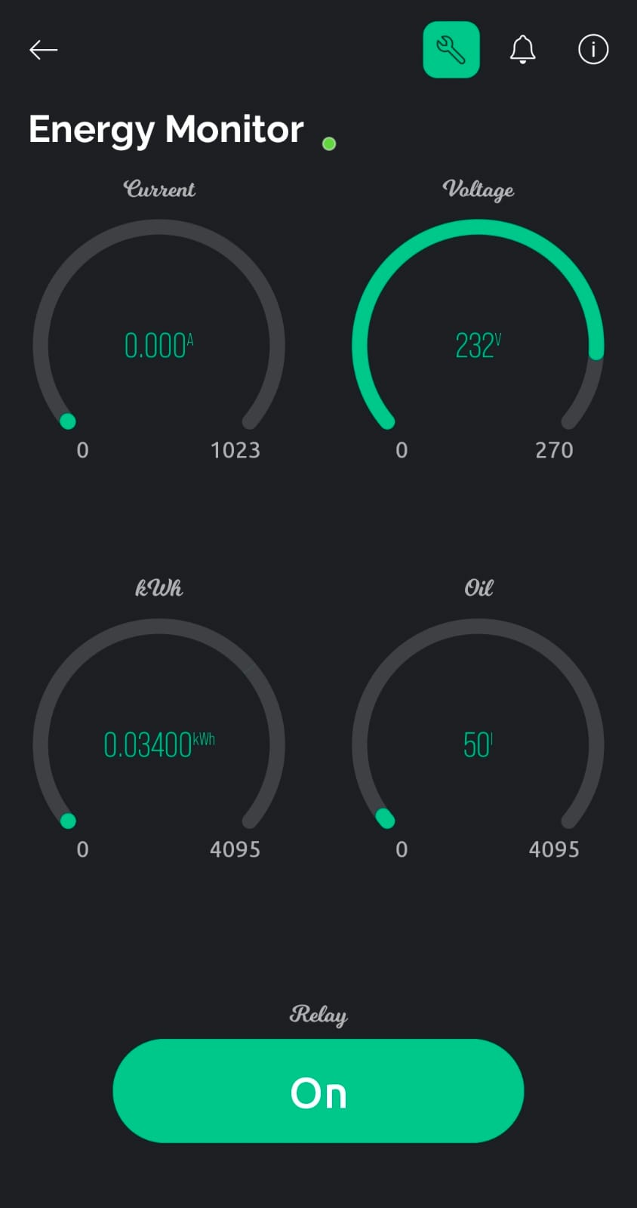 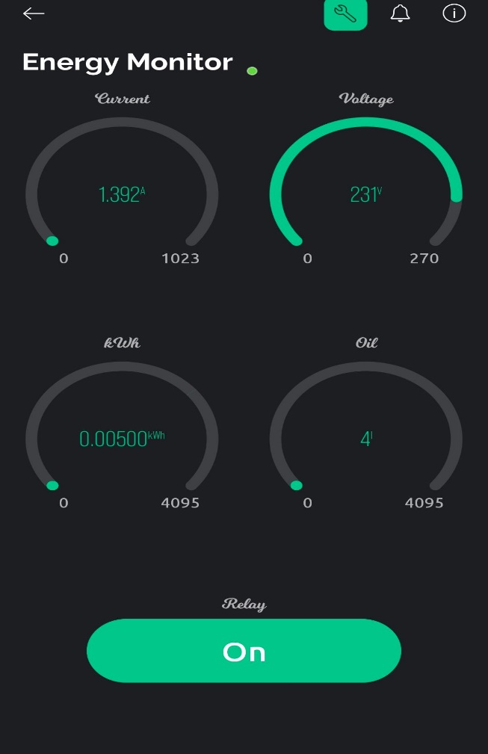

Fig. 5.1.3 Output of Voltage Fig. 5.1.4 Output of Oil level

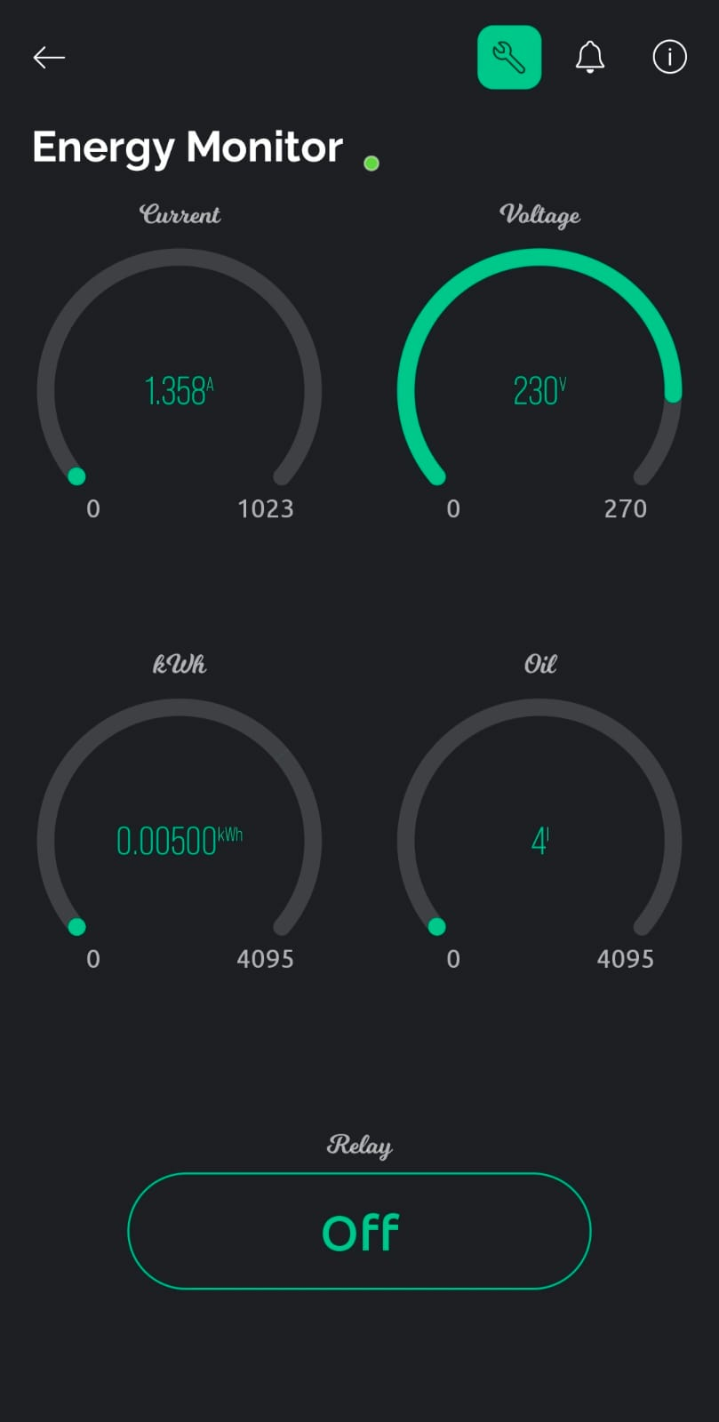 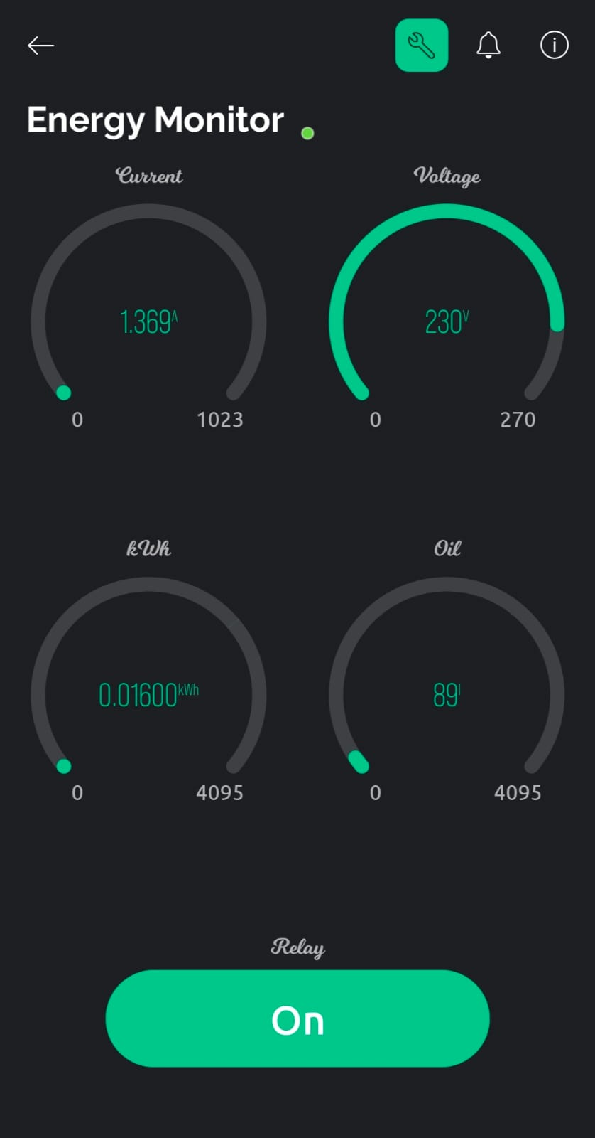

Fig. 5.1.5 Output of Relay Fig. 5.1.6 Output of Current & kwh

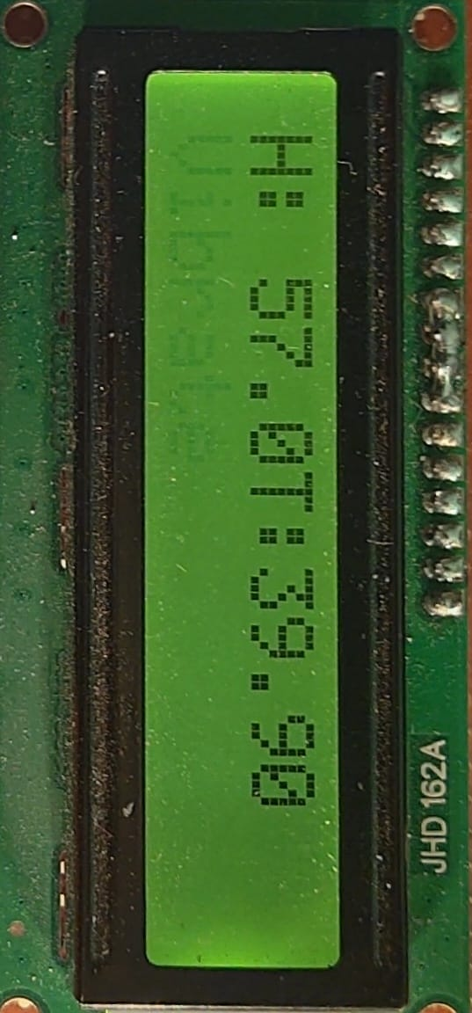

Fig. 5.1.7 Output of Temperature

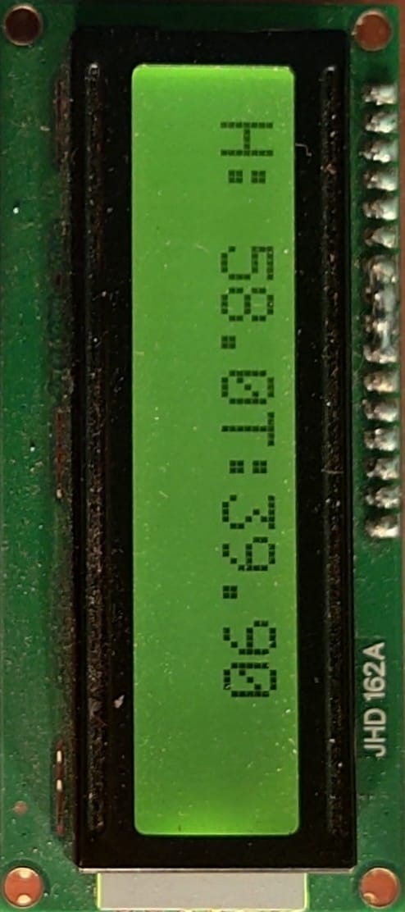

Fig. 5.1.8 Output of Humidity

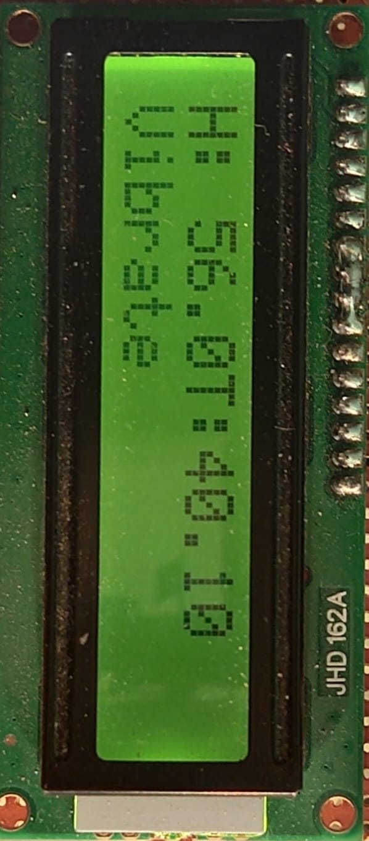

Fig. 5.1.9 Output of Vibration

**5.2** **COST ESTIMATION**

|  |  |
| --- | --- |
| **COMPONENTS** | **COST** |
| Current Transformer | 700 |
| Potential Transformer | 550 |
| Temperature & Humidity | 300 |
| Vibration Sensor | 400 |
| Oil Sensor | 400 |
| Buzzer | 50 |
| LCD Display | 350 |
| ESP32 | 700 |
| Buck converter | 700 |
| Relay | 300 |
| Lamp | 50 |
| **TOTAL** | **4500** |

**CHAPTER 6**

**CONCLUSION**

The main goal of the project is to design and construct an Internet of Things Transformer Monitoring System which can display real time state in the transformer. After the construction of the device, the system was tested successfully. That is the device can monitor the condition of the transformer and send data accumulated from the sensors through the Wi-Fi and displayed over the IoT platform. Transformers are among the most generic and expensive piece of equipment of the transmission and distribution system. Regular monitoring health condition of transformer not only is economical also adds to increased reliability. In the past, maintenance of transformers was done based on a predetermined schedule. With the advancement of communication technology now it is possible to receive fault information of transformer through Esp32 technology remotely to the operator and authorities so one can able to take possible solution before converting fault in to fatal situation.

**CHAPTER 7**

**REFERENCES**

[1] Abdul-Rahman AI-Ali, Abdul Khaliq & Muhammad Arshad “GSM Based Distribution Transformer Monitoring System,” SSRG International Journal of Electrical and Electronics Engineering (SSRG-IJEEE) , Vol. 3, No. 4.(2021)

[2] Buyung Sofiarto Munir, Johan J. Smi:”Evaluation of Various Transformations to Extract Characteristic Parameters from Vibration Signal Monitoring of Power Transformer”2020 Electrical Insulation Conference, Annapolis, Maryland, 5 to 8 June 2020 Vol 4, no 3.

[3] Suresh D S, Prathibha T, KouserTaj,” Oil Based Transformer Health Monitoring System” International Journal of Science and Research (IJSR) ISSN (Online): 2319-7064 Impact Factor (2018),vol 2,no 4.

[4] Drasko Furundzic, Zeljko Djurovic, Vladimir Celebic, and Iva Salom, “Neurel Network Ensemble for Power Transformers Fault Detection,”11th symposium on Neural Network Applications in electrical Engineering NEUREL-2019.

[5] Length Matching". Labcenter Electronics. Retrieved 13 February 2018.

[6] Satar, Mohamad Nasrul Abdul; Ishak, Dahaman (2011). "Application of Proteus VSM modelling brushless DC motor drives". 2011 4th International Conference on Mechatronics (ICOM). pp. 1–7. doi:10.1109/ICOM.2011.5937161. ISBN 978-1-61284-435-0. S2CID 43626052.

[7] Narasimham, P.V.R.L.; Sarma, A.V.R.S; Roshankumar, P.; Rajasekhar, K. (2006). "An efficient approach for implementing Space Vector Modulation for controlling induction motor". 2006 India International Conference on Power Electronics. pp. 411–415. doi:10.1109/IICPE.2006.4685408. ISBN 978-1-4244- 3450-3. S2CID 33844636.

[8] Xiumei, Xu; Jinfeng, Pan (2011). "The simulation of temperature and humidity control system based on PROTEUS". 2011 International Conference on Mechatronic Science, Electric Engineering and Computer (MEC). pp. 1896–1898. doi:10.1109/MEC.2011.6025856. ISBN 978-1-61284-719-1. S2CID 15575589.

[9] Ravishankar Tularam Zanzad, Prof. Nikita Umare,Prof Gajanan Patle , ” ZIGBEE Wireless Transformer Monitoring, Protection and Control System”, International Journal of Innovative Research in Computer and Communication Engineering (An ISO 3297: 2007 Certified Organization), Vol. 4, Issue 2, February 2016. 2395-4396.

[10] Sachin Kumar B S, Dr.NageshPrabhu ,”Simulation And Analysis Of Compact Remote Monitoring System”, International Journal of Innovative Research in Electrical, Electronics, Instrumentation and Control Engineering Nitte Conference on Advances in Electrical Engineering NCAEE-2016 , Nitte Vol. 4, Special Issue 2, April 2016.