**ANANALYSIS OF FIBONACCI AND**

**GOLDEN RATIO IN HUMAN BODY**

**N. Sarala1, M. Kalpana2, A. Pragadeeshwari2**

Associate Professor1, B.Sc., Mathematics Students2

Department of Mathematics, A.D.M College for Women (Autonomous)

Affiliated to Bharathidasan University, Nagapattinam, Tamilnadu.

E-mail: 1saralaadmc68@gmail.com

2kalpanamadhavannvp@gmail.com

2pragathi2564@gmail.com

**Abstract:**

# 

# Pythogoras, plato and Euclid’s paved the way for classical geometry. The idea of shapes that can be mathematically defined by equations led to the creation of great structures of modern and ancient civilizations and milestone in mathematics and science. However, the classicalgeometryfailstoexplainthecomplexityofnon-linearshapesrepleteinnaturesuch as the curvature of a flower or the wings of a butterfly.

* Suchphenomenonnon-linearitycanbeexplainedbythefractalgeometrywhichcreates the shapes that emulate those found in nature with remarkable accuracy. Fibonacci sequence may establish in origin for such a development.
* theobservationoftheFibonaccisequenceisexistenceinalmostallaspectsoflikeranging from leaves of a fern tree, architecture and even paintings makes its highly unlikely to be a stochastic phenomenon. Despite its wide spread occurrence and existence, the Fibonacci sequence and the rule of golden proportion has been widely documented in the human body. This paper analysis the observed documentation of Fibonacci and golden ratio in human body.

# Introduction

The mathematician Leonardo of Pisa, better known as Fibonacci, had a significant impact on mathematics. His contributions to mathematics have intrigued and inspired the people through the centuries to delve more deeply into the mathematical world. He is best known for the sequence of numbers bearing his name. As the thirteenth century began, Europe started to awaken from the Dark Ages and move in to the Renaissance. As the stifling effects of the Dark Ages began to be replaced by a growing interest in the scientific world, artists, scholars, architects, Scientists, and mathematicians all began making revolutionary discoveries and advances in knowledge. One such person was Leonardo of Pisa, who contributed to the transformation of the mathematical world at that time.

# Fibonacci Series

The Fibonacci series, named after Italian mathematician named Leonardo Pisano Bogollo, later known as Fibonacci, is a series (sum) formed by Fibonacci numbers denoted as Fn.The Fibonacci series numbers are given as: 0, 1, 1, 2, 3, 5, 8, 13, 21, 38 . . . In

a Fibonacci series, every term is the sum of the preceding two terms, starting from 0 and 1 as the first and second terms. In some old references, the term '0' might be omitted.

The **Fibonacci series** is the [sequence](https://www.cuemath.com/algebra/sequences/) of numbers (also called Fibonacci numbers), where every number is the sum of the preceding two numbers, such that the first two terms are '0' and '1'. In some older versions of the [series](https://www.cuemath.com/numbers/sequence-and-series/), the term '0' might be omitted. A Fibonacci series canthusbegivenas,0,1,1,2,3,5,8, 13, 21, 34 . . . It can thus be observed that every term can be calculated by adding the two terms before it.

Given the first term, F0and second term, F1as '0' and '1' respectively, the third term here can be given as, F2=0

+1=1

Similarly,

* F3=1 +1 =2
* F4=2 +1 =3
* F5=2 +3 =5
* F6=3 +5 =8
* F7=5 +8 =13
* and so on

Therefore, to represent any (n+1)th term in this series,wecangive the expression as, Fn= Fn-1+ Fn-2The Fibonacci series formula in maths can be used to find the missing terms in a Fibonacci series.

# Golden Ratio

**Golden ratio**, in [mathematics](https://www.britannica.com/science/mathematics), the [irrational number](https://www.britannica.com/science/irrational-number)(1 + Square root of√5)/2, often [denoted](https://www.britannica.com/dictionary/denoted) by the Greek letter ϕ or τ, which is approximately equal to 1.618. It is the ratio of a line segment cut into two pieces of different lengths such that the ratio of the whole segment to that of the longer segment is equal to the ratio of the longer segment to the shorter segment. The origin of this number can be traced back to [Euclid](https://www.britannica.com/biography/Euclid-Greek-mathematician), who mentions it as the “extreme and mean ratio” in

the [*Elements*](https://www.britannica.com/topic/Elements-by-Euclid). In terms of present day [algebra](https://www.britannica.com/science/algebra), letting the length of the shorter segment be one unit and the length of the longer segment be *x* units gives rise to the equation

(*x*+1)/*x*=*x*/1;thismayberearranged to form the [quadratic](https://www.britannica.com/science/quadratic-equation) [equation](https://www.britannica.com/science/quadratic-equation) *x*2– *x* – 1 = 0, for which the positive solution is *x*=(1+Squareroot of√5)/2, the golden ratio.

**Skull**

---------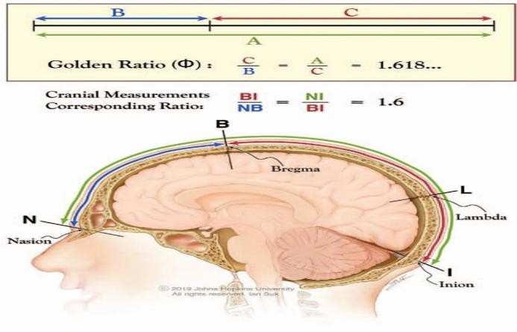----

## Golden Ratio (Φ) in the partition of a line and also of the nasioiniac arc on the human skull. Division of a line into 2 segments such that the ratio of the line(A) to the longer segment (C) is identical the ratio of the longer to the shorter segment(B).Thisratiois1.618…,known as the Golden Ratio or Φ. In an analogous situation in human skulls, division of the nasioiniac arc (from nasion to inion, NI) by bregma into a shorter frontal arc (from nasion to bregma, NB) and longer parieto- occipital arc (from bregma to inion BI), creates a geometrical relationship in which the ratio of the nasioiniac arc over the bregma-inionarc(NI/BI)coincides with the ratio of the bregma-inion arc over the nasion-bregma arc (BI/NB), both 1.6. The subdivision of the nasioiniac arc by bregma into 2 unequal arcs emulates the geometrical division of a line into the Golden Ratio.

## Human face:

* Length of the face: width of the face.
* Hair line to end of the nose: end of the nose to chin
* Length between eyebrows :length of the lips.
* Length of mouth: width of nose.
* Length of face: distance between tip of jaw and where the eyebrows meet.
* Width of nose: distance between nostrils

# Human Hand

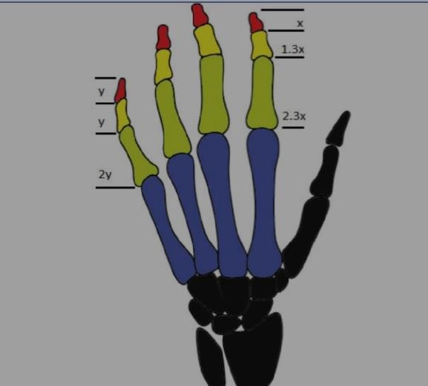

Each finger in the human hand has three parts called the phalanges. In the human hand, the length of bones is also in Fibonacci numbers. According to Hamilton and Dunsmuir’s findings a series of 1x, 1.3x,2.3xisobservedinindex,second,and third digits. Additionally, they provided dimension data for the fourth digit (little finger)that follows the first initial values of a Fibonacci sequence of 0,1,1,2, represented by y, y, and 2y.

Therefore, additive rule of Lucas series is followed for index ,second and third digits while approximating Fibonacci values for the fourth digit (little finger).

# EAR

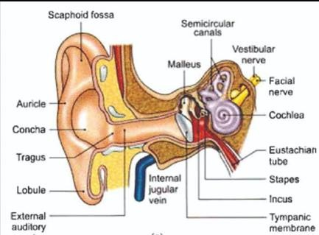The Golden Ratio can also be observed in the hearing mechanism of humans specifically the spirals of pinna and spiral shaped cochlear bone. In humans pinna is spiral shaped which correspond to the change in the perception of sound if the ears are either bend forwards or backwards. Research has shown ,that over time the shape of cochlea in some mammals and marsupials have evolved into spiral shape. Spiral shapes cochlear bones present in the inner ear are exclusive to mammals. Sound waves enter through the tympanum. Essentially, as the length of the cochlea increases, so does the range of sound that can be perceived due to a greater number of hair cells. M. Pietsch et al. suggested that a longer cochlea can best supplement space within the constraints of a mammalian skull by conforming into a coil shape, most efficiently, a Golden Ratio spiral, alike the packing of a seed head in plants. Although there were some drawbacks in the study which demands further research. It has been proposed that if the results of Golden ratio are substantiated then it can help in research for new areas such as Cochlear implants.

## Golden proportion and dental health

Facial beauty corresponds with anatomical symmetry and with mouth and teeth. Thus, professionals in the field of dentistry have tried to characterise the parameters of an aesthetically appealing smile. Mack MR highlighted the importance of treating the dentition according to the face based on the divine proportion. He stated that the lowed one- thirds of the face significantly impacts the facial appearance. He also warned that the complications may appear in facial esthetics when only mounted casts were

used for diagnosis. In 1973, Lombardi officially proposed the existence of having proportionate teeth, but rejected the idea of using golden proportion to create aesthetic teeth . Levin in 1978, was the first to observe that the width of maxillary central incisor is in golden proportion to the width of the lateral incisor and width of lateral incisor is in golden proportion to the width of canine. He later developed a tooth caliper based on this observation. This proportion has been combined in a grid, called the diagnostic grid or the golden proportion grid which can be used to assist in perfecting the esthetics of the anterior teeth. These grids are available in seven sizes to accommodate all widths of thecentralincisorfrom7mmto10mmin steps of 1/2 mm

## Lung

The golden ratio can also be found in the lungs. The presence of asymmetrical branching lung structure proved the existence of golden ratio. The irregular branching configuration of the bronchial tree in mammals is in accordance with a process by Fibonacci Goldberger AL et al., confirmed the fact of the Golden Ratio.

Each bronchus branches into two unequally sized bronchioles, with the ratio of these two tubes approximating the Golden Ratio. This pattern continues throughout the bronchial tree demonstrating a relative proportion roughly equal to phi. This confirms that breathing is not a one step process rather it is a system of discrete steps. This knowledge has been applied in the development of biological variable ventilators. The variable ventilation followed a fractal pattern that corresponded with the natural branching found within the patients’ lungs, that is the Golden Ratio.

## DNA

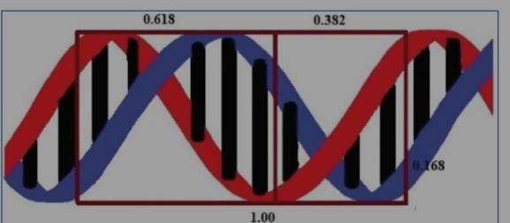

The basic structure of life i.e., the DNA also contains Golden Proportion in its structure. The double helix cross section of the DNA forms a golden decagon. It is constituted by two pentagons rotated at as angle by 36 degrees having diagonal ratio of 1:1.68. The ratio of length by width of the DNA molecule(34Ålongby21 Å)for each full cycle of the double helix shape makes a ratio of 1.619 (ratio 34/21 equals 1.619…). The ratio of the major to the minor groove (21 angstroms to 13 angstroms) in DNA is also golden (21/13 equals 1.619)

# Heart

Henein MY et al., in their study observed golden ratio and golden angle measurements application in the absolute dimensions of the heart irrespective of ethnicity. They theorized that since the golden ratio and angle are so intensely entrenched in nature, they must have some correspondence in the healthy heart structure and function. In their studytheleftventriclesof30Chinese,alongwith30 Swedish patients were measured via echocardiogram. The Chinese population tended to have less significant smaller measurements than the Swedish population; however, an evaluation between the vertical (~8 mm) and transverse (~5 mm) measurements yielded a Golden Ratio in both populations. They observed that the vertical and transverse dimensions follow the golden ratio. The angles between the outflow tract axis and inflow tract axis and angle between

foot has several proportions based on phi lines, including:

The pulmonary trunk and ascending aorta approximated to the golden angle i.e.137.5 degree. This suggests that the overall ventricular and cardiac dimensions of a normal heart are in accordance with the golden ratio and angle. Any deviation from normality could have anatomical, functional values and may act as prognostic indicator markers. In a separate study, Yetkin et al. monitored the blood pressure, an indication of heart function, of 462 patients using an ambulatory blood pressure monitor. They found that, at night, the systolic to diastolic blood pressure ratio of patients approximated the Golden Ratio. They hypothesized that the non-existence of Golden Ratio during the day was due to an activated sympathetic nerves system’s influence on the heart, caused by daytime environmental stimuli and physical activity. On the contrary, at night, when patients are in a more relaxed state, the parasympathetic nervous system have a tendency control bodily function, causing the systolic/diastolic ratio to gravitate towards the Golden Ratio.

According to Prasanth G, the cardiac performance is subordinated to the Golden section law. The studies of human heart anatomy and function correlated best with the golden ratio and good health, but the implications have yet.

## Feet:

1. The middle of the arch of the foot

2 .The widest part of the foot

1. The base of the line and big toe
2. The top of the toe line and base of the “index” toe

Note that not every individual has body dimensions in exact phi proportions but average across populations tend towardsphi and phi proportions are perceived as being the most natural or beautiful.

## Conclusion:

## The nature’s numbering system appears everywhere. Though there are other numbering systems also, the present review highlights the application of Fibonacci numbers in nature, human body and architecture which is considered as the key to esthetics with regards to the anecdotal evidence of applications of the fibonacci numbers in the field ofmedical literature, further studies are recommended. This will help in substantiating the esthetic correction and treatment planning; and authenticate its application from different perspectives.

## References

## https://[www.scribd.com/document/43](http://www.scribd.com/document/43)2874614/The-Golden-Ratio

## <https://journals.lww.com/jcraniofacialsurgery/fulltext/2019/09000/mammalian_skull_dimensions_and_the_golden_ratio.34.aspx>

## [https://www.ncbi.nlm.nih.gov/pmc/articles/PMC7329205/#:~:text=In%20humans](https://www.ncbi.nlm.nih.gov/pmc/articles/PMC7329205/#%3A~%3Atext%3DIn%20humans%2C%20the%20ratio%20of%2C1.618)%20within%201%20standard%20deviation)

## [%2C%20the%20ratio%20of,1.618)%20within%201%20standard%20deviation](https://www.ncbi.nlm.nih.gov/pmc/articles/PMC7329205/#%3A~%3Atext%3DIn%20humans%2C%20the%20ratio%20of%2C1.618)%20within%201%20standard%20deviation)

## 4.<https://letstalkscience.ca/educational-resources/backgrounders/fibonacci-and-golden-ratio>

## 5.https://[www.britannica.com/science/gol](http://www.britannica.com/science/gol) den-ratio

