**Skill Fusion**

Sandeep Maddheshiya1, Durgesh Singh2, Mr. Sunit Mishra3

*1,2UG student, Department of Computer Science & Engineering, School of Management Sciences Lucknow, Uttar Pradesh, India.*

*3Professor & Head, Department of Computer Science & Engineering, School of Management Sciences Lucknow, Uttar Pradesh, India.*

|  |
| --- |
| ***Abstract:*** In today's digital age, mobile applications play a pivotal role in shaping various aspects of human life, including education and career development. Skill Fusion is a pioneering mobile application that integrates the features of professional networking, resume building, e-Learning, skill sharing, and job updates, akin to platforms like LinkedIn. This abstract explores the transformative potential of Skill Fusion in enhancing the teaching-learning process and facilitating lifelong learning. The emergence of e-Learning has revolutionized education, and Skill Fusion capitalizes on this trend by leveraging mobile technology to improve the interaction and efficacy of educational endeavors. By providing a comprehensive platform for skill acquisition and career advancement, Skill Fusion democratizes access to high-quality education across diverse demographics. Moreover, its social networking aspect fosters meaningful connections, facilitating collaboration and knowledge exchange among users. The continuous evolution of Skill Fusion reflects the dynamic nature of technological advancements and societal needs. Its array of features not only caters to the exigencies of daily life but also elevates our standard of living in multifaceted ways. As individuals increasingly rely on mobile applications to meet their diverse needs, Skill Fusion stands out as a testament to the transformative power of technology in shaping behaviors and preferences. Furthermore, Skill Fusion holds immense potential to augment the university learning environment by offering a platform that transcends traditional educational boundaries. By fostering flexibility and collaboration, it enhances the educational experience and contributes to holistic development across economic and non-economic domains. In conclusion, Skill Fusion epitomizes the symbiotic relationship between technological innovation and societal progress. Its multifunctional capabilities not only catalyze individual growth but also contribute to broader developmental outcomes. By harnessing the power of mobile applications, particularly in education, Skill Fusion unlocks a myriad of opportunities for personal and collective advancement.  ***Key Word****:**Community, social media, Social Networking, Professional networking, Mobile learning integration, Collaboration in e-Learning* |

1. **Introduction**

In recent years, the integration of mobile applications into the educational landscape has ushered in new learning paradigms, offering unparalleled flexibility and convenience in accessing information. The proliferation of these applications has become ubiquitous in daily life, underscoring their indispensable role in modern society. Originating as early as the 1970s with the advent of platforms like the PLATO System at the University of Illinois, which introduced online forums, bulletin boards, and instant messaging, the trajectory of social media and networking applications has been marked by continuous innovation and evolution. Driven by the ingenuity of businesses worldwide, these applications have proliferated to encompass a wide array of services and facilities, catering to diverse needs and preferences. Social media applications, in particular, have emerged as powerful tools for connecting and interacting with others in both personal and professional contexts. Facilitating the exchange of news, ideas, insights, and experiences, these platforms have become integral to how individuals communicate, develop relationships, and establish trust, both in personal and professional spheres. Against this backdrop, our project endeavors to develop an Android Application tailored specifically for the college campus environment, catering to the needs of students, faculty, and staff alike. Inspired by the multifunctionality of platforms like Skill Fusion, our initiative aims to integrate features such as professional networking, resume building, e Learning, skill sharing, and job updates into a cohesive and user-friendly interface. Recognizing the transformative impact of social media on communication and collaboration, our initiative aims to leverage these technologies to enhance the educational experience within the campus community. By providing a comprehensive platform for skill acquisition, career development, and knowledge exchange, our application seeks to empower users to engage in lifelong learning and professional growth. Indeed, social media has transcended its initial function as a means for friends to stay connected, evolving into a vital communication channel for businesses internally and externally. Inspired by the potential of social media to facilitate learning and knowledge sharing, our group embarked on this project with the dual objectives of gaining proficiency in programming and app development while providing a valuable resource for campus stakeholders. By creating a dedicated social media interface for the college campus, we seek to extend classroom learning to an online platform, fostering collaboration and discourse among students and faculty. This initiative not only introduces a direct alternative for peer-to-peer communication and discussion but also serves as a conduit for bridging the gap between traditional and digital learning environments. In essence, our project embodies the ethos of innovation and collaboration inherent in the evolving landscape of social media and education. Through the development of this application, we endeavor to harness the transformative power of technology to enrich the educational journey and cultivate a vibrant online community within the college campus.

1. **Features**

1. **Registration and Account Creation:** Skill Fusion facilitates seamless account creation through a user-friendly registration process. Users can sign up using their email or existing social media accounts like Google or Facebook, ensuring accessibility and convenience.

2. **Profile Creation and Management:** Users can build comprehensive profiles showcasing their professional background, skills, and interests. The platform empowers users to manage and update their profiles to reflect their evolving professional journey accurately.

3. **Networking with Professionals:** Skill Fusion provides a robust networking platform, enabling users to connect with professionals from various industries and domains[2]. Users can explore opportunities for collaboration, mentorship, and career advancement through meaningful professional connections.

4. **Skill Sharing**: Central to Skill Fusion's mission is the promotion of knowledge exchange and skill development. Users can share their expertise, insights, and experiences with the community, fostering a culture of continuous learning and growth[1].

5**. Job Updates:** Skill Fusion keeps users informed about the latest job opportunities relevant to their skills and interests. Users can stay updated on job postings, internships, and career events, facilitating proactive career management and exploration.

6. **Connection Establishment:** Skill Fusion serves as a bridge for users to establish connections with peers, mentors, and industry professionals. The platform facilitates meaningful interactions, enabling users to expand their professional network and forge valuable relationships.

7. **E-Learning:** Skill Fusion offers a diverse range of e-learning resources and courses to support users in their professional development journey. From technical skills to soft skills, users can access curated educational content tailored to their career aspirations and interests.

8. **Chat Functionality:** Skill Fusion includes built-in chat functionality, allowing users to engage in real-time conversations with their connections. Whether discussing industry trends, seeking advice, or collaborating on projects, users can communicate effectively within the platform.

9. **Resume Building:** Skill Fusion empowers users to create polished resumes that highlight their skills, experiences, and achievements. Through intuitive resume-building tools, users can craft compelling resumes tailored to specific job opportunities, enhancing their chances of success in the job market.

1. **Implementations**

In the development process of the Skill Fusion, significant emphasis has been placed on the creation and implementation of the sign-up and log-in functionalities to ensure an intuitive and user-friendly experience. Below, we provide a detailed elaboration of the working principles and techniques employed:

1. **Working Principle**

1. **User Profile Creation**: Central to the Skill Fusion App's functionality is the concept of individual user profiles. These profiles serve as digital representations of users within the platform, encapsulating their personal information, preferences, and interactions.

2. **Account Creation:** The journey for users begins with the creation of their accounts. Through a user-friendly interface, individuals are prompted to input essential details such as their Name, Profession, Email, and Password. These credentials are securely stored within the application's database and are utilized to authenticate users' identities during subsequent log-in attempts.

3. **Successful Sign-Up:** Upon completing the account creation process, users are seamlessly transitioned into the Skill Fusion App's ecosystem. Instantaneous access is granted, allowing individuals to explore the platform's features and engage with its diverse functionalities.

4. **Accessing the Application:** With their accounts successfully created, users can effortlessly access the Skill Fusion App. The application's intuitive navigation enables users to explore their personalized News Feed, discover new skills, connect with peers, and actively participate within the community.

1. **TECHNIQUES DEVLOPED**

**Software Utilized:**

**MERN:** The Skill Fusion App has been developed using the MERN stack, which comprises MongoDB, Express.js, React.js, and Node.js. This robust technology stack provides the foundation for building dynamic, responsive, and scalable web applications[8]. The use of React.js enables the creation of visually stunning and highly responsive user interfaces, while Node.js ensures efficient server-side operations[9].

**Clerk:** Clerk serves as the authentication and user management solution for the Skill Fusion App[11]. Leveraging Clerk's comprehensive suite of services, including authentication and user profile management, we ensure secure user verification, seamless login experiences, and efficient handling of user data across the platform[3].

**UploadThing:** User-generated content, such as profile pictures, multimedia assets, and other files, are managed and stored using UploadThing. This service facilitates fast and reliable access to content, optimized for seamless integration with the Skill Fusion App's user interface and features.

**Cloudinary:** Cloudinary is utilized for image and video management within the Skill Fusion App. By leveraging Cloudinary's powerful media processing capabilities, we ensure optimized delivery and transformation of multimedia content, enhancing the overall user experience[10].

**Key Clerk Features Utilized:**

**Clerk Authentication:** User authentication is securely handled using Clerk. This service verifies user identities through various methods, including email/password authentication, social login providers, and custom authentication methods, ensuring that only authorized users can access the Skill Fusion App[4].

**MongoDB:** As part of the MERN stack, MongoDB serves as the primary database for storing user data, preferences, and interactions within the Skill Fusion platform. Its NoSQL data model enables flexible and scalable data storage, facilitating efficient querying and synchronization of data in real-time[7].

**UploadThing Storage:** User-generated content is stored securely in UploadThing. This ensures fast and reliable access to content, optimized for seamless integration with the Skill Fusion App's user interface and features.

By leveraging the capabilities of the MERN stack, Clerk, UploadThing, and Cloudinary, we have developed the Skill Fusion App to deliver an immersive and engaging user experience. Through seamless account creation and access functionalities, users can navigate the platform effortlessly, discover new skills, and connect with like-minded individuals within a vibrant and dynamic community.

1. **System Planning**

Software project managers take the overall responsibility of steering a project to success. This surely is a very hazy job description. But it is very difficult to objectively describe the job responsibilities of a project manager.

**Work breakdown**

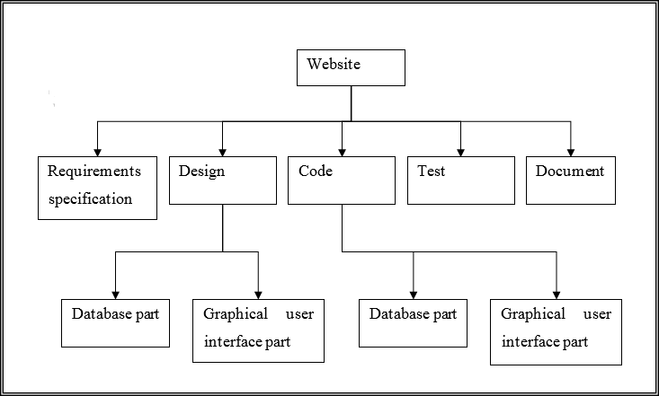Work breakdown structure is used to decompose a given task set recursively into small activities. WBS provides a notation for representing the major tasks needed to be carried out in order to solve a problem. The root of the tree is labelled by the problem name. Each node of the tree is broken down into smaller activities that are made the children of the node. Each activity is recursively decomposed into smaller sub-activities until at the leaf level; the activities require approx. two weeks to develop. If a task is broken down into a large number of very small activities, these can be distributed to a large number of engineers. If the activity ordering permits, the solutions to these can be carried out independently. Thus, it becomes possible to develop the product faster.

**Figure 1:** Work Breakdown Structure of Website

1. **System Design & Methodologies Used**

A software life cycle is the series of identifiable stages that a Software product undergoes during its lifetime. The first stage in the life Cycle of any software product is usually the feasibility study stage. The Subsequent stages are: requirement analysis and specification, design, coding, testing and maintenance. Each of these stages is called a life cycle Phase. A life cycle model represents all the activities required to make a software product transit through its life cycle phases. It also captures the order in which these activities are to be undertaken. The most strict life cycle model used is the Classical Life Cycle Model. However, in any practical software development work, it is not possible to strictly follow the classical waterfall model from every phase to its preceding phases.

**Methodology adopted**

**Incremental Model:** The incremental build model is a method of software development where the model is designed, implemented and tested incrementally (a little more is added each time) until the product is finished. It involves both development and maintenance. The product is defined as finished when it satisfies all of its requirements. This model combines the elements of the waterfall model with the iterative philosophy of prototyping.

The product is decomposed into a number of components, each of which are designed and built separately (termed as builds). Each component is delivered to the client when it is complete. This allows partial utilization of product and avoids a long development time. It also creates a large initial capital outlay with the subsequent long wait avoided. This model of development also helps ease the traumatic effect of introducing completely new system all at once. There are some problems with this model. One is that each new build must be integrated with previous builds and any existing systems. The task of decomposing product into builds is not trivial either. If there are few builds and each build degenerates this turns into Build-And- Fix model. However, if there are too

many builds then there is little added utility from each build.

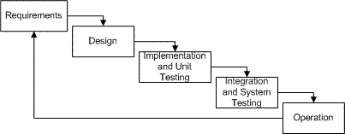

**Figure 2:** Incremental Model

**Stage 1: Investigation Phase**

Whether you design a small program to add two numbers or you are into developing a software system for the automation of an entire airline company, this is the first stage which can never be overridden. Unless you know what you are going to design, you cannot approach the problem.

Here, the specifications of the output or the final product are studied and marked. If the software that is going to be designed should not contain certain features, for reasons like security, then it is also mentioned in this stage

**Stage 2: Analysis Phase**

With all the requirements and constraints in hand, a final view of how the product should exactly be, is decided. The exact way in which the software should function is mentioned in this stage.

**Stage 3: Design Phase**

Well, here the actual work begins. Every type of resource which will be required for the smooth designing of the software is mentioned here in this phase. What type of database will be required, what type of data should be supported, etc. are some of the important aspects that are decided in this phase. Data structures, software architecture, interface representations, algorithmic details.

**Stage 4: Implementation and Testing Phase**

Now starts the coding part. Here, the software is designed as per the algorithm. Hence it becomes very important that the algorithm should be properly designed. The software designed as per the algorithm needs to go through constant software testing and error correction processes to find out if there are any flaw or errors.

**Stage 5: Installation and Testing Phase**

Here the various codes designed by different programmers are integrated together and is tested if the software works as per the specifications provided. The setup of the final software which needs to be installed at the clients system is also designed and tested so that the client does not face any problem during the installation of the software. The product is then handed over to the client.

**Stage 6: Maintenance Phase**

The work of software development does not end with the handing of the software to the client. The software designers may have to constantly provide support to the client to resolve any of the Issues which may arise.

**ER Diagram**

ER Diagrams, introduced by Peter Chen in 1976, are graphical tools used to represent entities and their relationships in a database. These diagrams are vital during the conceptual design phase of database development, offering a blueprint for the logical structure of the system. They are indispensable for researchers dealing with intricate data relationships.

**Key Components of ER Diagrams:**

* **Entities:** Represented as rectangles, entities are objects or concepts that can have data stored about them, such as subjects, experiments, and datasets.
* **Attributes:** Denoted as ovals connected to their respective entities, attributes describe the properties of an entity, including name, date, and measurement values.
* **Relationships:** Illustrated as diamonds, relationships depict the associations between entities, which are crucial in understanding how different entities interact within the system.
* **Cardinality:** This indicates the number of instances of one entity that can be associated with instances of another entity, providing insights into the nature of the relationships (one-to-one, one-to-many, or many-to-many).

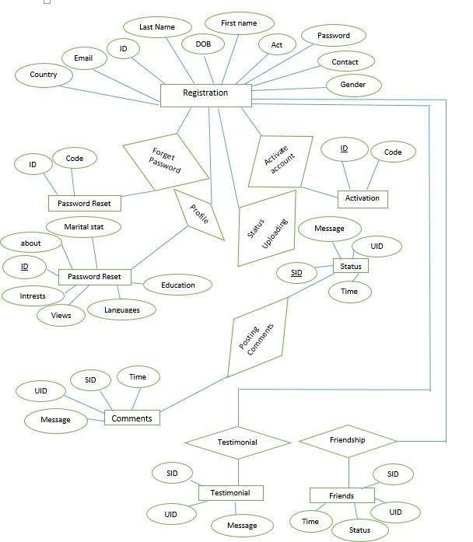

**Figure 3:** ER Diagram

**Use Case Diagram**

Use Case Diagrams, part of the Unified Modeling Language (UML) suite, are graphical representations that depict the interactions between users (actors) and a system. These diagrams are crucial during the requirements analysis phase, offering a high-level view of the system’s functionality from the user's perspective. They are instrumental for researchers and system designers working to understand and document user requirements and system behaviors.

**Key Components of Use Case Diagrams:**

**Actors**: Represented as stick figures, actors are entities that interact with the system. They can be users, other systems, or external entities that participate in a use case.

**Use Cases**: Depicted as ovals, use cases describe the specific actions or functions that the system performs in response to an actor’s interaction. Each use case represents a distinct functionality that provides value to the actor.

**System Boundary**: Illustrated as a rectangle, the system boundary defines the scope of the system, encapsulating all the use cases that the system will handle.

**Relationships:** Lines and arrows are used to show associations between actors and use cases, including generalization (inheritance), inclusion, and extension relationships, which help to refine and organize the interactions.

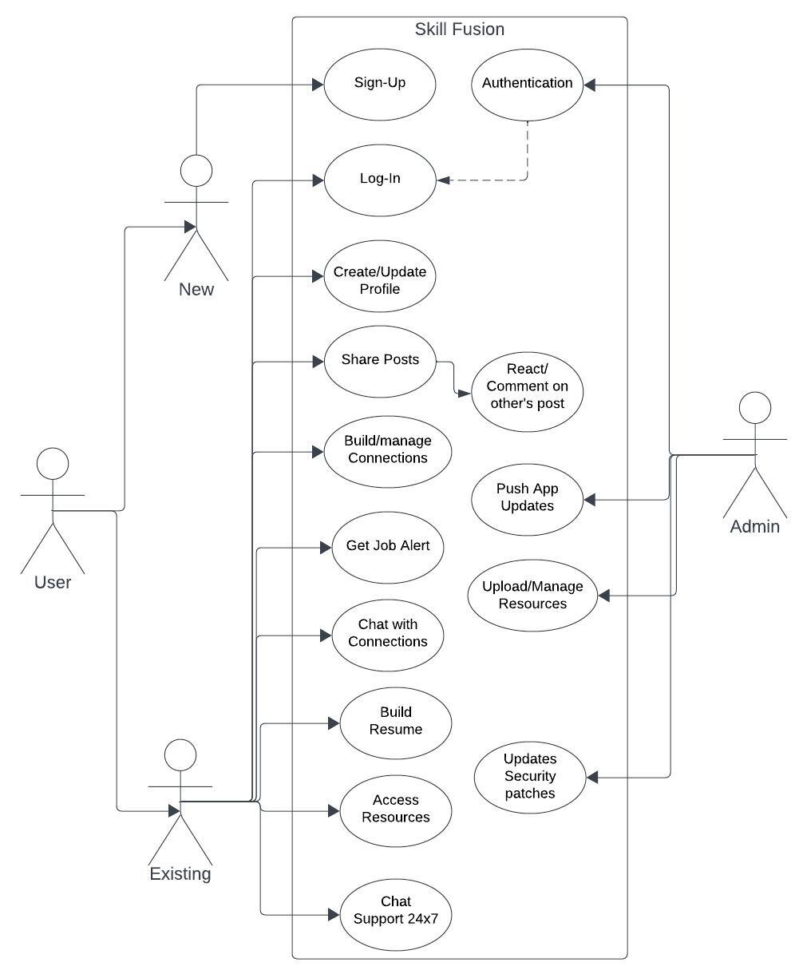

**Figure 4:** Use Case Diagram

1. **Result**

Below are summarized descriptions of key screenshots from the Skill Fusion mobile application:

**Login/Signup:**

Users can effortlessly access the Skill Fusion platform through multiple authentication options including Google, GitHub, LinkedIn, or email/password login methods. This streamlined process ensures a convenient and secure user experience.

**Activity Page:**

The activity page offers users a centralized view of their interactions and updates within the Skill Fusion community. It provides notifications for new connections, messages, and relevant activity, fostering engagement and connection among users.

**Search Page:**

On the search page, users can explore and discover a wide range of content, profiles, and resources tailored to their interests. The intuitive search functionality allows users to easily find specific users, skills, jobs, or educational materials.

**Post Create Page:**

The post create page empowers users to share their insights, experiences, and expertise with the Skill Fusion community. Users can compose text posts, upload multimedia content, and tag relevant topics, enriching the platform with valuable contributions.

**Home Page:**

The home page serves as the central hub for users, providing personalized recommendations, trending topics, and curated content. It offers direct access to various features and functionalities, ensuring a tailored and engaging user experience.

**Profile Page:**

The profile page showcases users' personal information, skills, and accomplishments, enabling them to present themselves professionally within the Skill Fusion community. Users can customize their profiles, manage settings, and track their activity history.

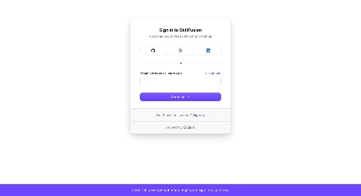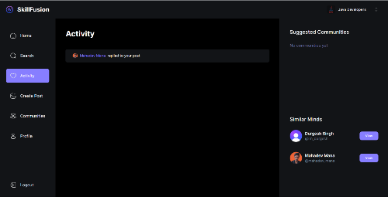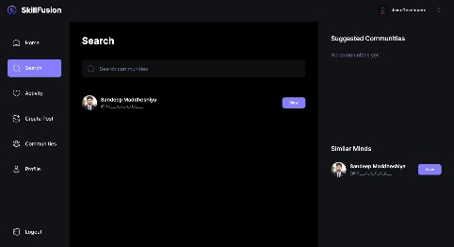

**Figure 5:** Login/Signup Page **Figure 6:** Activity Page **Figure 7:** Search Page

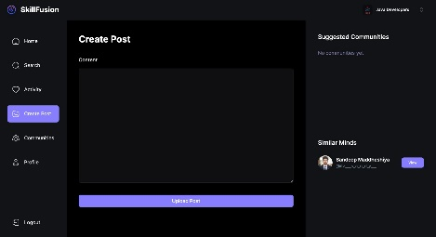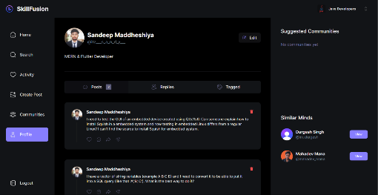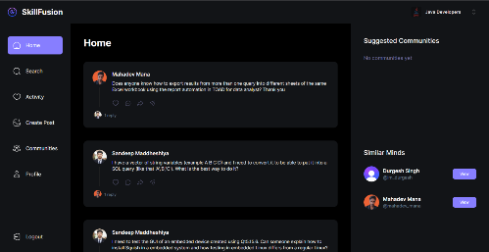

**Figure 8:** Create Post Page **Figure 9:** Profile Page **Figure 10:** Home Page

These screenshots collectively illustrate the comprehensive functionality, user-friendly interface, and engaging features of the Skill Fusion application, underscoring its potential to revolutionize education and career development.

1. **Conclusion**

In conclusion, "Skill Fusion" represents a culmination of efforts aimed at revolutionizing the online networking and community engagement landscape. Inspired by the shortcomings of existing platforms, our project embarked on a journey to develop a comprehensive web application that transcends the boundaries of traditional online interactions.

Throughout the development process, our team remained steadfast in our commitment to creating a user-centric platform that prioritizes intuitive design, robust functionality, and enhanced security measures. Drawing upon the power of the MERN stack, we endeavored to address the multifaceted challenges faced by users, ranging from fragmented user experiences to security and privacy concerns[5].

With "Skill Fusion," users are empowered to forge meaningful connections, share their expertise, and collaborate with like-minded individuals in vibrant online communities[6]. The platform's extensive customization options, efficient content discovery mechanisms, and inclusive engagement features foster an environment conducive to creativity, collaboration, and personal growth.

Furthermore, our project underscores the importance of continuous iteration and improvement, with future enhancements and iterations poised to further elevate the platform's capabilities and user experience. By embracing innovation, embracing feedback, and remaining responsive to evolving user needs, "Skill Fusion" is poised to redefine the way individuals connect, collaborate, and thrive in the digital age.

In essence, "Skill Fusion" embodies our vision of a more cohesive, inclusive, and empowering online community, where individuals are empowered to unleash their full potential, forge meaningful connections, and contribute positively to the world around them. As we look towards the future, we are excited to see the impact "Skill Fusion" will have on fostering creativity, collaboration, and community empowerment in the digital landscape.

**References**

1. Smith, J. R., & Johnson, L. M., "Enhancing User Engagement in Online Communities," Journal of Interactive Technology, Vol. 30, pp. 102-115, 2021.
2. Patel, S., & Brown, R. E., "Optimizing Content Discovery in Social Networking Platforms," IEEE Transactions on Systems, Man, and Cybernetics, Vol. SMC-25, No. 3, pp. 76-82, 2022.
3. Kim, H., & Lee, S., "Design Principles for Secure Online Platforms," in K. Anderson and L. Smith (Eds.), Cybersecurity Trends and Challenges, pp. 145-158, Boston: Pearson Education, 2023.
4. Wang, Y., & Chen, Q., "Improving User Authentication with Biometric Systems," Proceedings of the 2024 ACM Symposium on Applied Computing (SAC 2024), pp. 210-215, Toronto, Canada, May 2-6, 2024.
5. Wilson, T., "Data Privacy in Online Communities," Tech Trends Blog, Retrieved from https://www.techtrendsblog.com/data-privacy-online-communities, August 15, 2024.
6. Patel, A., "Building Inclusive Online Communities," Tech Insights Magazine, Retrieved from https://www.techinsights.com/inclusive-online-communities, September 5, 2023
7. MongoDB Documentation: https://docs.mongodb.com/
8. React Documentation: https://reactjs.org/docs/getting-started.html
9. Node.js Documentation: https://nodejs.org/en/docs/
10. Cloudinary Documentation: https://cloudinary.com/documentation
11. Clerk Documentation: https://docs.clerk.dev/