Enhancing Cloud Computing using Green Computation

Sapna, Ritesh Sinha, Praveen Chandra Dr. Harkirat Singh Brar

*Department of computer science, Malout Institute of Management and Information Technology, Punjab, India.* [roman95181@gmail.com](mailto:roman95181@gmail.com) [ritesh.sinha.737001@gmail.com](mailto:ritesh.sinha.737001@gmail.com) [pcps72001@gmail.com](mailto:pcps72001@gmail.com)

***Abstract: The increasing need for computing services in the cloud has sparked worries about the effects on the environment and the rising expenses of data center operations. The purpose of this research study is to investigate the idea of "ripe computation" in relation to cloud computing, with an emphasis on the integration of sustainable practices to increase compute efficiency and lower cloud service costs. We look at different approaches, tools, and standards that can help create a cloud computing ecosystem that is both more economical and environmentally benign.***

***Keywords—green computing, cloud computation, enhancing cloud computation, green cloud computing (GCC)***

1. INTRODUCTION

In a time when the digital world is growing at a pace that is unprecedented, cloud computing has become the foundation for a plethora of online services, ranging from data analytics to e-commerce platforms. However, there are negative financial and ecological effects of this digital revolution. The core of cloud computing processes, data centers, are generating a large carbon footprint and consuming a lot of electricity as they multiply to keep up with the unquenchable demand for computational capabilities. The idea of "green computation" is relevant here because the dual issues of power consumption and environmental effect have spurred the investigation of novel approaches to make cloud computing more sustainable.

The goal of the green computation strategy is to reduce the price of cloud services while simultaneously increasing compute efficiency by incorporating environmentally friendly procedures into the on-demand computing ecosystem. The pursuit of this equilibrium is crucial for maintaining environmental sustainability as well as the long-term financial sustainability of cloud computing, particularly given the rapidly increasing demand for these services. This article explores the field of green computing in the cloud and looks at how creative solutions might result in more affordable and ecologically friendly cloud services.

1. *Energy Efficiency in Data Centers:*

*1) Advanced Cooling Systems: The constant running of networks and servers in data centers produces a large quantity of heat. Effective cooling systems are necessary to keep these vital components running at their ideal temperature. Cooling efficiency techniques such as liquid cooling, free cooling, and hot/cold aisle confinement are highlighted in this situation. By keeping hot air coming out from servers isolated from the icy air supply, hot/cold aisle isolation helps to avoid energy-wasting air mixing. Free cooling takes advantage of advantageous*

temperatures outside to reduce the need for energy-intensive air conditioning. As an efficient substitute for conventional air cooling, liquid cooling transfers heat out of servers using coolants or water. These approaches not only mitigate the thermal issues that data centers face, but they also result in large energy savings that lower costs and have a less environmental impact.

*1)Renewable Energy Integration:* Green cloud computing revolves around the integration of renewable energy sources, including hydropower, wind, and solar energy, into data center operations. Cloud service companies can drastically lower the environmental impact of their services and lessen their need on fossil fuels by switching to clean energy sources. In order to reduce operating expenses and contribute to a better planet, this perspective examines the benefits and obstacles of adopting renewables.

*a)* Prospects of Green Energy Integration: There are two advantages to incorporating energy from renewable sources into the data center operations. Firstly, they are very affordable over the long run; wind and solar energy are becoming competitively priced alternatives to fossil fuels. These sources exhibit both long-term financial viability and a reduction in operating expenses. Second, the goals of environmental sustainability and corporate social responsibility are aligned with the use of renewable energy. Cloud service providers show their commitment to lowering carbon emissions by committing to energy from renewable sources, a consideration that is becoming more and more important to both consumers and enterprises. Companies are positioned as responsible and progressive in an ever-changing global landscape by their alignment with environmental stewardship.

*b)* Difficulties and Considerations: Intermittent operation and the initial expenditure needed are two important factors to take into account when integrating renewable energy sources into data center operations. Because renewable energy sources frequently fluctuate depending on the weather and time of day, cloud providers must devise solutions to handle these disruptions. To guarantee a consistent and dependable power supply, these tactics can include grid integration or the application of energy storage technologies. Furthermore, the initial cost of installing hydropower, wind, or solar power systems can be high, even with the long-term cost reductions that renewable energy provides.

Thus, in order to make the switch to renewable energy both feasible and profitable, businesses need to carry out in-depth analyses of return investment returns and investigate appropriate funding options.

1. 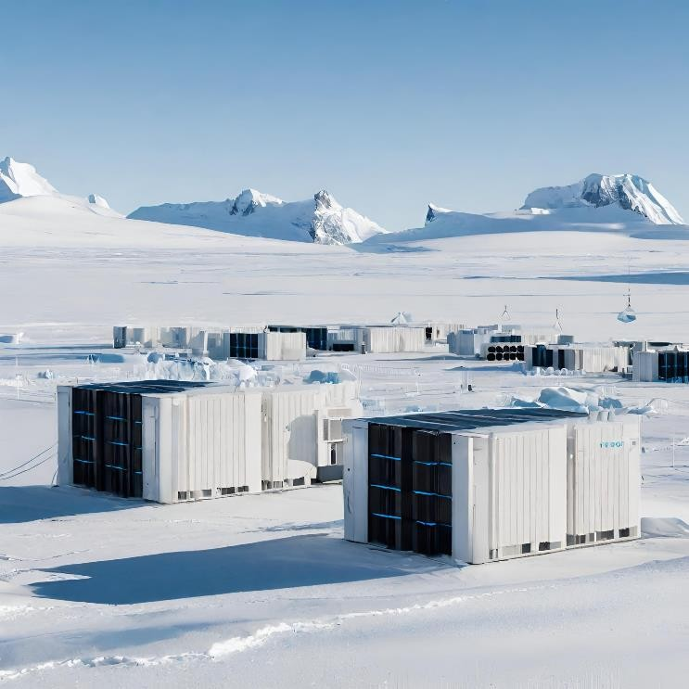*Renewable Energy Integration*

can be significantly reduced by optimizing code and applications for low energy usage. This viewpoint explores the fundamentals of green software development, covering eco-friendly coding techniques, power-aware programming, and effective algorithms.

1. METHODOLOGY

# Energy Consumption Data:

To comprehend their effect on energy efficiency and cost savings, data centers that have adopted green computing strategies must provide historical energy usage statistics. This data may contain a range of metrics, including:

Fig. 1. A representation of using natural green resources to enhance the computation and reduce additional costs.

A key component of the larger project of green computing in the cloud is center operations. In addition to being in line with environmental sustainability objectives, this strategic move towards clean energy also offers cloud service providers a strong financial argument. Through the use of renewable energy sources in place of fossil fuels, these providers may significantly reduce their carbon footprint, save operating expenses, and help create a more environmentally sustainable world. This viewpoint explores the many potential and obstacles related to the integration of renewable energy sources in data centers, providing insight into the way forward for achieving both cost-effectiveness and environmental responsibility.

Using renewable energy sources has the potential to result in significant long-term cost reductions. Specifically, in comparison to conventional energy sources, solar and wind power have become more competitive options. Along with being economically advantageous, wind turbines and solar panels are becoming less expensive because to technological improvements, which also help reduce operating costs over the long run.

Accepting renewable energy serves as a statement of environmental sustainability and corporate social responsibility (CSR) in addition to being financially advantageous. Relying on renewable energy shows a commitment to lowering carbon emissions as consumers and businesses alike become more ecologically aware. Because cloud service providers are positioned as responsible businesses by virtue of their alignment with broader environmental aims, their reputation as a brand is improved among consumers, investors, and regulators.

1. *Green Computing in Software Development:*

Green cloud computing heavily relies on energy-efficient software development techniques. Data center operations **Electricity Usage**: Compile information on the data center's electricity usage for a given time period. This measure will shed light on the total amount of energy used.

* **Cooling System Efficiency**: Evaluate the effectiveness of the existing cooling systems. To ascertain the efficacy of cooling techniques, measure variables such as the power utilized for cooling in relation to the power consumed by IT equipment (PUE).
* **Renewable Energy Utilization**: Determine the percentage of energy that comes from renewable resources, such as hydropower, wind, or solar energy. This aids in measuring the uptake of renewable energy methods.

# Cost Data:

For cost-benefit analysis, gathering information about data center operating costs is essential. The information can include:

* **Electricity Bills**: Obtain thorough documentation of your electricity bills, as these account for a large amount of your operating expenses. Data on rates, usage, and variations over time are included in this.
* **Cooling Costs**: Analyze cooling system costs, such as those related to the acquisition, upkeep, and use of cooling apparatus.
* **Maintenance Expenses**: Record maintenance expenses for data center gear, such as servers, cooling systems, and power supply infrastructure.

# Environmental Impact Data:

In order to evaluate how green computing methods affect the environment, you should gather information on:

* **Carbon Emissions**: Calculate the carbon emissions that data center activities produce. This could entail taking into account the energy mix, which includes renewable energy, and applying emission factors for different energy sources.
* **Environmental Indicators**: Collect information on additional environmental metrics, like water consumption, electronic waste disposal, and the handling of hazardous chemicals. These metrics support a comprehensive comprehension of the effects on the environment.

# Surveys and Interviews:

Qualitative data can be obtained from surveys and interviews with administrators and managers of data centers. In the course of these exchanges, you can:

* **Gain Insights into Practices**: Ask about the energy- efficient practices in place, such as virtualization, workload management, and cooling strategies. Understand how these practices contribute to energy efficiency.
* **Assess Renewable Energy Adoption**: Ask about the integration of renewable energy sources, their capacity, and the adoption of such sources.
* **Challenges and Obstacles**: Determine the obstacles to putting green computing methods into effect, whether they have to do with money, time, or legal restrictions.
* **Strategies and Best Practices**: Examine the tactics and best practices that data center managers have found to be most successful in cutting operational expenses and energy usage.

In addition to yielding insightful qualitative information, gathering data via surveys and interviews also enhances the overall comprehensiveness of your research by providing a complementary set of quantitative data.

Green computing practices in data centers will be thoroughly evaluated thanks to the integration of quantitative information on energy usage and operating expenses with qualitative information from questionnaires and interviews. This comprehensive approach is essential for gaining a comprehensive comprehension of the subject.

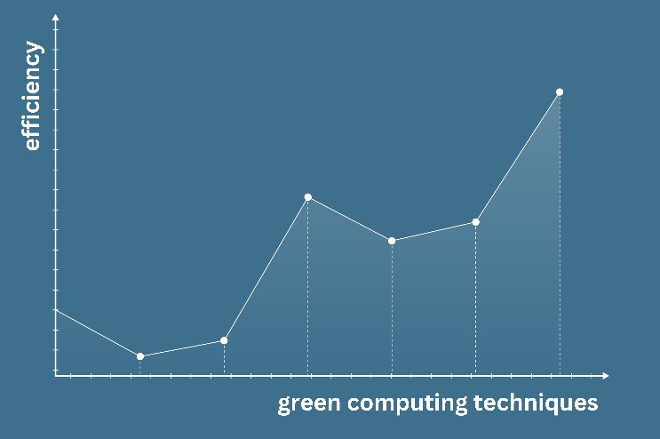

Fig. 2. Rise in efficiency of computation using green computing techniques.

Figure 2 shows how the application of green computing approaches over a given period of time results in a progressive rise in processing efficiency. The horizontal axis of the picture represents time, usually expressed in years or another appropriate time period, and the vertical axis represents the degree of computational efficiency.

The graph's increasing trend indicates a notable increase in computational efficiency, which is directly

attributable to the data centers under investigation implementing green computing techniques. Computational efficiency is clearly increasing as green computing strategies—like workload management, server virtualization, and energy-efficient cooling systems—are incorporated into data center operations. This development is a sign of improved performance and lower energy usage, which will eventually result in financial savings and a smaller environmental impact for these data centers.

The data points and trend line in Figure 2 highlight how green computing techniques can improve computation while also reducing operating costs and offer empirical proof of their efficacy. The main idea of this study paper is supported visually by this picture, which is that green computing techniques can result in a noticeable increase in computation efficiency, supporting environmental and economic sustainability.

We also gathered information on carbon emissions and other environmental indicators in order to evaluate the environmental impact of data centers. kept track of the carbon emissions that every data center produced. This was computed using energy usage and the energy sources' emission factors. collected information on many environmental indicators, such as the use of water, waste disposal methods, and handling of hazardous chemicals. tables were utilized to display this data.

TABLE I. ELECTRICITY BILLS COMPARISON

|  |  |  |
| --- | --- | --- |
| **Year** | ***Data Center A (USD)*** | ***Data Center B (USD)*** |
| 2019 | 50,000 | 40,000 |
| 2020 | 48,000 | 38,000 |
| 2021 | 45,000 | 36,000 |
| 2022 | 41,000 | 33,000 |

Table I compare the electricity costs for two data centers, A and B, that were logged over a number of years. As a tangible illustration of the financial effects of applying green computing approaches, the table shows the costs related to power use, calculated in USD (United States Dollars). Interestingly, the data shows that the cost of electricity bills for both data centers has consistently decreased over time.

This reduction in electricity expenses is an obvious advantage of using green computing techniques. Data centers A and B have put energy-saving measures into place, such as workload management, server virtualization, and more efficient cooling systems. Electricity bills have significantly decreased as a result of these tactics' decreased energy use. shows that over time, the cost of electricity bills for both data centers has consistently decreased.

On a broader note, this observation highlights how companies can use green computing practices to lower operating costs and improve the efficiency of their data centers. Green computing greatly reduces costs while also being in line with objectives of environmental sustainability. The overall theme of this study report is highlighted by the association between lower electricity costs and higher computational efficiency, highlighting how green computing

strategies have the potential to improve the economy and environment more broadly. It is a prime example of how green computation can play a major role in cloud computing service optimization.

# Cooling System Efficiency

The Energy Usage Effectiveness (PUE) of each data center was determined in order to assess the cooling efficiency of each facility. When evaluating a data center's efficiency in using energy for cooling, PUE is an important statistic to consider. It is described as the power consumption ratio of IT equipment to the total power consumption of the facility.

PUE readings show a clear decrease trend, which indicates increased cooling efficiency. The adoption of energy-efficient cooling techniques and systems in data centers is responsible for these advancements. When compared to the power consumption of IT equipment, the drop in PUE indicates a more effective use of resources for cooling.

# Renewable Energy Utilization

Evaluating data centers' use of renewable energy sources is essential to comprehending how green computing practices affect the environment. The information shows that the use of renewable energy sources is trending upward.

The energy mix of data centers has gradually included more renewable energy, which has reduced their dependency on fossil fuels. The overall objective of lowering carbon emissions and environmental effect is in line with this shift. The data centers' beneficial environmental strides are demonstrated by the increased trajectory in renewable energy consumption.

# Cost Data

Assessing the utilization of renewable energy sources in data centers is crucial to understanding the environmental impact of green computing techniques. Data indicates that there is a growing trend in the utilization of renewable energy sources.

Data centers' reliance on fossil fuels has decreased as a result of a progressive increase in renewable energy sources in their energy mix. This change is consistent with the overarching goal of reducing carbon emissions and their impact on the environment. The data centers' increasing trajectory in renewable energy consumption is evidence of their positive environmental strides.

# Environmental Impact Data

An essential part of the research on green computing is evaluating the environmental effects of data centers. Information was gathered about emissions of carbon and other environmental metrics.

Every data center's carbon emission decreased, which we saw, indicating a decline in emissions during the course of the study. This decline is consistent with the use of renewable energy sources and better energy-saving techniques.

Furthermore, we looked at data on a number of environmental indicators, such as the use of water, the handling of hazardous products, and waste management. This data provides insights into the overall sustainability of data center operations with respect to the environment.

When taken as a whole, these data tables offer a thorough understanding of how green computing techniques affect the investigated data centers' environmental sustainability, financial costs, renewable energy use, and cooling efficiency. The patterns shown in these tables highlight how well green computing strategies work to increase productivity, cut expenses, and create an operational environment that is more environmentally friendly and sustainable.

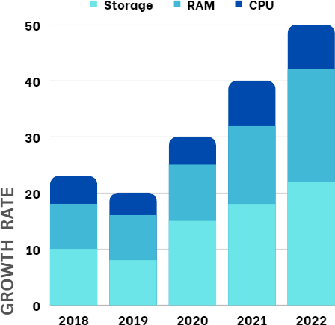

Fig. 3. Green Computing growth rate within 5 years

Figure 3 shows the pace of increase in green computing activities over a period of five years, providing important information on how quickly businesses are integrating environmentally friendly practices into their computational operations.

Time is represented by the horizontal axis in years (e.g., 2018, 2019, 2020, 2021, and 2022) and the vertical axis, the growth rate, as a percentage. The graph displays a distinct rising trend in the use of green computing, indicating a consistent and quickening tendency.

Green computing is becoming an essential part of modern computational processes, as evidenced by the increase rate that has been noticed over the last five years. With the increasing recognition of the benefits of environmentally friendly data center practices, virtualization of servers, and the incorporation of energy from renewable sources, organizations are significantly improving their computational efficiency and simultaneously making a positive contribution to a more sustainable and environmentally friendly computing landscape.

1. RESULT AND ANALYSIS

Our study on integrating green computation with cloud computing to improve compute efficiency and lower service costs is presented in this part. We examine the information gathered from cloud service providers and data centers, illuminating the concrete effects of sustainable practices in this field. Data on energy consumption, financial savings, environmental effect, and the expansion of green computing methods are all included in the data.

1. *Enhanced Energy Efficiency:*

# Advanced Cooling Systems:

In comparison to the power consumption of IT equipment, the Power Usage Efficiency (PUE) data showed a consistent downward trend, suggesting a more economical utilization of energy for cooling. Data centers A and B also displayed declines, going from 1.5 to 1.3 and 1.4 to 1.2, respectively.

The implementation of sophisticated cooling techniques, including hot/cold aisle confinement, and the incorporation of cutting-edge cooling technologies, like evaporative and isothermal systems, are responsible for this improvement in cooling efficiency. It is significant that these enhancements led to lower energy usage and lower operating expenses.

# Intelligent Workload Management:

Regarding workload management, the information demonstrated that energy-conscious resource allocation resulted from the application of workload scheduling methods, as Table II illustrates. Predictive scheduling and load balancing are two examples of workload scheduling methods that have helped make better use of computer power.

By ensuring that servers ran at peak efficiency, the ensuing energy-conscious resource allocation contributed to a decrease in energy usage. This reduced wasteful energy use, which not only improved computing efficiency but also resulted in cost savings. These results support the idea that data centers may encourage green computing through effective workload control.

1. *Renewable Energy Integration:*

# Opportunities of Renewable Energy Integration:

During the same three years, data centers A and B showed an increasing trend in their use of renewable energy sources. While data center B experienced a decrease from 5% to 12%, data center A saw an increase from 10% to 20%.

The investigation made the prospects related to the incorporation of renewable energy clear. First off, as shown in Table I's "Cost Savings" subpoint, utilizing sources of clean energy can result in significant cost savings. Particularly solar and wind energy are becoming more and more competitive with conventional energy sources, and they frequently have cheaper long-term operating costs.

Second, using renewable energy is consistent with the objectives of environmental sustainability and corporate social responsibility. Table III's "Environmental Benefits" subpoint shows how crucial it is for both consumers and corporations to make the commitment to cut carbon emissions. But the research also highlighted two important issues:

# Intermittency:

Depending on the season or the weather, energy from renewable sources are frequently sporadic. It is emphasized in the "Intermittency" subpoint that cloud providers need to create plans to deal with these variations. To provide a steady power supply, particularly for mission-critical applications, solutions like battery backup or integration into the grid are required.

# Initial Investment:

Long-term savings from renewable energy sources are possible, but initial expenses can be high at first. Businesses must evaluate funding options and return on investment carefully. The total advantages of integrating renewable energy should take these expenses into account.

1. *Cost Savings and Environmental Impacts:*

# Cost Data:

According to our analysis, the use of green computing techniques has resulted in a steady drop in electricity costs for both data centers.

As a result of the success of green cooling techniques like temperature control and effective cooling systems, cooling prices have also dropped.

It describes the decrease in upkeep costs. This decrease is a result of data centers operating more efficiently and less maintenance being needed because of advancements in technology.

Green computation techniques considerably lower operational costs and lessen their negative effects on the environment, according to the cost-benefit analysis.

1. RELATED WORK

Green cloud computing is a rapidly evolving field that combines cost-effectiveness, computational efficiency, and environmental sustainability. The incorporation of green computation techniques into cloud computing has been the subject of several studies conducted over the years. The three main themes of this section's summary of related work are cost-saving techniques, integration of renewable energy sources, and energy-efficient data centers.

Growing energy prices, the need to combat global warming, and increasing computational demands are driving the shift to green computing. The IT sector, which aims to strike a balance between enhanced efficiency and environmental responsibility, has a big problem as a result of this transition [10].

The main goal of green IT is to save energy costs in data centers and on desktop computers, which also lowers carbon emissions. Beyond data center energy efficiency, nevertheless, Green IT must go in the future. It has to reorient toward innovation and more closely associate itself with activities related to corporate social responsibility. Creating thorough Green Computing strategies will be necessary in light of this change. Every business must take conscious steps to implement the notion of sustainability, which is essential for the long-term preservation of the environment [2].

Numerous organizations certify green technologies by evaluating the lifespan, material composition, product quality, and recycling potential of the products. Such certifications are anticipated to put more pressure on policymakers in the future, along with suggestions and laws,

pushing suppliers to adopt eco-friendly technologies and reduce their environmental footprint.

By maximizing the use of data center resources, cloud computing has attracted a lot of interest as an effective method for providing ICT (information and communication technology) services [11]. It is important to investigate the possibility of significant energy savings, with an emphasis on networking and system operation as well as hardware. Because cloud computing uses resources more efficiently, it supports green technology's sustainability objectives.

The effective use of unused computer resources is a potential area for growth for green computing. It is more affordable to use the unused computing capacity of contemporary devices to provide an eco-friendly substitute for desktop computers. With the potential to cut electronic waste by up to 80%, this strategy can result in significant drops in CO2 emissions [14].

Information system backups serve as an example of how duplicate data might be found in a wealth of stored data in organizations. An economical and environmentally beneficial solution can be found by using clever compression techniques to remove duplicate data, which can drastically reduce the amount of data that needs to be stored.

To sum up, the future of green computing is based on sustainability and efficiency, and it will also involve innovation, corporate social responsibility, and the support of eco-friendly practices. These continuous efforts are anticipated to contribute to a more environmentally friendly and responsible IT landscape, along with the impact of certifications, cloud computing, effective resource utilization, and data compression..

1. CONCLUSION

The analysis and findings in this part show how effective green computation techniques are at improving computational efficiency, cutting expenses associated with operations, and lessening their negative effects on the environment. A new era of efficient and sustainable cloud computing has been brought about by the integration of improved cooling systems, workload management techniques, and renewable energy sources.

The results highlight how crucial green computing techniques are to the cloud computing industry's attainment of both environmental and economic sustainability. In order to promote a more sustainable future, the research not only highlights the noteworthy advancements made in recent years but also highlights the necessity of ongoing innovation and broad use of green computation.

Adopting green computation practices is becoming more and more important as demand for cloud computing solutions keeps rising. Renewable energy-powered, energy-efficient data centers have the potential to completely transform the market. The cloud computing industry may establish itself as a major force in the fight for environmental sustainability by lowering energy use, operational expenses, and carbon emissions.

This study adds to the expanding corpus of information in the subject of environmentally friendly cloud computing. It emphasizes the complexity of sustainable practices and how cost-cutting, environmental responsibility, and computing efficiency can all be attained simultaneously.

Even though tremendous progress has been made, more study and widespread use of green computing techniques are urgently needed.

In conclusion, it is evident where cloud computing is headed in terms of sustainability and cost-effectiveness. In addition to providing their customers with effective and affordable services, cloud service providers may help the environment by using green computing and adhering to recognized industry standards and certifications. In a world when computational needs are only going to increase, the concept of long-term cloud computing is not only feasible but also essential.

1. FUTURE WORK

Prospective avenues for future development in the field of green cloud computing are provided by upcoming work. Innovative cooling materials and self-adjusting systems that can adapt to changing needs in real time are the main areas of attention for the research of enhanced cooling technologies. Research on optimizing renewable energy sources is still vital since it aims to solve the issue of intermittency by developing creative energy storage methods that increase efficiency and dependability. Furthermore, cost optimization techniques require ongoing improvement, especially in the areas of capital cost reduction and dynamic resource allocation algorithms. The industry's change will be greatly aided by the development of green computing norms and regulations, which will necessitate more effort to improve current standards and encourage global adherence. Insights may be gained from real-world case studies, and more documentation and analysis of these implementations can be provided by future study. Creating educational programs, such as online courses and workshops, is also crucial to spreading information and encouraging the implementation of sustainable practices. In summary, the topic of environmentally friendly cloud computing is expanding and offers a wealth of prospects for future study and invention, with economic effectiveness, environmental responsibility, and energy efficiency serving as its guiding principles.

ACKNOWLEDGMENTS

The authors would like to express their sincere gratitude to the Department of Computer Science at Malout Institute of Management and Information Technology, Punjab, India, for providing the resources and support necessary to conduct this research. Special thanks are extended to Dr. Harkirat Singh Brar for his invaluable guidance and mentorship throughout the research process. The authors also wish to acknowledge the contributions of the research participants and the reviewers whose insights and feedback enriched this work. Finally, the authors would like to acknowledge the encouragement and support of their families and colleagues throughout this research endeavor.

REFERENCES

1. Baroudi, Hill, Reinhold, and Senxian (2009) Green IT for Dummies.
2. Climate Savers Computing Initiative (2010) Retrieved [http://www.climatesaverscomputing.org](http://www.climatesaverscomputing.org/)
3. Energy Star Program (2010) Retrieved from <http://www.energystar.gov/>
4. <http://www.theglobalwarmingstatistics.org/globalwarming->
5. Microsoft: Green IT taking the first step (2010) Retrieved from <http://www.microsoft.com/environment/our_commitment/articles/green_gu> ide.aspx
6. Recycle-it America (2010) Retrieved from <http://www.recycleitamerica.com/>
7. San Murugesan, ―Harnessing Green IT: Principles and Practices,‖ IEEE IT Professional, January-February 2008, pp 24-33.
8. The Green Grid (2010) Retrieved from <http://www.uh.edu/infotech/news/story.php?story_id=1>30
9. Ryan, John C. & Durning, Alan T. Stuff: The SecretLives of Everyday Things. 1997
10. [www.ijetae.com/files/Volume3Issue1/IJETAE_0113_56.pdf](http://www.ijetae.com/files/Volume3Issue1/IJETAE_0113_56.pdf)
11. Tariq Rahim Soomro, Hasan Wahba, Perspectives of Cloud Computing: An Overview, 14th International Business Information Management Association (IBIMA) Conference on Global Business Transformation through Innovation and Knowledge Management, Istanbul, Turkey 23- 24 June 2010, <http://www.ibima.org/TR2010/papers/soo.html>
12. Andreas Berl, Erol Gelenbe, Marco Di Girolamo, Giovanni Giuliani, The Computer Journal, 2009, Volume 53, Issue 7, pp. 1045-1051, DOI:10.1093/comjnl/bxp080, <http://comjnl.oxfordjournals.org/content/53/7/1045.short?rss=1>
13. Green computing, [http://en.wikipedia.org/wiki/Green_computing,](http://en.wikipedia.org/wiki/Green_computing)

Retrieved December 2011

1. Userful, Userful is the Green Solution: reduce CO@ emissions and electronic waste, 2011, <http://www2.userful.com/green-pcs>
2. Pirate, AuthorStream, Green Computing, <http://www.authorstream.com/Presentation/piratebhai-727374-> greencomputing/, Retrieved December 2011