**Review on transdermal drug delivery system**

**Yogesh kumar kaushal*1, Mansi sharma2, Piyush kashyap3, Dr Ravinesh mishra4**

1,2Research scholar, school of pharmacy and emerging science, Baddi University of Emerging Sciences and Technology, Baddi , Himachal Pradesh

3 Maharaja Agrasen University, Kalu Jhanda, Barotiwala, Himachal Pradesh

4Dean of Pharmacy, School of Pharmacy and Emerging Sciences, Baddi University of Emerging Sciences and Technology, Baddi, Solan, H.P.,

* Mail address1: [Yogeshkaushal.123p@gmail.com](mailto:Yogeshkaushal.123p@gmail.com), Mobile. No +919816771288

**Abstract**

Transdermal drug delivery devices are used to provide medications topically. Transdermal patches are pharmaceutical preparations of varied sizes that include one or more active ingredients and are meant to be placed to unbroken skin in order to pass through the skin barriers to transport the active ingredient to the systemic circulation , therefore avoiding the first pass effect. A transdermal drug delivery system has an advantage over other types of medication delivery such as oral, topical, intravenous, intramuscular, and so on because the patch offers a controlled release of the medication into the patient. In TDDS drug is placed within the patch, and the patch is worn on the skin for a long time. This method ensures that the drug remains in the circulation for an extended period of time due to its steady concentration. The primary components of TDDS are a polymer matrix, drugs, plasticizer and permeation enhancers. Polymers include HPMC, carbopol, methylcellulose, gum Arabic, starch, shellac, and synthetics such as acetyl copolymer, polyvinyl chloride, polyamide, and polyvinyl acetate. TDDS have different types of system which includes single layer drug in adhesive, multilayer drug in adhesive, matrix, reservoir and Vapour Patch. There are several factors that affect TDDS such as physico-chemical Factors, biological and environmental factors. Transdermal drug delivery is a relatively new technology with great potential to reduce the usage of needles for administering various drugs; however, the cost is also a factor that needs to be considered, especially in developing countries like India, which have the largest populations worldwide. Because TDDS are more expensive, they are a hidden aspect of therapy that must be used in. An overview of TDDS, including its benefits and drawbacks, essential components, types, and evaluation, is provided in the review article

**KEYWORDS**

Transdermal drug delivery system (TDDS), Transport mechanism, Permeability, Skin, Permeation mechanism, Iontophoresis, Microneedles.

1. **INTRODUCTION**

Many medications are now taken orally, however it has been noticed that they are not as effective as expected, hence TDDS was developed to improve such characters. Transdermal drug delivery refers to the administration of medication through the skin to have a systemic impact. (Kandavilli et al., 2002) Compared to the commonly utilized direct administration routes, which involve injections with needles, TDDS has emerged as one of the most extensively researched methods of non-invasive drug delivery into the body through the skin. The distribution of many therapeutic substances has been greatly affected by TDDS, particularly in the treatment of disorders of the cardiovascular and central nervous systems, hormone therapy, and pain management. (Ali, 2017), The most popular transdermal technology on the market today is based mostly on semi-permeable membranes, which are also known as patches. Topically placed patches that deliver drugs for systemic effects do so at a predetermined and regulated rate. The most widely used systems for dermatological problems in the past were topically administered lotions and ointments. (Mujoriya & Dhamande, 2011) The development of a novel delivery system for existing therapeutic molecules boosts patient compliance and overall therapeutic benefit significantly in addition to boosting the treatment's efficacy and safety.(Allen Jr, 1990). In addition to improving the efficacy and safety of the treatment, the invention of a novel delivery mechanism for already existing therapeutic molecules dramatically increases patient compliance and overall therapeutic benefit. Transdermal delivery eliminates pulsed systemic circulation for medications with short biological half-lives, which frequently results in unfavorable side effects, and permits continuous, controlled drug administration.(Chein, 1987)

**1.1 ADVANTAGES OF TDDS**

* Reduced dose frequency number
* In compared to the nasal and buccal cavity, the area of application is large
* Incompatibilities with GIT are avoided. (Divyesh et al., 2011)
* IV treatment risks and difficulties are eliminated.
* Reduced dosage frequency, as well as predicted sustained and prolonged duration of effect.
* It is easy to self-administrate. (Brahmankar & Jaiswal, 2019)

**1.2 DISADVANTAGES OF TDDS**

* It irritates the skin and induces an allergic reaction.
* Many medications, particularly those with hydrophilic structures, may not reach therapeutic levels because they enter the skin too slowly.
* Drugs with extremely low or high partition coefficients do not enter the bloodstream. (SHINGADE, 2012)
* Because of the natural restrictions of drug entrance imposed by the skin's imperability, only potent drugs are appropriate candidates for transdermal patch. (DebMandal & Mandal, 2011)

1. **SKIN**

The skin, which has a surface area of roughly 2 square meters and receives nearly one third of the blood flowing through the body, is the biggest organ in the human body. It acts as a permeability barrier to prevent different chemical and biological substances from being absorbed transdermally. (Adekola et al., 2017)

**2.1 FUNCTION OF SKIN**

* Maintains a barrier between the blood circulation system underneath and the environment outside.
* Protects against biological, chemical, and physical assaults.
* Serves as a thermostat to keep the body at the proper temperature.
* It helps to regulate blood pressure.
* Prevents UV rays from penetrating the skin. (Nikam & Nikam, 2021)

**2.2 ANATOMY AND PHYSIOLOGY OF SKIN**

Three separate yet interdependent tissues make up human skin:

* "Epidermis" refers to the stratified, vascular, and cellular layer
* Underlying connective tissue's dermis,
* Hypodermis

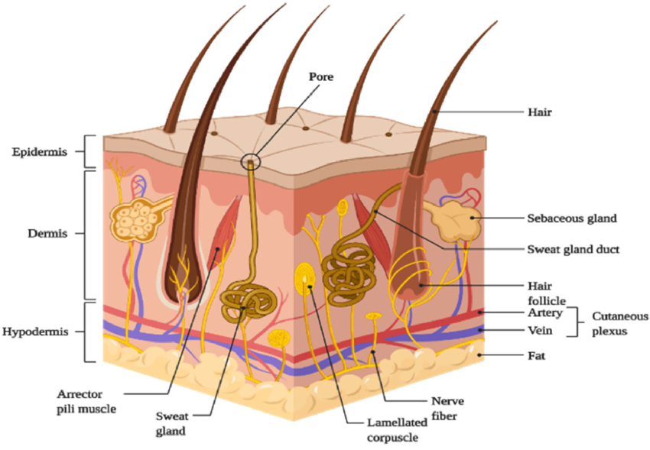

**Figure 1: Skin anatomy and physiology**

* + 1. **EPIDERMIS**

Depending on the size of the cell and the number of layers of the epidermis, the multilayered epidermis has a range of thicknesses, from 0.8 mm on the palms to 0.06 mm on the eyelids. This is the skin's topmost layer. When dry, it is around 10 mm thick, but when completely hydrated, it expands to many times that thickness. It is made up of 10 to 25 layers of dead, keratinized cells known as corneocytes. It is stretchy but somewhat impermeable.(Akombaetwa et al., 2023)

**2.2.1.1 TYPES OF EPIDERMIS**

* **Stratum corneum :** The outermost layer of skin is often referred to as the horny layer. When fully hydrated, it expands to many times this thickness from its initial dry thickness of roughly 10 mm. The primary defense against drug entry is the stratum corneum. A wall-like structure can be constructed using horny layer architecture.
* **Viable Epidermis:** the thickness of this layer, which lies under the stratum corneum, ranges from 0.06 mm on the eyelids to 0.8 mm on the palms. It is made up of layers such as the stratum basal, stratum lucidum, stratum granulosum, and stratum spinosum.
  + 1. **Dermis**

The 3 to 5 mm thick layer of dermis is made up of a matrix of connective tissue that houses nerves, lymphatic vessels, and blood vessels. While eliminating toxins and waste materials, it also gives the skin nutrition and oxygen. Capillaries offer a sinking environment for many molecules that penetrate the skin barrier and extend to within 0.2 mm of the skin's surface.

* + 1. **Hypodermis**

The dermis and epidermis are bolstered by the hypodermis.. It serves as a location for fat storage. This layer offers nutritional assistance, mechanical protection, and aids in temperature regulation. Principal blood arteries, nerves, and perhaps pressure-sensing organs are carried there to the skin. (Allen Jr, 1990), (Tanwar & Sachdeva, 2016)

* 1. **Routes of drug penetration through the skin**:

A drug molecule may diffuse through shunts, particularly those provided by the rather widely dispersed hair follicles and eccrine glands as illustrated in Figure No. 2, or it may pass through the epidermis itself during the percutaneous penetration process. Drug molecules can pass through the skin along with hair follicles or sweat ducts during the initial transitory diffusion stage and subsequently be absorbed by the f sebaceous glands and follicular epithelium. The predominant channel for transdermal penetration becomes diffusion via the intact stratum corneum after a steady-state has been attained. (Jain, 1997)

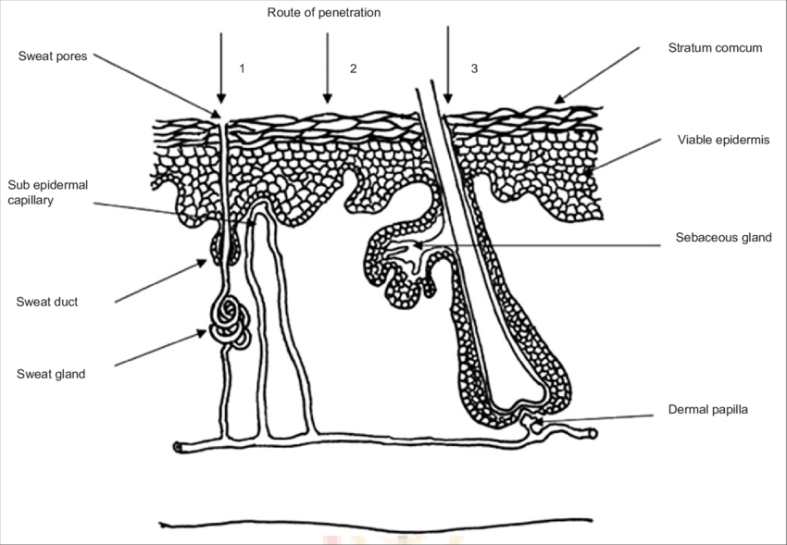

**Figure 2: Routes of drug penetration through skin**

There are two primary ways that molecules applied to the skin might permeate the skin.

* Transepidermal route
* Trans follicular route

**2.3.1 Transepidermal route**: Molecules move through the intact horny layer during transepidermal transfer. The transcellular (or intracellular) and the intercellular pathways, as seen in Figure No. 2, are two potential micro-routes of entrance. Different processes are used for the transcellular and intercellular diffusion of both polar and non-polar molecules. The non-polar molecules dissolve and diffuse via the stratum corneum's non-aqueous lipid matrix, the polar molecules mostly diffuse through the polar route made up of "bound water" in the hydrated stratum corneum. As a result, the partition coefficient (log K) plays a major role in determining the main route that a penetrant takes. Lipophilic permanents go through the stratum corneum through the intercellular pathway, while hydrophilic pharmaceuticals preferentially partition into the intracellular domains. The majority of molecules go through the stratum corneum both ways**.** (Dhiman et al., 2011)

**2.3.2 Trans follicular route (Shunt pathway**): This strategy includespassing through the sweat glands and hair follicles along with the corresponding sebaceous glands. These channels have a high permeability, but due of their modest size—roughly 0.1% of the total skin—they are thought to be of secondary relevance. (Jain, 1997)

**3. BASIC TRANSDERMAL PERMEATION PRINCIPLE**

The basis for transdermal permeation is passive diffusion. Only a millimeter of tissue separates the skin's surface from the underlying capillary network, making it the most intensive and easily accessible organ in the human body. It takes many steps for a medicinal substance to release from a formulation applied to the skin surface and go to the systemic circulation, which includes.

* Drug diffusion from the drug to the rate-regulating membrane.
* Release from the formulation and internal dissolution.
* penetration through healthy epidermis and sorption by the stratum corneum
* Drug uptake via the capillary network of the dermal papillary layer. The effect on the intended organ.
* dividing into the stratum corneum, the top layer of skin
* Diffusion mostly by a lipidic intercellular route through the stratum corneum. (Tanwar & Sachdeva, 2016)

1. **Basic components of TDDS**

* Backing laminate
* Release liner
* Pressure sensitive adhesive
* Drug
* Permeation enhancers
* Polymer matrix
  1. **Backing laminate**

While they are packaged in their pouch for the TDDS as well as while the system is being used, backing films must play a crucial function. A film's job is to safeguard the active layer, which is responsible for the stability of the system, as well as to affect skin tolerance and penetration, which form the basis of occlusion or breathability. The release liner must be completely inert to the components in order to avoid any form of incompatibility due to the broad categories of ingredients. It must exhibit comfort and flexibility, as well as good adhesion to the adhesive and outstanding printability. Polypropylene, saran , Polyester film, Nylon, & PVC are the most often utilized materials for releasing liners. (Walters, 1996)

* 1. **Release liner**

Before being applied to skin, the protective liner that covers the patch while it is in storage is instantly removed. As a result, it is seen as a component of the vital bundle instead of a component of the dosage form for apportioning the medicine. The base layer of a release liner is often non-occlusive (for example, paper fabric) and occlusive (for example, polyethylene, polyvinyl chloride), and the release coating layer is typically formed of silicon or teflon. Metallic laminates and polyester foil are other materials utilized for TDDS release liners.(Foco et al., 2004)

* 1. **Pressure sensitive adhesives**

The Transdermal medicine delivery device is securely attached to the skin using pressure-sensitive adhesive (PSA). Adhesives must be gentle on the skin, cause little discomfort or sensitization, & be easily removed without causing damage to the surface of the skin or leaving behind residue. Additionally, they must retain their adhesive qualities and skin tolerability while dissolving medication and excipient in amounts necessary for the required pharmacological action. Polyisobutylene, Polyacrylate & polysiloxane   are PSAs used in commercially marketed transdermal systems. (Jain, 1997)

* 1. **Drug**

The medicine should be carefully chosen in order to design an transdermal drug delivery method properly. Some desirable qualities of a medication for transdermal distribution include the ones listed below.

* The drug's atomic weight ought to be underneath around 1000 Daltons.
* The medication must be able to bind to both the lipophilic as well as hydrophilic phases. Highly portioning qualities are inappropriate for successfully administering medications through the layer of skin.
* The drug's melting point need to be minimal.
* Transdermal administration is an option for medications that break down in the gastrointestinal system or are rendered inactive by the hepatic first-pass effect.
* Drugs that need to be supplied over a long duration of time or that have negative side effects on tissues other than the target tissue can also be designed for transdermal administration. (Karande et al., 2005)
  1. **Permeation enhancers**

By interacting with the structural elements of the stratum corneum, such as proteins or lipids, these chemicals are beneficial for increasing the permeability of the stratum corneum and achieving greater therapeutic level of an medicine. Sodium lauryl sulphate, oleic acid, Caraway oil, Lemon oil, Menthol, Limonene, and Linoleic Acid are a few examples. (Nagadev et al., 2020; Yadav, 2012)

* 1. **Polymer matrix**

The polymers regulate how quickly the medication leaves the drug reservoir. Examples of both naturally occurring and synthetic polymers are shown below: (Bw, 1998)

**Table 1: Polymers used in TDDS**

|  |  |  |
| --- | --- | --- |
| **Natural polymer** | **Synthetic Elastomers** | **Synthetic polymer** |
| Zein, gelatine,  Protein,  sellac, strarch,  Cellulose derivative | polysiloxane, acrylonitrile  neoprene,  chloroprene,  hydrinrubber | polyethylene, Polyamide,  polystyrene,  Polyvinyl alcohol |

1. **TYPES OF TRANSDERMAL PATCHES**

Different kinds of transdermal patches exist.

* Single-layer drug-in-adhesive.
* Multi-layer drug-in-adhesive.
* Reservoir.
* Matrix.
* Vapour patch.
  1. **Single-layer Drug-in- Adhesive**

The medication is also included in this system's adhesive layer. The adhesive layer in this kind of patch releases the medication in addition to holding the system as a whole and the individual layers to the skin together. The adhesive layer is surrounded by a backing and a temporary liner. The pace at which this kind of device releases medication is determined by how rapidly the substance penetrates the skin. (Chickering et al., 1999)

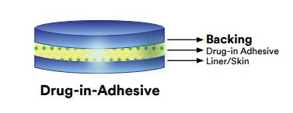

**Figure 3: single layer drug in adhesive**

* 1. **The Multi-layer Drug-in-Adhesive**

In that both sticky layers are in charge of the drug's release, the multi-layer drug-in adhesive patch and the single-layer method are comparable**.** The multi-layer method differs, though, in that it incorporates an additional drug-inadhesive layer, which is often (but not always) divided by a membrane. This type of patch also has a temporal liner layer and a permanent backing. (Monti et al., 1995)

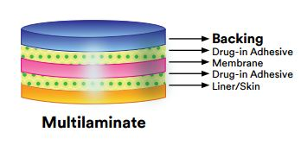

**Figure 4: multilayer drug in adhesive**

* 1. **Reservoir** :

It is distinguished by the presence of a fluid compartment with a medication solution or suspension that is kept apart from its release liner by an adhesive and semi-permeable membrane. The rate of delivery in this kind of system is zero order**.** (Sharma et al., 2012)

C:\Users\Parveen\AppData\Local\Microsoft\Windows\INetCache\Content.Word\reservoir-drug-in-adhesive.jpg

**Figure 5: Reservoir type system**

* 1. **Matrix**

It is distinguished by the presence of a partially solid matrices that is in close contact to the release liner and contains a medication solution or suspension. The skin-adhering component is coordinates into an overlay and encompasses the semisolid framework in a circular design.(Ghafourian et al., 2004)

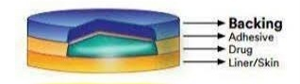

**Figure 6: Matrix type system**

* 1. **Vapour Patch**

This kind of patch uses an adhesive layer that releases vapour in addition to holding the different layers together. The newest products on the market are vapour patches, which emit essential oils for as long as six hours. Vapour patches, which have the potential to emit essential oils over up to six hours, are a relatively recent addition to the market. Decongestion is treated by vapour patches. Controller vapour patches are another type of vapour patch available that enhances the quality of sleep. There are also vapour patches on the market that  decreases the amount of cigarettes a person smokes in a given month. (Keleb et al., 2010)

1. **FORMULATION APPROACHES UTILIZED IN THE DEVELOPMENT OF TDDS**

**6.1 Matrix diffusion controlled system**

The medicine is dispersed into an adhesive polymer to generate a reservoir, which is then applied to an impermeable backing layer by hot melting or solvent casting the medicated polymer adhesive. A non-pharmaceutical rate-regulating adhesive polymer of constant thickness is then used to cover the drug reservoir layer, resulting in an adhesive diffusion-controlling drug delivery system. (Jain, 1997)

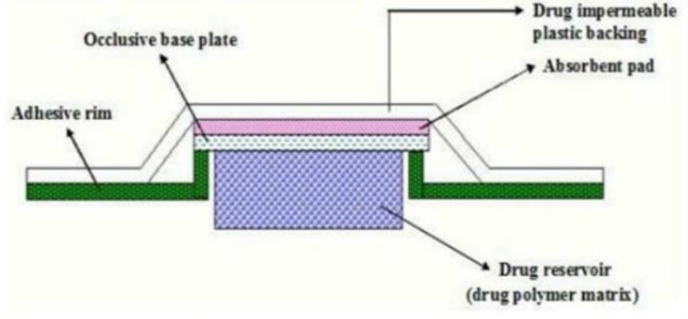

**Figure 7**: **Matrix diffusion controlled system**

* 1. **Reservoir System (Membrane Moderated TDDS):**

The drug reservoir in the reservoir system is surrounded by a rate-controlling membrane and an impermeable backing layer. The medicine is purely released by the rate-controlling membrane, which can be either non-porous or microporous. The drug in the drug's storage compartment might be in the form of a solution, suspension, gel, or disseminated in a solid polymeric matrix. A small coating of drug-appropriate, non-allergenic adhesive polymers could be placed to the polymeric membrane's outermost surface area. (Jain, 1997)

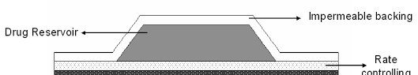

**Figure 8: Reservoir System (Membrane Moderated TDDS)**

* 1. **Microreservoir Dissolution-Controlled TDD Systems:**

This kind of delivery system may be thought of as a cross between matrix dispersion and reservoir delivery systems. The drug reservoir is made using a procedure that involves first suspending the drug in an aqueous solution of a water-soluble polymer and then uniformly spreading the solution inside a lipophilic polymer to generate thousands of tiny, impenetrable drug reservoir spheres. Thus, by immediately cross-linking the polymer, the thermally unstable dispersion is instantaneously stabilized, This results in a medicinal polymeric disc with a certain thickness and uniform surface area. (Ghulaxe & Verma, 2015)

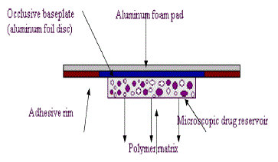

**Figure 9: Microreservoir Dissolution-Controlled TDD Systems**

1. **METHOD OF PREPARATION** 
   1. **Asymmetric TPX membrane method**

With a concave backing membrane of 1 cm in diameter, thermal sealable polyester film may be used to create a prototype patch using this approach. A concave membrane containing the drug was coated with an asymmetric TPX membrane {poly (4-methyl-1-pentene) and sealed with an adhesive.

Asymmetric TPX membrane preparation: These are made by the wet/dry inversion method. Here, TPX is dissolved at 60°C in a combination of non-solvent agents and solvent (cyclohexane) to create a solution of polymers. After 24 hours at 40°C, the mixture of polymers is cast onto a glass plate. After 30 seconds of evaporation at 50°C, the glass plate must be promptly submerged in a coagulation bath with a temperature maintained at 25°C. The membrane may be taken out after soaking for ten minutes, and it can air dry for twelve hours at 50°C in a circulation oven. (Kumar et al., 2010)

* 1. **Circular Teflon Mould Method**

An organic solvent consisting of polymeric solution in different ratios is utilized, and the solution is split in halves. A certain quantity of medication is dissolved in half, while enhancers at varying concentrations are dissolved in the second half. The two halves are then combined. Plasticizer is added to a drug polymer solution, such as Di-N butyl phthalate. After 12 hours of stirring, the entire mixture should be put into a ring-shaped Teflon mold. The molds in the laminar flow hood model need to be placed on an even surface and covered with an inverted funnel in order to control solvent evaporation at an air speed of 0.5 m/s. For a whole day, the solvent is left to evaporate. Before assessment, the dried films must be held for a further twenty-four hours at 25±0.5°C in an a dehydrator filled with silica gel to prevent aging effects. (Kumar et al., 2010)

* 1. **By using “IPM Membranes” Method**

Drug is distributed and mixed for 12 hours in a magnetic stirrer with a mixture of water and polymer (propylene glycol with Carbomer 940 polymer). The purpose of adding triethanol amine to a dispersion is in order to neutralize it and make it viscous. Since the medication is not highly soluble in an aqueous solution, a solution gel is produced by employing a buffer with a pH of 7.4. (Shinde et al., 2023)

* 1. **Mercury substrate method**

This approach dissolves the medication in a solution of polymers containing plasticizer. After stirring for ten to fifteen minutes, the mixture is transferred onto a flat mercury surface and covered with an inverted funnel to prevent the evaporation of the solvent. (Kumar et al., 2010)

* 1. **Aluminium backed adhesive film method**

If the loading dose for a TDDS is more than 10 mg, unstable matrices may be produced. It is feasible to use the sticky film technique with aluminum backing. Since most medications and adhesives dissolve in chloroform, it is the solvent of choice for preparing the same. Adhesive substance was added to a solution of drug and dissolved once the medication is dissolved in chloroform. Aluminum foil is used to line a specially constructed aluminum former, and cork blocks that fit firmly are used to blank off the ends. (Shaila et al., 2006)

* 1. **Using “EVAC Membranes” Method**

Rate-control membranes can be used to create TDDS. Examples of these membranes are polyethylene (PE), 1% carbopol reservoir gel, and ethylene vinyl acetate copolymer (EVAC) membrane. Gel is made using propylene glycol if the medication fails to be soluble in water. Propylene glycol is used to dissolve the drug. Carbopol resin is then added to the mixture and neutralized with 5% w/w solution of sodium hydroxide. The medication (in gel state form) is applied to a backing layer sheet that covers the designated region. To create a leak-proof device, a rate-regulating membrane will be put over the gel and the borders will be sealed with heat. (Shaila et al., 2006)

* 1. **Preparation of TDDS by using proliposomes**

Applying the film deposition approach, the proliposomes are synthesized by using the carrier method. Lecithin as well as the previously mentioned reference drug in a 1:2 ratio can be utilized as an ideal combination. To create the proliposomes, five milligrams of mannitol in powdered form is placed in a 100 ml round-bottom flask and heated to between 60 and 70 °C. The flask is then spun at 8090 rpm and vacuum-dried for 30 minutes. The water bath's temperature is changed to between 20 and 30 °C after drying. A appropriate blend of organic solvent is used to dissolve the drug and lecithin. After the organic solution has finished drying, another aliquot of 0.5 milliliters of a solution should be added to the round-bottomed flask containing mannitol at 37 °C. The flask holding the proliposomes is connected to a lyophilizer after its final loading. The drug-loaded mannitol powdered forms (proliposomes) are then left in desiccators for the night before being sieved through a 100 mesh screen. After being collected, the powder is put into a clear glass bottle and kept at freezing temperature until it is characterized. (Benson et al., 2019)

* 1. **By using free film method**

Casting onto a mercury surface creates a  film of the cellulose acetate. Chloroform is utilized to create a 2% w/w solution of polymer. 40% weight percentage of the polymer weight is the concentration at which plasticizers are integrated. The glass ring on a glass petri dish with the mercury surface on top was filled with five milliliters of the polymer solution. By covering the petridish with an inverted funnel, the solvent's rate of evaporation may be adjusted. After the solvent has completely evaporated, the mercury surface is examined to detect the creation of a layer. Before being used, the dried film will be removed and kept in desiccators within the wax paper sheets. It is possible to make free films with varying thicknesses by adjusting the amount of the polymer solution. (Benson et al., 2019)

1. **EQUIPMENT ASSISTED TRANSDERMAL DELIVERY ENHANCEMENT (ACTIVE DELIVERY)**

When compared to topical medication treatment on the skin, external stimuli including mechanical, electrical, or physical stimulation are known to increase the permeability of medicines and biomolecules through the skin. Active transdermal delivery, or TDDS enhanced by suitable equipment, is a well-established method of delivering medications into the skin with speed and consistency. Furthermore, this improved TDDS mode can hasten the therapeutic effectiveness of medications that are administered. (Wang et al., 2021)

* 1. **Iontophoresis**

Iontophoresis has been shown to improve skin penetration and accelerate the release rate of certain medications that have poor absorption/permeation profiles by encouraging the migration of ions through the membrane with the influence of a tiny locally applied potential difference (fewer than 0.5mA/cm2). This method is used to transport ionic or nonionic medicines in body employing an electrochemical potential gradient. (Park et al., 2019)

* 1. **Sonophoresis**

Transdermal administration of drugs can be enhanced by an ultrasound device's intended spectrum of ultrasonic frequencies. Because low-frequency ultrasound uses cavitation to create an aqueous channel in the disturbed bilayer, it is more effective at facilitating medication flow. (Seah & Teo, 2018)

* 1. **Electroporation**

This technique creates tiny holes in the SC that increase permeability and facilitate drug diffusion by applying high voltage pulses of electricity to the skin for brief exposure intervals (~ms) (Cheng et al., 2023). These pulses range from 5 to 500V.It is used to improve transdermal delivery. (Chen et al., 2020)

* 1. **Photomechanical waves**

The medication can enter the temporary channel generated by photodynamic waves that are conveyed to the skin and penetrate the SC (Jeong et al., 2021). In order to successfully transmit, the depth must be increased to 50–400 μm, which is accomplished by little radiation exposure of around 5–7 J/cm2. The incident wave induces little ablation. In comparison to previous direct ablation procedures, this restricted ablation demonstrated a longer rise and duration, necessitating the regulation of photodynamic wave characteristics to assure product delivery to the desired depth in the skin. (Chen et al., 2020)

* 1. **Microneedle**

A needle is used in a microneedle drug delivery method, a new drug delivery method, to administer medications to the circulatory system. This is a common transdermal medication delivery technology that is currently being researched. This approach includes puncturing the skin's superficial layer with needles the size of microns, which diffuses the medicine throughout the epidermal layer. These short, thin microneedles carry medications effectively to the blood vessel region for active absorption, reducing the risk of discomfort**.** (Zaid Alkilani et al., 2015)

* 1. **Thermal ablation**

By locally using heat to selectively disturb the stratum corneum structure, a method called thermal ablation, or thermophoresis, offers improved medication administration by creating microchannels in the skin. (Zaid Alkilani et al., 2015)

1. **TDDS USING CHEMICAL ENHANCERS (PASSIVE DELIVERY)**

Drugs should have low molecular weight (less than 1 kDa), a affinity towards hydrophilic and lipophilic phases, a short half-life, and little skin irritation in order to maximize transdermal delivery and therapeutic effectiveness. Numerous factors, including species variations, skin age and site, temperature, skin condition, site of application, time duration of exposure, skin moisture content, pretreatment techniques, and physical properties of the penetrant, influence how well a medicine penetrates the skin. Aspects of trans-dermal drug delivery (TDDS) technologies have become the subject of recent studies. These have included the development of chemical enhancers that improve drug solubility or spread across the skin, as well as new and creative approaches that expand this idea to include the creation of super-strong formulations, microemulsions, and vesicles. (Hadgraft & Lane, 2006)

* 1. **Vesicles**

Vesicles are water-filled colloidal particles made up of two layers of amphiphilic molecules. These amphiphilic compounds create multilayer vesicles, or concentric bilayers containing one or more shells, when there is an excess of water present. Drugs that are soluble in fat or water can be delivered in vesicles for transdermal absorption. Using vesicles topically, medications that have been stored can be released gradually. Vesicles in TDDS can also be used to regulate the absorption rate via a multilayered structure. Because vesicle systems contain a variety of components, they may be classified into many categories based on the characteristics of the constituent molecules, including liposomes, transfersomes, and ethosomes. (Babaie et al., 2020)

* 1. **Polymeric nanoparticles**

Nanoparticles are nanocarriers that range in size from 1 to 1000 nm. Based on their composition, Nanoparticles may be further divided into many categories. When a medication is administered as nanoparticles (NPs), it exhibits targeted and controlled release behavior, modifies the drug's in vivo dynamics, and lengthens its blood half-life. All of these features contribute to increased drug bioavailability and decreased toxicity and adverse effects. Traditionally, polymerization and crosslinking are utilized to create NPs, and biodegradable polymeric materials like poly-lactic  acid (PLA) and gelatin are frequently employed in this process. (Dhal et al., 2020), (Lee et al., 2020)

* 1. **Nanoemulsion**

The properties of nanoemulsions include low viscosity and isotropic, dynamic and thermodynamic stability. Transparent or translucent oil globules are mixed with an aqueous phase and stabilized by a thin interfacial membrane made of very small droplet-sized surfactant or co-surfactant molecules. Commonly utilized nanoemulsions have particle sizes between 100 to 1000 nm, yet because of their nanoscale dimensions, a upper limit of the particle size is proposed. While nanoemulsions and microemulsions have nearly the same size of droplets range, content, and appearance, they diverge significantly in terms of structural features and long-term thermodynamic stability. Close contact with the skin is ensured by the great wettability of nanoemulsions due to their large specific surface area, low surface tension, and tiny particle size. Furthermore, nanoemulsions have several advantages including enhanced bioavailability, long shelf life, low energy input during manufacture, excellent solubilization capacity, and physical stability. Compared to popular topical skin treatments, nanoemulsions show superior transdermal absorption and a shorter transdermal time. (Szunerits & Boukherroub, 2018)

1. **FACTORS AFFECTING TRANSDERMAL PERMEATION:**

There are several factors that affect TDDS.

* + 1. **PHYSICO-CHEMICAL FACTORS**
    2. **Skin hydration**

Skin becomes much more permeable when it comes into touch with water. The most crucial element in boosting skin penetration is hydration. Humectants are therefore used in transdermal delivery. (Verma et al., 2003)

* + 1. **Temperature and Ph**

Temperature variations cause the drug's penetration to rise tenfold. With a drop in temperature, the diffusion coefficient lowers. pKa or pKb levels and pH determine the dissociation of weak bases and weak acids. The concentration of pharmaceuticals in the skin is determined by the percentage of unionized medications. As a result, two key variables influencing medication penetration are temperature and pH. (Verma et al., 2003)

* + 1. **Drug concentration**

Drug concentrations across barriers determine the concentration gradient, which is inversely correlated with flow. A larger concentration gradient indicates a higher concentration of a drug.

* + 1. **Diffusion coefficient**

Drug penetration is dependent upon its diffusion coefficient, which is dependent upon the characteristics of the drug, the diffusion medium, and the interaction between them at a constant temperature.

* + 1. **Partition coefficient**

The optimal partition coefficient (K) is necessary for good action. It appears that drugs having high K can't escape the lipoid area of the skin. Moreover, low-K medicine won't seep through.

* + 1. **Molecular size and shape**

Molecular weight and drug absorption are inversely correlated; tiny molecules absorb more quickly than big one.

* 1. **BIOLOGICAL FACTORS** 
     1. **Skin age**: The skin of kids and adults is more porous than that of elderly people, although there is no significant difference. Children's bigger area of surface per kilogram of body weight has harmful consequences. As a result, strong steroids, boric acid, and hexachlorophene have had detrimental side effects.
     2. **Skin conditions**

The skin's barrier function is maintained by the intact layer itself, but other substances, such as acids and alkalis, can pass across the skin's barrier cells and open the horny layer's intricate, thick structure. Lipid fraction is removed by solvents like methanol and chloroform, creating artificial shunts that allow drug molecules to travel freely through.

* + 1. **Blood Supply**

Peripheral circulation modifications may have an impact on transdermal absorption.

* + 1. **Regional skin site**

Site differences include differences in appendage density, stratum corneum type, and skin thickness. These variables significantly affect penetration.

* + 1. **Skin metabolism**

Chemokines, hormones, steroids, and some medications are all metabolized by the skin. Thus, skin metabolism controls how well medications absorbed via the skin work.

* + 1. **Species differences**

The penetration is influenced by the differences in skin thickness, appendage density, and keratinization between species. (Jalwal et al., 2010), (Dhiman et al., 2011)

* 1. **Environmental factors**
     1. **Cold Season**

Itchy, dry skin is a common result of this. Skin reacts by producing extra oil to offset the weather's drying effects. Using a decent moisturizer will help reduce dry skin complaints. Additionally, consuming a lot of water helps maintain moisturized, glowing skin.

* + 1. **Sunlight**

Sunlight causes blood vessel walls to weaken, which can result in bruises in places exposed to the sun with just little impact. Moreover, pigmentation An solar lentigo and freckle  is the most obvious pigment change brought on by the sun.

* + 1. **Air Pollution**

Pimples or spots can result from dust clogging pores and increasing germs on the skin's surface and on the face. Drug distribution via the skin is impacted by this**.** (Singh et al., 2010)

1. **EVALUATION**
   1. **PHYSICOCHEMICAL EVALUATION** 
      1. **Thickness**

The thickness of the patch is measured using a digital micrometer, a micrometer screw gauge, a traveling microscope, or vernier callipers at various positions along the created patch and Calculate the patch's standard deviation and mean thickness. (Reddy et al., 2003)

* + 1. **Folding endurance**

A specific area of the patch is cut evenly and folds it repeatedly at the same place till it broke. The number of folds is recorded prior to patch breaking. It will give the folding endurance. (Singh et al., 1993)

* + 1. **Weight uniformity**

Before testing, the created patches must be dried for four hours at 60°C. A predetermined patch area needs to be divided into several sections, then weighed using a digital balance. It is necessary to compute the standard deviation and average weight based on the individual weights. (Reddy et al., 2003)

* + 1. **Percentage of Moisture content**

Each of the created films must be weighed separately, and they must be stored for 24 hours in a room temperature in the desiccator that contains fused calcium chloride. The films must be weighed again after 24 hours in order to calculate the % moisture content using the formula below. (Reddy et al., 2003)

Moisture content percentage = [original weight - final weight / final weight] ×100.

* + 1. **Percentage Moisture uptake**

To maintain 84% relative humidity, the weighted films must be stored in a desiccator with a saturated potassium chloride solution for 24 hours at room temperature. The films must be reweighed after 24 hours to ascertain the moisture absorption percentage.

* + 1. **Shear Adhesion test**

The purpose of the test is to determine a adhesive polymer's cohesive capability. The molecular weight, degree of cross-linking, polymer composition, kind, and quantity of tackifier used can all have an impact. An stainless steel plate is covered with adhesive-coated tape, and to cause the tape to pull in the direction that is parallel against the plate, a predetermined weight is suspended from it. The time it takes to remove the tape from the plate is used to calculate shear adhesion strength. Greater shear strength results from longer removal times.

* + 1. **Drug content**

A precisely weighed piece of the film (around 100 milligrams) is mixed in 100 mL of a suitable solvent (the medication should dissolve in this solvent). The mixture is then continually stirred in an incubator with a shaker for an entire day. After that, the entire mixture is sonicated. Drug in solution is measured spectrophotometrically by suitable dilution following sonication and filtration. (Naik et al., 1995)

* + 1. **Content uniformity test**

A total of 10 patches are chosen, and each patch's content is determined. Transdermal patches are considered to pass the content uniformity test if nine out of ten contain content that ranges from 85% to 115% of a prescribed value and one have content that ranges from 75% to 125% of the stipulated value. However, an additional twenty patches get tested for the drug content if three of the patches have content within the range between 75% to 125%.Transdermal patches will passed the test if the range of these 20 patches is between 85% and 115%. (Patel et al., 2012)

* + 1. **Flatness**

The transdermal patch shouldn't tighten with time and have a surface that is smooth. The flatness study could be used to illustrate this. Two strips are cut out of each side of the patches and one from the center to determine the flatness of the patches. Every strip's length is measured, and the percentage of constriction is used to calculate the variance in length. 100% flatness is equal to 0% constriction.

Constriction percentage = I1 – I2 X 100

I2 = Each strip's final length

I1 = starting length of every strip.

* + 1. **Tensile Strength**

Polymeric films are placed individually between corked linear plates of iron to measure the tensile strength. An iron screen holds one of a ends of the films in place, while the other end is attached to a freely moveable thread on a pulley. The weights were progressively added to the pan, which is connected with the thread's hanging end. The film's elongation is measured using the pointer on a thread. It is remarked that the weight is exactly right to breaks the film. (Gupta & Chokshi, 2011)

* + 1. **Polariscopic examination**\

To determine if the medication is present in the patch in an amorphous or crystalline form, a certain portion of the piece must be placed on the sample slide of a Polariscopic microscope and examined for drug crystals. (Udell et al., 2012)

* + 1. **Stability studies**

In accordance with the ICH standards, stability tests must be carried out by keeping the TDDS samples for six months under 40±0.5°C and 75±5% relative humidity. The samples were taken out at 0,30,60,90, and 180 days, and their drug content was appropriately analyzed. (Udell et al., 2012)

* 1. **Adhesive studies: -**
     1. **Shear adhesion test**

This test determines an adhesive polymer's cohesive strength. The amount of inter linking, molecular weight, polymer makeup, and quantity of tackifiers applied can all have an impact on the strength value. A stainless steel plate is used to stack an adhesive-coated patch, and a predetermined weight is suspended from the patch which is parallel to this plate. The cohesive strength is determined by how long it takes to remove the patch out of the plate. The shear strength increases with increasing time. (Raghuraman et al., 2002)

* + 1. **Peel adhesion test**

Adhesion is the unit used to quantify the patch strength within a substrate and an adhesive. The adhesive covering on the steel that was utilized as the test substrate had to be removed with force. The molecular weight and type of polymer, along with its composition, influence the adhesive characteristics. The single patch adheres to the test surface (Steel) and is dragged away from it at a 180-degree angle. The absence of residue over the test surface (steel) signifies an adhesive failure.

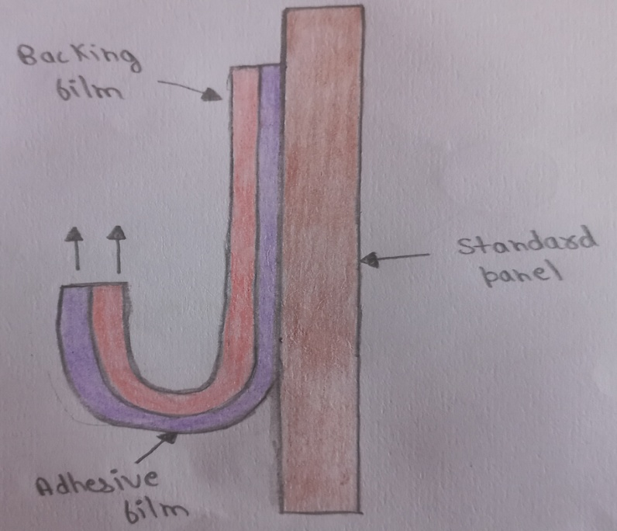

**Figure 10**: **Peel adhesion test**

* + 1. **Tack properties**

The capacity of a polymer to stick to a substrate by using little contact pressure is known as tack.

Tests to determine tack properties are as follows:-

* **Thumb tack test**: Pressing the thumb into the adhesive is how this subjective test is evaluated. (Udell et al., 2012)
* **Rolling Ball Tack Test**: The evaluation measures the amount of time a ball made of stainless steel travels on an upward-facing adhesive. A ball that travels farther suggests that the adhesive used is less sticky.

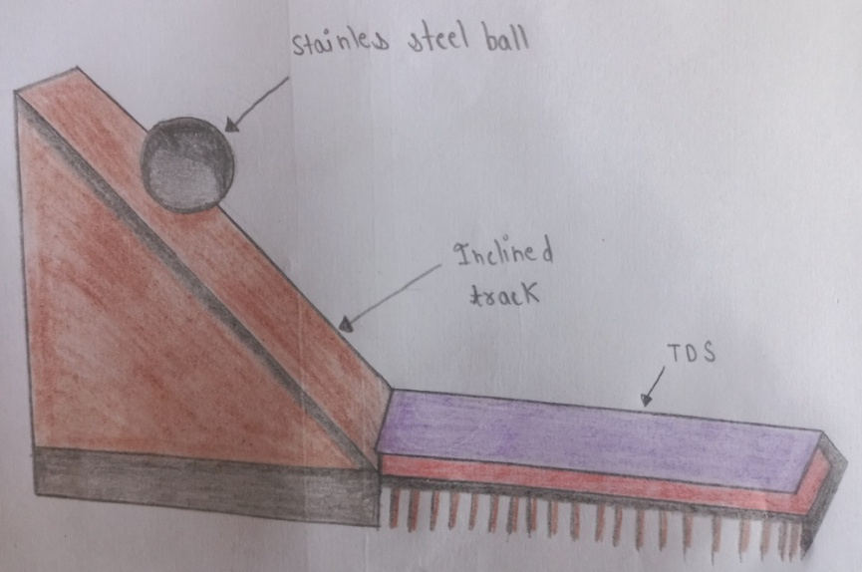

**Figure 11:** **Rolling Ball Tack Test**

* **Quick stick test**: By removing the tape (the adhesive layer) from the substrate (the stainless steel plate) at a pace of 12 inches per minute, the peel force needed for breaking the bond among the adhesive as well as the substrate is measured.
* **Probe Tack Test:** The force needed to remove the probe from the adhesive layer at a set rate is measured. Grams are used to express it.

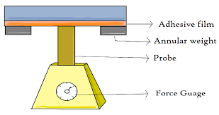

**Figure 12:** **Probe Tack Test**

* 1. **IN VITRO RELEASE STUDIES**

Two aspects of dosage forms that are crucial in explaining its dissolution profile from the controlled-release dosage forms and, therefore, their in vivo performance are their drug release mechanisms & kinetics. Many mathematical models have been created to explain the kinetics of drug dissolution in CRDDS. The drug release rate of TDDS may be found using a variety of techniques. (Tortora & Derrickson, 2018)

* + 1. **The Paddle over Disc**

A transdermal system is fixed to the disc or cell that is sitting at the bottom of a vessel containing medium at 32 ±5°C. Other than that, this approach is the same as the USP paddle dissolving equipment. (Tortora & Derrickson, 2018)

* + 1. **The Cylinder modified USP Basket**

This technique is comparable to an USP basket type dissolving apparatus, with the exception that a hollow cylinder submerged in a liquid at 32 ±5°C has the system connected to its surface. The amount of drug discharged by polymeric transdermal films has a significant impact on the amount of medicine accessible for absorption into the systemic pool. Once the medication reaches the skin's surface, it penetrates the epidermis and travels between its cells via skin appendages to enter the dermal microcirculation.

* + 1. **I n v i t r o skin permeation studies**

A diffusion cell can be used to conduct the in vitro permeation research. The cell is divided into two distinct compartments: donor and receptor. The surface area that is effective of the receptor compartment is 1–5 cm2, with a volume of 5–12 ml. A magnetic bar constantly stirs the diffusion buffer at 600 rpm. Thermostatically heated water is circulated via a water jacket enclosing the receptor compartment to sustain the temperature in the majority of the solution. The appropriate method is used to determine the drug content, and sink condition maintenance is crucial. (Thejaswi et al., 2011)

* 1. **In vivo Studies**

The most accurate representation of a drug's performance comes from in vivo tests. In vivo investigations allow for the comprehensive exploration of factors that are not possible to examine in vitro.

TDDS may be evaluated in vivo using the methods listed below:

* Animal Models
* Human volunteers
  + 1. **Animal models**

Small-scale research with animals are chosen over human subjects because they need less time and funding. The most often utilized animal species for TDDS evaluations include guinea pigs, mice, hairless rats, dogs, and hairless rhesus monkeys. (Chien, 1991)

* + 1. **Human models**

After the patch is applied to human volunteers, the last phase of a transdermal device's development is gathering pharmacokinetic and pharmacodynamic data. Clinical studies have been carried out to evaluate the effectiveness, risk, adverse effects, patient compliance, and other factors. Phase I clinical studies are carried out primarily to figure out volunteer safety, whereas clinical trials in phase II are carried out primarily to determine patient efficacy and short-term safety. Phase IV studies at post-marketing monitoring are carried out for commercialized patches to identify adverse medication responses, whereas phase III trials show safety and efficacy in a wide patient population. (Gaur et al., 2009)

1. **Applications of TDDS**
2. Nicotine transdermal patches, which provide regulated releases of nicotine to aid in quitting tobacco use.
3. For the treatment of angina, nitroglycerine patches are occasionally administered.
4. Transdermal patches are another kind of non-steroidal anti-inflammatory medication, such as ketoprofen and clonidine, which are antihypertensive drugs.
5. In certain cases, menopausal symptoms and postmenopausal osteoporosis are treated using estrogen patches.
6. The contraceptive patch is one of the several transdermal patches used for hormone administration.
7. Two opioid drugs that are frequently used in patch form to treat severe pain 24/7 include: Together with Buprenorphine (Chien, 1991)
8. **TRANSDERMAL MARKET**

Transdermal product sales have been steadily increasing, and this trend is probably going to continue for the near future. Globally, a growing number of TDD medications are still providing patients with significant therapeutic benefits. The table provides comprehensive details on the many medications that are supplied by this route, along with the common names used for their marketing. It also lists the ailments for which each method is intended to be used. (Gordon & Peterson)

**Table 2**: drugs utilized in transdermal patches (Ghulaxe & Verma, 2015),(Chauhan et al., 2019)

|  |  |  |
| --- | --- | --- |
| **Brand name** | **Drug** | **Manufacturer** |
| Alora | Estradiol | TheraTech |
| Androderm | Testosterone | TheraTech/ GSK |
| Climaderm | Estradiol | Wyeth-Ayerest |
| Habitraol | Nicotine | Novartis |
| E-Trans | Fentanyl | Alza Corporation |
| Estraderm | Estradiol | Novartis |
| Nitrodisc | Nitroglycerin | Roberts Pharmaceuticals |
| TransdermScopR | Scopolamine | Alza/Novartis |
| NeuproR | Rigotine | UCB and Schwarz Pharma |
| NuPatch 100 | Diclofenac diethylamine | Zydus Cadila |
| SonoDerm | Insulin | Imarx |
| Sono prep | Peptides | Sontra Medical corporation |
| Transderm nitro | Nitroglycerin | Novartis |
| Nicoderm | Nicotine | GlaxoSmithKline |
| Oxytrol | Oxybutynin | Watson Pharma |
| MatrifenR | Fentanyl | Nycomed |
| NicotinellR | Nicotine | Novartis |
| Chadd | S-caine | ZarsInc |
| Macroflux | Vaccines & Therapeutic proteins | Alza Corporation |
| Powderject | Insulin | Powderject Pharmaceuticals |
| Intraject | Vaccines | Weston medical |
| Testoderm | Testoderm | Alza Corporation |
| SonaPrep | Lidocaine | Echo Therapeutics |
| Catapres-TTS | Clonidine | Alza/Boehinger |
| Climara | Estradiol | 3M Pharmaceuticals/Berlex Labs |
| Deponit | Nitroglycerin | Schwarz-Pharma |
| Duragesic | Fentanyl | alza/Janssen Pharmaceutical |
| Fematrix | Estrogen | Ethical Holdings/Solvay Healthcare Ltd. |
| FemPatch | Estradiol | parke-Davis |
| Nitro-dur | Nitroglycerin | key Pharmaceuticals |

1. **Recent advances in TDDS**

Transdermal delivery is used to provide several therapeutically active compounds, such as patches for pain relief, big proteins, testosterone, and oxybutynin.

* 1. **Patch technology for protein delivery**

One innovative and fascinating delivery technique for big proteins is transdermal delivery. Proteins cannot yet be incorporated into transdermal patches using any commercial technique. TransPharma complements its ViaDerm delivery technique with its special printed patch technology, which allows for transdermal administration of proteins. These printed patches have precise protein dosages in a dehydrated condition. It is hypothesised that the interstitial fluid released from the skin through the RF-Micro Channels dissolves the highly water soluble proteins, generating a highly concentrate protein solution in-situ. The dissolved molecules are subsequently delivered into the skin's living tissues through the RF-Micro Channels, where they diffuse over a sharp concentration gradient. (Prausnitz & Langer, 2008)

* 1. **Testosterone transdermal patch system in young women with spontaneous premature ovarian failure**

About half of the 300 μg of testosterone produced daily by premenopausal women comes from adrenal glands and the other half from the ovaries. When compared to women who ovulate normally, young women having spontaneous premature ovarian failure (SPOF) could have lower amounts of testosterone. To administer the typical ovarian production rate of testosterone, the testosterone transdermal patch (TTP) was created. When TTP was added to cyclic E2/MPA treatment, average free testosterone levels in women with SPOF approached the upper limit of the normal. (Kalantaridou et al., 2005)

* 1. **Pain free diabetic monitoring using transdermal patches**

The patch (about 1 centimeter square) is constructed from metallic thin films and polymers. It is possible to plainly observe the sampling array and the metallic linkages. A localized application of the high-temperature heat pulse that penetrates the stratum corneum can be achieved by utilizing micro-heating devices that are incorporated into the supporting layer of the patch nearest to the skin surface. The skin surface is heated to 130°C for thirty minutes during this ablation procedure. The temperature quickly drops below the skin's surface, having little effect on live tissue or nerve endings. By disrupting a 40–50 μm diameter area in the dead skin layer—roughly the size of a hair follicle—this painless and bloodless procedure enables the fluid called interstitial fluid to interact to the electrode locations on the patch. (Udell et al., 2012)

* 1. **Transdermal Patch of Oxybutynin used in overactive Bladder (OAB)**

In the United States, a patch for transdermal use containing oxybutynin hydrochloric acid (Oxytrol) is approved and in Europe, it is marketed as Kentera. Twice a week, Oxytrol, a transparent, thin, and flexible patch, is put to the belly, hip, or buttocks to provide oxybutynin continuously and consistently over the course of three to four days. With some of the adverse effects associated with an oral formulation, like dry mouth and constipation, Oxytrol provides OAB patients with continuous, efficient bladder control**.** (Homma & Koyama, 2006)

* 1. **Molecular absorption enhancement technology**

The substances known as "absorption enhancers" facilitate the medications' passage through the stratum corneum. Certain phenols and derivatives of terpenes appear to enhance transdermal absorption. (Ahad et al., 2011)

* 1. **Pain relief**

Transdermal patches are a common tool for pain treatment. The majority of readers are familiar with the Duragesic patch. There are a number of others on the market. Lidoderm is a 5% lidocaine patch used to treat postherpetic neuralgia. (Katz et al., 2002)

**CONCLUSION**

Transdermal delivery offers advantages such as improved patient compliance, reduced systemic side effects, and sustained release of medications. Furthermore, advancements in technology have led to the development of innovative TDDS formulations capable of delivering a wide range of drugs, including small molecules, peptides, and biologics. Despite the progress made in TDDS, challenges remain, including skin permeability limitations, formulation stability issues, and variability in drug absorption rates among individuals. Overcoming these challenges requires interdisciplinary collaboration and continued research into novel delivery strategies and materials. Research scientists working on transdermal drug delivery systems will find this article to be a useful resource since it offers detailed information on TDDS and its evaluation method.

**ACKNOWLEDGMENT**

I sincerely thank my supervisor Prof**. (Dr.) Ravinesh Mishra**, Dean of Pharmacy, School of Pharmacy and Emerging Sciences, Baddi University of Emerging Sciences & Technology, for his guidance, help and motivation, and most of all his never-ending support to all my ideas, my success and failures.

**Reference**

1. Adekola, K., Salleh, A., Zaidan, U., Azlan, A., Chiavaro, E., Paciulli, M., & Marikkar, J. (2017). Total phenolic content, antioxidative and antidiabetic properties of coconut (Cocos nucífera L.) testa and selected bean seed coats. Italian Journal of Food Science, 29(4).
2. Ahad, A., Aqil, M., Kohli, K., Sultana, Y., Mujeeb, M., & Ali, A. (2011). Role of novel terpenes in transcutaneous permeation of valsartan: effectiveness and mechanism of action. Drug development and industrial pharmacy, 37(5), 583-596.
3. Akombaetwa, N., Ilangala, A. B., Thom, L., Memvanga, P. B., Witika, B. A., & Buya, A. B. (2023). Current advances in lipid nanosystems intended for topical and transdermal drug delivery applications. Pharmaceutics, 15(2), 656.
4. Ali, H. (2017). Transdermal drug delivery system & patient compliance. MOJ Bioequiv Availab, 3(2), 47-48.
5. Allen Jr, L. V. (1990). Pharmaceutical Dosage Forms and Drug Delivery Systems. In: Oxford University Press.
6. Babaie, S., Del Bakhshayesh, A. R., Ha, J. W., Hamishehkar, H., & Kim, K. H. (2020). Invasome: A novel nanocarrier for transdermal drug delivery. Nanomaterials, 10(2), 341.
7. Benson, H. A., Grice, J. E., Mohammed, Y., Namjoshi, S., & Roberts, M. S. (2019). Topical and transdermal drug delivery: from simple potions to smart technologies. Current drug delivery, 16(5), 444-460.
8. Brahmankar, D., & Jaiswal, S. B. (2019). Biopharmaceutics and pharmacokinetics. Vallabh prakashan.
9. Bw, B. (1998). The Lpp Theory of Skin Penetration Enhancement. Maturitas, 29, 165-185.
10. Chauhan, L., Thakur, P., & Sharma, S. (2019). Microemulsions: New vista in novel drug delivery system. Innov Pharm Pharmacother, 7(2), 37-44.
11. Chein, Y. W. (1987). Transdermal controlled systemic medication. New York and Basel, Marcel Dekkar Inc, 159-176.
12. Chen, X., Zhu, L., Li, R., Pang, L., Zhu, S., Ma, J., Du, L., & Jin, Y. (2020). Electroporation-enhanced transdermal drug delivery: Effects of logP, pKa, solubility and penetration time. European journal of pharmaceutical sciences, 151, 105410.
13. Cheng, T., Tai, Z., Shen, M., Li, Y., Yu, J., Wang, J., Zhu, Q., & Chen, Z. (2023). Advance and challenges in the treatment of skin diseases with the transdermal drug delivery system. Pharmaceutics, 15(8), 2165.
14. Chickering, D. E., Lehr, C.-M., & Mathiowitz, E. (1999). Bioadhesive Drug Delivery Systems: Fundamentals, Novel Approaches, and Development. Marcel Dekker.
15. Chien, Y. (1991). Novel drug delivery systems. (No Title).
16. DebMandal, M., & Mandal, S. (2011). Coconut (Cocos nucifera L.: Arecaceae): in health promotion and disease prevention. Asian Pacific journal of tropical medicine, 4(3), 241-247.
17. Dhal, S., Gavara, R. R., Pal, K., Banerjee, I., Mishra, M., & Giri, S. (2020). Facile transdermal delivery of upconversion nanoparticle by iontophoresis-responsive magneto-upconversion oleogel. Nano Express, 1(1), 010012.
18. Dhiman, S., Singh, T. G., & Rehni, A. K. (2011). Transdermal patches: a recent approach to new drug delivery system. Int J Pharm Pharm Sci, 3(5), 26-34.
19. Divyesh, P., Nirav, P., Meghal, P., & Navpreet, K. (2011). Transdermal drug delivery system: Review. Int J Biopharm Tox Res, 1, 61-80.
20. Foco, A., Hadziabdić, J., & Becić, F. (2004). Transdermal drug delivery systems. Medicinski Arhiv, 58(4), 230-234.
21. Gaur, P., Mishra, S., Purohit, S., & Dave, K. (2009). Transdermal drug delivery system: a review. Asian Journal of pharmaceutical and clinical Research, 2(1), 14-20.
22. Ghafourian, T., Zandasrar, P., Hamishekar, H., & Nokhodchi, A. (2004). The effect of penetration enhancers on drug delivery through skin: a QSAR study. Journal of controlled release, 99(1), 113-125.
23. Ghulaxe, C., & Verma, R. (2015). A review on transdermal drug delivery system. The Pharma Innovation, 4(1, Part A), 37.
24. Gordon, R. D., & Peterson, T. A. Transdermal Drug Delivery. Drug Delivery Technology. www. Drugdeliverytechnology. Com.
25. Gupta, I., & Chokshi, M. (2011). Transdermal drug delivery system: an overview. Asian J Pharm Sci. Clinical Res, 1(1), 25-43.
26. Hadgraft, J., & Lane, M. E. (2006). Passive transdermal drug delivery systems: recent considerations and advances. American Journal of Drug Delivery, 4, 153-160.
27. Homma, Y., & Koyama, N. (2006). Minimal clinically important change in urinary incontinence detected by a quality of life assessment tool in overactive bladder syndrome with urge incontinence. Neurourology and Urodynamics: Official Journal of the International Continence Society, 25(3), 228-235.
28. Jain, N. K. (1997). Controlled and novel drug delivery. CBS publishers & distributors New Delhi.
29. Jalwal, P., Jangra, A., Dahiya, L., Sangwan, Y., & Saroha, R. (2010). A review on transdermal patches. The Pharma Research, 3, 139-149.
30. Jeong, W. Y., Kwon, M., Choi, H. E., & Kim, K. S. (2021). Recent advances in transdermal drug delivery systems: A review. Biomaterials research, 25(1), 24.
31. Kalantaridou, S. N., Calis, K. A., Mazer, N. A., Godoy, H., & Nelson, L. M. (2005). A pilot study of an investigational testosterone transdermal patch system in young women with spontaneous premature ovarian failure. The Journal of Clinical Endocrinology & Metabolism, 90(12), 6549-6552.
32. Kandavilli, S., Nair, V., & Panchagnula, R. (2002). Polymers in transdermal drug delivery systems. Pharmaceutical technology, 26(5), 62-81.
33. Karande, P., Jain, A., Ergun, K., Kispersky, V., & Mitragotri, S. (2005). Design principles of chemical penetration enhancers for transdermal drug delivery. Proceedings of the National Academy of Sciences, 102(13), 4688-4693.
34. Katz, N. P., Gammaitoni, A. R., Davis, M. W., & Dworkin, R. H. (2002). Lidocaine patch 5% reduces pain intensity and interference with quality of life in patients with postherpetic neuralgia: an effectiveness trial. Pain Medicine, 3(4), 324-332.
35. Keleb, E., Sharma, R. K., Mosa, E. B., & Aljahwi, A.-A. Z. (2010). Transdermal drug delivery system-design and evaluation. International journal of advances in pharmaceutical sciences, 1(3).
36. Kumar, J. A., Pullakandam, N., Prabu, S. L., & Gopal, V. (2010). Transdermal drug delivery system: an overview. Int J Pharm Sci Rev Res, 3(2), 49-54.
37. Lee, S. Y., Kang, M. S., Jeong, W. Y., Han, D.-W., & Kim, K. S. (2020). Hyaluronic acid-based theranostic nanomedicines for targeted cancer therapy. Cancers, 12(4), 940.
38. Monti, D., Saettone, M., Giannaccini, B., & Galli-Angeli, D. (1995). Enhancement of transdermal penetration of dapiprazole through hairless mouse skin. Journal of controlled release, 33(1), 71-77.
39. Mujoriya, R., & Dhamande, K. (2011). Review on transdermal drug delivery system. Res J Sci Tech, 3(4), 227-231.
40. Nagadev, C., Rao, M., Venkatesh, P., Hepcykalarani, D., & Prema, R. (2020). A review on transdermal drug delivery systems. Asian Journal of Research in Pharmaceutical Science, 10(2), 109-114.
41. Naik, A., Pechtold, L. A., Potts, R. O., & Guy, R. H. (1995). Mechanism of oleic acid-induced skin penetration enhancement in vivo in humans. Journal of controlled release, 37(3), 299-306.
42. Nikam, N. M., & Nikam, D. N. (2021). Journal Of Pharmacy And Experimental Medicine.
43. Park, J., Lee, H., Lim, G.-S., Kim, N., Kim, D., & Kim, Y.-C. (2019). Enhanced transdermal drug delivery by sonophoresis and simultaneous application of sonophoresis and iontophoresis. Aaps PharmSciTech, 20, 1-7.
44. Patel, D., Patel, M., Patel, K., Patel, B., & Patel, P. (2012). Transdermal patches: a complete review on transdermal drug delivery system. Int. J Pharm Res. Scholars, 1(1), 55-71.
45. Prausnitz, M. R., & Langer, R. (2008). Transdermal drug delivery. Nature biotechnology, 26(11), 1261-1268.
46. Raghuraman, S., Velrajan, G., Ravi, R., Jeyabalan, B., Johnson, D. B., & Sankar, V. (2002). Design and evaluation of propranolol hydrochloride buccal films. Indian journal of pharmaceutical sciences, 64(1), 32-36.
47. Reddy, K. R., Mutalik, S., & Reddy, S. (2003). Once-daily sustained-release matrix tablets of nicorandil: formulation and in vitro evaluation. Aaps PharmSciTech, 4, 480-488.
48. Seah, B. C.-Q., & Teo, B. M. (2018). Recent advances in ultrasound-based transdermal drug delivery. International journal of nanomedicine, 7749-7763.
49. Shaila, L., Pandey, S., & Udupa, N. (2006). Design and evaluation of matrix type membrane controlled Transdermal drug delivery system of nicotin suitable for use in smoking cessation. Indian Journ. Pharm. Sci, 68(2), 829-831.
50. Sharma, N., Parashar, B., Sharma, S., & Mahajan, U. (2012). Blooming pharma industry with transdermal drug delivery system. Indo Global J Pharm Sci, 2(3), 262-278.
51. Shinde, N., Manikpuriya, S., & Sanap, G. (2023). REVIEW OF TRANSDERMAL DRUG DELIVERY SYSTEM.
52. SHINGADE, G. M. (2012). Review on: recent trend on transdermal drug delivery system. Journal of Drug Delivery and Therapeutics, 2(1).
53. Singh, J., Tripathi, K., & Sakya, T. (1993). Effect of penetration enhancers on the in vitro transport of ephedrine through rat skin and human epidermis from matrix based transdermal formulations. Drug development and industrial pharmacy, 19(13), 1623-1628.
54. Singh, M. C., Naik, A. S., & Sawant, S. (2010). Transdermal drug delivery systems with major emphasis on transdermal patches: A review. J Pharm Res, 3(10), 2537-2543.
55. Szunerits, S., & Boukherroub, R. (2018). Heat: a highly efficient skin enhancer for transdermal drug delivery. Frontiers in bioengineering and biotechnology, 6, 15.
56. Tanwar, H., & Sachdeva, R. (2016). Transdermal drug delivery system: A review. International journal of pharmaceutical sciences and research, 7(6), 2274.
57. Thejaswi, C., Rao, K., Gobinath, M., Radharani, J., Hemafaith, V., & Venugopalaiah, P. (2011). A review on design and characterization of proniosomes as a drug carrier. Int. J Advances Pharm Nanotechnology, 1(1), 16-19.
58. Tortora, G. J., & Derrickson, B. H. (2018). Principles of anatomy and physiology. John Wiley & Sons.
59. Udell, J. A., Scirica, B. M., Braunwald, E., Raz, I., Gabriel Steg, P., Davidson, J., Hirshberg, B., & Bhatt, D. L. (2012). Statin and aspirin therapy for the prevention of cardiovascular events in patients with type 2 diabetes mellitus. Clinical cardiology, 35(12), 722-729.
60. Verma, D. D., Verma, S., Blume, G., & Fahr, A. (2003). Particle size of liposomes influences dermal delivery of substances into skin. International journal of Pharmaceutics, 258(1-2), 141-151.
61. Walters, K. (1996). Transdermal drug delivery systems. Swarbrick J, Boylan JC. Encyclopedia of pharmaceutical technology, 15, 253-286.
62. Wang, Y., Zeng, L., Song, W., & Liu, J. (2021). Influencing factors and drug application of iontophoresis in transdermal drug delivery: an overview of recent progress. Drug delivery and translational research, 1-12.
63. Yadav, V. (2012). Transdermal drug delivery system. International journal of pharmaceutical sciences and research, 3(2), 376.
64. Zaid Alkilani, A., McCrudden, M. T., & Donnelly, R. F. (2015). Transdermal drug delivery: Innovative pharmaceutical developments based on disruption of the barrier properties of the stratum corneum. Pharmaceutics, 7(4), 438-470.