**Regenerative Braking System for self-reliant India**

**Dr. (Mrs.) Shubhrata Nagpal1Anubhav Bhatt2**

1. ***Professor, Mechanical Engineering Department, Bhilai Institute of Technology, Durg, Chhattisgarh (shubhrata.nagpal@bitdurg.ac.in)***
2. ***UG scholar from Bhilai Institute of Technology, Durg, Chhattisgarh***

**Abstract:**

*We are slowly reaching the age of electric vehicles. Electric cars are being adopted world-wide as it does not produce any tailpipe emission and gives great efficiency. The major issue faced by the electric vehicles is the battery charging time and lack of charging stations. This papers deals with this problem via regenerative braking system. This braking system will allow a vehicle to generate electrical energy each time brakes are applied. This will improve the battery efficiency by 16%-25%. This paper also deals with how India has also put its steps into this market creating employment, improving economy and implementing 'Make in India' initiative.*

**Keywords**: *Regenerative Braking, Electric vehicles, battery charging*

**1. Introduction:**

*Conventional braking system* use friction to counteract the forward momentum of moving car. When any vehicle moves in any direction it carries with it some amount of Kinetic energy. As soon the brakes are applied by applying pressure, break pad rub against the wheel’s lining. This rubbing of brake pads to the wheel lining cause friction which creates excessive heat. This heat energy dissipates into the air wasting up to 30% of the car’s generated power.

As *Law of conservation of Energy* says **“**Energy can neither be created nor be destroyed by can only be converted from one form to another.” This is the base principle on which regenerative braking system is build.

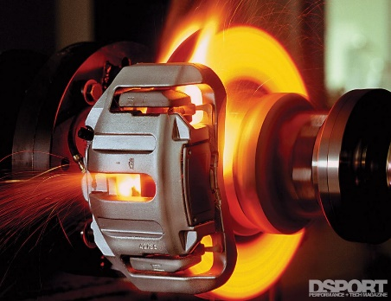

Figure 1. Heat in conventional braking

*Regenerative Braking system (RBS):* Regenerative braking is an energy recovery mechanism. This braking mechanism slows down a moving vehicle or object by converting its kinetic energy into a form that can be either used immediately or stored until needed. As electric cars are revolutionizing the automobile sector, most important issue faced be electric vehicles is battery efficiency and charging system. RBS can solve this issue with a less impact by future research in this field can increase its efficiency.

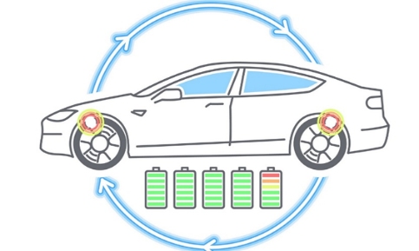

Figure 2

**2. Methodology:**

Regenerative braking is the braking mechanics in which as soon as the breaks are applied the kinetic energy stored in the vehicle due to acceleration is converted into electrical energy, at this time the motors of the vehicle act as the generator.

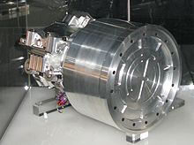

Figure 3. Regenerative braking system

Regenerative braking system consist of 5 major components:

a) Brake drums

b) Brake pedal

c) Brake lining

d) DC motor/generator

e) Linking mechanism

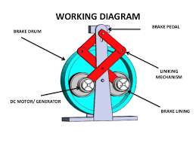

Figure 4. Parts of RBS

**2.1 Working:**

RBS undergoes two mechanism during the course of movement of vehicle

a) Acceleration: As regenerative braking is used in electric vehicles, primary fully electric vehicles and hybrid electric vehicles. The major source of power for these vehicles is the battery which converts electrical energy to mechanical energy via the instructions from the control system. For hybrid electric vehicles some of the power source is also generated from the engine which converts chemical energy form the combusted fuel into mechanical energy. Both these power sources help motors of the vehicle to gain positive torque which helps in the motion of the vehicle.

b) Braking: As the brakes are applied the motion of the motor gets reversed which helps motor to generate negative torque. At this time the motor acts as a generator converting the, mechanical energy to electrical energy. During this process in the hybrid vehicles the supply from the engine cuts off and the electrical energy is thus fed in the car batteries and can be stored for any other use.

For storing this electrical energy *electrical storage unit* is installed which has two primary function. First, to recover the stored braking energy and Second, to absorb the access engine energy during the light mode operations. The selection criteria for an effective energy storage includes high specific energy storage density, high energy transfer rate and small space requirement.

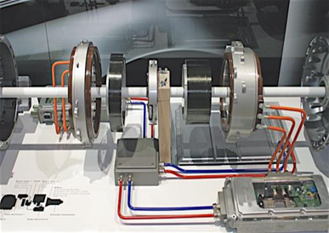

Figure 5. Regenerative braking system

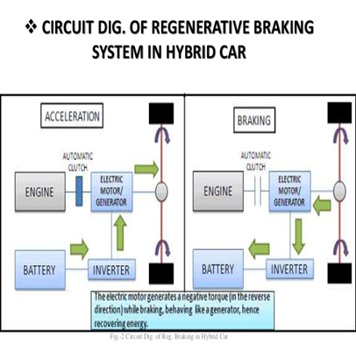



**2.2 Control system of RBS:**

An ON-OFF engine control system is used which means that engine is on until the energy storage unit has been reached desired charge capacity and then is decoupled and stopped until the energy storage unit charge fall below its minimum requirement. Brake controllers are the electronic device that can control brakes remotely, deciding when braking begins and how quickly the brakes need to be applied. During the braking operations the brake controller directs the electricity produced by the motor into the batteries or capacitors.

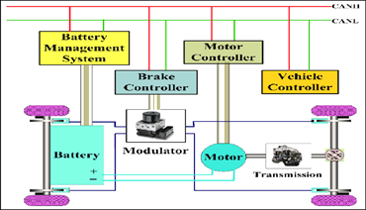



**3. Social impact:**

There are many ways through which Regenerative Braking can help society. Clearly RBS converts great amount of lost heat energy into electrical energy. This will reduce the range anxiety to a great level which will promote more and more people to go towards electric vehicles. As in Hybrid and electric cars there will be very less or no tail-pipe emissions, due to this environment would be much cleaner as decrease in CO2 level will maintain the balance in the environmental functioning. Also the society would be much healthier as atmosphere will have less amount of CO2 level. This will help in decreasing cardiovascular decreases and many more health issues. And many more….

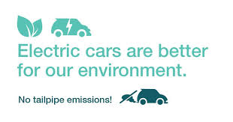

Figure 8. Zero CO2 emission in EVs

**4. Conclusion:**

Regenerative braking is an effective method of improving vehicle efficiency and longevity. India has started the Initiative of using these regenerative Braking as proposed by the Railway Ministry, the concept involving the energy-efficient regeneration system was put into shape by BHEL in a 5,000 HP WAG-7 electric locomotive. Regenerative Braking is one of key features of powertrain of Electric and Hybrid Vehicles like Roadster, Mahindra E20, and Toyota Prius etc…

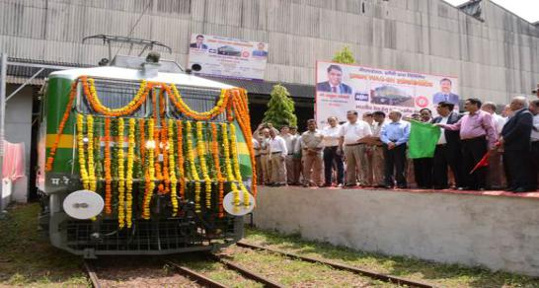

Figure 9. BHEL's WAG-7

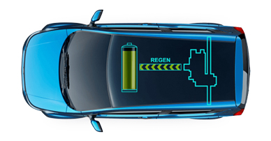

Figure 10. Mahindra E20 graphic

Concept of Electric Vehicles is India is to be developed. Range anxiety and battery charging system is big reason why electric cars are not being taken as an option. But Regenerative Breaking can help gaining boost in this market and youth and Engineers of India can conquer this market by proposing new model and better Designs for Electric Vehicles. This will help India to boost up the economy and create employment.

**5. References:**

1. Regenerative Braking-Methods to Efficiently Use Regenerated Energy (by Priya Sharma M.Tech, G.H Raisoni College of Engineering, Nagpur, India): https://www.hilarispublisher.com/open-access/regenerative-brakingmethods-to-efficiently-use-regenerated-energy-2332-0796-1000146.pdf

EDX Electric cars professional course <https://www.edx.org/professional-certificate/delftx-electric-cars>

Wikipedia <https://en.wikipedia.org/wiki/Regenerative_brake>

Figure 1. https://dsportmag.com/the-tech/education/brake-tech-201-understanding-upgrades/

Figure2.https://www.automotive-iq.com/autonomous-drive/articles/regenerative-braking-in-an-electrifiedautonomous-landscape

2 <http://auto.howstuffworks.com/auto-parts/brakes/brake-types/regenerative-braking.html>

<http://www.hybridcars.com/components/regenerative-braking.html>

<http://www.hybridcars.com/related-technologies/hydraulic-hybrids.html>

https://www.slideshare.net/divyanshu2k/regenerative-braking-system-32602945

Figure 3. https://en.wikipedia.org/wiki/File:Flybrid_Systems_Kinetic_Energy_Recovery_System.jpg

Figure 4. https://www.slideshare.net/pascalfelix/regenerative-braking-system-91636665

Figure 5. https://www.brakeandfrontend.com/regenerative-braking-service/

Figure 6. https://cecas.clemson.edu/cvel/auto/systems/regenerative_braking.html

Figure7.<https://www.researchgate.net/figure/Scenario-diagram-of-the-regenerative-braking-system_fig1_258177739>

3 Figure8.<https://hi-in.facebook.com/pugetsoundenergy/photos/driving-an-electric-car-drastically-reduces->your-carbon-emissions-no-tailpipe-no/2442895409071281/

4 <http://www.railway-technical.com/brake1.shtml>

<http://cleantech.com/news/4201/delhi-metro-earns-carbon-credits-re>

Figure9. https://energy.economictimes.indiatimes.com/news/power/bhel-develops-regenerative-system-for-indian-railways-electric-locomotives/67898198

Figure10. https://www.mahindraelectric.com/vehicles/e2oPlus/