**Smart Agriculture Utilising IOT-Powered Soil Nutrient Analysis and Crop Recommendation Model.**

Prabhavathi Krishnegowda

*Assistant Professor*

*Department of ECE,*

*BGS Institute of Technology,*

*Adichunchanagiri University,*

B. G. Nagara, Karnataka, India.

pdevimtech@gmail.com.

Gagan C G

*UG Student,*

*Department of ECE,*

*BGS Institute of Technology,*

*Adichunchanagiri University,*

B. G. Nagara, Karnataka, India.

Gagancg52@gmail.com.

Lokesh K V

*UG Student,*

*Department of ECE,*

*BGS Institute of Technology, Adichunchanagiri University,*

B. G. Nagara, Karnataka, India. Lokeshgowdakv999@gmail.com.

Harsha M V

*UG Student,*

*Department of ECE,*

*BGS Institute of Technology, Adichunchanagiri University,*

B. G. Nagara, Karnataka, India. Gowdaharshan8@gmail.com.

Chandu A S

*UG Student,*

*Department of ECE,*

*BGS Institute of Technology, Adichunchanagiri University,*

B. G. Nagara, Karnataka, India. cg0796020@gmail.com.

*Abstract*— **Smart agriculture is a system approach to farming. To be viable, both economic and environmental benefits must be considered, as well as the practical questions of field-level management and the needed alliances to provide the infrastructure for technologies. Farmers usually are aware that their fields have variable yields across the landscape. These variations can be traced to management practices, soil properties and/or environmental characteristics. Soil characteristics that affect yields include texture, structure, moisture, organic matter, nutrient status and landscape position. Environmental characteristics are also important which include weather, weeds, insects and disease. Smart agriculture can address both economic and environmental issues that surround production agriculture today. It is clear that many farmers are at a sufficient level of management that they can benefit from precision management. While the question of cost-effectiveness and optimal uses of current technology capabilities remain, the idea of "doing the right thing in the right place at the right time" has a compelling intuitive appeal. The ability to locate the knowledge required to direct the new technologies quickly and effectively will ultimately determine how successful smart agriculture is.**

# Introduction

An important factor in the growth of any nation's economy is the agriculture sector. Food and crop production are crucial due to the world's rapid population growth. Thus, there have been numerous technological advancements in this field. Crop production and storage can be done in a variety of ways. We view smart farming as having access to the Internet of Things, smart technology, artificial intelligence, and automated devices. These technologies can occasionally be expensive and require specialised knowledge to implement. A big component of agriculture is precision farming, where data transfer technology is essential. Soil testing, either in a laboratory or using sensors, can be used to determine the minerals in the soil. The utilisation of several sensors makes it possible to get real-time data.

For better cropping, we need to identify crops that are suggested for a given field. Improved crop forecast and yield can be achieved by addressing several elements such as soil qualities, weather patterns, water availability, soil temperature, sunlight, wind, pollution levels, and so on. Soil parameters such as phosphorus (P), nitrogen (N), and potassium (K), as well as pH value, temperature, moisture, water level, and water pollution, should be measured area-wise using sensors. The selection of crops based on their optimal requirements is made possible by these data. However, in order to manage these sensors, we need to pay a lot of money and have a lot of experience. Periodic maintenance is also necessary.

Precision agriculture now depends on the correct integration of IoT sensors, mobile devices, cloud computing, and data analysis. To further enhance agriculture's sustainability, technology also need to align with the expertise and

experience of farmers. The properties of the soil and the availability of its minerals fluctuate somewhat throughout time. As a result, real-time data will provide predictions for particular domains with more accuracy than offline datasets based on geographic locations. Thus, a strategy to greatly increase the significance of real-time data investigations is needed. Periodic real-time data must be methodically stored in the cloud.

# Literature survey

Akhter, R.; Sofi, S.A. Precision agriculture with machine learning and IoT data analytics. Saud Univ.-J. King, ComputeScience.2021,34,5602–5618.   
In the field of smart farming, machine learning and the Internet of Things are highly significant. The farmer must overcome a number of obstacles to put them into practice, one of which is the forecast of crop disease. Apple scab is the most prevalent pathogen affecting apple crops. An author presented a methodology for gathering real-time data and early disease prediction that consists of IoT nodes with WSN strewn around apple orchards. He also talked about the many difficulties farmers encountered when managing the hardware units and sensors because of external environmental influences.

Srivastava, G.; Ahmed, U.; Lin, J.C.W.; Djenouri, Y. An algorithm for recommending nutrients to fertilise soil using evolutionary computation. Electronic Agriculture Compute. 2021,189,106407.   
The qualities of the soil are crucial in preserving its fertility; as farming causes the soil's nutrition level to decline annually, this is an appropriate strategy to use in order to maximise soil fertility and boost crop yields.

Sivakumar, R., Kathiravan, S.; Muthuraja, S.; Biswajita, M.; Madhumathi, A.; Prabhadevi, B.; Velvizhi, G. Applications of Machine Learning and the Internet of Things for Intelligent Precision Agriculture. Intech Open: London, UK, 2022; In IoT Applications Computing, p. 135.   
Practically every stage of precision farming involves the use of sensors. The author then went into detail about several sensors that are used to measure soil moisture, pH, humidity, water level, and mineral deficiencies in the soil. Thus, we may use sensor technology to raise the level of agricultural product output. Consequently, it enhances crop profitability, food safety, and soil quality. Here, a writer offers a comprehensive model that illustrates the use of sensors and machine learning at every level, including crop health management, fertiliser management, water management, and crop selection.

"Efficient IoT system for Precision Agriculture," G. Suciu, I. Marcu, C. Balaceanu, M. Dobrea, and E. Botezat, 2019 15th International Conference on Engineering of Modern Electric Systems (EMES), Oradea, Romania, 2019, pp. 173-176,doi:10.1109/EMES.2019.8795102.   
In order to address the effects of population expansion and climate change on farming methods, this article investigates the integration of automation and telemetry systems in precision agriculture. The report, which focuses on irrigation, highlights how the market is interested in completely automated monitoring and automation solutions for crop cultivation that is both economical and energy-efficient. Significant technical impact and marketing potential are shown by the suggested system architecture's low energy usage, scalability, forecasting capabilities, and cost-effective management. The literature review explores comparable work, offering instances such Farm bot and Farm Beats, and talks about the metrics tracked in

irrigation, encompassing evapotranspiration, humidity, and temperature. The paper describes the telemetry and automation solution and presents an efficient design for the energy system. The monitoring systems for agricultural crops' energy efficiency are innovative. The experimental data portion demonstrates the accuracy of a mathematical model by validating the proposed system through measurements of temperature, humidity, and rainfall. In order to maximise crop output, the study's conclusion emphasises the benefits of IoT technology in precision agriculture and stresses the significance of supplying water when needed. Funding for the work is acknowledged under the NETIO project and the subsidiary contract for the Smart Agro project.

"Improving Crop Productivity Through A Crop Recommendation System Using Ensemble Technique," N. H. Kulkarni, G. N. Srinivasan, B. M. Sagar, and N. K. Cauvery, 2018 3rd International Conference on Computational Systems and Information Technology for Sustainable Solutions (CSITSS), Bengaluru, India, 2018, pp. 114-119,doi:10.1109/CSITSS.2018.8768790.   
A suggested crop recommendation system makes use of the machine learning method's ensemble approaches. Using ensemble approaches, a system was constructed that combines the predictions of multiple machine learning techniques to recommend the best crop based on soil types and characteristics for optimal performance. Lagrangian SVM, naive Bayes, and random forest are among the ensemble models.

Kaur, S.; Malik, K. Using Machine Learning Techniques to Predict and Estimate the Major Nutrients of Soil. Pages 539–546 in Soft Computing for Intelligent Systems, Springer,Singapore,2021.   
The link between N-K, N-P, and P-K was discovered by the application of machine learning techniques. It has been found that the p value is highly influenced by the N value in the soil. While there is no significant correlation between the N and K values, the p value has an impact on the K value as well. A model was proposed by one author to assess the interdependency of primary nutrients, also known as the most important nutrients found in soil, namely nitrogen (N), phosphorus (P), and potassium (K), and to determine the impact of N concentrations on another major nutrient in the soil.

"Kernel-based fuzzy C-means clustering based on fruit fly optimisation algorithm," Q. Wang, Y. Zhang, Y. Xiao, and J. Li, 2017 International Conference on Grey Systems and Intelligent Services (GSIS), Stockholm, Sweden, 2017, pp. 251-256,doi:10.1109/GSIS.2017.8077713.   
The data in which the FFO is applied for optimisation was classified using a kernel-based C-mean clustering algorithm, and it has been found that this enhances the clustering performance.

"Kernel-based fuzzy C-means clustering based on fruit fly optimisation algorithm," Q. Wang, Y. Zhang, Y. Xiao, and J. Li, 2017 International Conference on Grey Systems and Intelligent Services (GSIS), Stockholm, Sweden, 2017, pp. 251-256,doi:10.1109/GSIS.2017.8077713.   
Hydraulic researchers find that predicting the scour characteristics of ski jump spillways is crucial. A hybrid model was proposed by one author, and it was found to perform better than other approaches when support vector regression and FFO were used.

Bhojani, S.H.; Bhatt, N. Predicting wheat crop yield with novel neural network activation functions. 2020, 32, 13941–13951;Neural Compute.Appl.   
A staple crop in Indian cuisine is wheat. A time series dataset on meteorological parameters from the Gujarat region for the years 1990–1991 and 2016–2017 was analysed by some writers. Numerous neural network activation functions, including sigmoid, Re LU, Soft max, Clog log, Sech, Wave, Root sig, Radial Basis, etc., were used by the author. The author suggested using a multi perception neural network technique in conjunction with the new activation functions Dhara Sig, Dhara Sigma, and SHB Sig to increase the accuracy of wheat production prediction.

Soil analysis and crop forecast Prabhu, S.; Revandekar, P.; Shirdhankar, S.; Paygude, S. 2020, 7, 117–123. Int. J. Sci. Res.Science.Technology. One author concentrated on using soil sample analysis to determine the best crop for a given field. The author collected soil temperature, moisture content, and mineral values using an Arduino board, Computers 2023, 12, 61 5 of 34 ESP 8266 Wi-Fi module, and additional sensors before storing them in the cloud. Using the rainfall dataset, the algorithms naive Bayes, logistic, and C 4.5 were tested. It was found that C 4.5 had the highest accuracy, at 85.07%.

# III. Proposed methedology

The suggested approach, which uses IoT to enable soil nutrient measurement and crop suggestion in smart agriculture, includes a number of essential phases. IoT sensors would first be positioned thoughtfully around the agricultural area to collect data in real-time on a variety of characteristics, including temperature, nutrient content, pH levels, and soil moisture. Then, this information would be sent via wireless protocols like NB-IoT or LoRa WAN to a central database or cloud platform. After the data is gathered, machine learning algorithms are used to handle and analyse it. Preprocessing, feature selection, and predictive model training are the methods used to determine the nutrient levels of the soil. A crop recommendation system would be created using this analysed data, accounting for variables including crop nutrient requirements, climate, and past production data. Furthermore, there would be a smooth integration of this recommendation system.

precise agricultural techniques are made possible by fertilisation systems. Lastly, a user-friendly interface, such as a web dashboard or mobile application, would be created to enhance user involvement and decision-making. This interface would show farmers real-time soil data, crop recommendations, and practical insights. Through the use of data-driven insights, this all-encompassing approach seeks to provide farmers with the tools they need to maximise crop +yields, conserve resources, and improve overall farm production within the framework of smart agriculture.

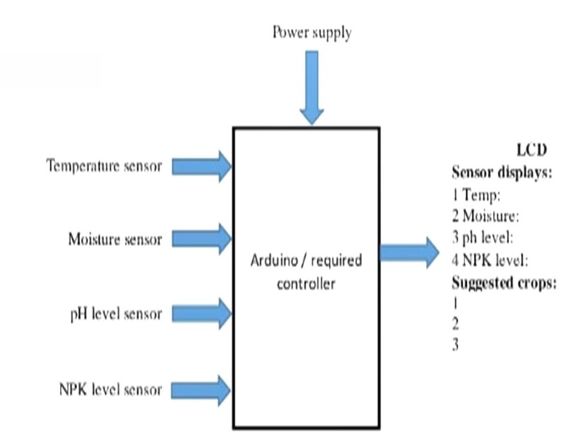

Fig 1: Block diagram

# METHODOLOGY

The system's objectives are to give farmers timely information about the condition of their soil and suggest appropriate crops based on the quantities of nutrients in the soil. The main parts are an embedded system (Arduino with ATmega328P), communication modules, a crop suggestion algorithm, and soil sensors (NPK, temperature, moisture, and pH).   
We can develop a strong IoT solution for smart agriculture by combining this technique and Embedded C programming to build the components as outlined. This would help farmers make informed crop selection decisions based on real-time soil health data.

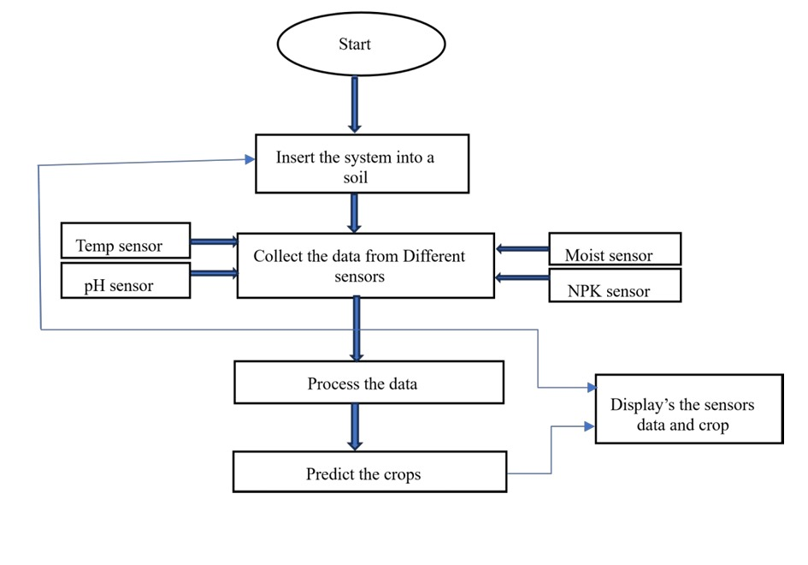

Fig 2: flow chart

# V. RESULT

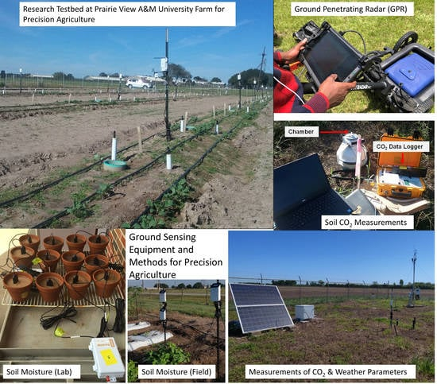

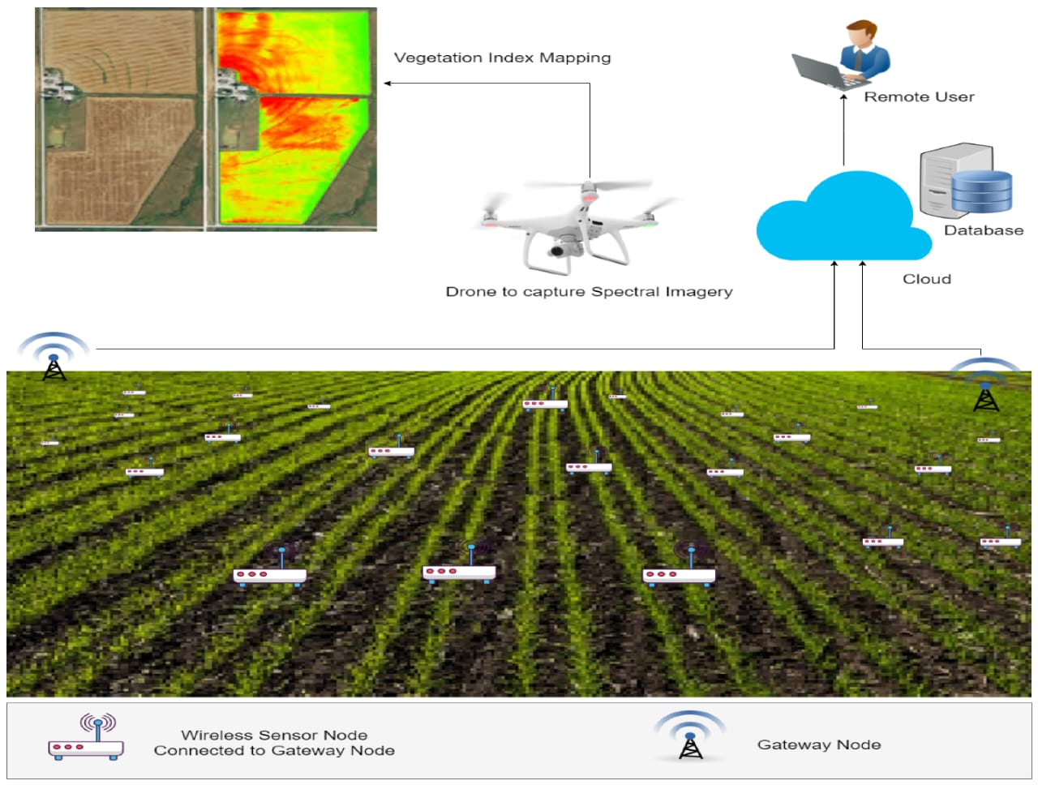

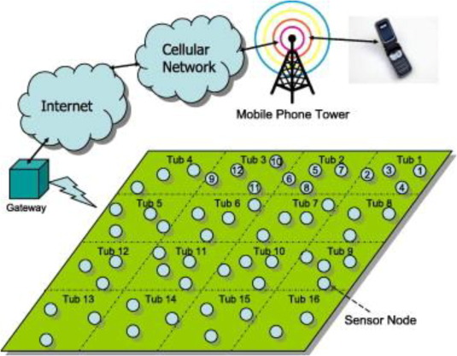

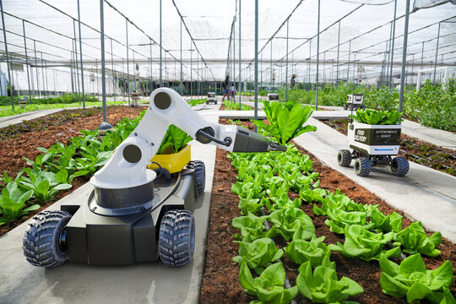

# CONCLUSION

A major progress in precision farming has been made with the creation of an IoT-enabled soil nutrient analysis and crop recommendation model for smart agriculture, powered by the Embedded C programming language. This system is based on an Arduino ATmega328P microcontroller, which is responsible for coordinating the integration of critical sensors, including NPK, temperature, moisture, and pH sensors. Carefully designed to enable exact data collecting from various sensors, the Embedded C code guarantees reliable readings via analogue or digital communication protocols. After that, the Embedded C code handles the gathered data, using algorithms to normalise and decipher sensor readings and give important information like pH, temperature, moisture content, and nutrient levels in the soil.

The crop recommendation algorithm, which is a key component of this innovation, is skilfully implemented in Embedded C. This algorithm takes into account a variety of complex aspects, such as the ideal ranges of nutrients, crop-specific pH requirements, temperature preferences, and moisture requirements. A score is given to each crop according on how well it fits into the current soil conditions. Moreover, various user interfaces such as LCD displays can offer crop recommendations and real-time sensor readings for local monitoring. The communication module's buzzer notifications for audible alerts offer a proactive method of farmer intervention.

The system is prepared for installation in agricultural fields after it has been verified. During this stage, weatherproofing techniques and environmental element protection are taken into account. The result of these efforts is a cutting-edge Internet of Things system that gives farmers access to real-time information about the health of their soil, empowering them to make well-informed decisions about crop choices. In addition to guaranteeing the system's reliable operation, the use of Embedded C programming in this context puts smart agriculture at the forefront of effective and sustainable agricultural techniques.

##### References

1. Akhter, R.; Sofi, S.A. Precision agriculture with machine learning and IoT data analytics. Saud Univ.-J. King, Compute Sci. 2021, 34, 5602–5618.
2. A nutrient recommendation system for soil fertilisation based on evolutionary computation, Ahmed, U.; Lin, J.C.W.; Srivastava, G.; Djenouri, Y. Electronic Agriculture Compute. 2021, 189, 106407.
3. Sivakumar, R., Biswajita, M.; Madhumathi, A.; Muthuraja, S.; Kathiravan, S.; Velvizhi, G.; Prabhadevi, B. Applications of Machine Learning and the Internet of Things for Intelligent Precision Agriculture. Intech Open: London, UK, 2022; In IoT Applications Computing.
4. "Efficient IoT system for Precision Agriculture," 15th International Conference on Engineering of Modern Electric Systems (EMES), Oradea, Romania, 2019, pp. 173-176, Doi: 10.1109/EMES.2019.8795102, G. Suciu, I. Marcu, C. Balaceanu, M. Dobrea, and E. Botezat.
5. "Improving Crop Productivity Through A Crop Recommendation System Using Ensemble Technique," N. H. Kulkarni, G. N. Srinivasan, B. M. Sagar, and N. K. Cauvery, 2018 3rd International Conference on Computational Systems and Information Technology for Sustainable Solutions (CSITSS), Bengaluru, India, 2018, pp. 114-119, Doi: 10.1109/CSITSS.2018.8768790.
6. Predicting and Estimating the Major Nutrients of Soil Using Machine Learning Techniques, Kaur, S., and Malik, K. Pages 539–546 in Soft Computing for Intelligent Systems, Springer, Singapore, 2021.
7. "Kernel-based fuzzy C-means clustering based on fruit fly optimisation algorithm," Q. Wang, Y. Zhang, Y. Xiao, and J. Li, 2017 International Conference on Grey Systems and Intelligent Services (GSIS), Stockholm, Sweden, 2017, pp. 251-256, Doi: 10.1109/GSIS.2017.8077713.
8. Sun, X., Band, S.S.; Mousavi, A.; Bi, Y.; Karami, H.; Naini, S. Ski-jump spillway scour geometry is predicted using a hybrid model that combines the fruit fly optimisation technique with support vector regression. Fluid Mech. Eng. Appl. Compute. 2021, 15, 272-291.
9. Bhojani, S.H.; Bhatt, N. Predicting wheat crop yield with novel neural network activation functions. 2020, 32, 13941–13951; Neural Compute. Appl.
10. Prabhu, S., Revandekar, P., Shirdhankar, S., Paygude, S. Soil analysis and crop prediction. 2020, 7, 117–123. Int. J. Sci. Res. Sci. Technol.