Self-Configuration and Smart Binding Control System for Autonomous Home Applications

Suvarna Aranjo, Krishna Garg, Santhosh Nambirajan, Rohan Talekar, Prithvi Badipuram

*Department of Information Technology, Xavier Institute of Engineering Mahim, Mumbai India*

[suvarna.b@xavier.ac.in](mailto:suvarna.b@xavier.ac.in)

[202003005.krishnagap@student.xavier.ac.in](mailto:202003005.krishnagap@student.xavier.ac.in)

[202003013.santhoshnns@student.xavier.ac.in](mailto:202003013.santhoshnns@student.xavier.ac.in)

[202003016.rohantsk@student.xavier.ac.in](mailto:202003016.rohantsk@student.xavier.ac.in)

[202003039.prithvibhs@student.xavier.ac.in](mailto:202003039.prithvibhs@student.xavier.ac.in)

***Abstract: In* wireless communication, traditional technologies such as Bluetooth and Wi-Fi face persistent challenges related to connectivity, bandwidth, power efficiency, and speed. This project endeavours to overcome these limitations by implementing a self-configuring system based on the Zigbee model. The primary objective is to establish a robust network comprising interconnected Zigbee devices capable of dynamic configuration, optimizing network performance, and adapting to changing conditions within a specified range. The proposed system addresses the shortcomings of conventional wireless technologies by exploring efficient routing algorithms, adaptive channel selection, and power management strategies. By harnessing these elements, the project aims to achieve seamless communication while minimizing energy consumption. The self-configuring Zigbee network serves as a testament to an improved solution for wireless communication in environments where traditional technologies fall short. Through these endeavours, the project not only showcases the feasibility of a self-configuring Zigbee network but also emphasizes its potential to provide reliable and efficient communication. The outcomes of this research contribute to advancing the field of wireless communication, offering a promising alternative for environments that demand adaptability and optimization beyond the capabilities of conventional wireless technologies.**

***Keywords: ZigBee, IOT, Self-Configuration, Smart Binding, Home Automation.***

1. **INTRODUCTION**

The Internet of Things (IoT) has ushered in an era of interconnected devices that seamlessly communicate and collaborate to enhance various aspects of our daily lives. As the number of IoT devices continues to grow exponentially, the challenges of managing their connectivity, configuration, and interaction become increasingly complex. In response to these challenges, the concepts of self-configuration and smart binding control have emerged as pivotal components in creating truly autonomous IoT applications. Self-configuration refers to the ability of IoT devices to autonomously establish their network connections and adjust their operational parameters without the need for manual intervention. Traditionally, configuring IoT devices involved time-consuming and error-prone manual processes, which are not scalable for the vast and diverse IoT ecosystems that exist today. Self-configuration empowers devices to discover their peers dynamically, allocate network addresses, and adapt to changing network conditions for home applications, thereby streamlining deployment and improving system reliability for home applications. Binding control complements self-configuration by focusing on the intelligent management of how IoT devices communicate and collaborate within the network. Rather than using static communication patterns, smart binding control enables devices to adapt their interactions based on contextual cues, performance requirements, and environmental factors. This dynamic approach optimizes resource allocation, minimizes data transmission overhead, and enhances Quality of Service (QoS) metrics, ensuring that IoT applications achieve their desired performance levels while conserving energy and bandwidth. Zigbee is a wireless communication protocol commonly used for creating low-power, short-range wireless networks. It’s designed for applications that require low data rates, low power consumption, and long battery life. Zigbee is particularly well-suited for applications in home automation, industrial control, smart lighting, and sensor networks.

1. **Advantages**

The advantages of implementing self-configuration and smart binding control systems for autonomous home applications.

* Efficiency: Efficiency lies at the heart of modern technological advancements, and in the realm of autonomous home applications, it plays a pivotal role in shaping the effectiveness and sustainability of interconnected systems.
* Adaptability: Adaptability is a crucial characteristic in the design and operation of autonomous home applications. It refers to the ability of IoT systems, devices, and networks to adjust, evolve, and respond effectively to changing conditions, requirements, and environments. In the context of self-configuration and smart binding control, adaptability plays a fundamental role in ensuring the success of IoT deployments.
* Reliability: Reliability is a cornerstone of successful IoT applications, particularly those aiming for autonomy and seamless connectivity. It refers to the consistent and dependable performance of devices, networks, and systems under various conditions.
* Adaptive Communication: Implement smart binding control mechanisms to enable devices to adapt their communication patterns based on contextual information such as network conditions, available resources, and application requirements. This ensures optimal data exchange and minimizes unnecessary network congestion.
* Enhanced Quality of Service (QoS): Improve QoS metrics such as latency, reliability, and throughput by intelligently prioritizing communication and allocating resources to critical tasks. This results in more responsive and dependable IoT applications.

1. **PROBLEM DEFINITION**

The self-configuring system based on the Zigbee model addresses the challenges of connectivity, bandwidth, power efficiency, and speed encountered by traditional Bluetooth and Wi-Fi technologies. The goal of this project is to create a robust network of interconnected Zigbee devices that can dynamically configure themselves to optimize network performance, adapt to changing conditions, and provide reliable wireless communication within a specified range. The system should explore efficient routing algorithms, adaptive channel selection, and power management strategies to ensure seamless communication while minimizing energy consumption. By implementing this self-configuring Zigbee network, the project aims to demonstrate an improved solution for establishing reliable and efficient communication in environments with the ability to self-configure where traditional wireless technologies fall short.

1. **HARDWARE AND SOFTWARE REQUIREMENTS**
2. *Hardware Requirements:*
3. *Arduino Uno Micro-Controller:*

The Arduino Uno is an open-source microcontroller board created by Arduino CC that was initially made available in 2010. It is based on the Microchip ATmega328P microprocessor (MCU). The microcontroller board has sets of digital and analogue input/output (I/O) pins that may be connected to other expansion boards, shields, and other circuits. Using a type B USB connector and the Arduino IDE (Integrated Development Environment), the board may be programmed. Six of its fourteen digital I/O ports may produce pulse width modulation (PWM). Six analogue I/O pins are also present. It may be powered by a USB cable or a barrel connection (such as a rectangular 9-volt battery) that takes voltages between 7 and 20 volts. It shares headers with the Leonardo board and the same microprocessor as the Arduino Nano board.

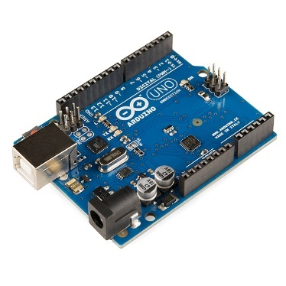

Figure 1: Arduino Uno Micro-Controller

1. *Breadboard:*

Breadboard is an approach to building gadgets without utilizing a fastening iron. Parts are driven into the attachments on the breadboard and afterwards, extra 'jumper' wires are utilized to make associations.

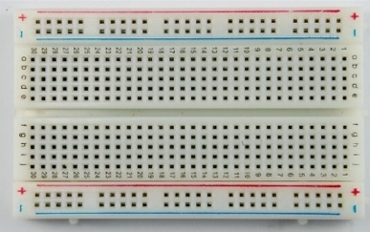

Figure 2: Breadboard.

1. *Other Hardware Components*
2. *Zigbee Adapter*
3. *Micro USB Cable*
4. *Mini USB Cable*
5. *Jumper Wires*
6. *Batteries*
7. Software Requirements:
8. *XCTU*

* XCTU is a free application that works on Windows, MacOS, and Linux.
* Graphical Organization View for straightforward remote organization arrangement and design.
* Programming interface Edge Developer is a straightforward improvement instrument for rapidly constructing XBee Programming interface outlines.
* Users can look through and read firmware release notes with the Firmware Release Notes Viewer.



Figure 3: XCTU Software

1. *Arduino Cloud:*

Arduino Cloud is a stage given by Arduino, a famous open-source gadgets stage given simple to-utilize equipment and programming. Arduino Cloud empowers clients to associate their Arduino sheets with the web and communicate with them from a distance. It makes it easier for makers, hobbyists, and professionals to create connected projects by offering a variety of features that make connecting and managing IoT (Internet of Things) devices simpler.



Figure 4: Arduino Cloud

1. *CupCarbon Simulator:*

CupCarbon is a Wireless Sensor Network (SCI-WSN) simulator for Smart Cities and the Internet of Things. Its goal is to configure, picture, investigate and approve disseminated calculations for checking, ecological information assortment, and so on, and to make natural situations like flames, gas, mobiles, and by and large inside instructive and logical undertakings.



Figure 5: CupCarbon

Not only can it assist scientists in testing their wireless topologies, protocols, and other ideas by providing a visual representation of the fundamental ideas behind sensor networks and how they operate.

1. **MODERN TOOLS**
2. *Zigbee:*

Zigbee is a wireless technology developed as an open global market connectivity standard to address the unique needs of low-cost, low-power wireless IoT data networks. The Zigbee connectivity standard operates on the IEEE 802.15.4 physical board radio specification and operates in unlicensed radio bands including 2.4 GHz, 900 MHz, and 868 MHz

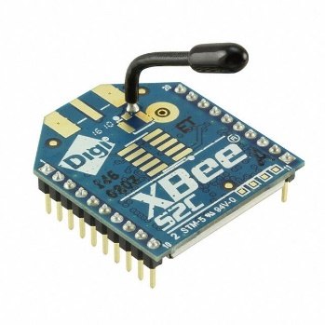

Figure 6: ZigBee.

The specification is a packet-based radio board protocol for products and devices that run on batteries and are inexpensive. The convention permits gadgets to convey information in various organization geographies and can have a battery duration enduring quite a long while.

1. *ZigBee IP:*

With the improvement of the Web of Things, the ZigBee organizing standard, which empowers the insightful activity of organizations, has become progressively important. The Web Designing Team (IETF), the subsidiary of the ZigBee Coalition, has laid out different working gatherings to survey these detecting and control organizations. The quick exhaustion of the addresses of the fourth release of the Web Convention (IPv4), IPv6 tending to, joined with existing IP arrangements for low power detection and control of the Web, appears to address a sensible way forward. Expanding the quantity of organization and security layers and application engineering as expected by the IEEE 802.15.4 norm, the ZigBee Partnership reported the ZigBee IP arrangements concerning new IPv6 tending to innovation in Walk 2013.

1. **ARCHITECTURAL OVERFLOW**

This is the Architecture for the proposed system. Figure Illustrates the various home devices connected through a mesh topology.

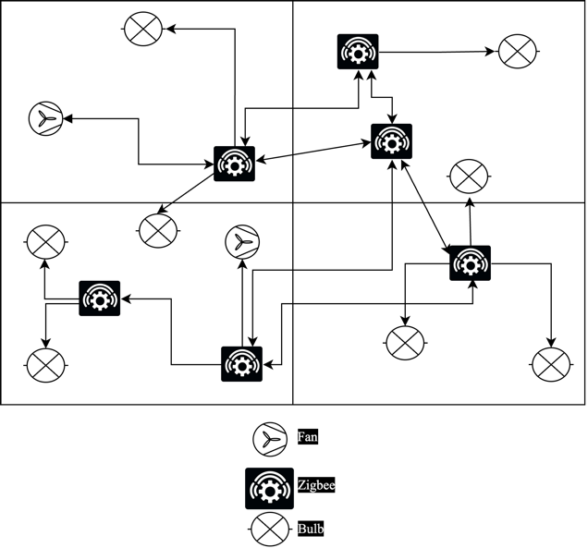

Figure 7: Architecture of Proposed Diagram

* The proposed system above illustrates the architecture of Self-Configuration and Smart Binding Control System for Autonomous Home Applications.
* The process involves connecting various end devices through Zigbee Coordinator and Routers.
* The architecture uses Mesh topology. Among all other topologies Mesh topology is the best suitable for Home Automation because it can self-heal by itself.
* The end devices are connected to the coordinator and configured so that they can self-configure and self-heal themselves.
* The system is tested, optimized for real-time performance, integrated with other components, and deployed.

1. **IMPLEMENTATION METHODOLOGY**

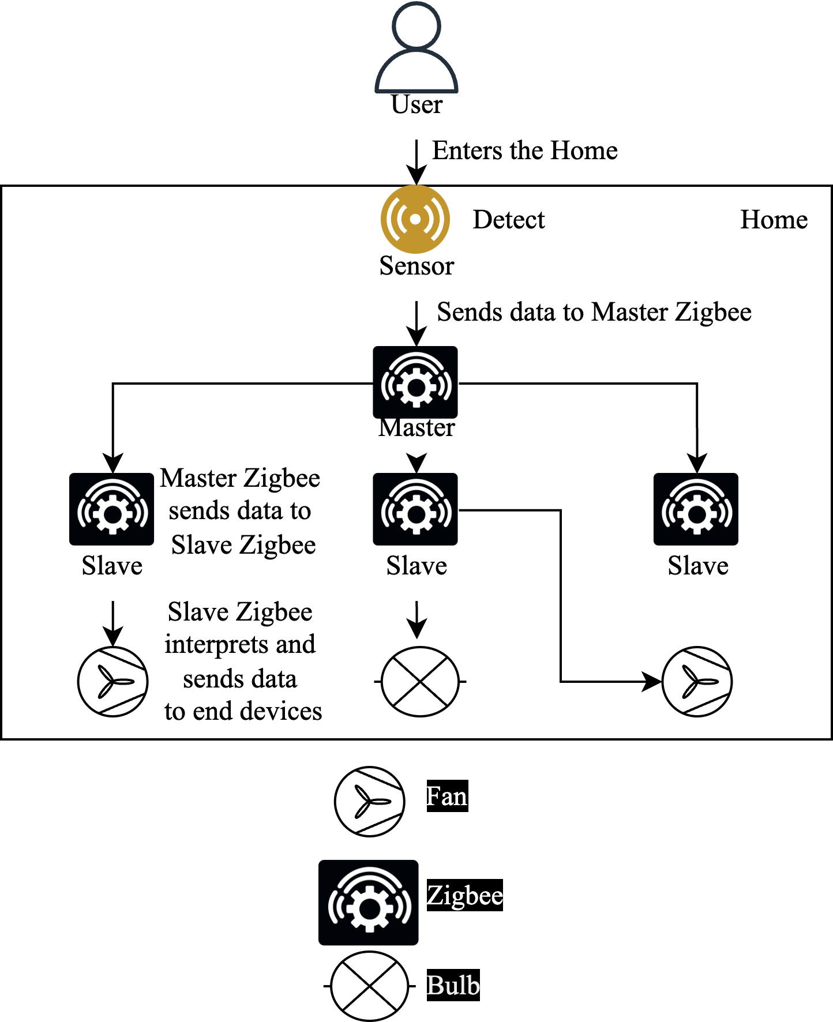

Figure 8: Implementation flow of Self-Configuration and Smart Binding Control System for Autonomous Home Application

1. **RESULTS**

Figure 9: Zigbee Communication

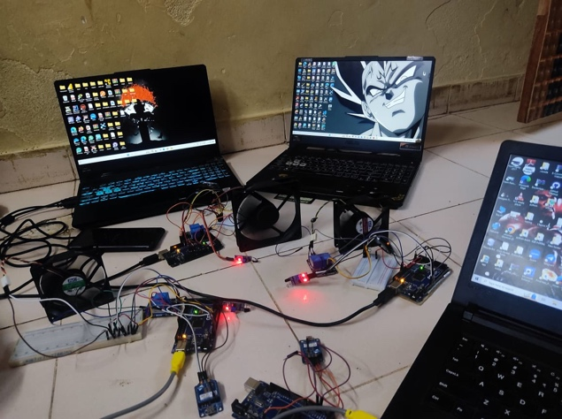

Master Zigbee

End Device

Slave Zigbee

Figure 10: Zigbee Devices connected.

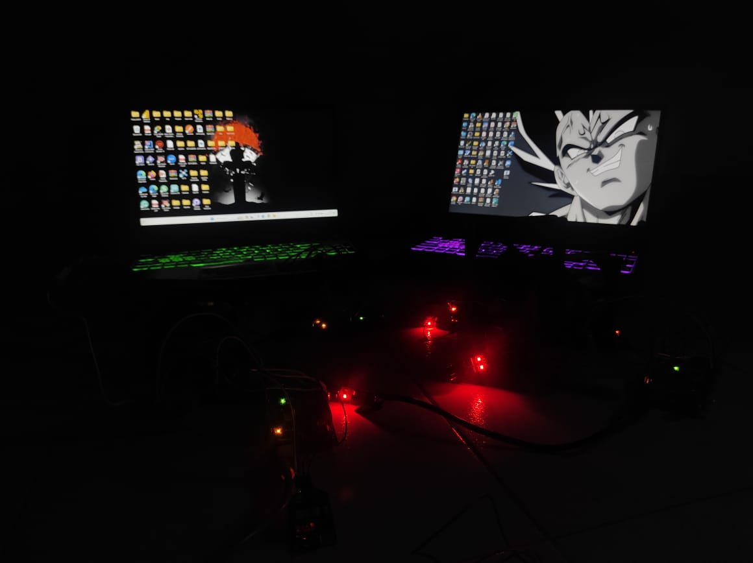

Figure 11: End-device working from data received from slave Zigbee.

This picture demonstrates the communication between two Zigbee i.e., Master and Slave. Similarly, there will be communication between four ZigBee, and they receive and send signals. After sending a signal from the Master Zigbee to the Slave Zigbee, the Slave Zigbee will send the data to the end devices to perform their actions.

1. **CONCLUSION**

Concerning the purchaser market ZigBee-related innovations have existed for quite a while yet are not generally utilized. About shrewd families, for instance, costs, framework establishment and functional intricacy influence shopper acknowledgement. The consistent restricting of remote innovations to a wide range of home machines, end of the unwieldy setting, and making clients feel that utilizing a controller is essentially as basic as utilizing a PDA might give new open doors connected with the IOT. In this work, the 'Self-design and Shrewd restricting Control Framework' is produced for Independent Home Applications.

**REFERENCES**

[1] G. SIDDARTHA and H. RAGHUPATHI, “Iot based self-configuration & smart binding control system.”

[2] W.-K. Hsieh, W.-H. Hsieh, J.-L. Chen, and C.-Y. Lin, “Self-configuration and smart binding control on iot applications,” in 2016 18th International Conference on Advanced Communication Technology (ICACT), 2016, pp. 80–85.

[3] H. Chen, S. Hariri, and F. Rasul, “An innovative self-configuration approach for net-worked systems and applications.” in AICCSA, 2006, pp. 537–544.

[4] A. Konstantinou, D. Florissi, and Y. Yemini, “Towards self-configuring networks,” in Proceedings DARPA Active Networks Conference and Exposition, 2002, pp. 143–156.

[5] D. Weyns, G. S. Ramachandran, and R. K. Singh, “Self-managing internet of things,” in SOFSEM 2018: Theory and Practice of Computer Science: 44th International Conference on Current Trends in Theory and Practice of Computer Science, Krems, Austria, January 29-February 2, 2018, Proceedings 44. Springer, 2018, pp. 67–84.

[6] M.-C. Shie, P.-C. Lin, T.-M. Su, P. Chen, and A. Hutahaean, “Intelligent energy moni- toring system based on zigbee-equipped smart sockets,” in 2014 International Conference on Intelligent Green Building and Smart Grid (IGBSG), 2014, pp. 1–5.

[7] B. Huang, D. Chaki, A. Bouguettaya, and K.-Y. Lam, “A survey on conflict detection in iot-based smart homes,” arXiv preprint arXiv:2310.04447, 2023.

[8] D. Weyns, N. Bencomo, R. Calinescu, J. Camara, C. Ghezzi, V. Grassi, L. Grunske, P. Inverardi, J.-M. Jezequel, S. Malek et al., “Perpetual assurances for self-adaptive sys- tems,” in Software Engineering for Self-Adaptive Systems III. Assurances: International Seminar, Dagstuhl Castle, Germany, December 15-19, 2013, Revised Selected and Invited Papers. Springer, 2017, pp. 31–63.

[9] C. Perera, P. P. Jayaraman, A. Zaslavsky, D. Georgakopoulos, and P. Christen, “Sensor discovery and configuration framework for the Internet of things paradigm,” in 2014  
IEEE World Forum on Internet of Things (WF-IoT). IEEE, 2014, pp.94–99.