“DESIGN AND DEVELOPMENT OF AN RTC BASED RELAY BOARD FOR PRECISION CONTROL OF INDUSTRIAL MOTORS”

Dr. Pravin Tajane (Asst. Professor) Electronics and communication Engineering

Tulsiramji Gaikwad-Patil College of Engineering & Technology Nagpur, India

pravin.ece@tgpcet.com

Prof.Amol Dhenge (Asst. Professor) Electronic and communication Engineering

Tulsiramji Gaikwad-Patil College of Engineering & Technology Nagpur, India

amol.ece@tgpcet.com

Mr.Shashank P. Wankar*

Electronics and communication Engineering

Tulsiramji Gaikwad-Patil College of Engineering & Technology Nagpur, India

shashank20wankar@gmail.com

**Abstract**- An Arduino-based time-regulated electrical apparatus control mechanism undertakes the responsibility of activating and deactivating electric equipment as per a pre-set timetable. This exploration introduces an option to manual switching by elevating technology in a manner that is more secure and more user-efficient. It showcases an integrated clock that updates in real-time, turning the associated device on or off when real-time aligns with the scheduled time. The input control panel enables users to alter the switching schedule at their convenience, while the numeric display illustrates the current time.

**Keywords**: Arduino, Liquid Crystal Display (LCD), Temporal clock, Relay unit, control inputs.

I. INTRODUCTION

We are encompassed by numerous embedded devices, and our everyday life hinges on the proper functioning of these contrivances. Employing handheld devices in our workplace empowers us to carry out tasks efficiently, encompassing activities such as operating televisions, radios, and kitchen appliances. With technological advancements, tasks become more straightforward, and through automation, devices are regulated to diminish human labor in the production of goods and services. A pressing issue in our society pertains to the misuse of electricity and ensuing energy wastage, either intentionally or unintentionally. This initiative endeavors to tackle the aforementioned challenges head-on, aiming to provide effective solutions and pave the way for lasting improvements.

A time-regulated electrical apparatus control mechanism, grounded in Arduino, emerges as the focal point of this endeavor. Initial manual systems imposed precision requirements on individuals, creating a necessity for continuous training and management oversight. The manual approach proved inefficient, requiring considerable effort and physical space. This system, in contrast, is poised to offer accuracy, flexibility, and rapid response times, overcoming the challenges posed by manual systems.

**II. LITERATURE REVIEWS**

The amalgamation of Arduino-based systems for time-regulated electrical apparatus control has garnered considerable attention in contemporary research. Automation, fueled by strides in embedded technology, stands pivotal in amplifying the efficacy and sustainability of daily activities. The literature review delves into key facets concerning the utilization of Arduino in time-based electrical apparatus control systems, underscoring the advantages and advancements in this ddomain.

1.Automation in Daily Existence:-

The reliance on embedded products for daily undertakings, such as operating electronic gadgets, has become widespread. Automation, as emphasized by researchers, simplifies these tasks, delivering convenience and curbing human intervention in production.

2.Energy Conservation and Electrical Prudence:-

An Arduino-centric solution emerges to counteract the societal predicament of electricity misuse. The temporal control system serves as a remedy, ensuring precision and curtailing superfluous power consumption.

3.Technological Strides:-

The literature underscores the pivotal role of technological progress in easing tasks. Arduino, a versatile open-source platform, plays a crucial part in crafting and implementing temporal control systems, integrating real-time clocks, LCD displays, and relay modules for heightened efficiency and reliability.

4.Manual System Drawbacks:-

Comparative analyses accentuate the pitfalls of manual systems, necessitating continuous training, liable to errors, and sluggish in response. Arduino-driven automated systems, as illuminated in the literature, surmount these challenges, offering accuracy and expedited response times.

5.User-Interactive Interfaces:-

A recurrent theme in the literature is the inclusion of user-friendly interfaces, such as keypads and numeric displays. The significance lies in empowering users to effortlessly modify schedules and stay abreast of the current time, augmenting the overall effectiveness of Arduino-based control systems.

6.Sustainability Aspects:-

The literature, amid the global pursuit of sustainability, underscores the contribution of automated systems in reducing energy wastage. Arduino-fueled temporal controls align with the broader objective of fostering eco-friendly solutions for electrical appliance management.

7.Future Trajectories:

As technology evolves, the literature beckons future research avenues. These include exploring additional functionalities, refining energy efficiency, and ensuring compatibility with emerging technologies.

In summation, the literature review establishes the significance of Arduino-based time-regulated electrical apparatus control systems in mitigating challenges linked to manual switching. The integration of advanced technologies promises to augment efficiency, reduce energy misusage, and foster a more sustainable and user-effective approach in daily life.

**III. PROPOSED SOLUTION**

Our proposed work predominantly centers on designing and fabricating a microcomputer-based system to govern electrical appliances, such as lights and fans. The input control panel is utilized for editing activation inputs based on real-time integration of CMOS on IC DS 1307. Arduino, LCD, and RTC 1307 are employed to illustrate the control time.

**Arduino description**

Arduino serves as an open-source computer hardware and software endeavoring to render interactive objects and their surroundings more accessible. The hardware encompasses a board designed around an 8-bit ATMEL AVR microcontroller or a 32-bit ARM. The Arduino UNO, reliant on ATMEGA328, is pivotal in this project. Nestled within its electronic framework are 14 meticulously designed digital I/O pins, including 6 finely tuned PWM outputs, accompanied by a 16 MHz ceramic resonator, an ICSP header, a seamlessly integrated USB connection, a power jack exhibiting functional elegance, and a strategically placed reset button.

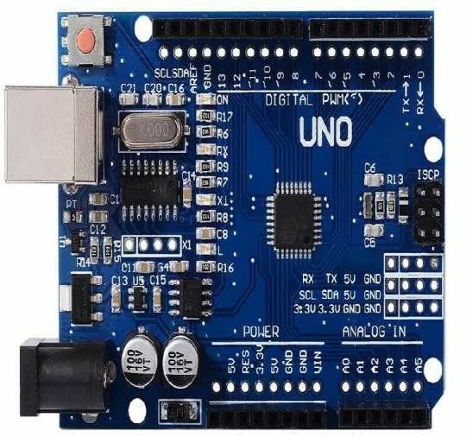

Figure 1: Arduino UNO module

Various Arduino iterations are available, with Arduino UNO R3 and Arduino Nano V3 being the primary official versions. They operate at 16 MHz, featuring an ATMEL ATmega328p 8-bit microcontroller, 32 KB of flash RAM, 14 digital I/O with 6 analog I/O, and 32 KB.

**RTC MODULE**

A real-time clock module, essentially a time-monitoring device, provides current time and date details. The DS 1307-based RTC module is employed in this project, operating on the I2C protocol. It furnishes information such as seconds, minutes, hours, day of the week, day of the month, month, and year. The module operates in either 12-hour or 24-hour format, with a negligible current consumption in the nanoampere range. Communication with the microcontroller transpires through the serial communication protocol, I2C.

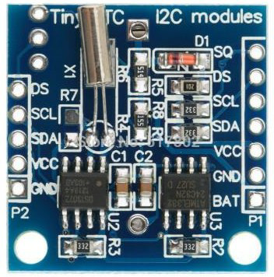

FIGURE 2: RTC MODULE

DS1307 will act as slave in communication network. The Arduino embarks on its operational journey by orchestrating a commencement scenario, seamlessly intertwining a start condition and a meticulously assigned device address, ushering communication with the awaiting slave. The commencement of Arduino's operation unfolds with the orchestration of a distinctive start condition, coupled with the conveyance of a device address to the awaiting slave. Subsequently, a journey into the data realm necessitates the transmission of the register number, unlocking access to the concealed values within. The conduit for this interaction lies in the simplicity of the I2C interface, where the SDA and SCL pins intricately interlace with their corresponding counterparts on the Arduino, creating a synchronized dance of communication. On the software front, the choreography is directed by the Wire library, a digital maestro orchestrating the harmonious dialogue between Arduino and I2C/TWT devices.

**LCD DISPLAY**

The LCD display module, housing 20*4 characters, features an RW1063 controller IC with interface options including 6800, 4-line SPI, or I2C. The display module is governed by SPLC780D, akin to the common HD44780. Display control is achievable through a single-wire serial interface using a serial-enabled LCD backpack.

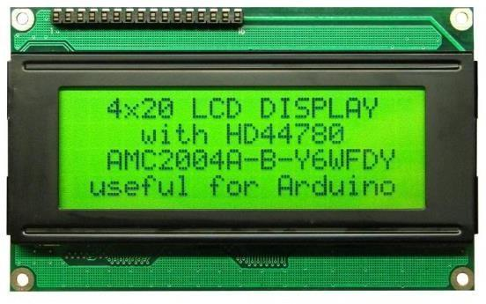

Figure 3: LCD display

**Features of LCD:**

* A multitude of characters, 20 in each line, spans the narrative across 4 lines, weaving a tapestry of textual intricacy
* Character table : English-european
* Viewing area :77.0*26.5 mm
* Dot size : 0.55*0.55mm
* Dot pitch: 0.60*0.60mm,
* character size: 2.95*4.75mm
* Character pitch : 3.55*5.35 mm
* LCD type : yellow/Green STN positive, transflective
* Backlight type : yellow/green LED
* Supply voltage for logic : 5v
* Supply voltage for backlight :3.8-4.2v
* Operating voltage : 20 to +70 0 c.

**Relay module:**

The relay module, operable at 5V and accommodating a current of 10A, is equipped with a 2-channel relay interface board. This module facilitates the control of various appliances and equipment with substantial current requirements. Direct control from Arduino is viable with 3.3V or 5V logic signals.

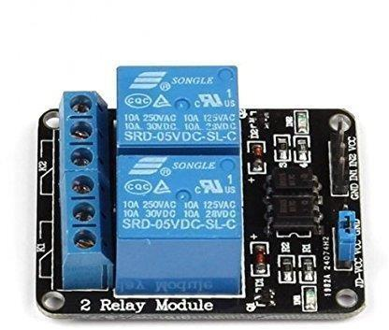

Figure 4: Relay module

* Ground (GND): Connects to 0V.
* Input 1 (IN1): Controls relay 1, active low. Relay turns ON when this input falls below approximately 2.0V.
* Input 2 (IN2): Controls relay 2, active low. Relay turns OFF when this input falls below approximately 2.0V.
* Voltage Common Collector (VCC): Connects to 5V.

A second pin header, 13 (2.54mm pitch), supplies the relay side of the board with 5V. A jumper on this header, at delivery, selects the 5V signal from the 14 pin to power the relays.

**IV. CIRCUIT DESCRIPTION**

The ensuing diagram delineates the use case diagram of the time-regulated electrical appliances control system.

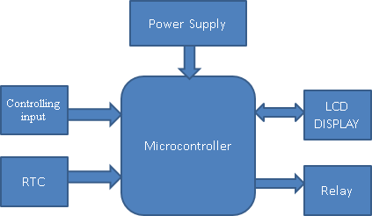

Figure 5: Block diagram

The system administrator of the time-regulated electrical appliances control system using Arduino possesses the capability to append or erase diverse appliances and their functionalities. Users can issue directives to existing devices, retrieve device statuses, and configure the operations of varied appliances. Arduino emerges as an economical solution to electronically regulate myriad processes. Use case diagrams play a pivotal role in modeling the system output, portraying a set of use cases and their interconnections. The circuit encompasses two relays for fan and light control, a keypad for input control, an LCD for instructional display, and a power supply circuit for AC to DC conversion. Arduino functions as the centerpiece in automated devices, with the system activating when Arduino is in operation.

The RTC module interfaces through four wires: VCC, GND, serial data line, and serial clock line. VCC and GND link to Arduino's 5V and GND, providing operational biasing voltage. Communication between Arduino and the RTC DS 1307 occurs via these two pins. Five push buttons serve as inputs to Arduino, pulled down to ground through 10K resistors. Depression of any button results in a logic 1 (HIGH) input on the corresponding Arduino pin. The LCD's D4-D7 data pins link to Arduino pins 10-13, while control pins Rs and En connect to pins 8 and 9, respectively. Control pins RW and VEE ground. The LCD's backlight LED receives a 5V supply.

**WORKING**

The choreography of operational stages unfolds as the circuit gracefully executes its intricate ballet of functionality.

1. Upon powering the circuit via USB, the initial state is OFF for both the relay and the device.
2. The user sets the device's ON and OFF times. The initial LCD message reads "Device ON time."
3. The user configures the device's ON time using the push buttons.
4. The LCD screen illuminates with the message "Device ON time successfully configured to XX:XX:XX.”
5. Similarly, the user sets the device's OFF time, and the LCD confirms the setting with "Device OFF time set to XX:XX:XX."
6. After a 2-second delay, the circuit becomes operational.
7. Arduino reads the current time from the RTC module, displaying it on the LCD as "Time: - XX:XX:XX." The LCD also shows the set device ON and OFF times as Lon, Loff, Fon, and Foff.
8. Continuous monitoring checks if the current time and device ON time coincide. Upon a match, the relay and device activate, with the LCD signaling "Device is ON."

**V. RESULT**

Electrical devices, whether in a factory, home, or other settings, consume electrical power. The imperative lies in power conservation, prompting the need for effective and efficient control of electric devices at any time and from anywhere. This project, designed for the precise control of electrical appliances, relies on temporal dependencies to regulate different devices at distinct times. Applicable in industrial and domestic settings, this design minimizes human intervention and enhances life's ease without compromising appliance efficiency. Functioning autonomously as an automated circuit, it has the potential to monitor hazardous situations, offering real-time implementation and contributing significantly to minimizing energy wastage in diverse applications.

**VI. CONCLUSION**

This paper concludes with the implementation of a low-cost, adaptable electrical control system. The time-regulated electrical appliances control system, tailored for switching devices based on time, caters to both home and commercial domains. This design curbs electrical hazards and facilitates post-operation monitoring. Its utility spans various industries for time-dependent device control. Future iterations aim to streamline the circuit complexity and integrate memory card interfaces through the incorporation of ARM technology.

**VII. REFERENCES**

1. B.SARATHPRANAV,K.VELPRASANTH,R.VIJAY,K.SRIVASAN,Dr.S.VIMAL RAJ, “REAL-TIME-CLOCK USING ARDUINO”, Dogo Rangsang Research Journal UGC Care Group I Journal, ISSN : 2347-7180 Vol-13, Issue-5, No. 1, May2023
2. IMbne Joha, M. Shafiul Islam and S. Ahamed, "IoT-Based Smart Control and Protection System for Home Appliances," 2022 25th International Conference on Computer and Information Technology (ICCIT), Cox's Bazar, Bangladesh, 2022, pp. 294-299, doi: 10.1109/ICCIT57492.2022.10054941.
3. AOndrei, S. Ungureanu, A. Miron and A. C. Cziker, "IoT power monitoring device using Wi-fi and Arduino," 2021 9th International Conference on Modern Power Systems (MPS), Cluj-Napoca, Romania, 2021, pp. 1-6, doi: 10.1109/MPS52805.2021.9492651.
4. LK. Hameed and N. H. Barnouti, "Electricity Monitoring and Controlling IoT Smart System," 2019 International Engineering Conference (IEC), Erbil, Iraq, 2019, pp. 182-187, doi: 10.1109/IEC47844.2019.8950612.
5. DBebnath, R. Dey and S. Roy, "Smart Switching System Using Bluetooth Technology," 2019 Amity International Conference on Artificial Intelligence (AICAI), Dubai, United Arab Emirates, 2019, pp. 760-763, doi: 10.1109/AICAI.2019.8701298.
6. L.A Vergara and H. M. Villaruz, "Development of an Arduino-based automated household utility power monitoring system," 2014 International Conference on Humanoid, Nanotechnology, Information Technology, Communication and Control, Environment and Management (HNICEM), Palawan, Philippines, 2014, pp. 1-6, doi: 10.1109/HNICEM.2014.7016233.
7. Anif J, Louis S, Agus S, et al. Design Real Time Battery Monitoring System Using LabVIEW Interface For Arduino. In: International Conference on Rural Information & Communication Technology and Electric-Vehicle Technology, November 26-28,2013.
8. Khizir M, Md. Shamsul A, Rakesh G. Design of Digital Thermometer Based on PIC16F77A Single Chip Microcontroller. In: International Conference on Consumer Electronics, Communications and Networks, November 20-22, 2013, pp 246-49.