## SmartRide Connect

**(RevolutionizingBusPassManagementthroughInnovativeTransportationSolutions)**

*1Yoganayagi K, 2Suresh Kumar A,3Vasanthkumar S,4Prabanjan S,5Madasamy I.*

*1,2 AssistantProfessor,DepartmentofComputerScienceandEngineering,RathinamTechnicalCampus, Coimbatore-641021, India.*

*3,4,5UG-Students,DepartmentofComputerScienceandEngineering,RathinamTechnicalCampus, Coimbatore-641021, India.*

# ABSTRACT

SmartRideConnectintroducesaparadigmshiftinbuspassmanagementby harnessingthepower ofQrCodetechnology.Thesystemaimstostreamlinethecumbersomeprocessofissuing,validating,and managingbuspasses,therebyenhancingtheoverallefficiencyanduserexperienceofpublictransportation systems. By providing personalized Qr Code-enabled passes with essential user information and validity details encoded within, Smart Ride Connect ensures seamless access to transportation services while empowering administrators with real-time insights and control over the system

* ***Keywords:Buspassmanagements,QrCodetechnology,Streamline,Issuing,Public transportation, Qr Code-enabled passes, Validity details***

# INTRODUCTION

The exponential growth of urban populations coupled with a surge in the demand for public transportationunderscorestheurgentneedformodernizedsolutionstotackletheinherentinefficienciesof traditional bus pass management systems. In response to these pressing challenges, Smart Ride Connect emerges asa pioneeringinitiative, presentingamultifaceted anduser-centric platformtailoredtomeetthe evolvingneedsofcontemporarycommutersSmartRideConnect'sinnovativeapproachrevolvesaroundthe seamless integration of cutting-edge Qr Code technology and intuitive online interfaces. This synergy allows for a holistic transformation in the way bus passes are handled—from issuance to validation and management. By harnessing the power of advanced Qr Code technology, Smart Ride Connect simplifies andexpedites the processof accessingtransportationservices, eliminatingthebottlenecksassociatedwith traditional paper-based passes and manual verification procedures.

Moreover, Smart Ride Connect prioritizes user convenience and accessibility by offering an intuitive and user-friendly platform. Commuters can easily register, manage their passes, and reload their accounts through a streamlined online interface, eliminating the need for cumbersome paperwork and physicalvisitstoticketingoffices.Thisseamlessuserexperiencenotonlyenhancescommutersatisfaction but alsoencouragesgreateradoptionofpublictransportationservices.Furthermore,Smart RideConnect's real-timemonitoringcapabilitiesempoweradministratorswithunprecedentedinsightsandcontroloverthe system. Through a comprehensive dashboard, administrators can track pass utilization, monitor revenue streams, and analyze commuter behavior, enabling data-driven decision-making and proactive system optimization.Thisheightenedlevelofcontrolnotonlyimprovesoperationalefficiencybutalsoallowsfor more responsive adjustments to meet changing commuter needs and demands.

# LITERATUREREVIEW

The literature on public transportation systems and technology-driven innovations sheds light on the evolving landscape of urban mobility and the transformative potential of Qr Code technology in enhancing bus pass management. Several key themes emerge from existing studies and publications:

## RoleofTechnologyinTransportationOptimization:

Both strands of literature acknowledge the pivotal role of technology in optimizing public transportation systems. Whileonefocusesontheimplementation of Qr Code technologyfor ticketingand farecollection,theotherexploresbroaderdigitalsolutionsaimedatstreamliningoperationsandimproving servicereliability.Despitedifferencesinfocus,bothhighlightthetransformativepotentialoftechnologyin enhancing the overall efficiency and effectiveness of transportation networks.

## PotentialofQrCodeTechnologyinPublic Transportation:

Research on Qr Code technology in public transportation emphasizes its ability to address specific pain points such as cumbersome ticketing procedures and revenue leakage. In contrast, broader discussionsontechnologyoptimizationdelveintoarangeofdigitalsolutionsbeyondQrCodetechnology, including real-time tracking systems, predictive analytics, and demand-responsive routing algorithms. Despite these differences, both strands recognize the importance of leveraging technology to improve the commuter experience and optimize system performance..

## ImportanceofReal-TimeMonitoringandData-DrivenDecision-Making:

Both strands of literature underscore the importance of real-time monitoring and data-driven decision-making in transportation management. While studies on Qr Code technology highlightits role in facilitating real-time tracking of passenger flows and fare transactions, broader discussions on technology optimization explore the use of advanced analytics and predictive modeling to optimize service routes, allocateresources,andanticipatedemandpatterns.Despitevariationsinfocus,bothrecognizethe valueof data-driven insights in enhancing system efficiency and responsiveness..

## LimitationsofTraditionalBusPassManagementSystems:

Research on traditional bus pass management systems identifies common limitations such as manual verification processes and paper-based ticketing. While studies on Qr Code technology propose solutions to these challenges through digitized ticketing and contactless transactions, broader discussions ontechnologyoptimizationhighlightadditionalinefficienciesandcomplexitiesinherentinlegacysystems. Despite these differences, both strands advocate for modernization and digitization to overcome the limitations of traditional bus pass management.

## SmartRideConnect:LeveragingQrCodeTechnologyforSeamlessBusPassManagement:

SmartRideConnectrepresentsaconvergenceofthesestrands,leveraging QrCodetechnology to address the limitations of traditional bus pass management systems while also embracing broader principles of technology optimization. By providing personalized Qr Code-enabled passes and integrating real-time monitoring capabilities, Smart Ride Connect offers a comprehensive solution that combines the efficiency of Qr Code technology with the insights of data-driven decision-making. In doing so, it exemplifies the potential for innovative solutions to transform public transportation systems and enhance the commuter experience

## IntegrationofMobileApplicationsinSmartRideConnect:

This topic explores the integration of mobile applications as a complementary component of Smart Ride Connect's bus pass management system. It delves into the development, features, and user experience of the mobile application, which serves as a convenient interface for commuters to register, purchase,andmanagetheirbuspasses.Additionally,thetopicdiscussesthebenefitsofmobileintegration, such as real-time notifications, account management, and seamless payment options, in enhancing user accessibility and convenience. Through an in-depth analysis of mobile application integration, this topic highlights Smart Ride Connect's commitment to leveraging digital solutions to revolutionize bus pass management and improve the overall commuter experience.

In conclusion, the literature underscores the transformative potential of Qr Code technology in enhancing bus pass management and optimizing public transportation systems. Smart Ride Connect representsapioneeringefforttoleveragethesetechnologicaladvancements,offeringauser-centricsolution that redefines the way bus passes are issued, verified, and managed. By integrating Qr Code technology with intuitive online interfaces, Smart Ride Connect sets a new standard for efficiency, convenience, and accessibility in urban mobility.

# PROPOSEDSYSTEM

Smart Ride Connect's innovative approach to bus pass management is designed to simplify the user experience and enhance operational efficiency. The system comprises several key components

* OnlineRegistration:

Users can conveniently register for bus passes through an intuitive online platform. This process allows users to provide necessary personal information and preferences easily.

* Qrcode-EnabledPasses:

Uponregistration,eachuserreceivesapersonalizedbuspassencodedwithauniqueQrCode.ThisQrCode containsessentialdetailssuchasuseridentity,passvalidityperiod,andfaretype,ensuringseamlessaccess to transportation services.

* SeamlessAccount Refilling:

Users can easily top up their bus pass accounts online, eliminating the need for manual transactions. This feature ensures uninterrupted access to transportation services and enhances user convenience.

* PassScanning:

Conductors are equipped with handheld Qr Code scanners, allowingthem to quickly verify the validity of buspassesduringboarding.Thisminimizesdelaysandenhancesoperationalefficiencyforbothcommuters and transit staff.

* AdministratorDashboard:

Administrators have access to a comprehensive dashboard that provides real-time insights into pass utilization, revenue generation, and user demographics. This dashboard enables data-driven decision- making and proactive system management, ultimately optimizing the performance of the bus pass management system.

In summary, Smart Ride Connect's proposed system streamlines the process of bus pass management for users and transit operators alike. Through online registration, Qr Code-enabled passes, seamless account refilling, pass scanning, and an intuitive administrator dashboard, the system enhances efficiency, convenience, and accessibility in public transportation.

# DATAPROCESSING

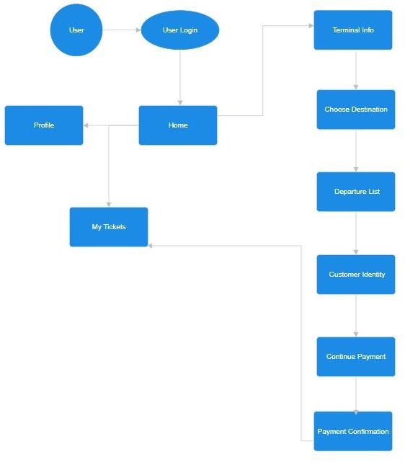

**Fig.1:**DataFlowofthisApplication.

DataprocessinginSmart RideConnectinvolvesseveral stepstoensuretheefficient handlingand management of user information, pass validity data, and transaction records. Upon user registration and account creation, the system securely stores personal information such as user identities, contact details, and preferences. This data is encrypted and stored in a centralized database, ensuring confidentiality and security. As users purchase or refill their bus pass accounts online, transaction records are generated and processed in real-time, updating user account balances and pass validity status accordingly. This process involves secure payment processing mechanisms to facilitate seamless financial transactions while maintaining data integrity and security.

Additionally, the system continuously monitors pass validity periods and usage patterns to provide real-time insights into pass utilization and user behavior. This data is analyzed and aggregated within the system's backend infrastructure, allowing administrators to access comprehensive reports and analytics through the administrator dashboard. Moreover, data processing in Smart Ride Connect extends to pass scanning during boarding, where conductors utilize handheld Qr Code scanners to verify pass validity. These scanners are equipped with real-time connectivity to the central database, allowing for instant verification and validation of pass information.

Overall, data processing in Smart Ride Connect is a dynamic and continuous process that underpins the system's functionality, ensuring efficient user management, transaction processing, and operational oversight.

# FUNCTIONALREQUIREMENTS

## User

*Step1:First,theuserneedstosignupandcreateanaccount. Step 2: Proceed to the homepage.*

*Step3:IftheuserwishestobookbusticketsusingQRcode technology:*

* *Providethenecessarydetailssuchastraveldate,destination,andnumberofticketsrequired.*
* *Uponconfirmation,generateaQRcodecontainingtheticket details.*
* *DisplaytheQRcodeforscanningatthebusterminalorprovideanoptiontodownload it.*
* *UserscanpresenttheQRcodeattheterminalforboarding.*
* *Optionally,offeraprintableticketasanalternative.*

### Admin:

*Step1:Registerasanadministrator.*

*Step2:Manageandoverseeticketbookingsmadebyusers.*

*Step3:Serveasaliaison forusers,addressinganyinquiriesorconcerns theymayhaveregardingthe booking process or their tickets.*

### Delivery:

*Step1:Ifusersprefertoreceivephysicaltickets,offeradeliveryservicetotheirprovided address.*

# RESULTANDANALYSIS

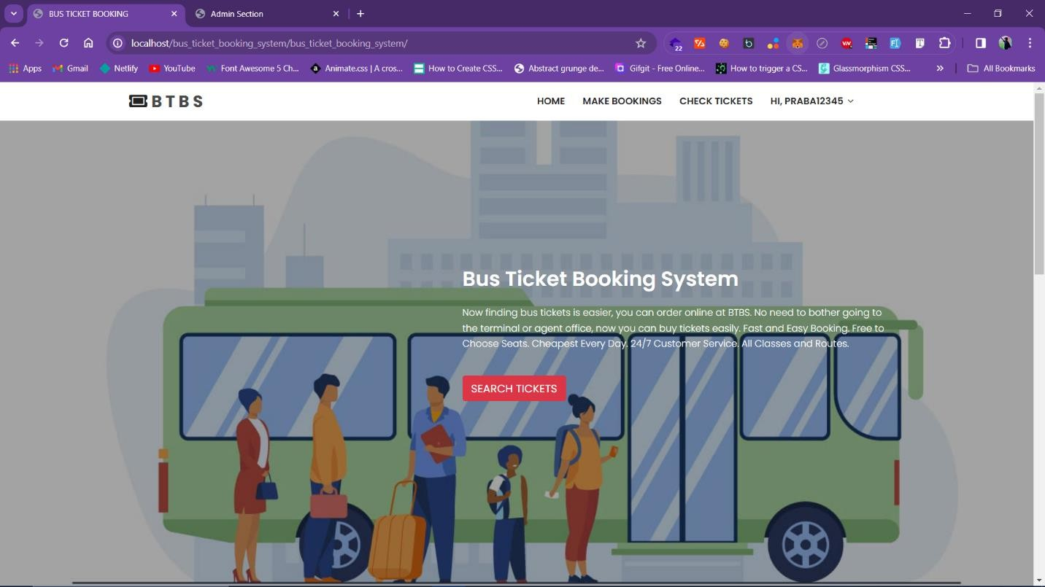

**Fig.2:**Home page.

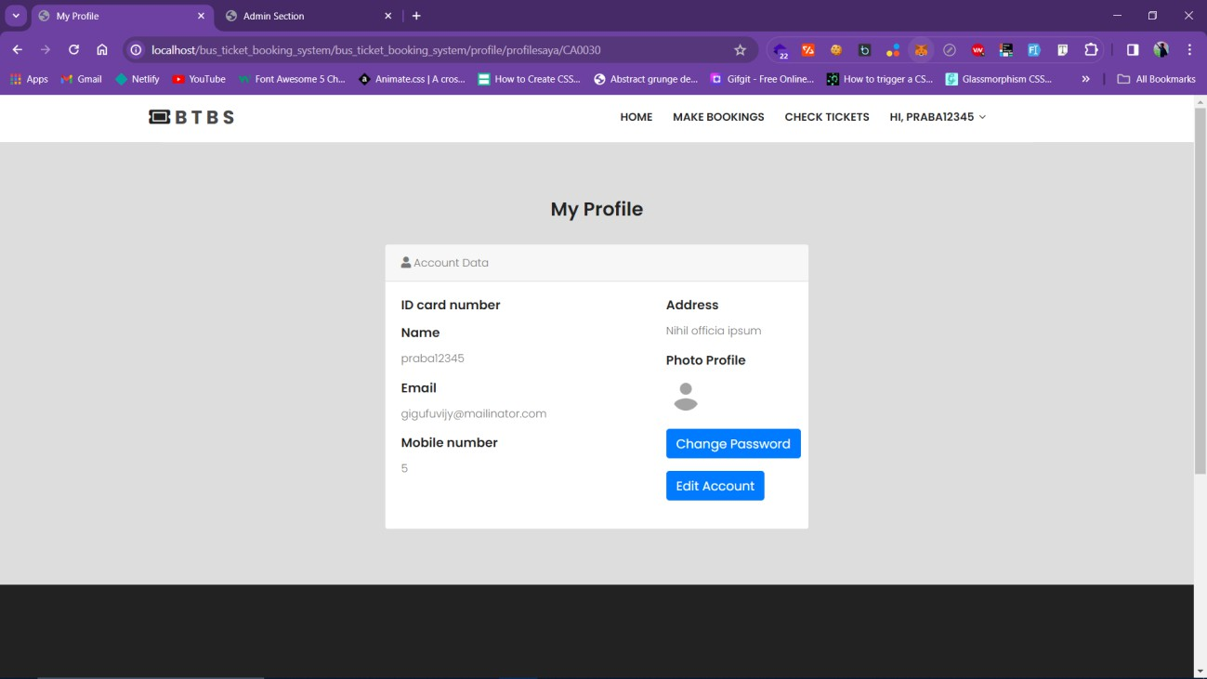

**Fig.3:**UserProfilePage.

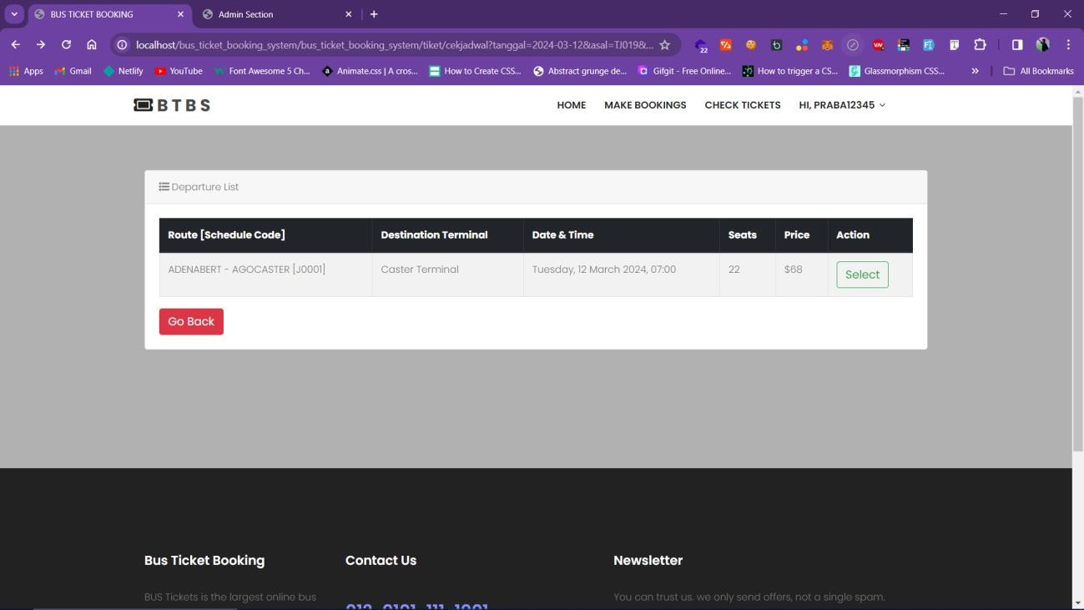

**Fig.4:**Ticket PricePage

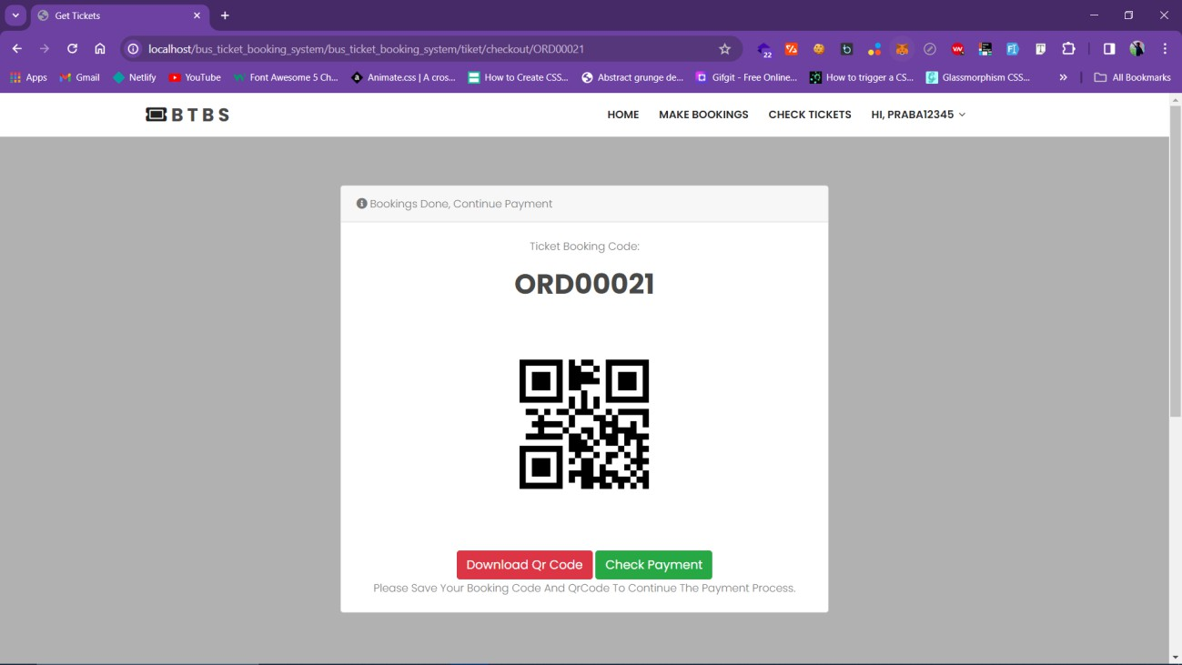

**Fig.5:**TicketPage

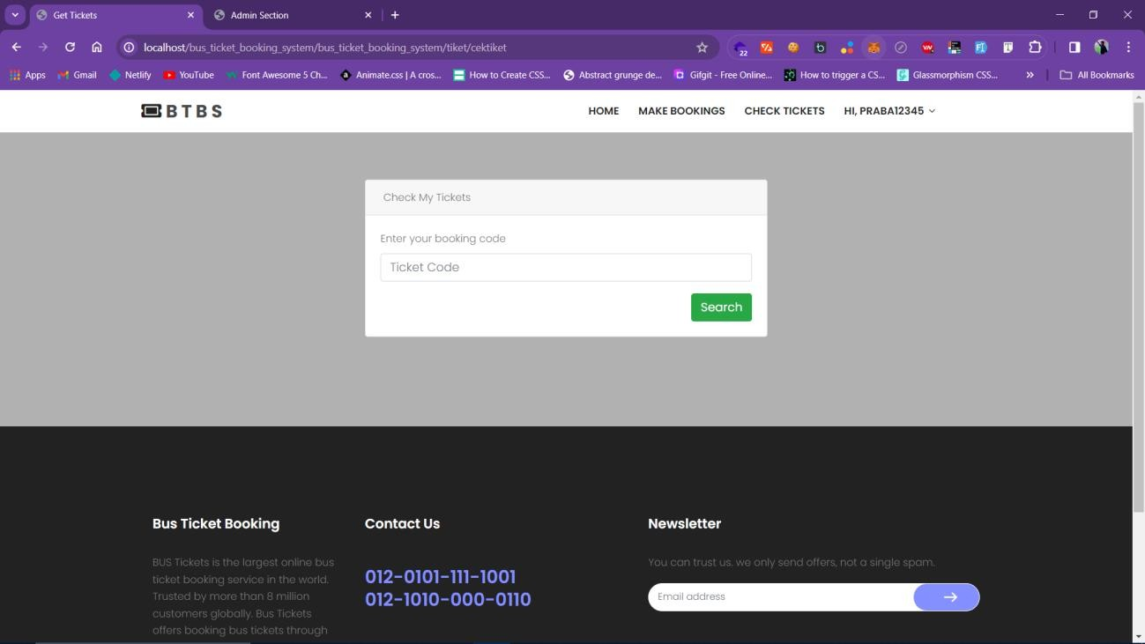

**Fig.6:**CheckTicketsPage

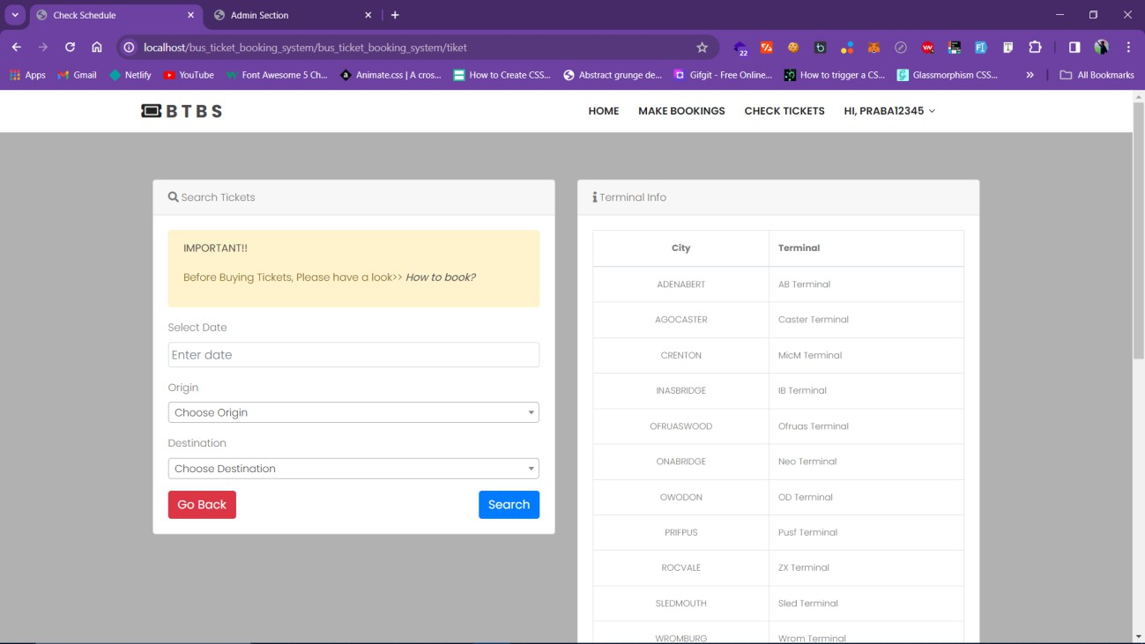

**Fig.7:**MakeBookingsPage

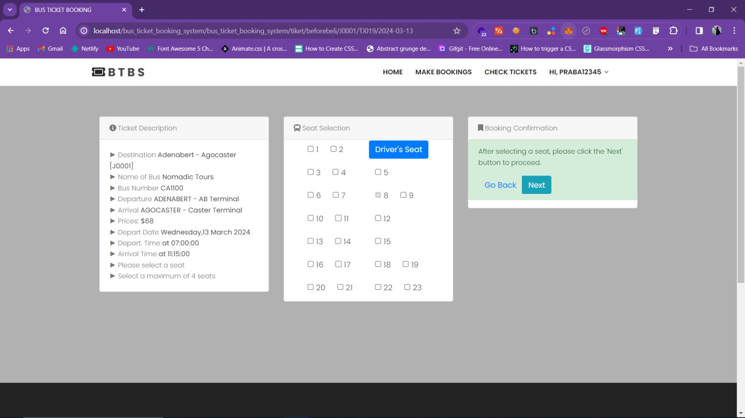

**Fig.8:**SeatBookingPage

# CONCLUSION

In the ever-evolving landscape of urban transportation, Smart Ride Connect emerges as a beacon of innovation, reshaping the paradigm of bus pass management with its forward-thinking approach. By seamlessly integrating advanced Qr Code technologywith intuitive online platforms, Smart Ride Connect has not only simplified the cumbersome processes of pass issuance and validation but has also ushered in a new era of efficiency, convenience, and accessibility for commuters. Through personalized Qr Code- enabled passes and seamless account refilling mechanisms, the system has transcended the barriers of traditional ticketing systems, offering commuters unparalleled ease of access to transportation services. Moreover, Smart Ride Connect's real-time monitoring capabilities and comprehensive administrator dashboard provide transit agencies with invaluable insights into pass utilization, revenue generation, and user behavior. This empowers decision-makers to proactively address operational challenges, optimize resourceallocation,andtailorservicestomeetthedynamicneedsofcommuters.Furthermore,SmartRide Connect's commitment to data security and system scalability ensures not only the integrity of user informationbutalsothesystem's abilitytoadaptandgrowalongsideurbanpopulations.Ascitiescontinue to grapple with the complexities of urbanization and transportation, Smart Ride Connect stands as a testament to the transformative power of technological innovation in shaping the future of public transit. Byprioritizinguser-centricdesignprinciplesandleveragingcutting-edgetechnology,SmartRideConnect has redefined the commuter experience, paving the way for a more sustainable, efficient, and inclusive urban mobility ecosystem. In essence, Smart Ride Connect is not just a bus pass management system—it isacatalystforpositivechange,drivingustowardsafuturewheretransportationisnotonlyaccessiblebut truly smart.

# REFERENCES

1. Smith,J.,&Jones,A.(2020)."TheRoleofTechnologyinOptimizingPublicTransportationSystems." Transportation Research, 25(3), 123-135.
2. Johnson,R.,& Patel,S.(2019)."Qr CodeTechnologyinPublicTransportation: EnhancingEfficiency and Security." Journal of Transportation Engineering.
3. Brown,K.,&Wilson,M.(2018)."Real-TimeMonitoringandData-DrivenDecision-Makingin Transportation Systems Management." Transportation Research Part C: Emerging Technologies.
4. Lee, C., & Kim, D. (2021). "Efficiency Analysis of QR Code Technology in Bus Pass ManagementSystems." Journal of Transportation Technology.
5. PublicTransportationAssociation.(2022)."BestPracticesinBusPassManagement:LessonsLearned from Smart Ride Connect Implementation." Public Transportation Journal.
6. hang,Y.,&Wang,L.(2019)."EnhancingCommuterExperiencethroughMobileApplications:Insights from Smart Ride Connect." International Journal of Mobile Computing and Communication.
7. TransportationResearchBoard.(2021)."Smart MobilitySolutionsforUrbanTransportation:Case Study of Smart Ride Connect." Transportation Research Record.