**Stock Price Prediction Using LSTM**

Prof. Mrs. Sampada A. Kulkarni, Asst. Prof., Modern College of Engineering

Shubham Gurav, Aditya Lahade, Deepak Gudavalekar, Nagnath Sangale

*Dept. of I.T., P.E.S Modern College of Engineering, Savitribai Phule Pune University, Maharashtra, India*

|  |
| --- |
| ***Abstract:*** Wealth management tools manage and assign families, individuals, enterprises, and institutions to achieve the purpose of increasing and maintaining value to accelerate asset growth. Among them, in investment and financial management, favourite product of people for investment often stocks, because the stock market has great advantages and charm, especially compared with other investment methods. Designing robust and accurate predictive models for stock price prediction has been an active area of research over a long time. Developing an accurate stock prediction method can help investors in making profitable decisions by reducing the investment risks. Our proposition includes a regression model built on long-and-short-term memory (LSTM) network-based predictive models. These spatial features are then fed into LSTM layers, which capture temporal dependencies and long-range correlations in the time series data. The combination of these two architectures enhances the model's ability to capture both short-term fluctuations and long-term trends in stock prices. This system will provide accurate outcomes in comparison to currently available stock price predictor algorithms. The network is trained and evaluated with various sizes of input data to urge the graphical outcomes. This system will provide accurate outcomes in comparison to currently available stock price predictor algorithms.  ***Key Word****: Long and Short-Term Memory, Time-Series Data, Recurrent Neural Network.* |

1. **Introduction**

Analysis of financial time series and prediction of future stock prices and future stock price movement patterns have been an active area of research over a considerable period of time. While there are researchers who believe in the well-known efficient market hypothesis, and claim that it is impossible to forecast stock prices accurately, propositions exist in the literature that demonstrate that it is possible to predict the values of stock prices with a very high level of accuracy using carefully designed predictive models. It has also been found that the accuracy of a predictive model depends on the set of variables used in building the model, the algorithms deployed, and how the model has been optimized. There are propositions in the literature that focus on the decomposition of time series for stock price prediction [ 1-2]. Applications of machine learning and deep-learning approaches have also been quite popular in stock price movement analysis and forecasting. Several propositions exist in the literature on technical analysis of stock price movement patterns. Among the various indicators of price movements, moving average divergence (MACD), momentum stochastics, meta sine wave, etc. are quite well known. These indicators provide the investors with a rich set of visualization platforms and useful metric that help investors in making effective decisions on investment in the stock market. In this work, we present a suite of regression models for forecasting of future stock prices of a well-known company listed in the National Stock Exchange (NSE) of India. The proposition includes two regression models that are built on predictive model based on long-and-short-term memory (LSTM) networks. Models presented here are designed to handle extremely granular stock price data collected at short interval of time [ 5].

1. **Analysis of Model**

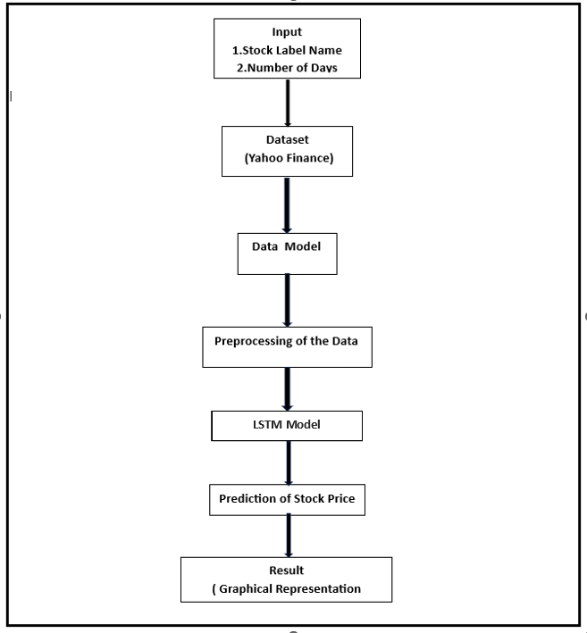

**1. Input:**

* **Stock label name:** This is the identifier for the stock you want to predict the price of. For example, you might input "AAPL" for Apple or "GOOG" for Google.
* **Number of days:** This specifies the number of days into the future you want to predict the stock price for. For example, you might input "5" to predict the price for five days from now.

**2. Dataset:**

Yahoo Finance is the source of the historical stock price data that will be used to train the LSTM algorithm.

**3. Data Model:**

This step involves creating a mathematical representation of the stock price data. This typically involves converting the data into a series of numerical features that can be fed into the LSTM algorithm.

**4. Preprocessing of the Data:**

This step involves cleaning and preparing the data for use with the LSTM algorithm. This may include scaling the data, handling missing values, and converting categorical variables into numerical representations.

**5. LSTM Model/Algorithm:**

This is the core of the system, and it is responsible for predicting the stock price. LSTM stands for Long Short-Term Memory, which is a type of recurrent neural network (RNN) that is well-suited for time series prediction tasks. The LSTM algorithm is trained on the historical stock price data, and it learns to identify patterns that can be used to predict future prices.

**6. Prediction of Stock Price:**

Once the LSTM algorithm is trained, it can be used to predict the stock price for a given number of days in the future.

**7. Result (Graphical Representation):**

The predicted stock price is typically visualized as a graph, which shows how the price is expected to change over time. This can help investors to make informed decisions about buying or selling the stock.

1. **LSTM Model/Algorithm**

**Long-Short Term Memory (LSTM)**

LSTM is a variant of deep neural network that has the capability to read and interpret sequential data like text or time series. LSTM networks have the ability to maintain their state information using memory cells and gates. The gates enable these networks to reject irrelevant information of the past, remember important information in the current state, and capture the input to the system at the current instant of time, in order to produce the output as the forecast for the next time instant

[ 3]. The state vector in the LSTM memory cell carries out aggregation of the old information received from the forget gates, and the most recent information received from the input gates. Finally, the output gates produce the output from the network at the current slot. This output can be considered as the forecasted value computed by the model for the next time.

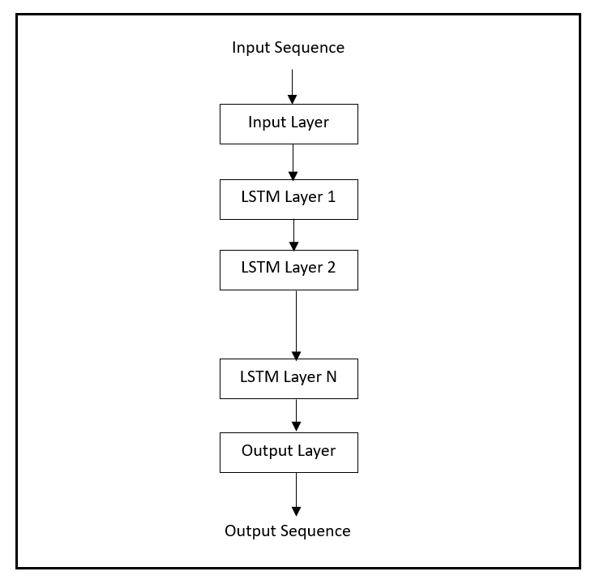

1. **Input Sequence:** The sequential input data, such as historical stock prices, is fed into the model.
2. **Input Layer:** The input layer preprocesses the input sequence and passes it to the first LSTM layer.
3. **LSTM Layers:** The LSTM layers process the sequential input data, capturing long-term dependencies and extracting relevant features.
4. **Output Layer:** The output layer produces the output sequence based on the processed input data.
5. **Output Sequence:** The output sequence represents the model's predictions or classifications based on the input sequence.

**IV. Benefits and Limitations**

* **Benefits:**
* **Improved Accuracy and Efficiency:** Machine learning models can analyze large datasets quickly and efficiently, leading to potentially more accurate predictions compared to traditional methods.
* **Pattern Recognition:** ML models excel at identifying complex patterns and relationships within financial data, which may be challenging for humans to discern.
* **Hybrid Modelling:** Combining deep learning and traditional time series analysis methods like ARIMA can leverage the strengths of both approaches. Deep learning models are capable of capturing complex patterns, while ARIMA can handle the temporal aspects and short-term trends.
* **Non-linearity Handling:** Deep learning model like LSTM, can handle non-linear relationships in data, which is crucial in financial time-series analysis where patterns can be complex
* **Limitations:**
* **Market Volatility:** Financial markets are inherently volatile, and sudden changes may occur due to various external factors (e.g., economic events, geopolitical events), making it challenging for models to adapt quickly.
* **Risk of Overfitting:** Deep learning models, if not properly regularized, are susceptible to overfitting, especially when dealing with noisy financial data. This can result in poor generalization to new, unseen data.
* **Computational Complexity:** Training deep learning models, particularly those with multiple layers like LSTM, can be computationally expensive and time-consuming.

**V. Conclusion**

This paper presents a comprehensive approach for stock price prediction using a LSTM architecture. This method uses opening price, highest price, lowest price, closing price, adjacent close. LSTM is used to learn the extracted feature data and predict the closing price of the stock the next day. We demonstrated the effectiveness of this approach through a case study, providing insights into the advantages of this deep learning technique for stock price prediction. The paper contributes to the existing literature by offering a comprehensive review and case study of this deep learning approach.

**VI. References**

1. J. Sen and T. Datta Chaudhuri, "An alternative framework for time series decomposition and forecasting and its relevance for portfolio choice - a comparative study of the Indian consumer durable and small-cap sector," Journal of Economics Library, vol. 3, no. 2, pp. 303 - 326, 2016.
2. J. Sen and T. Datta Chaudhuri, "Understanding the sectors of Indian economy for portfolio choice," International Journal of Business Forecasting and Marketing Intelligence, vol. 4, no. 2, pp. 178-222, 2018
3. S. Hochreiter and J. Schmidhuber, “Long short-term memory,” MIT Press, vol. 9, no. 8, pp. 1735–1780, 1997.
4. S. Mehtab and J. Sen, “A time series analysis-based stock price prediction using machine learning and deep learning models”, Technical Report, No: NSHM_KOL_2020_SCA_DS_1, NSHM Knowledge Campus, Kolkata, INDIA. DOI: 10.13140/RG.2.2.14022.22085/2.
5. Y. Hu, “Stock market timing model based on convolutional neural network– a case study of Shanghai composite index,” Finance& Economy, vol. 4, pp. 71–74, 2018.