Techno-Economical Suitability of Hybrid Renewable Energy System for an Industry

**Harshvardhan Kamble1, Kshitiz Pashine2, Praful Meshram3, Nishant Chapke4, Tanu Rizvi5, Devanand Bhonsle6**

1234B.tech student, Department of electrical engineering, SSTC, Bhilai

5Assistant Professor, Department of electrical engineering, SSTC, Bhilai

6Sr. Assistant Professor, Department of electrical engineering, SSTC, Bhilai

**Abstract— This research paper presents an analysis of the system architecture, economic viability, and pollutant emissions of a grid-integrated system designed for the Bhilai Steel Plant (BSP), situated in Bhilai, District Durg, Chhattisgarh (C.G.) state. In the current context, there is a persistent government push towards promoting the utilization of alternative and renewable energy sources to conserve coal in manufacturing industries. The Indian Renewable Energy Development Agency Limited (IREDA) has established a robust policy framework aimed at providing incentives for the advancement of power generation from diverse renewable energy sources, with solar energy emerging as a particularly promising option due to its widespread availability and advantageous topological characteristics for local power generation in industrial settings. In the context of heavy industry in Chhattisgarh (C.G.), the proposed approach represents a novel initiative. This state boasts abundant solar radiation, owing to its location along the Tropic of Cancer, which renders it conducive for the deployment of solar-dependent technologies. This research paper focuses on assessing the economic feasibility of heavy industry, with a particular emphasis on analyzing metrics such as Net Present Cost (NPC) and Levelized Cost of Energy (LCOE). Additionally, it addresses the implementation of a technical system aimed at minimizing pollutant emissions while evaluating the feasibility of integrating a grid system to fulfill the load requirements of the Bhilai Steel Plant (BSP).**

**Keywords— Net Present Cost, Levelized Cost of Energy, Pollutant Emission, PV system, Grid.**

1. Introduction

In contemporary times, renewable energy is increasingly recognized as pivotal for off-grid services, representing a significant choice for diverse generating stations. A comparative study conducted by the International Energy Agency (IEA) on global energy consumption reveals projections indicating that solar arrays' installation will cater to approximately 50% of the world's energy demand by 2050. To identify the optimal mix of renewable energy sources that can be integrated into industrial operations to maximize energy efficiency and minimize environmental impact [20]. It is incumbent upon energy engineers to devise and implement systems that offer energy solutions by enhancing energy proportions while prioritizing sustainability, stability, and ultimately enhancing overall efficiency [2]. The system should be economically feasible, meaning that the cost of implementing and operating the system is justified by the environmental and economic benefits it provides [3]. In Bangladesh, a system has been devised to optimize solar PV system utilization during daylight hours, supplemented by grid power during the night for industrial operations [9]. Certain scholars have conducted a comprehensive technical and economic assessment of hybrid renewable energy systems to power auxiliary units in small-scale plants [10]. The persistent energy crisis in industries spanning decades necessitates integration with additional renewable energy sources [11]. Opportunities for enhancing grid-connected systems in industries exist. Power system planners and regulators have identified integrated units as highly beneficial in distribution systems, contingent upon the comprehensive assessment of each unit's characteristics, including photovoltaic systems, wind systems, and load profiles, alongside local renewable resources [13]. Proposed Method-I (PM-I), which relies entirely on solar power, and Proposed Method-II (PM-II), a solar-grid integrated system. Both of the systems are meticulously modelled and simulated using the Hybrid Optimization Model for Electrical Renewable (HOMER) Pro software. By using scraps and renewables, the objective could be to reduce the environmental impact of power generation, including greenhouse gas emissions and other pollutants associated with traditional energy sources [21]. This could include methods for managing the variability of renewable energy sources and ensuring grid stability and reliability [15].

# Proposed Study

BSP is situated at a latitude of 21°10.7N and a longitude of 81°23.4E, with an elevation of 319 meters above sea level. Data regarding temperature resources have been sourced from the National Aeronautics & Space Administration (NASA) surface meteorology and solar energy database, as well as the National Solar Mission (NSM) administered by the Government of India. Figure 1 and 2 depict month- wise variations in solar radiation, with the maximum recorded solar radiation of 6.710 kWh/m2/day observed in April, followed closely by May. Conversely, the lowest radiation levels are typically observed in August. The clearness index is calculated at 0.639, with an average radiation level of 5.08 kWh/m2/day. Additionally, the highest recorded temperature, as identified by HOMER Pro, is 32°C.

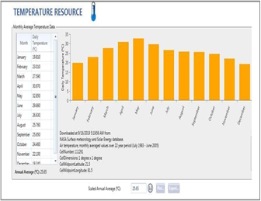

**Figure 1** Month-wise solar GHI resources at the site

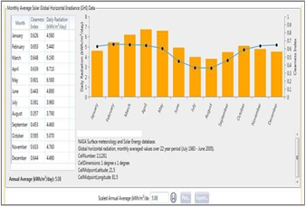

**Figure 2** Yearly temperature data at the site

1. METHODOLOGY

In this section, we propose the improvement in the existing technologies to find the potential in renewable sources and discuss the proposed options that may be required for enhancing the existing systems. It deals with modelling of existing system and the two other proposed systems in Homer Pro.net present cost includes capital cost, replacement cost, O&M cost, fuel cost, emission penalties with cost of power purchased from the grid. The salvage and grid sales value are included in revenues.

A. NPC

NPC of any system is defined as the present value of a system cost over its lifetime minus the present revenue cost earned by the system during its lifetime. HOMER Pro calculates NPC in each for reducing output in real-world operating conditions compared to conditions under which the PV panel was rated. NPC is also a value of ranking system configuration by Homer Pro in optimized results. It is a baseline to calculate LCOE and the total annualized cost.

B. LCOE

LCOE is calculated by dividing the total annual cost of electricity production by total served electric load following an equation:-

lcoe = cann, tot –cboiler hserved

eserved

where,

Cann, tot = total annualized cost of system (Rs/year)

Cboiler = boiler marginal cost(Rs/kw)

Year of system lifetime by summing the total discounted cash flows

Hserved = total thermal load served (kwh/year)

C. Slavage

Salvage is the value remaining in the component of a power system at the end of the project's lifetime. HOMER Pro assumes linear depreciation of components.

1. SYSTEM ARCHITECTURE

A. PM-I model

In this setup, the plant operates exclusively with PV generation, as illustrated in Figure 3. The system is modelled by integrating the plant load with the PV system and PP. A total of 730 solutions were simulated, resulting in 380 deemed feasible and 350 deemed infeasible, while 153 solutions were omitted by the HOMER simulator.

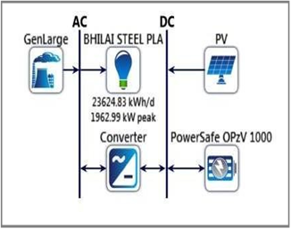

**Figure 3** Arrangement in homer pro for PM-I system

B. PM-II model

The plant operates utilizing grid supply alongside captive generation plants PP and PV systems, depicted in Figure 4. A total of 13,921 solutions were simulated, with 10,662 deemed feasible. Conversely, 3,259 solutions were found to be infeasible, and 3,865 solutions were omitted by the HOMER simulator. Among the omitted solutions, none were due to infeasibility, 1,450 lacked converters, and 250 included unnecessary converters.

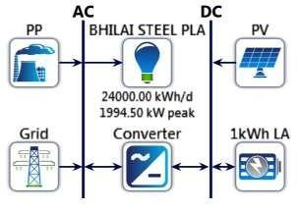

**Figure 4** Arrangement in homer pro for PM-II system.

1. DISCUSSION

The above two models were simulated in HOMER using advanced optimization techniques. Among them, the PM-II model emerged as the preferred system architecture. Figure 5 presents the cost breakdown of PM-I, where the total system cost amounts to 33.1 million Rs. This includes a capital cost of 2.00 million Rs., operating cost of 2.09 million Rs., a replacement cost of 3.91 million Rs., a salvage value of -172,794 Rs., and a resource cost of 25.2 million Rs.

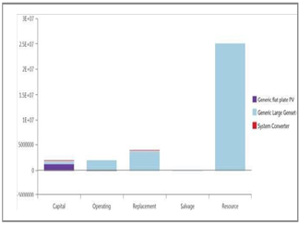

**Figure 5** Cost Summary of PM-I

Figure 6 and 7 illustrates the cost summary analysis and total load consumption for the PM-II system, which emerged as the winning system architecture, with a total system cost of 38.1 million Rs. This encompasses a capital cost of 7.83 million Rs., operating cost of 9.00 million Rs., replacement cost of 3.83 million Rs., a salvage value of -2.32 million Rs., and a resource cost of 19.8 million Rs.

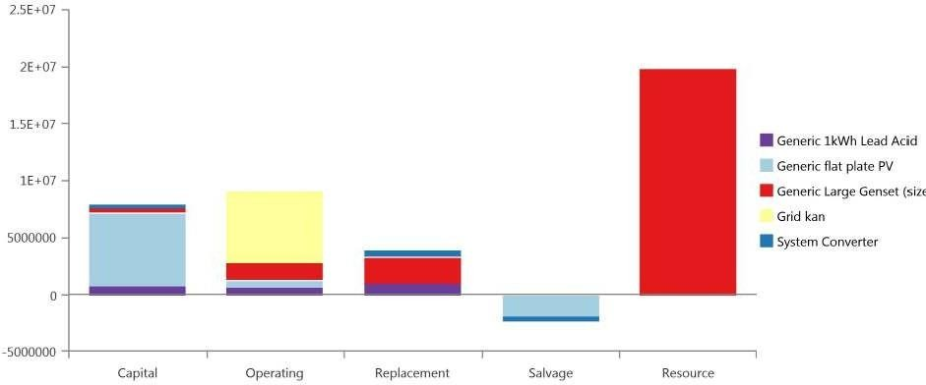

**Figure 6** Cost Summary of PM-II

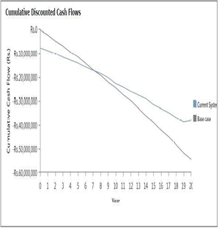

**Figure 7** Cumulative discounted cash flow for PM-II system

Figure 8 indicate that the PM-II method is the most optimized, boasting a simple payback period of 7.92 years. Additionally, generators contribute 29.9% to production, PV systems contribute 44.4%, and the grid system contributes 25.8%, showcasing efficient utilization in terms of percentage production and figure 9 shows the overall cost (NPC) of PM-II system components is relatively lower compared to the total cost (NPC) when power is purchased from the grid. The Net Present Cost (NPC) for the PM-II system amounts to Rs. 24,444,170, indicating a lower value in comparison to PM-I configurations.

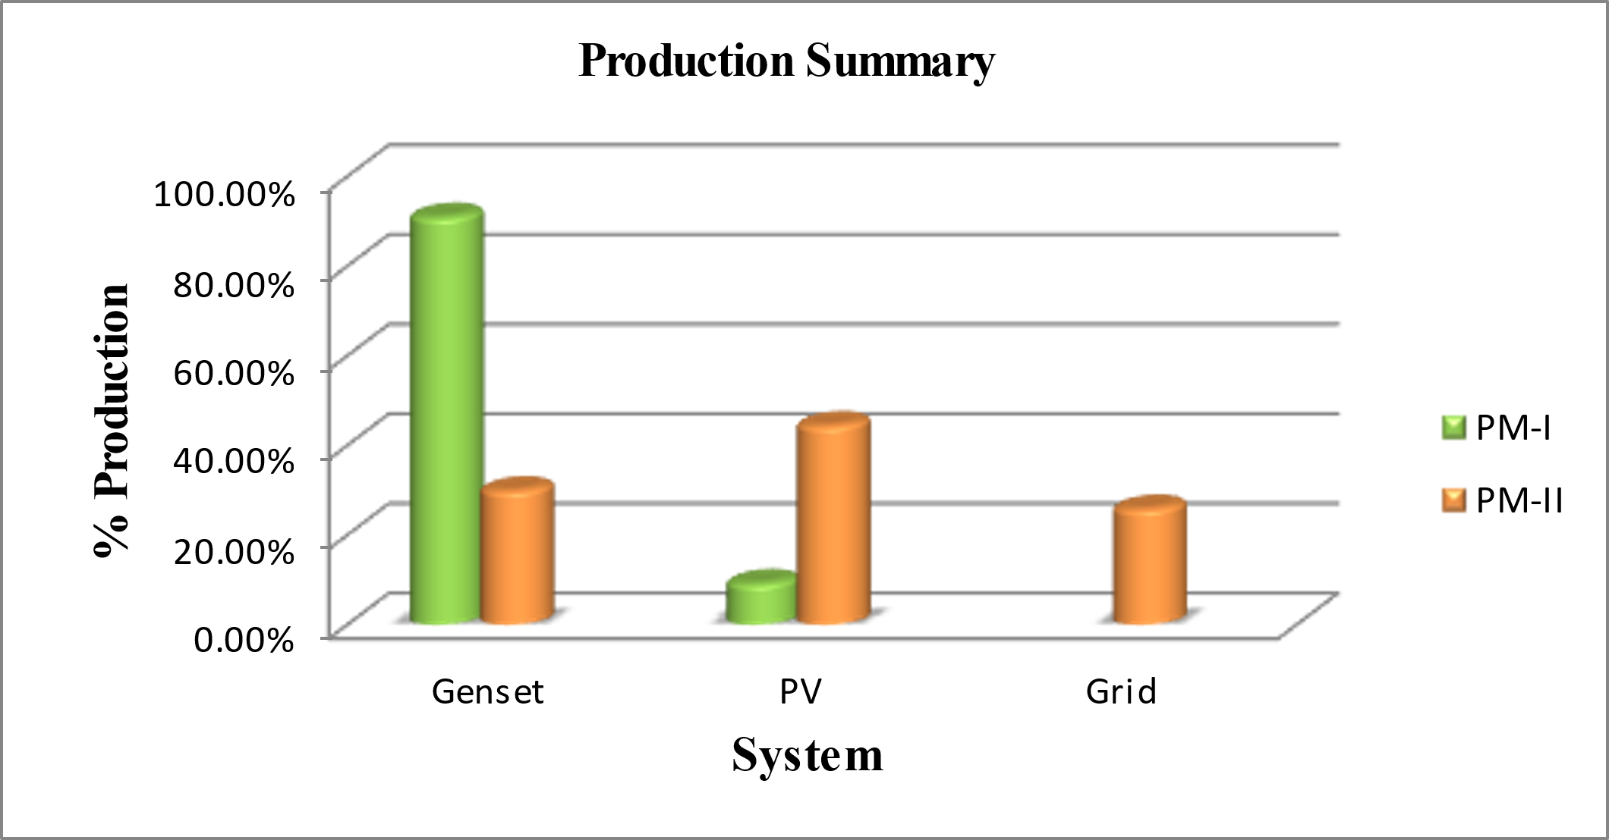

**Figure 8** Production Summary

**Fig 9** NPC of both systems

1. CONCLUSION

In the conducted study, the PM-II method emerges as the closely optimized approach tailored to the BSP plant's system. Notably, the grid-integrated system stands out as the most feasible option. HOMER identifies various optimal systems for BSP, with the one exhibiting the lowest NPC indicating a discounted payback of 7.97 years and a simple payback of 7.97 years for the winning system architecture, whereas payback is not applicable for PM-I. Additionally, the inclusion of sensitivity analysis cases could enrich the comprehensive nature of this research endeavour.

**References**

[1] P. Khayyer and U. Orguner “Decentralized Control of Large-Scale Storage Renewable Energy System” IEEE Transactions on Smart Grid, Vol.5, Issue 3, 2014, pp. 1300-1307.

[2] A V. Khan, P. Akhter and G. M. Muftit “Techno-Economic Evaluation of the Centralized Hybrid Renewable Energy Systems for Off-Grid Rural Electrification” International Journal of Smart Home, Vol.10, Issue 5, 2016, pp. 61-68.

[3] T. Rizvi, S. P. Dubey and S. P. Tripathi “Designing of a Feasible Low Pollutant Grid Integrated System for Steel Plant” CSVTU Research Journal, Vol.10, Issue 2, 2021, pp. 144-154.

[4] S.D. Srivastava and R. Banerjee 2015 “Hybrid Renewable Energy Systems & their Suitability in Rural Regions” in IOSR Journal of Mechanical and Civil Engineering (IOSR- JMCE) e-ISSN: 2278-1684, p-ISSN: 2320-334X.

[5] S.P. Makhija and S. P. Dubey "Optimally Sized Hybrid Energy System for Auxiliaries of a Cement Manufacturing Unit with Diesel Fuel Price Sensitivity Analysis” Taylor & Francis, International Journal of Ambient Energy, 2016, pp. 1-6.

[6] A. B. Awan “Performance Analysis and Optimization of a Hybrid Renewable Energy System for Sustainable NEOM City in Saudi Arabia” Journal of Renewable Sustainable Energy, Vol.11, Issue 2, 2018, pp. 11-17.

[7] Kim S M Oh M. and HD Park “Photovoltaic System Potential for Res P. Analyse and Prioritization of the Floating Reservoirs” in Korea. Applied Science, Vol.9, Issue395, 2019, pp. 1-17.

[8] J.C. Miszczuk “Small-Scale Renewable Energy Systems in the Development of Distributed Generation” in Poland, Vol.22, Issue 2, 2014, pp. 34-43.

[9] N A. A. Jamil, SA Jumaat S. Salimin, M. N. Abdullah and Nor AFM “Performance Enhancement of Solar Powered Floating Photovoltaic System Using Arduino Approach” International Journal of Power Electronics and Drive System (UPEDS), Vol.11, Issue 2, 2020, pp. 651-657.

[10] S. M. Shahnewaz Siddiquee, Md. S. Alam, Md. K. Islam, Mortuza, H. Reza and M. Al Arafat “Optimized Hybrid Renewable Energy System for Efficient Industrial Electrification” IEEE 2nd International Conference on Electrical Engineering and Information & Communication Technology, Dhaka, Bangladesh, 2015, pp. 1-5.

[11] J. Pfaff Terrapon, C. Carmendienst, J. könig and W. Ortiz 2014 “A Cross- Sectional Review: Impacts and sustainability of small-Scale Renewable energy projects in developing countries” Sci verse Science direct, Renewable and sustainable energy reviews, Vol.40, pp. 1–10.

[12] Rizvi. T., Dubey. S. P., Tripathi. N., Srivastava. S., Makhija. S. P. and Mohiddin. Md. K.2023*.*FSPV-Grid system for an Industrial subsection with PV price sensitivity analysis. Sustainability, Vol.15, Issue 3, 2023, pp. 1-18.

[13] E. Akyuz, Z. Oktay and I. Dincer, “Environmental and Economic Aspects of a Hybrid Renewable Energy System: A Case Study”, International Journal of Low-Carbon Technologies, Vol.6, 2010, pp. 44-54.

[14] C. Lupangu and R.C. Bansa “A Review of Technical Issues on the Development of Photovoltaic Systems”, Renewable & Sustainable Energy Reviews, Vol. 73, 2017, pp. 950-965.

[15] B. A. Rao, A. Kumar, V. Harne, T. Rizvi and D Bhosle. “Integration of Hybrid Renewable Energy Sources with the Grid for Sustainable Energy Production” International Research Journal of Modernization in Engineering Technology and Science (IRJMETS), Vol.5, Issue 4, 2023, pp. 1451-1457.

[16] Y. Dhuri, S.K. Verma, P.K. Yadav, T. Rizvi and D. Bhonsle “Improvement in Efficacy of Solar System using Dual Axis Solar Tracking System” International Journal of Innovative Research in Engineering (IJIRE), Vol.3, Issue 2, 2022, pp. 110-113.

[17] S. Mekhilefa, R. Saidur, and A. Safari “A Review on Solar Energy use in Industries” Elsevier, Renewable and Sustainable Energy Reviews, Vol.15, 2011, pp. 1777–1790.

[18] A. Asrari, A. Ghasemi and Md. Hossein Javidi “Economic Evaluation of Hybrid Renewable Energy Systems for Rural Electrification in Iran—A Case Study” Sci verse Science direct, Renewable and Sustainable Energy Reviews, Vol.16, 2012, pp. 3123–3130.

[19] J. Divya Navamani, A. Lavanya, C.M. Prahadheeshwar, S. Mohammed Riyazudeen “Hybrid Power System Design using Homer Pro” International Journal of Recent Technology and Engineering (IJRTE) ISSN, 2019, pp. 2277-3878.

[20] M. I. Khan, N. Dewangan, N. Prasad, O. Dewangan, S. Fatima, T. Rizvi and D. Bhosle “Economical and Environmental Impact of Hybrid Renewable Energy Source Applicable to Industries” International Research Journal of Modernization in Engineering Technology and Science (IRJMETS), Vol.5, Issue 4, 2023, pp. 3593-3603.

[21] R. Verma, S. Das, S. Parmar, S. Kumar, T. Rizvi and D. Bhosle “An efficient way of power generation with Integrated use of Scraps and Renewables” International Journal of Scientific Research in Engineering and Management (IJSREM), Vol.7, Issue 4, 2023, pp. 1-5.