**A Critical Review of Text to Image Synthesis Using GAN : Unveiling the Power of GANs**

***Abstract -*** Text image synthesis is central to graphic synthesis. In previous studies, text-image integration whose primary goal was to find matching words and images through sentence or keyword retrieval has improved over image integration as it holds promise due to advances in deep learning, especially deep genetic models in image fusion. use of an important generational model is generative adversarial network, it has been successfully used in computer vision, NLP, and other fields. In this research, we explore recent research on Generative Adversarial Networks-based text-to-image synthesis and to sum it up, its development. Traditional and advanced models are also summarized. Let's present the explanation. The Generative Adversarial Networks based text-to-image synthesis input details the specific structure of each class, including visual structure and dialog language, in addition to the detailed text description used in previous experiments. The most common application of text to image synthesis is all text-based images, which fall into three categories based on advances in text information processing, network topology, and output control conditions.

Keyword- Text to image synthesis, GAN, Generative AI

# **Introduction**

Today we see a rise in the generation of pictures and also video clips making use of Generative Adversarial Networks are They have 2 elements: initially a generator as well as 2nd discrimination educated on aggressive targets. The generator is educated to produce examples near to real information circulation to rip off the discrimination while the discriminator is educated to differentiate genuine examples from actual information circulation as well as phony examples produced by the generator Text to image synthesis utilizing Generative Adversarial Networks is an intriguing research study location in expert system plus computer system vision. This strategy entails the production of sensible photos from textual summaries, coupled with basically the translation of all-natural language summaries right into aesthetic depictions. Generative Adversarial Networks, an artificial neural network, are crucial in achieving this job. The objective of photo synthesis from a message is to develop a reasonable photo from the textual story. Over the previous year’s image titles extra composed summaries of provided images have actually remained in need. It is essential that the illustrations have excellent resolution as well as that the composed summary reveals the connection in between the functions explained. This is a difficult as well as appealing area that has actually excited the rate of interest of lots of scholars, as well as has actually brought about substantial progression recently. 2 significant difficulties in incorporating messages plus photos are aesthetic truth and also web content uniformity. Aesthetic fact is made use of to establish whether a substitute photo appears like the actual picture in framework plus information. As a result of the enormous dimensionality of picture information, scientists go to excellent sizes to approximate the real circulation of information

# **Fundamentals**

This area assesses the 4 crucial aspects required to recognize the Text to image strategies defined in the following paragraph: the standard (unconditional) Generative Adversarial Networks that deals with sound as input in which to produce photos the conditional Generative Adversarial Networks ​​ (cGAN) that produced The photos permit conditioning on the tag, message encoders made use of for installing of message summary for conditioning, coupled with information collections of Text to image neighborhood is frequently made use of.

## **Generative Adversial Network**

The initial Generative Adversarial Networks suggested Goodfellow [16] includes 2 nerve cells: A Generator network G (z) with sound z ~Pz tasted from the previous sound circulation, and also a discriminator network D(x), where x ~ pdata are genuine as well as x ~ Pgare artificial pictures, all the same. The training is structured as a two player game in which the discriminator is educated to compare actual plus artificial pictures while the generator is educated to utilize genuine information circulation and also create pictures to deceive the discriminator figure 1 for an image of pictures of the Generative Adversarial Networks design. Much more officially, as in Goodfellow 2014 the training can be specified as a minimum two-player video game with a worth feature V(DG) where the Discriminator D(x) is educated to make best use of the log likelihood doled out to the proper course while the generator G (z) as well as the discriminator are trained to minimize the chance of a false prediction by 1-D(G( z))), see Eq. (1) no. In our number the loss feature is represented as

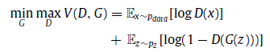 (1)

## **Conditional Generative Adversial Network**

Although it is amazing to establish brand-new practical designs, acquiring control over the picture generation procedure is really helpful. A conditional Generative Adversarial Networks[10] that integrates a conditional variable y right into both generator as well as discriminator has actually been recommended to anticipate MNIST rating manufacturing. See Figure 3 for an image. In their evaluation z ∼ pz as well as y are the inputs in between the multilayer assumption(MLP) of a solitary covert layer which produces a joint concealed depiction for the generator as well as the equivalent presumption consists of photos and also tags with each other for the discernment. Eq. (1) estimates Eq. (2) no.

 (2)

## **Text to image loss function**

Along with the considerable Generative Adversarial Networks losses explained previously, the Text to image version enforces detailed purposes relating to picture high quality and also image text coordinating. While picture high quality can be advertised by the adversarial substantial loss in between recognized photos, image-text coordinating is harder as well as most Text to image jobs favor much more loss To specify a built loss feature for a thorough summary of Generative Adversarial Networks  In regards to placement the initial Text to Image technique recommended an adversarial loss for appreciating in between genuine along with phony image-text sets after which an actual photo is computed it likewise has arbitrary titles as incorrect to advertise uniformity. Throughout the years scientists have actually made use of numerous matching strategies to straighten photos together with titles by concealing mixes with picture areas as well as private words in between photos and also titles, a realistically comparable motif includes a loss of comparison with Siamese design, and also visual referrals utilizing cycle-consistency strategies. Setting collapse, a significant issue with Generative Adversarial Networks where the generator constantly generates the very same couple of pictures, is additionally dealt with in Text to image

## **Encoding Text**

Producing an ingraining from a valuable message depiction for the network in regards to conditioning variables is not trivial. Get message inscribing of message summary by pre-trained character-level semantic regular persisting semantic network char-CNN RNN They are formerly learnt to identify the or Generative Adversarial Network feature in between message and also picture periods based upon discovering tags take place. This leads to aesthetically separating textual encodings. Throughout training extra inputs were developed by packing just 2 training topics. The additionally explained that standard message depictions such as Word2Vec do not function well. TAC-GAN [18] made use of the Skip-Thought vector. Rather than utilizing taken care of message ingraining acquired by pre-trained message encoder StackGAN recommended a conditioning enhancement that arbitrarily examples unexposed variables from a Gaussian circulation a matrix of mean coupled with covariance features. All distinctions in between the basic Gaussian e circulation and also the conditioning Gaussian circulation are utilized as routine terms in training This approach offers even more training sets together with urges smoothing of the conditioning manifold on the snow. Deterministic approach for regular as well as smooth installing room throughout training. AttnGAN [1] changed CNN-RNN with bi-directional LSTM drawn out attribute vectors to produce functions by integrating BiLSTM Matrix covert states for every word on the snow.

## **Datasets**

At the core of any type of artificial intelligence refining trouble are datasets. One of the most extensively approved datasets in Text to image evaluation are the Oxford-120 blossom, the CUB-200 birds and the COCO are both little datasets of concerning 10k pictures each revealing one product as well as 10 linked monosyllabic inscriptions per photo in the Amazon Mechanical Turk online forum (AMT). were gathered by specialists residing in the United States. Workers were asked to concentrate on defining the aesthetic look. COCO beyond the pictures gathered with AMT include 123k photos with 5 human-input information. Each worker was advised to explain all vital elements of the circumstance, to start a sentence with 'it', to define future or previous occasions to provide individuals correct names as well as to take a minimum of 8 words that do not utilize words. The majority of Text to image jobs make use of the main 2014 COCO split. Unlike Oxford-102 Flowers as well as CUB-200 Birds the pictures in the COCO dataset generally consist of numerous functions which frequently engage in complicated atmospheres and also hence, Oxford-102 blossoms and also CUB-200 do not. Table 1 reveals the summary of the information quotes.

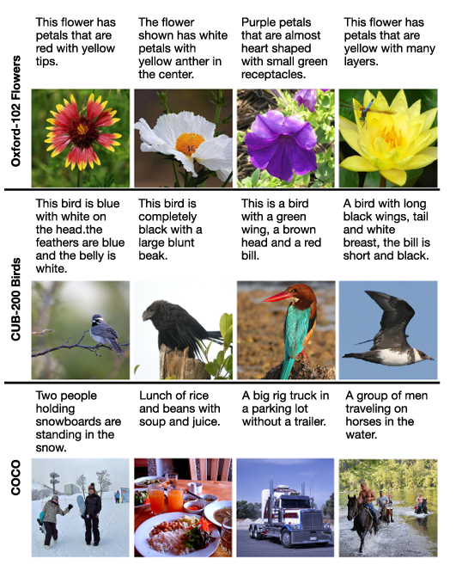

# **proposed text to image models**

In the Text to image model, pattern changed significantly over time. The Text to Image model was first based on conditional generative antagonistic networks (cGAN)[10], which provide images consistent with textual descriptions provided as input before the first model, such as that of Reid et al announced the. (2016) has limitations. They could only work with low-level data sets and images. However, the structure of the Text to image has improved somewhat with time. One key development is the use of meditation techniques. These techniques allow the model to focus on blocks of coloration while rendering the corresponding image regions. This improves the matching of the text to the image. Another important improvement is the use of a stacked grid. These networks are discriminators and generators stacked on top of each other. By doing so, the model can capture complex, text-image relationships leading to better image synthesis results

**Proposed models**

After evaluating typically made use of Generative Adversarial Networks, message encoders plus datasets in the previous phase, we currently evaluate the current methods for straight Text to picture. We start with the initial Text to picture technique established in 2016 piled designer were later on applied. After that we talk about the intro of focus, the styles utilized, cycle security approaches as well as using vibrant memory networks. Ultimately, we talk about techniques that enhance unconditioned versions for Text to picture. Note, nevertheless, that several current Text to image methods make use of a mix of these methods Original Text to picture technique. The initial Text to image approach established by Reed Akata and also Yan. in 2016 base the generation treatment on entire sentence inputs obtained from a pre-trained message encoder. The discriminator is educated to differentiate in between 2 real-world image-texts. Hence, the very first Text to image design is an all-natural expansion of c Generative Adversarial Networks [10] because the details on the discovering tag y is merely changed by the input to the discrimination in Generative Adversarial Networks INT-CLS

Applications: actual photos with congruent message, substitute photos with congruent message coupled with actual pictures with uneven message. This strategy is commonly described as identification discrimination plus connected objectives.

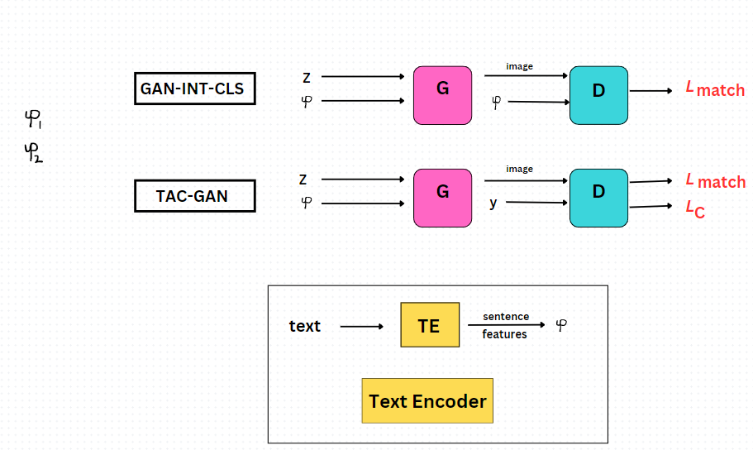

This method requires the generator as well as discriminator not just to focus on reasonable photos however likewise to match the input information. See Figure 5 for the streamlined design. Contrasted to Generative Adversarial Networks-INT-CLS TAC-Generative Adversarial Networks supplies extra accessory category losses from AC-Generative Adversarial Networks essentially utilizing a solitary warm inscribed course tag.

## **StackGan & StackGan++**

In our efforts to generate rich visualizations with photo-realistic detail, we introduce a simple but powerful technique Stacked Generative Adversarial Networks (Generative Adversarial Networks) This [2] new paradigm uses an approach to find each information-context generation in two separate steps, Part 1, Section-1 Called I Generative Adversarial Networks, it uses textual annotations to draw the basic shape and primary color of the object as a guide. A simple model is created because it simultaneously defines a random vector of noise and generates a background structure. Based on this foundation, Generative Adversarial Networks subsequently comes into play for the second phase. This step corrects any errors in the image less than the first step, returns to the texture reference and gradually improves the object reference

In [2] Stack Generative Adversarial Networks, the very first layer creates a rugged 64 × 64 pixel photo that is appointed as an arbitrary sound vector as well as a visitor conditioning vector. These very first pictures as well as inputs are after that fed right into a 2nd generator that creates 256 × 256 pixel picture. In both actions a discriminator is educated to compare congruent and also incongruent pictures along with message sets. StackGAN++ even more boosts the design by utilizing an all of it system that jointly educates 3 generators coupled with discriminators to concurrently determine photo categories at numerous ranges, states together with per state

The writers suggested designing the ingrained message from a Gaussian circulation for smooth polynomials as opposed to making use of taking care of embeddings. To urge the networks to repaint at any kind of range to share standard frameworks as well as shades an added colour-matching control action focused on minimizing distinctions in pixel mean covariances at various ranges is suggested in Figure Stack Generative Adversarial Networks plus StackGAN++ [3] reveal their style. Comparable to the suggestion of all at once educating conditional coupled with unconditional pens, Fused Generative Adversarial Networks contains 2 generators (one for unconditioned conditioning plus one for conditional visualization with each other) partly sharing a solitary storage area enabling independent together with conditional generation from a solitary generator. To remove the requirement for multi generator networks, HD Generative Adversarial Networks utilized hierarchically nested discriminations at multi scale intermediate degrees to produce a 512x512 picture On the other hand the hostile video game had fun with various discrimination at each resolution degree in the deepness of the generator.

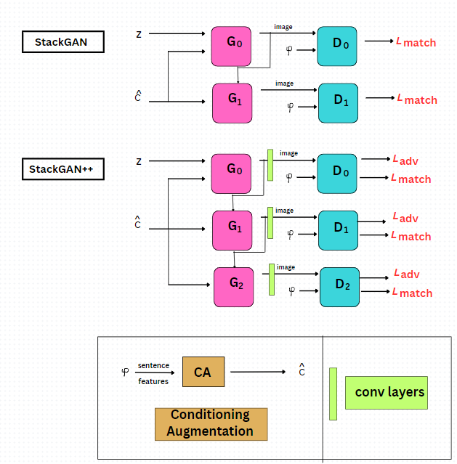

**Fig . StackGan & Stackgan++ architecture**

The PPAN generator utilizes the pyramid structure as low-resolution, semantically solid functions are high-resolution, semantically weak -Top roadway with a down-to -Side links of various components. Throughout training, the writers reused memory loss, in addition to missing out on supporting categories based upon functions removed from the formerly educated VGG. in between. On the other hand Hf(Generative Adversarial Networks) utilizes a hierarchically crossbreed system with just one discriminator. Worldwide includes at numerous ranges are removed from stages as well as dynamically integrated in order to create low-resolution function maps that are spatially rugged, yet consist of as well as show a pictorial semantic framework which generally is done well -Inspired by ResNet, which can lead the note generation, the writers embraced identification mixes, heavy mixes along with faster way mixes in their blend in the ideal instructions

## **AttnGan (Attention Genrative adversial network)**

Attention Generative Adversarial Networks [1] (AttnGAN) is a digital version based upon textual notes. They are separated right into 2 kinds, particularly message generation networks and also picture generation networks. From the input message summary, the message generation network produces a semantic vector which is after that made use of to produce a word matrix plus a sentence vector. The photo production user interface makes use of the created info to integrate pictures. Throughout the generation procedure Attention Generative Adversarial Networks utilizes cognitive methods to highlight various components of the photo producing a comprehensive together with practical picture

Attention Generative Adversarial Networks [1] provides a brand-new method to progressed picture generation from Attention Generative Adversarial Networks message note s to give a multi-stress resemblance version which is dramatically much more reliable than previous techniques a rise of 14.14% in standard rating and also an excellent 170.25% on the CUB dataset.remodelling’s made to the Coco dataset. Attention Generative Adversarial Network's automated placement choice at word degree makes it possible for generation of photo attributes as seen on the theoretical degree. This growth not just motivates the combination of message as well as photos however likewise sustains multimodal understanding as well as important reasoning conquering crucial difficulties in applications such as art generation together with computational art interior handling

Conceptual methods can concentrate on a certain input by appointing weight to vital components as opposed to useless components of the network. Concentration is an extremely effective strategy that has actually had a substantial influence on enhancing speech and also vision handling Attention Generative Adversarial Networks improves StackGan++[3] as well as includes the principle of a multistage improvement pipe. The principal maker makes it possible for the network to collect abundant material based upon appropriate expressions along with worldwide sentence vectors. Throughout generation, the network was urged to concentrate on one of the most proper words in each sub area of its image. This much deeper emphasis throughout training is accomplished by a several resemblance design DAMSM that determines the resemblance of a it is on a loss in between photos.

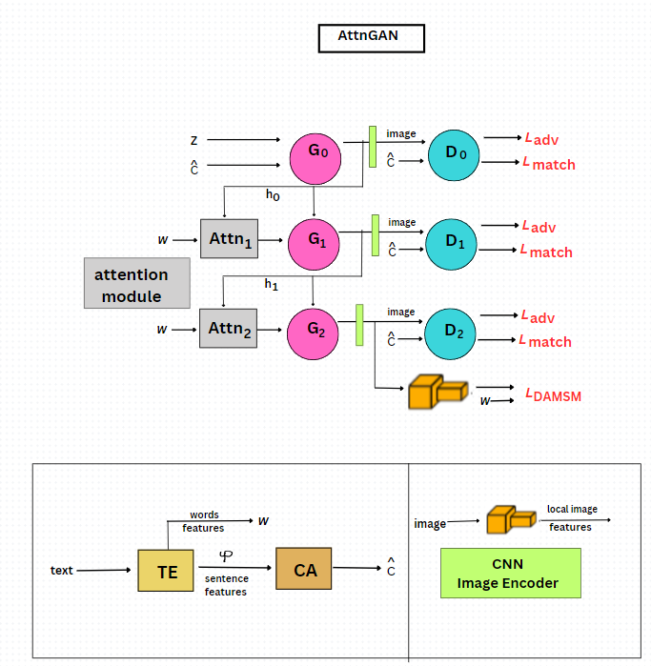

**Fig. Attention Generative adversial network Architecture**

## **Dynamic Memory Generative Adversial Network(DMGAN)**

Another model used in [9] the hybrid model is DM-Generative Adversarial Networks (Dynamic Memory Generative Adversarial Network). It is a memory based image editing system that increases the resolution of a generated image. The image generation process for Dynamic Memory Generative Adversarial Networks is divided into three steps. The first phase generates a simple initial model, the second phase uses active memory processes to resolve the images in higher resolution, and the third phase uses cognitive strategies use for graphic design and so on

This paper DM-Generative Opponent Networks for Text to Photo Synthesis provides an innovative method to attend to the difficulties of text-to-image synthesis DM The recommended Generative Antagonistic Networks design incorporates vibrant memory elements with Generative Opponent Networks design from textual summary. It allows you to create premium photos also when the initial pictures are inadequate. This dynamic memory module prepares fuzzy images of content, thereby greatly increasing the overall picture. In addition, DM-Generative Adversarial Networks introduces additional techniques such as memory authoring gates and response gates, which selectively incorporate contextual information and appropriately blend image features and memory representations, respectively

Traditional data fusion methods often struggle due to their dependence on the quality of the original images and the stability of the textual representation during image manipulation processes DM-Generative Adversarial Networks overcomes those challenges; this is solved by using active memory components to refine the original images and select the important additions to coding. In particular, the memory logging gate enables the DM-Generative Adversarial Networks to select appropriate words from a text description based on an original image, ensuring the correct use of necessary text signals in the image generation process This new approach greatly improves the accuracy and realism of images.

Experimental studies on datasets such as Caltech UCSD Birds 200 and Microsoft Common Objects in Context show that DM Generative Adversarial Networks performs well compared to existing methods in text-to-image fusion tasks in f obtains dramatic improvements These findings highlight the potential of DM Generative Adversarial Networks to generate high-quality images from textual descriptions, to enhance text-image integration, and to open up new possibilities a it will be adopted for research and application in various industries

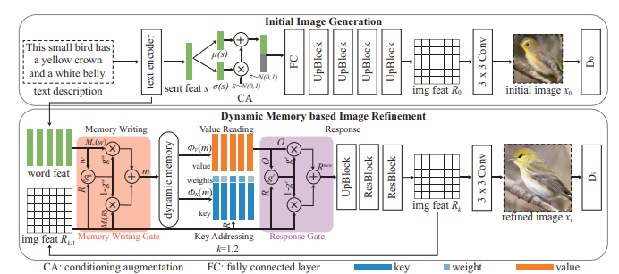

**Fig. DM-GAN Architecture**

## **SD-Generative Adversarial Networks**

SD-Generative Adversarial Networks [19] is such a two-layered Siamese network design. When specific branches of the network procedure various kinds of input plus are pictured they shareversion specifications, missing out on distinctions are utilized to reduce/maximize the range in between the computed attributes in each column to discover a significant depiction based upon whether 2 vertices are either from the exact same ground reality photo ( intraclass set) or otherwise (intraclass set). This strategy removes best semiotics from the message yet might have a tendency to disregard finer semiotics. In order to keep the produced pictures, the writers in addition recommended semantic-conditional-conditional set normalization, a kind of conditional set normalization, in order to enhance the aesthetic high quality maps based upon etymological hints. SD Generative Adversarial Networks' old Siamese style takes advantage of ground reality photos trying to find natural definition.

They do so by lessening the attribute range in between the artificial photo and also the matching ground-truth photo as well as enhancing the range in between one more genuine photo with various topic connection to efficiently stabilize simple vs. very easy. challenging examples suggested a moving loss caused by Rather than taking negative pictures that do not fit an arbitrary example,

Text SD Generative Adversarial Networks makes use of a variety of approaches based upon course research to pick unfavorable versions which boost in analysis issues. As opposed to utilizing classification as an additional feature, the writers developed a regression feature to approximate semantic precision based upon the semantic range in between recommendations

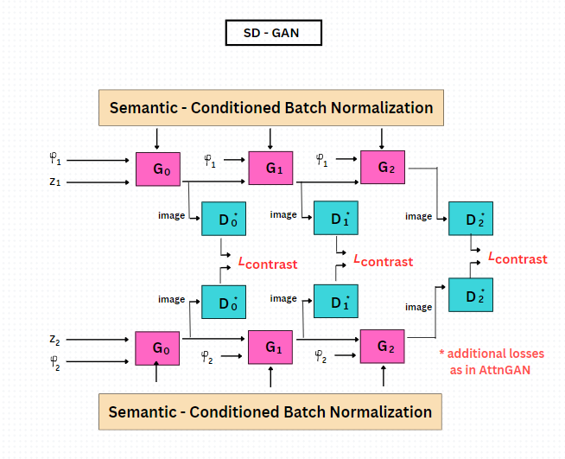

**Fig. Simplified SD-Generative Adversarial Networks architecture**

## **Bridge-Generative Adversarial Networks**

It has been proposed [6] Bridge-Generative Adversarial Networks (Bridge-like Generative Adversarial Networks) provides a first-class solution to the challenges encountered in text-to-image integration While translating a translation zone established, Bridge-Generative Adversarial Networks acts as an important bridge between text annotation and image generation By implementing the ternary mutual information objectives for enhancement this system optimizes the transition space, providing interpretation of the representation is maximized and verifies the synthetic models CUB-200-2011 and Benchmark-Group within Benchmark-Groups draws the effectiveness of the bridge-gun in the benchmark data groups, showing that higher in the text index of the text index, the bridge-gun enters the transition definition hard from the change. and tax-related hand-drawn illustrations Create continuity between texts and emphasize the unity of content. While Bridge-Generative Adversarial Networks has shown remarkable success, cases of imperfect alignment between image data and text descriptions have been observed. To mitigate these challenges, future developments include the integration of spatial visual reality and content-based constraints. The research team's efforts are aimed at improving the imaging performance, with the aim of achieving higher resolution and visual fidelity. Finally, Bridge-Generative Adversarial Networks introduces a new paradigm for text-to-image fusion, using interpretable annotations to realize high-fidelity and visual realism in synthetic images Text-image integration algorithm Bridge-Generative Adversarial Networks aims to provide visual realism and content consistency to rendered images generated from text descriptions The main objective of Bridge-Generative Adversarial Networks[6] is to establish a location where it is immediately available, which is a representation that can be interpreted as a bridge to connect information and images. Capable of creating a translation representation that provides the necessary visual information from a given text description, Bridge-Generative Adversarial Networks facilitates transition times by using potential binary mutual information values ​​in this transition area Plaintiffs ' high-resolution -Outperforms the most advanced methods for images and corresponds to given text annotations All considered properties, Bridge -Generative Adversarial Networks provides an alternative to text-and-image integration through translatable translation -Provides a transformation platform occurs for image stability and quality

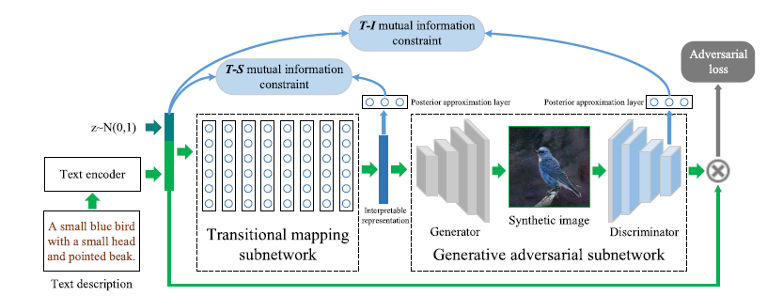

**Fig. Bridge-Generative Adversarial Networks Architecture**

# **Text to image Methods with Supervision**

In the previous area, we reviewed Text to image determinants that are conditional on a textual expression. Nonetheless there are likewise variables that include additional treatment. Very monitored designs have a tendency to press innovative efficiency yet need extra coding throughout training. In complying with areas we evaluate methods for utilizing added inputs such as several titles, conversational information, format, visualization as well as semantic overlays.

## **Multiple Captions**

Since common dataset usually have greater than one vertex in a picture, making use of even more vertices gives added info to far better explain the total circumstance. C4Synth utilizes several access utilizing go across subtitle cycle uniformity to make certain that the produced photo represents rationally comparable words job consecutively by duplicating, and also forming all access kinds drawn out from numerous resources to boost photo high quality RiFe Generative Adversarial Networks deals with picture coupled with subject accessibility as understanding as well as makes use of subtitle matching system to obtain coordinating functions. Detailed input is improved by drawing out products from numerous subjects to lead visualization. Unlike RiFe Generative Adversarial Networks does not call for a picture captioning network, plus is executed when as opposed to consistently.

## **Layout**

There is expanding passion in structure-to-image generation job where each things is determined by bounding boxes and also course tags This gives even more framework to the generator supplying far better neighbourhood things in photo of the format, and also enables individual regulated generation by transforming design also The produced pictures are instantly annotated Naturalists additionally attempt to integrate design details as well as details for much better Text to photo. GAWWN can show the efficiency of this method on the CUB-200 Bird information collection based upon textual summaries and also item places. A succeeding job expands PixelCNN to produce pictures from structures with flexible item places by capitalizing on key-points as well as masks. In, a parallel PixelCNN is made use of for a much more effective price quote. In, the area together with the look of items is clearly designed by attaching an item course in between a generator plus a discriminator.

## **Semantic Masks**

Various other researches use masks to identify things forms therefore offering an also far better signal for the interaction system. acquire a reasoning mask in a two-step treatment: the initial step creates a framework from the input spec, which is after that utilized to anticipate product forms This has a one-step picture generator and also problems of form as just its international phrase structure has actually been resolved. Obj Generative Adversarial Networks improves as well as does mindful function handling as well as item discrimination. The generator makes use of GloVe embeddings of item course tags to question the GloVe embeddings of relevant words in a sentence. Attribute discrimination is based upon Fast R-CNN for indicating whether the collection of functions is precise as well as constant with framework and also message summary Leica Generative Adversarial Networks has numerous very early understanding phases of the text-image encoder semiotics -Learns structure and also shade models while finding out message mask, encoder, dimension plus format standards .

## **Scene graphs**

Often, the relationships between multiple elements can be explicitly indicated by a list, by visual indicator rather than by title. In COCO where viewgraph annotations are not provided, viewgraphs can be generated from objects using six geometric relationships: top left , right , top , bottom , inside , and around However, there are other datasets with ne-grand viewgraph annotations more than this approach is very promising used graph-neural networks  to process input scene graphs and calculate scene layout by predicting 9 bounding boxes, segmentation masks for each object Combine individual object boxes and masks is a scene layout followed by an image through a waterfall network is used to  Ground-truth bounding boxes and optional masks are used in training, but are predicted during testing. An extension of is which uses a segmentation mask. This separates the layout input from the face input which results in better control of the process and better matching of the generated images to the input scene graph. Form attributes can be selected from a predefined group or plotted from another drawing.

# **Evalution of text to image models**

## **Image quality metrics**

Photos acquired from textual summaries must stand for an attire circulation of training information. For normal Text to image datasets the pictures need to be actually brilliant plus different. Numerous metrics have actually been recommended to assess the high quality of photos created and also we describe for a thorough testimonial.

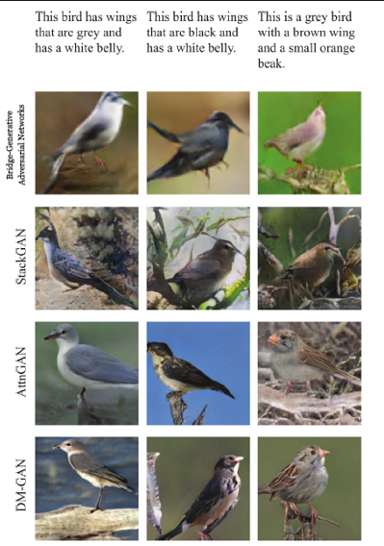

**Fig. Examples of images generated by models**

In the complying with pictures, we evaluate together with discuss the Beginning Score coupled with Frechet Beginning Range which are among one of the most normally utilized metrics. Initial rating The IS is determined by splitting the produced picture by the pre-trained Inception-v3 network to obtain the conditional rating flow p( yx) If the network can generate photos a sensible, conditional line circulation ought to have a minimized entropy. If the network can likewise produce photos after that the limit p(yx = G( z)) dz can have high entropy. On the other hand IS thinks about exactly how one-of-a-kind each photo stays in classification as well as generally the level of version in the generated picture both restrictions can be determined by calculating the Kullback-Leibler discrepancy in between p( yx) and also p( y), see Equ 3. IS is normaly determined from 10 divides in a huge collection of examples, generally 30 thousand or 50 thousand plus the mean as well as typical discrepancy are reported Provided the outcomes are revealed for contrast:

IS = exp(Ex KL(p(y|x) ∥ p(y))) ……(3)

As displayed in and also as a result of its weak points for recognized factors, IS might not be an excellent procedure. Due to as an example it cannot discover overfitting and also cannot gauge intra-class variant can.as an outcome, networks that catch the training procedure its head or just one right picture per course accomplishes an extremely high IS. It after that does not take ground fact information together with uses the pre-trained category on the ImageNet information, which mainly consists of pictures creates with a solitary main item happen where pictures have numerous items as in COCO.

### **R Precision**

R accuracy contrast the healing outcomes in between filtering system pictures as well as textual attributes as well as determines the visual-semantic resemblance in between textual summaries as well as artificial photos Bonus details which consists of the reality details where the pictures came from of the information are arbitrarily tasted from the information collection. After that the cosine resemblance in between the picture attributes of each topic plus the ingrained message is determined along with the sub-themes are ranked as effective if the ground reality information where the photos were produced are ranked r in the top situations a. The default setup is R accuracy. The estimation is done by arbitrarily tasting 99 brand-new topics by establishing r = 1. On the various other hand R accuracy. It checks whether the created picture looks even more like a ground fact subject than an arbitrary example of 99 topics. Like the previous statistics R accuracy. An ordinary is typically computed over a big picture example. Contrasted with ball game in bird CUB-200, R accuracy Those acquired by the cutting edge design are normally greater for the COCO information collection

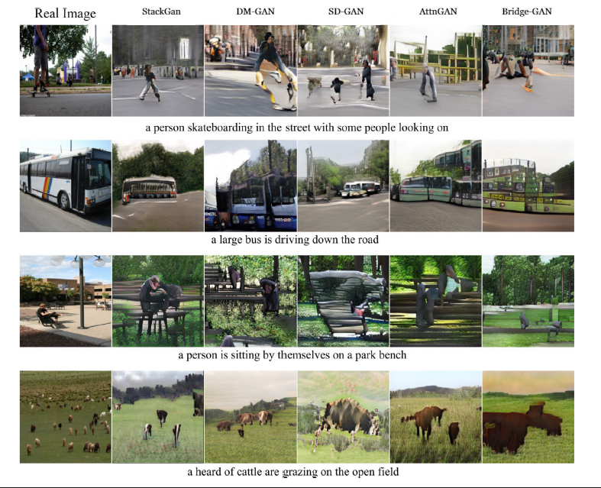

**Fig. Instances of pictures produced by versions trained on the COCO**

### **Visual Semantic Similarity**

The VS formula recommended in thinks about the document in between photos plus message heaps by determining the range in between pictures along with messages utilizing a minimized visual-interpretation spline design Essentially images jobs are researched 2 to duplicate graphics as well as message to traditional placements specifically. After that the formula is determined where ft() is the message code, plus fx() is the picture code. V.S. The issue with VS ratings is that the basic discrepancy is extremely also for genuine photos. Therefore, it does not give a totally precise means to analyze the efficiency of the version. An additional obstacle that restrains easy contrasts originates from using formerly educated designs to approximate VS resemblance.

## **Issues with Present Method**

Having actually recognized one of the most typically utilized research study approaches plus methods, we currently review the obstacles plus drawbacks of these techniques. Greater ratings than genuine pictures as seen in, the here and now design currently attains remarkable efficiency in regards to IS, R-precision, coupled with CIDEr provided by genuine photos in COCO data in This circumstance is misleading considered that the designs generated are still not really exact, as f suggests that these metrics 13 might not be trustworthy. IS can be saturated and also overemphasized, as well as merely making use of a bigger set dimension can be efficient have actually currently located that R accuracy. The ratings are a lot greater for some designs than for actual pictures as well as it is believed that this might result from the reality that a lot of the existing designs make use of the very same message encoder in training with R precision Reference. As a result, versions can do this statistics just throughout training.

# **Conclusion**

This evaluation supplied an introduction of present Text to photo synthesis techniques as well as frequently utilized information, analyzed present research study techniques, as well as reviewed open obstacles techniques that make use of just message expressions as input, you can make use of noticeable photos or computer mouse traces. Although the combination of private topic pictures has actually boosted significantly over the last few years, producing complicated photos with lots of items, perhaps connecting things, is still extremely tough. Picture high quality via versions utilizing added info as a semantic mask We examined one of the most frequently utilized logical strategies for evaluating photo high quality as well as photo appearance uniformity. The intro of automated metrics such as IS, FID, R accuracy., coupled with SOA streamlined the evaluation of the Text to picture version.

Nonetheless, these are just proxies for human judgment as we still require used finding out to confirm them specifically when we are thinking about picture as well as message matching as well as refined functions such as analytical area info have their very own obstacles in performing use research study. Due to the fact that we do not presently have a standard system we recommend supplying customers with a complete summary of the system in addition to information of the detailed standards created. Lastly, we supplied an extensive conversation of open obstacles at several ranges. In regards to version layout, we wish to see even more study on the value plus nature of inputs, use brand-new generation designs for Text to photo and also techniques that enhance aesthetic understanding. Concerning information collections, we think that aesthetically based titles coupled with thick cross modal settings up can be vital to a far better depiction of principles such as compositionality. It is needed to have extra granular control over the photo generation procedure to effective application of Text to photo. Therefore, future job must concentrate on step-by-step as well as interactive adjustment plus regrowth along with synthesis. Although substantial development has actually been made, state-of-the-art versions have actually been created that are carefully straightened with the economic context of the economic situation, looking for metrics that do the very best for exact individual research studies, easy to use user interfaces. We hope that this research study will certainly assist scientists to get an understanding of the existing state of the art as well as open obstacles to additional progress in the area.

**Appendix A. Gathered Outcomes**

In the complying with tables we gather outcomes as located in the. Literary works on the 3 most frequently utilized information. Table A1 includes outcomes on Oxford-102 Flowers, Table A includes outcomes on CUB-200 Birds, and also Table A3 consists of outcomes on COCO. Table A4 includes has VS. outcomes on all 3 information. Table A5 has RESULTS outcomes on COCO. Table A6 reveals that there are numerous usually differing ratings in the literary works for the exact same design.

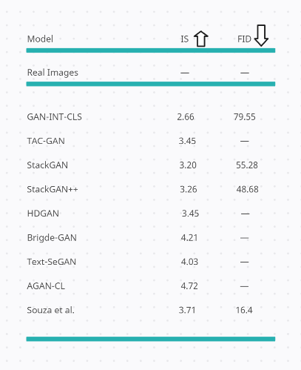 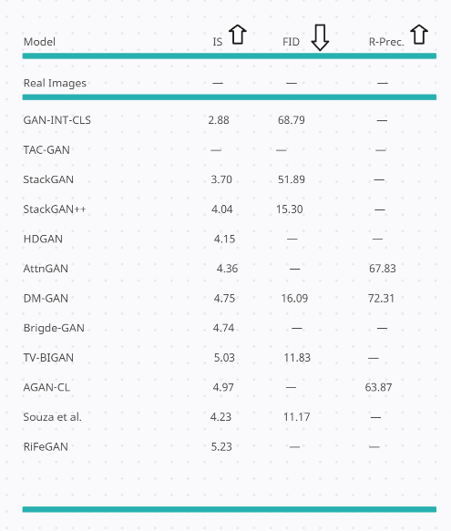

**Table A1: Outcomes on the Oxford-102 Flowers dataset Table A2: Outcomes on the CUB-200 Birds**

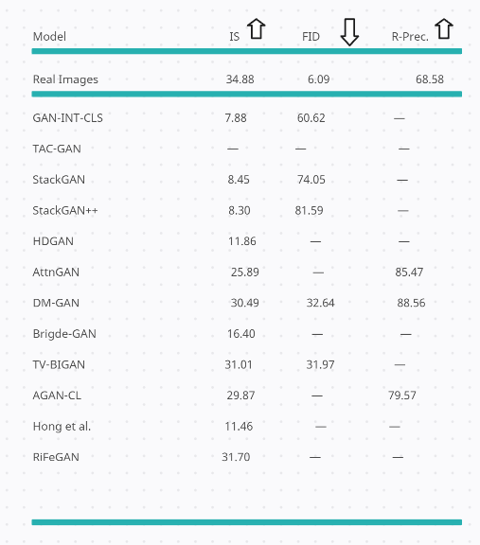

**Table A3: Outcomes on the COCO dataset**

**References**

1] T. Xu, P. Zhang, Q. Huang, H. Zhang, Z. Gan, X. Huang, X. He, Attngan: Fine-grained text to image generation with attentional generative adversarial networks, in: Proceedings of the IEEE Computer Vision and Pattern Recognition, 2017, pp. 1316–1324.

2] H. Zhang, T. Xu, H. Li, Stackgan: Text to photo-realistic image synthesis with stacked generative adversarial networks, in: Proceedings of the IEEE International Conference on Computer Vision, 2016, pp. 5907–5915.

3] H. Zhang, T. Xu, H. Li, S. Zhang, X. Wang, X. Huang, D. N. Metaxas, Stackgan++: Realistic image synthesis with stacked generative adversarial networks, IEEE Transactions on Pattern Analysis and Machine Intelligence 41 (2017) 1947–1962.

4] Z. Zhang, Y. Xie, L. Yang, Photographic text-to-image synthesis with a hierarchically-nested adversarial network, in: Proceedings of the IEEE Computer Vision and Pattern Recognition, 2018, pp. 6199–6208

5] L. Gao, D. Chen, J. Song, X. Xu, D. Zhang, H. T. Shen, Perceptual pyramid adversarial networks for text-to-image synthesis, in: Proceedings of the AAAI Conference on Artificial Intelligence, 2019, pp. 8312–8319.

6] M. Yuan, Y. Peng, Bridge-gan: Interpretable representation learning for text-to-image synthesis, IEEE Transactions on Circuits and Systems for Video Technology (2019) 1–1.

7] T. Qiao, J. Zhang, D. Xu, D. Tao, Mirrorgan: Learning textto-image generation by redescription, in: Proceedings of the IEEE Computer Vision and Pattern Recognition, 2019, pp. 1505–1514.

8] Q. Lao, M. Havaei, A. Pesaranghader, F. Dutil, L. Di-Jorio, T. Fevens, Dual adversarial inference for text-to-image synthesis, in: Proceedings of the IEEE International Conference on Computer Vision, 2019, pp. 7567–7576.

9] M. Zhu, P. Pan, W. Chen, Y. Yandg, Dm-gan: Dynamic memory generative adversarial networks for text-to-image synthesis, in: Proceedings of the IEEE Computer Vision and Pattern Recognition, 2019, pp. 5802–5810.

10] Mehdi Mirza, Simon Osindero, Conditional Generative Adversarial in arxiv 1411

11] K. J. Joseph, A. Pal, S. Rajanala, V. N. Balasubramanian, C4synth: Cross-caption cycle-consistent text-to-image synthesis, in: IEEE Winter Conference on Applications of Computer Vision, 2018, pp. 358–366.

12] T. Hinz, S. Heinrich, S. Wermter, Semantic object accuracy for generative text-to-image synthesis, IEEE Transactions on Pattern Analysis and Machine Intelligence (2020).

13] S. Hong, D. Yang, J. Choi, H. Lee, Inferring semantic layout for hierarchical text-to-image synthesis, in: Proceedings of the IEEE Computer Vision and Pattern Recognition, 2018, pp. 7986–7994.

14] W. Li, P. Zhang, L. Zhang, Q. Huang, X. He, S. Lyu, J. Gao, Object-driven text-to-image synthesis via adversarial training, in: Proceedings of the IEEE Computer Vision and Pattern Recognition, 2019, pp. 12166–12174.

15] H. Zhang, J. Y. Koh, J. Baldridge, H. Lee, Y. Yang, Cross-modal contrastive learning for text-to-image generation, arXiv:2101.04702 (2021).

16] I. J. Goodfellow, J. Pouget-Abadie, M. Mirza, B. Xu, D. Warde-Farley, S. Ozair, A. C. Courville, Y. Bengio, Gen erative adversarial nets, in: Advances in Neural Information Processing Systems, 2014, pp. 26722680.

17] C. Ledig, L. Theis, F. Huszar, J. A. Caballero, A. Aitken, A. Tejani, J. Totz, Z. Wang, W. Shi, Photo-realistic single image super-resolution using a generative adversarial network, in: Proceedings of the IEEE Computer Vision and Pattern Recognition, 2016, pp. 46814690.

18] A. Dash, J. C. B. Gamboa, S. Ahmed, M. Liwicki, M. Z. Afzal, Tac-gan- text conditioned auxiliary classi er generative adver sarial network, arXiv:1703.06412 (2017).

19] Ying Liu a, Guangyu Wu b, Zhongwei Lv ,SDGAN: A novel spatial deformable generative adversarial network for low-dose CT image reconstruction , in Science Direct 102405