**Transformer Monitoring And Control System**

Amit Kr. Mahant1, Dev Ashish Singh Banafar1, Harshvardhan Patel1, Pushpkant Sahu1, Swapnil Rathore1,

B. Chiranjeev Rao2

UG Students, Shri Shankaracharya Technical Campus, Bhilai, Chhattisgarh, India1

Assistant Professor, Shri Shankaracharya Technical Campus, Bhilai, Chhattisgarh, India2

**ABSTRACT:** When it comes to power systems, transformers are the most important construction piece. When a transformer sustains damage, it has a negative impact on the overall balance of a power system. Damages are mostly happening as a result of overloading and cooling that is not functioning well. One of the primary goals of the Internet of Things(IoT) technology implementation is to perform real-time monitoring of the health conditions of the distribution transformer. A transformer's properties, which include temperature, voltage, current, and oil level, are monitored, processed, and recorded on servers. These parameters include oil level. In order to do this, we make use of sensors that are attached to a Espwroom 32 microcontroller. With the use of Internet of Things technology, the data that has been collected may be sent via a Wi-Fi module and accessible from any location in the globe. Without human supervision, this assists in determining the extent of human reliance and finding a solution to a problem before it becomes a failure.

Keywords.: *Microcontrollers, Internet of Things Technology, Health Conditions, and Transformers.*

**I. INTRODUCTION**

Electricity is an essential component in almost every aspect of our lives. Electricity is essential to every one of our moments in life. Electricity is comprised of a variety of components and apparatus that assist humans in transferring and regulating the distribution of electricity according to their needs. When it comes to the transmission and distribution of electric power, the transformer is the most important piece of equipment. Distribution transformers are guaranteed to have a long service life if they are used at their rated conditions (as specified on their nameplate). On the other hand, their lifespan is greatly reduced if they are exposed to overloading, heating, low or high voltage current, which ultimately leads to an unexpected failure and the loss of supply to a large number of customers, which in turn affects the dependability of the system. Overloading, oil temperature load current, and insufficient cooling of the transformer are the primary factors that lead to failure in distribution transformers. In today's electric systems, it is impossible to manually assess the state of each and every transformer since there are a significant number of transformers that are dispersed over a big region. Therefore, we want a distribution transformer system that can monitor the functioning of all key parameters and communicate the information to the monitoring system at the appropriate moment. It offers every piece of information that is required on the condition of the transformer. This will assist and direct the utilities in making the most efficient use of the transformer and ensuring that this equipment continues to function for a longer length of time. The acquisition of real-time data of transformers remotely via the Internet, which falls under the category of Internet of Things (IoT), is the primary objective of the project which is being undertaken.

**II. METHODOLOGY**

This project under consideration offers the design and implementation of an Internet of Things embedded system that is capable of measuring load currents, over voltage, transformer oil level, and temperature. Using a single-chip Arduino microcontroller and sensors, this is accomplished via the use of an online measurement system that is connected to the Internet of Things (IoT). Installation takes place at the location of the distribution transformer. After being processed, the values that are produced by the sensors are then stored in the memory of the system. There are certain preset commands that have been coded into the system to check for aberrant situations. Details are immediately updated on the internet using serial communication in the event that there is any anomaly on the system. Through the use of this Internet of Things (IoT), utilities will be able to make the most efficient use of transformers and detect any potential issues before they result in a catastrophic collapse. In order to gather and evaluate temperature data over a period of time, an online measurement system is used therefore. Therefore, Transformer Health Measuring will be of assistance in identifying or recognizing unexpected conditions before to any catastrophic failure, which will result in increased dependability and considerable cost savings. The transformer is an essential piece of electrical equipment that is used in the power system. It is possible to avoid failures that are expensive to fix and result in a loss of energy by monitoring the transformer for problems before they arise throughout the monitoring process.

**III. MODELING AND ANALYSIS**

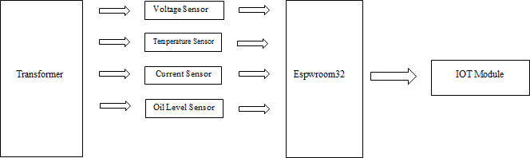

**Figure 1:** Block Diagram

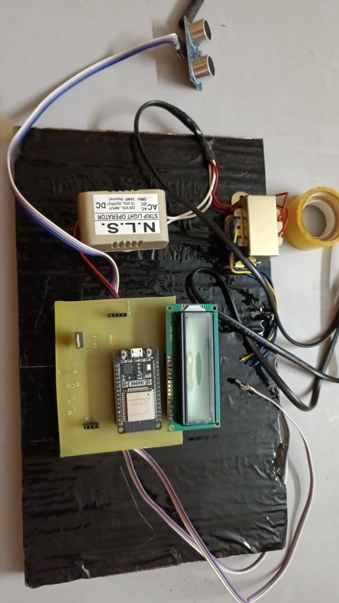For the purpose of our proposed real-time framework, we take a voltage sensor, an oil level sensor, a current sensor, and an LM35 temperature sensor for the purpose of monitoring the voltage, current, and temperature of the transformer, respectively, and then we send these sensors to a location of our choosing anywhere in the world. These three analog values were obtained by connecting a programmable microcontroller Arduino to a multiplexing mode and taking the necessary measurements. Following that, the values are sent directly over a Wi-Fi module using the TCP/IP protocol to a dedicated IP address, which then displays the data in the form of a real-time chart on any web-connected personal computer, laptop, or mobile device for display. Additionally, the real-time data may be seen at the sending end, which is an Android application that is interfaced with the microcontroller. Step-down transformer 230/12V, which reduces the voltage to 12V AC, is used to provide power. This transformer is responsible for stepping down the voltage. Using a bridge rectifier, this is converted to direct current (DC), and then it is regulated to +5V using a voltage regulator 7805, which is necessary for the operation of the Arduino. Additionally, 3.3 Volt is required for the connection of the Wi-Fi unit and other components. The microcontroller will send a data message to an Android application and a laptop in the event that the following conditions occur: overvoltage, less oil, overtemperature, and overcurrent.

**III. RESULTS AND DISCUSSION**

**Figure 2:** ProjectHardware

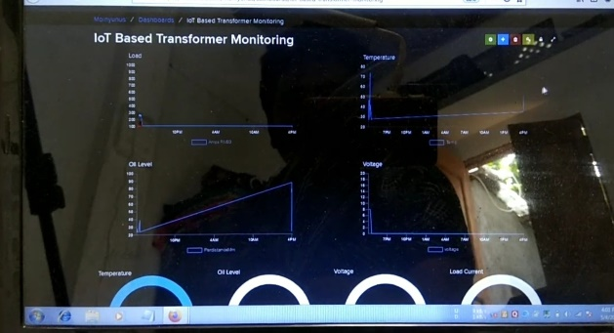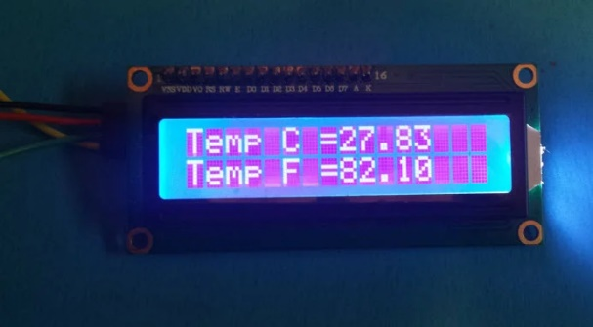

**Figure 3:** Experimental Results

It has been shown form above results that the use of the suggested method that the protection system functions appropriately and accurately. Furthermore, the sensitivity of this scheme is quite high for abnormal and defective circumstances. Transformer Health Monitoring will assist in identifying or recognizing unforeseen conditions before to any catastrophic failure, which will ultimately result in increased reliability, dependability, and considerable cost savings. If the transformer is in an abnormal state, we are able to determine this from any location. There is no need for human power to monitor the transformer. The website is automatically updated with the latest information on the transformer. voltage to direct current.

**IV.CONCLUSION**

The primary objective of the project is to design and build a Transformer Monitoring System that is connected to the Internet of Things and has the capability to show the current status of the transformer in real time. Subsequent to the completion of the device's fabrication, the system underwent satisfactory testing. Through the use of Wi-Fi, the gadget is able to monitor the state of the transformer and transmit the data that has been gathered from the sensors. This information is then presented on the Internet of Things (IoT) platform.

**REFERENCES**

[1] R. a. D. S. Pawar, "Health condition monitoring system for distribution transformer using internet of things(IoT)," in International Conference On Computing Methodologies And Communication(Iccmc), 2017.

[2] Techopedia, "techopedia," [Online]. Available: www.techopedia.com/definition/28247/internet-of-things-iot. [Accessed 30 October 2018].

[3] AEMO, "About the industry," [Online]. Available: www.aemo.com.au/about-aemo/aboutthe-industry. [Accessed 2 March 2019].

[4] M. M. a. S. Ballal, "Online condition monitoring system for substation and service transformer," IET Electric Power Applications, vol. 11, no. 7, pp. 1187-1195, 2017.

[5] M. a. S. Wang, "Review of condition assessment of power transformer in service," IEEE Electrical Insulation Magazine, vol. 18, no. 6, pp. 12-25, 2002.

[6] A. a. B. Zargari, "Acoustic detection of partial discharges using non-intrusive optical fibre sensors," in IEEE 6th International Conference On Conduction And Breakdown In Solid Dielectrics, 1998.

[7] F. Systems, "www.flir.com/power-distribution," [Online]. Available: www.flir.com/powerdistribution. [Accessed 10 March 2019].

[8] E. C. a. F. Mackenzie, "Online-monitoring and diagnostics for power transformers," IEEE International Symposium on Electrical Insulation, pp. 1-5, 2010.

[9] X. a. C. H. Ding, "On-line transformer winding's fault monitoring and condition assesssment," in Asian Conference on Electrical Insulating Diagnosis (ACEID 2001), 2001.

[10] A. a. I. Abu-Siada, "A novel online technique to detect power transformer winding faults," IEEE Transactions on Power Delivery, vol. 27, no. 2, pp. 849-857, 2012.