VIRTUAL HEALTH ASSISTANT

Agjelia Lydia C

Department of Computer Science

Sri Shakthi Institute of Engineering and Technology

Coimbatorem India

[agjelialydiacse@siet.ac.in](mailto:agjelialydiacse@siet.ac.in)

Rohith U

Department of Computer Science

Sri Shakthi Institute of Engineering and Technology

Coimbatore, India

[rohithu22cse@srishakthi.ac.in](mailto:rohithu22cse@srishakthi.ac.in)

Shreenethi A.M

Department of Computer Science

Sri Shakthi Institute of Engineering and Technology

Coimbatore, India

[shreenethiam22cse@srishakthi.ac.in](mailto:shreenethiam22cse@srishakthi.ac.in)

Thejasswiini S

Department of Computer Science

Sri Shakthi Institute of Engineering and Technology

Coimbatore, India

[thejaaswiinis22cse@srishakthi.ac.in](mailto:thejaaswiinis22cse@srishakthi.ac.in)

Yashvanth Kumar E Department of Computer Science

Sri Shakthi Institute of Engineering and Technology

Coimbatore, India

[yashvanthkumare22cse@srishakthi.ac.in](mailto:yashvanthkumare22cse@srishakthi.ac.in)

1. **ABSTRACT**

*This virtual health assistant is being offered as a full-service web-based companion to guide you through your health journey. Simplify your healthcare experience with easy appointments directly through the platform, allowing you to connect with the right doctors at your convenience. No more waiting rooms – schedule your call-in seconds, anytime, anywhere. Need immediate guidance? This virtual health assistant also facilitates secure online chats with doctors, allowing you to discuss your concerns from the comfort of your own home. In addition to counselling, it acts as a reliable guide, facilitating self-directed wellness exploration through symptom-based inquiry. By answering interactive questions, users gain evidence-based information, and identify reliable resources for research new Although not a substitute for professional medical advice, this automated health assistant empowers individuals with the knowledge and tools to make informed decisions for their health. Future iterations may require advanced technologies to further personalize the user experience and expand its capabilities.*

1. **INTRODUCTION**

Imagine a world where healthcare feels accessible, personalized, and empowering. That's the vision behind your unique virtual health assistant project. While the current web platform and chatbot offer a solid foundation, incorporating Artificial Intelligence unleashes its true potential. Picture this: AI analyses symptoms, offering insightful suggestions (not diagnoses) alongside reliable health information tailored to your needs. It crafts personalized recommendations for healthy habits, diet, and preventive measures based on your preferences and wearable data, guiding you towards a healthier lifestyle. Forget appointment hassles! AI optimizes scheduling and sends automated reminders, while advanced chatbots with Natural Language Processing understand your concerns and respond with empathy and context. Beyond convenience, the project encourages positive behaviour through gamification and incentives, making proactive choices rewarding. Remember, your virtual health assistant doesn't replace professional advice; it empowers you to collaborate with healthcare, shaping a future where technology bridges the gap towards an accessible, proactive well-being journey. This is more than just a project; it's a step towards a healthier you, a healthier community, and a healthier future.

1. **LITERATURE REVIEW**

This virtual health assistant project, offering symptom checking, appointment booking, online video consultations, BMI calculation, and diet planning, holds immense potential to empower individuals in managing their health. This literature review explores existing research on relevant technologies and their application in similar projects, highlighting opportunities and challenges to inform the development process.

This system uses SMART Goal Annotation for annotating specificity, measurability, attainability, realism of goal. Stage phase annotation is used for understanding the structure of health coaching dialogues. Autonomous health coaching system is used for improving the poor health via sms conversation between patient and health coach.**[4]** It uses language model to predict the most likely stage and phase tags for each of these topic boundaries, and use them to figure out the most recent and up to date goal of the patient.

This system used Data science for analysis of data and NLP is used for processing of data.Signal acquisition, processing and analysis system using lab-view. Virtual medical instrument such as PC based system can be an efficient alternative to standalone medical instrument and as the speed and reliability of the PC increases, there will be more of virtual medical instrument systems available.**[2]**

XAMPP and phpMyAdmin (Database behind Appointment System) Xampp offers various services such as apache, MySQL and phpMyAdmin. It is an open-source platform which provides a webserver. Whereas phpMyAdmin uses interactive user interface to handle database operations. Regarding our scenario, a sample database named hospital was created in phpMyAdmin. The integration of the database with our python code was done with the help of pymysql library. When the user provided the input through voice regarding their condition after the information which included name and email were specified the appointment was added to the database.**[1]**

The significance of user-centric design for virtual mental health assistants is highlighted by Brown and Smith (2020). In order to increase user engagement and adherence to mental health interventions, their research places a strong emphasis on gamification components, conversational agents that are adaptive, and intuitive interfaces.**[7]**

1. **EXISTING SYSTEM**

Ada health is a digital health platform that contains artificial intelligence to provide personalized health assessments and guidance to users. It serves as a valuable tool for patients seeking quick and reliable information about their symptoms and potential health conditions. By offering a user-friendly interface accessible via smartphone or computer, Ada health empowers individuals to take a proactive approach to their health and well-being. Through machine learning capabilities, the platform assists users in navigating their symptoms, recommending appropriate next steps such as seeking medical attention or providing self-care advice.

With these platforms continuously improving through machine learning and data analysis, they may not always provide precise diagnoses or recommendations, especially for conditions that require extensive testing or specialized medical expertise. Relying solely on an AI platform for health assessments may lead to missed in-person medical evaluation and personalized care from healthcare professionals

1. **PROPOSED SYSTEM**

This is virtual health assistant, which works in both physical health and mental health. This AI with integrated chatbot that implements methods from cognitive behaviour therapy to support people by their mood. We’re combining AI and technology with human medical expertise to create all-in-one healthcare. NLP – AI assistant will be able to understand and interpret human language in order to carry out tasks and provide useful information. Our system uses both manual and automated testing regularly to catch any errors or issues.

This platform contains online video call consultation to have sessions with doctors online without a in-person session. Also, this has an appointment booking option, for users who needs an in-person visit.This AI with an integrated chatbot that implements methods from cognitive behavior therapy [CBT] to support people by their mood.Shifting the focus of healthcare from sick to preventative care can result in better health and reduced costs. That's why we're combining AI and technology with human medical expertise to create all-in-one healthcareThe field of AI is constantly evolving, and it’s important to stay up-to-date, this involves implementing new machine learning algorithms.

**Functionality:**

• To give immediate and proper medication so that anyone with an internet facility can have access to it regardless of their time and place.

• To reduce the gap between users and doctors through online facilities.

• To help users to maintain a healthy lifestyle.

• To reduce paperwork and automate the existing system.

1. **METHODOLOGY**

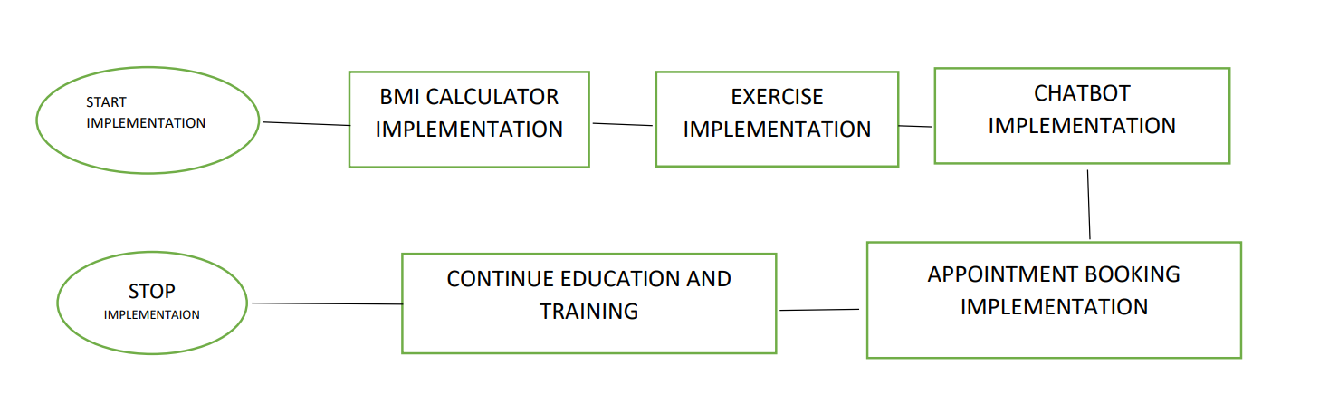

**WORKING:**

* User authentication
* Appoinment booking
* BMI calculator
* Health chatbot
* Online consultation
* Diet and exercise tips

**VII . EXPERIMENTAL RESULTS**

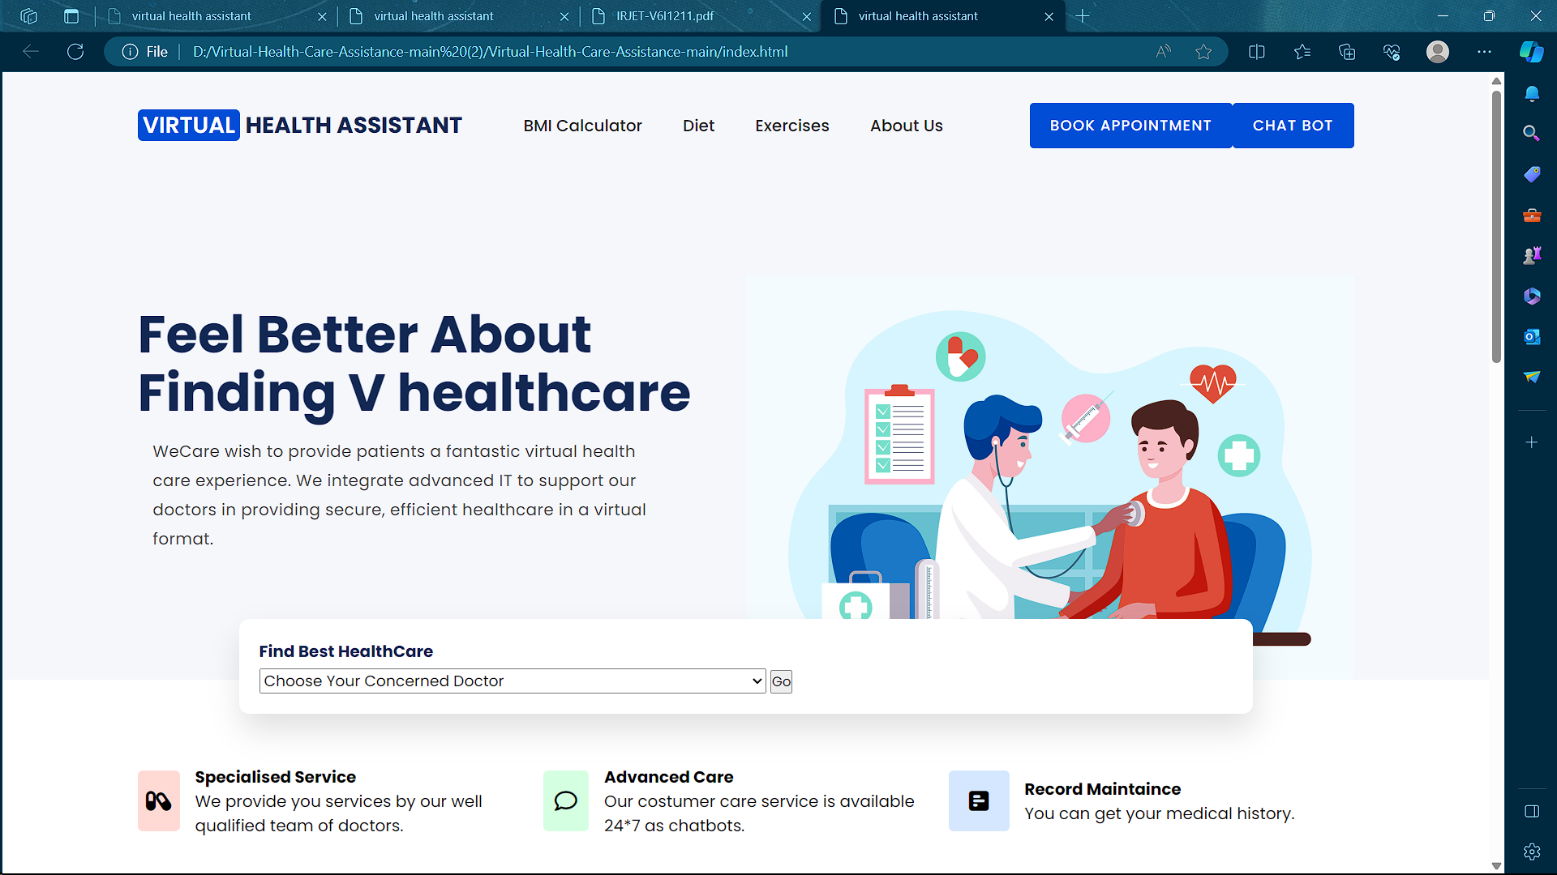

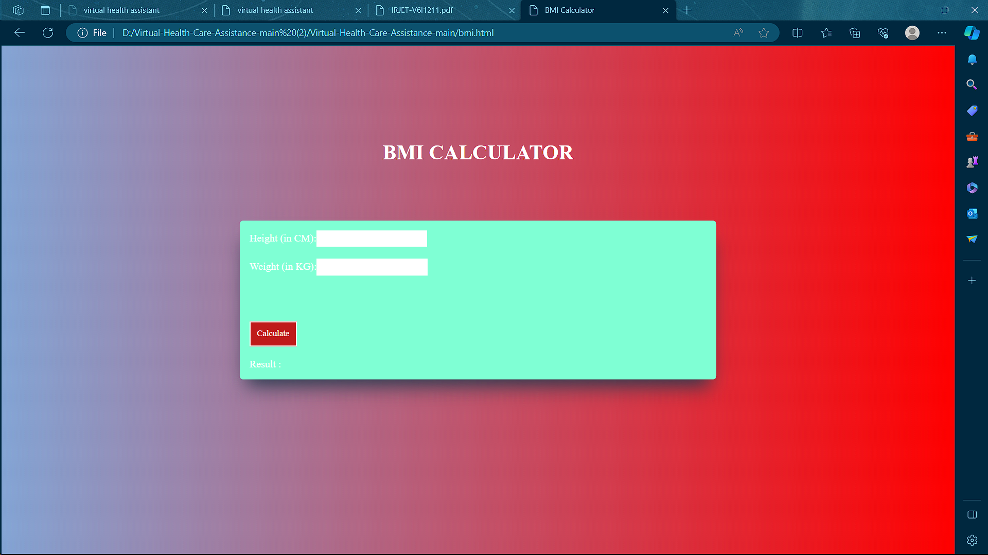

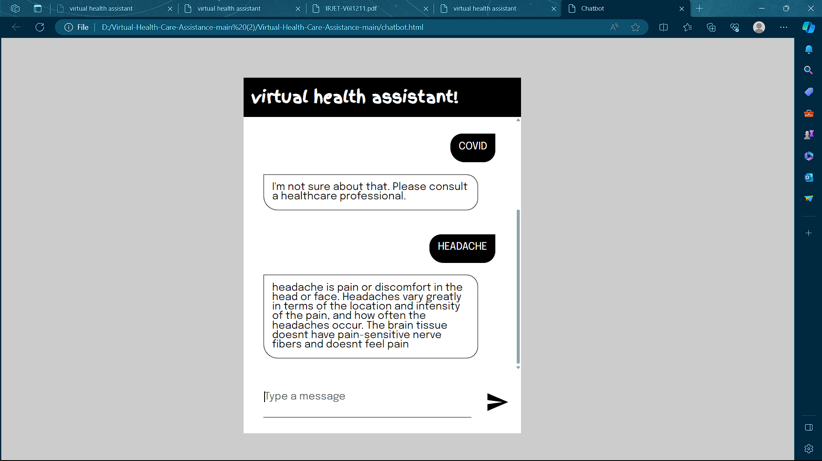

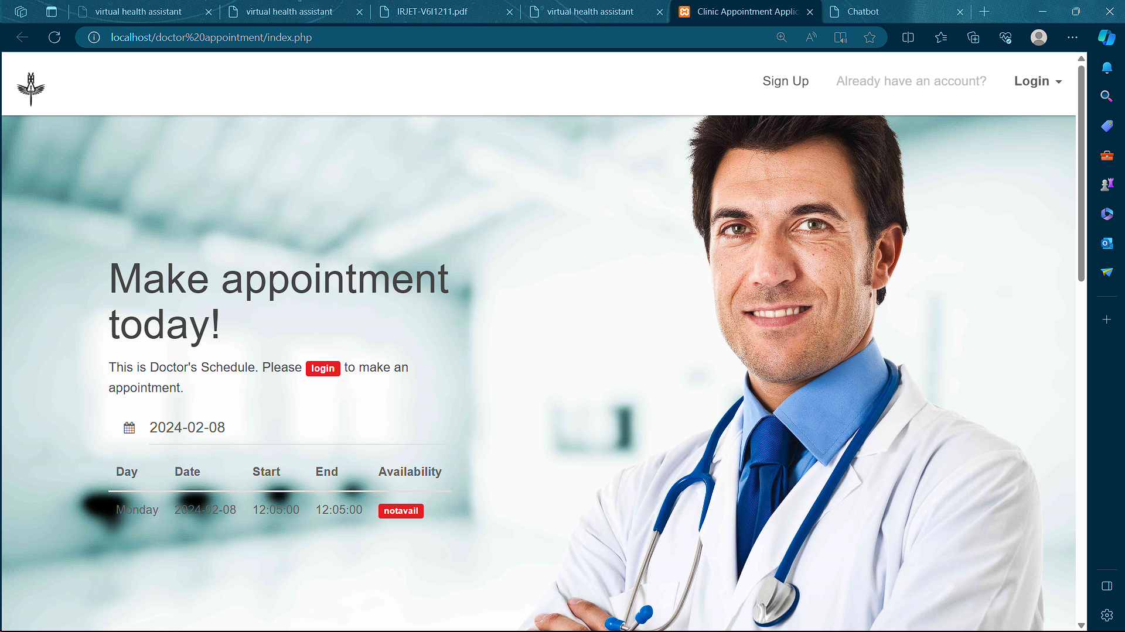

**VIII.CONCLUSION**

This paper describes a solution for creating consistent, scalable, and secure datasets for healthcare providers, such as paramedics and emergency physicians, to access patient clinical emergency data to provide better patient care. A Virtual Health Assistant provides personalized diagnoses based on symptoms. In the future, the bot’s symptoms recognition and diagnosis performance could be greatly improved by adding support for more medical features, such as location, duration and intensity of symptoms, and more detailed symptom description. Now Virtual Health Assistance comes into action. It is a web service in which the proposed system tries to eliminate user’s need to figure out their disease by giving them access to a centralized clinical repository in a much interactive manner. User can also ask questions regarding their disease and even book online and offline appointments with doctors.

**XI FUTURE WORK**

The future scope of virtual AI health assistants is vast and holds immense potential for transforming healthcare innumerous ways. Here are some potential areas where virtual AI health assistants could make a significant impact.

• Personalized healthcare: Virtual AI health assistants can gather and analyze patient data to create personalized healthcare plans that are tailored to an individual's unique needs.

• Disease prevention: Virtual AI health assistants can monitor patients' health and alert them to potential health risks, allowing for early intervention and disease prevention.

**X. REFERENCE**

1. Rachel G Curtis, Bethany Bartel – Improving user experience of virtual health assistant(2021)
2. Stefania Mele, Mena Izzo – The Study on Virtual Medical Instrument Based on Lab View (2005) (2021)
3. Shivam Malik – Virtual AI health assistantance(2023)
4. Itika Gupta, Barbara Di Eugenio, Brian Ziebert – Towards building a Virtual Assistant Health Coach
5. Sreevidya Iyer, Dhanashree Shetty, Purva Badgujar – A proposal for virtual mental health assistance(2016)
6. Salvatore La lacuna, Carmelo Militello, Luca D. Serbanati – Personal health system: A tool to support the patient empowerment(2016)
7. Ping-Jing Yang, Wai-Tat Fu – Mindbot: A Social-Based Medical Virtual Assistant(2016)
8. Veton Kepuska, Gamal Bohouta – Next generation of Virtual Health Personal Assistants(2018)
9. Sidharth Rai, Akshayanandi Raut, Akash Savaliya – Darwin: Convolutional Neural Network based Interlligent Health Assistant(2018)