IMPLEMENTATION OF WASTE MANAGEMENT SYSTEM

**Dr.Madhavi Pingili,** Associate professor and HoD, Department of Information Technology,

**CMR Engineering College, UGC Autonomous**, Hyderabad

**Dr .X.S. Asha Shiny**, Associate professor, Department of Information Technology,

**CMR Engineering College,UGC Autonomous**, Hyderabad

**B.Bhavana**,B.Tech.,Department of Information Technology,

**CMR Engineering College,UGC Autonomous**, Hyderabad

*Abstract*—In the present days, many times we see that the garbage bins or dust bins are placed at public placesin the urban cities, that which are overflowing due to the increase in the waste every day. Itcreatesanunhygienic condition for the people and creates bad smell around the surroundings. In the recentscenario, due to the rapid growth of population disorganization of city government a lack of publicawareness and limited fund for a program of waste management garbage disposal became a causeof concern in the world. This leads to spreading some deadly diseases &amp; human illness. Most of theviruses and the bacteria infection developed in the unclean and unhygienic environment. Tomaintain a strategic distance from such circumstances we have proposed wireless wastemanagement system. Which allows multiple corporations to monitor the status of dust beansremotely over a server, and keeps cities clean and hygiene very efficiently by optimizing cost andtime required for it.Waste management from its inception to its disposal is one of the importantchallenges for municipal corporations all over the world. When this was not in existence thegarbage was overflowing and people were getting all the diseases. In urban areas, people should beaware of this condition of overflowing garbage.With this overflowing of garbage on roadstransportation problem occurs. The people who work in municipal corporations will hesitate to pickall the overflowing garbage this is also a cause for developing unhygienic atmosphere. To overcomethis problem, we can use sensors and detect where the dustbin is overflowing. By this sensor, thehigher authority will get to know about this garbage overflow and then the information can bepassed and action could be taken on the municipal corporation.

Keywords—wireless waste management system, challenges in waste management system, Health and Environmental impacts, sensor technology in waste management, Municipal Corporation and waste management,Hygiene and cleanliness, Preventing transportation issues, Community Awareness.

INTRODUCTION

Centuries ago, waste management wasn't much of an issue. Relatively few people inhabited the earth. Trees were cut for fuel and burned without too much adverse effect, and smoke from widely scattered fires dissipated in the atmosphere. Sewage and garbage could be disposed of by individuals on their own property. City efforts to deal with resident’s waste go back to at least 500 B.C., when the first known dump was createdoutside of Athens. The ancient Romans created basic sewer systems. They also had trenches outside of cities where people threw trash, a practice that periodically led to epidemic diseases. With the advent of the Industrial Revolution in England in the mid-1700s, the problems of managing wastes grew far more serious. City populations swelled as people were drawn from rural areas to work in factories. This generated unprecedented quantities of concentrated garbage, sewage and other wastes. Alarm about municipal and industrial waste-handling practices climbed steadily in the early part of the 20th century. Scientists and other experts tried to warn others that poor waste management was a threat to human health and safety. It also was destroying the environment. Finally in the mid-1960s, the federal government took action. Studies about industrial and municipal waste handling were conducted. Funds were made available to states to develop waste-handling strategies for their municipalities and industries. The first waste-management legislation was passed in 1965. The Environmental Protection Agency (EPA) was created in 1970 to implement waste handling and other environmental regulations. Laws, such as the Resource Conservation and Recovery (RCR) Act of 1970 and its 1976 amendments, defined different types of wastes and described minimum actions for waste handling. Today, waste management is a major U.S.Industry, as well as the largest and fastest-growing part of the environmental industry.

PROBLEM

Nowadays, there are tons of flats and apartments which have been built in the rapid urbanization area. This is due to high housing demands which have been drastically risen as a result of migration from villages to cities to find work. In order to accommodate the growing population in the urban area, the government has also constructed more apartment complexes. There are several issues faced by the residents of the flats. One of them is disposal of solid waste. Unlike private houses, the residents of all the apartments use a common dustbin, which tends to fill up very quickly. This overflowing of garbage is a sanitary issue which might cause diseases like cholera and dengue. Moreover, it is a waste of fuel to travel around a complex or an area to find that some of the garbage are filled and some are not. Also, on rare days problems might arise that there is so much garbage that the truck doesn’t have enough capacity. The idea struck us when we observed that the garbage truck use to go around the town to collect solid waste twice a day.

Using that data, we can then optimize waste collection routes and ultimately reduce fuel consumption. It allows trash collectors to plan their daily/weekly pick up schedule. An IR Sensor is used for detecting whether the trash can is filled with garbage or not. If the bin is full or overflowed then the RF transmits the signal by the buzzer, we get the intimation to collect the garbage.

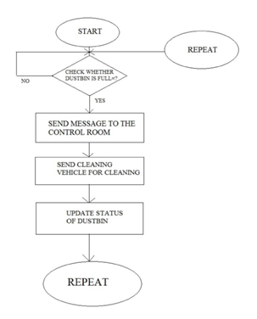

**Flowchart of waste management process**

**OBJECTIVES**

**1.**Reducing the toxicity of material entering the waste flow.

**2.**Maintaining clean and neat environment.

**3.**Reducing traffic in society.

METHODOLOGY

The Design and Methodology of this project was done in different stages. Initially the Locomotive was designed, which included finding appropriate motors, sensors. Next the Arduino was decided. But for this project Arduino ATMega 2560 was used, because of its consistency in data flow, low power consumption, and compact size. Subsequently the sensors where picked, as the objectives were specific, finding the sensors werea difficult task. For detection of overflowing of garbage, we have given IR sensors and RF module receives signal as transmits to vehicle.

**ARDUINO ATmega 2560**

Arduino is a software company, and user community that designs and manufactures computer open-source hardware, open-source software, and microcontroller-based kits for building digital devices and interactive objects that can sense and control physical devices. The project is based on microcontroller board designs, produced by several vendors, using variousmicrocontrollers.These systems provide sets of digital and analog I/O pins that can interface to various expansion boards (termed shields) and other circuits. The boards feature serial communication interfaces, including Universal Serial Bus (USB) on some models, for loading programs from personal computers. For programming the microcontrollers, the Arduino project provides an integrated development environment(IDE) based on a programming language named Processing, which also supports the languages C and C++.

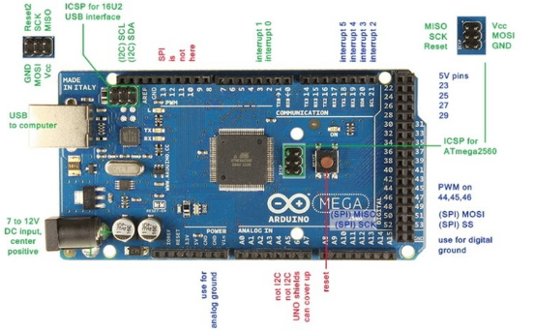

**Arduino ATmega 2560 board**

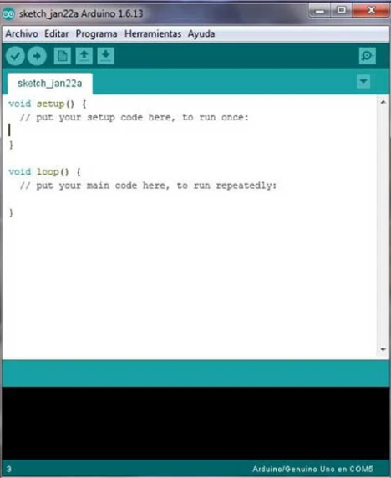

**Structure code of arduino software**

**UPLOADING**

Before uploading your sketch, you need to select the correct items from the Tools > Board and Tools > Port menus. On the Mac, the serial port is probably something like /dev/tty.usbmodem241 (for an Uno or Mega2560 or Leonardo)or /dev/tty.USA19QW1b1P1.1 (for a serial board connected with a Key span USB-to-Serial adapter). On Windows, it's probably COM1 or COM2 (for a serial board) or COM4, COM5, COM7, or higher (for a USB board) to find out, you look for USB serial device in the ports section of the Windows Device Manager. On Linux, it should be /dev/tty ACM x , /dev/tty USB x or similar. Once you've selected the correct serial port and board,presstheuploadbuttoninthetoolbarorselectthe Upload itemfromtheSketchmenu.Current Arduino boards will reset automatically and begin the upload. With older boards (pre- Diecimila) that lack auto-

Current Arduino boards will reset automatically and begin the upload. With older boards (pre- Diecimila) that lack auto-reset, you'll need to press the reset button on the board just before starting the upload. On most boards, you'll see the RX and TX LEDs blink as the sketch is uploaded. The Arduino Software (IDE) will display a message when the upload is complete, or show an error.

When you upload a sketch you're using the Arduino boot loader, a small program that has been loaded on to the microcontroller on your board. It allows you to upload code without using any additional hardware. The boot loader is active for a few seconds when the board resets, then it starts whichever sketch was most recently uploaded to the microcontroller. The boot loader will blink the on-board (pin 13) LED when it starts (i.e. when the board resets).

**TYPES OF IR SENSORS**

**1.** Active IR Sensors

(a) Break Beam Sensors

(b) Reflectance Sensors

**2.** Passive IR sensors

**RESULTS**

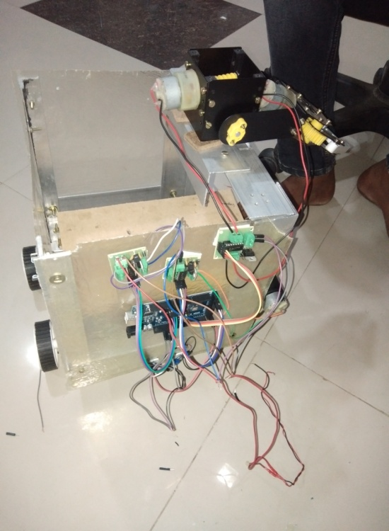

**Fig(a)**

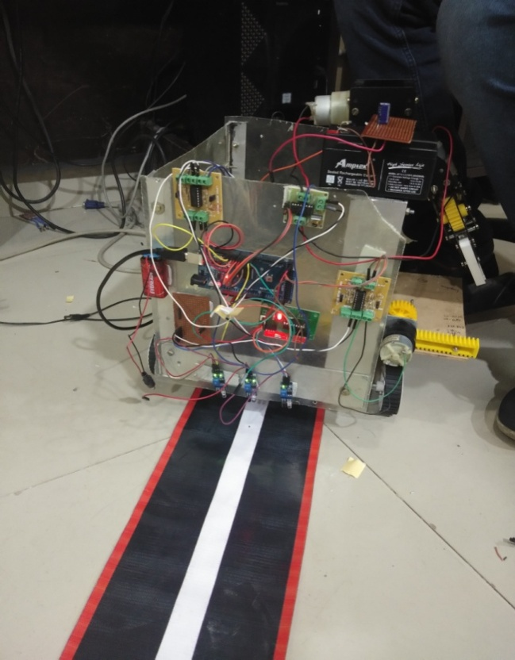

##### **ACKNOWLEDGEMENT**

**1.**We are extremely grateful to **Dr. A. Srinivasula Reddy**, Principal and **Dr. Madhavi Pingili,** HOD, **Department of IT, CMR Engineering College** for their constant support.

**2.**We are extremely thankful **to Dr. X.S. Asha Shiny**, Associate Professor, Internal Guide, Department of IT, for her constant guidance, encouragement and moral support throughout the project.

**3.**We express our thanks to all staff members and friends for all the help and co-ordination extended in bringing out this project successfully in time.

##### **REFERENCES**

**1.**[www.buildofy.in/smart_home_designs](http://www.buildofy.in/smart_home_designs).

**2.**<https://create.arduino.cc/projecthub/Technovation/smart-garbage-monitoring-systemusing-arduino-101-3b813c>.

**3.**<https://github.com/sourabhdeshmukh/Smart-Dustbin>.

**4.**<https://create.arduino.cc/projecthub/Technovation/smart-garbage-monitoring-systemusing-arduino-101-3b813c>.

**5.**Navghane S S, Killedar M S and Rohokale D V 2016 IoT Based Smart Garbage andwaste collection, International Journal of Advanced Research inElectronics And Communication.

**6.**Monika K A, Rao N, Prapulla S B and Shobha G 2016 Smart Dustbin-AnEfficientGarbage Monitoring System International Journal of Engineering Science &Computing.