BACTERIAL CONCRETE AS A SUSTAINABLE BUILDING MATERIAL

**ABSTRACT**

[[**6**](https://www.mdpi.com/2071-1050/12/2/696),[**7**](https://www.mdpi.com/2071-1050/12/2/696)]. All the building designs that are being implemented

The right selection of building materials plays should be functional with regard to increasing the durability, an important role when designing a building to technical and materials performance, and to reducing the life fall within the definition of sustainable cycle cost of the building [[**8**](https://www.mdpi.com/2071-1050/12/2/696)].

# development. One of the most commonly used construction materials is concrete. Its

Sustainable building materials are such materials that:

production causes a high energy burden on the  reduce the consumption of resources; environment. Concrete is susceptible to external  minimise the impact on the environment; factors. As a result, cracks occur in the material.

* do not pose a threat to human health.

# Achieving its durability along with the

assumptions of sustainable construction means there is a need to use an environmentally

These are materials that help in sustainable landscape

friendly and effective technique of alternative design strategies as well as materials from companies that

crack removal in the damaged material. pursue sustainable social, as well as environmental and

Bacterial self-healing concrete reduces costs in corporate policies.

terms of detection of damage and maintenance The building materials should be investigated because they

of concrete structures, thus ensuring a safe play an important role from the moment of conceiving the lifetime of the structure. Bacterial concrete can concept of constructing a building until the end of the building improve its durability. However, it is not when it is to be dismantled, so that the materials might be currently used on an industrial scale. The high recycled. Planners and architects, as well as engineers and

cost of the substrates used means that they are builders, are searching for new materials and technologies to be

not used on an industrial scale. Many research used in new or future structures which will bring benefits such

units try to reduce production costs through

various methods; however, bacterial concrete as energy efficiency, water resources and protection, improved

# can be an effective response to sustainability.

**INTRODUCTION**

air quality indoors, reduced life cycle costs and durability. In order to achieve these effects, it is important to apply the latest developments to various technologies, including the

Rapidly developing construction, particularly in development of material studies and environmentally friendly

developing countries, contributes to environmental building materials, and to achieve energy efficiency during the pollution, high energy consumption and natural production of such materials. Furthermore, the inclusion of resources. These actions have a direct impact on the sustainable building materials in construction projects will comfort and heath of building inhabitants [[**1**](https://www.mdpi.com/2071-1050/12/2/696),[**2**](https://www.mdpi.com/2071-1050/12/2/696)]. reduce the environmental impact of building materials. The Already in the 1970s, research was commenced into impact associated with the mining, transporting, processing, the harmful effect of building materials on users’ manufacturing, as well as installing, reusing and disposing [[**9**](https://www.mdpi.com/2071-1050/12/2/696)]. health. As a result of the research, ecological

materials were introduced, e.g., silicate blocks, materials based on gypsum binders, paints, wood, etc. These materials are intended to promote human health. Additionally, they are supposed to be of only a minimal burden to the environment. Their burden and life cycle consists of several stages. It begins with the sourcing of raw materials for their production. The next stage is operation, during which they can be renewed or preserved. The final stage is the disposal and recycling of materials. Therefore, green (sustainable) [[**3**](https://www.mdpi.com/2071-1050/12/2/696)] building materials should be designed and used in such manner as to minimize the sources of pollution. Throughout the life cycle of buildings and constructions [[**4**](https://www.mdpi.com/2071-1050/12/2/696)], they should save energy and be safe for human health. The energy of building materials is an important factor for the new energy-efficient building system [[**5**](https://www.mdpi.com/2071-1050/12/2/696)].

In the European construction industry, the right choice of building materials is an important factor in achieving sustainable development [[**1**](https://www.mdpi.com/2071-1050/12/2/696)]. The European Union promotes actions aimed at sustainable development. The priority is to reduce the consumption of energy and natural resources as well as to reduce the production of waste and pollution that may be caused by the transport of materials. Principles of sustainable development are being introduced for the entire life cycle of buildings. This may ensure a compromise between economic, as well as environmental and social performance

measure spring rigidity at low cost. For automotive springs, the main performance characteristic is stiffness under load or "spring".

**CONCRETE**

In civil engineering, concrete is usually used for construction work. This is associated with a low cost of building and construction materials and also with low maintenance costs. However, both concrete and reinforcement are a huge burden to the environment, due to the high energy consumption ([**Table 1**](https://www.mdpi.com/2071-1050/12/2/696)) during production and use. [**Table 1**](https://www.mdpi.com/2071-1050/12/2/696)presents examples of building materials and the amounts of energy produced by them .

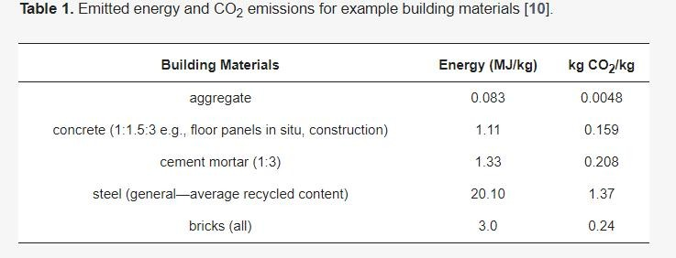

**Table 1.** Emitted energy and CO2 emissions for example building materials

For this reason, concrete should be protected against external factors in order to increase its durability. Structures deteriorate due to different reasons, such as the impact of the external environment, overload or accidental damage, and then they need to be repaired in order to extend their lifetime. The defects that occur are typically cracks [[**9**](https://www.mdpi.com/2071-1050/12/2/696)] resulting from reactions such as:

* freeze-thaw action;
* shrinkage;
* hardening of concrete;
* low tensile strength of concrete, etc.

## Self-Healing Mechanism

Biological concrete as well as a self-healing, or MICP, produces CaCO3 using bacteria. It fills cracks that appear in concrete materials. Several types of bacteria are used in concrete, e.g., *Bacillus subtilis*, *Bacillus pseudofirmus*, *Bacillus pasteurii*, *Bacillus sphaericus*, *Escherichia coli*, *Bacillus cohnii*, *Bacillus balodurans*, *Bacillus halodurans*, etc. These are bacteria that can survive in environments with high alkali contents, i.e., these bacteria use metabolic processes such as sulphate reduction, photosynthesis and urea hydrolysis. The result is calcium carbonate as a by-product. Some reactions also increase the pH from neutral to alkaline conditions, creating bicarbonate and carbonate ions. These precipitate with the calcium ions in the concrete to form calcium carbonate minerals. They are chemoorganotrophs, i.e., they draw energy from the oxidation of simple organic compounds. The microorganisms are *Bacillus* species and are not harmful to humans at all.

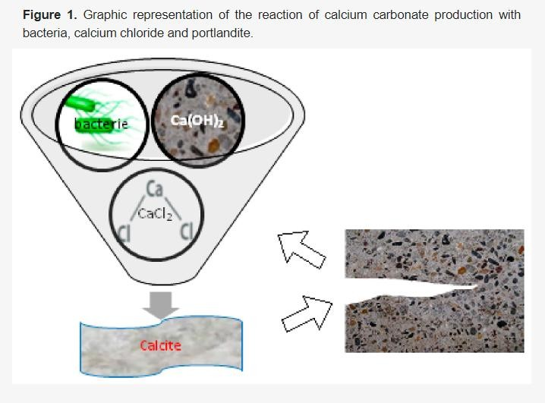

Bacteria genus *Bacillus* are used in this process, as well as bacterial nutrients. These can be calcium compounds, nitrogen and phosphorus. All the components are added to the concrete during the production process. The listed components remain non-reactive inside the material until the material is damaged, which can take up to 200 years.

**Figure 1.** Graphic representation of the reaction of calcium carbonate production with bacteria, calcium chloride and portlandite.

The process of self-healing of bacteria-based concrete is much more efficient, as calcium nutrients are actively metabolized by the bacteria present in the concrete [[**2**](https://www.mdpi.com/2071-1050/12/2/696)]. Carbon dioxide comes from bacterial metabolism. The reaction takes place according to (2):

Ca(C3H5O2)2 + 7O2 → CaCO3 + 5CO2 + 5H2O (1)

Therefore, calcium carbonate is formed in the process of bacterial metabolism. The effect of the process is the sealing of the cracks through the use of bacteria.

**Influence of Bacteria/Biomineralization on Concrete Properties:**

The authors of [[**14**](https://www.mdpi.com/2071-1050/12/2/696)] observed in their study that microbial metabolic activity taking place in concrete leads to increased overall concrete performance including compressive strength. Others [[**15**](https://www.mdpi.com/2071-1050/12/2/696)] observed that concrete’s compressive strength shows a significant an increase by 42% for the concentration 105 cells/mL and an increase in tensile strength by 63% after 28 days. The investigation also included the effect of acid on such concrete, and it was established that it prevents mass loss during exposure to acid up to a specific limit value. Water absorption test demonstrated a lower mass increase for bacterial concrete compared with the control sample; therefore, it can be assumed that concrete will become less porous leading to a lower water absorption rate. Results of a test for chloride content indicate that the addition of bacteria reduces mass loss due to exposure to chloride and increases compressive strength. In the paper

[[**16**](https://www.mdpi.com/2071-1050/12/2/696)] *Bacillus pasteurii* bacterium was used and a significant increase in the initial strength of concrete was observed. Bio- calcium carbonate filled a certain volume percentage of voids which made the texture more compact and resistant to penetration. In another study, the authors of [[**17**](https://www.mdpi.com/2071-1050/12/2/696)] proved that the *Bacillus subtilis* strain used by them can survive in temperatures ranging from −30 °C to 700 °C. They further observed an increase in the compressive strength of concrete. The study [[**18**](https://www.mdpi.com/2071-1050/12/2/696)] showed high early compressive strength, however, this decreased with time. The authors also found that

bacteria which are not reported as calcite precipitating, *Bacillus flexus*, exhibited maximum compressive strength. In this research study [[**19**](https://www.mdpi.com/2071-1050/12/2/696)] cement-based concrete with added GGBFS (ground granulated blast furnace slag) and silica fume was tested for compressive strength at 28 days. It was found that the concrete mixture containing 35% of GGBFS had a compressive strength value of 56 N/mm2. It was also found that, following the addition of silica fume as a mineral admixture, the mixture reached its maximum strength (37 N/mm2) with an addition of 12.5% of silica fume. According to the authors of [[**20**](https://www.mdpi.com/2071-1050/12/2/696)], the enhanced compressive strength of concrete reaches the maximum value for a cell concentration of approx. 105/mL. The authors of

[[**21**](https://www.mdpi.com/2071-1050/12/2/696)] used 30% fly ash and 30% GGBS to obtain concrete. This mixture replaced 70% of cement. In this paper the *Bacillus pasteurii* bacterium was used for fly ash and GGBFS. The result was a significant enhancement of compressive strength by 30% in the concrete mixture with bacteria and by over 15% with fly ash and by 20% in GGBS. It was observed that bacterial concrete reached its maximum tensile strength and flexural strength when 40 mL and 50 mL of bacterial solutions were used. In studies [[**22**](https://www.mdpi.com/2071-1050/12/2/696)] 5% bacterial additives and calcium lactate were used. It was found that the compressive strength of the concrete was 49.5 MPa at 28 days. This value was higher than for control concrete. The addition of calcium lactate in the amount of 10% and bacteria to the concrete results in a significant increase in compressive strength. According to [[**23**](https://www.mdpi.com/2071-1050/12/2/696)], *S. pasteurii* bacteria and fly ash increase the compressive strength of concrete by 22% at 28 days of the experiment. There is a four-fold decrease in water absorption and a practically eight-fold reduction in chloride permeability.

***Other Mechanisms***

There are several mechanisms of internal self-mutilation. The first group of mechanisms belongs to the natural family, in which chemical, physical and mechanical self-surge is distinguished. The second group is made up of chemical methods. The third group is biological methods. The fourth is the special method [[**62**](https://www.mdpi.com/2071-1050/12/2/696),[**63**](https://www.mdpi.com/2071-1050/12/2/696)]. The effectiveness of natural self-healing methods of concrete will depend on the composition of its matrix and the presence of water and carbon dioxide. The matrix determines the possibility of chemical reactions at the time of crack formation.

The most effective chemical self-healing method of concrete is to disperse a cure agent in the concrete mixture that will react with cement hydration products in the concrete. The result will be a crack-filling compound.

The effectiveness of biological methods depends mainly on the viability of bacterial spores and the presence of water leaking through the crack. The efficacy is random due to the randomness of simultaneous cutting of the crack capsules with the bacterium and with the food. However, from an economic point of view, the cost of capsule production is currently significantly higher (two to three times) than in normal concrete. The effectiveness of the method of self-treatment of concrete with mineral additives depends on their quantitative and qualitative selection. There is no undesirable internal tension in the concrete due to swelling. On the basis of water permeability tests in concrete it was found that it is possible to

close the crack to a width of 0.22 mm [[**65**](https://www.mdpi.com/2071-1050/12/2/696)].

## The Cost of Producing Self-Healing Concrete

studied the cost of utilization of microbial concrete as compared with conventional concrete. It is one of the main reasons for which this material is not mass produced and used in the construction industry at the moment. The cost analysis demonstrated that the price of microbial concrete is 2.3 to 3.9 times higher than the price of conventional concrete with lower quality. The high cost of bacterial cultures used in developing the material (bacteria and nutrients account for approx. 80% of the cost of raw materials [[**66**](https://www.mdpi.com/2071-1050/12/2/696)]) is the reason why the initial costs are an order of magnitude higher than for traditional concrete. The authors [[**20**](https://www.mdpi.com/2071-1050/12/2/696)] seek further reductions in the production cost of bacterial concrete in using nutrient ingredients, i.e., inexpensive industrial waste with a high protein content, e.g., stromata, liquid corn or lactose mother liquor from the starch industry—which they deal with in [[**26**](https://www.mdpi.com/2071-1050/12/2/696)]. Due to this, the total cost of the process would be significantly reduced

**CONCLUSIONS**

* The majority of Bacillus bacteria have a positive effect on the compressive strength of concrete and on bending strength compared to conventional samples.
* The use of a mixture (consortium) of *Bacillus pseudofirmus* and *Bacillus cohnii* resulted increase in compressive strength.
* The *Bacillus sphaericus* species showed a reduction in water absorption.
* Inorganic porous materials such as ceramite, zeolites and others are used to protect the bacteria from high pH.
* In lightweight aggregate concrete, the use of *Sporosarcina pasteuria* increased resistance to chloride ion penetration.
* Expanded perlite particles immobilized by bacterial spores and wrapped in a low alkali material ensure the best crack healing and reduced water permeability.
* The use of various substances, e.g., silica gel, protects bacteria from alkaline reactions.
* The use of autoclaved bacteria or their dispute reduces porosity and thus permeability.
* *Bacillus Pasteurii* reduce water absorption. The durability of concrete is increased and the permeability of chlorides is reduced.
* The encapsulation of *Bacillus Sphaericus* in closed microcapsules showed a greater effectiveness of crack treatment and lower water permeability.
* The PP and PVA fiber used caused a decrease in bacterial concentration. The surface repair level for samples with bacteria and fibers was slightly lower than for the bacteria themselves.
* The diffusion of chlorine ions decreased by for *Sporosarcina pasteurii* and *Skutarcina ureae* using zeolite and glass fiber reinforcement.
* RCA and 50% FA as bacterial immobilizers showed the most effective repair of cracks up to 1.1 mm wide and allowed to recover the compression strength of 85%.

**REFERENCES**

1. Franzoni, E. Materials selection for green buildings: Which tools for engineers and architects? *Procedia Eng.* **2011**, *21*, 883–890.
2. Melchert, L. The dutch sustainable building policy: A model for developing countries? *Build. Environ.* **2007**, *42*, 893–901.
3. Häkkinen, T.; Belloni, K. Barriers and drivers for sustainable building. *Build. Res. Inform.* **2011**, *39*, 239–255.
4. Chen, Z.S.; Martinez, L.; Chang, J.P.; Wang, X.J.; Xionge, S.H.; Chin, K.S. Sustainable building material selection: A QFD- and ELECTRE III-embedded hybrid MCGDM approach with consensus building. *Eng. Appl. Artif. Intell.* **2019**, *85*, 783–807.
5. Invidiata, A.; Lavagna, M.; Ghisi, E. Selecting design strategies using multi-criteria decision making to improve the sustainability of buildings. *Build. Environ.* **2018**, *139*, 58–68.
6. Stanaszek-Tomal, E.; Kozak, A. Mineral and organic coatings modified nano-TiO2 addition as elements of sustainable building. In *Energy Efficient, Sustainable Building Materials and Products*; Hager, I., Ed.; Wydawnictwo PK: Kraków, Polska, 2017; pp. 89–117.
7. Thormark, C. The effect of materials choice on the total energy need and recycling potential of a building. *Build. Environ.* **2006**, *41*, 1019–1026.
8. Akadiri, P.O.; Chinyio, E.A.; Olomolaiye, P.O. Design of a sustainable building: A conceptual framework for implementing sustainability in the building sector. *Buildings* **2012**, *2*, 126–152.
9. Roodman, D.M.; Lenssen, N. *A Building Revolution: How Ecology and Health Concerns are Transforming Construction*; Worldwatch Paper 124; Worldwatch Institute: Washington, DC, USA, 1995;

5.) Jian, Wang Design of Spring Load Testing and Separating System, 1–3.

6) ChandgudeViresh, ChattarNilesh, ChaudhariSharad, Gaikwad Vicky and BhaneAjit, “Modern Hydraulic Operated Spring Stiffness Testing Machine”, ISSN 2250-2459, April

7). G. S. Jagushte, S. S. Joshi, S. S. Jangali, D. S. Joshi and S. M. More, “ Design And Fabrication Of Hydraulic Spring Stiffness Testing Machine”, International Journal Of Engineering Research And General Science, Vol. 3, No. 2, March-April, 2015.

8.) PathanMosinAouraze , Patel SoyalDastagir, Pawar Santosh Balu, LabadeSuyogBajirao, “A Review On Spring Stiffness Testing Machine, International Research Journal Of Engineering And Technology” Volume:04 Issue: 01, Jan-2017.