**BACTERIAL CONCRETE AS A SUSTAINABLE BUILDING MATERIAL**

**Mr.Adarsh Jondhale , Mr.Samir Dadmal, Mr.Devendra Barthe,**

**Dr.Mohommad Rasool (Asst. Professor)**

Department of Civil Engineering

Tulshiramji Gaikwad Patil Collage of Engineering & Technology ,Nagpur

**ABSTRACT**

The right selection of building materials plays an important role when designing a building to fall within the definition of sustainable development. One of the most commonly used construction materials is concrete. Its production causes a high energy burden on the environment. Concrete is susceptible to external factors. As a result, cracks occur in the material. Achieving its durability along with the assumptions of sustainable construction means there is a need to use an environmentally friendly and effective technique of alternative crack removal in the damaged material.

Bacterial self-healing concrete reduces costs in terms of detection of damage and maintenance of concrete structures, thus ensuring a safe lifetime of the structure. Bacterial concrete can improve its durability. However, it is not currently used on an industrial scale. The high cost of the substrates used means that they are not used on an industrial scale. Many research units try to reduce production costs through various methods; however, bacterial concrete can be an effective response to sustainability.

**Keywords:** Analysis, investigation, research.

1. **INTRODUCTION (Font-Cambria, Bold, Font Size -12)**

Rapidly developing construction, particularly in developing countries, contributes to environmental pollution, high energy consumption and natural resources. These actions have a direct impact on the comfort and heath of building inhabitants. Already in the 1970s, research was commenced into the harmful effect of building materials on users’ health. As a result of the research, ecological materials were introduced, e.g., silicate blocks, materials based on gypsum binders, paints, wood, etc. These materials are intended to promote human health. Additionally, they are supposed to be of only a minimal burden to the environment. Their burden and life cycle consists of several stages. It begins with the sourcing of raw materials for their production. The next stage is operation, during which they can be renewed or preserved. The final stage is the disposal and recycling of materials. Therefore, green (sustainable) building materials should be designed and used in such manner as to minimize the sources of pollution. Throughout the life cycle of buildings and constructions, they should save energy and be safe for human health. The energy of building materials is an important factor for the new energy-efficient building system.

1. **METHODOLOGY**

**Concrete**

In civil engineering, concrete is usually used for construction work. This is associated with a low cost of building and construction materials and also with low maintenance costs. However, both concrete and reinforcement are a huge burden to the environment, due to the high energy consumption (**[Table 1](https://www.mdpi.com/2071-1050/12/2/696" \l "table_body_display_sustainability-12-00696-t001)**) during production and use. **[Table 1](https://www.mdpi.com/2071-1050/12/2/696" \l "table_body_display_sustainability-12-00696-t001)** presents examples of building materials and the amounts of energy produced by them For this reason, concrete should be protected against external factors in order to increase its durability. Structures deteriorate due to different reasons, such as the impact of the external environment, overload or accidental damage, and then they need to be repaired in order to extend their lifetime. The defects that occur are typically cracks [**[9](https://www.mdpi.com/2071-1050/12/2/696" \l "B9-sustainability-12-00696" \o ")**] resulting from reactions such as:

* freeze-thaw action;
* Shrinkage;
* Hardening of concrete;
* Low tensile strength of concrete;

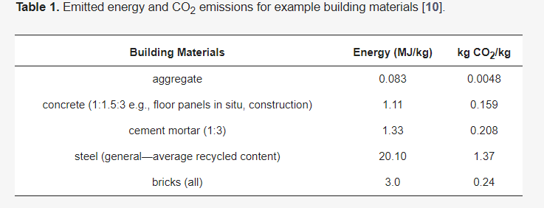

## **Self-Healing Mechanism**

Biological concrete as well as a self-healing, or MICP, produces CaCO3 using bacteria. It fills cracks that appear in concrete materials. Several types of bacteria are used in concrete, e.g., *Bacillus subtilis*, *Bacillus pseudofirmus*, *Bacillus pasteurii*, *Bacillus sphaericus*, *Escherichia coli*, *Bacillus cohnii*, *Bacillus balodurans*, *Bacillus halodurans*, etc. These are bacteria that can survive in environments with high alkali contents, i.e., these bacteria use metabolic processes such as sulphate reduction, photosynthesis and urea hydrolysis. The result is calcium carbonate as a by-product. Some reactions also increase the pH from neutral to alkaline conditions, creating bicarbonate and carbonate ions. These precipitate with the calcium ions in the concrete to form calcium carbonate minerals. They are chemoorganotrophs, i.e., they draw energy from the oxidation of simple organic compounds. The microorganisms are *Bacillus* species and are not harmful to humans at all.

1. **MODELING AND ANALYSIS**

Model and Material which are used is presented in this section. Table and model should be in prescribed format.

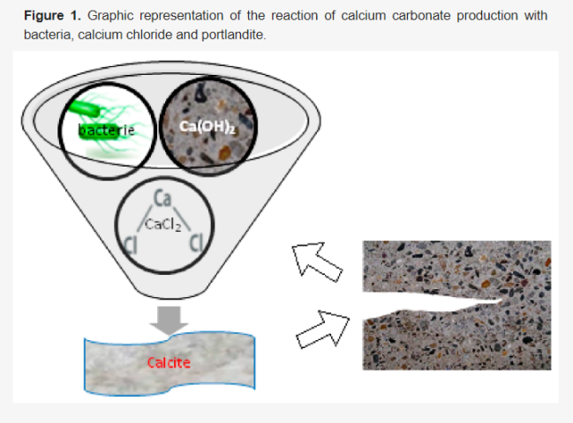

**Figure 1:** Graphic representation of the reaction of calcium carbonate production with bacteria, calcium chloride and portlandite.

Bacteria genus *Bacillus* are used in this process, as well as bacterial nutrients. These can be calcium compounds, nitrogen and phosphorus. All the components are added to the concrete during the production process. The listed components remain non-reactive inside the material until the material is damaged, which can take up to 200 years. However, this period can be shortened when the concrete is damaged. The water in the outside environment will then start to penetrate the damage. In this case, the bacterial spores will be able to grow in convenient conditions. Soluble nutrients are transformed into insoluble calcium carbonate. Then, it solidifies on the damaged surface or inside the material. In this way, the concrete is sealed [**[6](https://www.mdpi.com/2071-1050/12/2/696" \l "B6-sustainability-12-00696" \o ")**]. The bacteria consume oxygen during their growth, which is why the reinforcement does not corrode. This increases the durability of the concrete [**[1](https://www.mdpi.com/2071-1050/12/2/696" \l "B1-sustainability-12-00696" \o ")**].

On the surface, calcium carbonate is formed as a result of Reaction. The reaction of calcium hydroxide with calcium chloride and the products of bacterial metabolism causes the formation of calcite (calcium carbonate). **[Figure 1](https://www.mdpi.com/2071-1050/12/2/696" \l "fig_body_display_sustainability-12-00696-f001)** shows a representation of Reaction in concrete.

1. **CONCLUSION**

* The majority of Bacillus bacteria have a positive effect on the compressive strength of concrete and on bending strength compared to conventional samples.
* The use of a mixture (consortium) of *Bacillus pseudofirmus* and *Bacillus cohnii* resulted increase in compressive strength.
* The *Bacillus sphaericus* species showed a reduction in water absorption.
* Inorganic porous materials such as ceramite, zeolites and others are used to protect the bacteria from high pH.
* In lightweight aggregate concrete, the use of *Sporosarcina pasteuria* increased resistance to chloride ion penetration.
* Expanded perlite particles immobilized by bacterial spores and wrapped in a low alkali material ensure the best crack healing and reduced water permeability.
* The use of various substances, e.g., silica gel, protects bacteria from alkaline reactions.
* The use of autoclaved bacteria or their dispute reduces porosity and thus permeability.
* *Bacillus Pasteurii* reduce water absorption. The durability of concrete is increased and the permeability of chlorides is reduced.

1. **REFERENCES**
2. ctFranzoni, E. Materials selection for green buildings: Which tools for engineers and architects? *Procedia Eng.* **2011**, *21*, 883–890. [**[Google Scholar](https://scholar.google.com/scholar_lookup?title=Materials+selection+for+green+buildings:+Which+tools+for+engineers+and+architects?&author=Franzoni,+E.&publication_year=2011&journal=Procedia+Eng.&volume=21&pages=883%E2%80%93890&doi=10.1016/j.proeng.2011.11.2090" \t "https://www.mdpi.com/2071-1050/12/2/_blank)**] [**[CrossRef](https://doi.org/10.1016/j.proeng.2011.11.2090" \t "https://www.mdpi.com/2071-1050/12/2/_blank)**] [**[Green Version](https://www.mdpi.com/2071-1050/12/2/696" \t "https://www.mdpi.com/2071-1050/12/2/_blank)**]
3. Melchert, L. The dutch sustainable building policy: A model for developing countries? *Build. Environ.* **2007**, *42*, 893–901. [**[Google Scholar](https://scholar.google.com/scholar_lookup?title=The+dutch+sustainable+building+policy:+A+model+for+developing+countries?&author=Melchert,+L.&publication_year=2007&journal=Build.+Environ.&volume=42&pages=893%E2%80%93901&doi=10.1016/j.buildenv.2005.10.007" \t "https://www.mdpi.com/2071-1050/12/2/_blank)**] [**[CrossRef](https://doi.org/10.1016/j.buildenv.2005.10.007" \t "https://www.mdpi.com/2071-1050/12/2/_blank)**]
4. Chen, Z.S.; Martinez, L.; Chang, J.P.; Wang, X.J.; Xionge, S.H.; Chin, K.S. Sustainable building material selection: A QFD- and ELECTRE III-embedded hybrid MCGDM approach with consensus building. *Eng. Appl. Artif. Intell.* **2019**, *85*, 783–807. [**[Google Scholar](https://scholar.google.com/scholar_lookup?title=Sustainable+building+material+selection:+A+QFD-+and+ELECTRE+III-embedded+hybrid+MCGDM+approach+with+consensus+building&author=Chen,+Z.S.&author=Martinez,+L.&author=Chang,+J.P.&author=Wang,+X.J.&author=Xionge,+S.H.&author=Chin,+K.S.&publication_year=2019&journal=Eng.+Appl.+Artif.+Intell.&volume=85&pages=783%E2%80%93807&doi=10.1016/j.engappai.2019.08.006" \t "https://www.mdpi.com/2071-1050/12/2/_blank)**] [**[CrossRef](https://doi.org/10.1016/j.engappai.2019.08.006" \t "https://www.mdpi.com/2071-1050/12/2/_blank)**]
5. Stanaszek-Tomal, E.; Kozak, A. Mineral and organic coatings modified nano-TiO2 addition as elements of sustainable building. In *Energy Efficient, Sustainable Building Materials and Products*; Hager, I., Ed.; Wydawnictwo PK: Kraków, Polska, 2017; pp. 89–117. [**[Google Scholar](https://scholar.google.com/scholar_lookup?title=Mineral+and+organic+coatings+modified+nano-TiO2+addition+as+elements+of+sustainable+building&author=Stanaszek-Tomal,+E.&author=Kozak,+A.&publication_year=2017&pages=89%E2%80%93117" \t "https://www.mdpi.com/2071-1050/12/2/_blank)**]
6. Roodman, D.M.; Lenssen, N. *A Building Revolution: How Ecology and Health Concerns are Transforming Construction*; Worldwatch Paper 124; Worldwatch Institute: Washington, DC, USA, 1995; p. 5. [**[Google Scholar](https://scholar.google.com/scholar_lookup?title=A+Building+Revolution:+How+Ecology+and+Health+Concerns+are+Transforming+Construction&author=Roodman,+D.M.&author=Lenssen,+N.&publication_year=1995" \t "https://www.mdpi.com/2071-1050/12/2/_blank)**]
7. Akadiri, P.O.; Chinyio, E.A.; Olomolaiye, P.O. Design of a sustainable building: A conceptual framework for implementing sustainability in the building sector. *Buildings* **2012**, *2*, 126–152. [**[Google Scholar](https://scholar.google.com/scholar_lookup?title=Design+of+a+sustainable+building:+A+conceptual+framework+for+implementing+sustainability+in+the+building+sector&author=Akadiri,+P.O.&author=Chinyio,+E.A.&author=Olomolaiye,+P.O.&publication_year=2012&journal=Buildings&volume=2&pages=126%E2%80%93152&doi=10.3390/buildings2020126" \t "https://www.mdpi.com/2071-1050/12/2/_blank)**] [**[CrossRef](https://doi.org/10.3390/buildings2020126" \t "https://www.mdpi.com/2071-1050/12/2/_blank)**] [**[Green Version](https://www.mdpi.com/2075-5309/2/2/126/pdf" \t "https://www.mdpi.com/2071-1050/12/2/_blank)**]