A Holistic Visionary Aid for Visually Impaired People

# Dr Anand Babu R

*Assistant Professor(Grade-1) Department of Artificial Intelligence and Machine Learning*

# Panimalar Engineering College Chennai, India

Bavedra S

*UG scholar Department of Computer and Communication Engineering* Panimalar Engineering College

# Chennai, India

Ajitha R

*UG scholar Department of Computer and Communication Engineering* Panimalar Engineering College

# Chennai, India

Swathi K

*UG scholar Department of Computer and Communication Engineering* Panimalar Engineering College

# Chennai, India

***Abstract*—Individuals with visual impairments face significant challenges in their daily lives, heavily relying on visual cues for navigation and accessing information. To improve their quality of life and promote independence, there is an increasing demand for advanced assistive technologies tailored to their unique needs. This paper introduces a comprehensive assistive system designed to address these challenges and offer diverse functionalities for individuals with visual impairments. The core of this integrated system is an Arduino Mega microcontroller, which revolutionizes assistance for visually impaired individuals. The system utilizes Python-based facial recognition to identify familiar faces, facili- tating seamless interactions. Additionally, four ultrasonic sensors are employed to detect obstacles, ensuring safe navigation. A MIC sensor captures ambient sound and analyzes environmental noise. A flame sensor actively scans for fire hazards, enhancing safety measures. Soil moisture sensors monitor soil conditions, support- ing gardening and outdoor activities. Furthermore, a gyroscope detects body imbalance or falls, prioritizing user safety. An emergency push button is incorporated for swift responses, and a liquid crystal display conveys real-time updates. Moreover, a vibration motor alerts users of dry soil conditions. An APR voice module offers vocal guidance, while a GSM module sends SMS alerts to designated contacts during emergencies. GPS technology enables real-time location tracking, ensuring continuous security oversight. This multi-sensor, algorithm-driven system integrates various technologies to empower visually impaired individuals with safety, environmental awareness, and real-time communi- cation, thereby enhancing their independence and overall well- being.**

***Index Terms*—APR voice, SMS alerts, Visually impaired, gyroscope**

1. Introduction
2. *General*

Facial expression recognition, as a typical pattern recog- nition problem, encompasses two primary tasks: emotional feature extraction and representation, and expression classifi-

cation. The initial task involves extracting discriminative fea- tures and establishing robust representations for facial images. Over recent years, a plethora of feature representations has emerged, including local binary patterns (LBP), scale invari- ant feature transform (SIFT), histograms of oriented gradi- ents (HOG), Gabor features, non-negative matrix factorization (NMF), sparse coding, and deep features. The subsequent task is the design of an effective classifier based on the extracted emotional features. Literature has introduced various methods for this purpose, such as k-nearest neighbor classification (KNN), support vector machine (SVM), AdaBoost, and ex- treme learning machine (ELM). Moreover, in recent years, deep learning algorithms, including different convolutional neural networks (CNN), long short-term memory (LSTM), and generative adversarial network (GAN), have gained traction in facial expression recognition. Deep learning algorithms generally outperform traditional shallow ones; however, they exhibit certain limitations. Firstly, the superior performance among different deep learning models remains unclear. Sec- ondly, the computational cost associated with deep learning models is often considerably higher compared to traditional methods. Consequently, this study aims to focus on developing traditional algorithms within the transfer learning framework.

1. *objective of the project*
   * Implementing an embedded system architecture for porta- bility and real-time processing.
   * Utilizing Python OpenCV for advanced image processing and machine learning algorithms.
   * Developing algorithms for accurate people detection and differentiation, with a focus on fathers and mothers.
   * Designing an intuitive user interface with auditory cues and haptic feedback for ease of use.
   * Testing the system for reliability and accuracy in detect- ing and distinguishing between individuals.
   * Contributing to the field of assistive technologies by providing an inclusive solution for the visually impaired community.
   * Exploring future enhancements such as expanding the dataset for diverse facial recognition and integrating voice commands for seamless operation.
2. *Scope of The Project*

The scope of your project is quite comprehensive, encom- passing various aspects of assistive technology to enhance the safety and well-being of visually impaired individuals.

1. *Existing System*

In the existing system, there is a lack of automatic assistive technology specifically designed to aid blind individuals in their day-to-day activities. The absence of such systems creates significant challenges and limitations for blind people.

*a) Existing System Disadvantages:*

* + Existing systems lack automated assistance for blind individuals.
  + Existing systems do not provide automated assistance for blind individuals toidentify objects or recognize faces.

1. Literature Survey
2. *Overview*

***Title 1*** *:* Shortest Path Based Trained Indoor Smart Jacket Navigation System for Visually Impaired Person.

***Authors****:* Munmun Biswas1, Tanni Dhoom, Refat Khan Pathan1

***Year*** *:* 2020

***Description****:* Visually impaired people face a lot of challenges in their day-by-day life. Due to blindness most of the time they depend on others for their daily movements. Many assistive technologies have been developed for blind people; most of them are expensive and designed in a complicated way. So, in this paper, we represent a complete wearable navigation system for blind people based on the low expanse and truly subtle sensors, for example, Pi camera and Ultrasonic sensor. Live video analysis has been done to detect human faces and ultrasonic sensors are used to detect objects as obstacles. Raspberry Pi has been used as the main controller board. The indoor path has been pre-trained and saved in a database for blind assistance by voice command using Google Text. To Speech (gTTS) API so that blind people can navigate independently. In an emergency, the blind person can seek help from the specific person by sending SOS short message service (SMS) through pressing an integrated button. This system has been tested continuously by both blindfolded and visually impaired people at various indoor locations. The outcome shows that it operates more efficiently than other assistive systems.

***Title 2****:* Recognizing signs and doors for Indoor Wayfind- ing for Blind and Visually Impaired Persons

***Author****:* Mouna Afif, Edwige Pissaloux, Riadh ayachi, Mohamed Atri, Yahia Said

***Year****:* 2020

***Description****:* Indoor signage plays an essential component to find destination for blind and visually impaired people. In this paper, we propose an indoor signage and doors detection system in order to help blind and partially sighted persons accessing unfamiliar indoor environments. Our indoor signage and doors recognizer is builder based on deep learning algorithms. We developed an indoor signage detection system especially used for detecting four types of signage: exit we, disabled exit and confidence zone. Experiment results demonstrates the effectiveness and the high precision of the proposed recognition system. We obtained 99.8% as a recognition rate.

***Title 3****:* Assistive Navigation Application for Blind Peo- ple using a White Cane Embedded System

***Authors****:* Adrian Mocanu, Valentin Sita, Camelia Avram

***Year****:* 2020

***Description****:* The need to move independently is one of the most important factors conditioning an active life. A relative reduced number of devices and applications proved to havea real utility in this field, many of them presenting limitations and requiring improvements. The present paper proposes a system capable to assist impaired visual people to travel independently in smart cities. It is based on the enhancing of whitecanes with capabilities to read and interpret codes of colors special created to express previously elaborated routes for a given area. A decision part of the system compares the translated route with the real trial detected by sensors and transmits to the blind person guiding and warning coded tactile signals. The main functionalities of the system were modeled and tested in a laboratory environment, it proving to be reliable and easy to use.

***Title 4****:* Braille Assistance System for Visually Impaired, Blind & Deaf-Mute people in Indoor & Outdoor Application

***Authors****:* Sunil Kumar KN, Vinayak S

***Year****:* 2019

***Description****:* Navigation in outdoor and indoor is cer- tainly a challenging task for visually impaired, blind and deaf- mute people, indoor navigation itself is certainly becoming a harder task for blind, visually impaired people and dead-mute people. As far as observed for the non-visually impaired, it is even worse for the visually impaired. People with visual disabilities or blinds are often depending up on external assistance like trained dogs, humans, or special devices as support systems for making decisions. Hence blind people need an assistive device that will allow blind user to navigate freely and this requirement has become crucial. Here the interfacing of different sensors and actuators along with Braille keypad which is user friendly application to these peoples is done with ARM LPC-2148 and it helps in minimizing the problems faced by blind people by maximizing the use of technology.

***Title 5****:* Design and Development of Multisensory Smart Assistive Technology for Blind Persons

***Author****:* Pooja Nawandar, Dr. Mrs. Vinaya V. Gohokar

***Year****:* 2020

***Description****:* The world over, prevailing technologies to assist physically challenged people are either complex or available at high cost. The recent development in the medical world, however, claim to facilitate comfort and make their life autonomously operational but lack of information, training, and functional intricacies often lead to discouraging users. This paper presents a comprehensive study of an existing system called ‘Internet of Things ‘(ioT); this system is a programmable well synchronized network of different elec- tronic devices, sensors, mechanical & digital machines and highly active communication network. IoT is used to provide assistance to visually challenged (blind) people and help to extend their self-reliance not only in the known environment but also unknown places would become easily accessible to them. In this preliminary approach, various possibilities to develop multisensory network based on Inter of Things ‘have been proposed. This approach not only targets technical complications associated with available technologies but also introduces inexpensive and user-friendly applications which can easily be employed to providecomfort.

1. *Proposed System*

In the proposed system, an automatic assistive technology is designed to cater specifically to the needs of blind individuals, providing them with enhanced support and accessibility in various aspects of life.

* 1. *Proposed System Advantages:*
  + Enhanced mobility and safety through real-time obstacle detection and alerts.
  + Voice-based control and interaction for a hands-free and user-friendly experience.

1. Project Description
2. *General*

An assumption widely used in traditional facial expression recognition algorithms is that the training and testing are conducted on the same dataset. However, this assumption does not hold in practice, in which the training data and testing data are often from different datasets. In this scenario, directly deploying these algorithms would lead to severe information loss and performance degradation due to the domain shift. To address this challenging problem, in this article, we propose a novel transferable sparse subspace representation method (TSSR) for cross-corpus facial expression recognition. Specif- ically, in order to reduce the crosscorpus mismatch, inspired by sparse subspace clustering, we advocate reconstructing the source and target samples using the source data points based on ‘1—norm sparse representation. Each data point in source and target corpora can beideally represented as a combination of a few other source points from its own subspace. More- over, we take into account the local geometrical information within the cross-corpus data by adopting a graph Laplacian

regularizer, which can efficiently preserve the local manifold structure and better transfer knowledge between two corpora. Finally, extensive experiments on several facial expression datasets are conducted to evaluate the recognition performance of TSSR. Experimentalresults demonstrate the superiority of the proposed method over somestate-of-the-art methods.

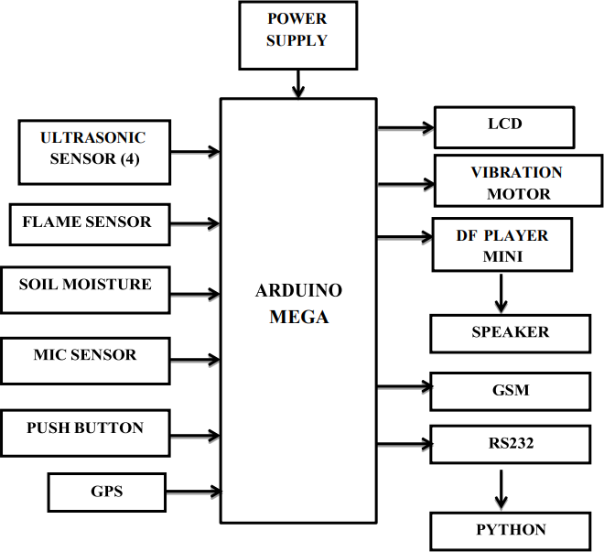

Fig. 1. Block diagram of system

1. *Module Description*

This project centers around aiding visually impaired indi- viduals through the utilization of an Arduino Mega micro- controller, serving as the core intelligence of the system. The ultrasonic sensor is employed to detect objects in the vicinity, providing obstacle detection capabilities. Additionally, a flame sensor is integrated to identify the presence of fire, enhancing safety measures. For activities like gardening, a soil moisture sensor determines whether the soil is wet or dry and conveys this information to the blind user through a vibration motor. To enhance situational awareness, a microphone(mic) sensor captures ambient noise in the surroundings. A DF Player is employed for voice alerts, delivering important information to the visually impaired individual. The pivotal element of our system is the Arduino Mega microcontroller, function- ing as the central processing unit. To address emergencies effectively,we’ve incorporated a push button that serves as an emergency trigger. Upon pressing this button, the system initiates an automatic process wherein the GPS location is instantly transmitted to the designated caretaker through the GSM module. Simultaneously, the LCD screen updates in real-time, providing the currentstatus ofthe situation. Within this project, the Arduino Mega microcontroller serves as the central processing unit, acting as the core intelligence

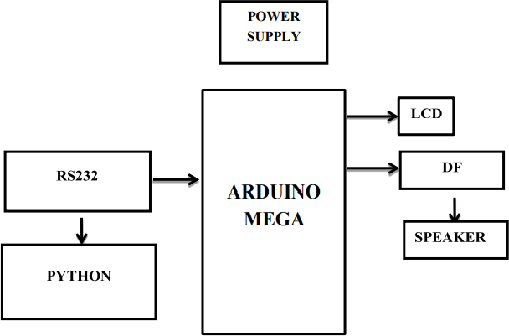

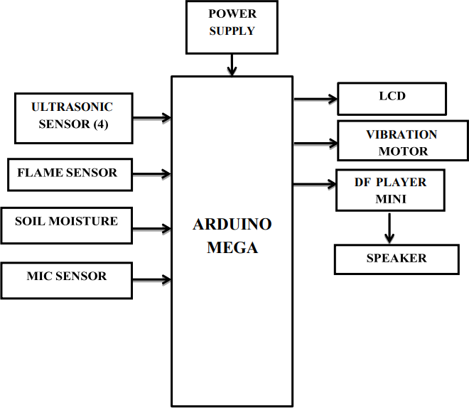Fig. 2. BBlock diagram of authentication

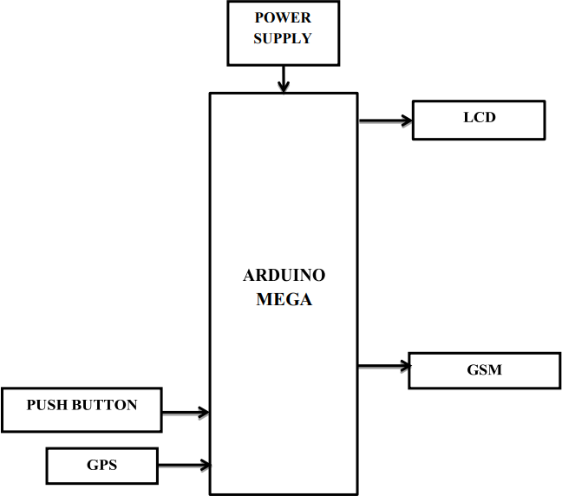

Fig. 3. Block diagram ofsecurity section

of our system. Additionally, Python is employed for face detection, enhancing the system’s capabilities The Python- based face detection mechanism identifies faces and triggers voice alerts, providingvaluable auditory information to assist visually impaired individuals.

1. Hardaware and Software Description
2. *Hardware Description*

***Arduino Mega 2560****:* It is designed for more complex projects. With 54 digital I/O pins, 16 analog inputs and a larger space for your sketch it is the recommended board for 3D

Fig. 4. Block diagram of face detection

printers and robotics projects. This gives your projects plenty of room and opportunities.

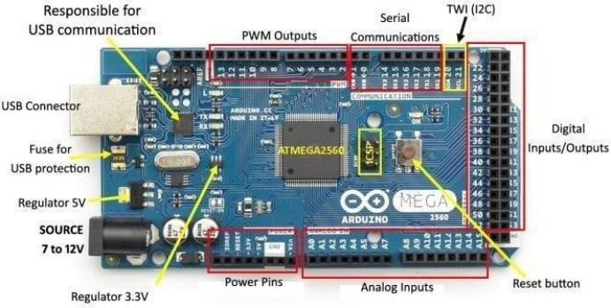

Fig. 5. Arduino Mega

TABLE I

Specification of Arduino Mega

|  |  |
| --- | --- |
| Microcontroller | ATmega2560 |
| Operating Voltage | 5V |
| Input Voltage (recommended) | 7-12V |
| Input Voltage (limit) | 6-20V |
| Digital I/O Pins | 54 (of which 15 provide PWM output) |
| Analog Input Pins | 16 |
| DC Current per I/O Pin | 20 mA |
| DC Current for 3.3V Pin | 50 mA |
| Flash Memory | 256 KB of which 8 KB used by bootloader |
| SRAM | 8 KB |
| EEPROM | 4 KB |
| Clock Speed | 16 MHz |
| LED BUILTIN | 13 |
| Length | 101.52 mm |
| Width | 53.3 mm |
| Weight | 37 |

***Power supply****:* This section describes how to generate

+5V DC power supply The power supply section is the important one. It should deliver constant output regulated

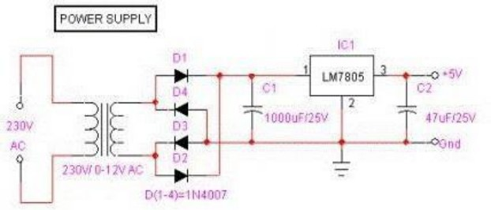 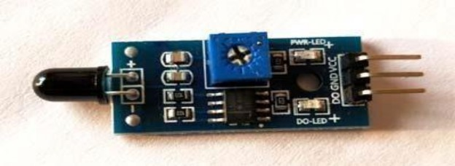

Fig. 6. Power supply

power supply for successful working of the project. A 0-12V/1 mA transformer is used for this purpose. The primary of this transformer is connected in to main supply through on/off switch& fuse for protecting from overload and short circuit protection. The secondary is connected to the diodes to convert 12V AC to 12V DC voltage. And filtered by the capacitors, which is further regulated to +5v, by using IC 7805.

***Ultrasonic sensor****:* Ultrasonic ranging module HC - SR04 provides 2cm - 400cm non-contact measurement func- tion, the ranging accuracy can reach to 3mm. The modules include ultrasonic transmitters, receiver and control circuit.

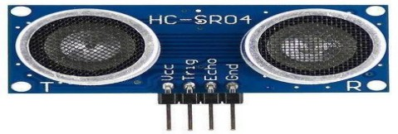

Fig. 7. HC-SR04

TABLE II

Parameters of Ultrasonic Sensor

|  |  |
| --- | --- |
| Parameter | Value |
| Working Voltage | DC 5 V |
| Working Current | 15 mA |
| Working Frequency | 40 Hz |
| Max Range | 4 m |
| Min Range | 2 cm |
| Measuring Angle | 15 degrees |
| Trigger Input Signal | 10 *µ*s TTL pulse |
| Echo Output Signal | Input TTL level signal and the range in proportion |
| Dimension | 45 mm *×* 20 mm *×* 15 mm |
| Main parts | Transmitter & receiver |
| Technology used | Non-contact technology |
| Resolution | 3 mm |

***Flame Sensor****:* It is designed to detect and respond to the presence of a flame or fire. Responses to a detected flame depend on the installation, but can include sounding an alarm, deactivating a fuel line (such as a propane or a natural gas line), and activating a fire suppression system.

Fig. 8. Flame sensor

***Soil Moisture sensor****:* FC-28 soil moisture sensor can be used to test the moisture of soil, when the soil is having water shortage, the module output is at high level, and else the output is at low level. By using this sensor one can automatically water the flower plant, or any other plants requiring automatic watering technique. Soil moisture sensors measure the volumetric water content in soil.

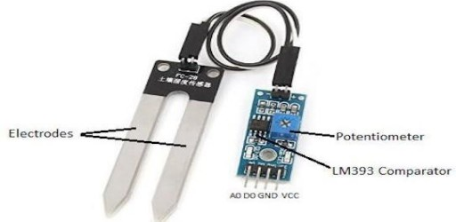

Fig. 9. Soil moisture sensor

TABLE III

Specifications of FC-28 soil moisture Sensor

|  |  |
| --- | --- |
| Operating Voltage | 3.3V–5V |
| Dual Output Mode | Analog output more accurate |
| Installation | Fixed bolt hole for easy installation |
| Indicators | Power indicator (red) and digital  switching output indicator (green) |
| Comparator Chip | LM393 comparator chip, stable |
| Panel PCB Dimension | Approx. 3cm *×* 1.5cm |
| Soil Probe Dimension | Approx. 6cm *×* 3cm |
| Cable Length | Approx. 21cm |
| VCC | 3.3V–5V |
| GND | GND |
| DO | Digital output interface (0 and 1) |
| AO | Analog output interface |
| Output Voltage | 0–4.2V |
| Input Current | 35mA |
| Output Signal | Both analog and digital |

***Sound Sensor****:* This sensor is capable to determine noise levels within DB’s or decibels at 3 kHz 6 kHz frequencies approximately wherever the human ear is sensitive. 32 In smartphones, there is an android application namely decibel meter used to measurethe sound level.

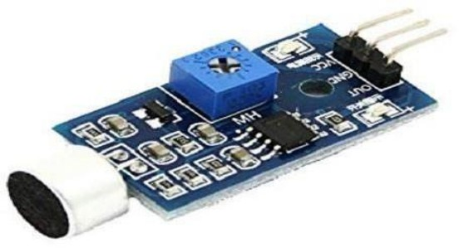

Fig. 10. Sound sensor

***LCD (Liquid Crystal Display)****:* LCD screen is an elec- tronic display module and find a wide range of applications. A 16x2 LCD display is very basic module and is very commonly used in various devices and circuits. These modules are preferred over seven segments and other multi segment LEDs.

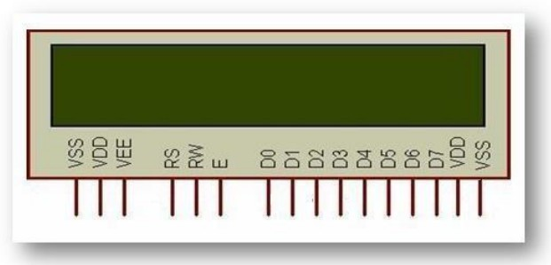

Fig. 11. LCD (Liquid Crystal Display)

TABLE IV

Pin Description of LCD

|  |  |  |
| --- | --- | --- |
| Pin No. | Function Name | Description |
| 1 | Ground (0V) | Ground |
| 2 | Vcc | Supply voltage; 5V (4.7V – 5.3V) |
| 3 | VEE | Contrast adjustment;  through a variable resistor |
| 4 | Register Select | Selects command register when low;  and data register when high |
| 5 | Read/Write | Low to write to the register;  High to read from the register |
| 6 | Enable | Sends data to data pins  when a high to low pulse is given |
| 7 – 14 | DB0 – DB7 | 8-bit data pins |
| 15 | Led+ | Backlight VCC (5V) |
| 16 | Led- | Backlight Ground (0V) |

***Coin Vibration Motors****:* Precision Micro drives currently produces coin vibration motors, also known as shaftless or pancake vibrator motors, generally in Ø8mm - Ø12mm diam- eters for our Pico Vibe range. Pancake motors are compact and convenient to use.

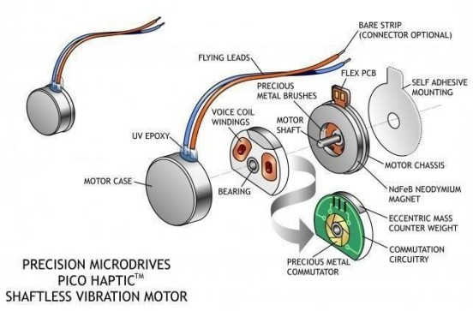Fig. 12. Exploded Coin Motor

***GPS****:* Global Positioning System is a satellite navigation system that furnishes location and time information in all climate conditions to the user. GPS is used for navigation in planes, ships, cars and trucks also. The system gives critical abilities to military and civilian users around the globe. GPS provides continuous real time, 3-dimensional positioning, navigation and timing worldwide.

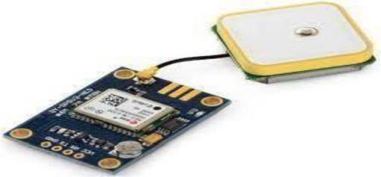

Fig. 13. GPS (Global Positioning System)

***SIM 900 GSM/GPRS module****:* GSM/GPRS Modem- RS232 is built with Dual Band GSM/GPRS engineSIM900, works on frequencies 900/ 1800 MHz The Modem is coming with RS232 interface, which allows you connect PC as well as microcontroller with RS232 Chip (MAX232). The baud rate is configurable from 9600-115200 through AT command. The GSM/GPRS Modem is having internal TCP/IP stack to enable you to connect with internet via GPRS. It is suitable for SMS, Voice as well as DATA transfer application in M2M interface.

***DF Player****:* The DF Player Mini MP3 Player For Arduino is a small and low-cost MP3 module with a simplified output directly to the speaker. The module can be used as a stand- alone module with attached battery, speaker and push buttons or used in combination with microcontrollers such as Arduino, ESP32, Raspberry Pi and any microcontrollers with Uart.

1. *Software Descriptions*
2. Conculsion and future enhancement

*Conculsion:* In this paper, to cope with the cross-corpus facial expression recognition problem, we have presented

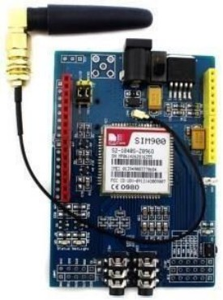

Fig. 14. SIM 900 GSM/GPRS module

TABLE V

Software Descriptions

|  |  |
| --- | --- |
| Software | Description |
| Embedded C | Widely used programming language  for programming microcontrollers in electronic devices. |
| Real-Time Operating Systems | Operating system specialized  for embedded system development, offering real-time processing. |

a novel transfer learning method, called transferable sparse subspace representation (TSSR), which can efficiently transfer knowledge from source corpus to target corpus. Specifically, under the theory of SSC, we adopt the source data as a dictionary and impose sparse constraint on the coefficients, each data in source and target databases can be represented as a combination of the source (dictionary) data. Furthermore, we introduce a graph Laplacian regularizer and a distance metric in our model, which can well preserve the local geometrical information within two corpora and efficiently reduce the divergence between the source and target corpora. Finally, extensive experimental results on several public facial expression databases verify that our method can significantly outperform some stateof-the-art transfer learning methods.

*Future Enhancement:* Upgrade the face detection system by incorporating more advanced and efficient face recognition algorithms. This could improve accuracy and speed in identi- fying authorized individuals.

References

1. Anwar, A.,& Aljahdali, S. (2017). A smart stick for assisting blind people. IOSR Journal of Computer Engineering, Vol.19, No.3, pp.86- 90.
2. Bayer, N.L. & Pappas, L., (2006). Accessibility Testing: Case history of blind testers of enterprise software. Technical Communication, Vol.53, No.1, pp.32- 35.
3. Beale, L., Field, K. Briggs, D. Picton & P. Matthews, H., (2006). Mapping for wheelchair users: route navigation in urban spaces. The Cartographic Journal, 2006, Vol.43, No.1, pp. 68-81.
4. Bigham, J. P., Jayant, C., Ji, H., Little, G., Miller, A., Miller, R.C., Miller,

R., Tatarowicz, A., White, B.,White, S. & Yeh, T., (2010). VizWiz: Nearly realtime answers to visual questions. In Proc. Of UIST’10, ACM Press (2010), pp.333-342.

1. Bourne RRA,Flaxman, SR,Braithwaite T,Cicinelli MV, Das A,Jost B et al., on behalf of the Vision Loss Expert Group. Magnitude, temporal trends and projections of the global prevalence of blindness and distance and near vision impairment: asystematic review and meta-analysis. Lancet 2017;5(9): e888- e879.
2. Charette, R. and Nashashibi, F. Real Time Visual Traffic Lights Recog- nition Based on Spot Light Detection and Adaptive Traffic Lights Templates. In World Congress and Exhibition on Intelligent Transport Systems and Service(2009).
3. Crandall, W., Brabyn, J., Bentzen, B.L., and Myers, L. Remote Infrared Signage Evaluation for Transit Stations and Intersections. Journal of Rehabilitation Research and Development, 36, 4 (1999), 341-355.
4. Freund, Y. and Schapire, R.E. A Decision-Theoretic Generalization of Online Learning and an Application to Boosting. Journal of Computer and System Sciences, 55 (1997), 119-139. 69
5. Gallo, O., Manduchi, R., and Rafii, A. Robust Curb and Ramp Detection for Safe Parking using the Canesta TOF camera. In IEEE Computer Society Conference on Computer Vision and Pattern Recognition Work- shops(2008).
6. G. Csurka, C. R. Dance, L. Fan, J. Willamowski, C. Bray, ”Visual categorization with bags of keypoints,” In Workshop on Statistical Learning in Computer Vision, ECCV, pp. 1-22, 2004.
7. Grundmann, T., Eidenberger, R., Zoellner, R.D.,Zhixing, X., Ruehl, S., Zoellner, J.M., Dillmann, R., Kuehnle, J.,and Verl, A. Integration of 6D Object Localization and Obstacle Detection for Collision Free Robotic Manipulation. In IEEE/SICE International Symposium on System Inte- gration(2008).
8. Ivanchenko, V., Coughlan, J. & Shen, H., (2008). Cross watch: A camera phone system for orienting visually impaired pedestrians at traffic intersections. In Proc. of ICCHP 2008, pp.1122 – 1128.
9. Kim, Y.K., Kim, K.W., and Yang, X. Real Time Traffic Light Recog- nition System for Color Vision Deficiencies. In IEEE International Conference on Mechatronics and Automation ( 2007).
10. Lienhart, R. and Maydt, J. An Extended Set of Haar-Like Features for Rapid Object Detection. In IEEE International Conference on Image Processing ( 2002).
11. Manduchi, R. & Kurniawan, S. (2011). Mobility-related accidents ex- perienced by people with visual impairment. Research and Practice in Visual Impairment and Blindness, Vol.4, No.2, pp.44-54.
12. Meyers, A.R., Anderson, J. J., Miller, D. R., Shipp, K. & Hoenig, H., (2002). ‘Barriers, facilitators, and access for wheelchair users: substan- tive and methodological lessons from a pilot study of environmental effects’, Social Science & Medicine, 2002, 55, (8), pp. 1435-1446.
13. N. Dalal, B. Triggs, ”Object detection using histograms of oriented gradients”, in European Conference on Computer Vision, vol. 1,pp 886- 893, 2006. 70
14. Pleis, J.R. and Lethbridge-C¸ ejku, M. Summary health statistics for U.S. adults: National Health Interview Survey, 2006. National Center for Health Statistics, 2007.
15. Ringbeck, T., Moller, T., and Hagebeuker, B.Multi dimensional Mea- surement by Using 3-D PMD sensors. Advances in Radio Science, 5 (2007), 135-146.
16. Shioyama, T., Wu, H., Nakamura, N., and Kitawaki, S.Measurement of the length of pedestrian crossings and detection of traffic lights from image data. Measurement Science And Technology, 13 (2002), 1450-

1457.

1. Tapu, B., Mocanu., B., Bursuc, A. & Zaharia, T., (2013). A smartphone- based obstacle detection and classification system for assisting visually impaired people. In Proc. of ICCVW 2013, 444 - 451.
2. Tombari, F., Stefano, L., Mattoccia, S., and Zanetti, A.Graffiti Detection Using a Time-of-Flight Camera. In 10th International Conference on Advanced Concepts for Intelligent Vision Systems ( 2008).
3. Uddin, M. and Shioyama, T. Detection of Pedestrian Crossing using Bipolarity and Projective Invariant. In IAPR Conference on Machine Vision Applications ( 2005).
4. Van Puffelen, C., van der Geest, T. & van der Meij, H., (2008). The use of digital skills by visually disabled people to participate in society. In Proc. of IADIS International Conference ICT, Society and Human Beings 2008, 85 - 90.
5. West, S. K., Rubin, G.S., Broman, A.T., Munoz, B., Bandeen-Roche, K. & Turano, K. (2002). How does visual impairment affect performance on tasks of everyday life? Arch Ophthalmol, 120, 774-780.
6. Zeng L. & Weber.G. (2015). A pilot study of collaborative accessibility: how blind people find an entrance. In Proc. of ACM Mobile HCI 2015, 24th August -27th August, 2015, Denmark.