INTELLIGENT LOCALIZATION SYSTEM FOR CONSTRUCTION ACCIDENT RESCUE USING RSSI

Dr. D. Kalaiyarasi Dhuraisamy1a), S. Keerthana Selvan2b), J. Jeeva Swasthika3C)

*1 Professor, Department of Electronics and Communication Engineering*

*Panimalar Engineering College, Chennai, India*

*2UG Student, Department of Electronics and Communication Engineering*

*Panimalar Engineering College, Chennai, India*

*3UG Student, Department of Electronics and Communication Engineering*

*Panimalar Engineering College, Chennai, India*

*a) kalaiccarthi@gmail.com*

*b) keerthanaselvan2001@gmail.com*

*c) jeevaswasthika@gmail.com*

**Abstract**— **The Intelligent Localization System for Construction Accident Rescue using RSSI for Person Identification and Health Monitoring System represents a critical advancement in ensuring the safety and wellbeing of workers in the construction industry. Leveraging the power of Radio Signal Strength Indicator (RSSI) technology, this system is designed to precisely locate and identify individuals within a construction site during emergencies or accidents. By analyzing RSSI signal strength, the system accurately pinpoints the location of each worker, enabling efficient and timely rescue operations. Furthermore, the system integrates health monitoring capabilities, providing real-time insights into the well-being of workers. This includes monitoring vital signs, such as heart rate and body temperature, ensuring early detection of distress signals and prompt medical intervention when needed. The amalgamation of person identification, localization, and health monitoring ensures a comprehensive safety net, enabling construction sites to respond swiftly and effectively in the event of an emergency.**

Keywords—RSSI Technology, Heartrate sensor, IOT, Buzzer, LED.

I. INTRODUCTION

Localization The Intelligent System for Construction Accident Rescue utilizing Received Signal Strength Indication (RSSI) technology is an innovative and critical project designed to enhance rescue operations in construction accident scenarios. RSSI technology is employed to accurately determine the location of trapped or injured individuals within the construction site based on the strength of radio signals emitted from their devices. Target-aware dual filter learning for real-time anti-dark UAV tracking [1]. Autonomous UAV trajectory for localizing ground objects a reinforcement learning approach [2]. Minimizing the longest tour time among a fleet of UAVs for disaster area surveillance [3]. Reinforcement learning-based collision avoidance and optimal trajectory planning in UAV communication networks [4]. Model predictive trajectory tracking and collision avoidance for reliable outdoor deployment of unmanned aerial vehicles [5].

**II. PROPOSED SYSTEM**

In our proposed system, By utilizing Receive Signal Strength Identification (RSSI) Technology, the system can precisely locate individuals trapped in the ruins of buildings. The inclusion of heart rate sensor in the wearable device allows continuous monitoring of the trapped person’s heart rate. This enable rescuers to quickly reach the affected person, reducing response time and improving overall rescue efficiency. This sensor information provide valuable insights into their health condition, enabling rescuers to prioritize their rescue efforts and provide appropriate medical assistance if needed.

EXISITING METHOD VS PROPOSED METHOD :

|  |  |
| --- | --- |
| EXISITING METHOD | PROPOSED METHOD |
| The existing system may rely on manual search and rescue method, which can be time-consuming and less precise. | By utilizing Receive Signal Strength Identification (RSSI) Technology, the system can precisely locate individuals trapped in the ruins of buildings. |
| The existing systems may not incorporate sensors to monitor the vital signs of trapped individuals, such as heart rate. | The inclusion of heart rate sensor in the wearable device allows continuous monitoring of the trapped person’s heart rate. |
| This can lead to delays in finding and rescuing individuals trapped in the debris of demolished buildings. | This enable rescuers to quickly reach the affected person, reducing response time and improving overall rescue efficiency. |
| It can be challenging for trapped individuals to signal for help or provide crucial information about their location and condition to the rescuers. | This sensor information provide valuable insights into their health condition, enabling rescuers to prioritize their rescue efforts and provide appropriate medical assistance if needed. |

*Table 1: Existing system vs proposed system*

SCOPE OF THE PROJECT :

The scope of this project is to develop an integrated system using RSSI technology, Arduino Uno microcontroller, and various sensors to facilitate efficient and timely rescue operations in construction areas following accidental building demolitions, enhancing safety for workers.

BLOCK DIAGRAM AND WORKING :

TRANSMITTER :

POWER SUPPLY

RSSI

DHT11

GPS

HEART RATE SENSOR

ZIGBEE TX

BUZZER

LED

LCD

**ARDUINO**

**UNO**

*Fig. 1: Block Diagram (Transmitter)*

RECEIVER :

POWER SUPPLY

**IOT**

ZIGBEE RX

*Fig. 2: Block Diagram (Receiver)*

This system is to help the rescuer in construction area if buildings have demolished accidentally. In this system, Arduino uno microcontroller is used to control all over system. The overall system acts as a device that fixed on the person who works the building construction area. Receive Signal Strength Identification (RSSI) is used to get signal from the person who is stuck into ruins of the buildings in construction area. It helps to rescue that person easily according to the Receive Signal Strength Identification (RSSI).

Heart rate sensor is into the device that used to monitor the heartrate of the person. DHT11 sensor is used to monitor the body temperature and humidity level of the person. When the signal strength is high, the person may be located nearly, so that time the LED will glow and BUZZER will scream automatically to ease the rescue work. Heartrate, humidity and temperature data will continuously be transmitted to IOT with the help of wireless communication device. Zigbee is a wireless communication device that helps to transmit the data from the module to IOT webpage.

The system not only collects data from various sensors but also provides real-time monitoring capabilities. Rescuers can access a dedicated dashboard or mobile application where they can view the live data streams from the heart rate sensor, DHT11 sensor, and RSSI signal strength. Additionally, historical data can be analyzed to identify patterns or trends that could aid in optimizing rescue efforts.

HARDWARE REQUIREMENTS :

## ARDUINO UNO MICROCONTROLLER :

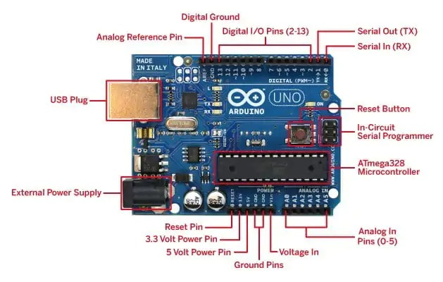

*Fig. 3: Arduino Uno Microcontroller*

Arduino Uno is a microcontroller board based on the ATmega328P (datasheet). It has 14 digital input/output pins (of which 6 can be used as PWM outputs), 6 analog inputs, a 16 MHz quartz crystal, a USB connection, a power jack, an ICSP header and a reset button.

Arduino is open-source hardware. The hardware reference designs are distributed under a Creative Commons Attribution Share-Alike 2.5 license and are available on the Arduino website. Layout and production files for some versions of the hardware are also available.

## HEART RATE SENSOR :

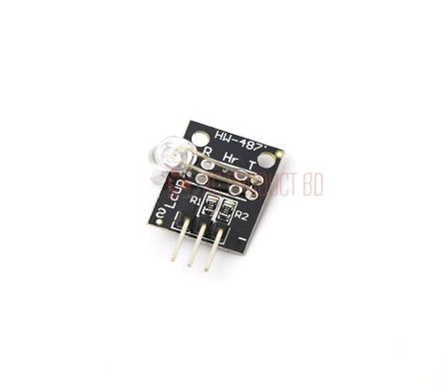

*Fig. 4: Heart Rate Sensor*

The heart rate sensor can monitor the heart rate of individuals, including workers in construction areas. It can provide early detection of health issues such as overexertion, stress, or medical emergencies like heart attacks.

By continuously monitoring heart rate data, the system can trigger alerts or alarms if abnormal patterns are detected, enabling timely intervention and assistance.

## DHT11-TEMPERATURE AND HUMIDITY SENSOR :

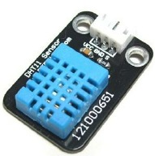

*Fig. 5: DHT11*

The DHT11 sensor can measure temperature and humidity levels in the surrounding environment. It is useful for monitoring the working conditions in construction areas to ensure they are within safe and comfortable ranges for workers.

|  |  |
| --- | --- |
| **PARAMETER** | **VALUE** |
| Accuracy at 25°C | ±0.5°C |
| Accuracy from 55°C to 150°C | ± 1°C |
| Temperature Slope | 10mV/°C |

*Table 2: Temperature parameters*

## RSSI:

RSSI stands for Received Signal Strength Indication. It's a measurement of the power level received by a radio receiver from a transmitter, typically measured in decibels (dBm) or signal strength bars. RSSI is commonly used in wireless communication systems such as Wi-Fi, Bluetooth, Zigbee, and cellular networks to assess the quality of the received signal.

The working principle of RSSI involves measuring the strength of the radio signal received by the receiver. This measurement is influenced by various factors including distance between transmitter and receiver, obstacles in the signal path, interference from other devices, and environmental conditions

|  |  |
| --- | --- |
| **RSSI** | **SIGNAL STRENGTH** |
| >-70 dbm | Excellent |
| -70 dbm to -85 dbm | Good |
| -86 dbm to -100 dbm | Fair |
| <-100 dbm | Poor |
| -100 dbm | No Signal |

*Table 3: signal strength parameters*

## IOT :

The internet of things (IoT) is the network of physical devices, vehicles, buildings and other items embedded with electronics, software, sensors, actuators, and network connectivity that enable these objects to collect and exchange data. In 2013 the Global Standards Initiative on Internet of Things (IoT-GSI) defined the IoT as "the infrastructure of the information society. The IoT allows objects to be sensed and controlled remotely across existing network infrastructure, creating opportunities for more direct integration of the physical world into computer-based systems, and resulting in improved efficiency, accuracy and economic benefit.

SOFTWARE REQUIREMENTS :

## A. ARDUINO SOFTWARE IDE :

## 

The Arduino Integrated Development Environment - or Arduino Software (IDE) - contains a text editor for writing code, a message area, a text console, a toolbar with buttons for common functions and a series of menus. It connects to the Arduino and Genuino hardware to upload programs and communicate with them.

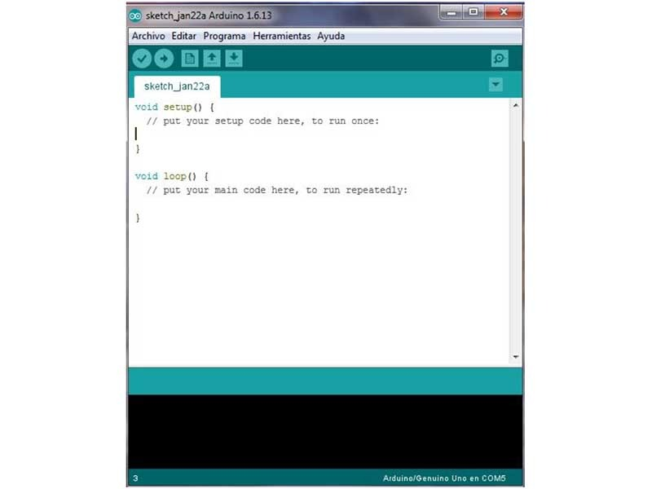

*Fig. 6: Arduino Software IDE*

## B. EMBEDDED C LANGUAGE :

## 

## Embedded C is most popular programming language in software field for developing electronic gadgets. Each processor used in electronic system is associated with embedded software.

#### Embedded C programming plays a key role in performing specific function by the processor. In day-to-day life we used many electronic devices such as mobile phone, washing machine, digital camera, etc. These all device working is based on microcontroller that are programmed by embedded .

## **III. RESULTS AND DISCUSSION**

## 

Implemented a real-time tracking and monitoring system capable of continuously updating the position of the trapped individual based on RSSI data.Integrated RSSI readings with algorithms to enhance localization accuracy, even in complex and dynamic construction environments with obstacles and interference.

Developed a novel localization technique leveraging Received Signal Strength Indication (RSSI) for accurately determining the location of individuals trapped in construction accidents. Utilized RSSI measurements from wireless communication devices, such as Zigbee or Wi-Fi modules, to estimate the distances between the trapped individual and reference points within the construction site.

Overall, the Intelligent Localization System for Construction Accident Rescue Using RSSI represents a significant advancement in leveraging wireless communication technology for enhancing rescue operations and improving outcomes in construction accident scenarios.

For example, If the person is located within 5 meters the LED bulb will glow “GREEN” in colour as show in fig.8.

If the person is located within 10 meters the LED bulb will glow “ORANGE” in colour as show in fig.9.

If the person is located within 20 meters the LED bulb will glow “RED” in colour as show in fig.10.

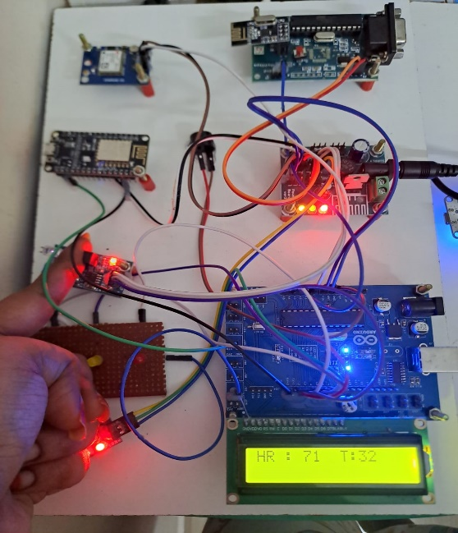 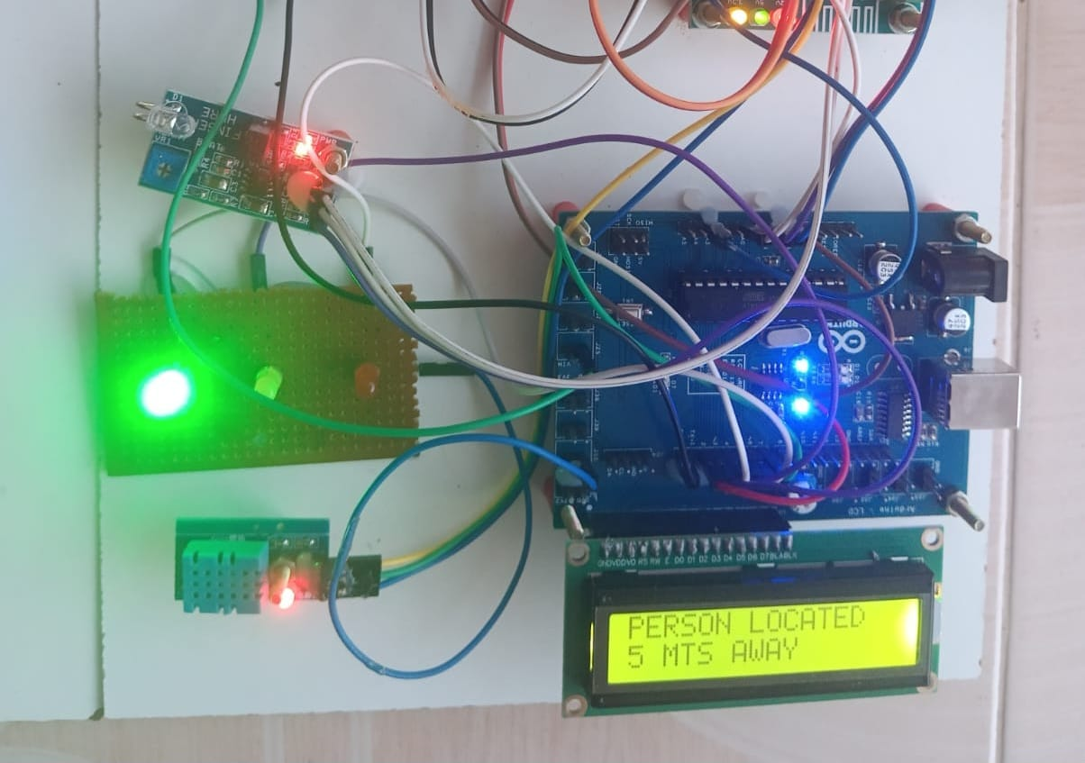

*Fig 7: placing the finger to Fig 8*

*display heart rate*

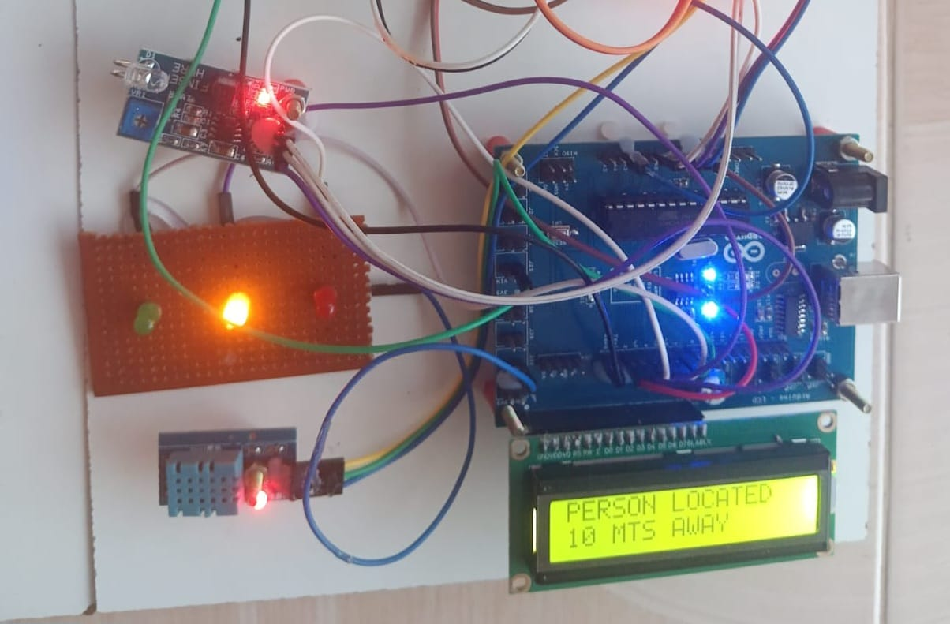 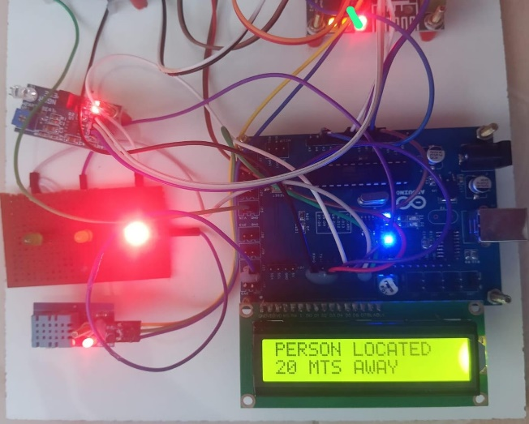

*Fig 9 Fig 10*

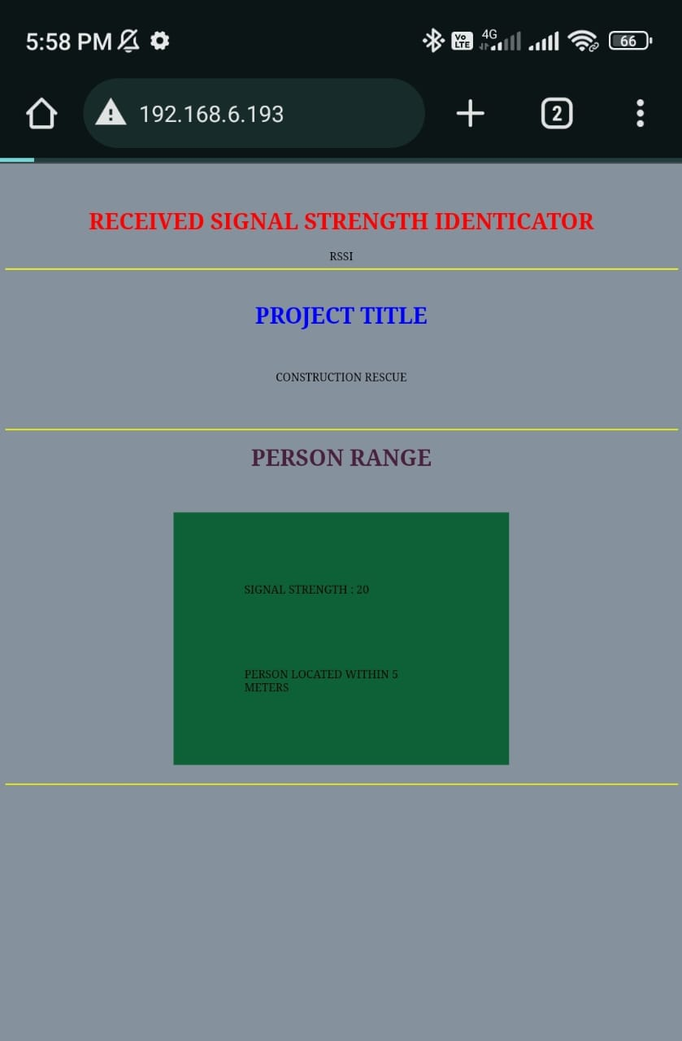 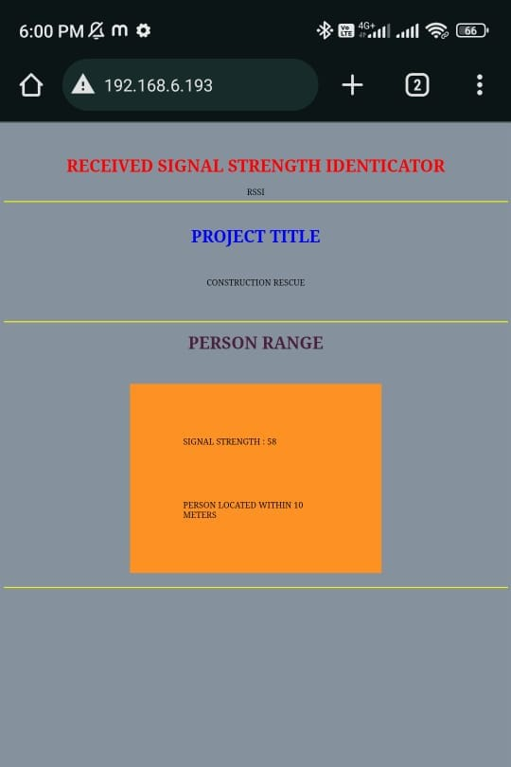

*Fig 11: IOT webpage displaying Fig 12*

*signal strength*

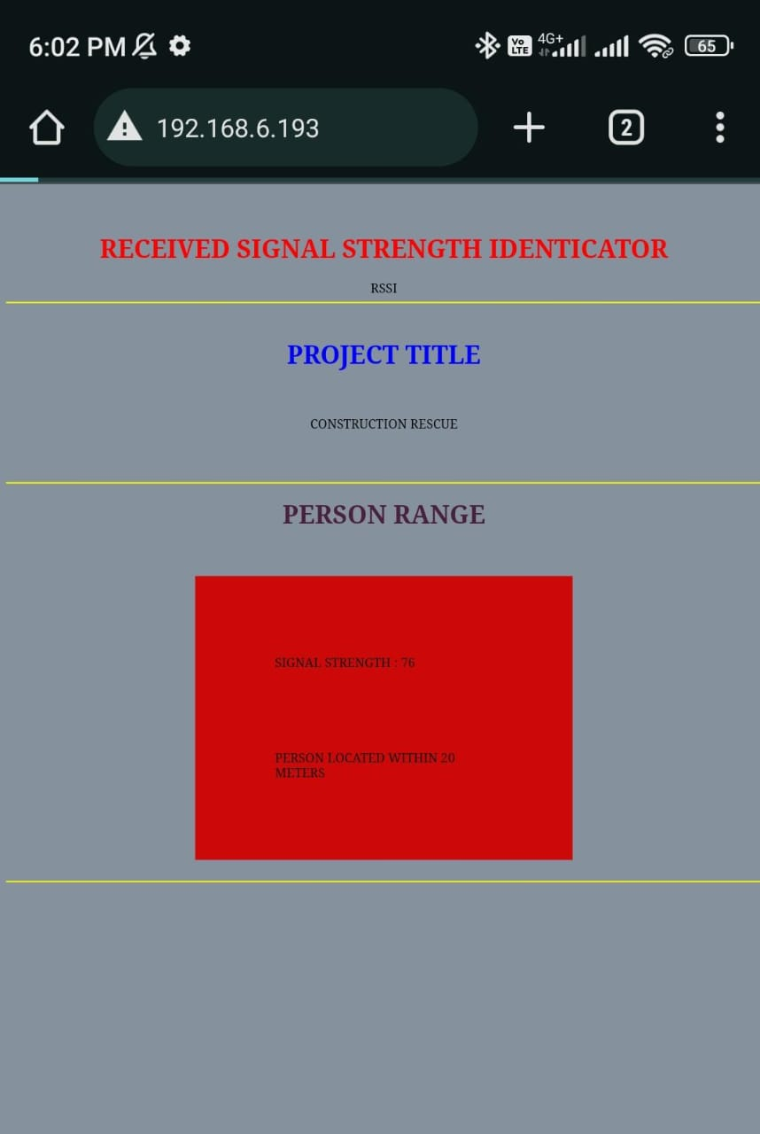 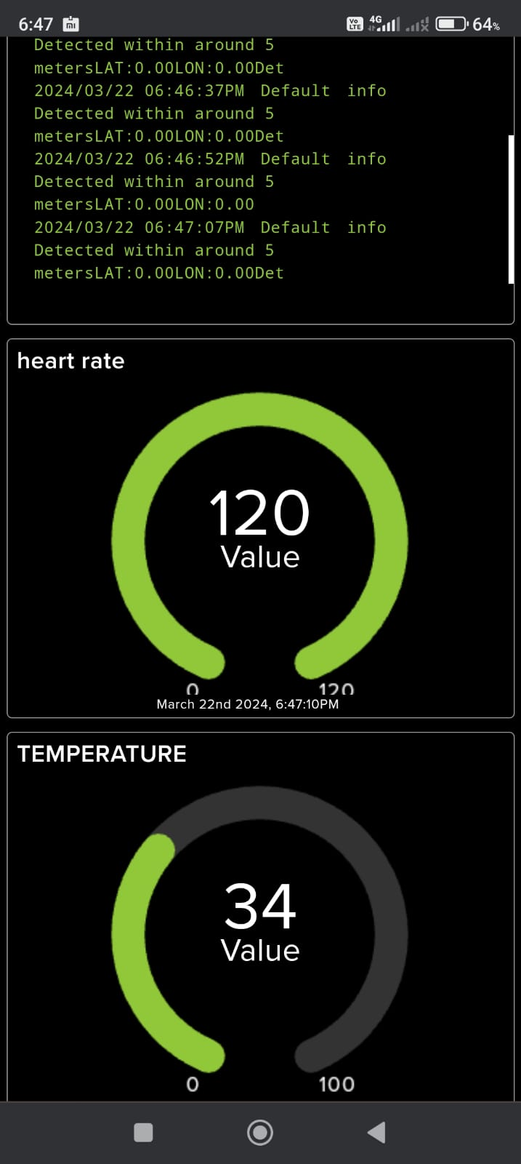

*Fig 13 Fig 14: displaying the Live status*

|  |  |  |  |
| --- | --- | --- | --- |
| ***Parameters*** | *Trail 1* | *Trail 2* | *Trail 3* |
| *Heart rate* | *120* | *116* | *90* |
| *Temperature* | *28.2* | *26.3* | *27.8* |

*Table 1: Experimental results*

|  |  |  |  |
| --- | --- | --- | --- |
| ***Parameters*** | *Trail 1* | *Trail 2* | *Trail 3* |
| *Signal strength* | *20* | *58* | *76* |
| *LED* | *Green* | *Orange* | *Red* |
| *Buzzer* | *-* | *-* | *Alarm* |

*Table 2: Experimental results*

## 

**IV. CONCLUSION**

In conclusion, the proposed Intelligent Localization System for Construction Accident Rescue showcases a seamless integration of Arduino Uno microcontroller and advanced sensor technologies to improve rescue operations in the event of construction accidents. By utilizing RSSI technology, the system effectively pinpoints the location of individuals trapped in the wreckage, aiding rescuers in their efforts. The incorporation of vital signs monitoring, including heart rate and body temperature, ensures real-time assessment of the person's health status during the rescue process. The use of Zigbee for wireless data transmission to an IoT platform further enhances the system's efficiency, providing crucial insights and aiding in decision-making for a swift and efficient rescue mission within construction sites. Overall, this project demonstrates a promising step towards leveraging technology for enhanced safety and responsiveness in critical construction-related emergencies.

REFERENCES

## [1] B. Li, C. Fu, F. Ding, J. Ye, and F. Lin, “ADTrack: Target-aware dual filter learning for real-time anti-dark UAV tracking,” in Proc. IEEE Int. Conf. Robot. Automat., 2021, pp. 496–502.

## [2] D. Ebrahimi, S. Sharafeddine, P.-H. Ho, and C. Assi, “Autonomous UAV trajectory for localizing ground objects: A reinforcement learning approach,” IEEE Trans. Mobile Comput., vol. 20, no. 4, pp. 1312–1324, Apr. 2021.

## [3] Ǫ. Guo et al., “Minimizing the longest tour time among a fleet of UAVs for disaster area surveillance,” IEEE Trans. Mobile Comput., early access, 2020, doi: 10.1109/TMC.2020.3038156.

## [4] Y.-H. Hsu and R.-H. Gau, “Reinforcement learning-based collision avoidance and optimal trajectory planning in UAV communication networks,” IEEE Trans. Mobile Comput., vol. 21, no. 1, pp. 306–320, Jan. 2022.

## [5] T. Baca, D. Hert, G. Loianno, M. Saska, and V. Kumar, “Model predictive trajectory tracking and collision avoidance for reliable outdoor deployment of unmanned aerial vehicles,” in Proc. IEEE/ RSJ Int. Conf. Intell. Robots Syst., 2018, pp. 6753–6760.

## [6] F. Vanegas, D. Campbell, N. Roy, K. J. Gaston, and F. Gonzalez, “UAV tracking and following a ground target under motion and localisation uncertainty,” in Proc. IEEE Aerosp. Conf., 2017, pp. 1–10

## [7] C. Fu, A. Carrio, M. A. Olivares-Mendez, R. Suarez-Fernandez, and P. Campoy, “Robust real-time vision-based aircraft tracking from unmanned aerial vehicles,” in Proc. IEEE Int. Conf. Robot. Automat., 2014, pp. 5441–5446.

## [8] J. Ye, C. Fu, F. Lin, F. Ding, S. An, and G. Lu, “Multi-regularized correlation filter for UAV tracking and self-localization,” IEEE Trans. Ind. Electron., vol. 69, no. 6, pp. 6004–6014, Jun. 2022.

## [9] C. Yuan, Z. Liu, and Y. Zhang, “UAV-based forest fire detection and tracking using image processing techniques,” in Proc. Int. Conf. Unmanned Aircr. Syst., 2015, pp. 639–643

## [10] S. Lin, M. Garratt, and A. Lambert, “Monocular vision-based realtime target recognition and tracking for autonomously landing an UAV in a cluttered shipboard environment,” Au

*[11] Bin Abdullah, M. F. A., Negara, A. F. P., Sayeed, M. S., Choi, D.-J., and Muthu, K. S. (2012). “Classification algorithms in human activity recognition using smartphones.” Int. J. Comput. Inf. Eng., 6, 77–84*

## [12] Kothari, N., Kannan, B., Glasgwow, E. D., and Dias, M. B. (2012). “Robust indoor localization on a commercial smart phone.” Procedia Comput. Sci., 10, 1114–1120.

## [13] Li, N., Becerik-Gerber, B., Krishnamachari, B., and Soibelman, L. (2014). “A BIM centered indoor localization algorithm to support building fire emergency response operations.” Autom. Constr., 42, 78–89.

## [14] Weiss, G. M., and Lockhart, J. W. (2012). “The impact of personalization on smartphone-based activity recognition.” Proc., AAAI Workshop on Activity Context Representation: Techniques and Languages, AAAI Press, Palo Alto, CA

## [15] Yan, Z., Subbaraju, V., Chakraborty, D., Misra, A., and Aberer, K. (2012). “Energy-efficient continuous activity recognition on mobile phones: An activity-adaptive approach.” Proc., 16th Int. Symp. on Wearable Computers (ISWC), IEEE, Piscataway, NJ, 17–24

## [16] Subbu, K. P., Gozick, B., and Dantu, R. (2013). “LocateMe: Magnetic-fields-based indoor localization using smartphones.” ACM Trans. Intell. Syst. Technol., 4(4), 1–27.

## [17] Goyal, H.R.; Ghanshala, K.K.; Sharma, S. Recommendation based rescue operation model for flood victim using smart IoT devices. Mater. Today Proc. 2021, 46, 10418–10424.

## [18] 3GPP. Location Services (LCS). In Technical Specification (TS) 22.071, 3rd Generation Partnership Project (3GPP); Version 16.0.0; 3GPP: Sophia Antipolis, France, 2020