the impact of personality traits on consumer buying behavior

Table of Contents

Introduction 1

Objective: 2

Literature review: 2

Personality traits 2

Consumer buying behaviour 3

The relationship between personality traits and consumer buying behaviour 3

Methodology: 3

Analysis: 4

Conclusion 6

Appendix: A 8

Appendix B 10

# 

# Abstract:

Consumer behavior has been a complex and interesting subject of interest for marketers, researchers, and scholars. An individual's personality traits are recognized as a significant factor influencing consumer behavior, as they define an individual's behavior, attitudes, and preferences. These traits can greatly shape an individual's buying behavior, affecting how they perceive and respond to marketing efforts.

The purpose of our research is to investigate the impact of personality traits on consumer buying behavior at Sukkur IBA University Kandhkot Campus. Our study will involve a comprehensive review of existing literature on personality traits and consumer behavior.

A thorough comprehension of the impact of personality traits on consumer buying behavior is crucial for marketers, as it enables them to develop effective marketing strategies that effectively connect with their target audience. By recognizing the most influential personality traits in shaping consumer behavior, marketers can craft persuasive marketing messages that are better suited to resonate with their intended audience.

Studies conducted in this field have pinpointed several personality traits that impact consumer behavior, such as openness, conscientiousness, extraversion, agreeableness, and neuroticism. For instance, individuals who score high in openness may exhibit a greater tendency to try new products and engage in risk-taking behavior, whereas those who score high in conscientiousness may be more inclined to conduct thorough product research before making a purchase decision.

## Objective:

To investigate the influence of personality traits on consumer buying behavior.

# Literature review:

## Personality traits

Personality is a fundamental aspect of an individual's psychological makeup that influences their responses to the surrounding environment. According to(Goldberg, 1990) The Big Five Personality Traits represent five key dimensions of personality. Extensive research has been conducted on personality as a crucial factor in consumer behavior, revealing that it can undergo changes due to social, cultural, and environmental influences. Each consumer possesses unique characteristics such as their preferences, level of competitiveness, degree of introversion or extroversion, and level of conservatism. According to (Pinki, 2014) These factors, suggests, play a significant role in determining what, when, and how consumers make purchases. Consequently, marketers have a keen interest in understanding the importance of personality traits and their impact on consumer behavior.

## Consumer buying behaviour

Consumer purchase behavior refers to the cognitive, affective, and behavioral actions individuals undertake when choosing, buying, using, and disposing of products and services to fulfill their needs and desires (Nagar, 2009). It includes purchasing and other consumption related acitivites of people engaging in exchange process. Solomon, Bamossy, Askegaard and Hogg (Hogg et al., 2006) Consumer behavior encompasses the examination of how individuals or groups go through the process of choosing, acquiring, utilizing, and discarding products, services, ideas, or experiences to fulfill their needs and wants. Economic factors, including income expenditure patterns, product pricing, complementary product pricing, availability of substitute goods, and demand elasticity, exert an influence on consumer purchasing behavior.(Abraham, 1997) Social and cultural influences shape consumer behavior, impacting both individuals' buying choices and the types of products they opt for. These influences play a crucial role in determining the purchasing decisions of individuals, as well as the specific categories or characteristics of goods they choose to purchase(Arnould & Thompson, 2005)

## The relationship between personality traits and consumer buying behaviour

Consumers tend to select products that align with their personality, as evident in their choices of home furnishings, furniture, appliances, automobiles, and jewelry. Higher status individuals often show a tendency to purchase more luxurious and expensive goods. Marketers strategically design their products, advertisements, and promotional campaigns to cater to the personality types of their target customers(Sarker et al., 2013) The connection between personality and consumer behavior is widely recognized and unique. An individual's personality can exert a considerable influence on their behaviors, encompassing brand preferences, responses to marketing stimuli, and timing of shopping activities.

# Methodology:

In our research project, we conducted a survey questionnaire of sample size of 33 students among 250 students at Sukkur IBA University Kandhkot Campus. In which we excluded the responses of 2 participants because of the inadequate information. The survey was intended to investigate the impact of personality traits on consumer buying behavior. The survey consisted of two parts: a grooming product section and main section containing questions about influence of personality traits on their buying behavior. From the questions, we collected the information about big five personality traits (Openness, Conscientiousness, Extraversion, Agreeableness, and Neuroticism) of people have different buying behavior in grooming products.

We used the qualitative approach in our survey questionnaire. Data was collected through online survey tool, and participants were invited to complete the survey via email. Participation was voluntary and anonymous. Participants were informed about the purpose (that our consumer behavior project will include your personality trait data in the results) of our project.

The survey was conducted in accordance with ethical guidelines for research and participants were informed about their right to withdraw from the survey questionnaire at any time. All data collected was kept confidential and anonymous.

# Analysis:

We collected data from the survey (See Appendix A) on impact of personality traits on consumer buying behavior in grooming products. In which there was 62.5% females and 37.5% males.

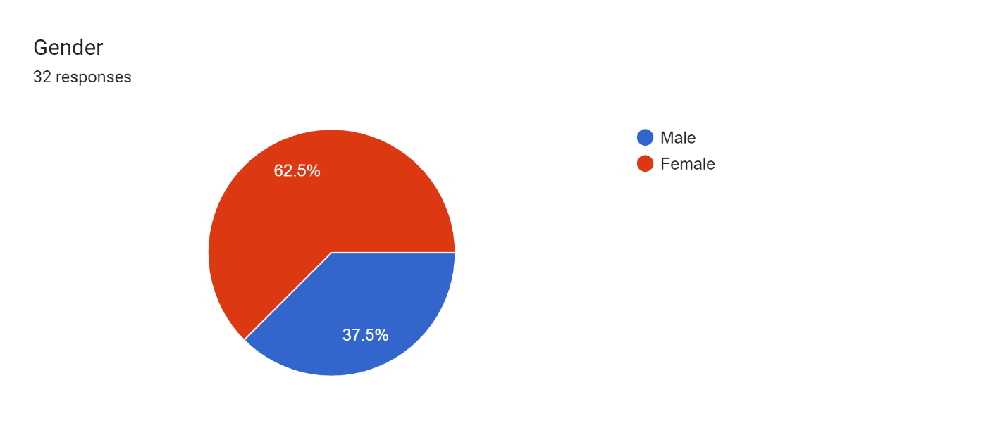

We had five personality traits from the big five personality test(Outgoingness & social skills, Co-cooperativeness & kindness , Dependentability & organization, Emotional stability, Creativity & curiosity) because According to Pinki [22], Each consumer is unique in terms of his or her ambitiousness, competitiveness, conservatism degree of extroversion and so on .in which we consider to choose people who are cooperativeness & kindness and social & outgoing personality traits because they contribute more than 50% of the data. After analyzing the data from the survey we have concluded the results (See Appendix C) that people who have social & cooperativeness personality traits are more likely to purchase grooming products. Also, People who are cooperative and kind They consider sustainability and eco-friendly products when making purchasing decisions They are more inclined to support brands or products that align with their values and contribute to social causes. And people who are social and outgoing are very likely to care about their appearance related to their buying decision.

Forms response chart. Question title: Which of the following personality traits best describes you?
. Number of responses: 33 responses.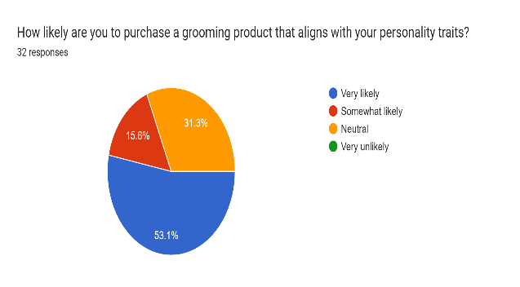

While describing personality based on grooming products, we focus on four personality types. Spontaneous & impulsive Thoughtful & analytical Practical & goal-oriented Creative & imaginative. In which more than 60% people are creative & imaginative, thoughtful and analytical and results shows that they frequently purchase grooming products once a month and 20% of them purchase once a week.

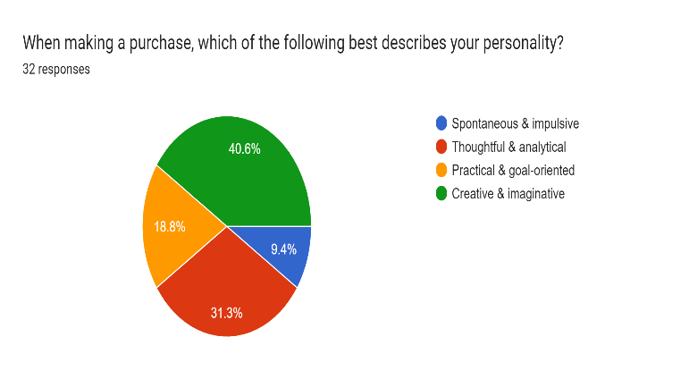Forms response chart. Question title: How frequently do you buy grooming products (e.g., shampoo, conditioner, body wash, facial
cleanser, etc.)?
. Number of responses: 33 responses.

From the results we come to know that 57.6% of the population are more likely comfortable on spending money on things they need and are less likely to save money whenever possible.

Forms response chart. Question title: Which of the following best describes your spending habits?
. Number of responses: 33 responses.

In the last, brand name and features are the important while purchasing grooming products in almost every personality trait.

Forms response chart. Question title: What factors do you consider when choosing grooming products?
. Number of responses: 33 responses.

# Conclusion

The study observed at how personality influenced undergraduate consumers at the Kandhkot campus of Sukkur IBA University. The 'Big Five' personality traits of agreeableness, extraversion, openness to experience, conscientiousness, and neuroticism were used to assess personality. The study also showed that personality is a strong determinant of consumer purchasing behaviour. Cooperativeness and compassion, out of the five personality traits, had the most impact on purchasing decisions, whereas creativity and curiosity had the least. It is the most widely used personality scale and the "Big Five" personality feature has attracted the greatest agreement from academics and researchers studying consumer behaviour.

References:

Abraham, A. A. (1997). Marketing insight lecture note post graduate school university of Calabar. *Nigeria*.

Arnould, E. J., & Thompson, C. J. (2005). Consumer culture theory (CCT): Twenty years of research. *Journal of Consumer Research*, *31*(4), 868–882.

Goldberg, L. R. (1990). An alternative" description of personality": the big-five factor structure. *Journal of Personality and Social Psychology*, *59*(6), 1216.

Hogg, M., Askegaard, S., Bamossy, G., & Solomon, M. (2006). *Consumer behaviour: a European perspective.*

Nagar, K. (2009). Evaluating the effect of consumer sales promotions on brand loyal and brand switching segments. *Vision*, *13*(4), 35–48.

Pinki, R. (2014). Factors influencing consumer behavior. *International Journal of Current Research in Academic Review*, *2*(9), 52–61.

Sarker, S., Bose, T. K., Palit, M., & Haque, E. (2013). Influence of personality in buying consumer goods-a comparative study between neo-Freudian theories and trait theory based on Khulna region. *International Journal of Business and Economics Research*, *2*(3), 41–58.

# Appendix: A

Consumer Behavior Survey

We are conducting this research for our marketing project to understand how personality traits influence buying behavior in grooming products. Your participation is entirely voluntary. All responses will be anonymous and kept strictly confidential.

1. Gender

* Male
* Female

1. Do you consider yourself to be someone who cares about their appearance?

* Yes
* No

1. Which of the following personality traits best describes you?

* Outgoingness & social skills
* Co-cooperativeness & kindness
* Dependentability & organization
* Emotional stability
* Creativity & curiosity

1. How likely are you to purchase a grooming product that aligns with your personality traits?

* Very likely
* Somewhat likely
* Neutral
* Very unlikely

1. When making a purchase, which of the following best describes your personality?

* Spontaneous & impulsive
* Thoughtful & analytical
* Practical & goal-oriented
* Creative & imaginative

1. How frequently do you buy grooming products (e.g., shampoo, conditioner, body wash, facial  
   cleanser, etc.)?

* Once a week
* Once a month
* Once every three months
* Once every six months

1. Which of the following best describes your spending habits?

* I am frugal and try to save money whenever possible.
* I am comfortable spending money on things I want or need.
* I am willing to spend more money on high-quality products.
* I am an impulse buyer and often make purchases on a whim.

1. What factors do you consider when choosing grooming products?

* Brand name
* Price
* Packaging
* Features

1. How important is it to you that yours grooming products are eco-friendly or sustainable?

* Not at all important
* Slightly important
* Moderatly important
* Very important

1. When it comes to grooming products, which statement do you agree with most?

* I prefer to stick with the same products I have always used.
* I am willing to try different products, but I don't usually switch brands.
* I like to experiment with different brands and products.
* I am always looking for the latest and greatest grooming products

Is there anything else you would like to share about your experience with grooming products and how your personality traits influence your buying behavior?



# Appendix B



Forms response chart. Question title: Do you consider yourself to be someone who cares about their appearance?
. Number of responses: 33 responses.

Forms response chart. Question title: Which of the following personality traits best describes you?
. Number of responses: 33 responses.

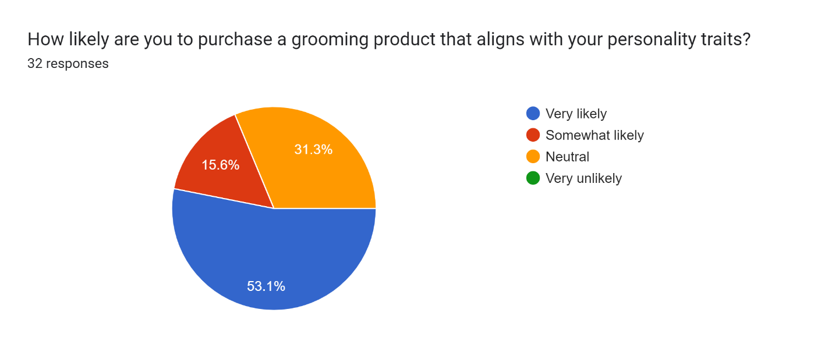

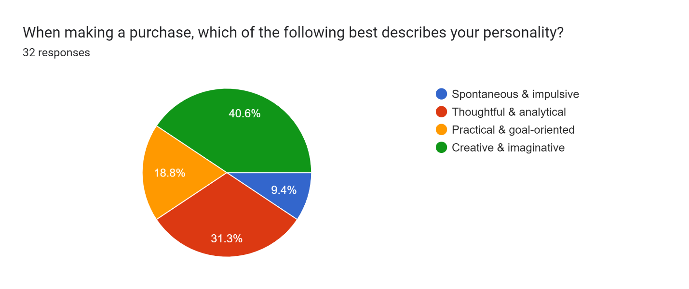

Forms response chart. Question title: How frequently do you buy grooming products (e.g., shampoo, conditioner, body wash, facial
cleanser, etc.)?
. Number of responses: 33 responses.

Forms response chart. Question title: Which of the following best describes your spending habits?
. Number of responses: 33 responses.

Forms response chart. Question title: What factors do you consider when choosing grooming products?
. Number of responses: 33 responses.

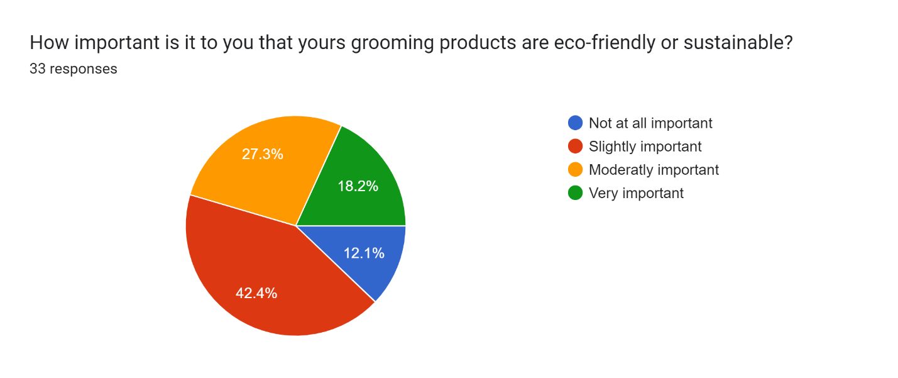

Forms response chart. Question title: When it comes to grooming products, which statement do you agree with most?
. Number of responses: 33 responses.

