A Critique of Hybrid Electric Vehicles

# 1st Antony Joy

*Department of Electrical and Electronics*

*Adi Shankara Institute of Engineering and Technology* Kalady, Ernakulam, India [antonyjo](mailto:antonyjoy2002@gmail.com)[y2002@gmail.com](mailto:y2002@gmail.com)

# 2nd P.Jeno Paul

*Department of Electrical and Electronics*

*Adi Shankara Institute of Engineering and Technology*

Kalady, Ernakulam, India email address or ORCID

***Abstract*—Cleaning operations will likely result from a sig- nificant contribution from HEVs in lowering greenhouse gas emissions. Reduced fossil fuel reserves are a defining feature of the current state of affairs. Because of the high cost of fuel, the transportation industry, which depends significantly on cars, is in dire straits. Further escalation of this issue is anticipated. Problems like air pollution, global warming, and the depletion of fossil resources are all consequences of the growing fuel consumption, and they all have a negative impact on the environment. The modern technology employed in hybrid electric vehicles and the technical characteristics of the various HEV kinds are the main topics of this study. Environmental effects of these cars are also covered in the study.**

***Index Terms*—hybrid electric vehicle (HEV), Plug-in Hybrid Electric Vehicles (PHEVs),**

1. INTRODUCTION

The history of car technology is nearly as old as the essence of HEVs. A hybrid electric vehicle moves by utilizing two or more separate power sources, typically a pair of energy sources combined, such as electricity and traditional fuel-powered au- tomobiles. Since its launch in 1997, approximately 17 million HEVs have been sold globally as of April 2020. Automobile manufacturers have researched hybrid electric vehicles (HEVs) in light of climate change, which is exacerbated by daily fuel consumption increases and contributes to global warming. The enhancement of efficiency and air quality is its primary environmental benefit.It has a significant deal of potential for lower emissions as well as higher fuel economy. It has been apparent in recent years.Itself to be successful despite being a transient replacement. The use of fossil fuels has lessened reliance on air. Additionally, it resolved nearly every issue that ICE had.[1]

Internal combustion engines, which are found in conven- tional cars, offer superior performance characteristics and a broad operating range. In hybrid-electric vehicles, the internal combustion engine is lighter, smaller, and more efficient than in conventional vehicles. Utilizing efficiency-boosting tech- nologies like regenerative braking, which uses the vehicle’s kinetic energy to charge the battery instead of dissipating it as heat energy like traditional brakes do, hybrid electric vehicles (HEVs) improve efficiency.In this paper it is exhibited the technologies in HEVs

1. CLASSIFICATION OF HEVS

Three primary forms of hybrid power systems are identified by the structure: series, parallel, and mixed hybrid.

1. *Series HEV*

A Series Hybrid Electric Vehicle (SHEV) is a type of hybrid vehicle that primarily uses an electric motor for propulsion. The main characteristic of this vehicle is that the driving force comes solely from the electric motor, making it distinct from other types of hybrid vehicles.

The powertrain of a SHEV consists of three main com- ponents: an internal combustion engine, a generator, and an electric motor. These components are connected in a series configuration, hence the name ’Series Hybrid’. In this setup, the internal combustion engine is not directly connected to the wheels. Instead, it is used to drive the generator, which in turn produces electricity. This electricity is then used to power the electric motor, which drives the wheels of the vehicle.[2]

One of the key advantages of a SHEV is its ability to run solely on electricity for short distances. This is particularly beneficial in urban environments, where short trips and stop- and-go traffic are common. By running on electricity, the vehicle can operate without producing any tailpipe emissions, contributing to cleaner air in urban areas.

When the battery’s charge level drops to a certain point, the internal combustion engine kicks in to power the generator. This extends the vehicle’s range, allowing it to continue operating even when the battery is depleted. This eliminates the ’range anxiety’ often associated with fully electric vehicles, as the vehicle can continue to operate as long as there is fuel in the tank.

SHEVs are typically more expensive than Plug-in Hybrid Electric Vehicles (PHEVs). This is due to the more com- plex powertrain configuration, which requires a larger electric motor and a more sophisticated control system. Additionally, the series configuration is less efficient at highway speeds compared to a parallel hybrid configuration, as used in PHEVs.

Despite the higher upfront cost, the operational cost of a SHEV can be lower than that of a conventional vehicle or a PHEV. This is because electricity is generally cheaper than gasoline or diesel, and electric motors are more efficient than internal combustion engines. Additionally, by running on

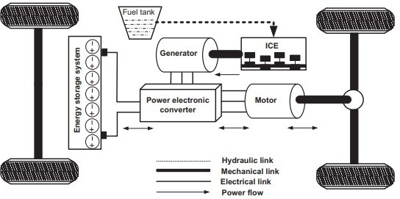 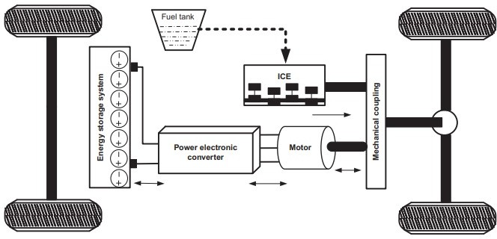

Fig. 1. Architecture of an SHEV [2]

electricity for short trips, the vehicle can save a significant amount of fuel over time.

A Series Hybrid Electric Vehicle offers a compelling blend of zero-emission driving for short trips and extended range for longer journeys. While it may be more expensive upfront compared to other types of hybrid vehicles, the potential fuel savings and environmental benefits make it an attractive option for many drivers. As technology continues to advance and the cost of batteries decreases, we can expect to see more and more of these vehicles on the road in the future.

1. *Parallel HEV*

A Parallel Hybrid System Overview combines both an internal combustion engine (usually fueled by gasoline) and an electric motor to propel the vehicle.Unlike series hy- brids,where the engine solely acts as a generator to charge the battery, parallel hybrids allow both the engine and elec- tric motor to directly contribute to driving the wheels.These systems are mechanically connected, meaning they share the load during propulsion.The engine and electric motor are mechanically linked to the same drive train.When both power sources are engaged, they drive the wheels together.This direct connection enables efficient power transfer without energy losses associated with complex transmission systems.

In a parallel hybrid, the engine and electric motor can work together or independently, depending on driving conditions and power demands.When maximum power is required (such as during acceleration or climbing steep hills), both the engine and electric motor collaborate to provide the driving force. This ensures optimal performance.During cruising or low- demand situations, the electric motor alone can propel the vehicle. The engine remains idle or operates at a lower output, conserving fuel.The ability to switch seamlessly between these modes allows PHEVs to balance efficiency and performance. PHEVs can optimize their electrical system design by reducing the capacity of the battery and associated com- ponents.Smaller batteries are sufficient because the engine can supplement power when needed.Reduced battery size translates to cost savings and frees up space within the ve- hicle.PHEVs recharge their batteries during braking or decel- eration.When the driver applies the brakes, the electric motor acts as a generator, converting kinetic energy back into electri-

Fig. 2. Architecture of parallel HEV [2]

cal energy.This regenerative braking feature enhances overall efficiency and extends electric-only driving range.By sharing the load between the engine and electric motor, PHEVs strike a balance between performance and economy.The smaller battery size reduces costs compared to fully electric vehicles (EVs).Additionally, the compact electrical components occupy less space, allowing for flexible vehicle designs.

Parallel hybrid electric vehicles offer versatility by seam- lessly blending engine and electric motor power. Their me- chanical connection ensures efficient energy transfer, while op- timized electrical systems strike a balance between capability, cost, and volume. As technology advances, PHEVs continue to evolve, providing environmentally conscious mobility options for drivers worldwide.

1. *Combined HEV*

A combined hybrid electric vehicle (CHEV) represents an advanced iteration within the realm of hybrid electric vehicles (HEVs), capable of operating in both series and parallel configurations. This dual functionality grants CHEVs a high degree of adaptability and versatility, allowing them to optimize power delivery and efficiency across a range of driving conditions.

One of the defining characteristics of a CHEV is its hybrid powertrain system, which comprises an internal combustion engine (ICE) system and a motor drive system. These two propulsion systems are interconnected through a mechanical transmission mechanism, which can include gear trains or planetary gear structures. This mechanical linkage enables precise control over the relationship between the internal combustion engine and the electric motor, facilitating seamless integration and coordination of power delivery.

Unlike parallel hybrid systems, which typically maintain a fixed relationship between the engine and motor speeds, CHEVs have the capability to dynamically adjust the engine’s power output and motor operation based on the prevailing operating environment. This flexibility allows for optimal uti- lization of both power sources, enhancing overall performance and efficiency.

The connection system within a CHEV is intricate and so- phisticated, involving precise control algorithms and real-time monitoring of various vehicle parameters. This complexity

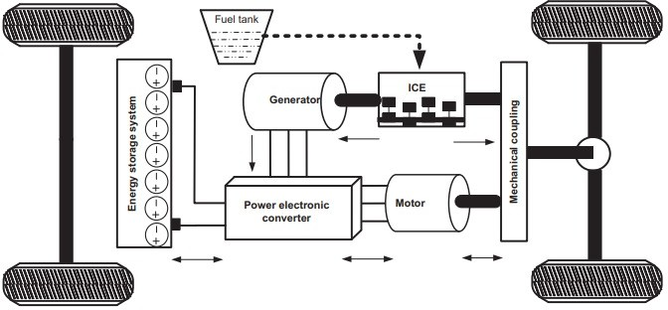 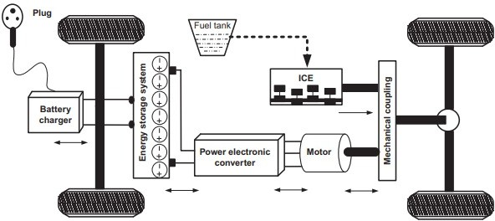

Fig. 3. Architecture of Combined HEV[2]

contributes to higher manufacturing costs compared to simpler hybrid configurations but results in superior adaptability and performance.

During vehicle operation, the CHEV employs a strategy known as engine-off motor propulsion at low speeds. In this mode, the internal combustion engine is disengaged, and propulsion is solely provided by the electric motor. This electric-only operation enhances fuel efficiency and reduces emissions, particularly in urban driving conditions where fre- quent stops and starts are common.

As the vehicle accelerates or demands more power, the internal combustion engine seamlessly transitions back into operation, providing additional propulsion and recharging the battery pack as necessary. At higher speeds, the engine may operate continuously, with the electric motor providing supple- mentary power as needed. The CHEV incorporates regenera- tive braking technology, which allows the electric motor to act as a generator during deceleration. When the vehicle brakes, kinetic energy is converted into electrical energy, which is then stored in the battery pack for later use. This energy recovery system enhances overall efficiency and helps to extend the electric-only driving range of the vehicle.

A combined hybrid electric vehicles represent a pinnacle of hybrid technology, combining the advantages of both series and parallel configurations to achieve superior performance, efficiency, and environmental sustainability. While the integra- tion of complex connection systems and control algorithms adds to manufacturing costs, the benefits in terms of adapt- ability and drivability make CHEVs a compelling choice for discerning consumers seeking an optimal balance between fuel economy and performance in their vehicles.

1. PLUG-IN HYBRID ELECTRIC VEHICLE(PHEVS) These cars are far nearer to HEVs. Its battery pack is

bigger.Both the engine and the electrical supply can charge it. It may be charged via external charging stations as well. Upon depleting the battery, the vehicle functions as a traditional, non-plug-in hybrid thanks to the conventional engine. PHEVs emit few emissions and run entirely on electricity.Each type of PHEV offers distinct advantages and trade-offs in terms of efficiency, performance, and driving experience. Series PHEVs tend to offer longer electric-only driving ranges but may lack the performance of parallel or blended PHEVs. Parallel

Fig. 4. Schematic diagram of PHEVs [2]

PHEVs provide more flexibility in powertrain configurations and can deliver strong performance using both power sources. Blended PHEVs strike a balance between the two, offering a compromise between electric range and performance. Overall, PHEVs offer consumers the versatility of electric driving with the reassurance of a gasoline engine for longer trips, making them an attractive option for those seeking to reduce their environmental impact without sacrificing convenience.

The main types of PHEVs are:

1. *Series PHEVs*

Extended-range hybrid electric cars are another name for them. The engine just generates electricity; the electric motor is what drives the wheels. These can simply be powered by energy up until the point where a battery recharge is required. PHEVs offer the ability to drive on electricity and the convenience of a gasoline backup when needed. Whether you’re cruising silently on electric power or relying on the gas engine for longer journeys, PHEVs provide a versatile and eco-friendly driving experience.

1. *Parallel PHEVs*

It is also known as blended PHEVs. Under the majority of driving circumstances, the vehicle is propelled by both the engine and motor, which are mechanically connected to the wheels. Generally speaking, electric operation only happens at low ranges.PHEVs offer a balance between electric driving and the convenience of an internal combustion engine, making them an excellent choice for environmentally conscious drivers who occasionally need longer driving ranges.

1. *Blended PHEVs*

Blended PHEVs combine elements of both series and paral- lel configurations. They typically have larger battery capacities than parallel PHEVs but can still operate with the engine and electric motor working in tandem or independently. The blending of power sources is managed by sophisticated control systems to optimize efficiency and performance.

1. HEVS ADVANCED TECHNOLOGIES

The promise of HEVs is a considerable reduction in CO2 emissions from the transportation sector. Among the important technologies are the following features:

1. *Technological advancements in internal combustion en- gines*

In order to increase fuel efficiency and lower emissions, hybrid electric vehicles, or HEVs, represent a key nexus of conventional internal combustion engine (ICE) technology and cutting-edge engineering. HEVs use cutting-edge technology to maximize performance, improving fuel economy and reduc- ing greenhouse gas emissions when compared to traditional ICE vehicles.

One obvious distinction is that HEVs have smaller gasoline engines in addition to innovations like high-pressure injection systems. By carefully supplying fuel into the combustion chamber, these systems maximize the air-fuel mixture for effective combustion. Better fuel economy and increased over- all efficiency are the results of this.When comparing HEVs to traditional ICE vehicles, lower compression ratios are frequently seen. In order to optimize fuel usage and allow for more exact control over combustion timing, lower compression ratios assist lessen the chance of knocking.

Peak cylinder pressure is usually higher when using a HEV. This is the outcome of sophisticated engine management tech- nologies that precisely regulate the combustion process. HEVs may extract more mechanical energy from each combustion cycle by raising the peak cylinder pressure, which improves overall performance and efficiency.Regenerative braking sys- tems, which gather and store kinetic energy during decelera- tion and transform it into electrical energy to recharge the bat- tery, are integrated into HEVs’ complex powertrain controls. By using fewer gasoline engines, this energy management technique improves fuel efficiency even more.

Fundamentally, HEVs outperform conventional ICE vehi- cles in terms of fuel economy and emissions thanks to a combination of advanced fuel injection, downsizing, optimized compression ratios, and improved combustion control. As such, HEVs are an essential technology in the shift towards more environmentally friendly transportation options.

1. *Battery storage and charging technologies*

In order to effectively store and use electrical energy in addition to conventional internal combustion engines, hybrid electric vehicles, or HEVs, rely on cutting-edge battery charg- ing and storage technology. The advanced technology vehicle battery is one of the most important parts of a hybrid electric vehicle (HEV). It is the main energy storage system for the electric motor.

By using complex chemistry, these batteries are able to store chemical energy and use electrochemical reactions to trans- form it into electrical energy. Lithium-ion, or Li-ion, batteries are unique among the several battery types used in hybrid electric vehicles (HEVs) due to their outstanding performance qualities. Li-ion batteries have a number of benefits, such as improved performance in cold climates, a higher abuse tolerance, and fast recharging times.

Since that hybrid electric vehicles run in a variety of temperatures, cold-weather performance is very crucial. Li- ion batteries provide consistent performance all year long

since they can withstand freezing conditions without losing efficiency or capacity. Furthermore, the resilience of HEV battery systems is improved by their capacity to withstand misuse, such as excessive charge or abrupt draining.

Li-ion batteries can also recharge quickly, which makes it possible to quickly refuel during regenerative braking or when connected to external charging sources. By decreasing the amount of time needed for recharging, this feature improves the efficiency and usefulness of HEVs.

HEV capabilities will be further enhanced by continued research and development in battery technology, which aims to increase Li-ion battery longevity, energy density, and safety features. Solid-state electrolytes and unique electrode materials are two innovations that could push battery performance limits and increase the efficiency and environmental friendliness of HEVs.Because they offer effective energy storage options with improved performance characteristics, modern battery technologies—especially Li-ion batteries—are essential to the development and widespread adoption of HEVs.

1. *Regenerative braking*

One of the most notable technologies in the field of Hy- brid Electric Vehicles (HEVs) is regenerative braking, which provides notable improvements in terms of performance and energy economy. This novel device serves as an energy recov- ery system, collecting and transforming the kinetic energy lost during braking operations into a form that may be utilized.

Fundamentally, regenerative braking works by converting kinetic energy into electrical energy, which can then be stored for use at a later time. This energy conversion method reduces the amount of heat that is normally produced by conventional friction braking systems in addition to aiding in vehicle de- celeration. Regenerative braking lessens the strain on braking parts by decreasing the need for friction-based braking, which prolongs the life of hybrid electric vehicles and lowers their maintenance costs.

Regenerative braking collects energy and channels it back into the vehicle’s battery packs, where it is stored until needed. The electric motor uses this stored energy as an additional power source, which improves the overall performance and efficiency of the propulsion system. The electric motor uses this stored energy to increase the main drive engine’s output when more power is required, such as during acceleration or uphill climbs. This produces smoother acceleration and better driving dynamics.

By cutting down on the quantity of energy lost during braking events, the incorporation of regenerative braking has the potential to greatly improve the fuel economy of hy- brid electric vehicles. HEVs can minimize fuel usage and emissions, increase overall efficiency, and lessen their envi- ronmental effect by repurposing this otherwise wasted en- ergy.In hybrid electric vehicles (HEVs), regenerative braking is a cutting-edge technology that has several advantages, such as increased performance, lower environmental impact, and increased energy efficiency. Its capacity to recover and repurpose kinetic energy is an example of the continuous

innovation influencing the direction of automotive engineering, in addition to supporting the sustainable operation of HEVs.

1. *Torque Assist*

One important piece of cutting-edge technology used in hybrid electric vehicles (HEVs) to improve performance and lower emissions and fuel consumption is torque assist. The Integrated Starter Generator (ISG), which serves as both a starter motor and an electric generator, normally facilitates this setup.

The ISG operates in its motor role, taking energy from the advanced dual battery system often found in HEVs. The internal combustion engine’s power output is augmented by the electric motor’s extra torque during acceleration and high- demand driving conditions. By reducing the engine’s burden, this additional torque enables the engine to run more effec- tively within its ideal power range.

Torque Assist maximizes the vehicle’s power delivery by utilizing electric motor assistance, which leads to more seam- less acceleration and enhanced performance. Additionally, the technique helps to conserve fuel and reduce pollutants, making HEVs more environmentally friendly by lessening the strain on the engine.

Torque assist technology’s incorporation into Smart Hybrid systems is a major development in the engineering of hybrid vehicles. In addition to improving acceleration responsiveness and efficiency, this technology also helps with overall fuel economy and environmental sustainability.For the purpose of maximizing energy efficiency and enhancing powertrain performance, torque assist systems frequently collaborate with other cutting-edge technologies like regenerative braking and power electronics control. HEVs may achieve remarkable levels of fuel efficiency and emissions reduction through the clever coordination of these systems, making them an appealing option for consumers who care about the environ- ment and assisting in the shift towards greener transportation alternatives.

1. ENVIRONMENTAL ISSUES

The advancement of internal combustion engine (ICE) automobiles undoubtedly marks a significant milestone in modern technology, revolutionizing transportation and driving economic growth. However, this technological feat also comes with adverse effects, primarily revolving around environmental concerns such as air pollution, global warming, and the depletion of fossil fuels.[8]

In contrast to internal combustion engine (ICE) vehicles, Hybrid Electric Vehicles (HEVs) offer a promising solution to mitigate the adverse effects associated with traditional auto- motive technology. HEVs integrate electric propulsion systems with conventional ICE engines, resulting in reduced fuel consumption and emissions. By leveraging electric power for low-speed driving and supplementing with the ICE for high- speed or high-demand situations, HEVs significantly decrease tailpipe emissions and improve fuel efficiency. Moreover, re- generative braking systems in HEVs capture and store kinetic

energy during deceleration, further enhancing efficiency and reducing environmental impact. With their ability to operate in electric-only mode for short distances, HEVs alleviate air pollution in urban areas where congestion is common. Ad- ditionally, HEVs contribute to reducing dependency on finite fossil fuel resources, as they consume less gasoline or diesel compared to traditional vehicles. Therefore, the widespread adoption of HEVs represents a crucial step towards achieving sustainable transportation and mitigating the environmental challenges posed by ICE vehicles.[3]

1. CONCLUSION

Hybrid Electric Vehicles (HEVs) play a vital role in resolv- ing major environmental concerns in the transport sector by lowering oil consumption, mitigating climate change effects, and limiting hazardous emissions. However, difficulties such as the heavyweight and huge size of batteries, together with the need for fast charging infrastructure, impede their broad use. Overcoming these technological and socio-economic constraints through breakthroughs in battery technology, the extension of charging infrastructure, and tailored regulations is vital to fully exploit the promise of HEVs in attaining sustainable and efficient transportation systems.

REFERENCES

1. Vidyanandan, K.V.. (2018). Overview of Electric and Hybrid Vehicles. Energy Scan (A House Journal of Corporate Planning, NTPC Ltd., India). III. 7-14.
2. J. Jain, S., & Kumar, L. (2018). *Fundamentals of Power Electronics Con- trolled Electric Propulsion. Power Electronics Handbook, 1023–1065.* doi:10.1016/b978-0-12-811407-0.00035-0
3. A. Kapustin, V. Rakov, ”Methodology to Evaluate the Impact of Hybrid Cars Engine Type on their Economic Efficiency and Environmental Safety,” in Transportation Research Procedia, vol. 20, pp. 247-253, 2017.
4. J. Liu and H. Peng, ”Modeling and Control of a Power-Split Hybrid Vehicle,” in IEEE Transactions on Control Systems Technology, vol. 16, no. 6, pp. 1242-1251, Nov. 2008, doi: 10.1109/TCST.2008.919447.
5. C. Shen, P. Shan and T. Gao, “A Comprehensive Overview of Hybrid Electric Vehicles,” in International Journal of Vehicular Technology, vol. 2011, Article ID 571683, 2011.
6. Singh, Krishna , Bansal, Hari , Singh, Dheerndra. (2019). A comprehen- sive review on hybrid electric vehicles: architectures and components. Journal of Modern Transportation. 27. 10.1007/s40534-019-0184-3.
7. M. Weiss, A. Zerfass and E. Helmers, “Fully electric and plug-in hybrid cars - An analysis of learning rates, user costs, and costs for mitigating CO2 and air pollutant emissions,” in Journal of Cleaner Production, vol. 212, pp. 1478-1489, 2019, ISSN 0959-6526. DOI: 10.1016/j.jclepro.2018.12.019.
8. A. A. Xarras, “A study on hybrid cars: Environmental effects and consumer habits,” Worcester Polytechnic Institute, 2010.
9. O. M. Govardhan, “Fundamentals and Classification of Hybrid Electric Vehicles,” Open Academic Journals Index, 2017
10. R. T. Soni, “Hybrid Electric Vehicle,” IOSR Journal of Mechanical and Civil Engineering, vol. 12, 2015.