**GSM-BASED HOME SECURITY SYSTEM USING ARDUINO MICROCONTROLLER**

Sunita Upasani1, Yashada Jagtap2, Kanaad Limaye3, Arpita Ingalgi4, Vaidehi Magare5, Avaneesh Joshi6,

Sarwadnya Mahajan7

*1 Assistant Professor Marathwada Mitra Mandal’s collge of Engineering, Pune , Maharashtra , Inaia*

*2-7 Students Department of Computer Engineering, Marathwada Mitra Mandal College of Engineering, Pune, Maharashtra ,India*

|  |  |  |
| --- | --- | --- |
|  | ***Abstract:*** *In response to the escalating demand for cutting-edge security systems due to the surge in criminal activities in the 21st century , to formulate a comprehensive home security solution is the main work of this project. Our system integrates an Arduino Uno microcontroller, a SIM800L GSM module for mobile communication, and a combination of security sensors including a LDR sensor, laser for intrusion detection, MQ-2 sensor for gas leakage identification, and a smoke detector for fire hazard awareness. This integration facilitates real- time alerts and notifications to homeowners in case of potential threats, including unauthorized intrusion, fire hazards, and gas leaks. Leveraging advanced technology at an affordable cost, our Integrated Home Security framework efficiently detects and responds to human movement, assuring enhanced security for residential communities. Through the exploration and implementation of these key components, this research contributes to the advancement and enhancement of home security systems, ensuring the safety and well-being of residential communities.*  ***Key Word****:**1. Home security, Arduino Uno, GSM module, Sensor integration, Real-time alerts* |  |

1. **Introduction**

Now a days there is huge advancement in the security system.But still there is theft, stealing is present in the society. . Therefore, in now a days to restrict and resist these stealer activities, implementation of various security devices is a vital area of research.

By taking the help of various electronic devices, home security can be done from such stealer.[1] Inside as well out side of the home security devices can be placed.Only sound alarm was used in few years back But due to the development and advancement of technology as well as the increase in smartness of burglars, sound alarms are not enough for the home security. Hence various controllers such as Arduino, Raspberry Pi, PIC microcontroller etc. Used for home security system have.

The significance of home security systems in guaranteeing the safety of residential spaces has become additionally pronounced in retort to the escalating incidences of burglaries and home thefts. Conventional security measures, comprising Closed-Circuit Television (CCTV) systems, often provide post-occurrence notifications to homeowners, limiting their convincingness in preventing intrusions in real-time. In discrepancy, innovative home security systems leverage interconnected devices, such as sensors, actuators, and communication devices, to offer a spectrum of services and applications with minimal intervention. Our systems encompass safety and security measures, automation, entertainment, and energy management, catering to the evolving needs of homeowners .Among these services, intelligent home safety and security systems hold certain significance due to the growing need for individuals to feel secure within their homes and mitigate the risk of crime. Improvements in technologies such as the compact micro-controllers and affordable sensors and actuators have paved the way for implementing sophisticated security features in intelligent homes. These systems play a vital role in keeping a tab on indoor environments, providing alerts and real time updates to homeowners, even when they are away from home. The primary objective of this project is to develop an integrated home security system that enhances the manageability and security of human life, especially in situations where individuals are not at home. With the rapid action of people, there is an increasing demand for robust security solutions, leveraging cellular phone technology for seamless information dissemination. This paper proposes an overview of existing research in the field of security system for home, contextualizing the proposed system within this framework. It summarizes the design and functionality of the proposed system, detailing its hardware and software components. The paper concludes with an analysis of results, future plans, and concluding remarks on the usefulness and potential of the developed home security system *.*

1. **Literature Review**

Recent research presents an Arduino Uno-based multi-laser alarm system for home security, enhancing detection precision by strategically positioning lasers. The device triggers an alarm upon obstruction of all lasers, enabling proactive security measures. Integration of Arduino Uno, lasers, light dependent resistors (LDRs), and a buzzer facilitates real-time detection and alerts. Literature review emphasizes the versatility and effectiveness of lasers in security applications. Previous studies showcase diverse implementations of laser-based security systems, highlighting their reliability and cost effectiveness. This research emphasizes the importance of advancing home security technology to address escalating crime rates, offering insights for innovative security solution[1]. The integration of wireless and computational units into physical items, known as the Internet of Things (IoT), emphasizing its application in security systems. It highlights the importance of addressing security concerns, particularly in light-dependent resistor (LDR)-based systems.

The paper proposes leveraging IoT technology to enhance LDR-based security systems, emphasizing their role in monitoring and protecting against intruders. It reviews related works, discusses advancements, addresses challenges, and explores the impact of installing LDR-based security systems[2]. Previous studies have demonstrated the effectiveness of Arduino-based systems in various applications, including environmental monitoring and home automation. Additionally, research on gas sensors, particularly MOS-type sensors like the MQ-2, has highlighted their sensitivity and versatility in detecting a wide range of gases. The integration of these technologies represents a promising approach to enhancing safety and security in residential and industrial settings[3]. Gas leakage detection systems, integrated with alerting mechanisms, offer significant benefits in residential, industrial, and mining environments. Utilizing sensors like MQ-6 and MQ-7, combined with wireless networks and micro-controllers, enables real-time monitoring and alerts for gas leaks. Additionally, the integration of IoT technologies allows for efficient management of gas resources and timely response to potential hazards.

Overall, the reviewed literature emphasizes the critical role of automated detection systems in mitigating risks and ensuring safety in various settings[4]. significance of gas leakage detection systems, particularly those employing GSM modules for wireless alerts. WSN-based systems offer flexible and efficient gas detection solutions, while embedded systems ensure low- cost and sustainable operation. Various sensor technologies, such as MQ2 and ARM-based sensors, are utilized for detecting gases like CO2 and propane. Additionally, IoT-based approaches enhance pollution tracking and agricultural systems, providing remote monitoring and control functionalities. These systems leverage microcontrollers, GSM modules, and IoT platforms to address diverse safety and environmental challenges, emphasizing the importance of real- time monitoring and alerting in critical situations[5]. gas detection systems, particularly in detecting LPG gas leaks, for ensuring safety in various environments. Different sensor technologies, including MQ series sensors, are utilized for gas detection. These systems often incorporate IoT technology and communication modules like GSM for real-time monitoring and alerting. The focus is on developing cost effective and efficient solutions to mitigate the risks associated with gas leaks, highlighting the significance of continuous monitoring and timely alerts[6]

1. **Proposed Systems**

In the modern society today, where technology plays a substantial role in our daily lives, security holds paramount importance akin to our health and daily assets. In light of this, we have developed a sophisticated security system comprising various modules aimed at reducing instances of misconduct, particularly home thefts. This system is designed to provide security even when users are away from home, ensuring their peace of mind during daily routines. Our proposed system integrates several key components, each playing a vital role in improving home security. In this system Arduino Uno works as a central processing unit, which is used for reading the sensor data, controlling system functionalities, also triggering communication protocols through the GSM module. The SIM800L GSM Module facilitates cellular communication The SIM800L GSM module communicates with the Arduino Uno through serial communication, following AT command protocols. When triggered by the Arduino, it connects to the cellular network and enables functions like making calls and sending SMS messages. The Arduino controls these operations by sending specific AT commands to the module, which responds accordingly. This interaction allows the Arduino- based system to integrate mobile communication capabilities, facilitating tasks such as remote monitoring and alerting in applications like home security systems. The Laser Security System utilizes a laser diode and Light-Dependent Resistor (LDR) to detect unauthorized movement by sensing disruptions in the laser beam. The Arduino processes these signals and initiates appropriate actions in response to potential intrusions. The Smoke Detector, interfaced with the Arduino, continuously monitors for the presence of smoke particles. Upon detection, it triggers an alarm and sends an SMS notification for immediate response to potential fire hazards. For the detection of flammable and explosive gases like liquefied petroleum gas (LPG) MQ-2 Gas Detector is used. Upon surpassing a predefined threshold, the MQ-2 sensor alerts the Arduino, triggering an alarm and initiating an SMS notification to mitigate gas leakage risks. The programming logic implemented in our system ensures reliable operation, effectively addressing potential challenges such as false positives from sensors. Moreover, the system architecture is designed to be easily expandable, allowing for seamless integration of additional sensors to further augment security abilities. Overall, our proposed system aims to provide a comprehensive and responsive home security solution, leveraging the combined power of Arduino microcontroller and GSM communication technology. By integrating multiple security measures, including intrusion detection, fire hazard awareness, and gas leakage identification, the system offers robust defence against various threats, contributing to the safety and well-being of residential communities.

1. **Hardware**

**Arduino Uno Microcontroller**: The Arduino Uno is a ATmega328P micro controller. Its compatibility with a wide range of sensors and actuators, along with its opensource nature, makes it a preferred choice for DIY projects and prototyping. It features digital and analog input/output pins, USB connectivity, and a power jack, making it ideal for controlling various electronic devices. The Arduino Uno boasts a versatile architecture, featuring 14 digital output/input pins (of which 6 can be used as PWM outputs), a 16 MHz ceramic resonator, a USB connection for programming, 6 analog inputs, a power jack, an ICSP header, and a reset button.

**SIM800L GSM Module**: The SIM800L GSM

module is a compact GSM/GPRS module that enables mobile communication in Arduino projects. It supports quad-band GSM/GPRS, allowing it to operate on any GSM network worldwide. The module features UART communication interface, making it easy to interface with microcontrollers like Arduino. Its low power consumption and compact size make it suitable for applications requiring mobile communication capabilities, including remote monitoring, tracking, and alert systems.

**Laser for Intrusion Detection:** This component emits a laser beam, which, when interrupted by an intruder, triggers a response in the system. It typically consists of a laser diode, a photodiode or phototransistor for detection, and supporting circuitry. The laser for intrusion detection emits a focused beam of light, typically in the infrared spectrum, and relies on a photodiode or phototransistor to detect interruptions in the beam caused by intruders. Its precise and directional nature enables accurate detection of unauthorized access, making it an essential component in security systems.

**MQ-2 Gas Sensor:** The MQ-2 sensor detects the presence of combustible gases such as LPG, propane, methane, alcohol, and smoke. It operates on the principle of gas detection by using a semiconductor gas sensor. The MQ-2 sensor employs a semiconductor gas sensor to detect a wide range of combustible gases and smoke. It operates on the basis of principle of gas absorption, where the presence of target gases alters the sensor's conductivity. Its sensitivity and responsiveness make it invaluable for detecting gas leaks and potential fire hazards in residential and industrial environments.

**Smoke Detector:** The smoke detector is a sensor- based device that detects the existence of smoke particles in the air. It typically contains a light source (LED) and a photodetector, which measure the scattering of light caused by the smoke particles. A smoke detector consists of a light source (typically an LED) and a photodetector (such as a photodiode or phototransistor) housed within a chamber. When smoke particles enter the chamber, they scatter light, causing a change in the photodetector's output. This change is detected by the smoke detector's circuitry, triggering an alarm to alert occupants of potential fire dangers. These hardware elements work together seamlessly to detect and react to potential security perils, like intrusion, gas leaks, or fire hazards, providing comprehensive protection for residential environments.

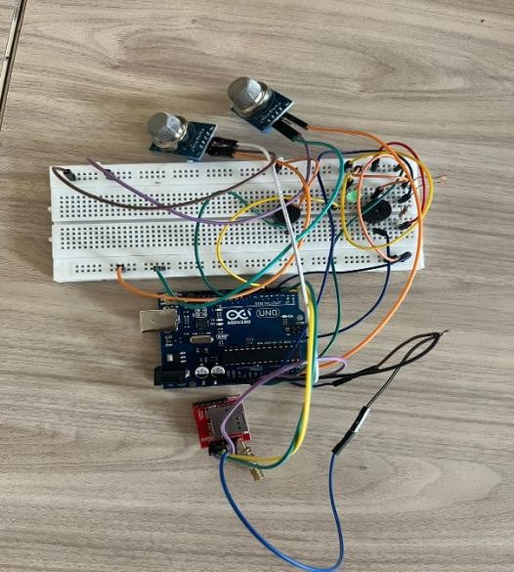

Hardware assembly

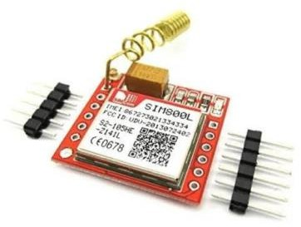

SIM800L

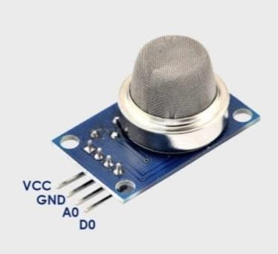

MQ2 Sensor

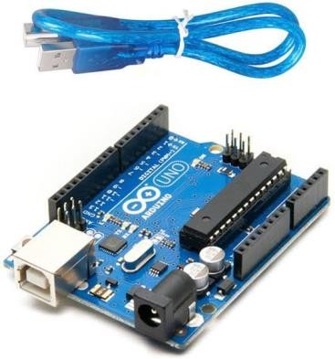

Arduino uno microcontroller

1. **Software**

The Arduino software, is pivotal in supervising and amalgamating the diverse hardware modules within the GSM-based home security system. It provides with a user-friendly programming interface, simplifying code composition and upload to the Arduino microcontroller. With built-in libraries and examples, it facilitates the integration of sensors like the MQ-2 Gas Sensor, Smoke Detector, and Laser for Intrusion Detection. Serial communication capabilities facilitate interaction with modules such as the SIM800L GSM module, enabling commands for SMS transmission or call initiation. Through C/C++ programming in Arduino sketches, developers can execute logic for threat detection and response, confirming timely actions against intrusions, gas leaks, or smoke detection. Moreover, the Arduino IDE endorses real-time monitoring, allowing continuous sensor data retrieval and system status updates for debugging and performance assessment. Overall, Arduino software empowers developers to develop a comprehensive and efficient home security solution tailored to residential needs.

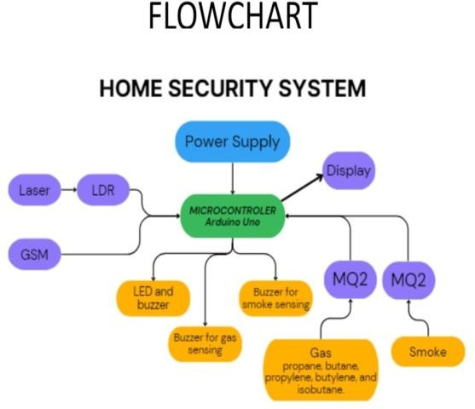

Flowchart of the system

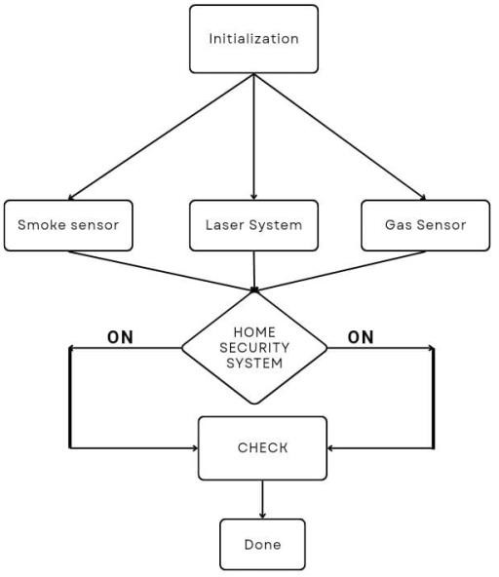 Signal flow diagram

1. **Result Analysis**

The proposed home security system, powered by Arduino and GSM technology, brings peace of mind to homeowners by offering a strong defence against possible threats like break-ins, gas leaks, and fires. By integrating various sensors and communication modules, it keeps a vigilant eye on the home, alerting residents in real-time to any danger. Using simple and accessible hardware components like the Arduino Uno and SIM800L GSM module, the designed system is to be user-friendly and practical. It's like having a smart guard constantly scrutinizing over your home, ready to notify you of any suspicious activity or hazards. Looking ahead, there are exciting plans to make the system even smarter and more intuitive. Imagine being able to regulate and monitor your security system from your smartphone, or even having video surveillance to provide visual confirmation of any security violations. These upgrades aim to make the system more versatile and customizable to fit the specific needs of each homeowner. In significance, this home security system isn't just about technology; it's about providing families with a sense of safety and security in their own homes. With ongoing improvements and advancements, it's poised to make a real difference in enhancing the well-being of residential communities everywhere.

1. **Future Plans**

In the future, we aim to improve the functionality and efficiency of our integrated home security system by incorporating advanced features and technologies. Some potential future plans include: 1. Integration of Machine Learning Algorithms: Implementing machine learning algorithms for the improvement of accuracy and responsiveness of the system in identifying and detecting security threats.

1. *Enhanced Remote Monitoring*: Developing a user-friendly mobile application that permits homeowners to remotely monitor and control their security system, receive real-time alerts, and permit recorded data.
2. *Integration of Video Surveillance*: Integrating video surveillance abilities into the system to provide visual assurance of security violations and enhance overall situational awareness.
3. *Expansion of Sensor Network*: Adding more sensors and actuators to the system to monitor and control additional aspects of home security and mechanization, such as temperature sensors, door/window sensors, and smart locks.

*Cloud Integration*: Integrating cloud-based services for data storage, analysis, and remote access, allowing homeowners to access their security system from anywhere in the world.

**VIII. Conclusion**

The development of GSM based home security system by using Arduino Microcontroller. is shown in this paper. By integrating various sensors, including PIR motion sensors, lasers, gas detectors, and smoke detectors, along with the SIM800L GSM module, we have created a comprehensive security solution that addresses multiple threats in real-time. Our system not only detects intrusions but also identifies potential hazards such as gas leaks and fire outbreaks, providing homeowners with timely alerts and notifications to take appropriate action. Furthermore, the system's modular design and scalability allow for easy expansion and customization to meet specific security needs. Overall, our integrated home security system offers a cost-saving and energy efficient solution for enhancing the safety and well-being of residential communities. With continuous innovation and improvement, our system will contribute significantly to the advancement of home security technology and provide peace of mind to homeowners worldwide.

**IX. References**

[1]. M. Andriansyah, M. Subali, I. Purwanto, A. Irianto S and R. A. Pramono, “e-KTP as the Basis of Home Security System using Arduino Uno”, IEEE 4 th Intern. Conf. Comp. Appl. Inform. Proc. Tech., pp. 8-10, August 2017, Kuta Bali, Indonesia

[2]. Vincent Lusterio, Robert Christian Montecer, Dr. Neil Balba, "Multiple Laser Alarm System using Arduino Uno" LPU- Laguna Journal of Engineering and Computer Studies Vol. 4 No. 3 October 2020

[3]. Mehmet Çavaş, Muhammad Baballe Ahmad,"A REVIEW ADVANCEMENT OF SECURITY ALARM SYSTEM USING INTERNET OF THINGS

(IoT)"International Journal of New Computer Architectures and their Applications (IJNCAA) 9(2): 38-49The Society of Digital Information and Wireless Communications, 2019 ISSN 2220-9085

[4]. Petar Stančić, Aleksandra Stojković and Miljana Milić Member,"ArduinoBased Gas and Smoke Detector Realized Using MQ- 2 Sensor" IEEE

[5]. Nithin Kamath, Darshan N Shetty, Koushik N S,Shreyas Rao, Mr. Ramesh Nayak,"IOT SMOKE DETECTION SYSTEM USING ARDUINO"International Research Journal of Engineering and Technology (IRJET)Volume: 09 Issue: 02

[6]. Syeda Bushra Shahewaz, Ch. Rajendra Prasad,"Gas leakage detection and alerting system using Arduino Uno"Global Journal of Engineering and Technology Advances(2020)

[7]. Raeesa, Navashree, Relin Jane Mascarenhas, Seema Jenitha Tauro, Mrs. Deeksha K R, "Gas Detection System using Arduino"International Journal of Engineering Research &amp; Technology (IJERT)(2021)

[8]. Al Rakib, Md Abdullah, et al. “GSM based home safety and security system.” European Journal of Engineering and Technology Research 6.6 (2021): 69-73.

[9]. Mahzan, Najwa Nasuha, et al. “Design of Arduino Based Home Security using GSM.” Journal of Electrical Power and Electronic Systems 1.2 (2019).

[10]. GUPTA, SHIKHA, et al. “SMART HOME SECURITY SYSTEM USING ARDUINO AND GSM.” Journal of Engineering Sciences 14.06 (2023).

[11]. Efe, Eseosa Ehioghae, and Samson Ogunlere. "Design and Implementation of a Mobile-Based Home Security System." American Scientific Research Journal for Engineering, Technology, and Sciences (ASRJETS) 72.1 (2020): 101-112.

[12]. J. Han, Y. Jeon and J. Kim, “Security Considerations for Secure and trustworthy smart home system in the IoT environment”, IEEE Intern. Conf.Inform. Comm. Tech. Conv., pp. 28-30, October 2015, Jeju, SouthKorea

[13]. H. Elkamchouchi and A. ElShafee, "Design and prototype implementation of SMS based home automation system", Electronics Design System and Application IEEE International Conference, pp. 162-167, Nov. 2012.

[14]. V. Mali, A. Gorasia, M. Patil and P.S. Wawage, "Home Automation and Security using Arduino Microcontroller", International Journal of Research in Advent Technology, March 2016.

[15]. Mohamed Abd El-Latif Mowad, Ahmed Fathy, Ahmed Hafez, “Smart Home Automated Control System Using Android Application and Microcontroller”,International Journal of Scientific &amp; Engineering