**A Report on**

Smart Attendence System using Facial Recognition

Submitted for partial fulfillment of award of

**BACHELOR OF TECHNOLOGY**

degree

In

Computer Science & Engineering

By

STUDENT

**Saurabh Singh (2000300100200)**

**Sujal Jain (2000300100236)**

**Suyash Shukla (2000300100244)**

Mentor

**Mr Mandeep Singh Katre**



**INDERPRASTHA ENGINEERING COLLEGE, GHAZIABAD,**

**Dr. A P J ABDUL KALAM TECHNICAL UNIVERSITY**

**LUCKNOW**

**Dec 2023**

**Certificate**

Certified that **Saurabh Singh, Sujal Jain , Suyash Shukla** has carried out the project work presented in this report entitled “**Smart Attendance System Using Facial Recognition** ” for the award of **Bachelor of Technology** from Inderprastha Engineering College, Ghaziabad, under my supervision. The report embodies result of original work and studies carried out by Student himself/herself and the contents of the report do not form the basis for the award of any other degree to the candidate or to anybody else.

Mr Mandeep Singh Katre

Designation :Assistance Professor

Computer Science & Engineering

Date: 23-12-2023

#### **Acknowledgement**

We take this opportunity to thank our teachers and friends who helped us throughout the project.

First and foremost I would like to thank my guide for the project **Mandeep Singh Katre ( Assistance Professor ) Computer Science and Engineering** for her/his valuable advice and time during development of project.

We would also like to thank **Dr. Vijai Singh (HoD, Computer Science Department**) for his constant support during the development of the project.

Saurabh Singh

(2000300100200)

Sujal Jain

(2000300100236)

Suyash Shukla

(2000300100244)

**Declaration**

*I hereby declare that this submission is my own work and that, to the best of my knowledge and belief, it contains no material previously published or written by another person nor material which to a substantial extent has been accepted for the award of any other degree or diploma of the university or other institute of higher learning, except where due acknowledgment has been made in the text.*

*Signature:*

*Name: Saurabh Singh*

*Roll No. 2000300100200*

*Signature:*

*Name: Sujal Jain*

*Roll No. 2000300100236*

*Signature:*

*Name: Suyash Shukla*

*Roll No. 2000300100244*

**Abstract**

We are living in a world where everything is automated and linked online. The internet of things, image processing, and machine learning are evolving day by day. Many systems have been completely changed due to this evolve to achieve more accurate results. The attendance system is a typical example of this transition, starting from the traditional signature on a paper sheet to face recognition.

This Project proposes a method of developing a comprehensive embedded class attendance system using facial recognition with showing whether the face of the person is the student for that specified class or not. The system is based on the machine learning algorithm which is to be implemented on python language and using computer/laptop camera for the input image of the students or a normal outer camera can also be used which has to be connected to the system which is programmed to handle the face recognition by implementing the Local Binary Patterns algorithm LBPs.

### **TABLE of CONTENTS**

**CHAPTER NO. TITLE PAGE NO.**

**ABSTRACT iii**

1. **INTRODUCTION 1 to 4**

1.1 Problem Definition 1

1.2 Background about the project idea 1

1.3 Objectives of proposed system 1

1.4 Feasibility Study, need and significance 2

1.5 Novelty of Project 3,4

1.6 Technical Specification 4

1.5.1Hardware and Software required

**2. LITERATURE REVIEW**  **5**

**3. PROPOSED SYSTEM 6**

**4. SOFTWARE REQUIREMENT ANALYSIS 8 to 11**

4.1.Functional Requirements

1. Use Case diagram with proper factoring 8
2. Use case descriptions 9

4.2. Nonfunctional Requirements 10

4.3. Major Modules and their functionalities 11

**5. SYSTEM ANALYSIS & DESIGN 13 to 15**

5.1 Sequence diagrams 13

5.2 Activity Diagrams 14

5.3 DFDs of the project 15

**6.**  **IMPLEMENTATION/CORE MODULE 16 to 18**

6.2 Used Algorithms/Approaches for projects. 16,17

6.3 Implementation of Modules/Algorithms. 17

**7. RESULTS / OUTPUTS & TESTING 18 to 19**

7.1 All user interfaces and output screens 18

7.2 Layouts of web Pages and screens 19

**8. CONCLUSIONS / RECOMMENDATIOS 20**

**9. REFERENCES 21**

# Chapter 1

**Introduction**

## **Problem Statement**

In the current educational and corporate landscape, traditional methods of attendance management are often time-consuming, error-prone, and susceptible to various fraudulent practices such as proxy attendance. To address these challenges, there is a critical need for an advanced and secure attendance management system that leverages cutting-edge facial recognition technology. The primary objective of this project is to design, develop, and implement an Intelligent Attendance Management System that utilizes facial recognition to accurately and efficiently record and manage attendance.

## **1.2 Background about Project Idea**

In the realm of educational institutions and organizations, managing attendance has long been a manual and time-consuming process. Traditional methods such as paper-based attendance sheets and card-based systems are not only prone to errors but also susceptible to various fraudulent activities like proxy attendance. As technology continues to advance, there is a growing need for innovative solutions that can streamline attendance management, enhance accuracy, and provide a more secure environment.

Facial recognition technology has emerged as a powerful tool in the field of biometrics, offering a non-intrusive and efficient means of identity verification. By leveraging facial recognition algorithms, it becomes possible to accurately identify individuals based on their unique facial features. This technology has found applications in various sectors, including security, finance, and now, attendance management.

## **1.3 Objectives of proposed system**

The objective of the proposed system is to Develop and implement facial recognition algorithms that ensure high accuracy in identifying and verifying individuals. Ensure that the individual present is the legitimate, enrolled user, enhancing the overall integrity of attendance data. Provide timely and up-to-date attendance information for educators, administrators, and other stakeholders. Enable real-time processing capabilities to facilitate instantaneous attendance recording.

## **1.4 Feasibility Study, Need, Significance**

**Feasibility Study**

Evaluate the practicality of integrating the system into daily operations within educational institutions or organizations.Assess the impact on current processes, training requirements, and any potential resistance to change among users.

**Need**

Enhanced Accuracy : Traditional attendance methods are prone to errors and can lead to inaccuracies. The facial recognition system addresses this need by providing a highly accurate and automated method of attendance tracking.

Fraud Prevention : The prevalence of proxy attendance and other fraudulent activities necessitates a more secure attendance management system. Facial recognition serves as a deterrent and preventive measure against such practices.

Real-time Monitoring: Timely and accurate attendance data is crucial for monitoring student or employee engagement. A facial recognition system enables real-time monitoring, providing immediate insights into attendance patterns.

**Significance**

Security and Integrity: The significance of the proposed system lies in its ability to enhance the overall security and integrity of attendance data. Facial recognition adds an extra layer of authentication, reducing the risk of unauthorized access or fraudulent activities.

Modernization of Processes: The adoption of facial recognition technology represents a step towards modernizing outdated attendance tracking methods. It aligns educational institutions and organizations with technological advancements.

## **1.5 Novelty of Project**

**1.Adaptive Learning Algorithms:**

Novel facial recognition systems incorporate adaptive learning algorithms. Over time, the system improves its recognition accuracy by continuously learning from new data, ensuring adaptability to changing facial features and environmental conditions..

**2Behavioral Analysis for Engagement:**

Some advanced systems include behavioral analysis to gauge user engagement. By assessing facial expressions, the system can provide insights into the level of attentiveness during classes or meetings, contributing to a more comprehensive understanding of attendance dynamics.

## **1.6 Technical Specification**

### **1.6.1** **Software Requirement**

* Python: Primary programming language for machine learning tasks.
* **Machine Learning Frameworks:**
  + TensorFlow or PyTorch: Widely used for building and training neural networks.
  + Keras: High-level neural networks API (often used with TensorFlow).
* **Computer Vision Libraries :**
  + OpenCV: For video and image processing.
* **Data Processing and Analysis:**
  + Pandas: For data manipulation and analysis.
  + NumPy: Essential for numerical operations.
* **Development Environment:**
  + Jupyter Notebooks or an IDE like VSCode or PyCharm

### **1.6.2 Hardware Requirements**

The hardware requirements for your video classification project will depend on factors such as the size of your dataset, the complexity of your model, and the desired speed of inference. Here are some general guidelines:

**CPU:**

A multi-core processor (e.g., quad-core or higher) for data preprocessing and training tasks.

**Memory (RAM):**

At least 8 GB of RAM is recommended for handling large datasets and training deep learning models efficiently.

**Storage:**

Fast and large storage capacity, preferably SSDs, to handle the storage and retrieval of video data during training and testing.

**Network Connectivity:**

High-speed internet connection for downloading datasets, models, and updates.

# **Chapter 2**

**Literature Review**

Facial Recognition-based Attendance Management Systems have emerged as a promising solution. This literature review explores key studies, methodologies, and advancements in the field.

Attendance management systems that rely on facial recognition have become a viable option. The important studies, approaches, and developments in the field are examined in this review of the literature.

Significant progress has been made in facial recognition technology in the past few years. The foundation of contemporary systems is built on the modern facial recognition algorithms developed by Turk and Pentland (1991) and Jain et al. (2011). Studies conducted by Zhang et al. (2019) and Li et al. (2020) demonstrate how deep learning approaches improve facial recognition accuracy. Concerns about anti-spoofing techniques are also covered in these studies, guaranteeing the system's resistance to deceptive attempts.  
Chen et al. (2017) assessed the amount of training that administrators and teachers should receive before implementing facial recognition technology. Programs for training are essential to guaranteeing successful implementation.

The research emphasizes the importance of seamless integration to minimize disruptions in daily operations. Integrating facial expressions for deeper insights into user engagement and sentiment during attendance sessions is an area of ongoing research.

Emerging technologies, such as edge computing, are explored by Liang et al. (2023) for real-time processing in attendance management systems. This presents opportunities to enhance the efficiency and responsiveness of facial recognition systems.

# **Chapter 3**

**Proposed System**

**1** **. System Architecture**

* The proposed system adopts a client-server architecture.
* Clients include facial recognition-enabled devices, such as cameras, at different locations.
* A centralized server manages enrollment, recognition, and attendance data storage.

**2. Facial Recognition Algorithms:**

* Utilize state-of-the-art deep learning algorithms, such as Convolutional Neural Networks (CNNs), for facial feature extraction and recognition.

**3. User Enrollment:**

* Develop a user-friendly enrollment process for students or employees.
* Capture multiple facial angles and expressions to enhance recognition accuracy.

**4.** **Real-time Attendance Tracking:**

* Implement real-time processing capabilities to capture and process facial data instantly.
* Ensure minimal latency for timely attendance recording.

**5. Integration with Existing Systems:**

* Design the system to integrate seamlessly with existing educational databases and information systems.
* Establish standard protocols for data exchange to support interoperability.

**6. User Interface:**

* Develop a user-friendly interface for administrators, instructors, and end-users.
* Include features for easy enrollment, attendance tracking, and reporting.

**7. Dynamic Reporting:**

* Provide administrators with dynamic reporting and analytics tools.
* Generate attendance reports, identify trends, and offer insights for informed decision-making.

**8** **Continuous Improvement:**

* Establish a feedback mechanism for users to report issues and suggest improvements.
* Regularly update the system to incorporate advancements in facial recognition technology.

**9.** **Security and Privacy Measures:**

* Robust security measures are implemented to protect user data and ensure the confidentiality of uploaded content.
* Privacy features are integrated to anonymize user information and maintain a secure and trustworthy environment.

**10. Scalability:**

* The system is designed to be scalable, accommodating increased user activity and expanding datasets.

**11. Gamification:**

* Introduce gamification elements to enhance user engagement.
* Users could earn rewards or badges based on consistent attendance.

The proposed Attendance System using Facial Recognition aims to provide a comprehensive and innovative solution, addressing accuracy, security, user-friendliness, and adaptability. Continuous feedback, regular updates, and an emphasis on privacy and compliance ensure that the system aligns with the evolving needs of educational institutions and organizations.

# **Chapter 4**

**Software Requirement Analysis**

## **4.1 Functional Requirements**

1. Use Case Diagram with proper factoring

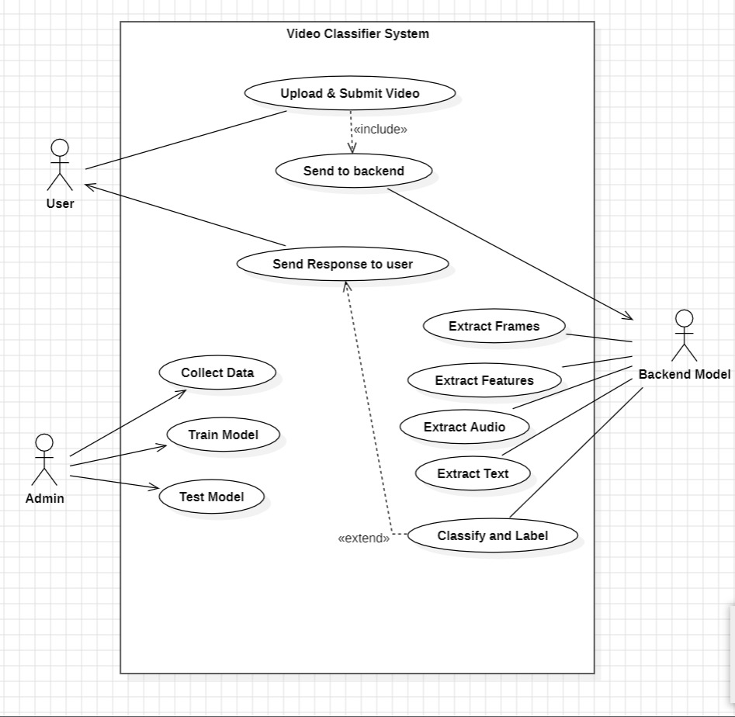

1. Use Case description

User interacts with the system by uploading the video, and the system performs the content classification using The Use Case Diagram represents the overall working of the system. ML frameworks. Users can also view the result of the classification.

**Actors:**

**Student/Employee:**

* Enroll in the system.
* View attendance records.
* Update personal profile.

**Admin:**

* Monitor attendance records.
* Manually override attendance.
* Generate attendance reports.

**Backend Model:**

* It will receive the uploaded images by the admin.
* It will then extract frames, and the basis of it train the Image
* It will classify the image and store it
* Now Matches with the pre-existing image and gives the result in text form.

## **4.2 Nonfunctional Requirements**

1. **Performance:**
   * The system should process a minimum of 10,000 video frames per second with a response time of under 100 milliseconds, ensuring seamless user experience and timely classification results.
2. **Scalability:**
   * The architecture must support horizontal scaling to accommodate a growing user base and increasing content volume, maintaining consistent performance during peak usage periods.
3. **Accuracy:**
   * Achieve an overall accuracy rate of at least 70% in video, audio, and text classification, continuously monitoring and improving accuracy through periodic model retraining.
4. **Adaptability:**
   * The model should dynamically adapt to emerging content trends and user behaviour, implementing a mechanism for dynamic learning and regular model updates.
5. **Explainability:**
   * Provide detailed explanations for classification decisions, promoting transparency in the decision-making process to build user trust and facilitate content creator understanding.
6. **Usability:**
   * Design a user-friendly interface for administrators to customize moderation policies and review classification results. Clear documentation must be provided for both system administrators and end-users.
7. **Resource Efficiency:**
   * Optimize resource utilization to minimize computational and storage costs. Implement caching mechanisms and data compression techniques to enhance overall resource efficiency.
8. **Interoperability:**
   * Ensure compatibility with various video formats, audio codecs, and text encodings, providing APIs or integration points for seamless interoperability with other systems and platforms.
9. **Ethical Considerations:**
   * Implement features to avoid biases in classification results, particularly concerning race, gender, and cultural diversity. Regularly review and address ethical implications of the model's decisions, adjusting algorithms accordingly.

## **4.3 Major Modules and their functionalities**

**1. Enrollment Module**

**1.1User Registration:**

* Allows students or employees to register by providing necessary information.
* Captures multiple facial images for enrollment.

**1.2Facial Feature Extraction:**

* Utilizes facial recognition algorithms to extract unique features from the captured images.
* Creates a unique facial template for each enrolled user.

**1.3Database Integration:**

* Integrates with the database to store user profiles, including personal details and facial templates.

**1.4User Profile Management:**

* Enables users to update their profiles, including contact information and profile pictures.
* Provides options for users to re-enroll or update facial features if necessary.

**2. Attendance Tracking Module:**

**2.1Real-Time Facial Recognition:**

* Employs real-time facial recognition algorithms to identify and verify users during specified time periods.
* Captures facial images from cameras installed in classrooms or entry points.

**2.2Automatic Attendance Recording:**

* Automatically records attendance for recognized users based on their facial features.
* Timestamps and logs attendance data in the system.

**2.3Anti-Spoofing Mechanisms:**

* Implements anti-spoofing techniques to prevent fraudulent attempts, such as using photographs or videos for recognition.
* Enhances system security and accuracy.

**2.4Manual Attendance Override:**

* Allows administrators to manually override attendance records if discrepancies or issues arise.
* Provides flexibility in handling exceptional cases.

**3. Reporting and Analytics Module:**

**3.1Dynamic Attendance Reports:**

* Generates dynamic reports showcasing attendance trends, patterns, and individual records.
* Enables users and administrators to access and analyze attendance data.

**3.2Analytics Dashboard:**

* Provides administrators with an analytics dashboard for visualizing attendance data.
* Supports informed decision-making based on attendance insights.

**3.3Customizable Settings:**

* Allows administrators to customize settings related to reporting formats, class schedules, and attendance parameters.
* Enhances adaptability to different educational or organizational environments.

**3.4 Notification Preferences:**

* Enables users to set notification preferences for receiving alerts related to attendance, system updates, or important announcements.

**4.Additional Consideration:**

**4.1Security and Privacy Module:**

* Ensures the secure storage and transmission of facial recognition data.
* Implements multi-factor authentication and encryption techniques.
* Adheres to privacy regulations and ethical considerations.

# **Chapter 5**

**System Analysis & Design**

## **5.1 Sequence Diagram**

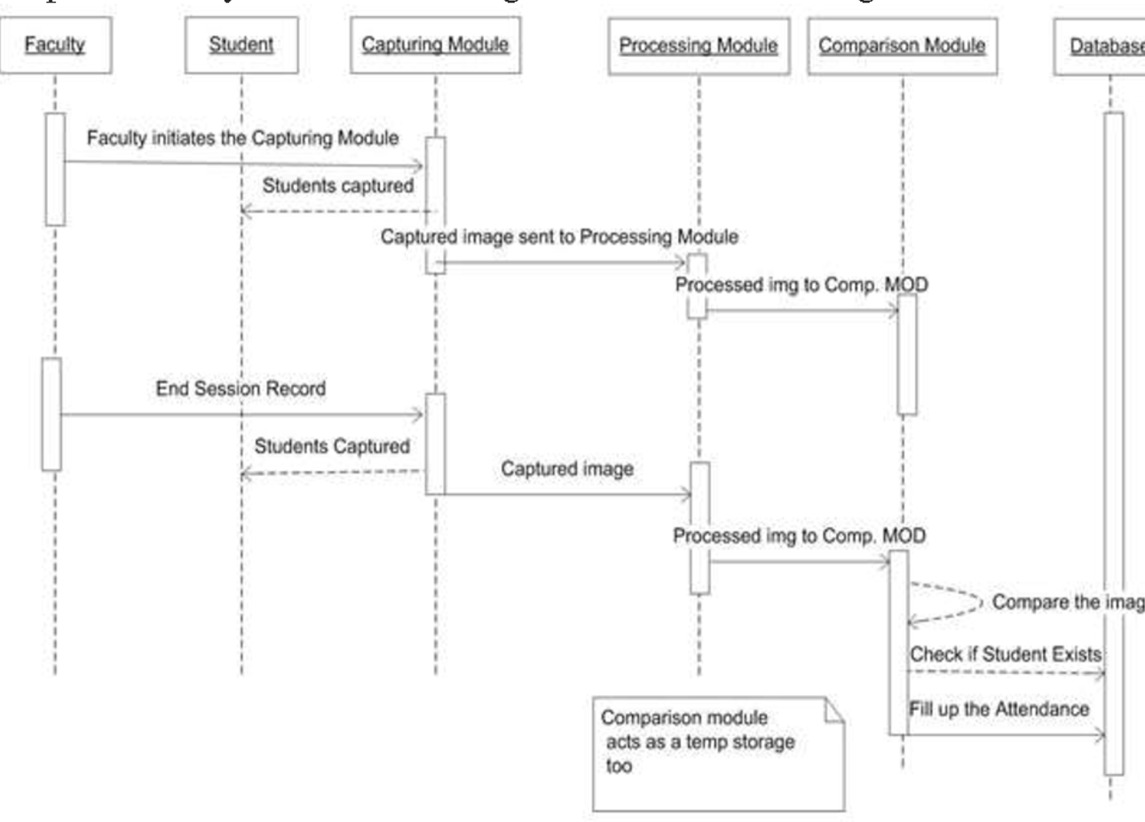

## **5.2 Activity Diagram**

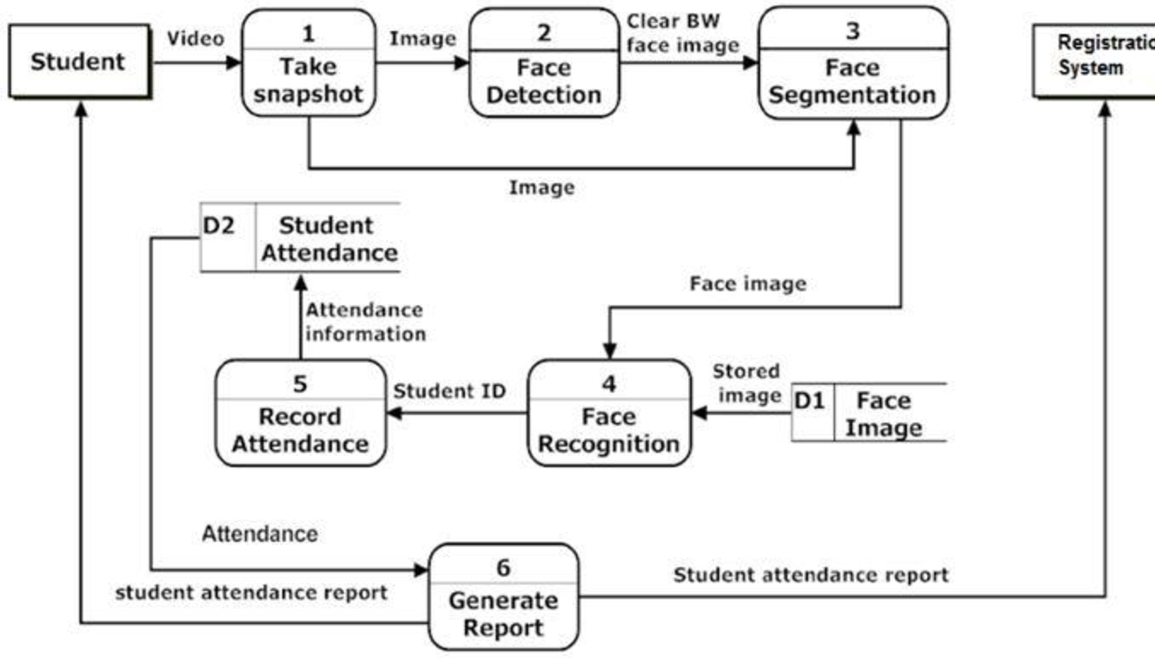

## **5.3 DFDs of the project**

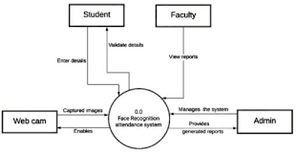

*Level 1*

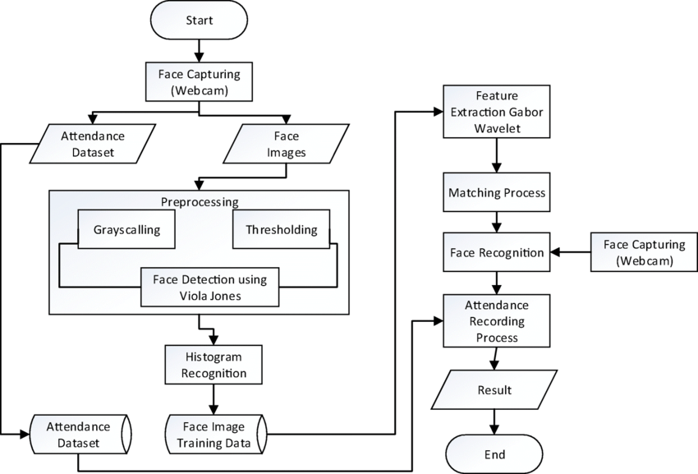

*Level 2*

# **Chapter 6**

**Implementation / Core Module**

## **6.1 Used Algorithms / Approaches for projects**

**1.LBPH (Local Binary Pattern Histogram)**

This section describes how to use LBPH for face recognition. First, a dataset is collected for the images and each image is tagged with a unique identifier**.** The images are divided into an 8x8 grid and converted to grayscale. The image is separated into a 3x3 matrix of each pixel containing its intensity (0-255).

Take the middle threshold of this matrix used to determine the matrix'sneighbor value. Each adjacent value is compared to the central value. If the neighbor value is greater than or equal to the threshold value, it is set to 1. If the neighbor value is less than the threshold value, it is set to 0. In this case, the matrix value contains only binary values **.**

 The decimal value is calculated by the given formula:  
**LBP (xc,yc) = ∑7 n=S(ic – in)2n**

In the above formula, 'n' are the 8 neighbors of the central pixel, ic **,** and in are the central pixel and surrounding pixel respectively shades ofgray. S(x) is 1 if x is greater than or equal to the threshold value. S(x) is 0 if x is less than the threshold

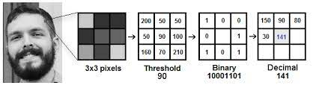

The calculated decimal value is replaced with the central value. Hence, we obtain the characteristics of the original image in a new image.

Once all the processes are complete, a histogram is extracted from each grid and are concatenated. This process is repeated for all the images and a histogram is generated. To compare two images, histograms are compared at a time. The comparison is done by Histogram Intersection.

Its formula is given below: ∑j=1 min(Ij,Mj)

Here, j is the bin number and I and M are histogram 1 and histogram2.

If the intersection value is greater than 80% then, the image is successfully recognized

**2 Haar cascade Algorithm : -**

It is a machine learning based approach where a cascade function is trained from a lot of positive and negative images (where positive images are those where the object to be detected is present, negative are those where it is not). It is then used to detect objects in other images. Luckily, OpenCV offers pre-trained Haar cascade algorithms, organized into categories (faces, eyes and so forth), depending on the images they have been trained on.

# **Chapter 7**

**Results / Outputs and Testing**

## **7.1 All user interfaces and output screens**

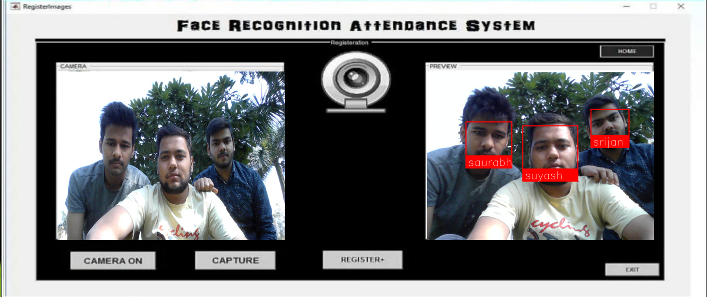

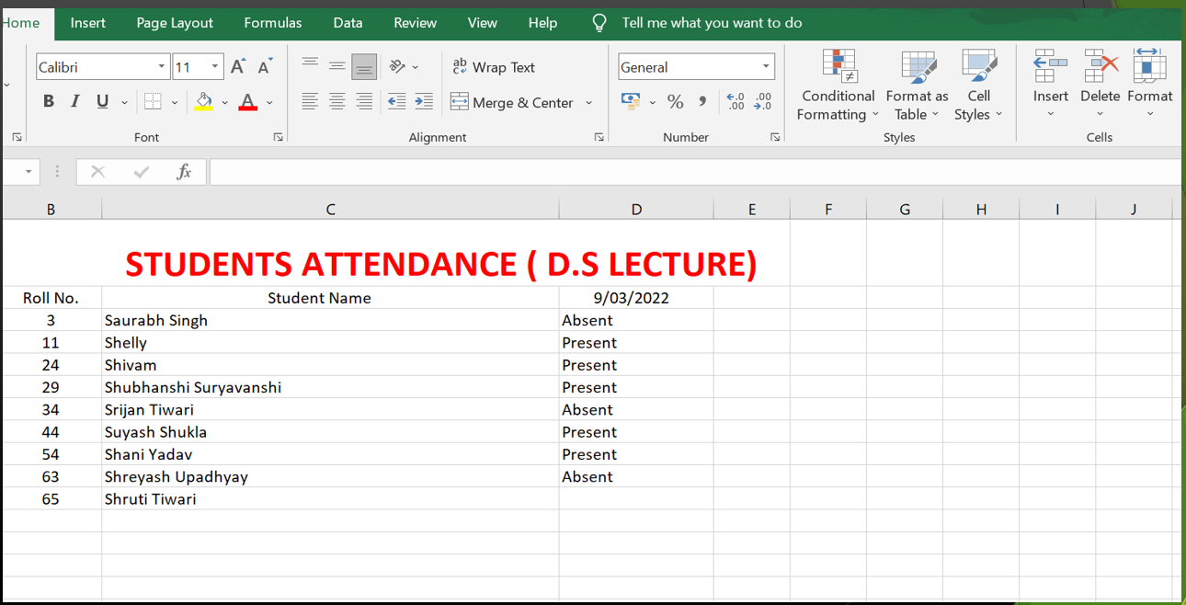

# **Chapter 8**

**Conclusions**

The Smart Attendance System using Facial Recognition heralds a paradigm shift in traditional attendance management, offering a seamless blend of accuracy, efficiency, and technological innovation. By leveraging facial recognition technology, this system not only eradicates the inaccuracies inherent in manual processes but also introduces a level of precision that significantly enhances operational efficiency.

The implementation of robust security measures and anti-spoofing mechanisms underscores the system's commitment to data integrity and user authentication. Multi-factor authentication, coupled with advanced facial recognition algorithms, ensures a secure and tamper-resistant environment, addressing concerns related to unauthorized access.

User experience takes center stage with an intuitive interface that facilitates user enrollment, profile management, and effortless access to attendance records. The system's adaptability to various educational and organizational settings, coupled with customizable features, ensures a seamless integration process and scalability to meet evolving needs.

Furthermore, the inclusion of dynamic reporting and analytics tools empowers administrators with actionable insights. The system not only records attendance but also provides a data-driven foundation for informed decision-making, resource allocation, and strategic planning.

In the ever-evolving landscape of technology, the Smart Attendance System using Facial Recognition stands as a beacon of efficiency, ethical conduct, and future possibilities. As it continues to evolve, incorporating advancements such as behavioral analysis and edge computing, the system is poised to redefine the dynamics of attendance management, fostering a more connected, intelligent, and secure educational or organizational ecosystem.

# **Chapter 9**

**References**

[1] Kennedy Ok okpujie,EtinosaNomaOsaghae,Samuel John, Kalu-Anyah Grace, ImhadeOkokpujie “ A face Recognition Attendance system with GSM Notification” inIEEE NIGERICON 2017.

[2] Jenif D Souza, Jothi S, Chandrasekar A, “Automated Attendance Marking and Management System by Facial recognition usingHistogram” in ICACCS 2019.

[3] Nandhini R, Duraimurugan N, S.P Chollalingam “Face Recognition AttendanceSystem” in IJEAT in 2019.

[4] E Varadharajan, R Dharani, S.Jeevitha, B Kavinmathi, S.Hemalatha ‘Automatic Attendance Management system using face detection’ at ICGET 2016. 2020 Department of Information Technology.

[5] Poornima S,Sripriya N, Vijayalakshmi B, Vishnupriya P “Attendance monitoring system using facial recognition with audio output gender classification “in ICCCSP 2017.

[6] Kritika Shrivastava, Shweta Manda P.S Chavan, “Conceptual model for proficient automated attendance system based on face recognition and gender classification using Haar- cascade” in IJEAT 2018. https://www.ripublication.com/ijaer18/ijaerv13n10_11 1.pdf

[7] Aruna Katara , Sudesh V, Amar P, Nikhil D, Bhele https://www.scribd.com/document/350875725/Att endance-System-Using-Face-Recognition-andClass-MonitoringSystem

[8 ]Omar Abdul Rhman Salim, Rashidha Olanrewaju , Wasiu Balogun “Class attendance management system using face recognition” in ICCCE 2018.